Consider a 2D char array initialized with data as below. #define MAX_LEN 80

char arr[][MAX_LENGTH]={“Antony:Joseph”, “Lata:Mary”, “Rajesh:Kumar”, “Joly:Akbar”};

Write an application with functions to perform the given operations on input array. Invoke the functions and test the application.
Requirement Tag | Requirement Description | Comments
ARR/01 | int getFirstNames(char arr[][MAX_LENGTH], int rowcount, char *firstnames[]);  should receive input array containing 'n' first name:last name pairs, where n=rowcount,  process each name, extract firstName, store address in firstname array of pointers. | Should return EXIT_SUCCESS on  success else EXIT_FAILURE  Hint: Use strtok() to tokenise
ARR/02 | int getLastNames(char arr[][MAX_LENGTH], int rowcount, char *lastnames[]);  Similar to getFirstName(), but it extracts and stores in lastnames

ARR/01
#include <stdio.h> int main() {

char firstname[20], lastname[20]; int bir_year; printf("Input your firstname: ");
("%s", firstname)

; printf("Input your lastname: "); scanf("%s", lastname); printf("Input your year of birth: ");
scanf("%d", &bir_year); printf("%s %s %d\n", firstname, lastname, bir_year); return 0;
}
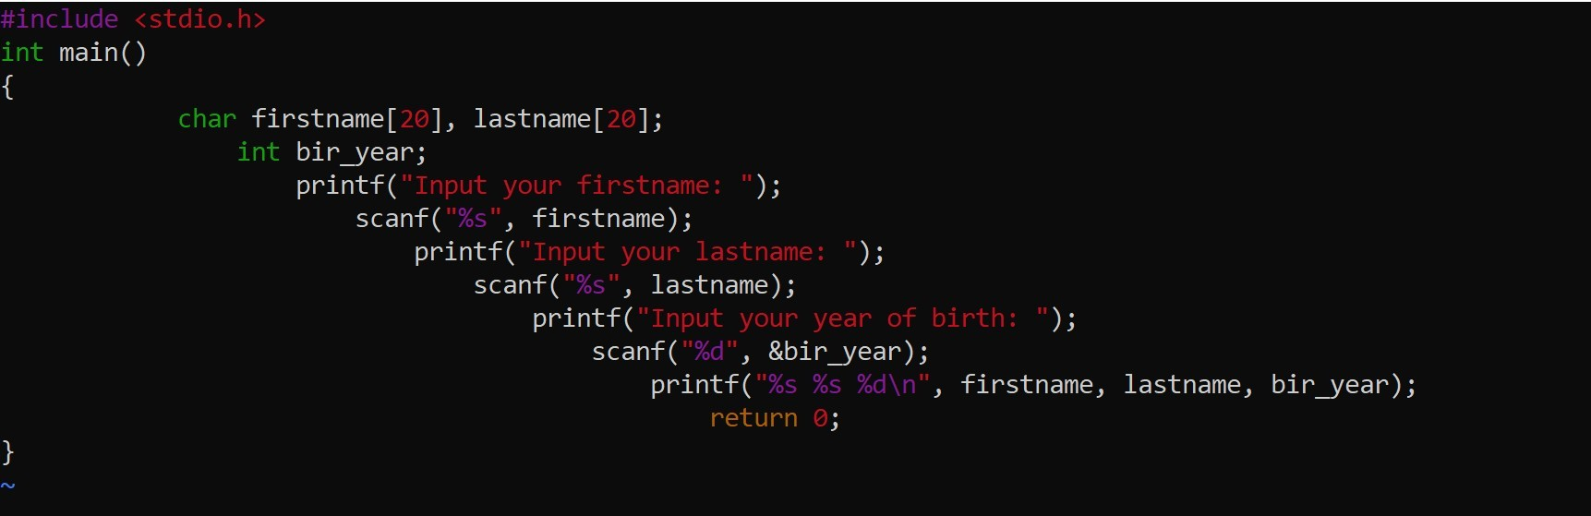

ARR/02
#include <iostream> #include <cstring> using namespace std;

int main() {
char getName[] = "sharat bhat";

cout << "String Length = " << strlen(getName);

return 0;
}

O/P:-

String Length = 8

