CPP_Assignment_6b

Write an application in C++ to read a line of text as a single string as command line argument, parse, extract, store and display the words following the specified steps:
Requirement Tag | Requirement Description | Comments
VSTR/01 | Read a line of text as a single string from command line
VSTR/02 | Create a class named “Wordset” with members as below  vector <string> vlist;  int addmember(string s) - add given string s to vlist  int deletemember(string s) – search and delete the given string s from vlist  void displaylist() – iterate the vlist and display all its contents
VSTR/03 | Parse the command line arguments, extract words and store them in vlist
VSTR/04 | Prompt the user for a word to search and delete, then call deletemember if found
VSTR/05 | Display the contents of vector.
VSTR/06 | Empty the vlist and display the size of vlist
VSTR/07 | For every unque word stored in vector, get its frequency and display. | Hint: Use a map with key as string and frequency as value

VSTR/01 Read a line of text as a single string from command line
Ans:
#include<iostream>
#include<vector>
#include<string>
using namespace std;

int main(int argc,char *argv[])
{
int i;
for(i=0;i<argc;i++)
{
cout<<argv[i]<<endl;
}
return 0;

}

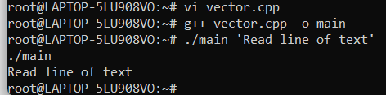
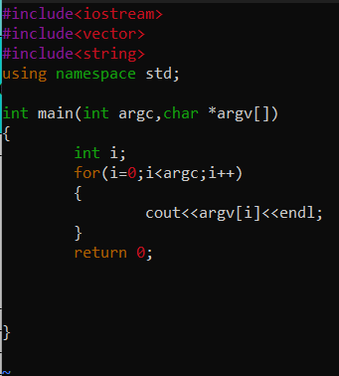

VSTR/02 Create a class named “Wordset” with members as below
vector <string> vlist;
int addmember(string s) - add given string s to vlist
int deletemember(string s) – search and delete the given string s from vlist
void displaylist() – iterate the vlist and display all its contents
Ans:

#include<iostream>
#include<vector>
#include<string>
using namespace std;

class Wordset{

private:
string s1="addmember";
string s2="deletemember";
public:

void add_delete()
{
vector<string>vlist={"Read the file", "As single", "Command line"};
vlist.push_back(s1);
vlist.push_back(s2);
for(string s:vlist)
cout<<s<<" "<<endl;
vlist.pop_back();
for(string s:vlist)
cout<<s<<" "<<endl;
vector<string>::iterator it;

for(it=vlist.begin();it<vlist.end();++it)
cout<<*it<<" "<<endl;
}

};

int main(int argc,char *argv[])
{
int i;
for(i=0;i<argc;i++)
{
cout<<argv[i]<<endl;
}

Wordset add;
add.add_delete();
return 0;

}

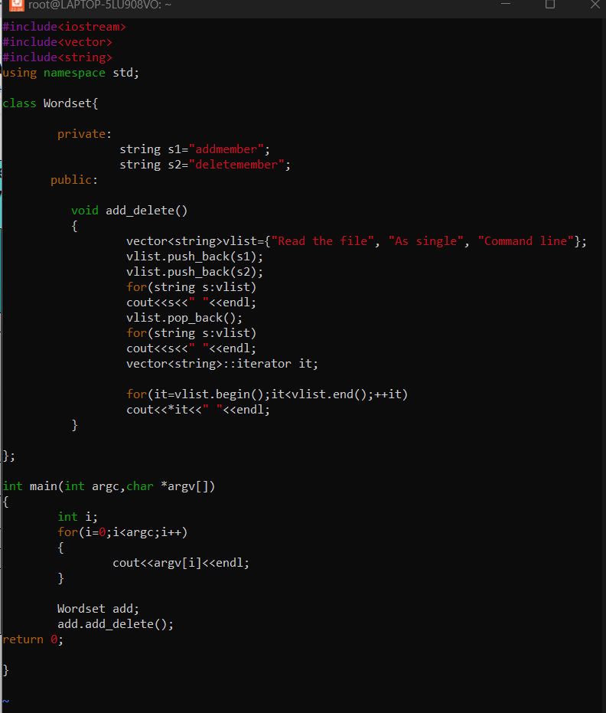

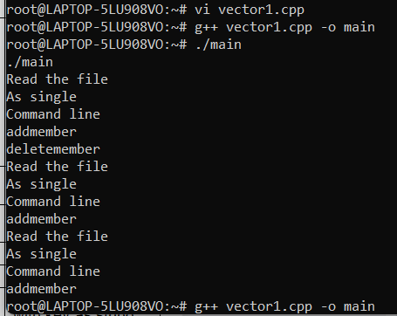

VSTR/03 Parse the command line arguments, extract words and store them in vlist
VSTR/05 Display the contents of vector.
Ans:
#include<iostream>
#include<cstring>
#include<vector>
using namespace std;
int main(int argc,char *argv[])
{ int i;
string str1,str2,str3,str4;
string str;
for(i=0;i<argc;i++)
{// cout<<argv[i]<<endl;

}
//str=argv[1];
//cout<<str<<endl;
str1=strtok(argv[1]," ");
//cout<<str1<<endl;

str2=strtok(argv[2]," ");
//cout<<str1<<endl;
str3=strtok(argv[3]," ");
//cout<<str1<<endl;
str4=strtok(argv[4]," ");
//cout<<str1<<endl;

vector<string>vlist={str1,str2,str3,str4};

for(string c:vlist){
cout<<c<<endl;
}
return 0;

}

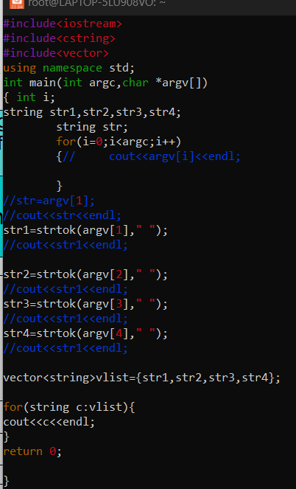

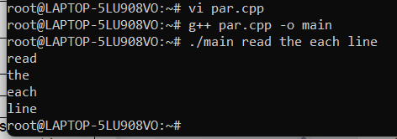

VSTR/04 Prompt the user for a word to search and delete, then call deletemember if found
Ans:
#include<iostream>
#include<vector>
#include<string>
using namespace std;
vector<string>vlist;
class Wordset{

private:
string s1="Rahul";
string s2="sai";
public:

void addmember()
{
cout<<"Pushing data:";
vlist.push_back(s1);
vlist.push_back(s2);

cout<<" "<<endl;
}
void deletemember()
{
cout<<"\nPoping data:";
vlist.pop_back();

cout<<" "<<endl;
}

void displaylist()
{
for(string s:vlist)
cout<<s<<" "<<endl;
}

};

int main(int argc,char *argv[])
{
int i;
for(i=0;i<argc;i++)
{
cout<<"command line input is:";
cout<<argv[i]<<endl;
}
for(i=1;i<argc;i++)
{
vlist.push_back(argv[i]);
}
cout<<endl;
cout<<"The vector is:"<<endl;
for(string s:vlist){
cout<<s<<"\n "<<endl;
}
Wordset add;
add.addmember();
add.displaylist();
add.deletemember();
add.displaylist();
cout<<"\nThe size of the vector before poping is:"<<vlist.size();
while(!vlist.empty())
{
vlist.pop_back();
}

cout<<"\nThe size of the vector after poping is:"<<vlist.size()<<endl;;
return 0;

}

