CPP_Assignment_9
I/O Generic Programming, Function and Class Templates Assignments

Mandatory Assignments
- Write a templated function to add() a maximum of 3 input strings OR 3 integers and return the final string or number. add() function may be called with atleast 2 arguments.
Ans:
#include<iostream>
using namespace std;
template<class t1>
t1 add(t1 a,t1 b,t1 c)
{
return a+b+c;
}
template<class t2>
t2 concat(t2 a,t2 b,t2 c)
{
return a+b+c;
}
int main()
{
cout<<"add of int:"<<add<int>(10,20,30)<<endl;
cout<<"add of string:"<<concat<string>("Rahul " ,"sai " ,"Kaggolu")<<endl;
return 0;
}

- Write a templated merge sort function which takes an array of data using merge sort with signature as below. Test with string and float data.
template <class T, int num>
int merge_sort(T arr[], int num> //num is no. of elements in array
{
//Add implementation here and return SUCCESS i.e 0
}

Ans:
#include<iostream>
#include<vector>
using namespace std;

// template function to merge 2 componenets of the array, arr
// the function merges the sorted components [start, mid] and [mid+1, end]
// such that the resultant array is also sorted
// the function uses a temporary variable, temp to store the result
// after that the result is written back to the original array
template<typename T>
void Merge(T arr[], int start, int end)
{

// x: start index of first half [start, mid]
// y: start index of second half [mid+1, end]
// z: start index of temp
// temp: temporary vector to store the merged array
int z, x, y, mid;
vector<T> temp(end -start + 1);
mid = (start + end) / 2;
z = 0;
x = start;
y = mid + 1;

while (x <= mid && y <= end)
{
if (arr[x] < arr[y])
{
temp[z] = arr[x];
++x, ++z;
}
else
{
temp[z] = arr[y];
++y, ++z;
}
}

while (x <= mid)
{
temp[z] = arr[x];
++x, ++z;
}

while (y <= end)
{
temp[z] = arr[y];
++y, ++z;
}

// write the merged sequence back to the original array
for (int i = start; i <= end; ++i)
{
arr[i] = temp[i - start];
}

}

// template function to perform merge sort on array, arr
template<typename T>
void MergeSort(T arr[], int start, int end)
{

if (start < end)
{
int mid = (start + end) / 2;
MergeSort(arr, start, mid); // merge sort the elements in range [start, mid]
MergeSort(arr, mid + 1, end); // merge sort the elements in range [mid+1, end]
Merge(arr, start, end); // merge the above 2 componenets
}

}

// Template function to print array
// n: size of arr[]
template<typename T>
void PrintArray(T arr[], int n)
{
for (int i = 0; i < n; ++i)
cout << arr[i] << " ";
cout << "\n\n";
}

int main()
{

int arr[] = { 1, 10, 10, 90, -32, 100, -1, 11, 9, 14, 3, 2, 20, 19 };
int n = sizeof(arr) / sizeof(int);

cout << "Array Before Sorting: " << endl;
PrintArray(arr, n);

MergeSort(arr, 0, n - 1);

cout << "Array After Sorting: " << endl;
PrintArray(arr, n);

}

Output:
Array before sorting:
1 10 20 60 -6 -5 -65 54 87 32

Array after sorting:
-65 -6 -5 1 10 20 32 54 60 87

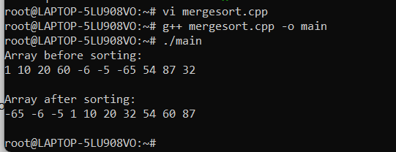
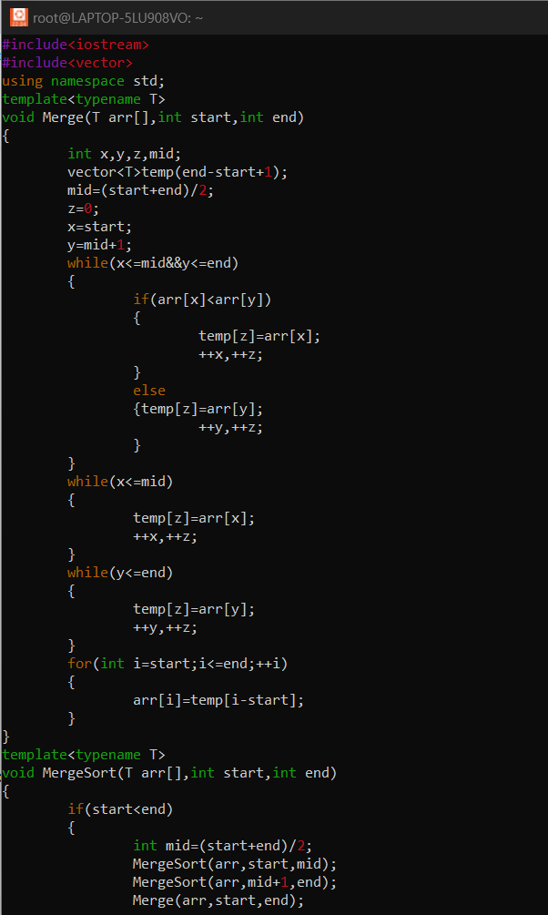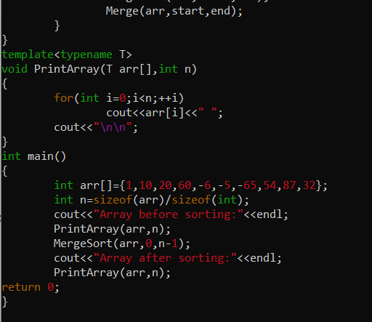

- Refer the file “function_template_classobj.cpp”. Complete the sections marked with TBD 1..4x to get the expected out as mentioned in the file.
- TBD1: Constructor
- TBD2: Create object allocating memory from heap, handle exception
- TBD3: Implement template function myadd()
- TBD4a, b: Deallocate the assigned memory

Verify your output with expected output

- Create a templated class named “MyArrayClass” with templated 1D array of MAX_ELEMENTS.
  - Populate the array using function below.
// populate MAX_ELEMENTS in the 1D array with input arr content, count = no . of elements in input array
PopulateData(T *arr, int count);

Ans:
#include<iostream>
#include<string>
using namespace std;
template<class t>
t MyArrayClass(t a[],int n)
{
t s=0;
for(int i=0;i<n;i++)
{
s=s+a[i];

}
return s;
}

int main()
{
int x[5]={10,20,30,40,50};

cout<<"Array:"<<MyArrayClass(x,5)<<endl;
return 0;
}
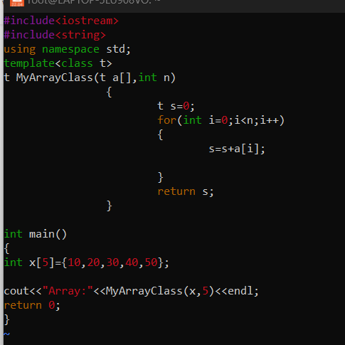

  - For character data provide customized handling i.e convert given character to uppercase and store.
Ans:
#include<iostream>
#include<cstring>
using namespace std;

int main(){
char s[30];

cout<<"enter lowercase:";
cin>>s; /* running the loop from 0 to the length of the string
* to convert each individual char of string to uppercase
* by subtracting 32 from the ASCII value of each char
*/

for(int i=0;i<=strlen(s);i++)
/* Here we are performing a check so that only lowercase
* characters gets converted into uppercase.
* ASCII value of a to z(lowercase chars) ranges from 97 to 122
*/

{
if(s[i]>=97&&s[i]<=122)
{
s[i]=s[i]-32;
}
}

cout<<"uppercase:"<<s<<endl;
return 0;
}

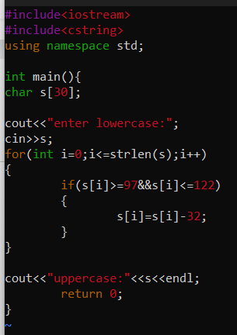

  - Test with int, float and char data.
Ans:
#include<iostream>
using namespace std;
template<class t1>
t1 add(t1 a,t1 b,t1 c)
{
return a+b+c;
}
template<class t2>
t2 concat(t2 a,t2 b,t2 c)
{
return a+b+c;
}

template<class t3>
t3 addi(t3 a,t3 b,t3 c)
{
return a+b+c;
}
int main()
{
cout<<"add of int:"<<add<int>(10,20,30)<<endl;

cout<<"add of float:"<<addi<float>(2.3,5.6,8.7)<<endl;

cout<<"add of string:"<<concat<string>("Rahul " ,"Sai " ,"Kaggolu")<<endl;
return 0;
}

Optional Assignments:

Opt1. Implement a templated stack class with push(), pop(), isempty(), isfull() functions to work with any type of data . Test stack with string and integer data. Extract and display the object type of the stack objects created
Opt2. Implement a class Sort to sort any type of data. Test with char, integer, string datasets.

