# TITLE OF PROJECT REPORT

# Note Log

### A MINI PROJECT REPORT

#### Submitted by

#### Group/Team No: G27/T11

#### Rahul -2210990703

#### Rahul Singh-2210990704

#### Rajat Saini-2210990706

#### Rajat Gupta-2210990705

#### in partial fulfillment for the award of the degree of

## BACHELEOR OF ENGINEERING

***in***

COMPUTER SCIENCE & ENGINEERING



**CHITKARA UNIVERSITY**

**CHANDIGARH-PATIALA NATIONAL HIGHWAY**

**RAJPURA (PATIALA) PUNJAB-140401 (INDIA)**

##### 4-May- 2023

**TABLE OF CONTENTS**

|  |  |  |
| --- | --- | --- |
| S.NO | TOPIC | PAGE NO. |
| 1. | Introduction | 1-3 |
| 2. | Problem Statement | 4 |
| 3. | Technical Details | 5 |
| 4. | Key Features | 5 |
| 5. | Project Highlights | 6 |
| 6. | Conclusion | 7 |
| 7. | References | 7 |

**INTRODUCTION**

This Project is created by:

* Rahul singh-2210990704
* Rahul-2210990703
* Rajat Saini-2210990706
* Rajat Gupta-22109-90705

**INTRODUCTION TO THE PROJECT**

A note log website is a project that was created to help users keep track of important information, notes, and tasks. The website is built using our knowledge of front-end technologies to make the website as user friendly, accessible and easy to use as possible.

The purpose is to provide individuals and organizations with an effective tool for managing information int this productivity and information-driven world.

It helps with tracking and keeping information in one place, henceforth reducing the stress of individuals. It helps but is not limited to making to-do lists, tracking work information, project ideas, setting reminders etc.

In addition to note-taking, it provides additional features such as note sharing, syncing etc. to make an even convenient tool matching the needs of the hour.

**PURPOSE**

Records the essence of the information, freeing their mind from having to recall everything. It provides individuals and organizations with an effective tool for managing information in a fast-paced and information-driven world.

**GOAL**

1. To help us to understand and retain essential information.
2. To set reminders and track important information to us.
3. To document insights, ideas and observations in a systematic way.

**PROBLEM STATEMENT**

A note log provides a focused and distraction-free interface for users to take notes, make lists, or jot down ideas.

It aims to address the challenges of information overload and the difficulty of keeping track of important information in this productivity-driven and expeditious world by providing a tool that is easy to use and always accessible.

The primary purpose of a note log is to provide users with a centralized digital platform to write down and organize their thoughts, ideas, and information and access them whenever they wish to do so. Whether it's taking notes during a meeting, brainstorming ideas, making a to-do list, or any other purpose, a note log offers a simple and efficient solution to the problem of organizing and managing information.

It provides a user friendly platform to help users manage their notes and information in a effective manner, increasing their overall productivity and proficiency.

**TECHNICAL DETAILS**

Note log is a simple application that can be created using HTML and CSS.

HTML was used for the structure and content of the page, while CSS was used for styling and layout.

To create a note log using HTML and CSS, the first step is to create a basic HTML structure that includes the necessary elements for a notepad, such as a text area, buttons, and input fields. Then, CSS is used to style the note log, including the fonts, colours, and layout.

Cross-Browser compatibility was ensured by testing it on various devices and was designed with responsive design principles in mind.

1. Flexboxes and Grids: This note log has immensive use of grids and flexboxes to maintain it’s Structure.
2. Bootstrap: It lends from Bootstrap library to take some icons used frequently in the structure.

**KEY FEATURES**

To solve the problem of note log, there are several key features that are essential. These include:

1.Simplicity: A note log should be simple and easy to use, with an intuitive interface that allows users to quickly capture and organize their thoughts.

2.Accessibility: A note log should be easily accessible, whether through a web-based application or a downloadable app that can be installed on various devices.

3.Customization: A note log should allow users to customize the appearance and functionality of the app, such as the ability to change the font size or colour scheme.

4.Syncing: A note log should have the ability to sync notes across different devices and platforms, ensuring that users can access their notes from anywhere.

5.Security: A note log should be secure, with features such as encryption and password protection to ensure that sensitive information is kept safe.

6. Note Sharing: Users should be able to share their notes easily, with friends, team members or clients to facilitate communication and mutual collaboration.

**PROJECT HIGHLIGHTS**

HTML Code for the index page:

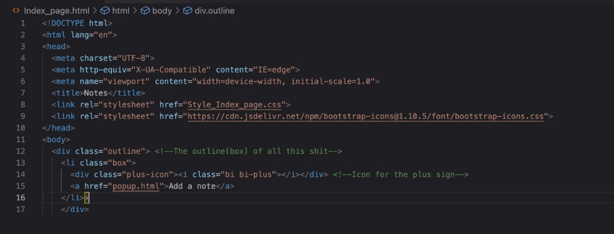

The window after running the code:

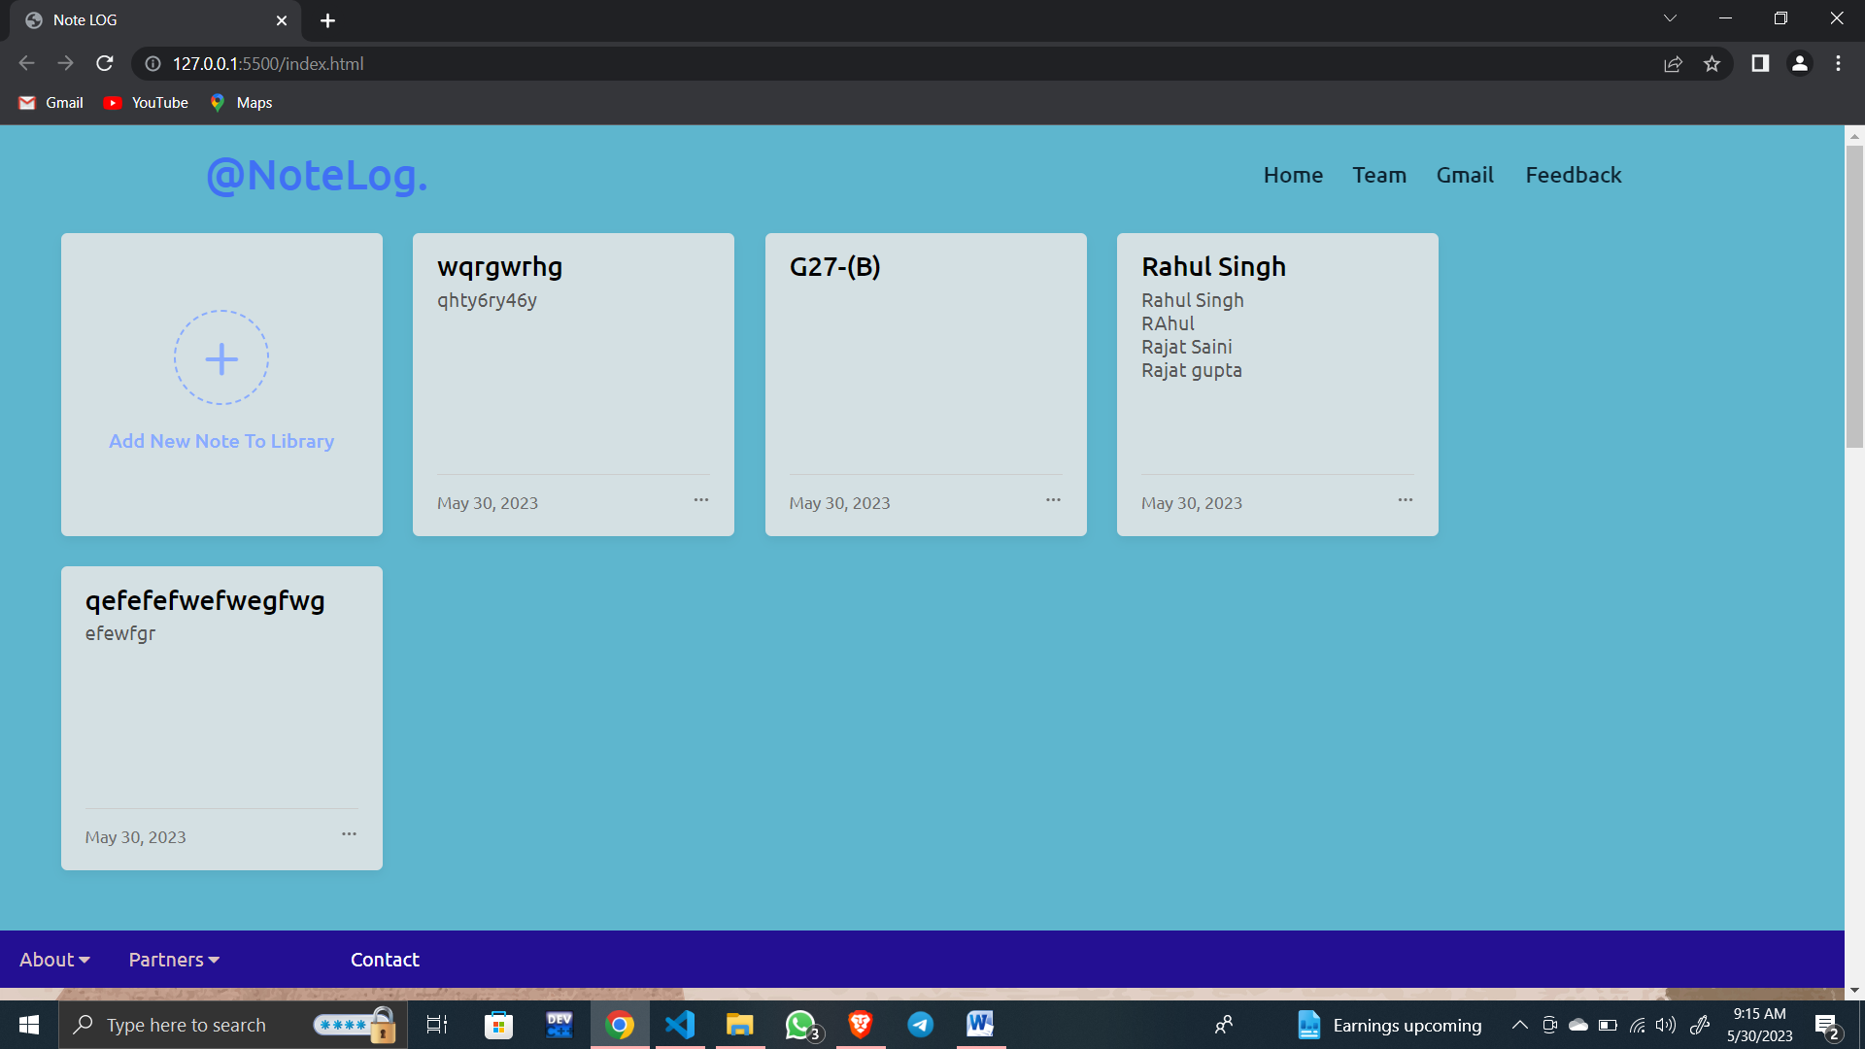

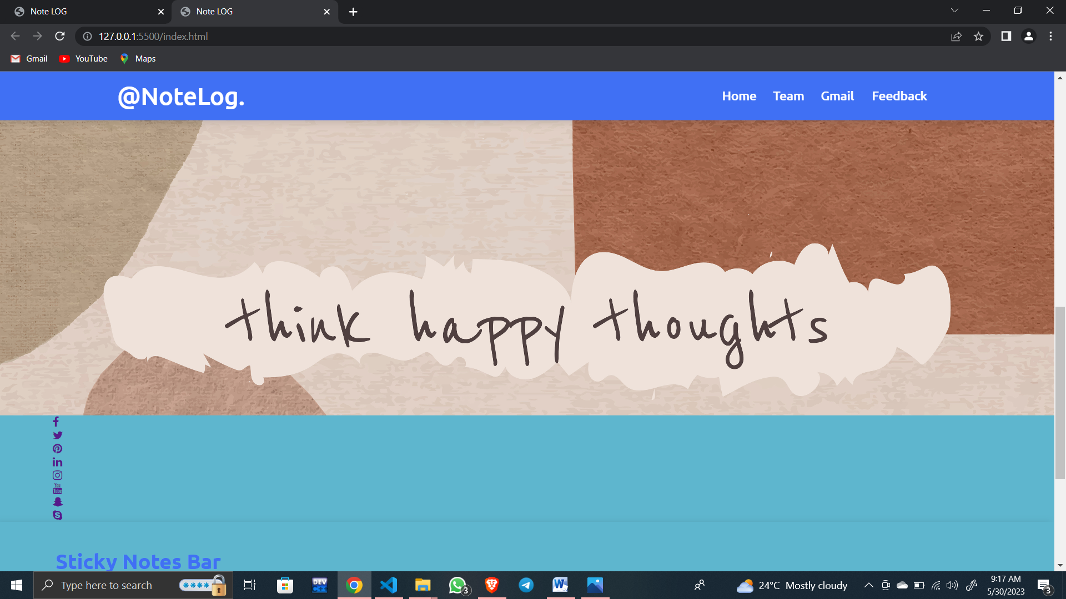

HTML Code for the popup:

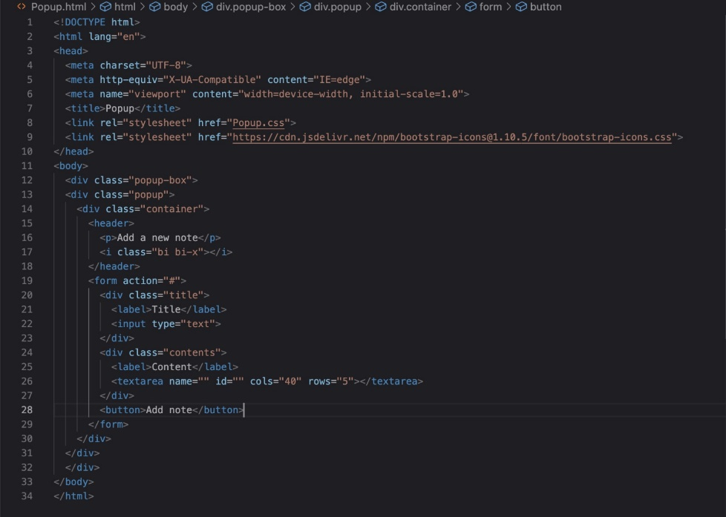

The popup screen:

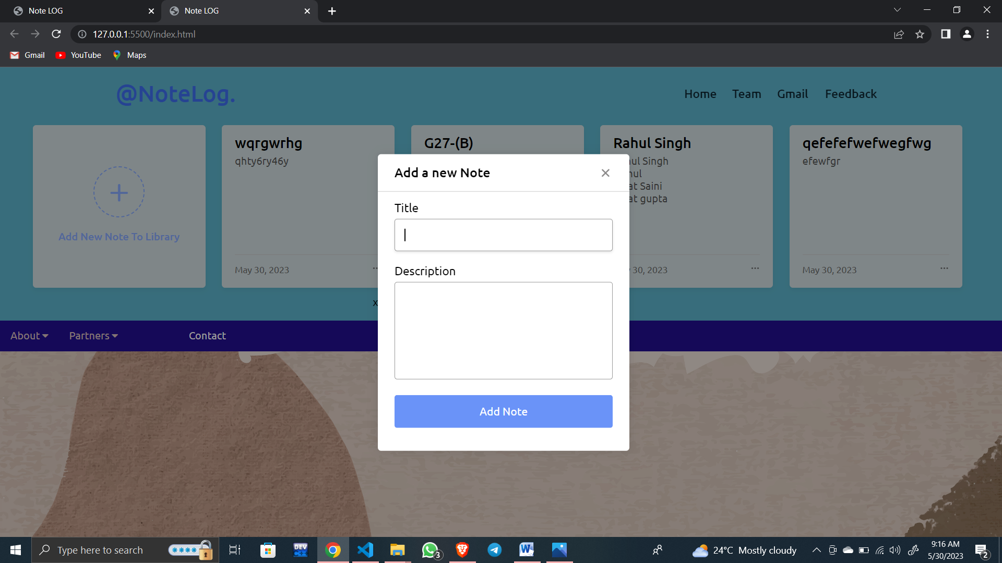

**CONCLUSION**

In conclusion, a note log website can provide significant benefits to individuals and organizations by helping them manage information more effectively and increasing their overall productivity.

The project involves the development of a web site to provide users with a user-friendly, customizable, and secure platform for creating, editing, and sharing notes with teammates and friends.

Various technical front end details and user interface knowledge has been taken into consideration. Note creation, organization, editing, sharing, and search functionality has been incorporated into the design to ensure the website meets the needs of its users.

**REFERNCES**

1. <https://www.wikipedia.org>
2. <https://www.youtube.com>
3. https://developer.mozilla.org