Subject Name: **Source Code Management**

Subject Code: **22CS003**

Session: **2022-23**

Department: **DCSE**



|  |  |  |
| --- | --- | --- |
| **Submitted By:**  RAHUL SINGH  2210990664  G27-B |  | **Submitted To:**  DR.CHETNA SHARMA |

**List of Programs**

|  |  |  |
| --- | --- | --- |
| **S. No** | **Program Title** | **Page No.** |
| 1 | Setting up of Git Client | 1-2 |
| 2 | Setting up GitHub Account | 3-4 |
| 3 | Git life cycle description | 5 |
| 4 | Add collaboration on git hub repo | 6-7 |
| 5 | Create and visualise branches | 8-9 |
| 6 | Generate logs | 10-11 |
| 7 | Fork and Commit | 12 |
| 8 | Merge and Resolve conflicts created due to own activity and collaborators activity. | 13 |
| 9 | Reset and revert |  |
|  |  |  |
|  |  |  |
|  |  |  |
|  |  |  |

**1)Setting up git client**

**Steps:**

1)Go to Git scm.com

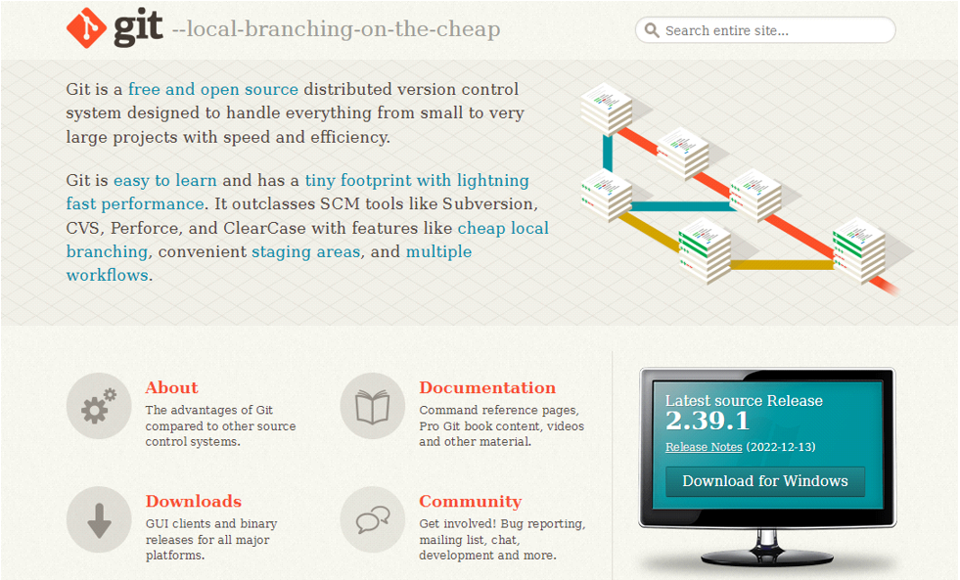

2)Click Download for Windows

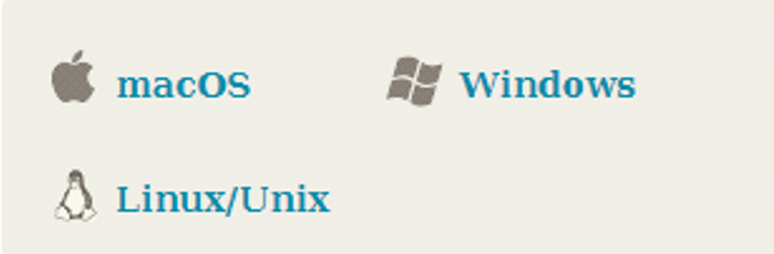

3)Click on 64 bit for Window Setup

1)standalone installer

32 bit , 64 bit

2)portable (“thumb drive edition”)

32 bit , 64 bit

4) run.exe file



5)INSTALLING GIT

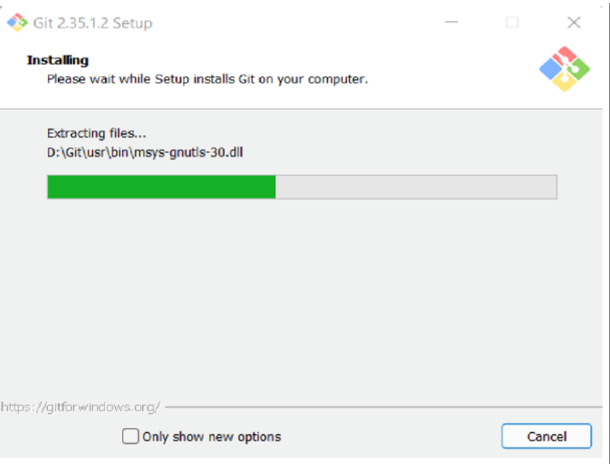

**2)Setting up a git hub account**

**Steps :**

1)Go to hit hub.com

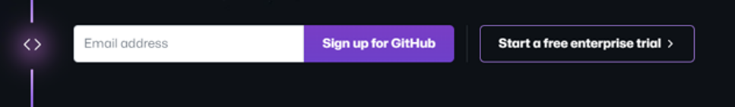

2)Enter your email address

3)Create a password

4)Setting up your account

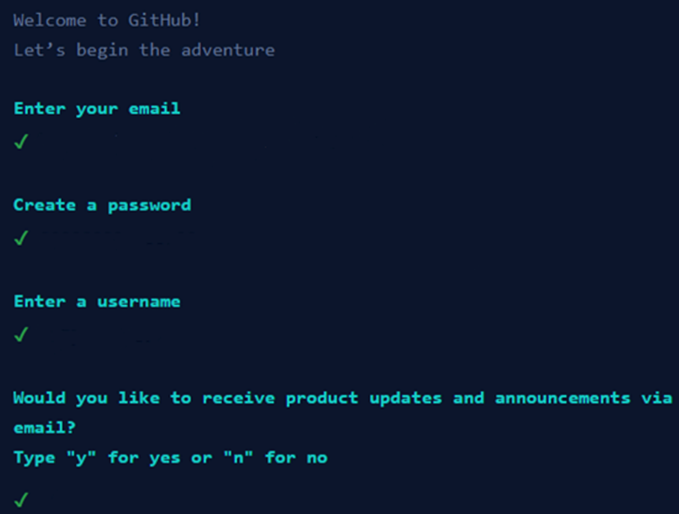

5)Your Account Has Been Setup

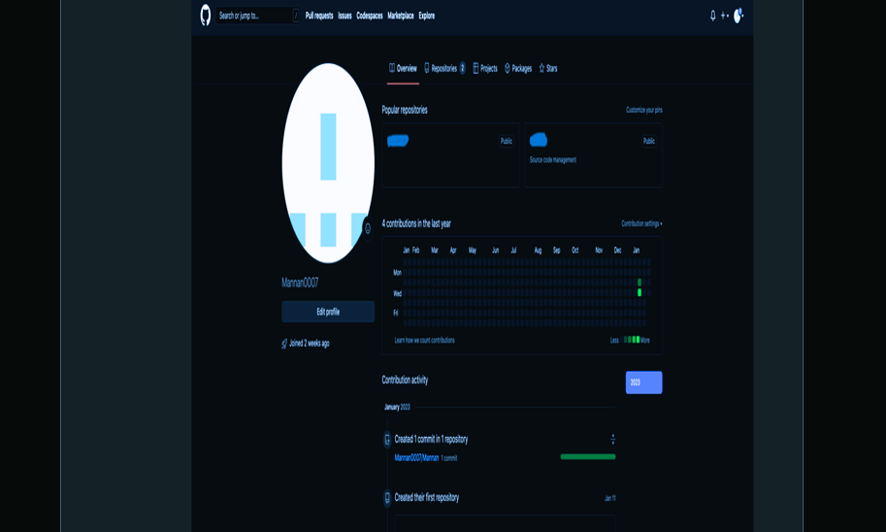

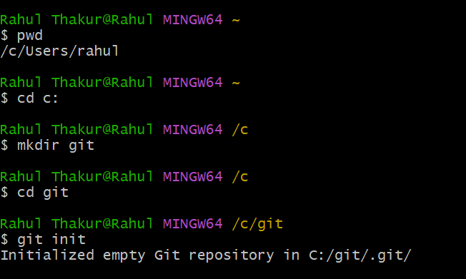

1. **Cd C :** It is used select a drive so that we can store a repository in that drive . here we select C drive.
2. **Mkdir git_demo :** It is used to make a directory . we give the name git_demo to our directory.
3. **Cd git* :** It is used to call the present directory which we are

using at present.

1. **Git init :** It is used to initialise the empty git repository .
2. **Pwd :** we can use use this command to see that which directory we are working presently

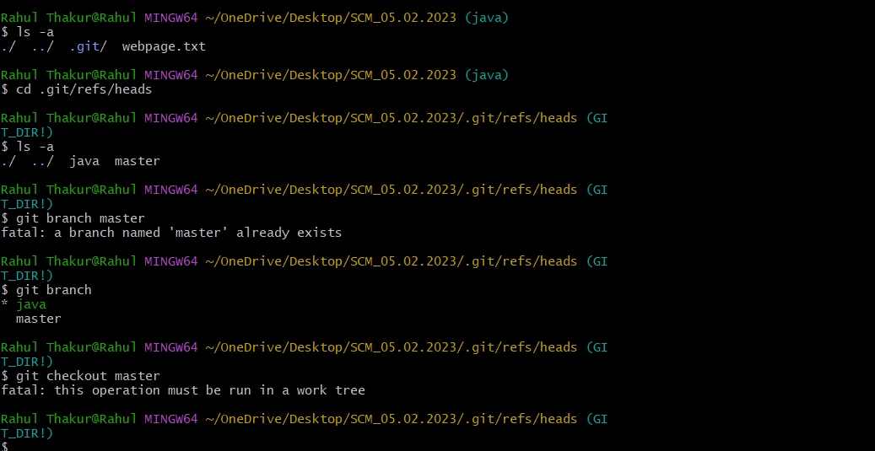

1)**git config :** It is tell us about all the command that we can use during further process.

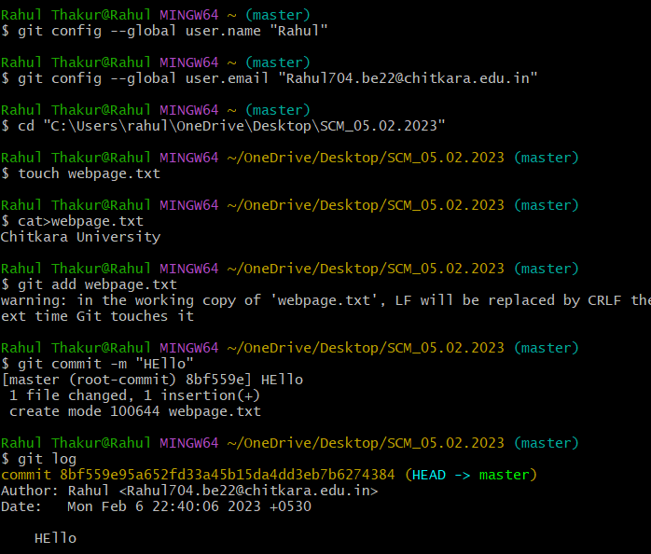

1)**git config –global user.name “name”:** it allow to set a global project username.

Name is used that we have given during creating the github account.

I used “NISCHAY3”

2)**git config –global user.email “email adress”:** it allow to set a global project email address. Email.address is used that address we have given during creating github account.

Mine is “barejaniscay5@gmail.com”

3)**touch name.txt :** it is used when we have a directory on my desktop created using powershell and now we are trying to create a text file within it.

“nischay-3.txt”is used here.

4)**cat>name.txt:** it is used to write the text within the file tha we have created using the touch command.”Ctrl D”command is used to comt out.

5)**git add name.txt :** it is used to add the changes that have been made in the present working directory .

6)**git commit -m :** it is used to take all the changes that have been made locally and push them upto a remote repository .

7)**git status :** it is used to display state of working directory and staging area .

8)**git log :** it is a utility tool to review and read a history of everything that happen to a repository.

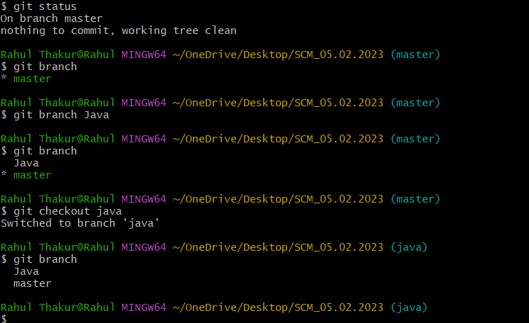

1)**git branch :** Git branches are effectively a pointer to a snapshot of your changes .

2)**git checkout :** git checkout command let you to navigate between the branches that we have created by git branch .

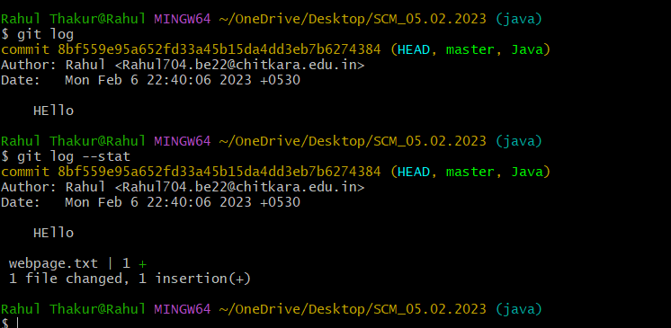

1)**git checkout activity :** it is used to change the branch to the activity .

2)**touch nitin.txt :** it is used to create a file only if the file does not already exist.

3)**cat command :** it is used to add some additional fact to the pre existing file .

4)**git log :** it is used to view repository and all the changes are also visible that we have made.it also tell us the name of author and time.

5)**git status :** now it tell us about the file and branch that we are presently working with .

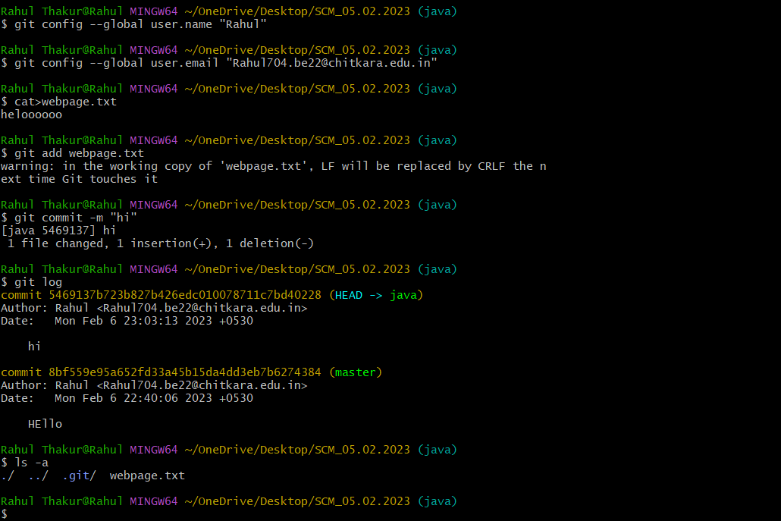

1)**git add filename:** This is used to the add a changes in the working directory.

2)**git commit -m :** this is used to print the message . the message must be short and descriptive .

3)**git checkout master :** it is used to change the branch to the master .

4)**git log :** now this we tell us the about all the work that has to be done .

5)**git status :** it tell us that the we are presently working on branch master .