Computer to Computer Learning System

Project ID: 21103
B.Tech. Project Report
submitted for fulfillment of
the requirements for the
Degree of Bachelor of Technology
Under Biju Patnaik University of Technology

Submitted By
Abhishek Kumar ROLL NO. 201710094
Rahul Kumar Yadav ROLL NO. 201710355


2020 – 2021

Under the guidance of
Mr. Santosh Kumar Kar

NATIONAL INSTITUTE OF SCIENCE & TECHNOLOGY
Palur Hills, Berhampur, Odisha – 761008, India

Table of Contents

Abstract…………………………………………………………………………………...3

List of Figures………………………………………………….…………………………4

Introduction……………………………………………………….………………………5

Admin………………………………………………………….……………………5

College……………………………………………………………………………..6

Student…………………………………………………………….……………….6

Problem Statement………………………..……………………………………………..7

Possible outcome of the project……………………………………………...…………8

Work done completed……………………………………………………………….…...8

Steps by Steps Work Done Process……………………………………………...….…10

Future Work……………………………………………………………………..…...…...21

Byte code……………….………………………………………………………….21

JVM………………………………………………………...……………………….22

Conclusion…………………………………………………………………………………24

References…….………………………………………..…………………………………25

Abstract

Computer to computer learning system is the modern way of education. It is more

successful than traditional forms of learning because it offers more variety of

instructional methods such as text, videos, audio and graphics, which can be tailored

according to the needs of the learner. In this project we are mainly focus on three

modules such as Admin, College Faculty and Student in which admin handle the whole

scenarios like admin can give access to college and student and can also delete them if

he feels that they are unauthorized members of this system. College which can handle

student and faculty details and also update their profile, students have any query related

to study materials so they can request to college to provide specific materials with

proper documentation. Generally, an existing system the educational institutions

provide online material which is one-way uploading and hence the database is limited to

a single person and hence the information updating needs time, But in this project, the

database was made online so the database was accessible to multiple users.

This system provides student to easily navigate through the application for more

information in a most secure manner and easy access to their particular account so that

student can access their study materials as per their convenience.

List of Figures

Figure 1: Login Page

Figure 2: College Registration

Figure 3: Student Registration

Figure 4: Admin Login

Figure 5: College Page

Figure 6: Add Faculty

Figure 7: Update College

Figure 8: Send Feedback

Figure 9: Student Page

Figure 10: Update Profile

Figure 11: Send Request

Figure 12: Architecture Diagram

Introduction
The objective of this project is to develop the environment were various college

institutes will provide their respective materials in form of text document, pdf, etc. and

students will able to refer those materials at any point of time when they need, so that

they can grasp their study materials in a better way.

The system is a computerized system which is maintained at Centralized

databases i.e., in automated forms it’s a very fast process. And maintaining all the

records in online systems database which makes it very easy to access and retrieve

data from the database. If they want any articles, they can easily upload and download.

It provides multiple user accessibility and also has different user privileges. So the

system is accessible for all the students of the college. In this system, there are three

modules

1. Admin

Admin can view the institutes and students registered and delete them if he feels

unnecessary. Admin can also view the complaints given by students All the users are
controlled by admin. Administrator services are
1.Approve the institute
2.Delete institute
3.View students and colleges
4.View and send response

2. College Faculty

The college needs to register and log in and upload the articles on different topics
providing the information and maintains the faculty details and view the responses and
requests provided by students.
College is an Organization which can handle the all the student details. The College
services are
1.Registration
2.Upload articles
3.Faculty management
4.Update profile of college
5.Send responses
6.view request and send feedback
3. Student
The student will log in with a valid username and password and he can send a request
to college he can view the response from college and he can also give feedback to
admin. He can also update his profile .The Student services are
- Registration
- Download articles
- Update Profile
- Send request
- View response

Problem Statement
The Existing system is a computerized system but which is maintained at individual

databases i.e., in excel sheets, it’s a time delay process. And maintaining all the records

in Excel sheets is difficult. If they want any record, they have to search all the records. It

doesn’t provide multiple user accessibility and also doesn’t have different user

privileges. So, the system is not accessible for all the students of the college.

Limitations in Existing System

- The current system is not completely complete computerized and manual system in entering students and faculty data and handling it.
- There is no centralized database maintenance.
- There is no easy access to the particular students records and articles.
- The student cannot easily navigate through the database.

So, to solve the above problem statement we have used these software/tool or

Processes: -

- Java 8

- MySQL

- MySQL thin driver for java

- Tomcat

- Eclipse ide

Possible outcome of the project

These are the possible outcome of this project-:

1.In this system college can easily handle the specific faculty and student details because of centralized database.

2.It provides multiple user accessibility and also has different user privileges so that system is accessible for all the students of particular college.

3.This system provides student to easily navigate through the application for more information in a most secure manner respectively.

4.Easy access to the particular students records and information for colleges so that they can handle data in appropriate way.

Work Done Completed

In this project we have completed the frontend and backend part of all the three

modules like we have Admin, College Faculty and Student modules and in each

module, we have different functions such as admin services are approving the institute,

delete institute and other functions similarly college services are upload articles, update

profile, send response for appropriate requests, view requests and same as for student

update profile, send request to the college, send feedback, etc.

While making the frontend part we have used HTML, CSS, JavaScript and made one

Folder, attach all the programs in one folder with particular images.

HTML is used to describe the structure of information on a web page, it allows the user

To create and structure sections, paragraphs, headings, links, and blockquotes for web

Pages and applications.

CSS, for describing the presentation of web pages, including colors, layouts and fonts.

It allows one to adapt the presentation to different types of devices, such as large

Screens, as well as variety of other effects.

And JavaScript allows us to implement complex features on web pages and used to

Modify website content and make it behave in different ways in response to a user’s

Actions.

Steps by Steps Work Done Process
- In this project for frontend part, first we made a login page of computer to

computer Learning system having the features of Home, Login, About us,

Contact us. In Login page we have three modules like Admin, College and

Student, Modules act as button in login page they have their own

username and password which we have to fill correctly then only you can enter

in other functions and it has two more buttons Login and Reset respectively.

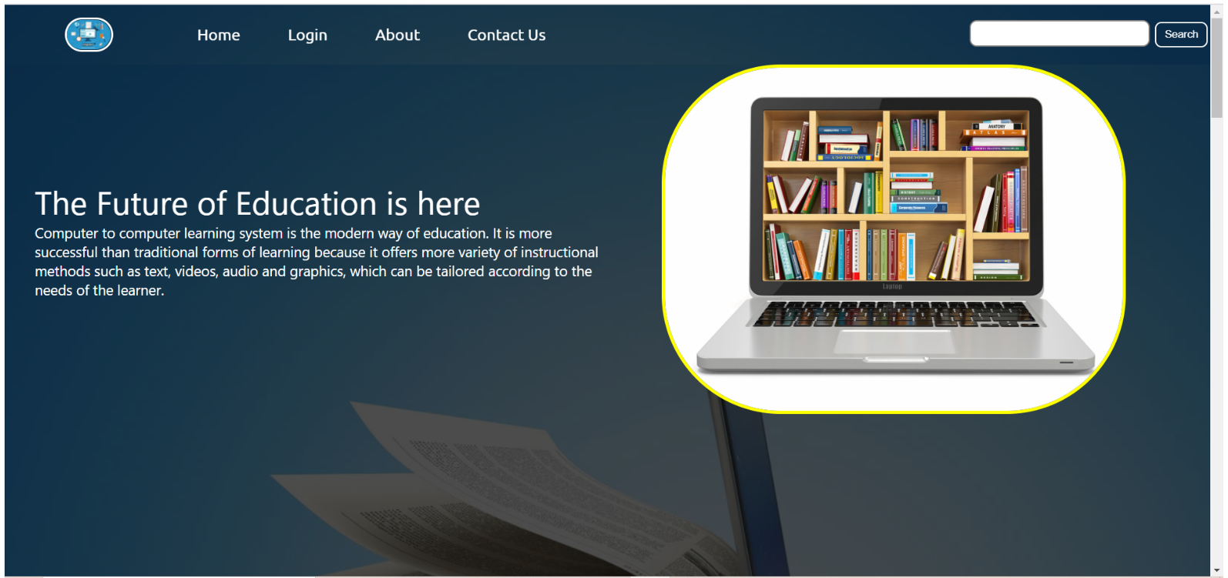

Figure 1: Login Page

- In the registration page we have College registration and Student registration

Options in which if you enter in college registration then you have to fill required

Details like College name, User name, Password, College postal address,

College phone number and it has text fields for input purpose, it is used for

registration of various college after this process verification will be done by admin

and then specific college will be the part of college module.

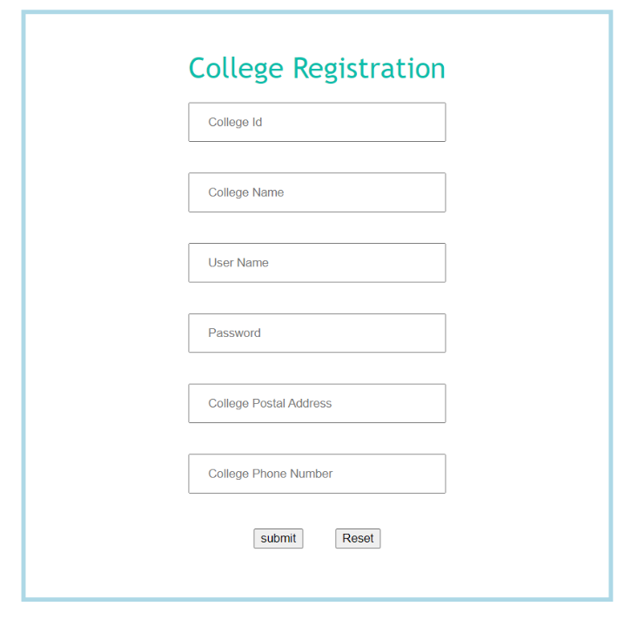

Figure 2: College Registration

- In Student registration options, we have to fill First name, Last name, User

name, Password, Mobile, Email id, Address, College having two buttons Update

and Reset if you want to save the details click on Submit or else if you want to fill

fresh details then click on reset, it is used for the registration of students, so that

no fake id could be the part of student module and the details of student will be

stored in student database respectively.

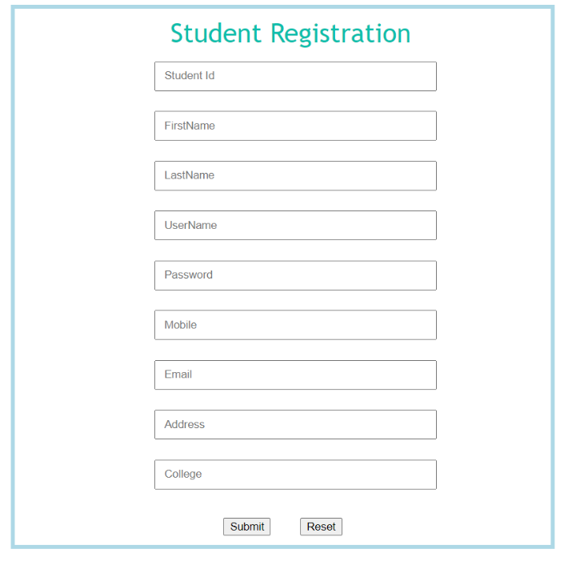

Figure 3: Student Registration

- While in Admin login the options are approve institute, delete institute, view

students and colleges, view and send response, each option has its own

features like in approve Institute admin has the capability to add any institute as

per admin choice, and in delete institute if admin found that college has filled the

wrong information in college registration or inappropriate management by

college then admin can delete the specific college at that time also able to see

response details which are given by students.

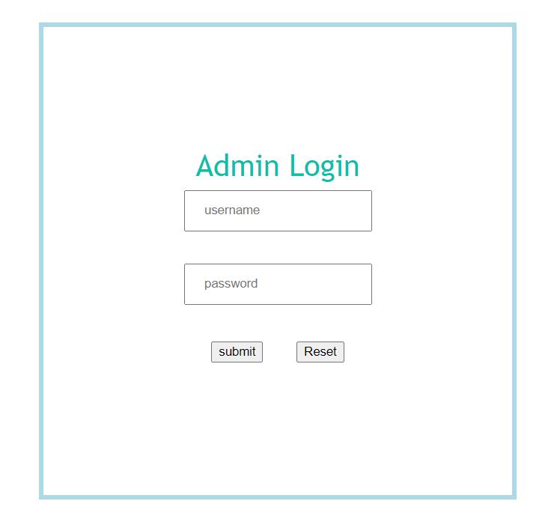

Figure 4: Admin Login

- In College page, functions have Upload articles, Faculty management, Update

Profile, send response, View students requests respectively. Like in faculty

management it has two features Add faculty and Update faculty information, in

add faculty it has Faculty name, Qualification, Experience, Skill and having two

buttons Submit and Reset, like in upload articles college has the capability to

upload different materials on regular basis on the portal.

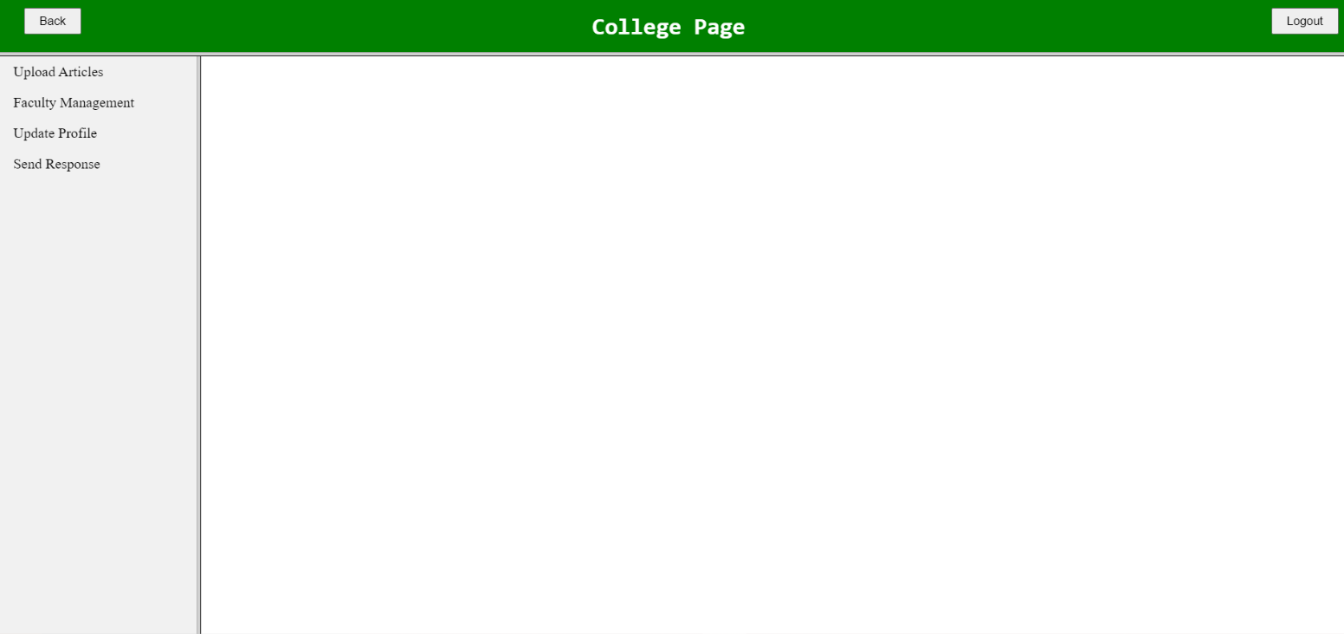

Figure 5: College Page

- For Storing the data of faculty, we created add faculty page so that different

colleges having their faculty details could be managed in proper way in database

and for the update faculty there is list of faculties information present in which it

has two actions update and delete if you want to change something in faculty

profile like experience details, skill set and all then simply click on update.

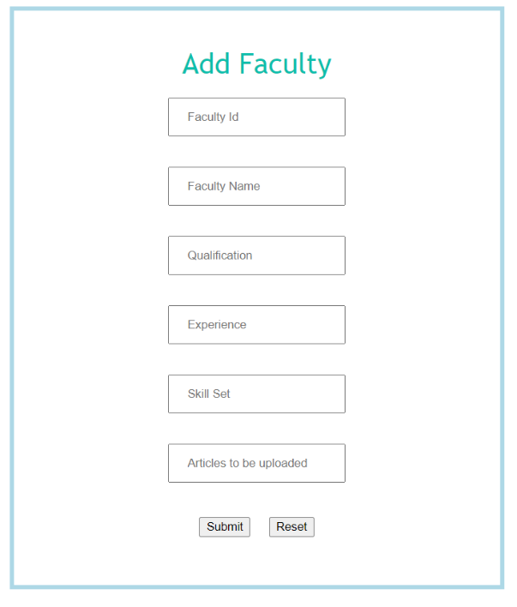

Figure 6: Add Faculty

- In Update profile of College login, it has College name, User name, Password,

College Postal address, College phone number for upgradation of college profile

Like colleges want to change their college phone number, user name and

Password for their convenience in a certain time interval and update college

page is required because by mistake if some information has entered incorrectly

then college can change their details immediately.

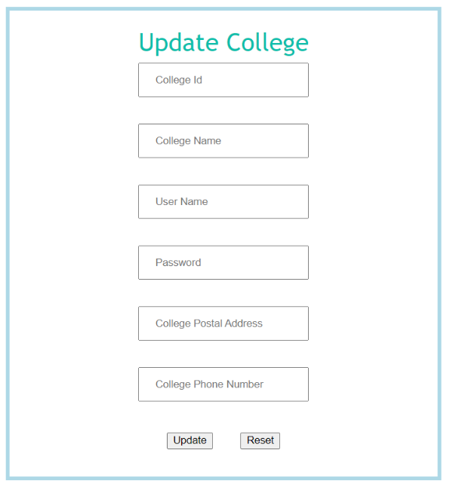

Figure 7: Update College

- If student sent a request to particular college, then college can identify the

Details with student name, request for (reasons for sending the message),

Requested date (when the request was delivered) and also has the option to

Send feedback to students so that mis information cannot be created between

the student and college respectively.

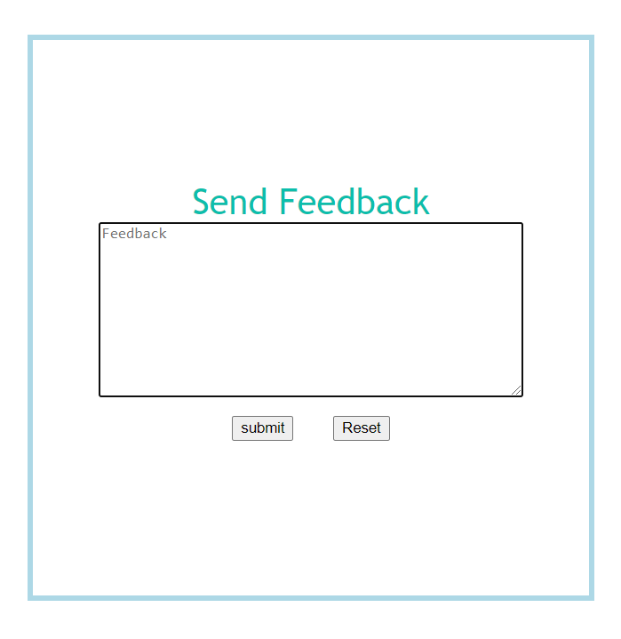

Figure 8: Send Feedback

- In Student page, functions are Download articles, Update profile, Send requests

To college, View response. Like if any student wants to download materials at

any point of time, he can do as per his convenience so that he could not face

any difficulty to fetch any articles, if student has entered wrong or outdated

information then he can update his profile at that point of time and any student

wants specific article for his preparation then he can send request to his college

to upload that article in system.

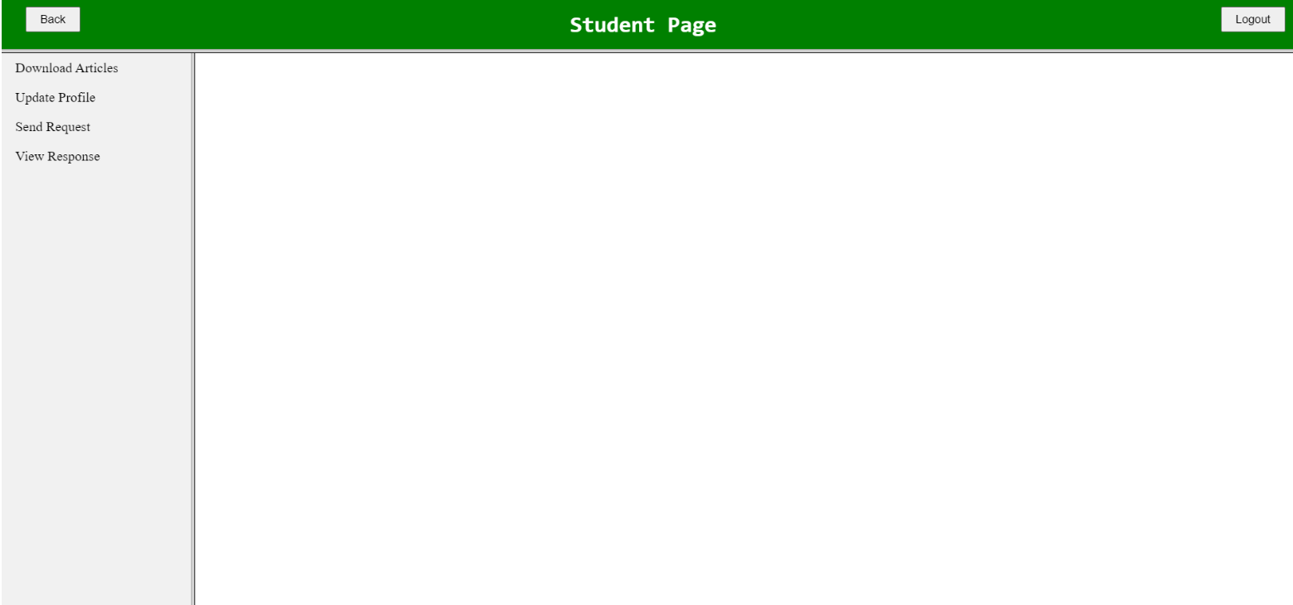

Figure 9: Student Page

- In update profile of Student page, First name, Last name, User name, Password,

Mobile, Email, Address, College name functions are there and one update

button for upgradation of particular student profile, if students want to change

certain data for their correction, generally students forget their username and

password for login so after retrieving the new username and password they can

update the same in their profile for further use and the data will be directly

updated on the student database.

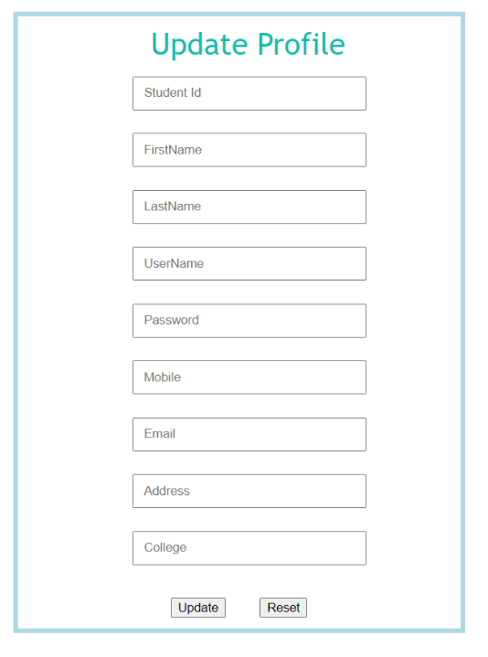

Figure 10: Update Profile

- In Student profile, it has also the features of send request so that if any student

Face any problem regarding fetching details of study materials or any request to

College to post particular materials in website so that they can get information

As per their needs for enhancement in academic profile and the request will be

visible to college and the admin as well.

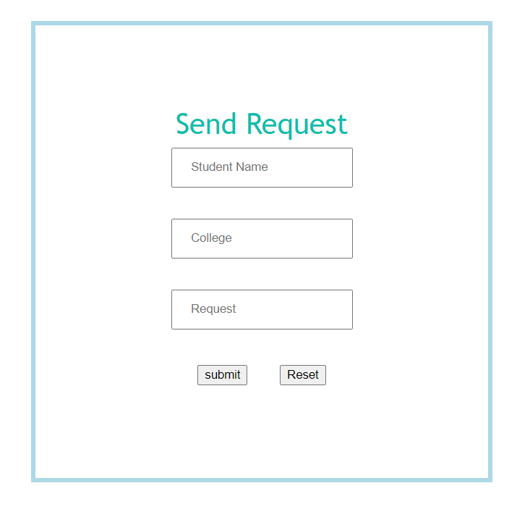

Figure 11: Send Request

Future Work

Now the next part of our project is to make this website more secure for use. We have

Used Java programming language for backend and web applications are JDBC, JSP

With MySQL database. Create the folder structure of a web application archive file and

Then deploy it to a Tom EE web server for execution.

And import jdbc packages, load and register the jdbc driver, open a connection to the

Database, create a statement object to perform a query, execute the statement object

And return a query result set, process the result set, close the result set and statement

Objects and close the connection for connectivity with database respectively.

The Byte code

The key that allows the Java to solve the security and portability problems is that the

output of Java compiler is Byte code. Byte code is a highly optimized set of instructions

designed to be executed by the Java run-time system, which is called the Java Virtual

Machine (JVM). That is, in its standard form, the JVM is an interpreter for byte code.

Translating a Java program into byte code helps makes it much easier to run a

program in a wide variety of environments. The reason is, once the run-time package

exists for a given system, any Java program can run on it.

Although Java was designed for interpretation, there is technically nothing about Java

that prevents on-the-fly compilation of byte code into native code. Sun has just

completed its Just in Time (JIT) compiler for byte code. When the JIT compiler is a part

of JVM, it compiles byte code into executable code in real time, on a piece-by-piece,

demand basis. It is not possible to compile an entire Java program into executable code

all at once, because Java performs various run-time checks that can be done only at

run time. The JIT compiles code, as it is needed, during execution.

Java Virtual Machine (JVM)

Beyond the language, there is the Java virtual machine. The Java virtual machine is an

important element of the Java technology. The virtual machine can be embedded within

a web browser or an operating system. Once a piece of Java code is loaded onto a

machine, it is verified. As part of the loading process, a class loader is invoked and does

byte code verification makes sure that the code that’s has been generated by the

compiler will not corrupt the machine that it’s loaded on. Byte code verification takes

place at the end of the compilation process to make sure that is all accurate and correct.

So, byte code verification is integral to the compiling and executing of Java code.

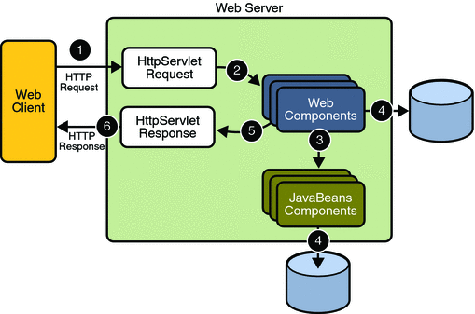

Figure 12: Architecture diagram

These are the process for understanding the above architecture diagram: -

- The user sends the command to the server through the internet, using the browser or the interface of the application.

- The web server is responsible for forwarding the command to the requested server.

- The server finds the results of requested commands (either the data processing or the database querying).

- The web application delivers the processed information to the server.

- The server provides the user with the requested data respectively.

Conclusion

In this project we used multiple access databases like three modules admin, college

and student can perform the operations as per their requirements and it is automatically

updated with the multiple users on the system so this makes the system fast and it

provides easy navigation for all the users like different institutes can upload articles and

manage the records of particular faculty and student and college has facilities to send

response to appropriate requests so it makes it makes the environment with two way

communication as student has any problem regarding unable to understand and

confused in any topic for learning so they can directly contact to specific college to

solve that problem as soon as possible and able to ask admin as well. This project

provides student and college to easily navigate through the application for any

information in a most secure manner.

References
- Core Java 2 Volume II – Advanced Pearson Education – Sun Microsystems (Cay S. Hortsman, Gary Cornell)

- Effective Java – Programming Language Guide Pearson Education – Sun Microsystems (Joshua Bloch)

- Java Database Best Practices O’Reilly – SPD (George Reese)

- Head First Servlets & JSP O’Reilly - SPD (Eric Freeman, Elisabeth Freeman)

- The Book of JavaScript 2nd Edition SPD (thau)

