PYHTON ASSIGNMENT –RA20025100

1) CODE

#!/usr/bin/python

a, b = 20, 10

c = a + b

print ("\n Addition of two numbers is", c)

c =a-b

print ("\n Subtraction of two numbers is", c)

c = a * b

print ("\n Multiplication of two numbers is", c)

c = a / b

print ("\n Division of two numbers is", c)

OUTPUT

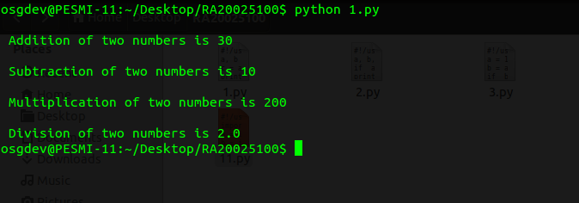

2) CODE

#!/usr/bin/python

a, b, c = 20, 10, 30

if a > b and a > c :

print ("Biggest of three numbers is", a)

if b > a and b> c :

print ("Biggest of three numbers is", b)

if c > a and c > b :

print ("Biggest of three numbers is", c)

OUTPUT

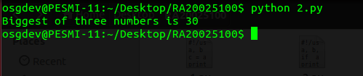

3) CODE

#!/usr/bin/python

a = 10

b = a % 2

if b == 0 :

print ("Given number is", a, "even")

else :

print ("Given number is", a, "odd")

OUTPUT

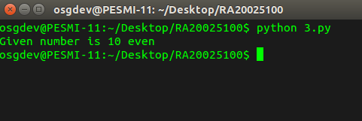

4) CODE

#!usr/bin/python

a = 7

for i in ( 2, a-1 ):

if a % i == 0 :

print (" The given number ", a ,"is not prime")

else :

print (" The given number ", a ,"is prime")

OUTPUT

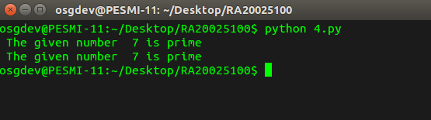

5) CODE

#!/usr/bin/python

import sys

print (" First number is ", sys.argv[1])

print ("Second number is ", sys.argv[2])

print (" Third number is ", sys.argv[3])

print ("The biggest of three numbers is ", max ( sys.argv[1], sys.argv[2], sys.argv[3] ))

OUTPUT

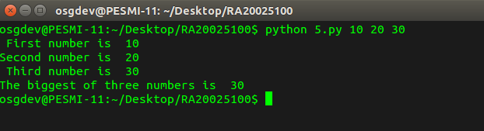

6) CODE

#!usr/bin/python

str1 = "Chennai"

str2 = "city"

for i in range (len(str1)):

print ("current letter is", str1[i])

str3 = str1[2:5]

print (" sub-string is ", str3)

print (" Repeated string is ", str1 * 100)

print (" Concatenated string is ", str1 + str2)

OUTPUT

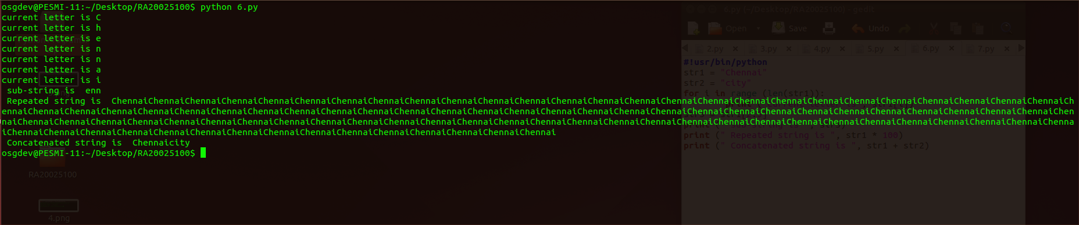

7) CODE

#!/usr/bin/python

List = [ 12, 23, 'Hello', 60.6, 'Chennai' ]

List1 = [ 21, 32, 60 ]

a = List [ 1:3 ]

b = List * 2

c = List + List1

print (List)

print ("\n", a )

print ("\n", b )

print ("\n", c)

OUTPUT

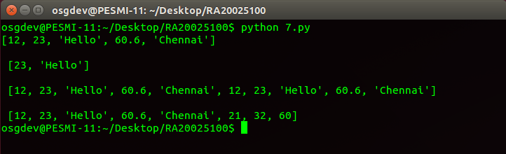

8) CODE

#!/usr/bin/python

Tuple = ( 12, 23, 'Hello', 60.6,'Chennai' )

Tuple1 = ( 21, 32, 60 )

List = [ 12, 23, 'Hello', 60.6, 'Chennai' ]

List1 = [ 21, 32, 60 ]

a = Tuple[ 1:3 ]

b = List * 2

c = List + List1

print (List)

print ("\n", a )

print ("\n", b )

print ("\n", c)

OUTPUT

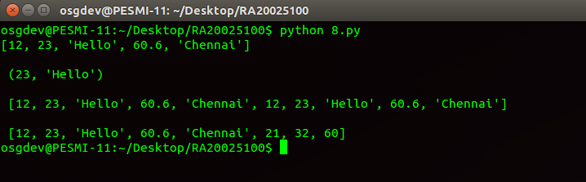

9) CODE

#!/usr/bin/python

import sys

a = complex(int(sys.argv[1]), int(sys.argv[2]))

b = complex (int(sys.argv[3]), int(sys.argv[4]))

c = a + b

print ("\n Addition of two numbers is", c)

c=a-b

print ("\n Subtraction of two numbers is", c)

c = a * b

print ("\n Multiplication of two numbers is", c)

c = a / b

print ("\n Division of two numbers is", c)

OUTPUT

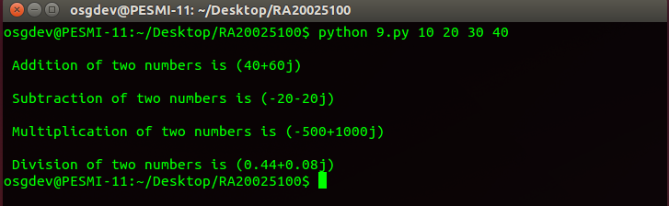

10) CODE

#!/usr/bin/python

import sys

c=int(sys.argv[1]) + int(sys.argv[2])

print ("\n Addition of two numbers is", c)

c=int(sys.argv[1]) -int(sys.argv[2])

print ("\n Subtraction of two numbers is", c)

c=int(sys.argv[1]) * int(sys.argv[2])

print ("\n Multiplication of two numbers is", c)

c=int(sys.argv[1]) / int(sys.argv[2])

print ("\n Division of two numbers is", c)

c=int(sys.argv[1]) % int(sys.argv[2])

print ("\n modulus of two numbers is", c)

c=int(sys.argv[1]) ** int(sys.argv[2])

print ("\n Exponentiation of two numbers is", c)

c=int(sys.argv[1]) // int(sys.argv[2])

print ("\n Floor division of two numbers is", c)

OUTPUT

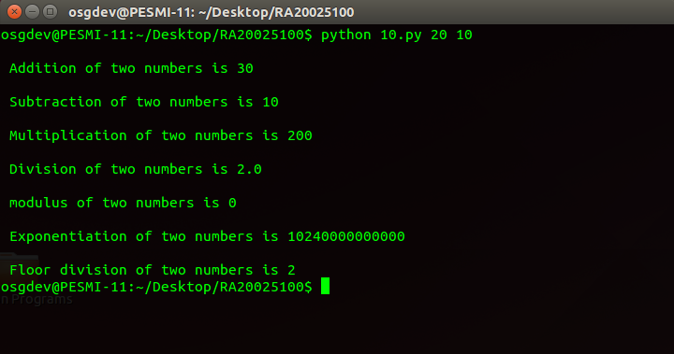

11) CODE

#!/usr/bin/python

import sys

a= int(sys.argv[1]) and int(sys.argv[2])

b= int(sys.argv[1]) or int(sys.argv[2])

c= not(int(sys.argv[1]) and int(sys.argv[2]))

print (a)

print (b)

print (c)

OUTPUT

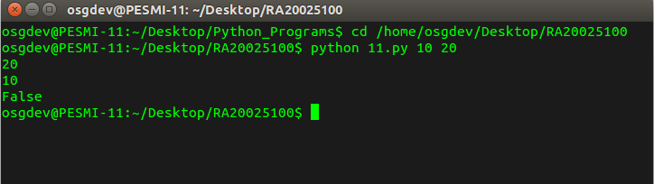

12) CODE

from sys import argv as arg

arg_list=[]

arg_len=len(arg)-1

gavg=lavg=eavg=0

for i in range(1,len(arg)):

arg_list.append(int(arg[i]))

average=float(sum(arg_list))/float(arg_len)

print "average is all the command line arguments is" ,average

for i in range(len(arg_list)):

if arg_list[i]>average:

gavg+=1

elif arg_list[i]<average:

lavg+=1

else:

eavg+=1

print "Count of numbers greater than average is", gavg

print "Count of numbers lesser than average is", lavg

print "Count of numbers equal to average is", eavg

OUTPUT

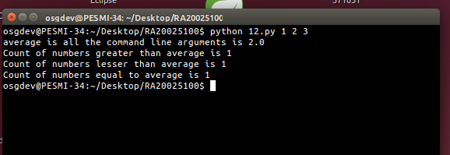

13) CODE

a=int(input("Enter the first number"))

b=int(input("Enter the second number"))

c=int(input("Enter the third number"))

d=int(input("Enter the fourth number"))

e=int(input("Enter the fifth number"))

big=a

if b>big and b>c and b>d and b>e:

big=b

elif c>big and c>a and c>d and c>e:

big =c

elif d>big and d>b and d>c and d>e:

big=d

elif e>big and e>b and e>c and e>d:

big=e

print "Biggest of 5 numbers is",big

OUTPUT

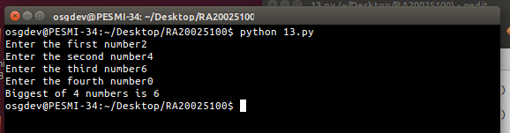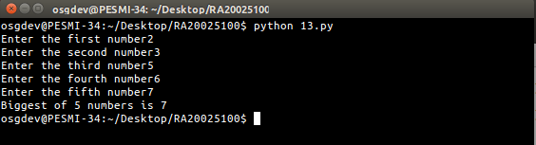

14) CODE

empid=[1,2,3,4,5,6,7,8,9,10]

ename=["Ram","Raj","Ramu","Aj","Ajay","Kiran","Sham","Pooja","Preetam","Niha"]

length=len(empid)

for i in range(length):

print ename[i]

usr=raw_input("Enter the name of Employee to search")

for i in range(length):

if ename[i]==usr:

print "Employeed id and his name", empid[i], ename[i]

for i in range(4,10):

print "Names from position 4 to 10", ename[i]

for i in range(3,):

print "Names from postion 3 to end", ename[i]

N=input("Enter the numbe rof times to repeat the string")

print ename*N

print empid+ename

for i in range(length):

print empid[i], ename[i]

**OUTPUT**

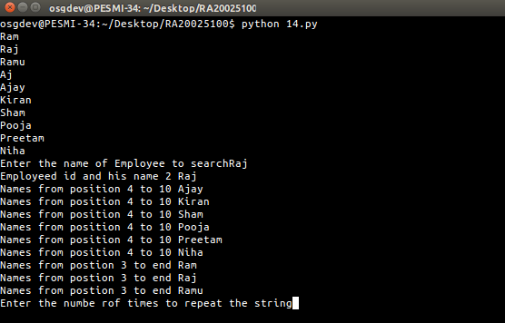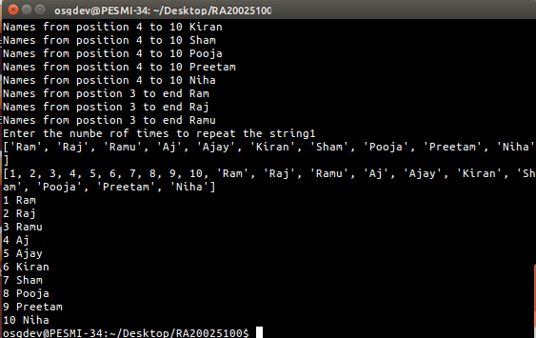

**15) CODE**

a=["Ram","Raj","Ramu","Aj","Ajay"]

usr=raw_input("Enter the Name")

if (usr in a):

print usr,"present in list a"

else:

print usr,"does not exist in list"

for i in range(len(a)):

if a[i]==usr:

print usr,"present in list a"

else:

print usr,"does not exist in list"

for i in range(len(a)-1,-1,-1):

print a[i]

**OUTPUT**

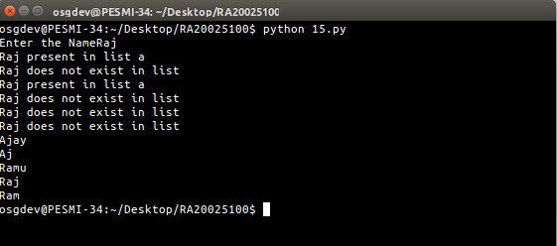

**16)CODE**

def prims(c):

flg=1

for i in range(2,c/2+1):

if c%i==0:

flg=0

break

return flg

a=input("Enter the number to check if prime")

b=input("Enter to print the prime numbers in range")

z=prims(a)

if(z==1):

print "The number is prime"

else:

print "The number is not prime"

for i in range(2,b):

if(1==prims(i)):

print i,"is prime"

**OUTPUT**

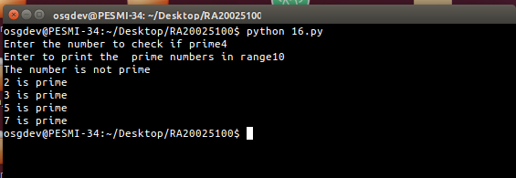

**17) CODE**

a=[9,7,9,1,5,4,2,8]

big=0

small=9999999

for i in range(len(a)):

if a[i]>big:

big=a[i]

elif a[i]<small:

small=a[i]

print "Smallest number is",small

print "Biggest number is", big

**OUTPUT**

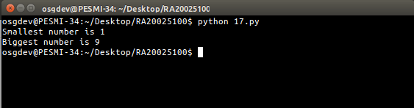

**18)CODE**for i in range(1,101):

print i

for i in range(100,0,-1):

print i

a=1

while a!=101:

print a

a+=1

a=100

while a!=0:

print a

a-=1

mystring="Hello World"

for i in range(len(mystring)):

print mystring[i]

**OUTPUT**

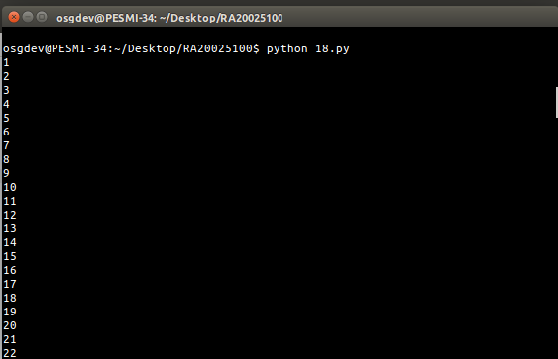

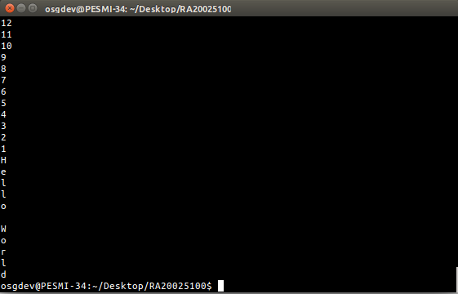

**19) CODE**

for i in range(1,101):

if i%2!=0:

continue

elif i==50:

break

elif i==10 or i==20 or i==30 or i==40 or i==50:

continue

else:

print i

i=0

while i!=101:

i+=1

if i%2!=0:

continue

elif i==90:

break

elif i==60 or i==70 or i==80 or i==90:

continue

else:

print i

**OUTPUT**

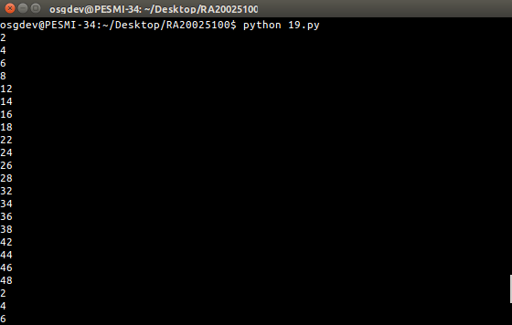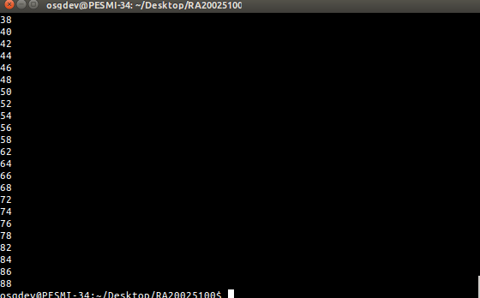

**20)CODE**

a=0

b=1

c=0

usr=input("Enter the length of Fibonacii series")

if usr>0:

if usr==1:

print a

elif usr==2:

print a

print b

else:

print a

print b

for i in range(2,usr):

c=a+b

print c

a=b

b=c

**OUTPUT**

