**TERADATA ASSIGNMENT**

1) Increment based on salary

EMPLOYEE TABLE

CREATE TABLE EMPLOYEE

(

EMPID INT NOT NULL,

NAME VARCHAR(10) NOT NULL,

YEAR_OF_EXP INT,

SALARY DECIMAL(9,2),

DESIGNATION VARCHAR(10)

)

UNIQUE PRIMARY INDEX(EMPID);

INSERT INTO EMPLOYEE(1,'WILLIAM',5,50000,'LEAD');

INSERT INTO EMPLOYEE(2,'SARA',3,30000,'ASSOCIATE');

INSERT INTO EMPLOYEE(3,'ROBIN',4,40000,'MANAGER');

INSERT INTO EMPLOYEE(4,'TED',7,70000,'ASSOCIATE');

INSERT INTO EMPLOYEE(5,'LILY',2,20000,'ASSOCIATE');

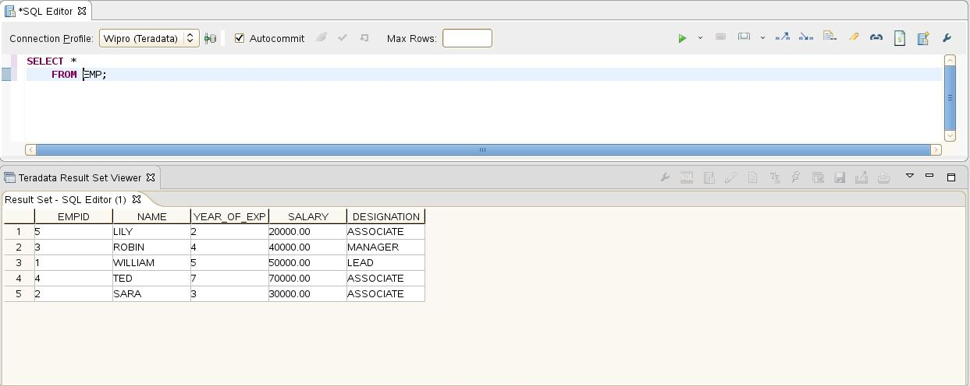

SELECT NAME, SALARY,

CASE

WHEN YEAR_OF_EXP < 5 THEN

CASE

WHEN SALARY<21000 THEN 1.5*SALARY

WHEN SALARY<25000 THEN 1.4*SALARY

ELSE 1.3*SALARY

END

WHEN YEAR_OF_EXP >=5 THEN 1.2*SALARY

END AS HIKE_SAL

FROM EMPLOYEE;

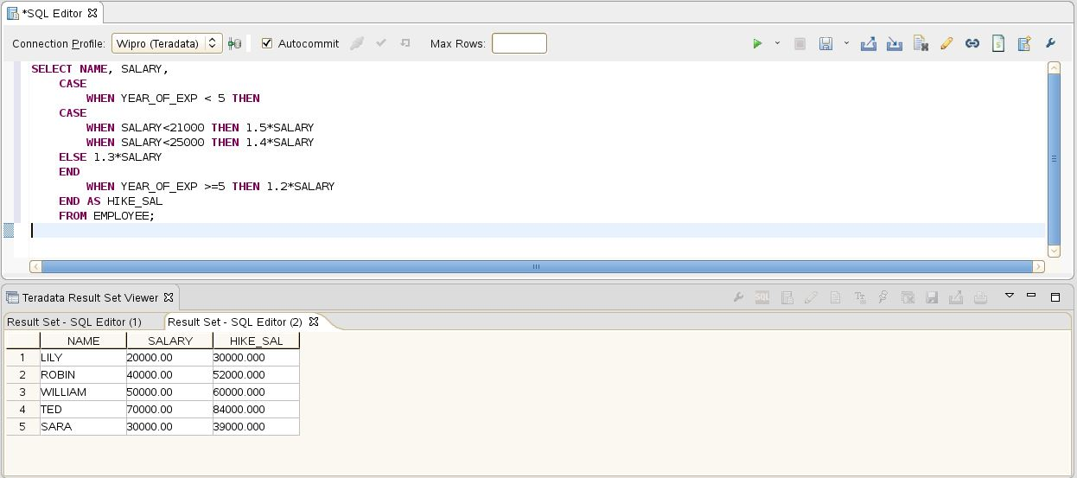

**2) Adding leading zero in number in SQL**

CREATE MULTISET TABLE

( DIGIT INTEGER);

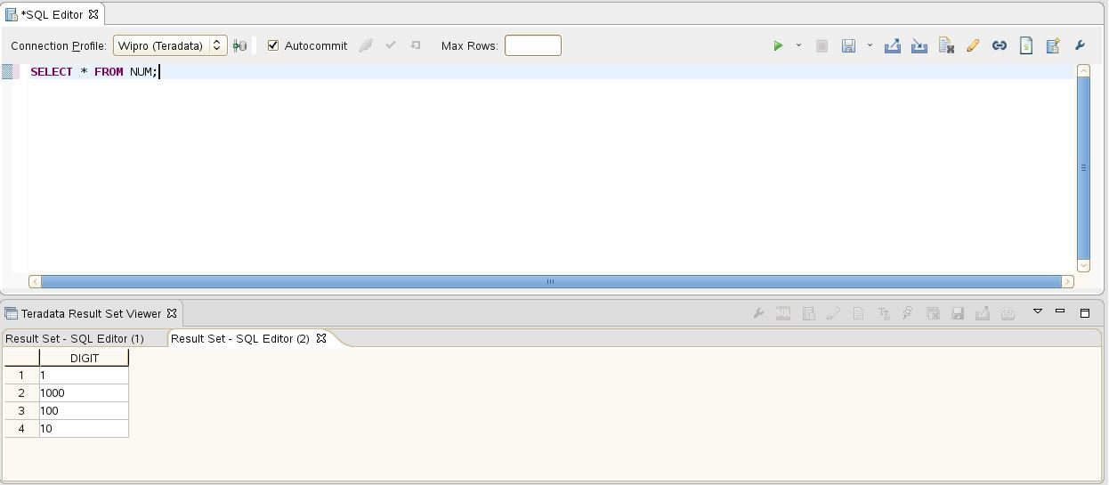

SELECT DIGIT,

CAST((DIGIT (FORMAT '9999')) AS CHAR(4)) AS NEW_DIGIT

FROM NUM;

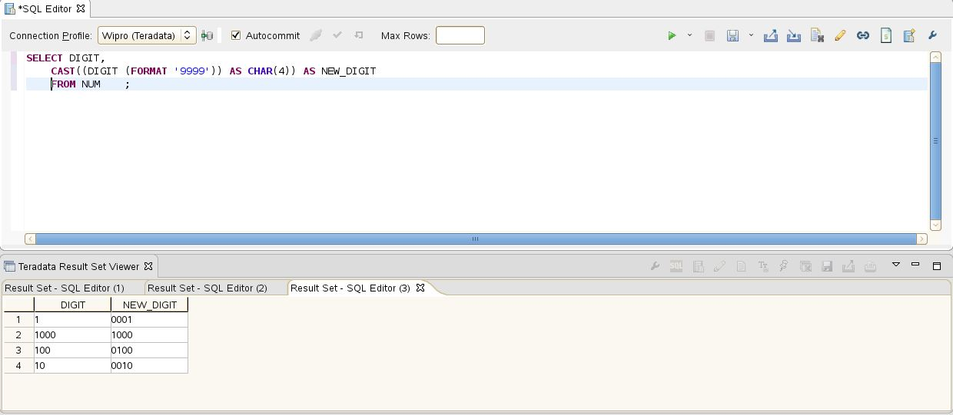

**3) Employee Detail**

CREATE TABLE EMPDETAIL

(

S_NO INTEGER,

FULL_NAME VARCHAR(25),

POS INTEGER

);

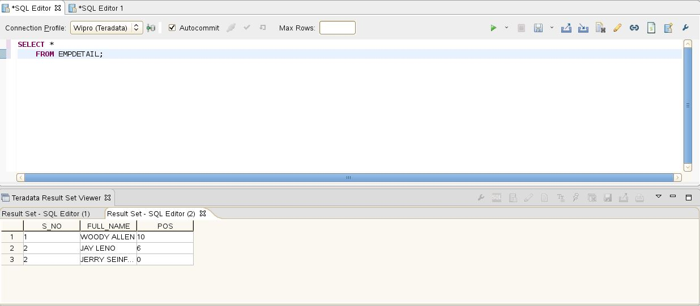

SELECT S_NO,

POSITION(' ' IN FULL_NAME) AS POS,

FULL_NAME,

SUBSTR(FULL_NAME,1,POSITION(' ' IN FULL_NAME)) AS FIRST_NAME,

SUBSTR(FULL_NAME,POSITION(' ' IN FULL_NAME)+1) AS LAST_NAME

FROM EMPDETAIL;

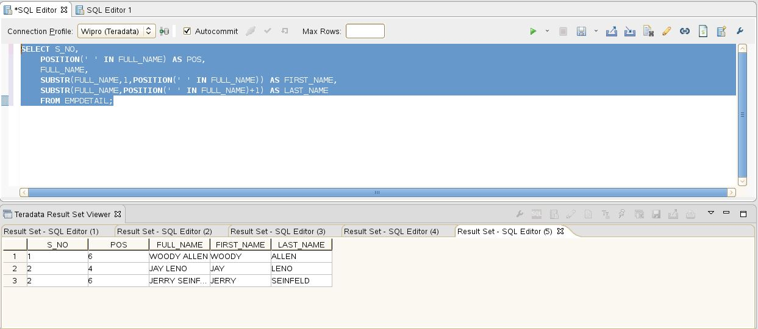

**4) STATE TABLE**

CREATE TABLE CUSTDETAIL

(

STATE_NAME VARCHAR(13),

STATE_ABBR CHAR(2),

STATE_CAPITAL VARCHAR(13),

STATE_CITY VARCHAR(13)

);

CREATE PROCEDURE STATE

(

IN in_STATE_NAME VARCHAR(13),

IN in_STATE_ABBR CHAR(2),

IN in_STATE_CAPITAL VARCHAR(13),

IN in_STATE_CITY VARCHAR(13)

)

BEGIN

INSERT INTO STATEDETAIL

(

STATE_NAME ,

STATE_ABBR ,

STATE_CAPITAL ,

STATE_CITY

)

VALUES

(

:in_STATE_NAME ,

:in_STATE_ABBR ,

:in_STATE_CAPITAL ,

:in_STATE_CITY

);

END;

CALL STATE ('KARNATAKA','KA','BANGALORE','BANGALORE');

CALL STATE ('TAMILNADU','TN','CHENNAI','MADURAI');

CALL STATE ('KERALA','KL','THIRUVANT','KOCHI');

SELECT *

FROM STATEDETAIL;

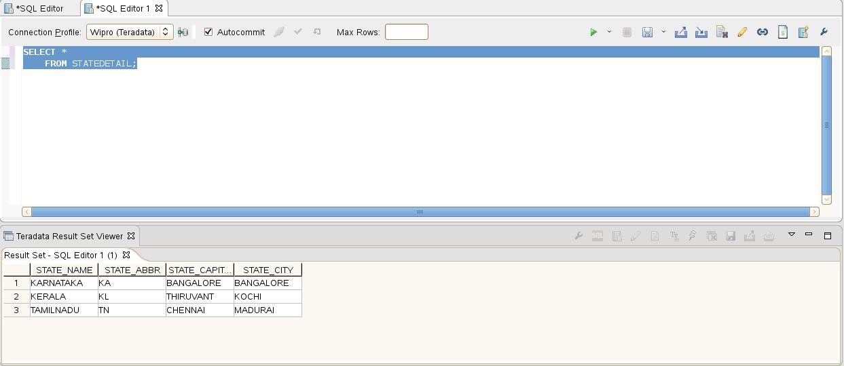

**5) CUSTOMER AND STATE**

CREATE TABLE CUSTOMER

(

CUST_ID INTEGER,

CUST_NAME VARCHAR(10),

CUST_CITY VARCHAR(25),

CUST_OPERATOR VARCHAR(10)

);

INSERT INTO CUSTOMER VALUES (1,'NITIN','BANGALORE','AIRTEL');

INSERT INTO CUSTOMER VALUES (2,'RAJ','BANGALORE','AIRTEL');

INSERT INTO CUSTOMER VALUES (3,'ANAND','BANGALORE','VODAFONE');

INSERT INTO CUSTOMER VALUES (4,'JOHN','MUMBAI','VODAFONE');

INSERT INTO CUSTOMER VALUES (5,'RAHUL','CHENNAI','RELIANCE');

INSERT INTO CUSTOMER VALUES (6,'SMITH','DELHI','RELIANCE');

INSERT INTO CUSTOMER VALUES (7,'WILLIAM','DELHI','AIRTEL');

INSERT INTO CUSTOMER VALUES (8,'JOHN','LUCKNOW','VODAFONE');

INSERT INTO CUSTOMER VALUES (9,'VAIBHAV','DELHI','AIRTEL');

INSERT INTO CUSTOMER VALUES (10,'RAVI','LUCKNOW','VODAFONE');

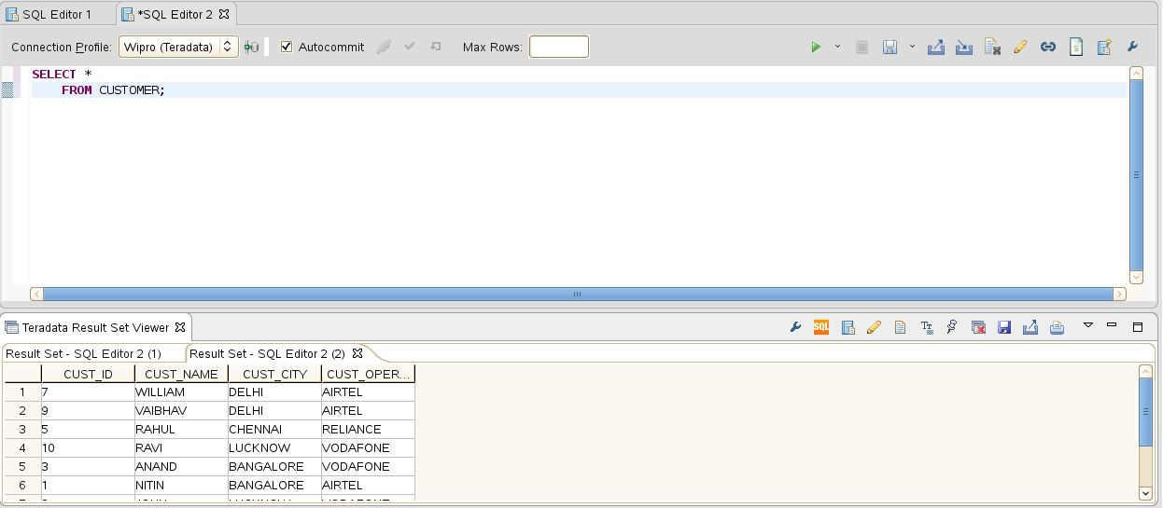

CREATE TABLE CITY

(

ZONE_ID INTEGER,

CITY VARCHAR(25),

STATE VARCHAR(25)

);

INSERT INTO CITY VALUES (1,'BANGALORE','KARNATAKA');

INSERT INTO CITY VALUES (2,'MUMBAI','MAHARASHTRA');

INSERT INTO CITY VALUES (3,'CHENNAI','TAMIL NADU');

INSERT INTO CITY VALUES (4,'DELHI','DELHI');

INSERT INTO CITY VALUES (5,'LUCKNOW','UTTAR PRADESH');

INSERT INTO CITY VALUES (6,'AHEMDABAD','GUJARAT');

INSERT INTO CITY VALUES (7,'INDORE','MADHYA PRADESH');

INSERT INTO CITY VALUES (8,'JAIPUR','RAJASTHAN');

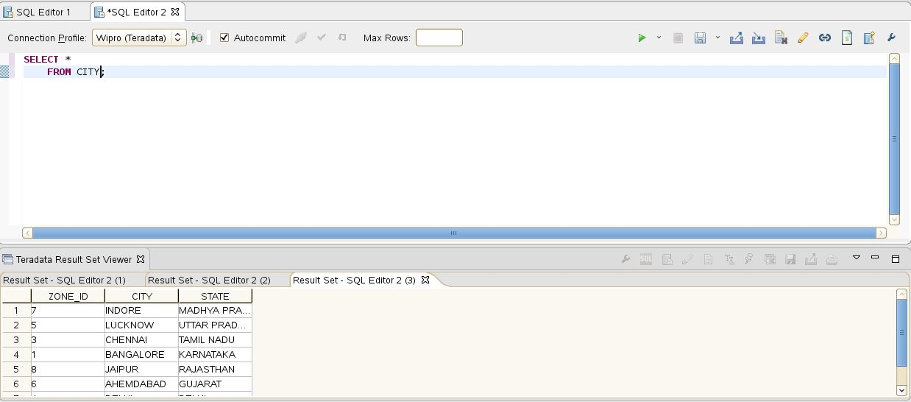

1) INNER JOIN

SELECT CUST_ID,

CUST_NAME,

CUST_OPERATOR,

CUST_CITY,

STATE

FROM CUSTOMER INNER JOIN CITY ON CUST_CITY=CITY;

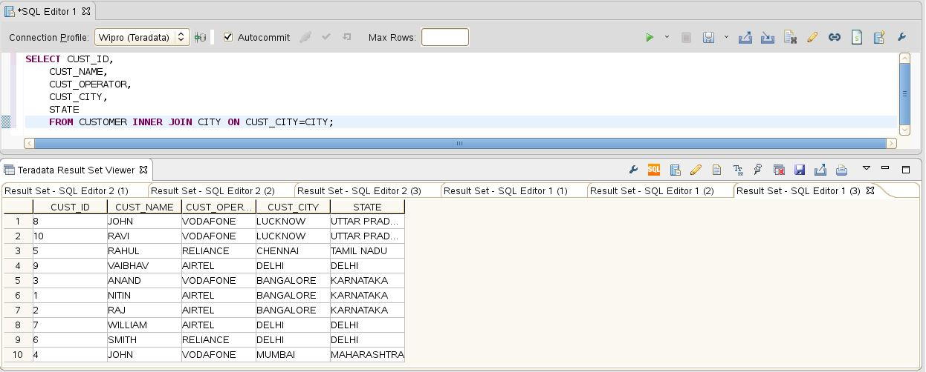

2) LEFT OUTER JOIN

SELECT CUST_ID,

CUST_NAME,

CUST_OPERATOR,

CUST_CITY,

STATE

FROM CITY LEFT OUTER JOIN CUSTOMER ON CUST_CITY=CITY;

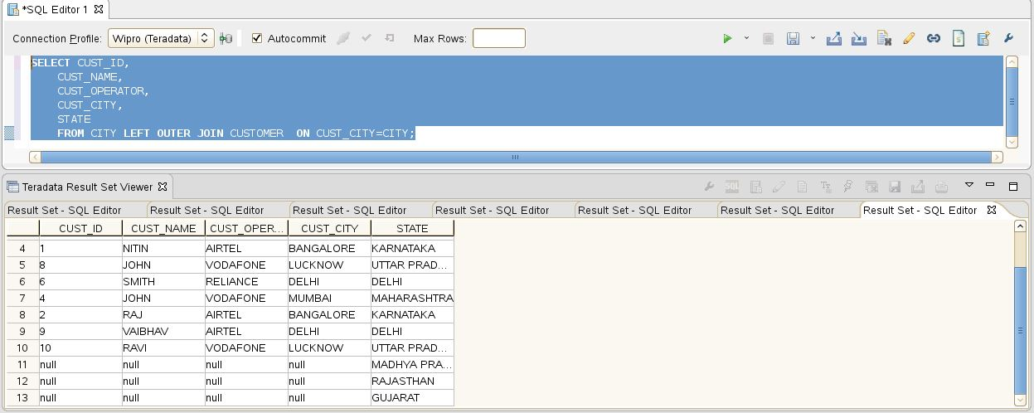

3) RIGHT OUTER JOIN

SELECT CUST_CITY,

STATE

FROM CUSTOMER RIGHT OUTER JOIN CITY ON CUST_CITY=CITY;

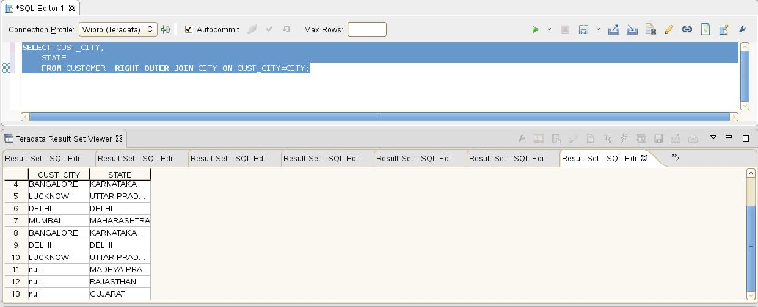

4) FULL OUTER JOIN

SELECT CUST_CITY,

STATE

FROM CUSTOMER FULL OUTER JOIN CITY ON CUST_CITY=CITY;

