**1. You need to write as many test cases as possible for a simple software program which computes the eligible discount for a customer. Try to describe all possible scenarios in a tabular format. Do not worry about ‘login’ kind of test cases, and just focus on how you will validate discount calculation. These are the rules. If the customer is new, and they are willing to sign up for a new loyalty card, they get a 15% discount on all their purchases on the day. Second if they are an existing customer and hold a loyalty card, they get a 10% discount. Third, if they have a discount coupon, they will get 20% off which cannot be used with the new customer discount but can be used with loyalty card discount. Discount amounts are added, if applicable.**

Ans)

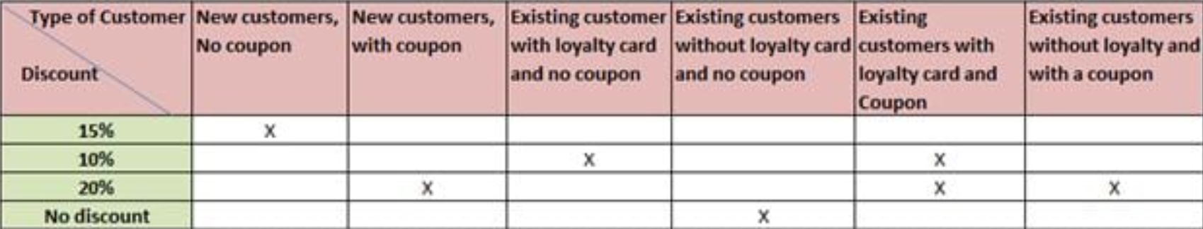

**3) How will you test a wireless mouse? What are the different things you will test and check before you can say that it is a good quality wireless mouse?**

**Ans)**

1. Check if the mouse is an optical mouse or not.
2. Verify that left-click and right-click buttons are working fine.
3. Check if the double click is working fine.
4. Verify the time duration between two left clicks, in order to consider it as a double click.
5. Check if the scroller is present at the top or not.
6. Verify the speed of the mouse pointer.
7. Check the pressure required for clicking the mouse buttons.
8. Verify the acceleration of the mouse pointer.
9. Verify that clicking the button and dragging the mouse operation is working fine(drag and drop functionality).
10. Check the dimension of the mouse, if it’s suitable to grip and work.
11. Verify that the mouse works in all the allowed surfaces.
12. Check if the mouse is a wireless mouse or corded mouse.
13. In the case of wireless mouse, check the range up to which the mouse remains operational.
14. In the case of a wireless mouse, check the battery requirement of the mouse.
15. Check if there is an option to switch on or mouse