//PROGRAM FOR JTabbedPane.

import javax.swing.*;

/* <applet code="JTabbedPaneDemo" width=400 height=100> </applet> */

public class JTabbedPaneDemo extends JApplet

{

public void init()

{

JTabbedPane jtp = new JTabbedPane();

jtp.addTab("Cities", new CitiesPanel());

jtp.addTab("Colors", new ColorsPanel());

jtp.addTab("Flavors", new FlavorsPanel());

add(jtp);

}

}

// Make the panels that will be added to the tabbed pane.

class CitiesPanel extends JPanel

{

public CitiesPanel()

{

JButton b1 = new JButton("New York");

add(b1);

JButton b2 = new JButton("London");

add(b2); JButton b3 = new JButton("Hong Kong");

add(b3); JButton b4 = new JButton("Tokyo");

add(b4);

}

}

class ColorsPanel extends JPanel

{

public ColorsPanel()

{

JCheckBox cb1 = new JCheckBox("Red");

add(cb1);

JCheckBox cb2 = new JCheckBox("Green");

add(cb2);

JCheckBox cb3 = new JCheckBox("Blue");

add(cb3);

}

}

class FlavorsPanel extends JPanel

{

public FlavorsPanel()

{

JComboBox jcb = new JComboBox();

jcb.addItem("Vanilla");

jcb.addItem("Chocolate");

jcb.addItem("Strawberry");

add(jcb);

}

}

OUTPUT:

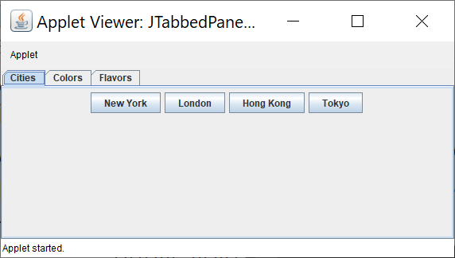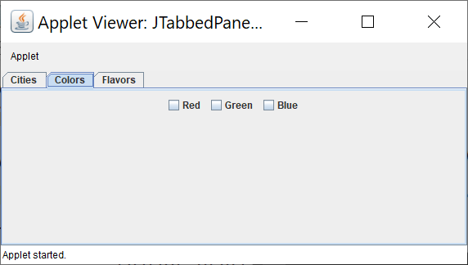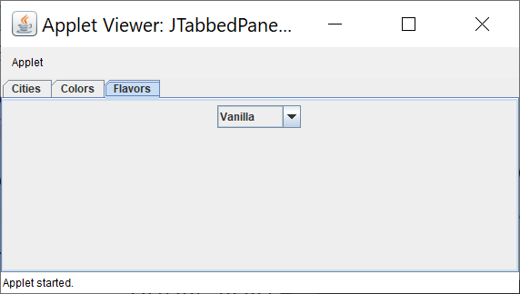

import java.awt.event.*;

import java.awt.*;

import javax.swing.*;

/*<applet code="JScrollpane" height=600 width=600></applet>*/

public class JScrollpane extends JApplet

{

public void init()

{

Container cp = getContentPane();

JPanel jp = new JPanel( ) ;

jp.setLayout( new GridLayout( 20, 20 ) ) ;

for(int i = 0 ; i < 20 ; i++)

{

for( int j = 0 ; j < 20 ; j++ )

{

jp.add(new JButton("Button " + j));

}

}

int v = ScrollPaneConstants.VERTICAL_SCROLLBAR_AS_NEEDED ;

int h = ScrollPaneConstants.HORIZONTAL_SCROLLBAR_AS_NEEDED ;

JScrollPane js = new JScrollPane( jp, v, h ) ;

cp.add(js, BorderLayout.CENTER) ;

}

}

OUTPUT:

