Day 5 — Wazuh SIEM & Continuous Monitoring
Zero Trust Network Access Lab
Rahul Rajkumar Kori
Status: ✅ Complete | July 2026

Day 5 Overview
Day 5 added continuous monitoring to the zero trust architecture by deploying Wazuh — an open-source SIEM (Security Information and Event Management) platform. This completes the third and final pillar of NIST 800-207 zero trust: Assume Breach.
Days 2-4 built the enforcement layer — blocking unauthorized access through OpenZiti and Authentik. But zero trust assumes that no defense is perfect. Day 5 built the detection layer: a system that watches every VM, collects all security events, detects threats, and alerts in real time.
Day 5 covered four major milestones: deploying the Wazuh manager, installing agents on all three infrastructure VMs, configuring OpenZiti-specific log collection, and writing custom SIEM detection rules for ZTNA authentication failures.
⭐ Continuous monitoring is not optional in zero trust — it is a core NIST tenet (Tenet 5 and 7). Day 5 makes 'assume breach' real.

What Is a SIEM
A SIEM collects logs and security events from across an environment, correlates them, and generates alerts. It answers the question: what is happening across my infrastructure right now, and is any of it a threat?
Wazuh is the open-source equivalent of enterprise SIEMs like Splunk, Microsoft Sentinel, or IBM QRadar. It consists of three components:
• Wazuh Indexer — stores and indexes all event data (based on OpenSearch)
• Wazuh Manager — analyzes events against detection rules and generates alerts
• Wazuh Dashboard — web interface to search events, view alerts, and manage agents

Architecture
Wazuh uses a manager-agent model. A central manager receives data from lightweight agents installed on each monitored VM. Each agent runs five sub-processes: log collector, file integrity monitor, rootkit scanner, security configuration assessor, and the communication daemon.
Wazuh Manager (ztna-wazuh)
Analyzes events, fires alerts
^
+---------------+---------------+
| | |
[Agent 001] [Agent 002] [Agent 003]
controller service authentik
OpenZiti auth nginx access login events
SSH logins SSH logins Docker logs
config changes file integrity brute force

What Was Built

1. Wazuh Manager Deployment
Deployed the Wazuh all-in-one stack on a dedicated VM with sufficient resources for the indexer, manager, and dashboard.
✅ Launched ztna-wazuh VM (c7i-flex.large — 4GB RAM, 50GB disk)
✅ Placed in public subnet with public IP for dashboard access
✅ Installed Wazuh 4.9.2 all-in-one (indexer + manager + dashboard + filebeat)
✅ Dashboard accessible over HTTPS on port 443
✅ Admin credentials generated and saved securely

2. Agents Deployed on All Infrastructure VMs
Lightweight Wazuh agents installed on every VM in the ZTNA infrastructure. All three agents connected and actively reporting to the manager.
✅ Agent 001 — ztna-controller (10.0.1.236) — connected and active
✅ Agent 002 — ztna-service (10.0.2.17) — connected and active
✅ Agent 003 — ztna-authentik (10.0.1.161) — connected and active
✅ Security group ports 1514 (events) and 1515 (enrollment) opened for agent communication
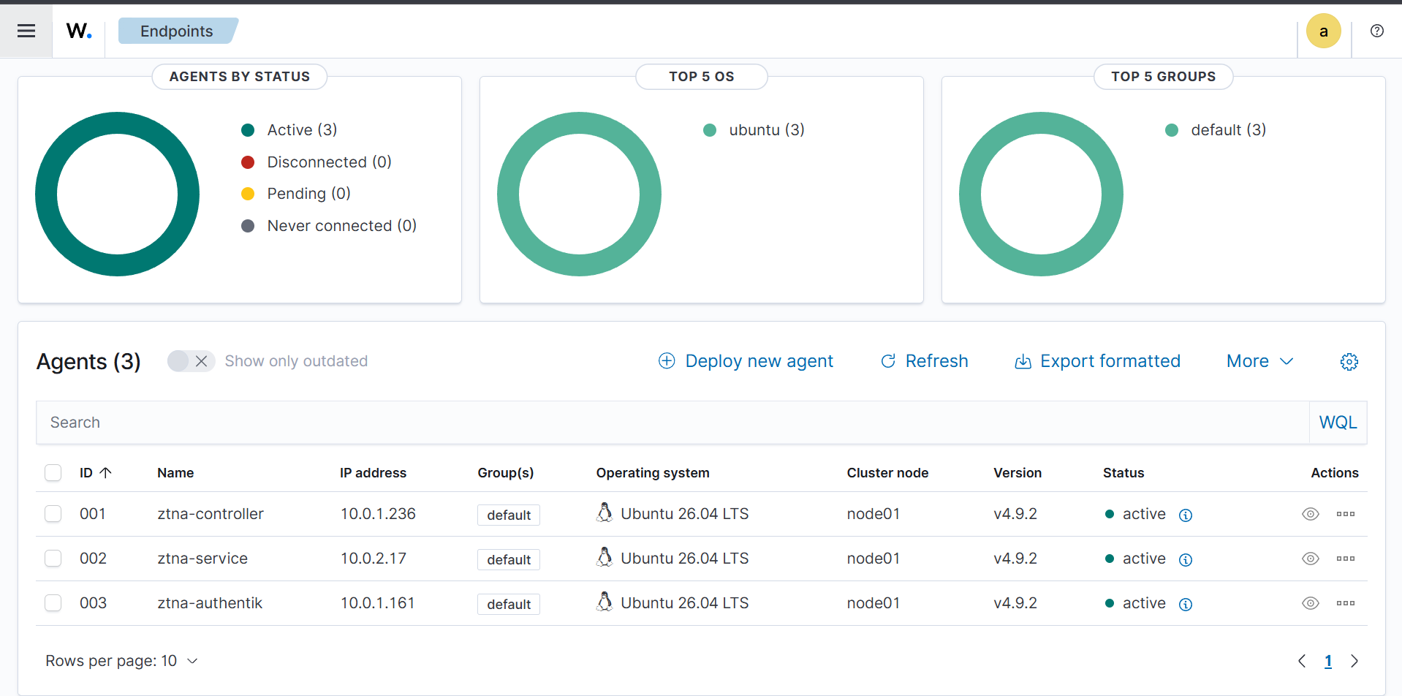
Wazuh Endpoints Summary — all three infrastructure agents (controller, service, authentik) connected and actively reporting to the Wazuh Manager. Status: Active (3), Disconnected (0).

3. OpenZiti Log Collection Configured
By default Wazuh agents collect system and SSH logs. Custom configuration was added to also ingest OpenZiti control plane logs — making the SIEM aware of zero trust authentication events, not just operating system activity.
✅ Created rsyslog rule to route OpenZiti logs to /var/log/ziti-controller.log
✅ Added localfile monitor in agent ossec.conf for the OpenZiti log file
✅ Configured nginx access and error log monitoring on the service agent

4. Custom Detection Rules
Wrote custom Wazuh detection rules specifically for ZTNA security events. These rules detect OpenZiti authentication failures and escalate when multiple failures occur in rapid succession — indicating a potential attack.
✅ Rule 100200 (Level 10) — single OpenZiti JWT authentication failure
✅ Rule 100201 (Level 12) — multiple failures within 120 seconds (brute force indicator)

Key Commands
Command | Purpose
sudo bash ./wazuh-install.sh -a | Install Wazuh manager, indexer, and dashboard
sudo WAZUH_MANAGER='10.0.1.81' WAZUH_AGENT_NAME='ztna-controller' dpkg -i wazuh-agent.deb | Install and register agent with manager
sudo systemctl enable --now wazuh-agent | Start agent as persistent service
sudo tee /etc/rsyslog.d/30-ziti.conf | Route OpenZiti logs to a file via rsyslog
ossec.conf <localfile> ziti-controller.log | Tell agent to monitor OpenZiti logs
local_rules.xml <match> valid for primary | Custom rule matching OpenZiti auth failures
sudo systemctl restart wazuh-manager | Reload rules after changes

Detection Proof 1 — Failed SSH Login
To validate that Wazuh detects real security events, a failed SSH login was simulated from an external machine using a non-existent username (baduser). Wazuh captured it immediately with full attribution.
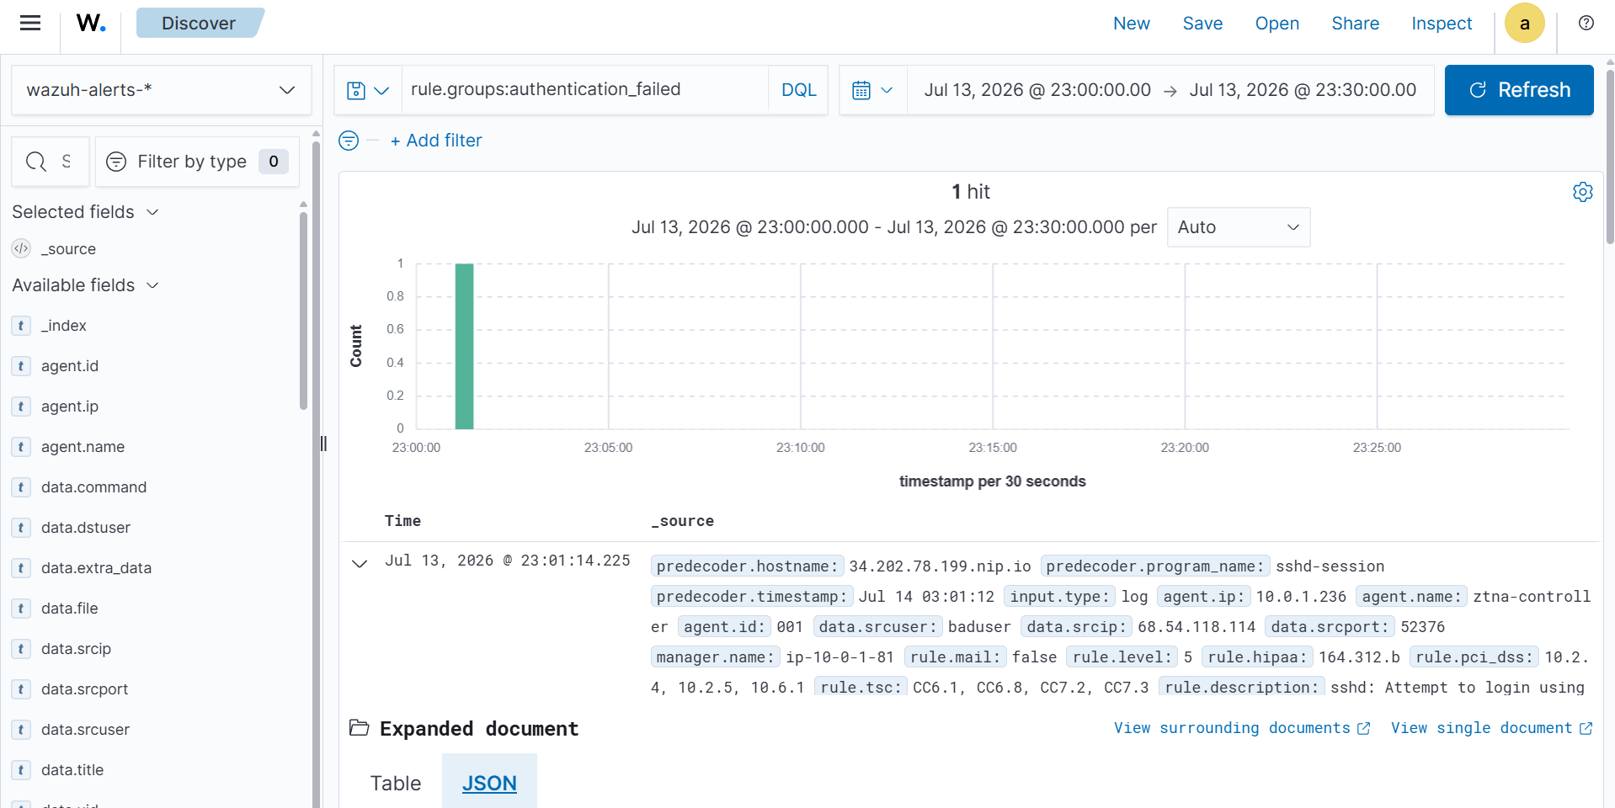
Wazuh detecting a failed SSH login attempt. Captured: source user (baduser), source IP (68.54.118.114), agent (ztna-controller), severity level 5, and automatic compliance mapping (HIPAA 164.312.b, PCI-DSS 10.2.4/10.2.5).
What this proves: Wazuh analyzes logs against detection rules in real time, identifies the attacker's source IP and attempted username, assigns severity, and automatically maps events to compliance frameworks. This is exactly how a production SOC operates.

Detection Proof 2 — OpenZiti Log Collection
Beyond system logs, Wazuh was configured to ingest OpenZiti control plane activity — making the SIEM aware of zero trust events.
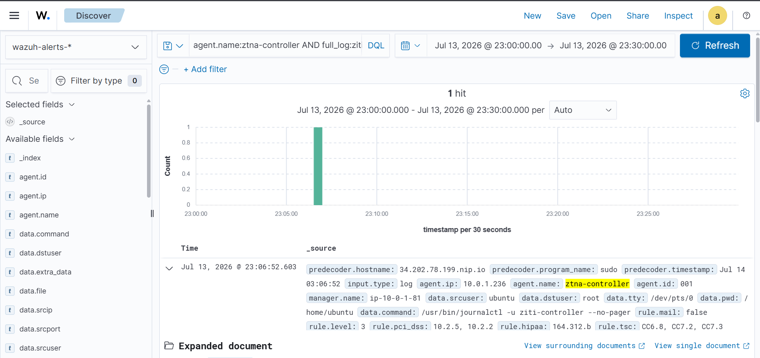
Wazuh ingesting OpenZiti-related activity from the controller agent. The event shows ziti-controller command execution captured and shipped to the manager.
This makes the monitoring ZTNA-aware. Any authentication activity, policy change, or anomaly on the zero trust control plane is now captured and available for alerting and forensic analysis.

Detection Proof 3 — Service VM Monitoring
The protected nginx service in the private subnet is fully monitored. All access events, SSH sessions, and PAM authentication events from the service VM flow to Wazuh in real time.
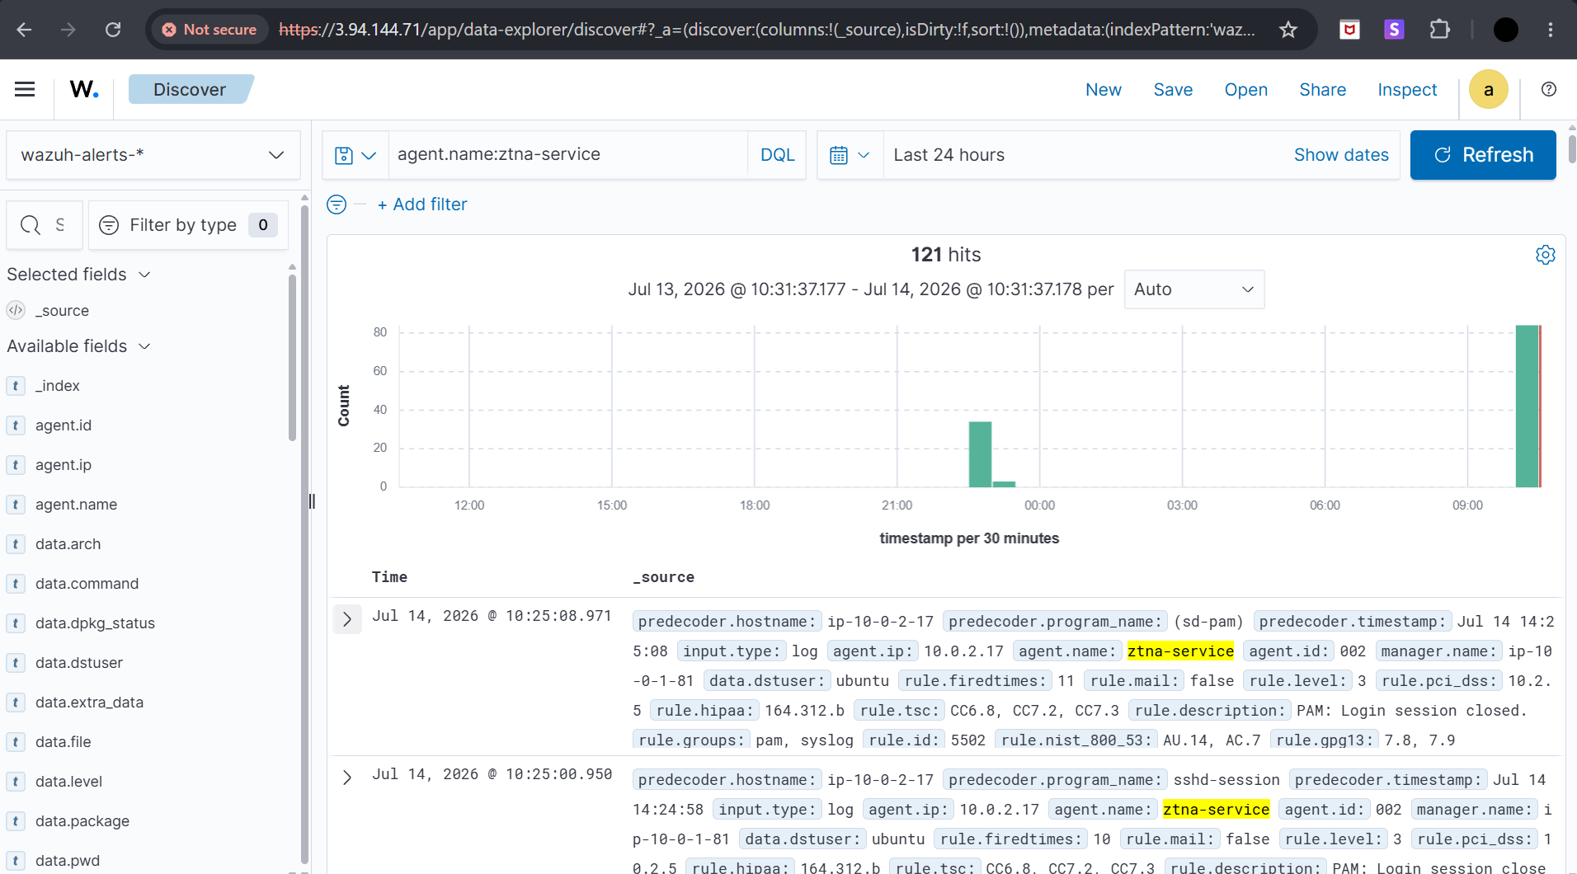
Wazuh Discover view showing 121 security events from the ztna-service agent (10.0.2.17). Events include PAM session management and SSH session tracking on the protected nginx VM.
This completes the end-to-end monitoring chain: a user accesses nginx through the OpenZiti tunnel, and that access is logged by the Wazuh agent on the service VM and visible in the central dashboard.

Detection Proof 4 — Custom Rule Firing
The custom detection rule (100200) was validated by sending invalid JWT tokens to the OpenZiti Controller. Each rejected authentication attempt triggered the custom alert.
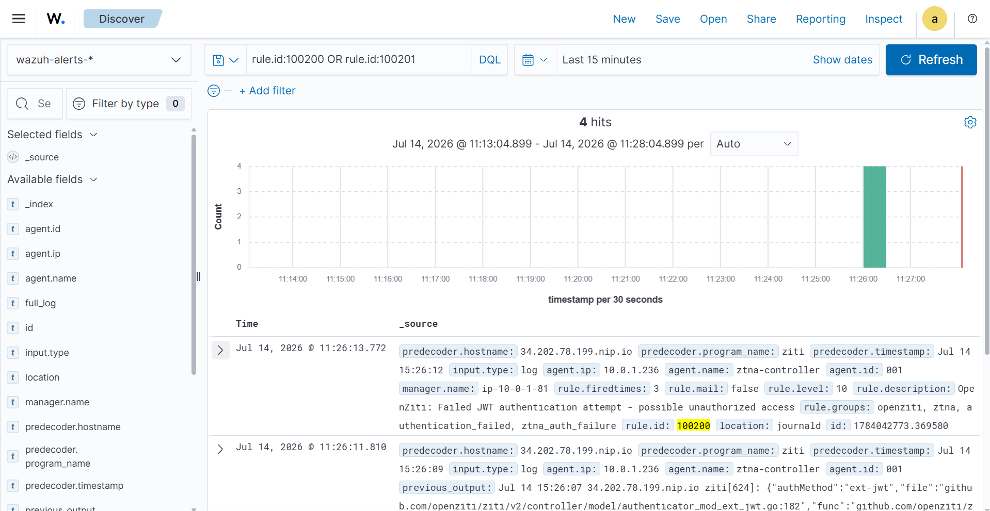
Custom Wazuh rule 100200 firing on OpenZiti JWT authentication failures. Four failed attempts detected with severity level 10, rule groups: openziti, ztna, authentication_failed, ztna_auth_failure.
This is the most advanced Day 5 achievement. A custom SIEM rule — written from scratch — detecting zero trust authentication failures in real time. This demonstrates the ability to extend a SIEM beyond default rules to detect application-specific security events.

The Custom Rule
<rule id="100200" level="10">
<match>none of which were valid for primary authentication</match>
<description>OpenZiti: Failed JWT authentication attempt</description>
<group>authentication_failed,ztna_auth_failure,</group>
</rule>

<rule id="100201" level="12" frequency="3" timeframe="120">
<if_matched_sid>100200</if_matched_sid>
<description>OpenZiti: Multiple failed JWT authentications</description>
<group>authentication_failures,ztna_bruteforce,</group>
</rule>
Rule 100200 fires on any single JWT authentication failure (level 10 — high). Rule 100201 escalates to level 12 if three or more failures occur within 120 seconds — indicating a brute force attack against the ZTNA control plane.

What Each Agent Monitors

Agent 001 — Controller (ztna-controller)
• SSH login attempts — successful and failed
• OpenZiti authentication events (JWT validation, identity enrollment)
• System changes — new users, sudo commands, package installations
• File integrity of OpenZiti configuration files
• OpenZiti controller and router log entries

Agent 002 — Service (ztna-service)
• nginx access logs — every request to the protected service
• nginx error logs — failed or suspicious requests
• SSH login attempts from the controller (jump host)
• File integrity of web content (/var/www/html/)
• System-level changes and package modifications

Agent 003 — Authentik (ztna-authentik)
• System authentication events (PAM, SSH)
• Docker container logs (Authentik server, worker, PostgreSQL)
• File integrity monitoring
• System changes and security configuration

How This Completes Zero Trust
NIST 800-207 defines three core principles. Day 5 delivers the third and final one:
• Verify Explicitly — OpenZiti mTLS + Authentik OIDC (Days 2-4)
• Least Privilege — OpenZiti service policies with role-based access (Day 3)
• Assume Breach — Wazuh continuous monitoring with custom detection rules (Day 5)
Assume Breach means accepting that attacks will occur and building the capability to detect, log, and respond fast. Without monitoring, a breach could go unnoticed for months — exactly what happened in the SolarWinds attack where attackers operated inside trusted networks for nine months before detection. Wazuh is the detection capability that prevents that scenario.
With Day 5 complete, the lab implements all three NIST zero trust principles end to end — a complete enterprise-grade ZTNA architecture.

Interview Talking Points

1. What is a SIEM and why does zero trust need one
A SIEM centralizes security event collection, correlation, and alerting across an entire environment. Zero trust requires it because the 'assume breach' principle demands continuous visibility. You cannot respond to what you cannot see. Monitoring addresses NIST Tenets 5 (monitor all assets) and 7 (collect everything and improve continuously).

2. Manager-Agent Architecture
Lightweight agents on each endpoint collect logs and ship them to a central manager for analysis. This model scales to thousands of endpoints — exactly how enterprises deploy Splunk forwarders or Microsoft Sentinel agents. The agent is small (~20MB RAM) and does not interfere with application performance.

3. What Wazuh Detects
Log-based threats (failed logins, brute force attempts, privilege escalation), file integrity changes (configuration tampering, web defacement), rootkits, vulnerabilities, and security misconfigurations via CIS benchmark scans. In the lab, Wazuh caught failed SSH logins and OpenZiti JWT failures in real time.

4. Custom Detection Rules
The ability to write custom rules is what separates a SIEM operator from a SIEM user. Rule 100200 matches a specific OpenZiti log pattern for JWT authentication failures. Rule 100201 correlates multiple failures within a time window to detect brute force. This pattern — single event detection plus frequency-based escalation — is the standard approach in production SOCs.

5. Compliance Mapping
Every Wazuh alert is automatically mapped to compliance frameworks including HIPAA (164.312.b), PCI-DSS (10.2.4, 10.2.5), NIST 800-53, and TSC. This is critical enterprise value — auditors require evidence of continuous monitoring, and the SIEM generates it automatically with every alert.

6. Enterprise Equivalents
Wazuh maps to Splunk, Microsoft Sentinel, IBM QRadar, and Elastic Security. The concepts are identical: agents/forwarders collect logs, a central engine correlates events against detection rules, dashboards visualize alerts, and compliance reports are generated automatically.

Likely Interview Questions
Interview Question | Your Answer
What does the 'assume breach' principle mean? | Accept that defenses will be bypassed. Build detection and response capabilities so breaches are caught fast, not after months. Wazuh implements this by monitoring every VM and alerting on anomalies.
How did you monitor OpenZiti specifically? | Routed OpenZiti controller logs to a file via rsyslog, configured the Wazuh agent to read that file, then wrote custom rules matching JWT authentication failure patterns.
What is the difference between rule 100200 and 100201? | 100200 fires on any single JWT auth failure (severity 10). 100201 uses frequency correlation — if 100200 fires 3+ times in 120 seconds, it escalates to severity 12 indicating a brute force attack.
How would this scale in production? | Add more agents on new endpoints. Use Wazuh clusters for high availability. Forward critical alerts to a SOAR platform for automated response. The architecture is the same at 3 agents or 3000.
What compliance frameworks does Wazuh map to? | HIPAA, PCI-DSS, NIST 800-53, TSC, and GDPR. Each alert automatically includes applicable compliance references — critical for audits.

Day 5 End State

Infrastructure
✅ Wazuh 4.9.2 fully operational (indexer + manager + dashboard)
✅ Three agents connected — controller, service, authentik
✅ All agents actively reporting — zero disconnected

Log Collection
✅ System and SSH log collection active on all agents
✅ OpenZiti control plane logs ingested via rsyslog + localfile
✅ nginx access and error logs monitored on service agent

Detection
✅ Failed SSH login detected with full attribution (IP, username, severity)
✅ Compliance mapping confirmed (HIPAA, PCI-DSS, NIST)
✅ Custom rule 100200 — single OpenZiti JWT auth failure
✅ Custom rule 100201 — multiple failures (brute force detection)
✅ Custom rules validated — 4 test alerts fired successfully

What This Proves About Your Skills
✅ Deploy and configure an enterprise-grade SIEM from scratch
✅ Manager-agent monitoring architecture across multiple VMs
✅ Custom log source configuration (rsyslog routing + agent config)
✅ Custom detection rule authoring with frequency-based escalation
✅ Understanding of NIST zero trust tenets and 'assume breach'
✅ Compliance awareness and automatic framework mapping
✅ Four documented proof screenshots showing real detection

Day 5 Complete | Rahul Rajkumar Kori | github.com/Rahul7259/zero-trust-network-lab

