Day 6 — Attack Simulation
STRIDE Threat Model + Spoofing Attacks
Zero Trust Network Access Lab
Rahul Rajkumar Kori
July 2026

Day 6 Overview
Day 6 marks the transition from the build phase to the validation phase. After spending Days 1-5 building the zero trust architecture, I switched roles from architect to attacker. My goal: try to break my own lab and prove that every layer of defense actually works.
Before attacking, I built a STRIDE threat model to categorize every possible threat systematically. Then I began executing attacks in category order, starting with Spoofing — the most fundamental threat category for any identity-based system.
This is where the project shifts from 'I built a zero trust architecture' to 'I proved my zero trust architecture stops real attacks.'

STRIDE Threat Model — What It Is and Why I Used It
STRIDE is a threat modeling framework developed by Microsoft. It categorizes security threats into six types, providing a systematic way to identify what could go wrong with a system before attackers do.
I chose STRIDE because it maps directly to the layers I built. Every mitigation in my architecture defends against one or more STRIDE categories. Using this framework, I could verify that my zero trust design has coverage for every threat class — not just the obvious ones.

The Six STRIDE Categories
• S — Spoofing Identity: Attacker pretends to be someone they're not
• T — Tampering with Data: Attacker modifies traffic or files
• R — Repudiation: Attacker performs actions and denies them (no evidence)
• I — Information Disclosure: Attacker sees data they shouldn't
• D — Denial of Service: Attacker makes services unavailable
• E — Elevation of Privilege: Attacker gains access beyond their permissions

How STRIDE Maps to My Architecture
Each category corresponds to specific defenses I built in Days 2-5:
• Spoofing is stopped by mTLS certificate validation and JWT signature verification (Days 2, 4)
• Tampering is stopped by mTLS encryption of tunnel traffic and Wazuh File Integrity Monitoring (Days 2, 5)
• Repudiation is stopped by Wazuh centralized logging — logs ship to a separate VM before an attacker can delete them (Day 5)
• Information Disclosure is stopped by the dark network principle — no open ports on protected services (Day 3)
• Denial of Service is stopped by systemd auto-restart, AWS security groups, and Wazuh flood detection (Days 2, 5)
• Elevation of Privilege is stopped by OpenZiti's least-privilege Dial/Bind policies and admin authentication (Day 3)

Why This Matters for the Project
Without a threat model, running attacks feels random. With STRIDE, every attack maps to a specific threat category and validates a specific defense. This is the difference between hacking and security engineering.

My Attack Approach
I decided against launching a dedicated Kali Linux VM. Instead, I attack from two positions that already exist in my architecture:
• My laptop (external attacker) — simulates someone on the internet trying to break in
• The controller VM (insider threat) — simulates an attacker who has already compromised a trusted VM and wants to pivot deeper into the network
This dual-position approach covers both threat scenarios enterprises face without requiring extra infrastructure. And because the controller has all the tools I need (nmap, tcpdump, python3, curl, ziti CLI), I can start attacking immediately.

Tools I Used
• nmap — port scanning to discover services on the network
• curl — direct HTTP requests to test service access
• ziti CLI — attempting authentication through the official OpenZiti client
• python3 — for crafting fake JWT tokens
• tcpdump — capturing network traffic (used in Attacks 4-6)

Attack 1 — Forge a JWT Token
STRIDE Category: Spoofing

What I Was Testing
The most direct attack against any identity-based system: create a fake authentication token and try to use it. If OpenZiti accepts a forged JWT, an attacker can impersonate any user. My entire zero trust architecture depends on this attack being impossible.

How I Performed the Attack
I wrote a Python script to construct a JWT token that looked structurally correct — proper header, payload, and signature format — but with a fake signature that no legitimate identity provider would create. Then I submitted this fake token directly to OpenZiti's authentication endpoint using curl, bypassing the normal client.

The exact command I ran
FORGED_TOKEN=$(python3 forged_jwt.py)
curl -k -i -X POST \
-H "Content-Type: application/json" \
-d "{\"token\": \"$FORGED_TOKEN\"}" \
https://127.0.0.1:1280/edge/client/v1/authenticate?method=ext-jwt

Expected Result
OpenZiti should reject the token immediately with a 401 Unauthorized response, explicitly indicating that no valid credential was found.

Actual Result
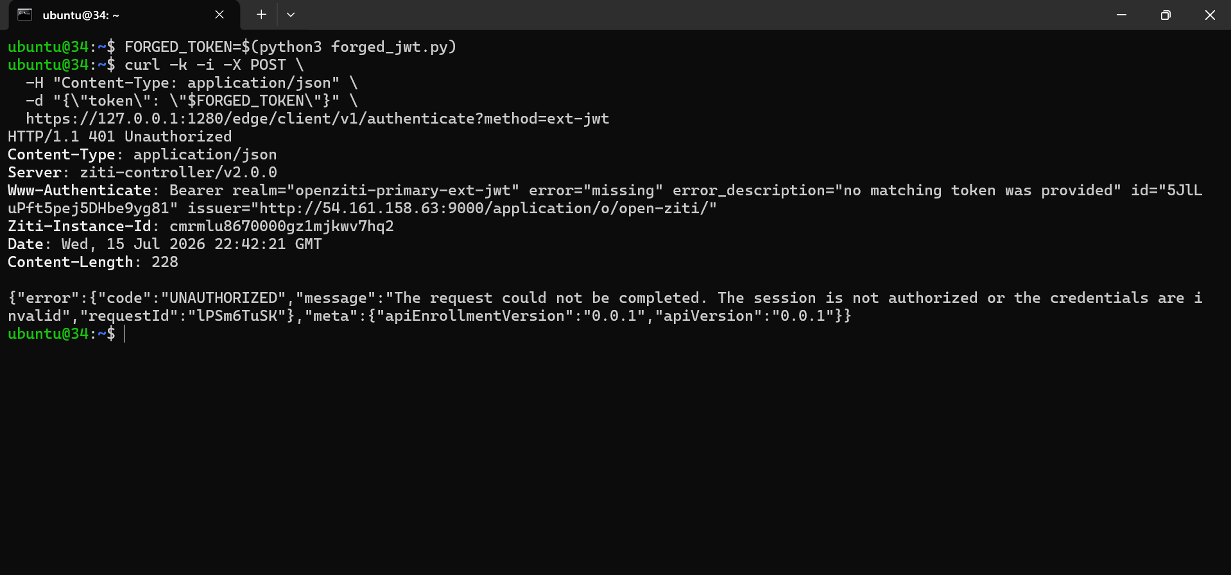
Attack 1 result: OpenZiti Controller rejected the forged JWT token with HTTP 401 Unauthorized. The response includes error="missing" and error_description="no matching token was provided" — confirming the token failed signature validation.
The response shows exactly what I hoped for:
• HTTP status: 401 Unauthorized
• error: 'missing'
• error_description: 'no matching token was provided'
• Error code: UNAUTHORIZED

Why This Attack Was Blocked (In Simple Terms)
Think of a JWT signature like a wax seal on a royal letter. Only the king has the special stamp (private key) that creates the seal. Anyone can look at a seal and recognize it (using the public key), but nobody else can make one. When I tried to forge a token, I could copy the letter's format, but I didn't have the king's stamp. So when OpenZiti checked the seal against the king's known pattern, it didn't match — and the letter was thrown out.
In technical terms: JWT signatures use asymmetric cryptography. Authentik signs tokens with a private key that only Authentik has. OpenZiti verifies signatures using Authentik's public key (fetched from the JWKS endpoint). My fake signature didn't match what the public key would produce for that payload — so OpenZiti rejected it.

What This Proves
Even with direct API access, forgery is mathematically impossible without the private key. This is the foundation of every modern identity system — from Google login to bank authentication.

Attack 2 — Invalid Identity Login via ziti CLI
STRIDE Category: Spoofing

What I Was Testing
Attack 1 tested the raw API endpoint. But what if an attacker uses OpenZiti's official CLI tool (like a legitimate user would)? Would the same forged token be rejected? This ensures the defense works consistently across every entry point.

How I Performed the Attack
I created a JWT token that was properly formatted (valid base64, three parts separated by dots) but with an invalid signature. Then I attempted to log in using the ziti edge login command — the same command a legitimate user would use to authenticate.

The exact command I ran
printf '%s' 'eyJhbGciOiJSUzI1NiIsInR5cCI6IkpXVCJ9.eyJpc3M...invalidsig' > /tmp/ghost.jwt
ziti edge login https://34.202.78.199.nip.io:1280 --ext-jwt /tmp/ghost.jwt

Expected Result
The ziti CLI should reject the token and return a 401 credential submission failed error, mirroring the behavior of the direct API attack.

Actual Result
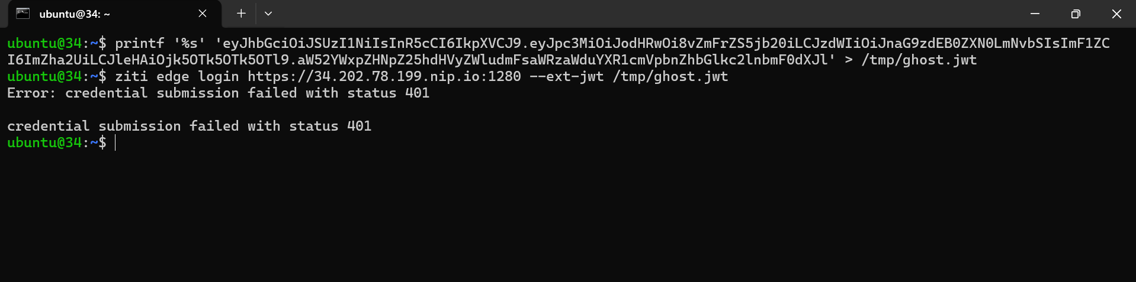
Attack 2 result: ziti CLI rejected the invalid token with 'credential submission failed with status 401'. The token was submitted through the legitimate CLI tool but still failed authentication — confirming the defense works regardless of the entry point.
The CLI returned:
• Error: credential submission failed with status 401
• No session was created
• The attacker gained no access

Why This Attack Was Blocked (In Simple Terms)
Imagine the bank vault has multiple entrances — a main door, a side door, an employee entrance. All three doors have the same identity checker. Attack 1 tested the main door. Attack 2 tested the employee entrance. Same result — the fake ID was rejected at both doors.
Technically: OpenZiti routes all authentication attempts through the same validation logic regardless of whether they come through the raw API or the ziti CLI. The CLI is just a wrapper that sends HTTPS requests to the same endpoints. Signature verification happens at the server, not the client.

Difference Between Attack 1 and Attack 2
• Attack 1 used curl to hit the raw API directly (simulates attacker who reverse-engineered the API)
• Attack 2 used the official ziti CLI (simulates attacker using stolen client software)
• Both hit different endpoints but both were rejected — proves the defense doesn't depend on the client behaving correctly

What This Proves
An attacker can't bypass authentication by switching tools. The defense is server-side, not client-side. This is a fundamental principle of secure design — never trust the client.

Attack 3 — Direct Access Without Identity (Dark Network Test)
STRIDE Category: Spoofing (Access Bypass)

What I Was Testing
The most important test of the entire zero trust architecture. If an attacker completely skips OpenZiti and tries to access nginx directly using its IP address, what happens? A properly designed dark network should make the service invisible — not just blocked, but undiscoverable.
This test is critical because most 'zero trust' products still leave services listening on the network. My architecture should make the protected service disappear entirely from the perspective of anyone without a valid identity.

How I Performed the Attack
I attacked in three phases, each testing a different discovery method an attacker might use.

Phase 1 — Try to access nginx by its private IP
curl --max-time 5 http://10.0.2.17
This is the most direct attack: I know the IP address, I try to connect to port 80 directly.

Phase 2 — Try DNS resolution without the OpenZiti tunneler
sudo pkill -f ziti-edge-tunnel
curl --max-time 5 http://nginx-service.ziti
This tests whether the OpenZiti service name is resolvable without the client tunneler active. If the DNS name works without the tunneler, that's a leak.

Phase 3 — Port scan the entire service VM
nmap -Pn 10.0.2.17
This is the reconnaissance an attacker would perform to discover what services exist on the target. If nginx (port 80) shows up in the scan, the service isn't truly hidden.

Expected Result
• Phase 1: Connection times out — no response from port 80
• Phase 2: DNS resolution fails — the service name doesn't exist without the tunneler
• Phase 3: Port scan shows no web services — only SSH visible

Actual Result
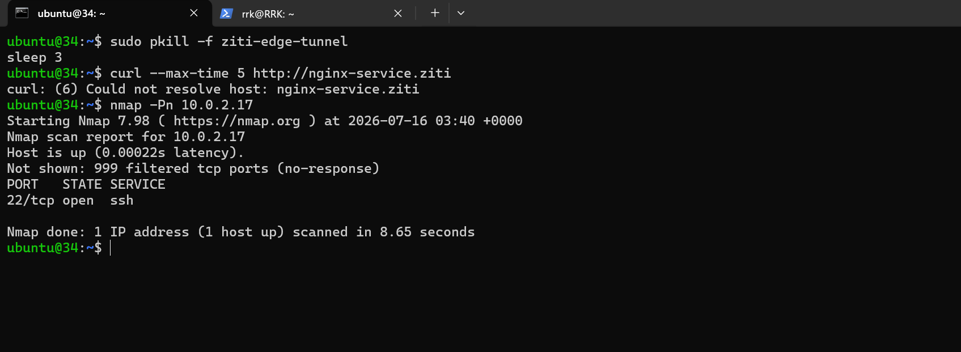
Attack 3 result: The dark network principle proven. DNS resolution failed without the OpenZiti tunneler ('Could not resolve host: nginx-service.ziti'). Nmap scan of the service VM shows 999 filtered TCP ports with no response, and only SSH (port 22) visible. The nginx web service is completely invisible to an insider attacker with SSH access to the controller VM.
The results confirm every phase:
• DNS resolution: FAILED — 'Could not resolve host: nginx-service.ziti'
• Nmap scan: 999 filtered TCP ports (no response) — only SSH open
• nginx on port 80: INVISIBLE — no evidence it exists

Why This Attack Was Blocked (In Simple Terms)
Imagine a house that's completely invisible from the street. Not just locked — invisible. You can't see it, you can't find its address, you don't even know it's there. That's what my zero trust architecture does to nginx. From an attacker's perspective, the service simply doesn't exist.
How is this possible? Three layers work together:
• Layer 1 — No public IP: The service VM is in a private subnet with no direct internet address
• Layer 2 — Security groups: AWS-level firewall blocks all inbound traffic except SSH from the controller
• Layer 3 — Dark network: nginx listens only on localhost. The OpenZiti tunneler brokers connections from the ZTNA fabric — no external listener means nothing for scanners to find
This is the 'assume compromise' principle in action. Even if an attacker gets SSH access to my controller (as I did in this test), they still can't reach the protected service because it's invisible at the network level.

Why This Matters
Traditional firewalls have a rule: 'block traffic to port 80.' Attackers can still see that something is being blocked — the firewall responds with reset packets. Dark networks have no rule at all because there's nothing to block — the service isn't listening, it isn't advertised, it doesn't exist as far as the network is concerned.
This is the single strongest visual proof of zero trust in the entire project. In one nmap scan, an insider attacker with SSH access to a trusted VM cannot find the protected service. That's the difference between traditional security and zero trust.

What This Proves
The dark network principle works. My protected service is invisible to attackers who have already breached one layer of defense. This is the core promise of zero trust: even if you're inside, you can't reach what you're not authorized to see.

Spoofing Category — Complete
With Attacks 1, 2, and 3, I've validated every mitigation against Spoofing threats in my architecture:
• Attack 1 proved forged JWT tokens fail signature verification
• Attack 2 proved the same defense holds through the official CLI
• Attack 3 proved the protected service is invisible even to insider attackers
All three attacks were blocked. The Spoofing category — the most fundamental threat to any identity-based system — is fully defended.

Interview Talking Point
If asked 'how did you validate your zero trust design,' this is my answer: 'I built a STRIDE threat model to categorize every possible threat, then executed targeted attacks against each category. For Spoofing, I forged JWT tokens, submitted invalid identities through the CLI, and attempted direct access from an insider position with SSH access. All three attacks were blocked. The nmap scan showing 999 filtered ports and no web service is the clearest visual proof of the dark network principle I know how to produce.'

Next — Attacks 4 through 18
With Spoofing complete, I move to the remaining STRIDE categories. Each will follow the same pattern: attempt the attack, capture the result, verify Wazuh detection, document.
• Tampering (Attacks 4-6): Capture tunnel traffic, modify JWT claims, tamper with nginx content
• Repudiation (Attacks 7-9): Delete logs, disable Wazuh agent, verify events persist in central SIEM
• Information Disclosure (Attacks 10-13): External port scans, subnet scans, traffic sniffing
• Denial of Service (Attacks 14-16): Flood attacks, invalid token bursts, controller crash recovery
• Elevation of Privilege (Attacks 17-18): Cross-VM access attempts, unauthorized admin commands
Each STRIDE category adds another layer of evidence that the zero trust architecture holds against real threats.

Day 6 End State
• STRIDE threat model documented and mapped to architecture
• Attack tools installed (nmap, tcpdump)
• 3 of 18 planned attacks completed — all Spoofing category
• All 3 attacks blocked by the architecture
• 3 proof screenshots captured for portfolio
• Dark network principle definitively proven with nmap scan

What This Proves About My Skills
• Structured threat modeling using an industry framework (STRIDE)
• Systematic attack methodology — hypothesis, execution, validation
• Understanding of asymmetric cryptography (JWT signatures)
• Understanding of network reconnaissance techniques (nmap)
• Ability to explain both attack and defense in clear terms
• Documentation discipline — every attack captured with evidence

Day 6 | Rahul Rajkumar Kori | github.com/Rahul7259/zero-trust-network-lab

