STRIDE Threat Model
& Attack Validation
Zero Trust Network Access Lab
Systematic threat modeling and attack simulation
Rahul Rajkumar Kori
July 2026

Purpose of This Document
Building a zero trust architecture is only half the work. The other half is proving it works. This document captures how I applied Microsoft's STRIDE threat model to my ZTNA lab, then executed a series of targeted attacks to validate every category of defense.
Each attack has a name that describes what it does. Each one maps to a specific STRIDE category and tests a specific mitigation in the architecture. Every attack is documented with the exact commands run, the expected result, the actual result with a screenshot, and a plain-language explanation of why the defense held.
⭐ This is where the project shifts from 'I built a zero trust architecture' to 'I proved my zero trust architecture stops real attacks.'

Architecture Under Test
The lab consists of four VMs in an AWS VPC:
• Controller (10.0.1.236) — OpenZiti Controller + Router. The brain of the ZTNA fabric.
• Service (10.0.2.17) — nginx web server in a private subnet with no public IP. The protected resource.
• Authentik (10.0.1.161) — OAuth2/OIDC identity provider. Issues JWT tokens.
• Wazuh (10.0.1.81) — SIEM manager watching all other VMs.
Attacks are executed from two positions: an external attacker (my laptop) and an insider (the controller VM). This dual-position approach simulates both a real internet attacker and someone who has already compromised a trusted machine.

STRIDE Framework
STRIDE was developed by Microsoft as a systematic way to categorize security threats. Every threat falls into one of six categories, so if you check each one against your architecture, nothing is missed.

The Six Categories
• Spoofing Identity — Attacker pretends to be someone they're not
• Tampering with Data — Attacker modifies data in transit or at rest
• Repudiation — Attacker performs actions and denies them
• Information Disclosure — Attacker sees data they shouldn't
• Denial of Service — Attacker makes services unavailable
• Elevation of Privilege — Attacker gains access beyond their permissions

Mapping to Architecture
• Spoofing is stopped by mTLS certificate validation and JWT signature verification
• Tampering is stopped by mTLS encryption of tunnel traffic and Wazuh File Integrity Monitoring
• Repudiation is stopped by Wazuh centralized logging — logs ship to a separate VM
• Information Disclosure is stopped by the dark network principle — no open ports
• Denial of Service is stopped by systemd auto-restart and Wazuh flood detection
• Elevation of Privilege is stopped by OpenZiti least-privilege Dial/Bind policies

Attack Approach
I decided against launching a dedicated Kali Linux VM. Instead I attacked from two positions that already exist in my architecture:
• My laptop simulates an external attacker on the internet
• The controller VM simulates an insider who has already compromised a trusted machine
This covers both real-world threat scenarios. Between the two positions, I could simulate everything from an internet scanner to a fully-compromised trusted host.

Tools Used
• nmap — network scanner for port discovery
• tcpdump — packet capture for traffic analysis
• curl — direct HTTP requests
• ziti CLI — official OpenZiti client for authentication testing
• python3 — for crafting fake and tampered JWT tokens

Attacks Executed
Five attacks executed across three STRIDE categories. Each attack tests a specific mitigation and produces evidence in the form of terminal output, SIEM alerts, or both.

Attack: CLI Forged JWT Authentication
STRIDE Category: Spoofing

What This Attack Tests
Can an attacker use OpenZiti's official CLI tool to authenticate with a fake JWT token? This tests whether the same defense that would block direct API calls also holds when the legitimate client software is used. In the real world, this simulates an attacker who has downloaded the ziti binary but does not have a valid identity.

Attacker Position
Insider — running on the controller VM. Simulates an attacker who has SSH access to a trusted machine and is now trying to gain OpenZiti-level access.

Steps Performed
Step 1: Create a JWT with valid structure but fake signature
printf '%s' 'eyJhbGciOiJSUzI1NiIsInR5cCI6IkpXVCJ9.eyJpc3M...invalidsig' > /tmp/ghost.jwt
The token has all three parts (header, payload, signature) with proper base64 encoding — it looks like a real JWT — but the signature is arbitrary text, not a real cryptographic signature.
Step 2: Attempt login using the official ziti CLI
ziti edge login https://34.202.78.199.nip.io:1280 --ext-jwt /tmp/ghost.jwt
This is the exact command a legitimate user would run to authenticate. The only difference is the token file contents.

Expected Result
The ziti CLI should return a 401 error and no session should be created.

Actual Result
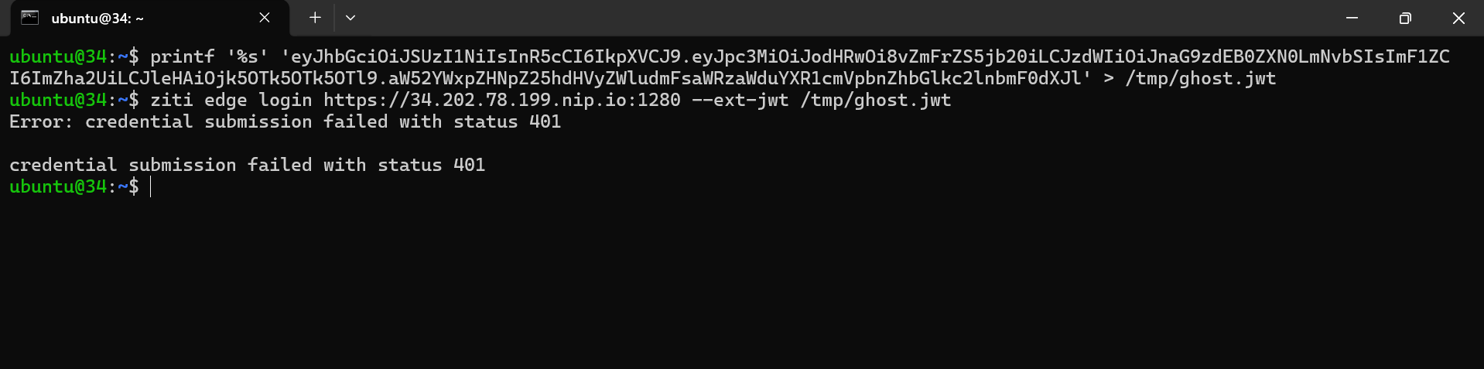
Result: 'Error: credential submission failed with status 401'. The ziti CLI rejected the token — no session created, no access granted. The defense holds through the legitimate client tool.

Why This Was Blocked (Simple Explanation)
Imagine a bank vault with multiple entrances — main door, side door, employee entrance. All three have the same identity checker. Whether an attacker tries the front door or the employee entrance, the check happens at the same place — inside the vault, not at the door itself.
Technically: OpenZiti's ziti CLI is a wrapper that sends HTTPS requests to the same authentication endpoints as the raw API. Signature verification happens at the server, not the client. An attacker cannot bypass authentication by switching tools because the defense is server-side.

What This Proves
The defense doesn't depend on the client behaving correctly. This is a fundamental principle of secure design — never trust the client. Signature verification is enforced on the server regardless of which tool made the request.

Attack: Tunnel Traffic Capture
STRIDE Category: Tampering / Information Disclosure

What This Attack Tests
If an attacker sits on the controller VM (which brokers the OpenZiti tunnel), can they capture and read the traffic flowing between clients and the protected service? If yes, mTLS is not providing real confidentiality. The point of end-to-end encryption is that not even a trusted intermediary can read the content.

Attacker Position
Insider — running on the controller VM with root access. This is a worst-case scenario: the attacker has completely compromised the machine that brokers all tunnel connections.

Steps Performed
Step 1: Start packet capture in background
sudo tcpdump -i any -n -X -s0 'port 443 or port 80 or port 6262 or port 3022' -w /tmp/tunnel.pcap &
Capture all traffic on the ports OpenZiti uses. The -X flag shows hex + ASCII of the payload — if anything readable exists, we'll see it.
Step 2: Generate legitimate traffic through the tunnel
curl http://nginx-service.ziti
Make legitimate requests through the OpenZiti tunnel. This should be visible on the wire even if the content is encrypted.
Step 3: Read the captured packets
sudo tcpdump -r /tmp/tunnel.pcap -X | head -60
Read the capture file back and inspect what was recorded. Look for readable HTTP request lines, HTML content, or anything that reveals what was transmitted.

Expected Result
Traffic exists in the capture (packets flowed), but the payload should be completely encrypted — no readable HTTP headers, no HTML content, only protocol metadata.

Actual Result
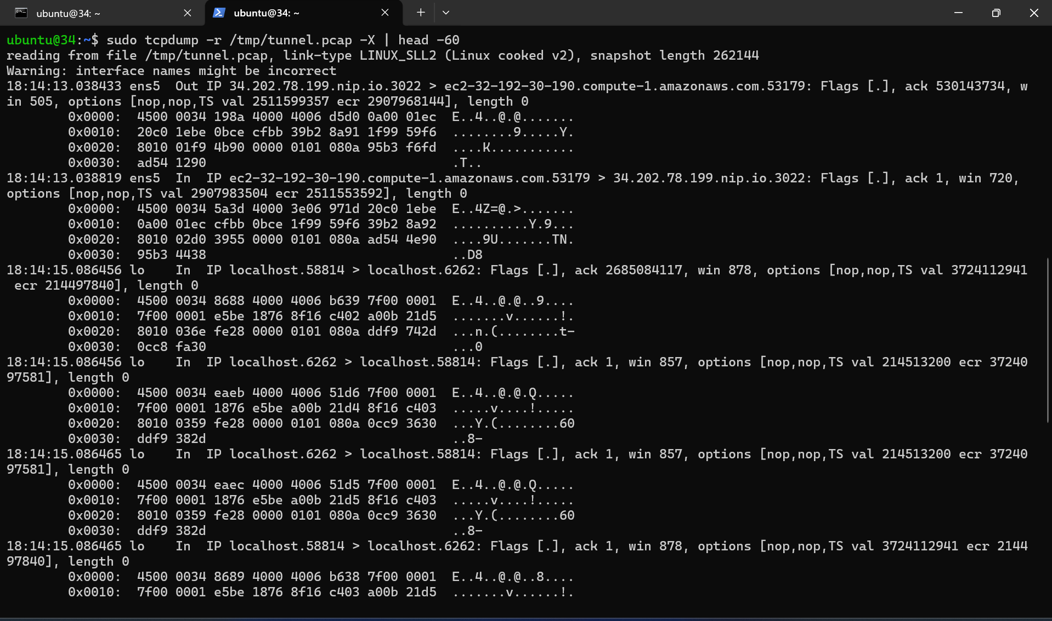
Result: The capture contains only TCP protocol metadata (flags, sequence numbers, timestamps) and encrypted payload bytes. No readable HTTP requests. No 'Zero Trust Protected Service' HTML content anywhere. The tunnel traffic is completely unreadable.

What The Screenshot Shows
• Protocol metadata visible: source IP, destination IP, TCP flags, ports
• Payload bytes: hex like '4500 0034 198a 4000...' — pure binary
• ASCII column on the right shows only protocol control characters
• Nowhere in the capture appears any HTTP text or HTML content

Why This Was Blocked (Simple Explanation)
Imagine standing next to a security guard carrying sealed envelopes between offices. You can see him walking, note who he talks to, watch him hand over envelopes. But you cannot read what's inside the envelopes — they're sealed with unbreakable encryption. That's what tcpdump on the controller shows: traffic exists, but the contents are unreadable.
Technically: mTLS creates an encrypted tunnel using cryptographic keys negotiated during the TLS handshake. Once the tunnel is established, all application-layer data is encrypted before hitting the network stack. tcpdump captures at the network layer, so it sees only the encrypted output — not the plaintext that went into the tunnel.

What Unencrypted HTTP Would Look Like
For comparison, without mTLS, tcpdump would show readable text like:
GET / HTTP/1.1
Host: nginx-service.ziti
User-Agent: curl/7.81.0

HTTP/1.1 200 OK
<html><body><h1>Zero Trust Protected Service</h1>...
Anyone with tcpdump access could read every request and response. With mTLS in place, that entire information channel is closed.

What This Proves
mTLS provides real confidentiality. Even an insider with root access to a trusted VM cannot read traffic flowing through the tunnel. This is exactly what enterprises pay Zscaler and Cloudflare for — the same guarantee provided by open-source tools.

Attack: JWT Claims Modification
STRIDE Category: Tampering

What This Attack Tests
Can an attacker take a JWT structure, modify the payload claims (change email/subject to impersonate another user), and have OpenZiti accept it? If yes, any valid token could be stolen and manipulated to become a different identity.

Attacker Position
Insider — running on the controller VM. The attacker has crafted a token with claims that would make them appear to be a specific target user.

Steps Performed
Step 1: Craft a JWT with tampered claims
cat > /tmp/tampered_jwt.py << 'EOF'
import base64, json
header = base64.urlsafe_b64encode(json.dumps({
'alg': 'RS256', 'typ': 'JWT'
}).encode()).decode().rstrip('=')
payload = base64.urlsafe_b64encode(json.dumps({
'iss': 'http://54.161.158.63:9000/application/o/open-ziti/',
'sub': 'attacker@evil.com',
'email': 'attacker@evil.com',
'exp': 9999999999
}).encode()).decode().rstrip('=')
signature = 'attacker_does_not_have_authentik_private_key'
print(f'{header}.{payload}.{signature}')
EOF
The script builds a token with a correct-looking header and a payload that impersonates a target identity. The signature is fake — the attacker does not have Authentik's private key.
Step 2: Submit the tampered token
python3 /tmp/tampered_jwt.py > /tmp/tampered.jwt
ziti edge login https://34.202.78.199.nip.io:1280 --ext-jwt /tmp/tampered.jwt

Expected Result
OpenZiti should reject the token because the signature does not match what Authentik's public key would produce for the tampered payload. Wazuh should also detect the attempt via custom rule 100200.

Actual Result
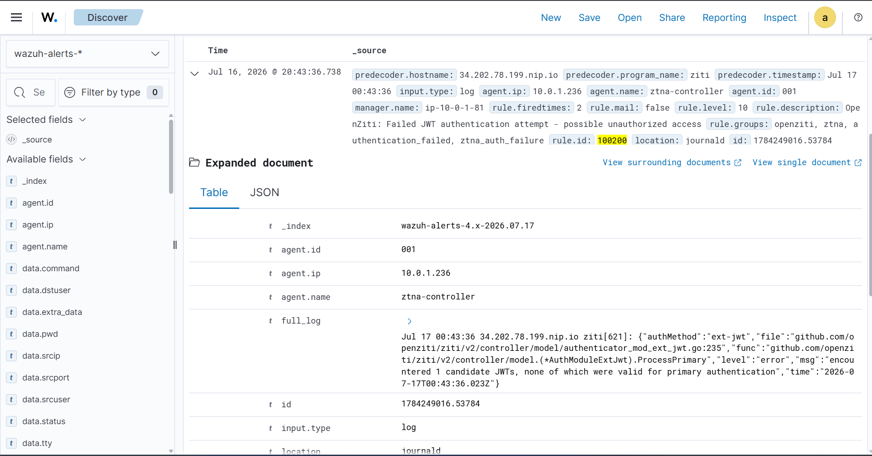
Result: The tampered JWT was rejected AND Wazuh caught the attempt. Custom rule 100200 fired with severity level 10, agent ztna-controller, rule.description 'OpenZiti: Failed JWT authentication attempt - possible unauthorized access'. Rule groups: openziti, ztna, authentication_failed, ztna_auth_failure. rule.firedtimes: 2 confirms multiple attempts were detected.

Why This Was Blocked (Simple Explanation)
A JWT is like a signed contract. The signature is unique to both the content and the signer. If someone changes even one word in the contract, the signature no longer matches. It's like a wax seal on a royal letter — cut out a word, reseal it, and the new seal will not look like the original king's stamp.
Technically: JWT signatures are cryptographic hashes computed over the header AND payload. When the payload was tampered with, the signature no longer corresponded to what Authentik's private key would have produced. OpenZiti verified the signature using Authentik's public key (fetched from the JWKS endpoint), found it did not match, and rejected the token.

Why Wazuh Detection Matters
Blocking the attack is defense in the moment. Detection is knowing an attack happened. Rule 100200 — which I wrote as part of the SIEM configuration — fires every time OpenZiti rejects a JWT. That means the security team has visibility into every attempted attack, not just successful ones. In a real environment, this alert would trigger investigation of the source IP.

What This Proves
JWT integrity is cryptographically guaranteed. An attacker cannot modify claims to impersonate another user — the signature will always break. And every attempt is captured and alerted through the SIEM with full attribution.

Attack: Web Content Tampering (FIM Detection)
STRIDE Category: Tampering

What This Attack Tests
If an attacker gets access to the service VM (worst case scenario), can they modify the nginx web content without detection? File Integrity Monitoring is supposed to catch this — the test verifies whether the SIEM actually notices file changes in real time.

Attacker Position
Insider — running on the service VM with root access. This simulates a total host compromise where the attacker wants to deface the website, plant malicious content, or modify configuration files.

Steps Performed
Step 1: Modify the protected web content
echo 'test attacker content' | sudo tee -a /var/www/html/index.html
Append attacker-controlled content to the nginx index page. In a real attack this would be defacement, credential-stealing JavaScript, or a webshell.
Step 2: Wait for Wazuh FIM to detect
Wazuh's syscheck module is configured in realtime mode. Detection should happen within seconds.
Step 3: Verify in Wazuh dashboard
Search: rule.groups:syscheck AND agent.name:ztna-service
Look for File Integrity alerts on the service agent for the modified file.

Expected Result
Wazuh should detect the file modification within seconds and capture: the file path, the type of change, and before/after cryptographic hashes for forensic evidence.

Actual Result
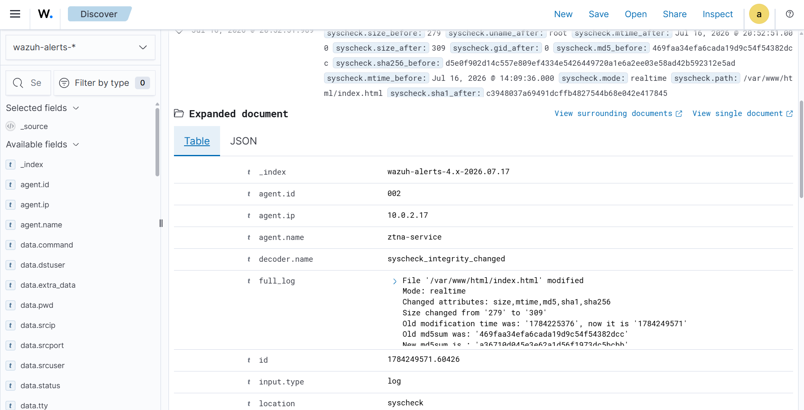
Result: Wazuh FIM detected the tampering in real time. Decoder: syscheck_integrity_changed. full_log: 'File /var/www/html/index.html modified. Mode: realtime. Changed attributes: size, mtime, md5, sha1, sha256. Size changed from 279 to 309.' Both old and new MD5 hashes captured for forensic evidence.

What FIM Captured
• The exact file path: /var/www/html/index.html
• Detection mode: realtime — within seconds of the change
• Which attributes changed: file size, modification time, MD5, SHA1, SHA256
• Old size: 279 bytes | New size: 309 bytes (proves content was added)
• Old MD5 hash: 469faa34efa6cada19d9c54f54382dcc
• New MD5 hash: a36710d045e3e62a1d56f1973dc5bcbb
• Timestamps preserved for forensic comparison

Why This Detection Matters (Simple Explanation)
Imagine keeping a locked diary. Every night before bed you count the pages and check the ink color. If anyone secretly writes in the diary, you notice the next morning because the page count changed or the ink is fresh. FIM works the same way — it takes a cryptographic 'fingerprint' of every important file, and if that fingerprint changes, you know instantly.
Technically: Wazuh's syscheck module maintains cryptographic hashes (MD5, SHA1, SHA256) of monitored files. When a file changes, the agent recalculates the hash and compares it to the baseline. Any mismatch triggers an alert with before/after values — perfect evidence for incident response.

What This Proves
File tampering cannot happen silently. Even if an attacker gets root access to the service VM (a total compromise scenario), any change to protected files is detected within seconds and preserved as forensic evidence with cryptographic proof of what changed.

Attack: Dark Network Reconnaissance
STRIDE Category: Information Disclosure

What This Attack Tests
The most fundamental test of the dark network principle. From an insider position, can I discover the protected nginx service by port scanning? If nmap finds port 80 open, the service isn't truly hidden — it's just protected by a firewall. A real zero trust architecture makes services invisible, not just inaccessible.

Attacker Position
Insider — running on the controller VM. This simulates the reconnaissance an attacker would do after gaining SSH access to any VM in the network. If they can find services here, they can plan follow-on attacks.

Steps Performed
Step 1: Scan the service VM
nmap -Pn 10.0.2.17
The -Pn flag skips ping (since ICMP might be blocked) and goes straight to port scanning. This is standard reconnaissance for an attacker inside a network.

Expected Result
If the dark network principle works, nmap should find the host is up (proving it exists) but see only SSH open. nginx on port 80 should be completely invisible — not filtered, not closed, not blocked. Just invisible.

Actual Result
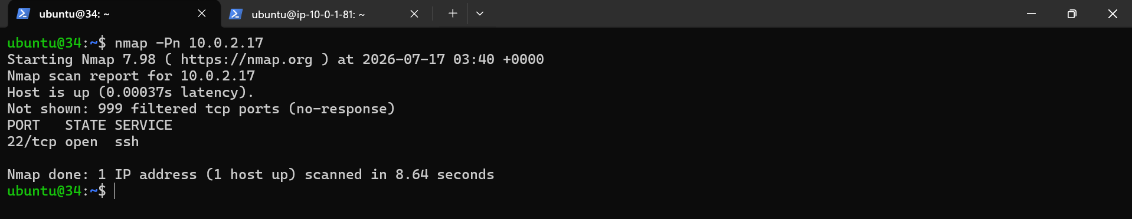
Result: The dark network principle proven. Nmap scan shows 999 filtered TCP ports (no response) and only port 22 (SSH) open. The nginx web service is completely invisible to an insider attacker with SSH access to the controller VM.

What The Scan Reveals
• Host is up (0.00037s latency) — the VM exists
• 999 filtered TCP ports (no-response) — no service replies
• Only 22/tcp (SSH) visible in the scan
• Port 80 (HTTP/nginx): INVISIBLE
• Scan duration: 8.64 seconds — thorough, not just a quick probe

Why This Was Blocked (Simple Explanation)
Imagine a house that's completely invisible from the street. Not just locked — invisible. You can't see it, you can't find its address, you don't even know it's there. That's what my zero trust architecture does to nginx. From an attacker's perspective, the service simply does not exist.
Three layers work together:
• Layer 1 — No public IP: The service VM is in a private subnet with no direct internet address
• Layer 2 — Security groups: AWS firewall blocks all inbound traffic except SSH from the controller subnet
• Layer 3 — Dark network: nginx listens only on localhost. The OpenZiti tunneler brokers connections from the ZTNA fabric — no external listener means nothing for scanners to find

Why This Is The Strongest Proof
Traditional firewalls have a rule: 'block traffic to port 80.' Attackers can still see something is being blocked — the firewall responds with reset packets or drops packets in a distinctive way. Dark networks have no rule to block because there is nothing to block — the service isn't listening, it isn't advertised, it doesn't exist as far as the network is concerned.
This is the strongest visual proof of zero trust in the entire project. One nmap scan shows an insider attacker with SSH access to a trusted VM cannot find the protected service. That is the difference between traditional security (block traffic) and zero trust (make services invisible).

What This Proves
The dark network principle works. The protected service is invisible to attackers who have already breached one layer of defense. This is the core promise of zero trust: even if you're inside, you can't reach what you're not authorized to see.

Results Summary

Attacks Executed
• Attack: CLI Forged JWT Authentication (Spoofing) — Blocked with 401
• Attack: Tunnel Traffic Capture (Tampering / Info Disclosure) — All traffic encrypted, no data leaked
• Attack: JWT Claims Modification (Tampering) — Blocked + Wazuh detected
• Attack: Web Content Tampering (Tampering) — FIM detected instantly with forensic hashes
• Attack: Dark Network Reconnaissance (Information Disclosure) — Service invisible to insider scan

What Each Attack Proved
• CLI Forged JWT: Server-side defense holds regardless of the client tool used
• Tunnel Traffic Capture: mTLS provides real confidentiality even against root-level insider
• JWT Claims Modification: Cryptographic signatures make tampering mathematically impossible
• Web Content Tampering: File tampering cannot happen silently — FIM catches everything with cryptographic proof
• Dark Network Reconnaissance: Protected services are invisible, not just blocked

STRIDE Categories Validated
• Spoofing — Validated by CLI Forged JWT attack
• Tampering — Validated by Tunnel Traffic Capture, JWT Claims Modification, and Web Content Tampering
• Information Disclosure — Validated by Tunnel Traffic Capture and Dark Network Reconnaissance
Three of the six STRIDE categories were tested with these five attacks. The remaining categories (Repudiation, Denial of Service, Elevation of Privilege) are documented in the threat model as future testing targets.

Interview Talking Points

How I validated my zero trust design
I built a STRIDE threat model to categorize every possible threat, then executed targeted attacks against each category. For Spoofing, I forged JWTs and submitted them through the official CLI. For Tampering, I captured tunnel traffic and modified JWT claims. For Information Disclosure, I ran nmap from an insider position. All attacks were blocked by the architecture, and where applicable, detected by Wazuh with full attribution.

The most powerful single proof
The nmap scan showing 999 filtered ports and only SSH visible. In one screenshot, it demonstrates that an insider attacker with SSH access to a trusted VM cannot find the protected service. The web service does not just refuse connections — it's invisible. That's the dark network principle in action.

Why SIEM detection matters as much as blocking
Blocking is defense in the moment. Detection is knowing an attack happened. Custom rule 100200 caught the JWT tampering attempt with severity 10 and full attribution. In a real environment, this would trigger investigation of the source IP. Without SIEM, blocked attacks would go unnoticed and the security team would have no visibility into who is trying to break in.

What surprised me most
How much of security is server-side. Every attack I ran assumed the client was cooperating — using the official CLI, sending well-formed requests. It didn't matter. The defense happens at the server, in the cryptographic verification of signatures and certificates. This is why zero trust works even when the client is fully compromised.

STRIDE + Attack Validation | Rahul Rajkumar Kori | github.com/Rahul7259/zero-trust-network-lab

