Flask Student Registration System — CI/CD Pipeline
A fully automated CI/CD pipeline using GitHub Actions that tests, builds, containerizes, and deploys a Python Flask + MongoDB application to AWS EC2, with email notifications on success or failure.

Architecture
Developer Push → GitHub Actions Trigger
│
├── 1. Checkout code
├── 2. Install dependencies (pip install)
├── 3. Run pytest (stops pipeline if tests fail)
├── 4. Build Docker image (tagged with commit SHA)
├── 5. Push image to Amazon ECR
├── 6. Deploy to EC2 via SSH (stop old → run new container)
├── 7. Verify /health endpoint (5 retries)
└── 8. Send email notification (success or failure)

Tech Stack
Component | Technology
Application | Python Flask
Database | MongoDB Atlas
Containerization | Docker
Container Registry | Amazon ECR
Compute Target | AWS EC2 (Ubuntu)
CI/CD Tool | GitHub Actions
Notifications | Gmail SMTP

Phase 1 — Local Setup

Step 1 — Fork & Clone the Repository
Fork and clone the flask_Practice repo from github.com/mohanDevOps-arch/flask_Practice.
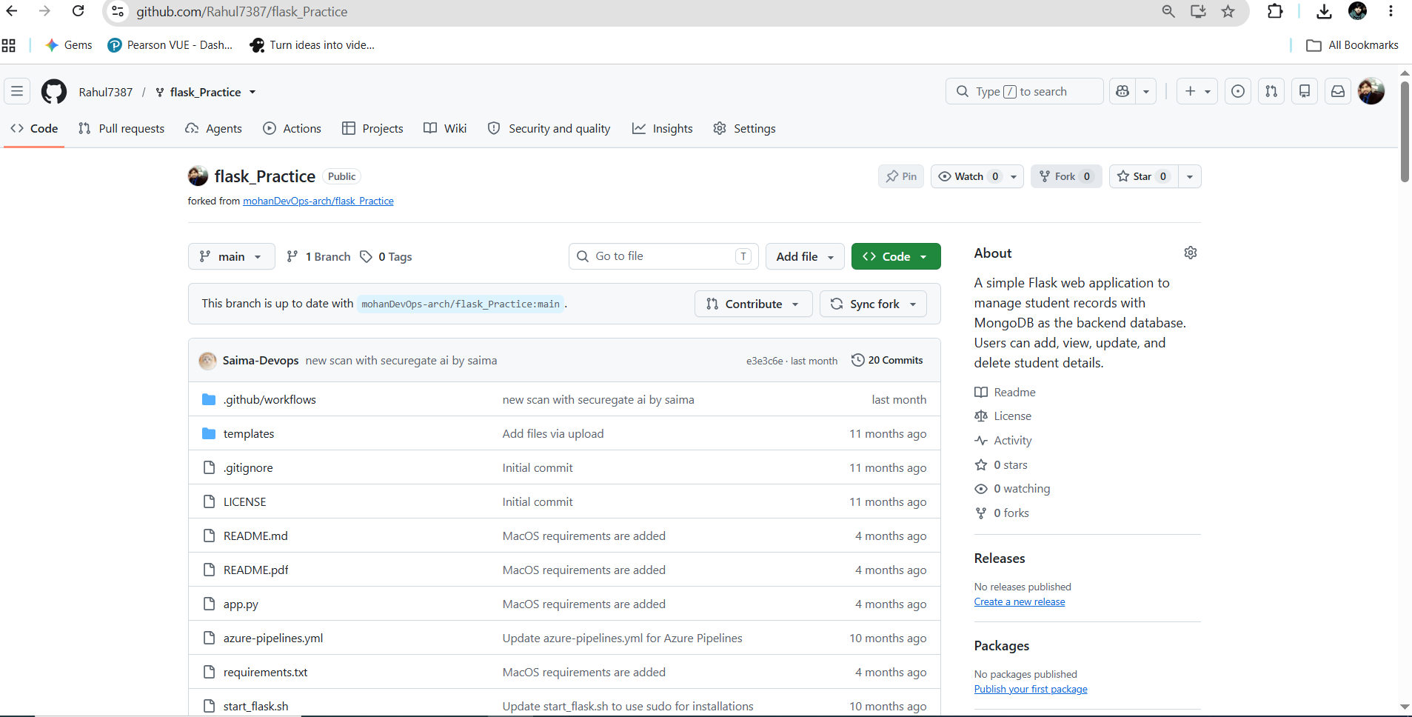
Forked GitHub repository
Verify the clone with git remote -v and ls:
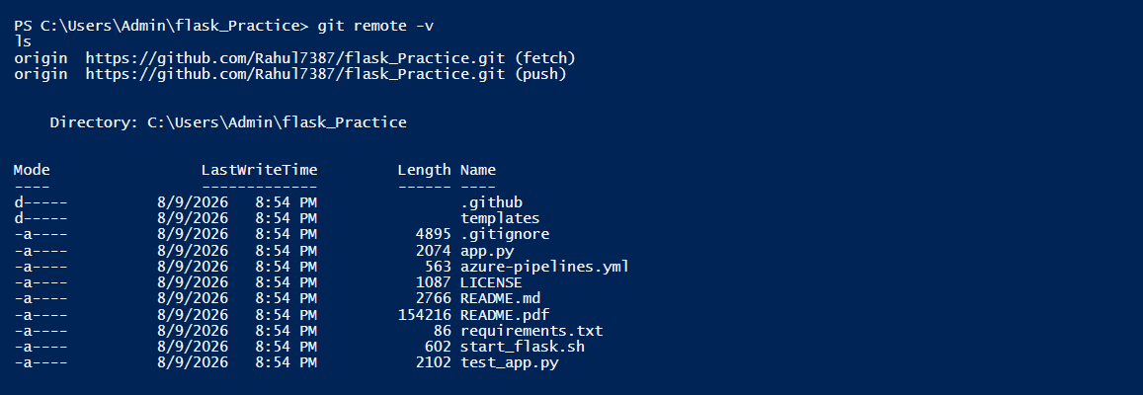
Local clone verification

Step 2 — Review Existing Code
Examine the existing app.py to understand the application structure:
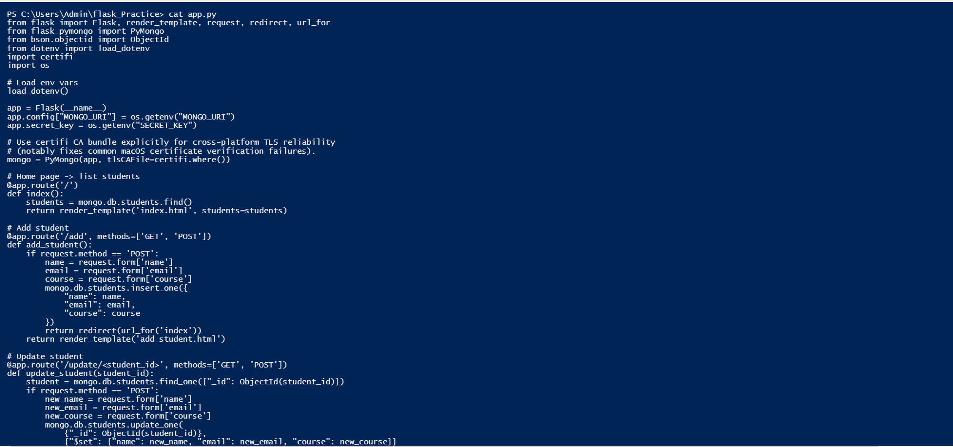
app.py source code
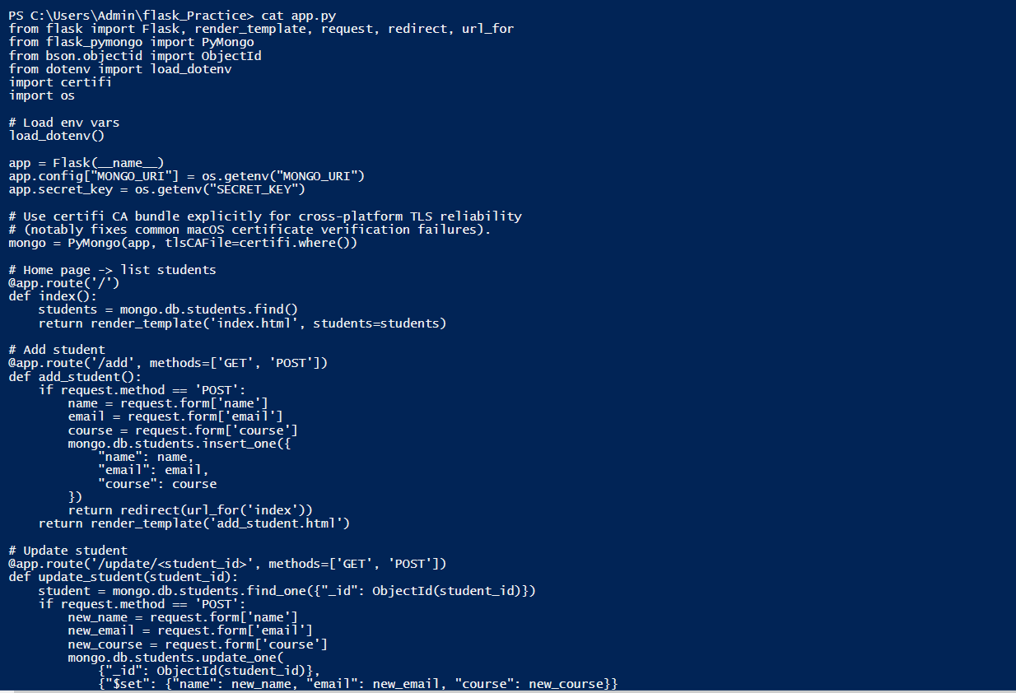
app.py continued
Review test_app.py and requirements.txt:
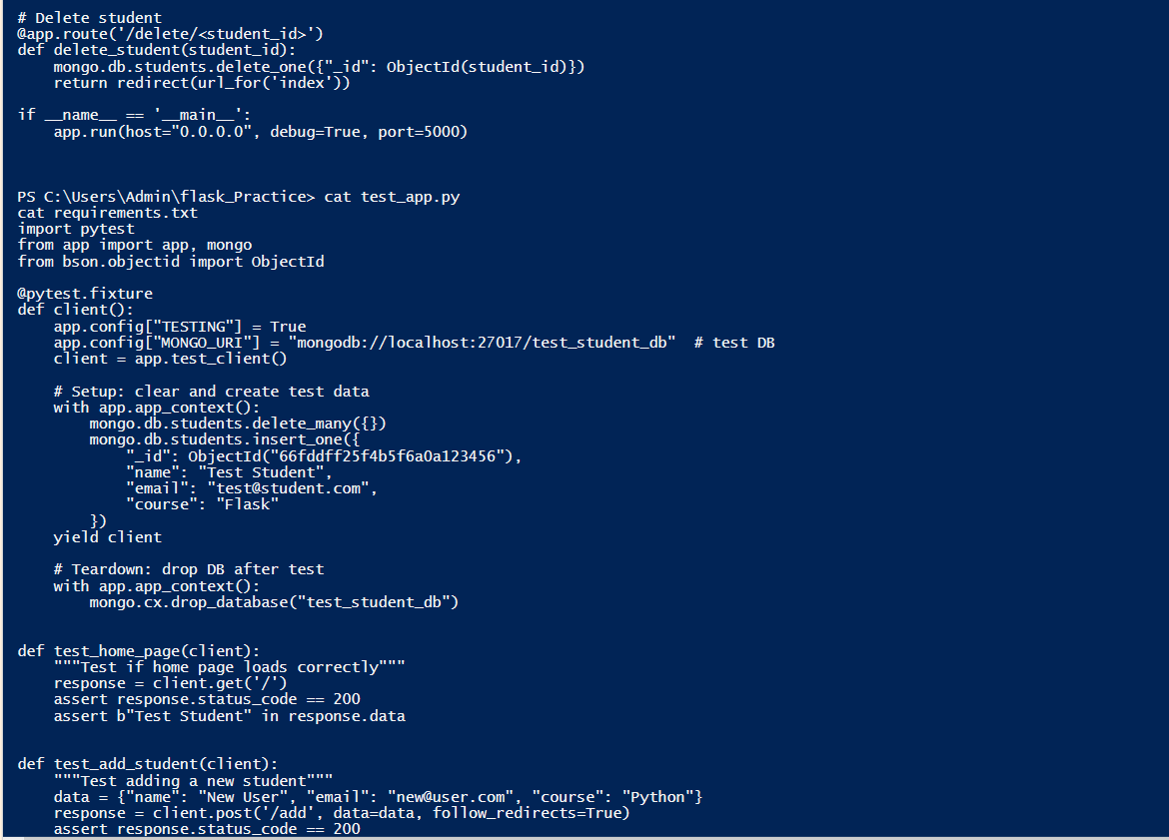
test_app.py source code
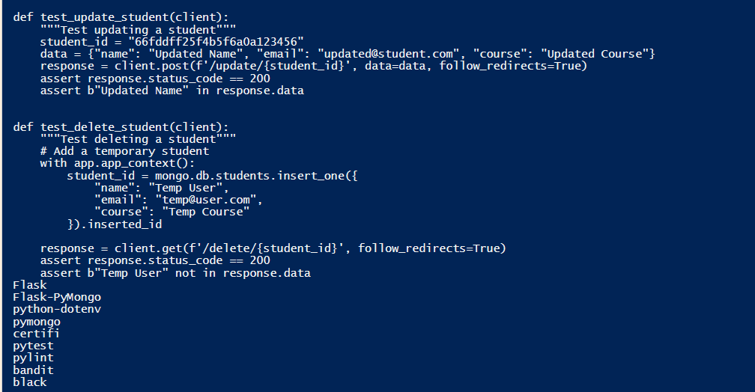
test_app.py continued and requirements.txt

Step 3 — Add the /health Route
Add the health check endpoint to app.py just before the if __name__ == '__main__': line:
@app.route('/health')
def health():
try:
mongo.db.command('ping')
return {"status": "healthy", "database": "connected"}, 200
except Exception as e:
return {"status": "unhealthy", "error": str(e)}, 500

Step 4 — Create the Dockerfile
Create a Dockerfile in the project root:
FROM python:3.11-slim
WORKDIR /app
COPY requirements.txt .
RUN pip install --no-cache-dir -r requirements.txt
COPY . .
EXPOSE 5000
CMD ["python", "app.py"]
Also create a .dockerignore to keep the image clean:
__pycache__
*.pyc
.env
.git
.github
*.pem
*.pdf
venv
.pytest_cache
Issue encountered: Windows Notepad saved the file as Dockerfile.txt instead of Dockerfile, causing a "file not found" error:
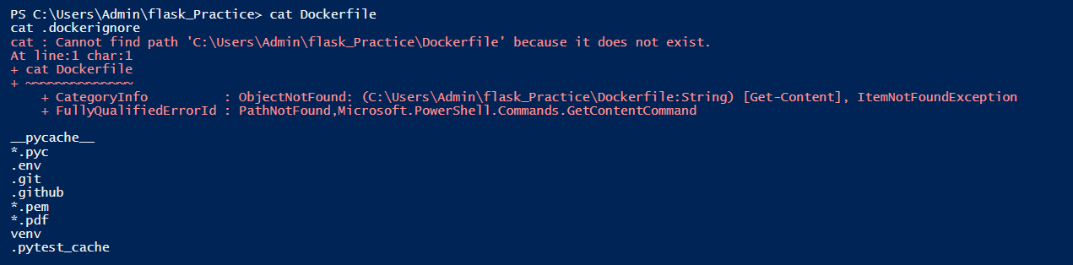
Dockerfile not found error
Fix: Rename the file:
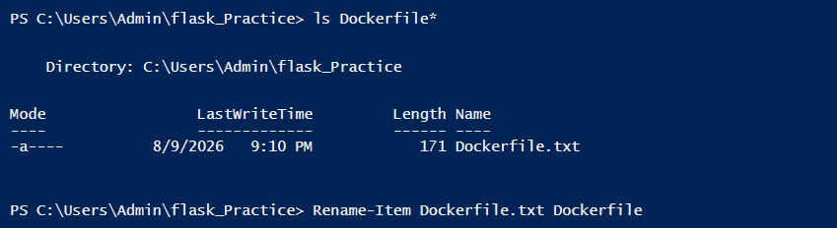
Dockerfile rename fix

Step 5 — Create .env.example
Create a template showing required environment variables (without actual values):
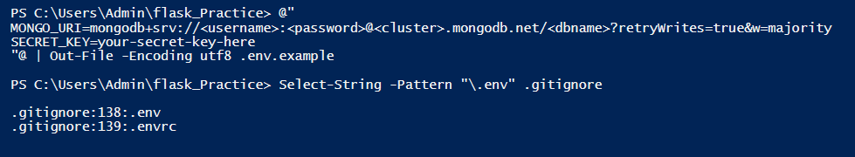
Creating .env.example
Verify the file contents:
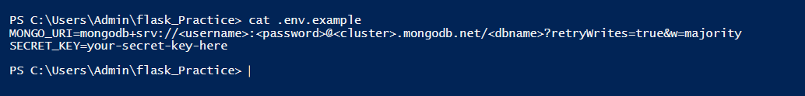
.env.example verification

Step 6 — Update test_app.py
Add a test for the /health route at the bottom of test_app.py:
def test_health_check(client):
"""Test if health endpoint responds"""
response = client.get('/health')
assert response.status_code in [200, 500]

Phase 2 — AWS Setup

Step 7 — Create an ECR Repository
Navigate to AWS Console → Elastic Container Registry:
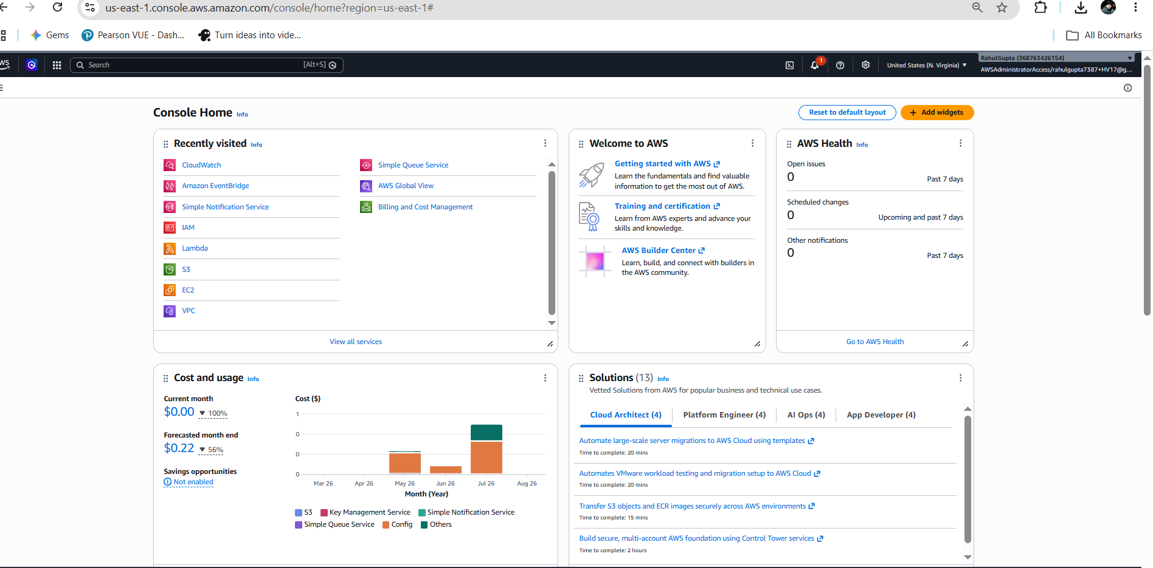
AWS Console Home
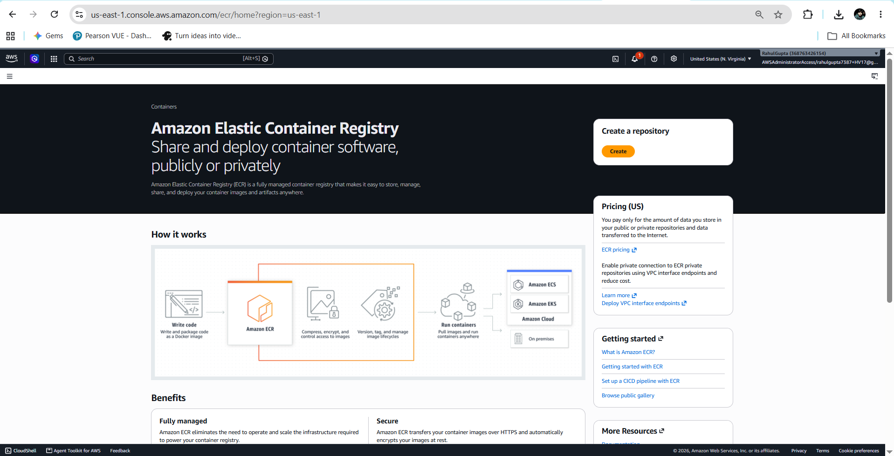
ECR landing page
Create a private repository named flask-practice:
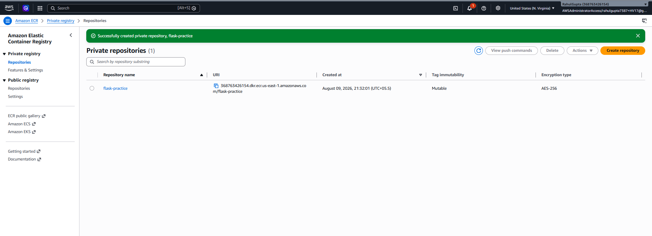
ECR repository created successfully
Repository URI: 368763426154.dkr.ecr.us-east-1.amazonaws.com/flask-practice

Step 8 — Launch an EC2 Instance
Navigate to AWS Console → EC2 → Launch instance:
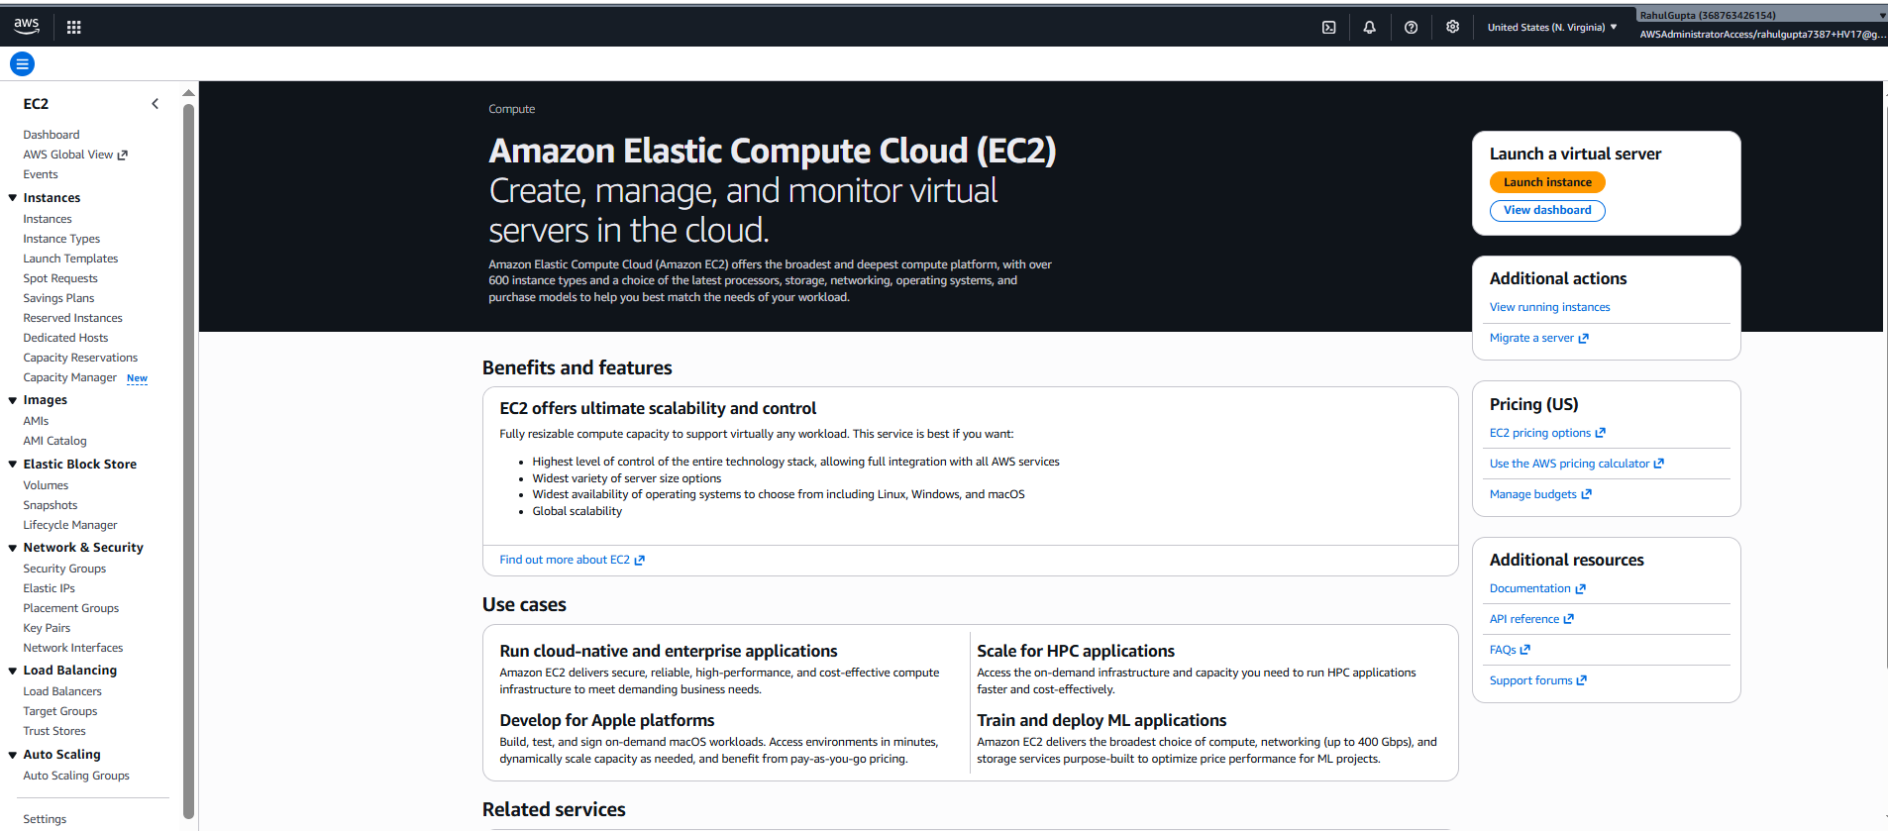
EC2 landing page
Settings:
- Name: flask-cicd-server
- AMI: Ubuntu 24.04 LTS
- Instance type: t2.micro (free tier)
- Key pair: flask-cicd-key (download .pem file)
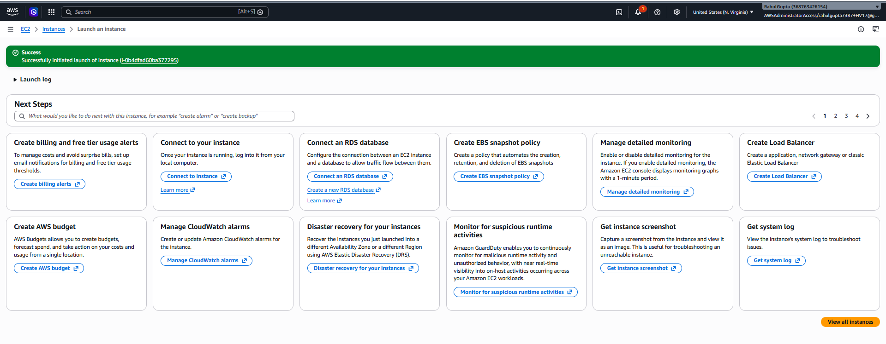
EC2 instance launched successfully

Step 9 — Attach IAM Role to EC2
Create an IAM role for EC2 to pull images from ECR:
- Trusted entity: AWS service → EC2
- Policy: AmazonEC2ContainerRegistryReadOnly
- Role name: EC2-ECR-Pull-Role
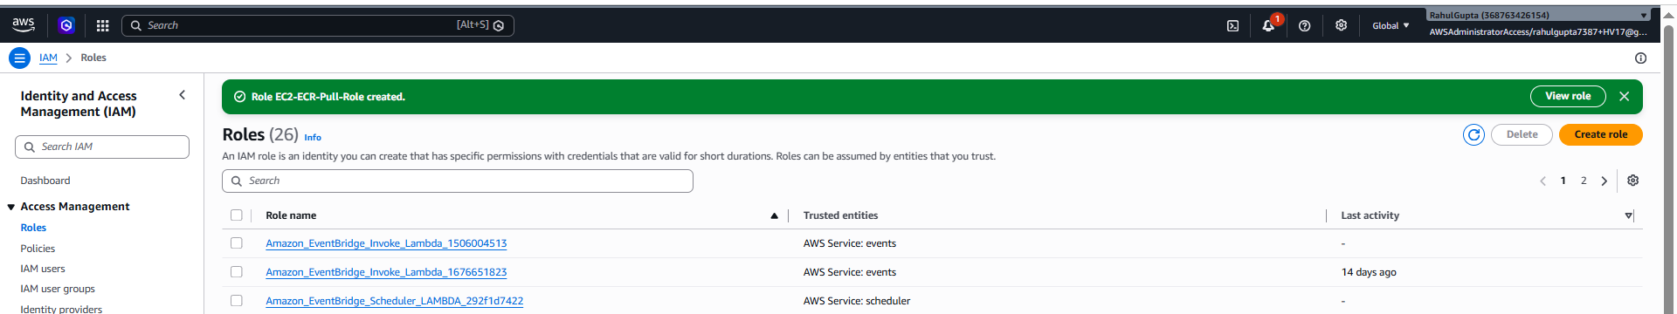
IAM Role EC2-ECR-Pull-Role created
Go to EC2 → select the instance → Actions → Security → Modify IAM role:
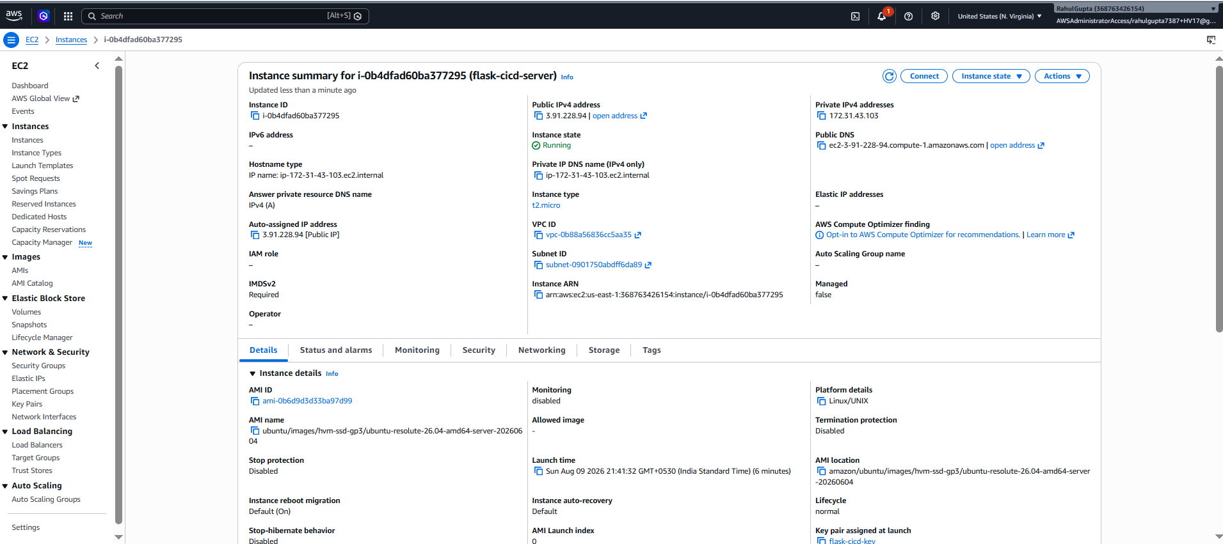
EC2 instance summary
Select EC2-ECR-Pull-Role and click Update IAM role:
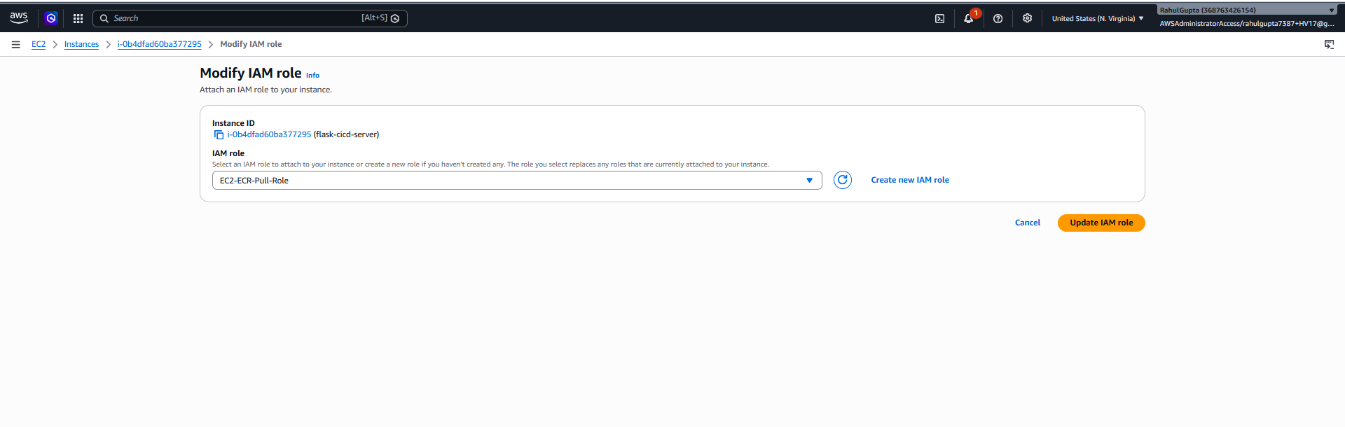
Modify IAM role — selecting EC2-ECR-Pull-Role
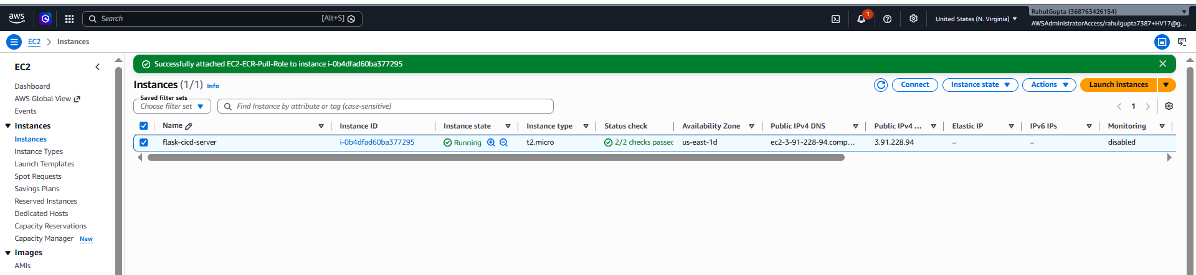
EC2-ECR-Pull-Role successfully attached

Step 10 — Configure Security Group
Add inbound rules for SSH and Flask app access:
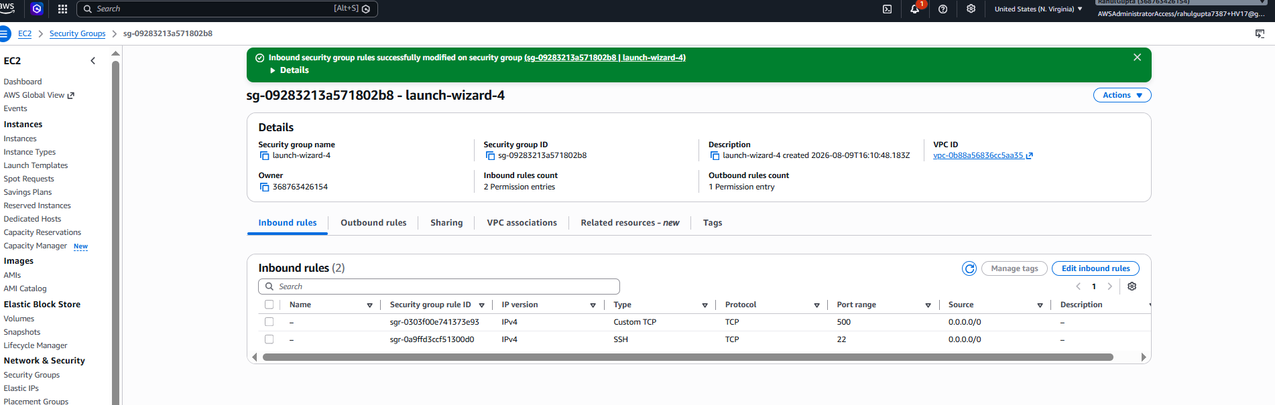
Security Group inbound rules (port 22 + port 5000)
Type | Port | Source | Purpose
SSH | 22 | 0.0.0.0/0 | Pipeline SSH deployment access
Custom TCP | 5000 | 0.0.0.0/0 | Flask app and health checks

Step 11 — Install Docker & AWS CLI on EC2
SSH into the instance and install prerequisites:
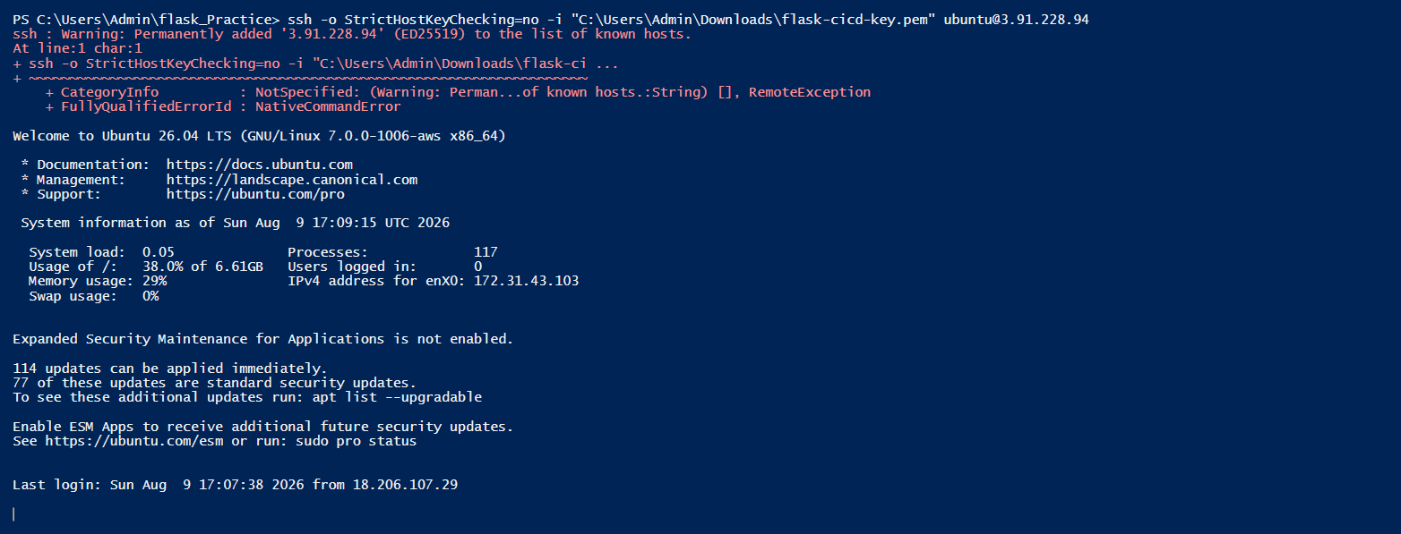
SSH into EC2 instance
Install Docker and AWS CLI, then verify:
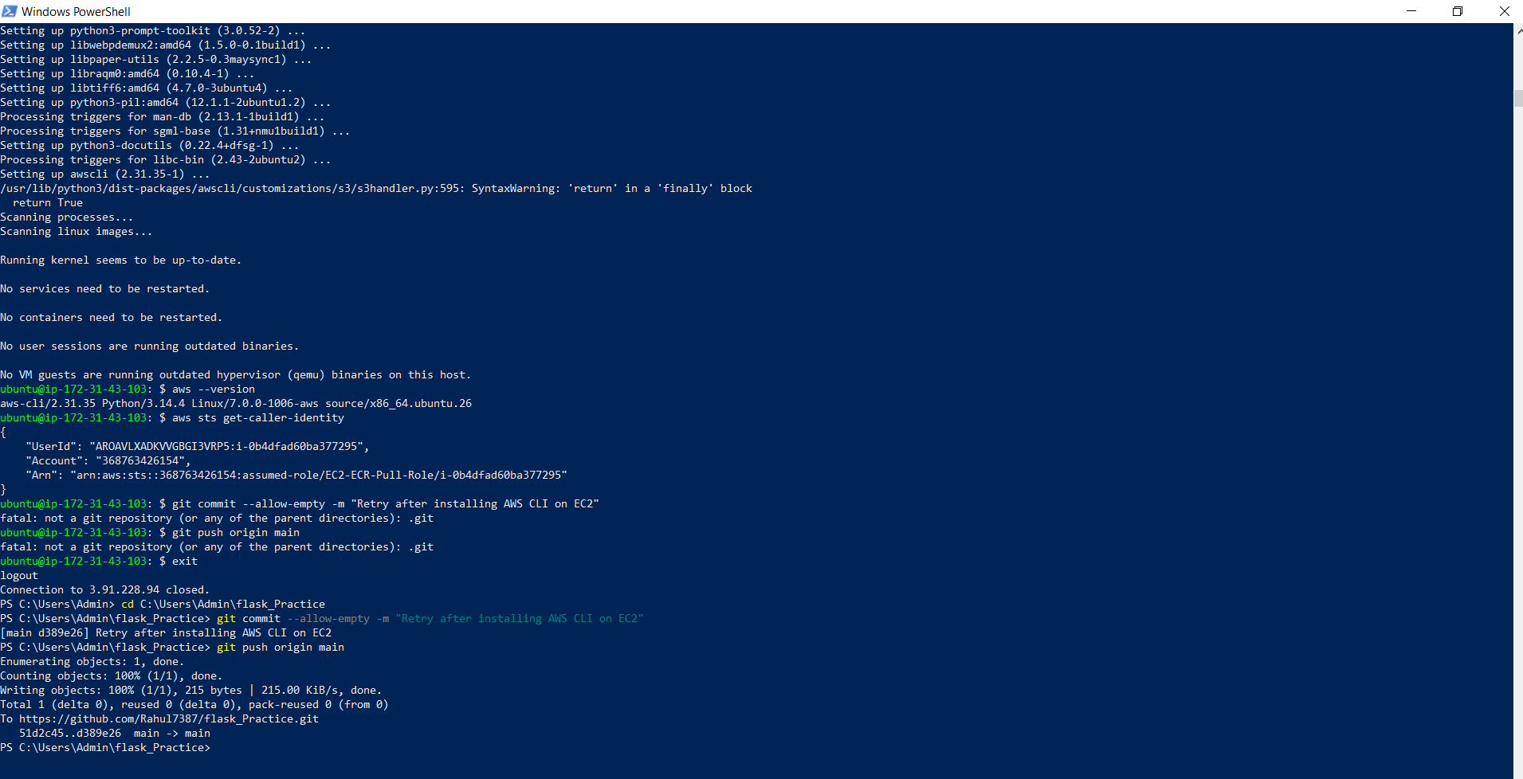
AWS CLI install and verification on EC2
sudo apt update && sudo apt install -y docker.io awscli
sudo systemctl enable docker && sudo systemctl start docker
sudo usermod -aG docker ubuntu

Phase 3 — GitHub Actions Pipeline

Step 12 — Configure Repository Secrets
Go to GitHub repo → Settings → Secrets and variables → Actions → New repository secret:
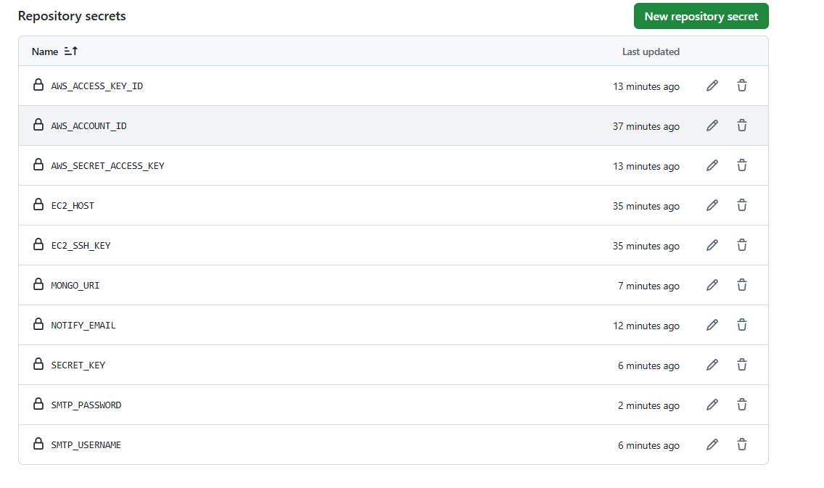
GitHub repository secrets configured
Secret Name | Description
AWS_ACCOUNT_ID | 12-digit AWS account number (no dashes)
AWS_ACCESS_KEY_ID | IAM user access key
AWS_SECRET_ACCESS_KEY | IAM user secret key
EC2_HOST | EC2 instance public IPv4 address
EC2_SSH_KEY | Full content of the .pem private key file
MONGO_URI | MongoDB Atlas connection string
SECRET_KEY | Any random string for Flask sessions
SMTP_USERNAME | Gmail address used to send notifications
SMTP_PASSWORD | Gmail App Password (16 characters, no spaces)
NOTIFY_EMAIL | Email address to receive pipeline notifications

Step 13 — Commit and Push
Review changes with git status:
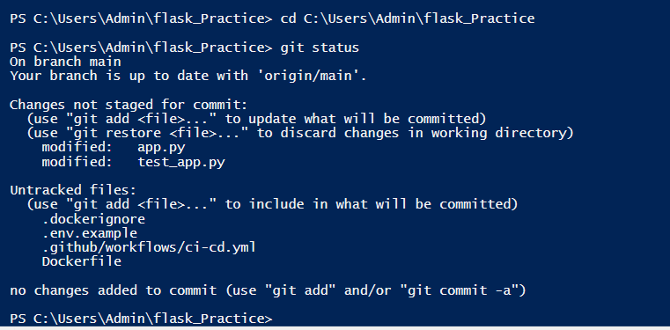
git status showing modified and untracked files
Stage, commit, and push:
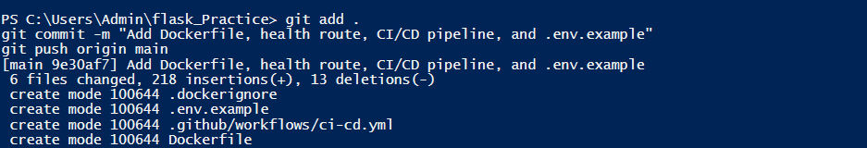
git add, commit, and push

Phase 4 — Pipeline Results

GitHub Actions Workflow Runs
After pushing, the pipeline triggers automatically. The Actions tab shows all workflow runs including the troubleshooting iterations:
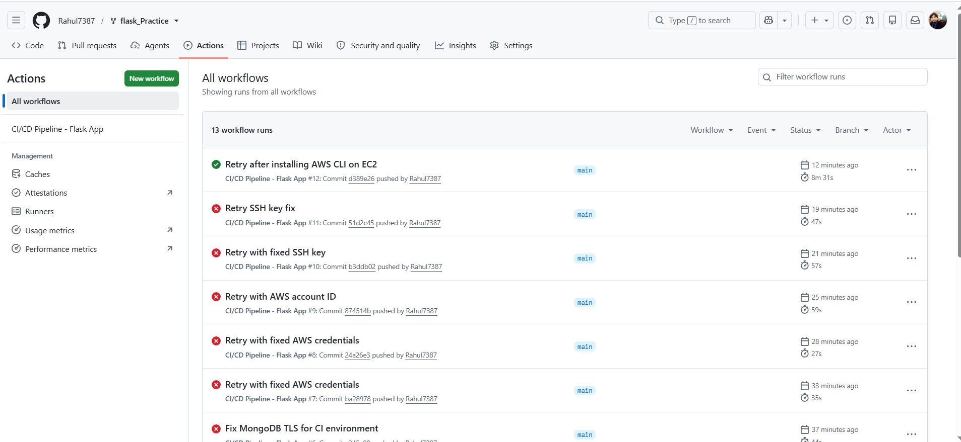
GitHub Actions workflow runs

Health Check Verification
The deployed application responds with a healthy status at the /health endpoint:
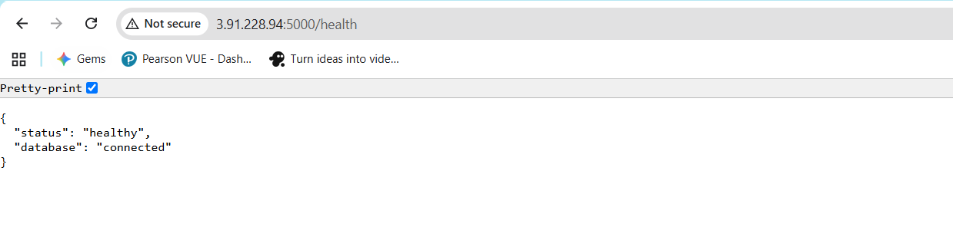
Health check endpoint — healthy response in browser

Email Notifications
Failure notification (custom SMTP via Gmail):
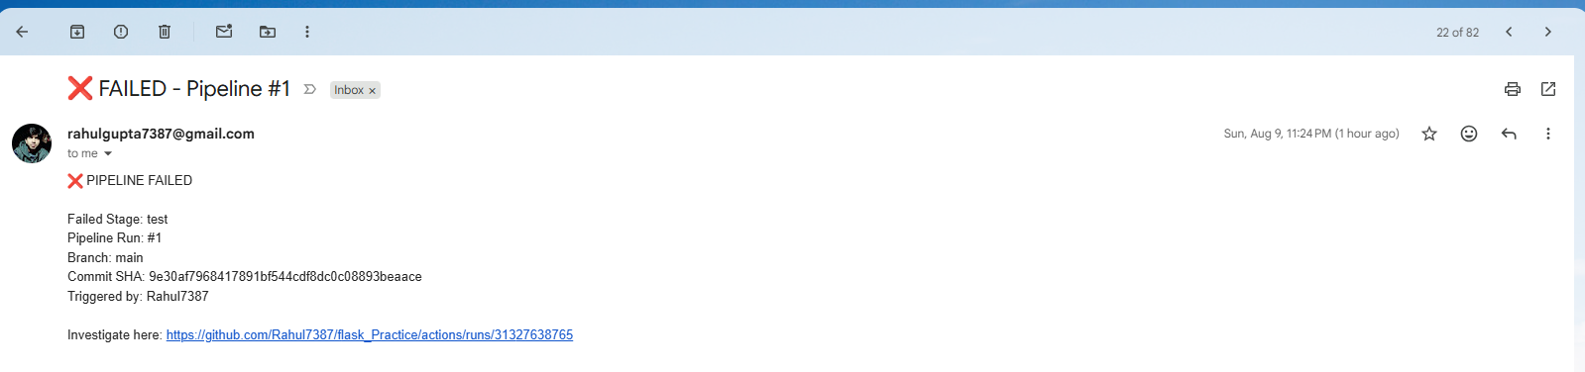
Pipeline failure email notification
GitHub notification for failed workflow run:
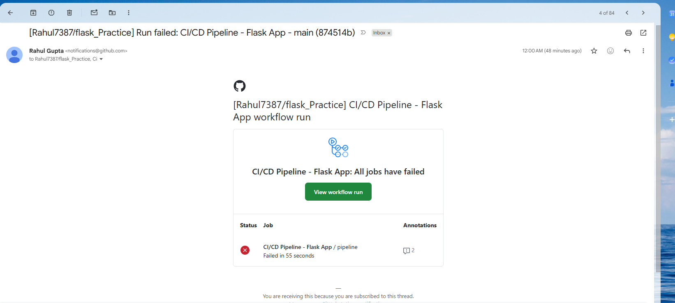
GitHub workflow failure notification email
Success notification after all stages pass:
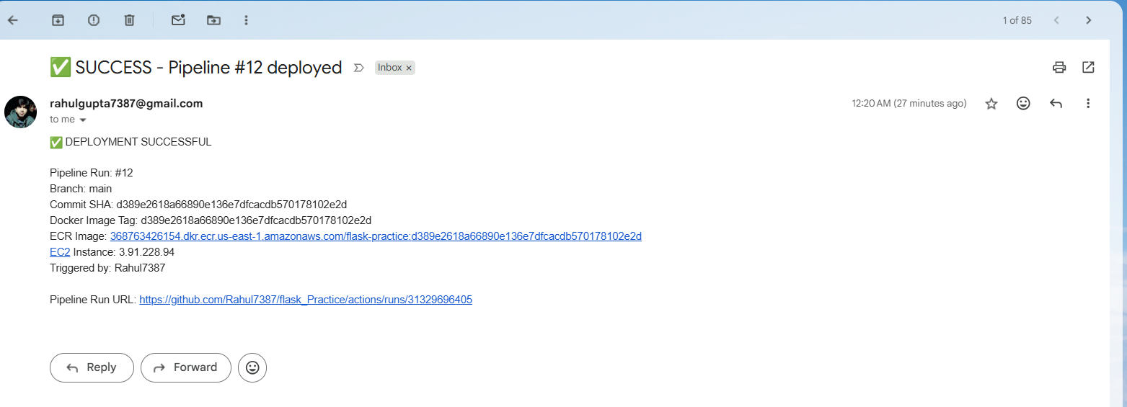
Pipeline success deployment email

Errors Encountered & Fixes
# | Error | Root Cause | Fix
1 | Old workflow running | Forked repo had securegate-security-check workflow | Deleted securegate*.yml from .github/workflows/
2 | Tests failing — MongoDB SSL/TLS | app.py forced TLS on every connection, CI MongoDB has no SSL | Made TLS conditional for mongodb+srv only
3 | Tests failing — no MongoDB in CI | Tests needed a running MongoDB instance | Added services block with mongo:7 on port 27017
4 | AWS credential signature mismatch | Access key copy-pasted incorrectly | Deleted old keys, generated new ones in IAM
5 | Docker build — invalid image tag | AWS_ACCOUNT_ID secret was missing | Added 12-digit account number as GitHub secret
6 | SSH key not found | EC2_SSH_KEY had encoding issues | Used Get-Content -Raw for clean key
7 | aws: command not found on EC2 | AWS CLI not installed | Ran sudo apt install -y awscli
8 | Health check getting 000 response | Security group only had port 22 open | Added port 5000 rule with source 0.0.0.0/0

Deployment Method: SSH
We chose SSH-based deployment over AWS SSM for the following reasons:
- Simpler setup: Only requires a key pair stored in GitHub Secrets.
- Direct control: The pipeline SSHes into EC2 and runs docker commands directly.
- Widely understood: SSH is a fundamental DevOps skill.
What the deploy step does:
# 1. Authenticate Docker with ECR
aws ecr get-login-password --region us-east-1 | docker login --username AWS --password-stdin <ECR_URI>

# 2. Pull the new image (tagged with commit SHA)
docker pull <ECR_URI>/flask-practice:<COMMIT_SHA>

# 3. Stop and remove the old container
docker stop flask-app || true
docker rm flask-app || true

# 4. Run the new container
docker run -d --name flask-app --restart unless-stopped \
-p 5000:5000 -e MONGO_URI='<from_secrets>' -e SECRET_KEY='<from_secrets>' \
<ECR_URI>/flask-practice:<COMMIT_SHA>

Pipeline Stages Explained

1. Checkout
Uses actions/checkout@v4 to pull the latest source code from the main branch.

2. Install Dependencies
Sets up Python 3.11 and runs pip install -r requirements.txt.

3. Test
Runs pytest test_app.py against a MongoDB service container (mongo:7 on port 27017). If any test fails, the pipeline stops — broken code never reaches EC2.

4. Build
Builds the Docker image and tags it with the full Git commit SHA, not just latest. This ensures every deployed image is traceable to a specific commit.

5. Push to ECR
Authenticates to ECR using aws-actions/configure-aws-credentials@v4 and aws-actions/amazon-ecr-login@v2, then pushes the tagged image.

6. Deploy to EC2
Uses appleboy/ssh-action@v1 to SSH into the EC2 instance and run the deployment commands (pull, stop old, run new).

7. Verify (Health Check)
Polls http://<EC2_HOST>:5000/health up to 5 times with 5-second intervals. Only an HTTP 200 counts as success.

8. Notify
Sends an email via Gmail SMTP using dawidd6/action-send-mail@v3:
- On success: Includes commit SHA, branch, image tag, ECR URI, EC2 target, and pipeline run link.
- On failure: Includes which specific stage failed, commit SHA, branch, and a direct link to the logs.

Files Added/Modified
File | Action | Purpose
app.py | Modified | Added /health route, made TLS conditional
test_app.py | Modified | Added test_health_check test
Dockerfile | Created | Builds runnable image of the app
.dockerignore | Created | Excludes secrets and unnecessary files from image
.github/workflows/ci-cd.yml | Created | Full CI/CD pipeline definition
.env.example | Created | Template for required environment variables
README.md | Updated | This documentation

Repository
GitHub: github.com/Rahul7387/flask_Practice
Forked from: github.com/mohanDevOps-arch/flask_Practice

