Rahul Srivastava_6360503

# Design Patterns and Principles

## Exercise 1: Implementing the Singleton Pattern

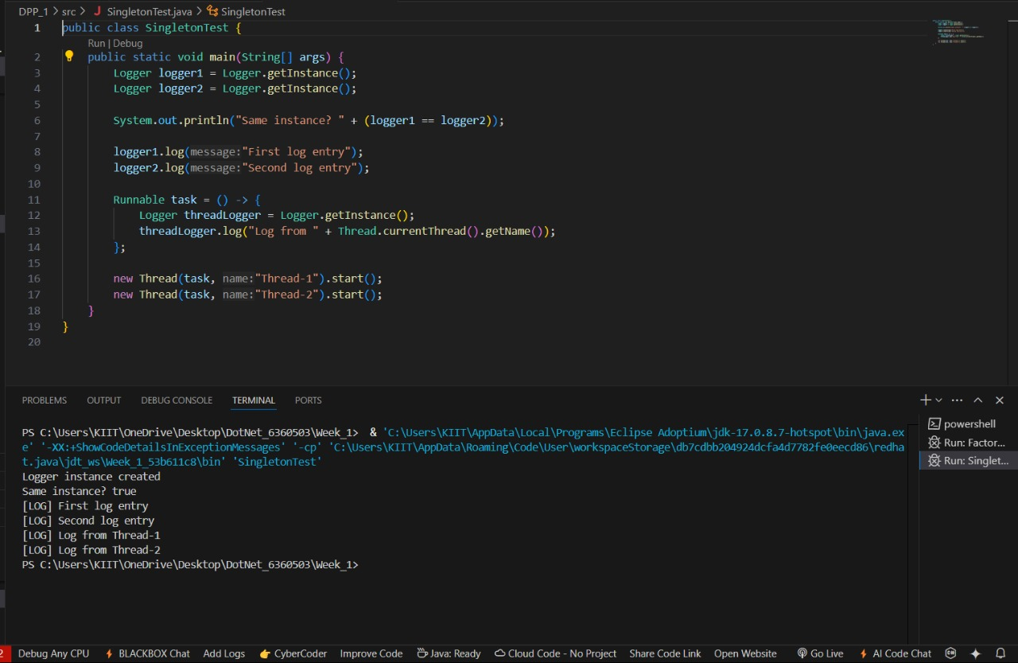

## Exercise 2: Implementing the Factory Method Pattern

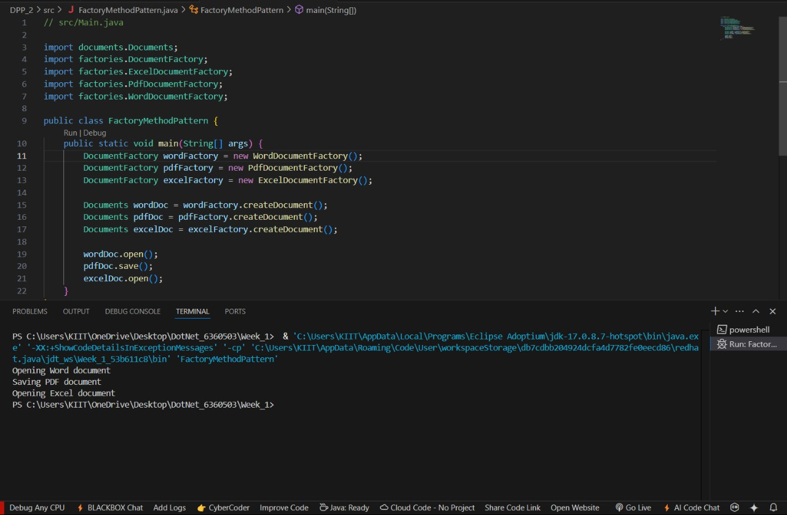

# Data structures and Algorithms

## 

## 

## Exercise 2: E-commerce Platform Search Function

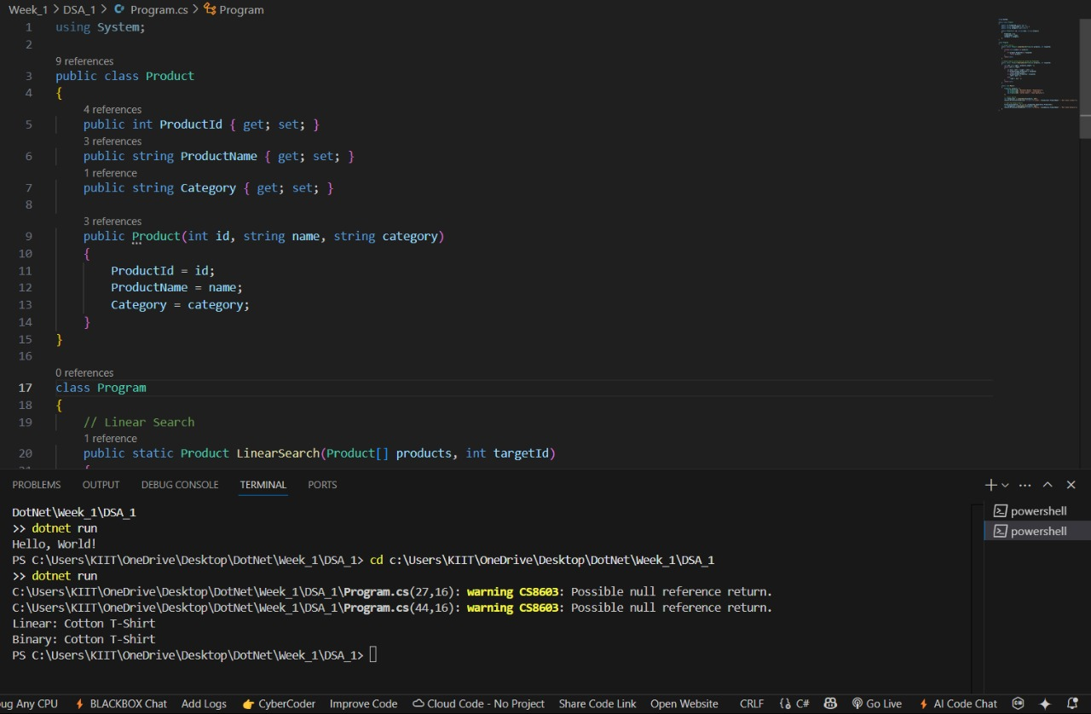

## Exercise 7: Financial Forecasting

