1. Check the current working directory command, then get a list of all files & folders including hidden file as well as file-size of each file and folder.

pwd – Check the current working directory
ls -sh – list of all files,folders including hidden file(human readable format)
du -h – file-size of each file and folder.

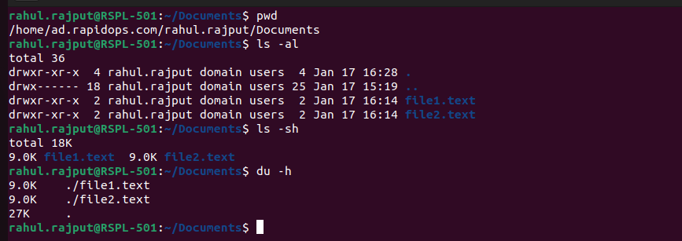
2. Then create two folders named as 'intern-2021' & 'rapidops-2021',

mkdir- for creating folders
3. Then create two files within 'intern-2021' folder, names are 'dev.txt' & 'helloworld.txt',

cd- for change a directory
touch- for creating files

4. Then open the 'dev.txt' file and write something in it, and in 'helloworld.txt' file write 'helloworld' using echo command,
cat- for writing text in file
echo
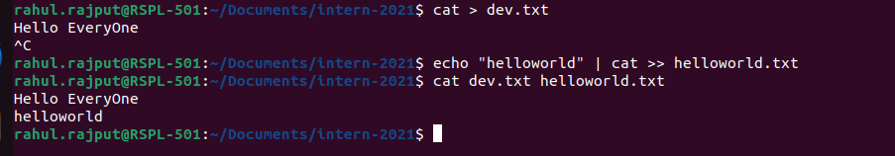

5. Now copy 'dev.txt' and 'helloworld.txt' into rapidops-2021 folder,
cp- for copying files

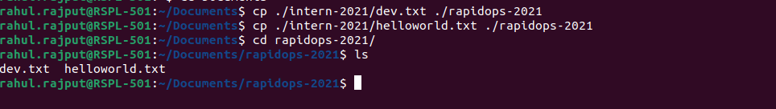
6. Now go to the rapidops-2021 folder and rename those two (dev.txt, helloworld.txt) files.
mv- we can rename using this command

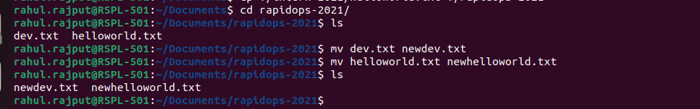
7. In the same directory path, give 'read only' permission to dev.txt for file’s owner, and for helloworld.txt give 'read-write-execute' permission to it's owner & 'read-write' permission to it's group.

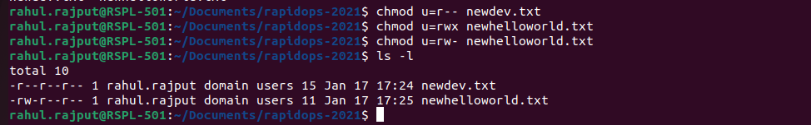
8. Now create archive file within same directory and shift into intern-2021 directory.
tar- tape archive file command used for compressing files

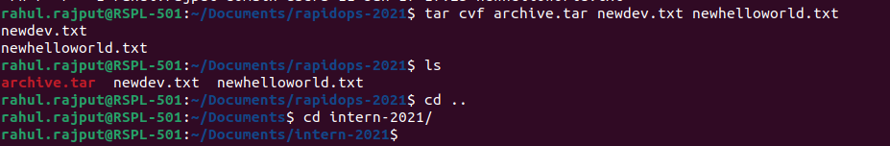
9. Now copy that archive file in this directory location and remove that older archive
file.
cp-
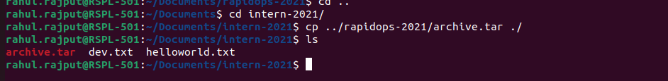
10. Using the command find out the dev.txt file.
find- for searching files in system

11. Check the CPU, memory usage using CLI.

Top- for check CPU, memory usage
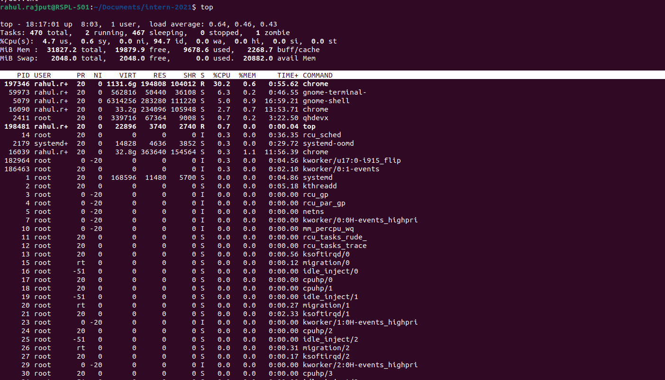
12. Check the disk usage and free disk space using CLI.

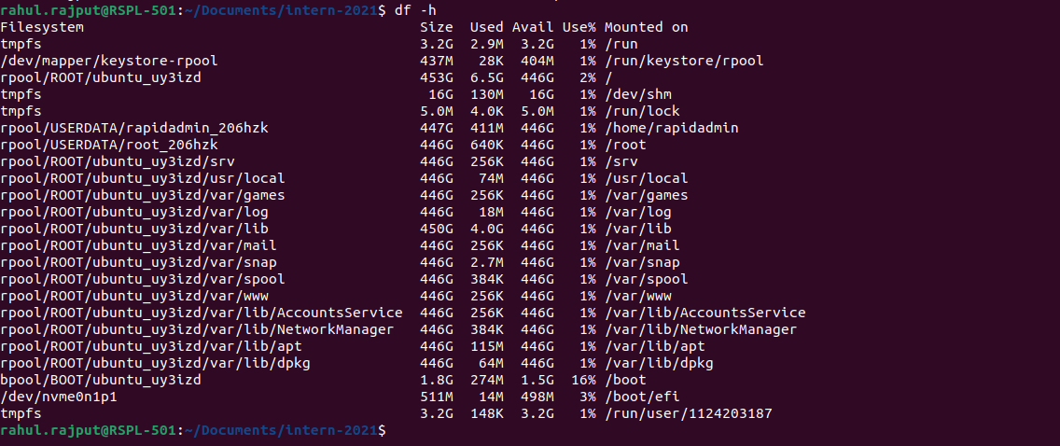
13. Check the all system process and filter out any of one process service using CLI.

Ps aux
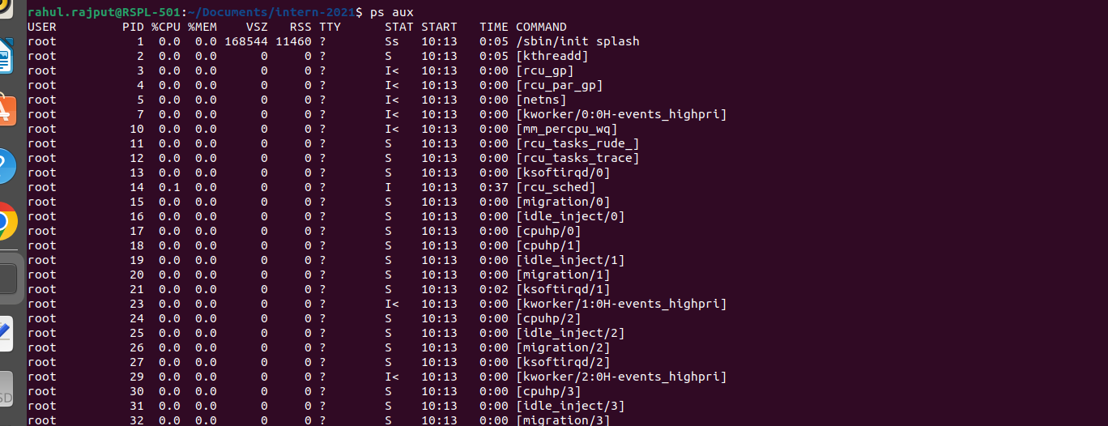
Ps aux | grep 550

14. Retrieve the content from web server using CLI. Here Link

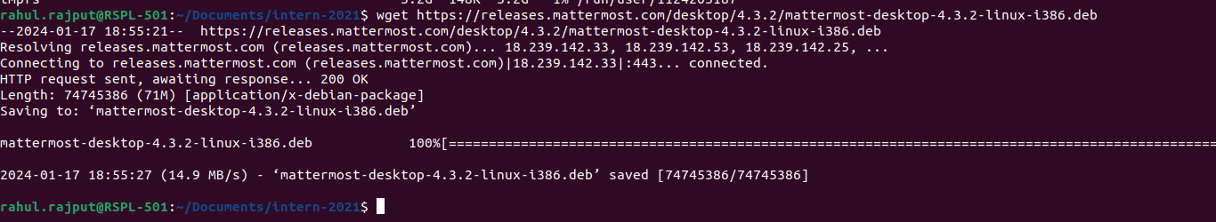
15. Check your network interface information using CLI.
ifconfig

