**Project Setup**

JDK Version : jdk-17.0.2 ([Download Link](https://jdk.java.net/archive/))

Maven Version: apache-maven-3.8.8 ([Download Link](https://maven.apache.org/download.cgi))

Postgres ([Download Link](https://www.postgresql.org/download/windows/))

**Database Setup:**

* Create a new Database named “**multi_user_app**” inPgAdmin
* Open the “Query Tool” and run the below query to create required tables

*CREATE TABLE users (*

*user_id VARCHAR(12) PRIMARY KEY,*

*name VARCHAR(255),*

*email VARCHAR(255) UNIQUE,*

*password VARCHAR(255)*

*);*

*CREATE TABLE tasks (*

*tid SERIAL PRIMARY KEY,*

*description TEXT,*

*status VARCHAR(50),*

*creator_id VARCHAR(12) REFERENCES users(user_id),*

*approver_emails TEXT[],*

*created_at TIMESTAMP DEFAULT CURRENT_TIMESTAMP*

*);*

*CREATE TABLE user_approvals (*

*uaid SERIAL PRIMARY KEY,*

*task_id BIGINT REFERENCES tasks(tid),*

*approver_email VARCHAR(255) REFERENCES users(email),*

*comment TEXT,*

*is_approved BOOLEAN,*

*approved_at TIMESTAMP DEFAULT CURRENT_TIMESTAMP*

*);*

**Running the project in Local**

* Clone the project in the local ([Repo Link](https://github.com/Rahul7k/MultiUserApproval.git))
* Go inside MultiUserApproval folder and open Command Prompt from there
* Type startServer.bat (it includes the build command)

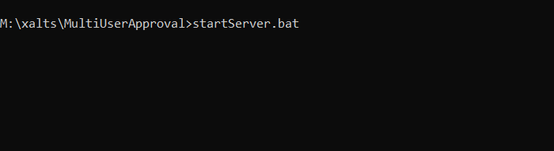

Wait for the server to start

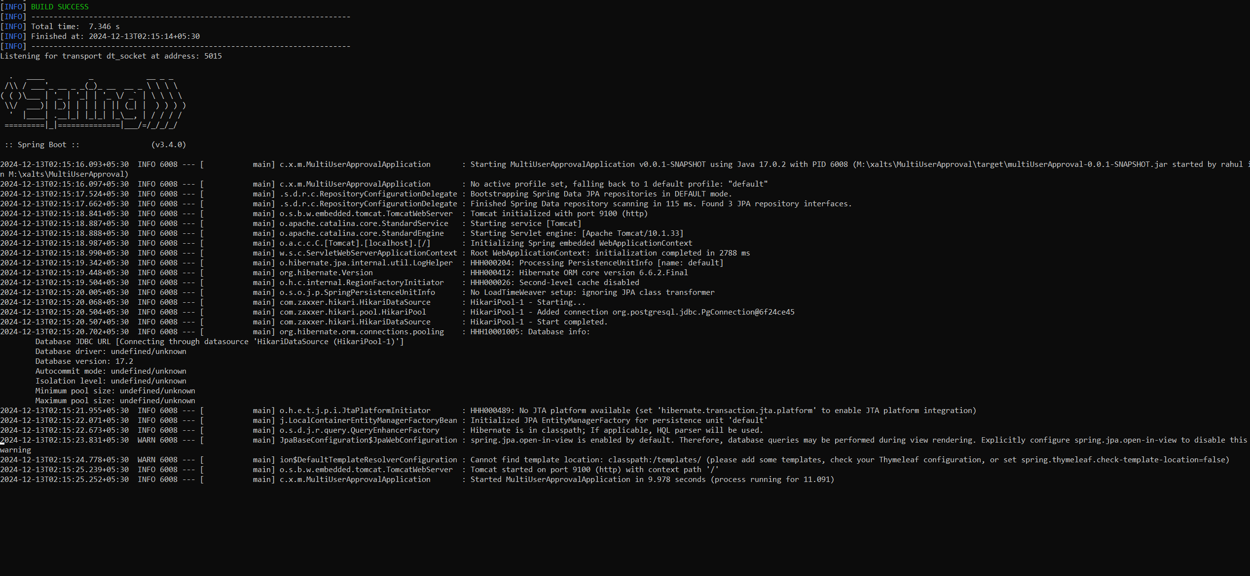

Download Postman collection from github repository ([Link](https://github.com/Rahul7k/MultiUserApproval/blob/ab87867b7ec50e1a34f21e1f518a785076e683dd/MultiUserApprovalReQ.postman_collection.json))

You are now ready to test the application.

**--- Thank You ---**