**Assignment day-8 (Rahul Kumar)**

Q1. Add, Remove, Insert and Search operations

namespace AddUpdateAssignment.Models

{

    public class Variables

    {

        public int EId{get; set;}

        public string EName{get; set;}

        public string EDesignation{get; set;}

        public double ESalary{get; set;}

    }

}

using System;

using System.Collections.Generic;

using AddUpdateAssignment.Models;

namespace AddUpdateAssignment.Contents

{

    public class EmployeeInfo

    {

        public List<Variables> Edetails;    *//first we have to define a list variable where we can put Employee details*

        public EmployeeInfo()

        {

            Edetails = new List<Variables>();

        }

*//Add operation*

        public List<Variables> AddingEDetails()

        {

            Edetails.Add(new Variables

            {

                EId = 21001,

                EName = "Rahul",

                EDesignation = "ASET",

                ESalary = 400000

            });

            Edetails.Add(new Variables

            {

                EId = 21002,

                EName = "Gurpreet",

                EDesignation = "ASET",

                ESalary = 400000

            });

            Edetails.Add(new Variables

            {

                EId = 21003,

                EName = "Nidhi",

                EDesignation = "AQAT",

                ESalary = 400000

            });

            Console.WriteLine("Add operation");

            return Edetails;

        }

*//Remove Operation (removing all elements of a particular position)*

        public List<Variables> DeletingEDetails()

        {

            Edetails.RemoveAt(1);

            Console.WriteLine("Delete/Remove operation");

            return Edetails;

        }

*//Insert Operation*

        public List<Variables> InsertingEDetails()

        {

            Edetails.Insert(1, new Variables

            {

                EId = 2122,

                EName = "Karan",

                EDesignation = "ASET",

                ESalary = 500000

            });

            Console.WriteLine("Insert operation");

            return Edetails;

        }

*// Read/Search Operation*

        public List<Variables> SearchEDetails()

        {

            Edetails.Contains(new Variables

            {

                EName = "Rahul"

            });

            Console.WriteLine("Read/Search operation");

            return Edetails;

        }

    }

}

using System;

using System.Collections.Generic;

using AddUpdateAssignment.Contents;

using AddUpdateAssignment.Models;

namespace AddUpdateAssignment

{

    class Program

    {

        static void Main()

        {

            EmployeeInfo Obj1 = new EmployeeInfo();

            List<Variables> EmpData1 = Obj1.AddingEDetails();

            int len1 = EmpData1.Count;

            for(int i=0; i<len1; i++){

                Console.WriteLine(EmpData1[i].EId+"\n"+EmpData1[i].EName+"\n"+EmpData1[i].EDesignation+"\n"+EmpData1[i].ESalary+"\n");

            }

            List<Variables> EmpData2 = Obj1.DeletingEDetails();

            int len2 = EmpData2.Count;

            for(int i=0; i<len2; i++){

                Console.WriteLine(EmpData2[i].EId+"\n"+EmpData2[i].EName+"\n"+EmpData2[i].EDesignation+"\n"+EmpData2[i].ESalary+"\n");

            }

            List<Variables> EmpData3 = Obj1.InsertingEDetails();

            int len3 = EmpData3.Count;

            for(int i=0; i<len3; i++){

                Console.WriteLine(EmpData3[i].EId+"\n"+EmpData3[i].EName+"\n"+EmpData3[i].EDesignation+"\n"+EmpData3[i].ESalary+"\n");

            }

        }

    }

}

PS D:\TaazaaAssignments\Day8\AddUpdateAssignment> dotnet run

Add operation

21001

Rahul

ASET

400000

21002

Gurpreet

ASET

400000

21003

Nidhi

AQAT

400000

Delete/Remove operation

21001

Rahul

ASET

400000

21003

Nidhi

AQAT

400000

Insert operation

21001

Rahul

ASET

400000

2122

Karan

ASET

500000

21003

Nidhi

AQAT

400000

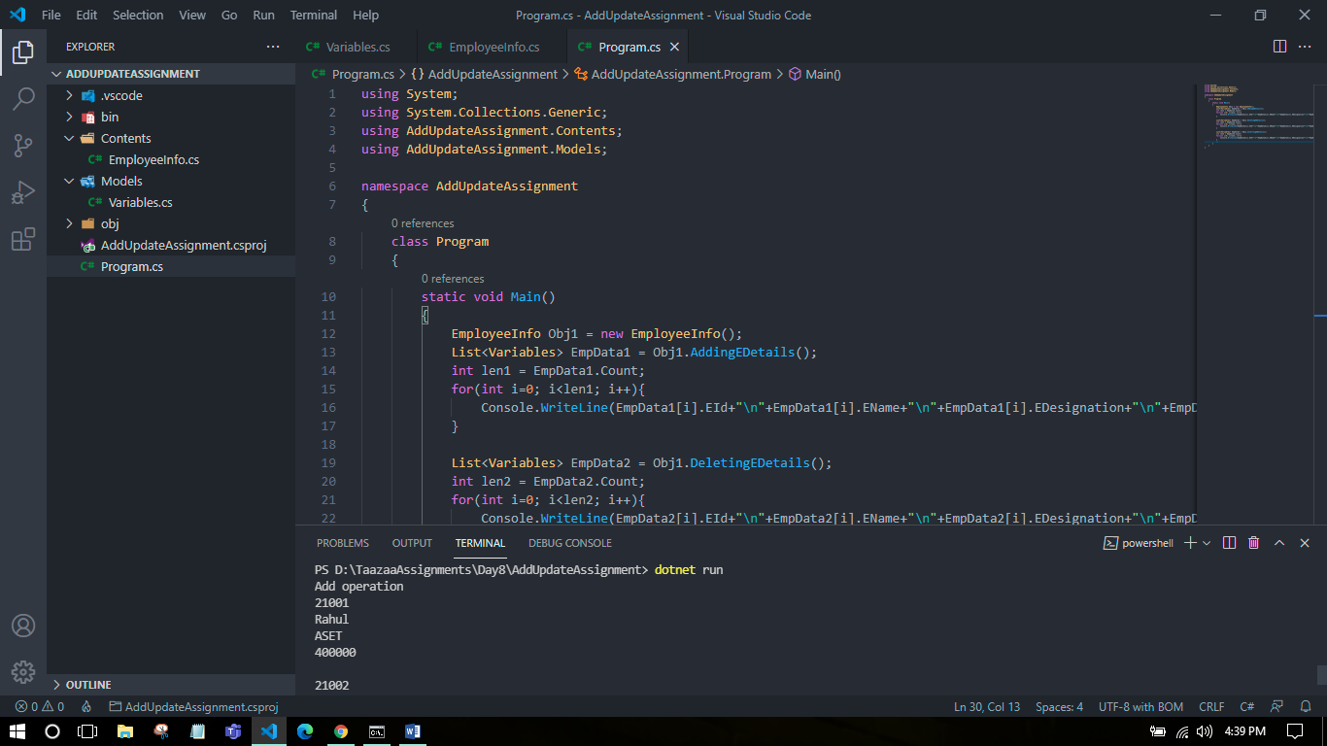

Q2. Delegate Assignment

using System;

namespace DelegateAssignment.Models

{

    public class Calculations

    {

        public static void Square(int num1)

        {

            Console.WriteLine(num1*num1);

        }

    }

}

using System;

using DelegateAssignment.Models;

delegate void CalcDelegate(int n1);

namespace DelegateAssignment

{

    class Program

    {

        static void Main()

        {

*// Delegate method*

            CalcDelegate mySq = new CalcDelegate(Calculations.Square);

            mySq.Invoke(6);

*// Anonymous Function*

            CalcDelegate myCube = delegate(int c1){

                Console.WriteLine(c1*c1*c1);

            };

*// Lamda Function*

            CalcDelegate mySqrt = (int s1) =>

            {

                Console.WriteLine(Math.Sqrt(s1));

            };

            myCube(7);

            mySqrt(16);

        }

    }

}

PS D:\TaazaaAssignments\Day8\DelegateAssignment> dotnet run

36

343

4

