

htt

ps://www.linkedin.com/in/rahul

-

singh

-

56a352239

Dehradun

,

India

9068043787

rahulsingh

9675

@gmail.co

m

Rahul Singh

I

am

dedicated

to

improving

skills

through

hands

-

on

learning

and

development

work.

Proficient

in

desktop development environments. Adept at using

React

JS

, JavaScript

and

other

programming

languags

to

produce

clean

code.

Well

-

organized

and passionate to learning new

technology and able to

work in a team with problem solving skills in creating and

designing

a

website.

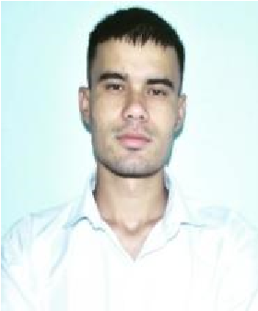

**intern at Brillica Services**

# PROJECTS

* Lamonk and Brillica Services Static Website Using HTML, CSS.
* Coffee Shop Responsive Website using HTML, CSS, Java Script.
* MEAL Finder App Using API.
* My Resume Portfolio Website using HTML, CSS, Java Script.
* Educational Website Using React JS.
* Chat App using React JS.

# EDUCATION

**• BA**

DAV P.G College Dehradun (H.N.B University)

*06/2020 - Present*,

# Subject

History.

**• Inter College**

GIC Kulsari Chamoli

*07/2017 - 07/2018*,

HTML CSS PythonJavaScript

BOOTSTRAP React JS

# ADDITIONAL SKILLS

* Ability to Communicate with Cross functional Team.
* Interested and Passionate to learn Professional Skills.
* Good Communication Skills.
* Fast Learner.

## **INTRESTED**

* Individually passionate learn (Machine Learning and AI.
* Photography.

## HOBBIES

•

* Reading Biographical Books.
* Watching Biographical Movies.
* Listening Music.

# LANGUAGES

* Hindi
* English.