Project Atlas – Autonomous LinkedIn Job Application Bot
Blueprint & Architecture Document

Project File Structure (Current)
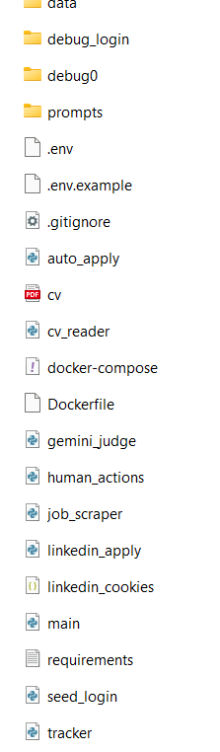
Figure: Current repository structure

1. Project Goal
Project Atlas is a fully automated system that searches LinkedIn for jobs, evaluates them using Google Gemini (ATS-style screening), applies using Easy Apply with human-like behaviour, and tracks results in Excel. The objective is to maximise interview calls with minimal human effort.

2. High Level Architecture
CV Reader → Job Scraper → Gemini Judge → LinkedIn Smart Apply → Excel Tracker
Each module is isolated, testable, and orchestrated by main.py as a single autonomous pipeline.

3. Tech Stack
Layer | Tool | Purpose
Language | Python | Automation backbone
Browser Automation | Playwright | Human-like LinkedIn interaction
AI Engine | Google Gemini (Free Tier) | ATS-style job judging
Scraping | BeautifulSoup | Parse job pages
Data Store | Excel (openpyxl) | Track applications
Container | Docker | Portable execution environment

4. Folder Blueprint (Mapped to Your Repo)
/data → Runtime outputs (cv.json, jobs_raw.json, jobs_filtered.json, applied.xlsx)
/prompts → Gemini prompt templates (customisable)
/debug_login → Login diagnostics & screenshots
auto_apply.py → Legacy apply module
cv_reader.py → CV → structured JSON using Gemini
job_scraper.py → LinkedIn job discovery
gemini_judge.py → ATS screening (YES/NO)
human_actions.py → Human-like typing, scrolling, delays
linkedin_apply.py → Smart Easy Apply engine (stealth mode)
tracker.py → Excel logger
main.py → Orchestrator (scrape → judge → apply)
Dockerfile → Container definition
docker-compose.yml → Service runner
requirements.txt → Python dependencies
.env / .env.example → Secrets template
seed_login.py → First-time login seeding
linkedin_cookies → Session persistence

5. Autonomous Pipeline (main.py)
main.py is the single entry point. It runs the full pipeline:
1) job_scraper.run()
2) gemini_judge.run()
3) linkedin_apply.run()
This design keeps the system clean, ethical, and production-ready.

6. Phase Roadmap
Phase 1: Environment Setup (Docker, Playwright, Gemini)
Phase 2: CV Intelligence (cv_reader.py)
Phase 3: Job Scraping (job_scraper.py)
Phase 4: ATS Judging (gemini_judge.py)
Phase 5: Auto Apply (linkedin_apply.py)
Phase 6: Stealth & Tracking (human_actions.py, tracker.py)
Phase 7: Scheduler (Task Scheduler / cron)

7. Configuration & Secrets
Create a .env file with:
GEMINI_API_KEY=...
LINKEDIN_EMAIL=...
LINKEDIN_PASSWORD=...
PHONE=...
Never commit .env to git.

8. Customisation Guide
Change target role & location in job_scraper.py.
Change ATS prompt in gemini_judge.py.
Adjust DAILY_CAP in linkedin_apply.py.
Edit prompts in /prompts for different industries (Software, Finance, Data, etc.).

9. Automation & Scheduling
Run once:
docker compose run atlas
Schedule daily:
Windows Task Scheduler or cron (macOS/Linux).

10. Success Metrics
15–25 applications/day, >5% interview rate, 90% time saved.

