Abstract
In this dataset, we performed a seven-day motor imagery (MI) based BCI experiment without feedback training on 20 healthy subjects. The MI tasks include left hand, right hand, feet and idle task.
Introduction
20 healthy subjects (11 males, mean age: 23.2±1.47 years, all right-handed) participated in this study. The recruited subjects were asked to participate seven sessions within two weeks. Each session lasted around 40 minutes and was organized into 6 runs. Subjects could have a short break between runs. During each run, subjects had to perform 40 trials (4 different MI-tasks, 10 trials per task, presented in random order), each trial lasting 9s. The direction of the arrow informed the subjects which task to perform, i.e., the left arrow corresponding to MI of the left hand, the right arrow corresponding to MI of the right hand, down corresponding to MI of both feet, up corresponding to the idle task. The experimental protocol can be seen in Fig. 1.
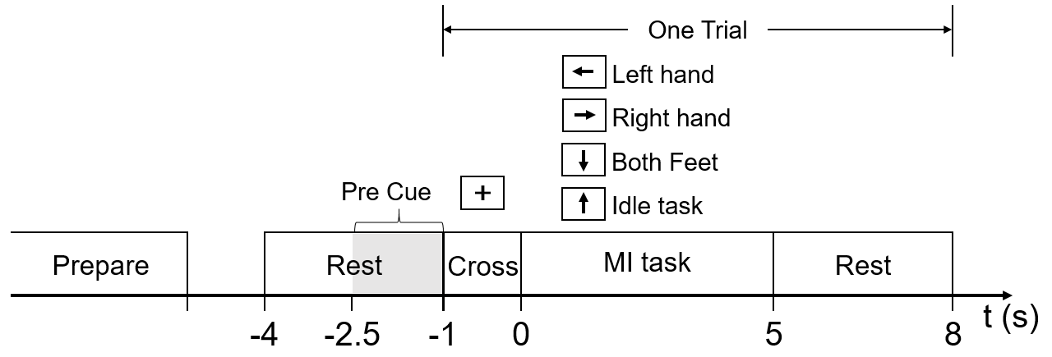
Fig. 1. experimental protocol
EEG Recording
The recording was performed using a 64-channel Synamps2 system (Neuroscan, Inc.) with a sampling frequency of 500 Hz. EEG scalp electrodes were prior-selected according to international 10-20 system, as seen in Figure 2. The reference was on the top of the head, and the ground was on the medial frontal of the head. The horizontal electrooculogram (EOG) and vertical EOG were recorded using the same system. A 50Hz notch filter was applied directly to the amplifier.
Each folder represents a subject namely ‘A1’ to ‘A8’ and ‘S1’ to ‘S12’. Folders begins with ‘A’ was recorded early than ‘S’ but the experimental protocols were the same. 26 EEG electrodes were recorded in subjects begins with ‘A’ and 41 electrodes were recorded in subjects begins with ‘S’, as seen in Figure 2.
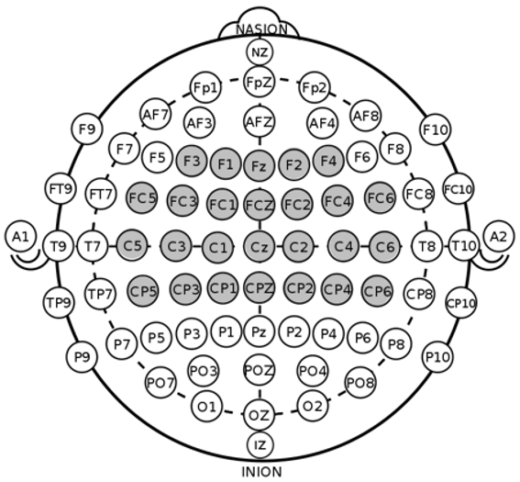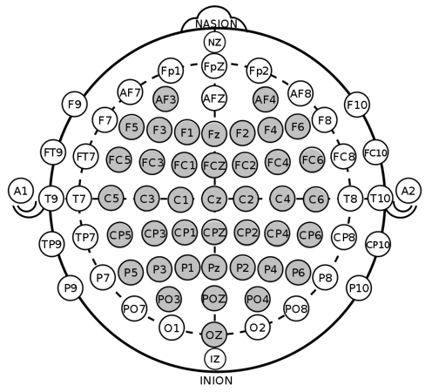
Fig. 2. 26-channel layout (left) and 41-channel layout (right)
Channel Index was showed in Table 1.
Table 1 Channel Index
26ch |  | 41ch
Index | Name | Index | Name
0 | F3 | 0 | F3
1 | F1 | 1 | F1
2 | Fz | 2 | Fz
3 | F2 | 3 | F2
4 | F4 | 4 | F4
5 | FC5 | 5 | FC5
6 | FC3 | 6 | FC3
7 | FC1 | 7 | FC1
8 | FCz | 8 | FCz
9 | FC2 | 9 | FC2
10 | FC4 | 10 | FC4
11 | FC6 | 11 | FC6
12 | C5 | 12 | C5
13 | C3 | 13 | C3
14 | C1 | 14 | C1
15 | Cz | 15 | Cz
16 | C2 | 16 | C2
17 | C4 | 17 | C4
18 | C6 | 18 | C6
19 | CP5 | 19 | CP5
20 | CP3 | 20 | CP3
21 | CP1 | 21 | CP1
22 | CPz | 22 | CPz
23 | CP2 | 23 | CP2
24 | CP4 | 24 | CP4
25 | CP6 | 25 | CP6
26 | hEOG | 26 | hEOG
27 | vEOG | 27 | vEOG
 |  | 28 | F5
 |  | 29 | AF3
 |  | 30 | AF4
 |  | 31 | P5
 |  | 32 | P3
 |  | 33 | P1
 |  | 34 | Pz
 |  | 35 | P2
 |  | 36 | P4
 |  | 37 | P6
 |  | 38 | PO3
 |  | 39 | POz
 |  | 40 | PO4
 |  | 41 | Oz
 |  | 42 | F6
hEOG: horizontal EOG; vEOG: vertical EOG;
AF3: left mastoid; AF4: right mastoid;
In addition, subjects ID begin with ’A’ and ‘S’ was different from subject ID analyzed in the paper ‘Changes in Brain Oscillations Correlate to Performance of Motor Imagery based Brain-Computer Interface: Inter-subject and intra-subject analysis’. The comparison relationship can be seen in Table 2.
Table 2 Comparison Relationship
Subject | A1 | A2 | A3 | A4 | S1 | S10 | S11 | S12 | S2 | S3
Subject ID | 0 | 1 | 2 | 3 | 4 | 5 | 6 | 7 | 8 | 9
Subject | S4 | S5 | S6 | S7 | S8 | S9 | A5 | A6 | A7 | A8
Subject ID | 10 | 11 | 12 | 13 | 14 | 15 | 16 | 17 | 18 | 19

Data format
The dataset is stored in NPZ format, the data can be accessed by:
npz_data = np.load(path)
npz_data_dict = dict(npz_data)
fs = self.npz_data_dict['SampleRate'][0]
index = self.npz_data_dict['MarkOnSignal']
data = self.npz_data_dict['signal']
The meaning of each mark can be seen in Table 3.
Table 3 The meaning of marks
Mark | Means
32769 | Experimental Start
32775 | Start of Preparation
32776 | End of Preparation
786 | Cross appeared
769 | MI of left hand（←）
770 | MI of right hand （→）
771 | MI of both feet （↓）
780 | Idle task （↑）
800 | End of a task

