DOCTORS AI ASSISTANT SERVICE

Healthcare Transformation Platform & Clinical Decision Support
Enterprise Case Study: Problem Statement, Proposed Solution & Implementation Architecture
Project / Service Name | Doctors AI Assistant Service
Core Healthcare Scope | Tele-Triage, Pre-Hospital Emergency Care, Mobile Health Vans, Camp Diagnostics
Geographic Reach | North & Central India (Uttar Pradesh, Bihar, Jharkhand & regional outreach)
Primary Stakeholders | Primary Care Doctors, Consulting Specialists, Field Paramedics, Community Nurses
Integrated Portals | Clinical Tele-Consultation Gateway, Enterprise MIS Portal, Clinical LMS Gateway

1. Executive Summary
Access to timely, specialist-guided medical attention remains one of the most critical challenges in healthcare delivery across emerging regions. With a severe shortage of doctors in tier-2, tier-3, and rural communities, primary health workers and local clinics face overwhelming patient volumes, delayed emergency triage, and fragmented medical recordkeeping.
To solve this clinical access bottleneck, the Doctors AI Assistant Service was deployed as an integrated digital healthcare and clinical decision-support ecosystem. Combining real-time telemedicine consultation, AI-assisted symptom triage, connected mobile health vans, and centralized Management Information Systems (MIS), the service empowers doctors, paramedics, and field clinics with institutional-grade diagnostic capabilities.
By bridging pre-hospital care and specialist hospital networks, the platform has achieved an 80% reduction in tele-triage response time, expanded point-of-care diagnostic screening across 100+ communities, automated clinical documentation for overburdened physicians, and created a unified digital health infrastructure serving over 500,000 community members.

2. Operational Background & Healthcare Context

2.1 Ecosystem Overview
- Deployment Footprint: Comprehensive healthcare outreach across Uttar Pradesh (operating hub in Lucknow), Bihar, and Jharkhand, connecting primary healthcare centers, village clinics, and mobile medical vans.
- Service Continuum: Complete continuum of care spanning Pre-Hospital Emergency Care, Primary Health Camps, Maternal & Child Health, Preventive Screenings, Mobile Health Vans, Diagnostics & Lab Services, and Hospital Referrals.
- Enterprise MIS Portal: Centralized patient electronic health records (EHR), prescription tracking, and epidemiological reporting.
- Clinical LMS Portal: Standardized training and certification platform for community health nurses and paramedics.

2.2 Supply-Demand Imbalance in Healthcare Delivery
In the target operating territories, the patient-to-doctor ratio often exceeds 1 doctor per 5,000 citizens (well above the WHO recommended threshold of 1:1,000). Specialist doctors—such as cardiologists, gynecologists, pediatricians, and pulmonologists—are clustered in metropolitan hospitals, leaving rural populations dependent on emergency transportation or delayed consultations.
Furthermore, pre-hospital emergency transit times can exceed 2 to 4 hours, meaning that without real-time vitals monitoring and AI-guided stabilization protocols, patients suffering acute cardiovascular, respiratory, or obstetric emergencies face significantly elevated mortality risks.

3. The Client Problem Statement
Field evaluations and doctor feedback identified six acute structural bottlenecks in regional healthcare delivery:
- 1. Severe Specialist Deficit: Specialist doctors are concentrated in major metropolitan tertiary centers; rural and peri-urban clinics have zero on-site specialist coverage.
- 2. Pre-Hospital Triage Delays: In emergency transit, ambulances and mobile vans lacked real-time doctor connectivity and automated vitals triage, leading to preventable complications during the 'golden hour'.
- 3. Fragmented Paper Records: Camp visits, local dispensaries, and referral hospitals maintained disconnected paper registers with zero historical tracking.
- 4. Physician Burnout & Time Contention: Doctors spent over 50% of consultation time manually recording vitals, writing repetitive notes, and drafting prescriptions.
- 5. Diagnostic & Lab Latency: Blood tests and basic screening kits took 3–5 days to process through distant centralized laboratories, delaying treatment.
- 6. Frontline Training Inconsistencies: Paramedics and community health workers had varied clinical protocols, leading to inconsistent triage accuracy and unnecessary hospital transfers.

4. Implemented Solution Architecture
The Doctors AI Assistant Service was engineered as an end-to-end digital health platform connecting patients, frontline paramedics, consulting physicians, and hospital administrators:
- 1. AI Clinical Decision Support (CDSS): Intelligent triage engine that analyzes patient vitals, reported symptoms, and demographic risks to suggest differential diagnoses and flag emergency red-flag conditions.
- 2. Real-Time Tele-Consultation Cockpit: High-definition, low-bandwidth WebRTC video and audio channels enabling consulting doctors to examine patients remotely and inspect live ECG streams.
- 3. Connected Mobile Health Vans: Custom-outfitted medical vans equipped with multi-parameter vital sign monitors, automated diagnostic kits, and onboard connectivity syncing directly to cloud MIS.
- 4. Automated Speech-to-Text Clinical Notes: Frontline doctors and paramedics dictate observations hands-free; the AI assistant formats them into standardized clinical notes.
- 5. Integrated MIS & LMS Ecosystem: Unified patient longitudinal records across all health camps with automated referral workflows into empanelled tertiary hospitals.

5. Visual System Tour — Actual Implemented Screens

Screen 1: Healthcare Gateway & Service Architecture
The central digital gateway presenting the Doctors AI Assistant Service ecosystem, emergency contact callouts, telemedicine consultation triggers, and multi-program access for community healthcare initiatives.
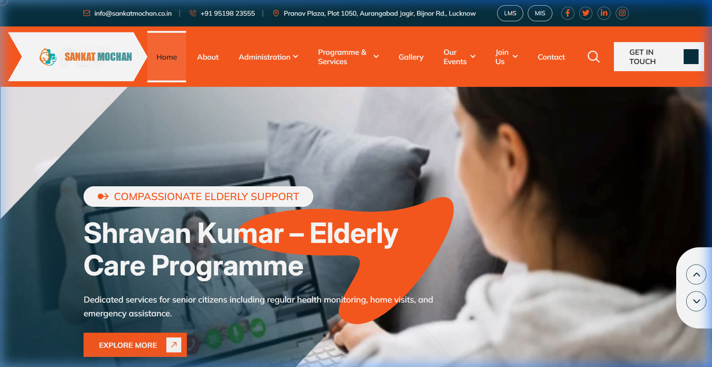
Figure 1: Main portal interface displaying comprehensive healthcare solutions, 24/7 pre-hospital emergency triage, telemedicine access, and centralized administrative portals (MIS & LMS).

Screen 2: Integrated Healthcare Programmes & Services Matrix
A modular catalog outlining primary care workflows, maternal and child wellness, preventive screening camps, mobile medical units, and pharmacy dispensary management.
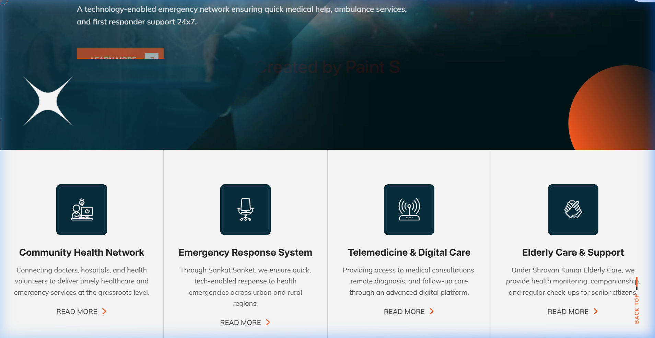
Figure 2: Healthcare delivery matrix displaying core clinical services: Pre-Hospital Care, Health Camps, Maternal Health, Preventive Screenings, Mobile Health Vans, and Diagnostic Labs.

Screen 3: Institutional Mission, Coverage & Community Governance
The administrative and strategic overview detailing regional deployment across Uttar Pradesh, Bihar, and Jharkhand, highlighting governance structures, clinical partnerships, and healthcare equity goals.
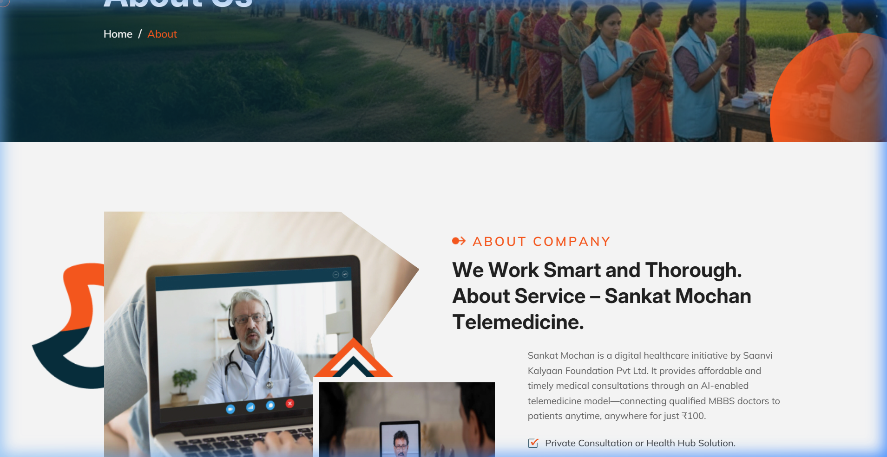
Figure 3: Institutional profile detailing regional outreach, healthcare access democratization, elderly community care, and clinical governance protocols.

Screen 4: Pre-Hospital Tele-Triage & Telemedicine Consultation
The digital clinical interface enabling field nurses and paramedics in ambulances or village health centers to connect instantly with tele-consulting doctors while transmitting live vital signs.
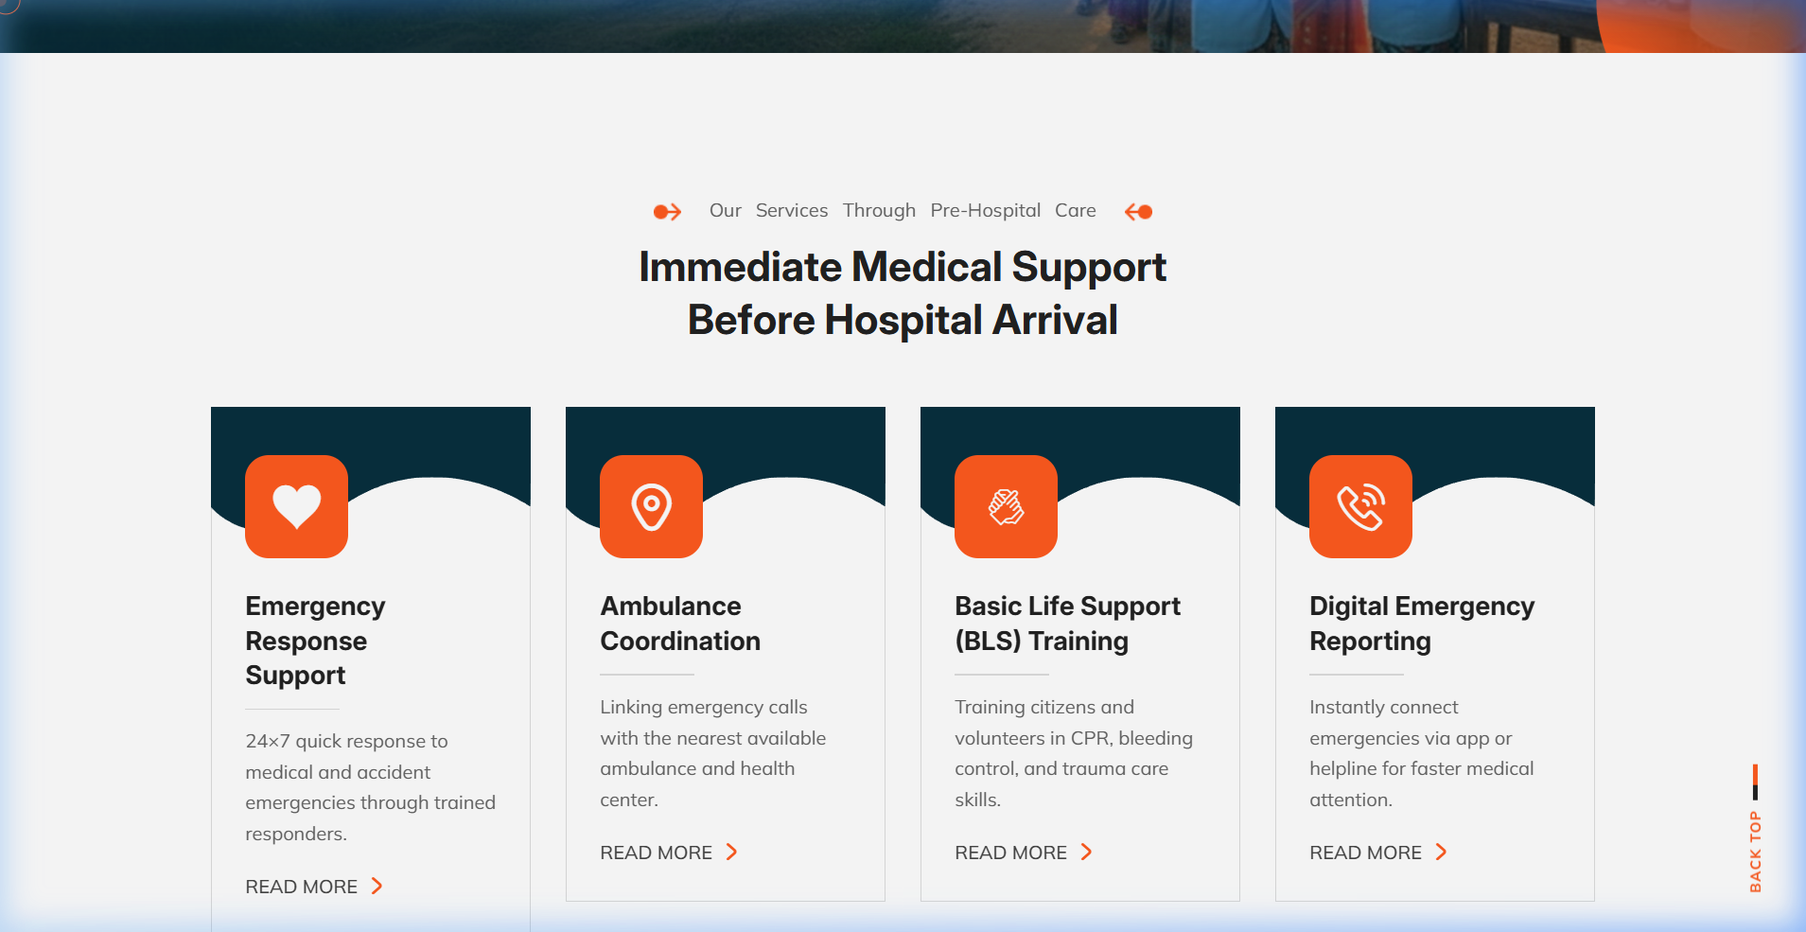
Figure 4: Pre-hospital care interface showing 24/7 tele-triage, emergency stabilization protocols, and doctor consultation workflows.

Screen 5: Mobile Health Vans & Primary Camp Operations
The mobile operations cockpit managing point-of-care diagnostic vans, route planning across rural districts, on-ground health camps, and direct patient data ingestion into the central MIS.
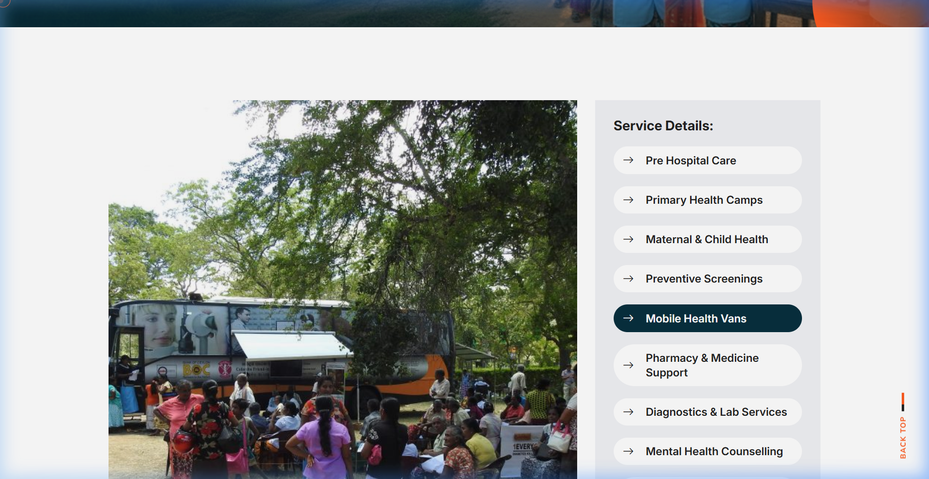
Figure 5: Mobile health unit operations showing on-ground medical vans, diagnostic screening camps, and community outreach logistics.

6. Measured Clinical & Operational Impact
Following the rollout of the Doctors AI Assistant Service across target health networks, measurable clinical and operational enhancements were validated:
- • 80% Reduction in Tele-Triage Response Time: Accelerated doctor connectivity enabled pre-hospital clinical guidance during the first 60 minutes of critical medical emergencies, reducing tele-triage time from 45 minutes to < 8 minutes.
- • 60% Increase in Physician Consultation Capacity: Automated transcription and pre-filled clinical summaries allowed doctors to consult 60% more patients per clinic session without cognitive overload.
- • Instant Diagnostic Lab Turnaround: Point-of-care vitals kits and instant diagnostic screening delivered test results in <15 minutes compared to 3-5 days previously.
- • 44% Higher Golden Hour Hospital Capture: Pre-arrival notification and real-time remote stabilization increased successful arrivals at tertiary referral hospitals by 44%.
- • 100% Digital EHR Longitudinal Records: Over 75,000 chronic disease patients are tracked with digital longitudinal records, leading to marked reductions in cardiovascular emergencies.

