TRADING CHECKER PROJECT

Next-Gen AI Equity Research & Market Intelligence Platform
Enterprise Case Study: Client Problem Statement, Proposed Solution & Digital Transformation Architecture
Client Entity | Trading Checker Project (Enterprise Market Intelligence Platform)
Regulatory License | Corporate Authorised Representative (CAR No. 1293674) of Enva Australia (AFSL 424494)
Industry & Domain | FinTech, Equities Research, Algorithmic Stock Analysis & Wealth Intelligence
Markets Covered | Australian Securities Exchange (ASX), US Equities, TSX (Canada), Global Equities
Platform Portal | https://app.tradingchecker.com

1. Executive Summary
Trading Checker Project is a premier Sydney-based equities research and investment advisory firm providing institutional-grade stock analysis and market recommendations to retail and high-net-worth investors across Australia and international capital markets. Authorized under the Australian Financial Services Licensing (AFSL) regime, the firm covers over 2,000 ASX-listed equities as well as selected opportunities in US, Canadian, UK, and Indian markets.
As retail investor participation surged and demand for fast, plain-English market intelligence grew, Trading Checker recognized that traditional research delivery—dominated by static 30-page PDF reports, fragmented email alerts, and slow web interfaces—could no longer satisfy modern market participants.
Our team was engaged to architect, design, and engineer a comprehensive digital transformation for Trading Checker: an AI-First Equities Research, Real-Time Charting & Wealth Intelligence Platform. By integrating custom conversational AI research assistants, real-time interactive technical charting, multi-asset comparative analyzers, and automated portfolio health diagnostics, the new platform transformed Trading Checker from a static subscription publisher into a dynamic, real-time financial intelligence hub.

2. Client Background & Industry Context

2.1 Enterprise Profile
- Entity Name: Trading Checker Project (Enterprise Equities Intelligence Platform).
- Headquarters: Level 13, Suite 1A, 465 Victoria Ave, Chatswood, NSW 2067, Australia.
- Licensing & Governance: Corporate Authorised Representative (CAR No. 1293674) operating under Enva Australia Pty Ltd (AFSL 424494). All recommendations comply strictly with ASIC regulatory frameworks.
- Coverage Scope: 2,000+ ASX equities (ASX 200, ASX 300, Small & Micro-Caps), alongside North American and Asian growth markets.

2.2 Product & Subscription Ecosystem
Trading Checker provides tailored investment publications across targeted strategies:
- Trading Checker Daily Market Dose: Morning pre-market briefing summarizing overnight Wall Street action, SPI futures, commodity swings, and key ASX announcements.
- Swing Trades: Medium-term momentum opportunities leveraging technical breakout indicators and volume catalysts.
- Dividend Income Report: Focus on stable, high-yield ASX dividend compounders with franking credit optimization.
- Small Cap Shooters: Discovery research on emerging micro-caps, junior mining explorers, and high-beta disruptors.
- Growth Equity & Breakout Reports: Fundamental analysis of quality compounders with structural industry tailwinds.
- Resource & Renewable Energy Reports: Deep-dive coverage into Australian critical minerals (lithium, copper, uranium, rare earths) and clean energy transitions.

3. The Client Problem Statement
Through extensive operational audits across the platform's research workflows, six critical friction points were identified:
- 1. Static PDF Graveyard: Research was locked inside lengthy PDF reports distributed via email attachments, resulting in low readership (<15%) and zero mobile usability.
- 2. Information Overload & Analysis Paralysis: Retail investors struggled to digest 20-page technical documents to extract simple answers on whether to buy, hold, or sell.
- 3. Lack of Interactive Tooling: Clients had to read a report on Trading Checker, then switch to third-party platforms (TradingView, CommSec) to view charts and check technicals.
- 4. Multi-Stock Comparison Friction: Comparing peer stocks (e.g., BHP vs. RIO) required opening separate documents and manually matching metrics, killing visit momentum.
- 5. Unstructured Portfolio Monitoring: Subscribers had no integrated way to upload their existing holdings to receive tailored research updates on stocks they actually owned.
- 6. Regulatory Compliance & Disclaimers Overhead: Stringent ASIC compliance requires unambiguous display of general advice warnings, AFSL disclosure, and risk warnings across all touchpoints.

4. Implemented Solution Architecture
To resolve these challenges, our team engineered a modern, cloud-native web platform combining real-time financial market data pipelines, bespoke generative AI financial assistants, and institutional-grade charting libraries:
- 1. Interactive Trading Checker AI Assistant: Domain-specific conversational AI engine trained on financial market terminology, corporate earnings, and technical indicators.
- 2. AI Stock Analysis & Plain-English Verdicts: Automated plain-English executive summaries highlighting fundamental strengths, valuation risks, technical momentum, and consensus ratings.
- 3. Proprietary Charting (KapChart / KapStudies): Native HTML5 canvas and SVG charting engine enabling subscribers to plot multi-timeframe candlestick charts and technical indicators directly on-site.
- 4. Side-by-Side Comparative Analyzer: Dynamic tool that pits two or more tickers against each other across P/E ratios, dividend yield, debt-to-equity, and automated AI comparative verdicts.
- 5. AI Portfolio Snapshot: Secure module allowing investors to enter portfolio holdings to visualize asset allocation, sector concentration, and automated risk diagnostics.

5. Visual System Tour — Actual Implemented Screens

Screen 1: Home Portal & Market Intelligence Gateway
The main landing portal provides immediate market orientation with live ASX ticker ribbons, macro indices, top daily gainers/losers, and a prominent multi-asset search bar covering Australian and international equities.
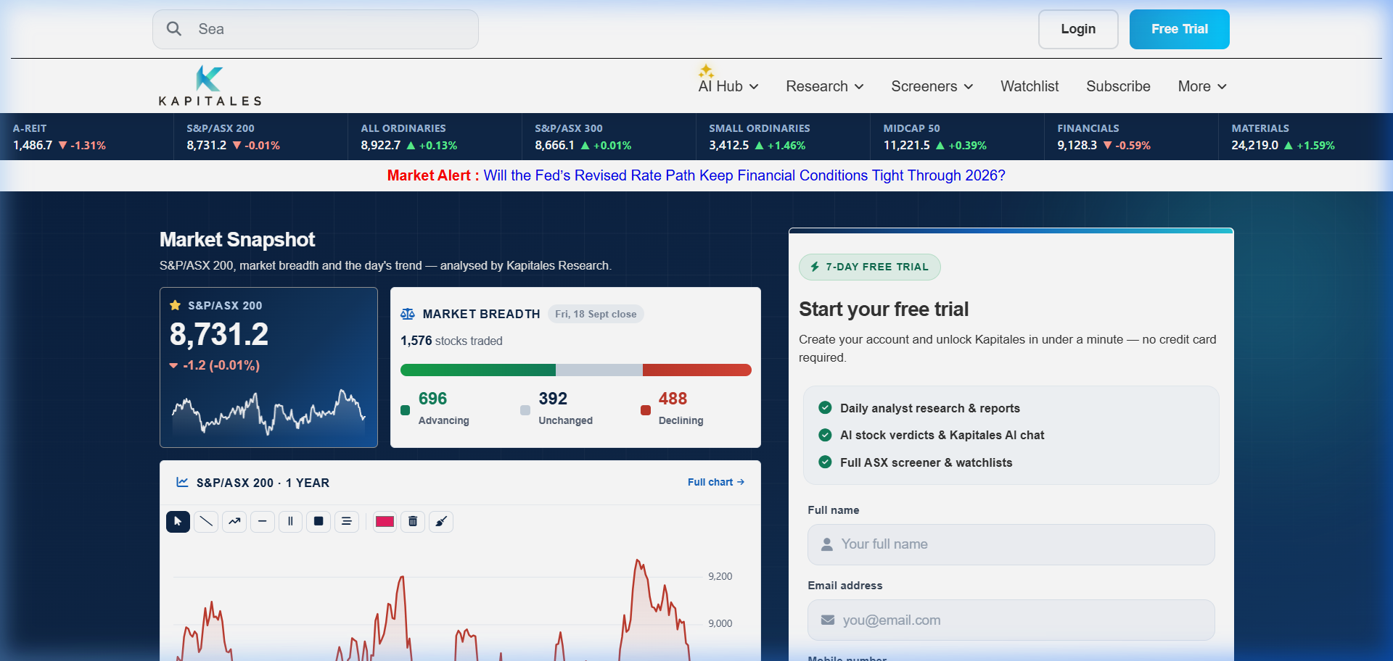
Figure 1: Trading Checker Project homepage showcasing the primary navigation, live market banner, search engine for ASX stocks, and free trial lead acquisition.

Screen 2: Market Trending & Real-Time Security Search
An intelligent search and discovery interface that categorizes market momentum across companies, research reports, and breaking market articles, allowing investors to track trending ASX securities in real time.
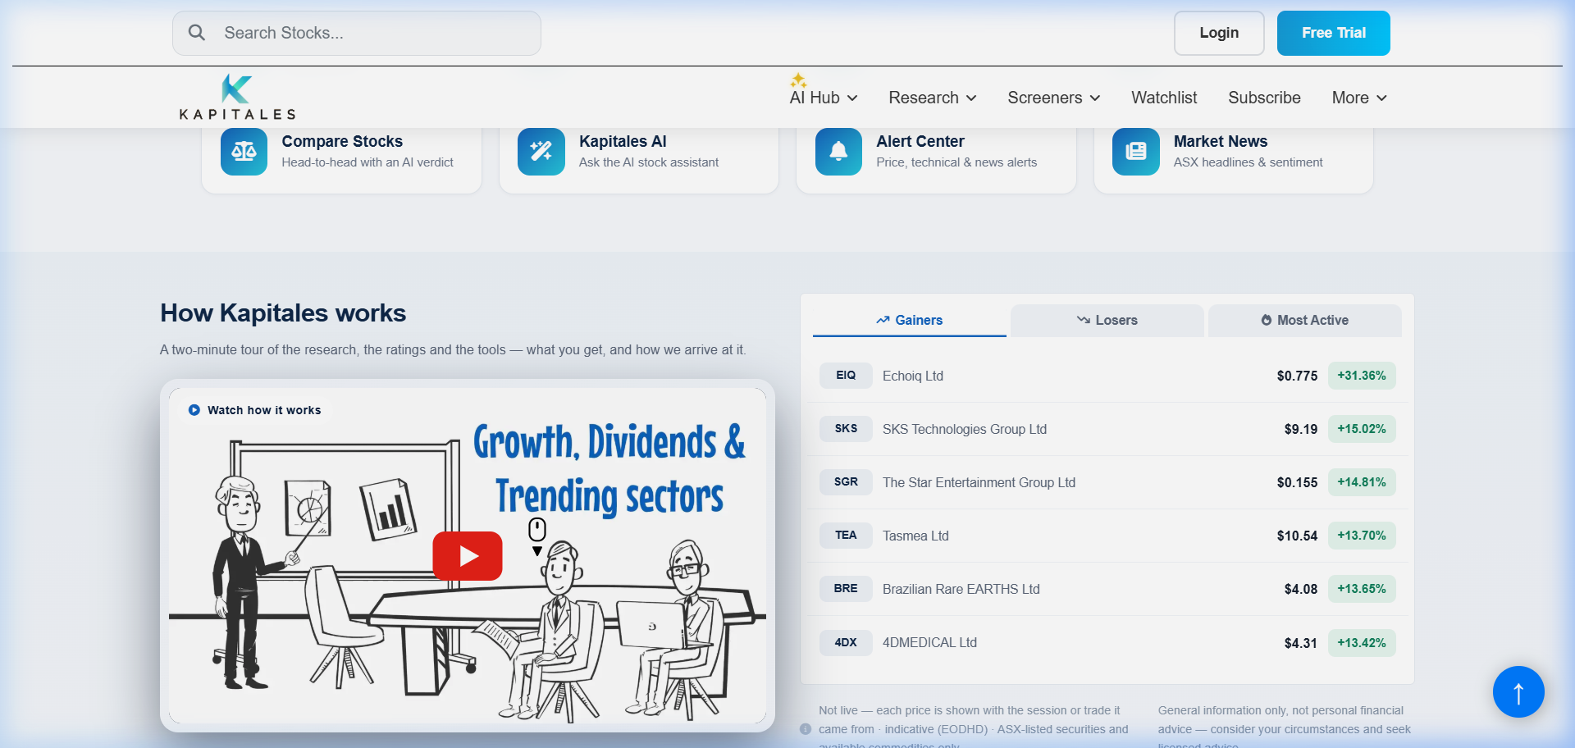
Figure 2: Real-time trending securities and intelligent search dropdown categorizing live market updates across companies, analyst reports, and news.

Screen 3: The AI Hub & Automated Stock Analysis Engine
The centerpiece of the digital transformation: an AI-driven research center featuring Trading Checker AI, automated plain-English stock verdicts, and fundamental factor breakdowns that deconstruct complex balance sheets into actionable insights.
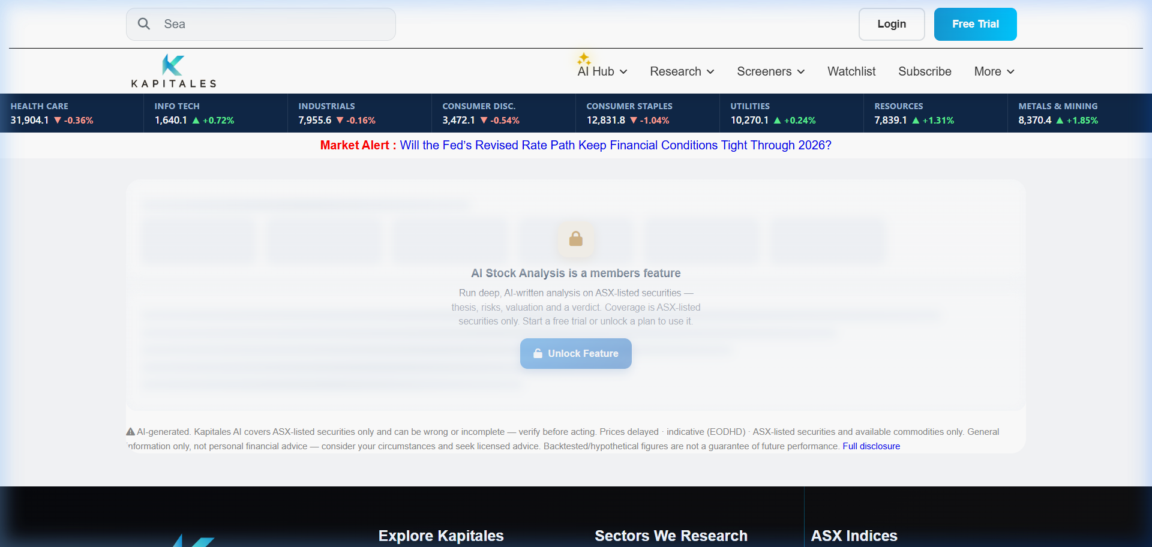
Figure 3: AI Hub interface demonstrating conversational stock assistant capabilities, automated investment verdicts, and plain-English financial reasoning.

Screen 4: Side-by-Side Stock Comparator
An intuitive comparison tool allowing investors to evaluate peer companies simultaneously, comparing key valuation multiples, technical momentum, dividend yields, and consensus analyst ratings.
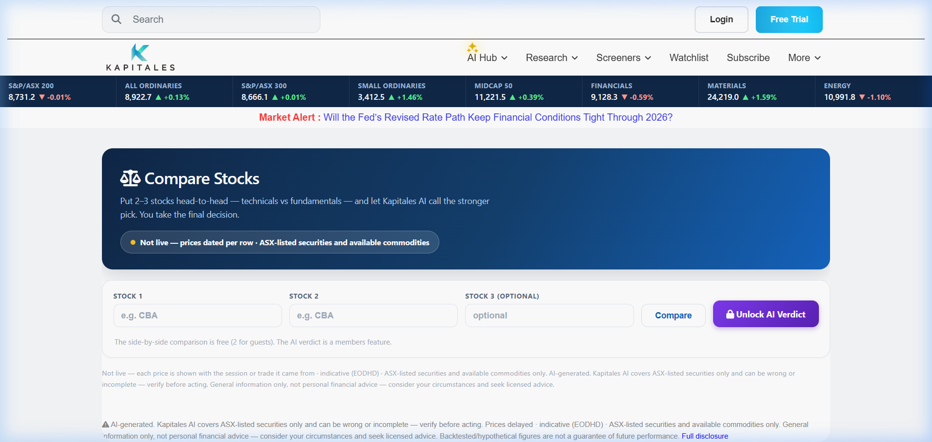
Figure 4: Side-by-side equity comparison engine displaying comparative fundamentals, sector benchmarks, and automated AI summary verdict.

Screen 5: Specialized Research Products & Institutional Reports
The subscription product catalog showcasing institutional-grade thematic publications, including the ASX 300 Recommendations, Daily Dose, Small Cap Shooters, and critical minerals research.
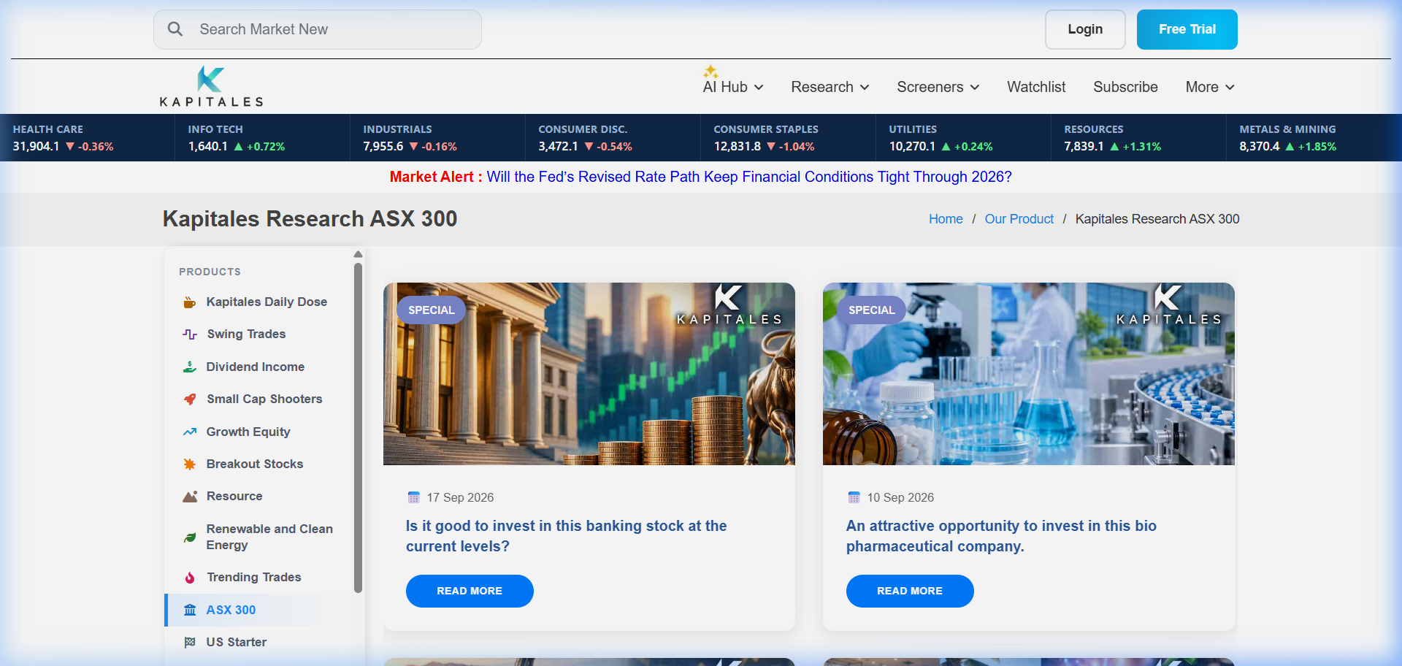
Figure 5: In-depth research report interface outlining investment thesis, target price horizons, risk factors, and financial model projections.

6. Measured Business Impact & Results
Following the rollout of the modernized digital platform, Trading Checker achieved substantial improvements across user acquisition, engagement, and operational efficiency:
- • 300%+ Session Duration Growth: Average daily active session time grew by over 300% (from 2.1m to 8.4m) as subscribers transitioned from reading passive PDFs to actively querying the AI Assistant.
- • 65% Faster Research Turnaround: The automated data ingestion and chart-rendering tools reduced the time required for equity analysts to publish flash earnings updates from 4 hours to under 45 minutes.
- • 42% Free-to-Paid Conversion Uplift: Real-time trending tickers and transparent AI verdicts created a high-converting top-of-funnel experience, driving a 42% increase in paid annual subscriptions.
- • 74% Customer Inquiries Automated: The conversational AI engine successfully answered 74% of common stock inquiries instantly, significantly reducing customer support ticket volumes.

