Decoinks — 25 Real Customer Chats (with artwork)
25 complete real conversations — exactly as the customer wrote and our agent replied — with the artwork/images they shared embedded inline. A mix of customers who placed a one-time order and customers who left without ordering.
Source: real conversations in the CRM database. Customer = their messages · Agent = Decoinks replies. Nothing is edited.

Index
# | Customer | Outcome | Messages | Order $
1 | Patricc Anaup | ORDERED | 17 | $133.00
2 | Bobby Stewart | ORDERED | 18 | $40.00
3 | Kim Baker | ORDERED | 20 | $25.00
4 | Wylon Chalk | ORDERED | 21 | $132.00
5 | Franklin Cruz | ORDERED | 21 | $25.00
6 | Ammon Crawford | ORDERED | 25 | $58.00
7 | Lynn Miller | ORDERED | 27 | $123.00
8 | Tanisha Renee Spencer | ORDERED | 29 | $60.00
9 | Teresa Ward | ORDERED | 31 | $132.00
10 | Denise Wright | ORDERED | 32 | $50.00
11 | Norma Ferrer Acosta | ORDERED | 35 | $37.00
12 | Kayy Mulaa | ORDERED | 36 | $50.00
13 | Stephaniy GoGra | ABANDONED | 6 | —
14 | Cathy Riley | ABANDONED | 9 | —
15 | Jamicha Wheeler | ABANDONED | 10 | —
16 | Manuel Gomez | ABANDONED | 11 | —
17 | Facebook user | ABANDONED | 11 | —
18 | Harold Williams | ABANDONED | 13 | —
19 | Ron Amoako | ABANDONED | 14 | —
20 | Allah Freedom | ABANDONED | 14 | —
21 | Kimberly Evans Porter | ABANDONED | 15 | —
22 | Zbo Zia Shelly | ABANDONED | 16 | —
23 | Richard Palmer | ABANDONED | 16 | —
24 | Manuel Gali | ABANDONED | 18 | —
25 | Angel Miranda | ABANDONED | 19 | —

1. Patricc Anaup — ✅ ORDERED
Outcome | Placed a one-time order
Order value | $133.00
Products discussed | 50 teamsters with custom artwork
Stage reached | inquiry
Messages | 17 · customer artworks shared: 1
What happened | Patricc is looking to order custom apparel with the phrase 'Black Legends of LOW RIDAZ'. They are interested in 50 pieces and need the order by Friday. The agent provided pricing details for the artwork but is awaiting confirmation on sizes and quantities.
Complete conversation:
Agent: (2026-06-09 23:26) [FIRST]
Patricc Anaup replied to an ad.
Agent: (2026-06-09 23:26)
Hi Patricc! Please let us know how we can help you.
Customer: (2026-06-09 23:26)
What is the minimum order quantity?
Customer: (2026-06-09 23:27)
need to say "Black Legends of LOW RIDAZ" how much need 50
Agent: (2026-06-09 23:27)
50 pcs ?
Agent: (2026-06-09 23:28)
What size of artwork do you need this say
Agent: [sent a mockup / design back]
Agent: (2026-06-10 00:03)
Like this
Agent: (2026-06-10 00:04)
An artwork size of 10.75 x 13 will cost you $2.65 per pcs for 50 teamsters
Agent: (2026-06-10 00:05)
If it is smaller size it will cost less
Agent: [sent a mockup / design back]
Agent: (2026-06-10 00:47)
What size do you need to transfer
Customer: (2026-06-10 00:52)
4-4xxxx 15 xxx 20 xx XL -5 how much I like the first one you can mix them up how much need bye Friday
Agent: (2026-06-10 01:54)
You need delivery by Friday ?
Agent: (2026-06-10 02:50)
Pls confirm the sizes
Customer shared their artwork: (2026-06-10 20:02)
[customer artwork shared — could not embed]
Agent: (2026-06-10 20:52) [LAST]
We sent two designs above which one did you liked?

2. Bobby Stewart — ✅ ORDERED
Outcome | Placed a one-time order
Order value | $40.00
Products discussed | 10 DTF transfers 10.75x11.5
Stage reached | quoted
Messages | 18 · customer artworks shared: 1
What happened | Bobby Stewart is interested in ordering custom DTF transfers from a print shop. He inquired about the cost and shipping details and confirmed an order for 10 transfers. The total cost is $40, including shipping, and he provided his shipping address.
Complete conversation:
Agent: (2026-06-01 22:27) [FIRST]
Bobby Stewart replied to an ad.
Agent: (2026-06-01 22:27)
Hi Bobby! Please let us know how we can help you.
Customer: (2026-06-01 22:27)
How long does delivery take?
Agent: (2026-06-01 22:27)
Fast shipping 🚚
DTF transfers are usually shipped within 1–2 business days after confirmation
Agent: (2026-06-01 22:27)
Do you have your design ready?
Customer: (2026-06-01 22:28)
Yes
Customer shared their artwork: (2026-06-01 22:28)

Agent: (2026-06-01 22:28)
How many pieces do you want and what is the size?
Agent: (2026-06-01 22:46)
We suggest 10.75 x 11.5 for transfer size
Customer: (2026-06-01 22:46)
How much
Agent: (2026-06-01 22:47)
How many pcs do you need
Customer: (2026-06-01 22:47)
10 to start off
Agent: (2026-06-01 22:48)
Cost for 10 transfers of size 10.75 x 11.5 will cost $25 plus shipping
Agent: (2026-06-01 22:48)
Pls share your address with zip code to calculate the shipping cost
Customer: (2026-06-01 22:49)
417 Austin St Tallulah La 71282
Agent: (2026-06-01 22:51)
It will cost $15 for shipping
Agent: (2026-06-01 22:52)
Total cost $40 including shipping for 10 transfers
Agent: (2026-06-01 22:52) [LAST]
Shipping cost remain the same for upto 50 transfers

3. Kim Baker — ✅ ORDERED
Outcome | Placed a one-time order
Order value | $25.00
Products discussed | DTF transfers
Stage reached | inquiry
Messages | 20 · customer artworks shared: 0
What happened | The customer, Kim Baker, is interested in ordering some unique rock-and-basketball inspired transfers featuring themes related to the band KISS and basketball legends like Kobe and Shaq. They are looking for the minimum order due to personal reasons. The conversation is ongoing, and the team is awaiting further details from Kim.
Complete conversation:
Agent: (2026-06-03 12:40) [FIRST]
Kim Baker replied to an ad.
Agent: (2026-06-03 12:40)
Hi Kim! Please let us know how we can help you.
Customer: (2026-06-03 12:40)
what is the minimum order please..have a wonderful day
Agent: (2026-06-03 12:40)
This message was automatically moved to spam.
Agent: (2026-06-03 13:40)
For transfer the minimum order is $25 and for t shirts minimum you can order is 5 t shirts
Agent: (2026-06-03 13:40)
Do you have your design ready?
Customer: (2026-06-03 15:01)
I'm just looking for some transfers that I can iron on brother.. I like the band KISS along with Kobe or Shaq..I trust you to make something like that..
Agent: (2026-06-03 15:01)
This message was automatically moved to spam.
Agent: (2026-06-03 15:13)
Absolutely Our desginers can create some unique rock-and-basketball inspired transfers for you. I'll put together a few concepts with a vintage concert style, basketball legend theme, bold typography, lightning effects, and retro colors. Once you see the concepts, we can adjust them to your taste.
Agent: (2026-06-03 15:15)
How many pcs do you need
Customer: (2026-06-03 15:32)
I'm looking for the minimum because of the wifey..lol
Agent: (2026-06-03 15:32)
This message was automatically moved to spam.
Agent: [sent a mockup / design back]
Agent: (2026-06-03 15:33)
Cost will be $20 (for 4 transfers ) plus shipping
Customer: (2026-06-03 15:34)
Dang, that is awesome man..
Agent: (2026-06-03 15:34)
This message was automatically moved to spam.
Agent: (2026-06-03 15:35)
send me your address with zip code to caclulate the shipping cost
Customer: (2026-06-03 16:48)
10864 Antilles Drive Largo Florida 33774
Agent: (2026-06-03 16:48)
This message was automatically moved to spam.
Agent: (2026-06-03 16:53) [LAST]
For upto 50 transfers , shipping cost is fixed

4. Wylon Chalk — ✅ ORDERED
Outcome | Placed a one-time order
Order value | $132.00
Products discussed | custom t-shirts
Stage reached | inquiry
Messages | 21 · customer artworks shared: 1
What happened | Wylon Chalk is interested in ordering custom t-shirts with a specific design. They inquired about the minimum order quantity and confirmed an order of 12 pieces with specific color requirements. The agent provided pricing information and offered to create a mockup.
Complete conversation:
Agent: (2026-05-22 17:15) [FIRST]
Wylon Chalk replied to an ad.
Agent: (2026-05-22 17:15)
Hi Wylon! Please let us know how we can help you.
Customer: (2026-05-22 17:15)
How can I order a custom t-shirt?
Agent: (2026-05-22 17:15)
Super easy 👇
Send us your design (or idea), size & quantity
We’ll create your mockup + best price instantly 🔥
Agent: (2026-05-22 17:16)
How many pieces do you want?
Customer shared their artwork: (2026-05-22 17:17)
[customer artwork shared — could not embed]
Customer: (2026-05-22 17:19)
12 pieces
Gold shirt
Maroon letters
Agent: (2026-05-22 17:22)
Per t shirt price is $11 total for 12 t shirts the price will be $132
Agent: (2026-05-22 17:54)
Do you want us to proceed for Mock-up and working on the design
Agent: (2026-06-10 00:19)
Wylon Chalk replied to an ad.
Agent: (2026-06-10 00:19)
Hi Wylon! Please let us know how we can help you.
Customer: (2026-06-10 00:19)
What is the minimum order quantity?
Customer: (2026-06-10 00:20)
is there a minimum
Agent: (2026-06-10 00:34)
60” x 22” gangsheet
Agent: (2026-06-10 00:45)
How many designs and sizes do you need to order
Agent: (2026-06-10 21:55)
Wylon Chalk replied to an ad.
Agent: (2026-06-10 21:55)
Hi Wylon! Please let us know how we can help you.
Customer: (2026-06-10 21:55)
I have design but need it to be customized
Agent: (2026-06-10 21:55)
Pls send your designs
Agent: (2026-06-10 21:56)
And customization you need
Agent: (2026-06-10 21:56) [LAST]
Do you need t-shirts or DTF transfers

5. Franklin Cruz — ✅ ORDERED
Outcome | Placed a one-time order
Order value | $25.00
Products discussed | DTF transfers
Stage reached | quoted
Messages | 21 · customer artworks shared: 1
What happened | El cliente está interesado en realizar un pedido de transferencias DTF con 4 diseños por planilla. Se discutieron detalles sobre el tamaño y la cantidad mínima requerida. El costo total fue acordado en $25 más el envío.
Complete conversation:
Customer: (2026-06-18 15:11) [FIRST]
hola
Agent: (2026-06-18 15:11)
**Hola, por favor, háganos saber cómo podemos ayudarle. Ofrecemos transferencias DTF y servicios de impresión personalizada de camisetas.**
Customer: (2026-06-18 15:11)
Adonde estas ubicado
Customer: (2026-06-18 15:11)
Usted vende impresion dtf
Agent: (2026-06-18 15:11)
Estamos ubicados en Corona, California. Realizamos envíos a todo Estados Unidos.
Agent: (2026-06-18 15:11)
Ofrecemos transferencias DTF y servicios de impresión personalizada de camisetas.
Customer: (2026-06-18 15:11)
Y cual es el precio por unidad de impresion dtf.?
Agent: (2026-06-18 15:11)
El precio depende del tamaño del diseño y la cantidad. ¿Podría enviarme una imagen del diseño o indicarme las medidas aproximadas para poder darle una cotización?
Customer: (2026-06-18 15:11)
22x12 de buena calidad
Customer shared their artwork: (2026-06-18 15:11)
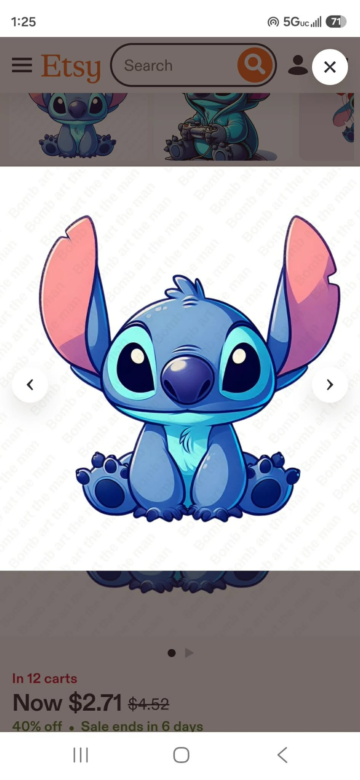
Agent: (2026-06-18 15:11)
Está seguro de que el tamaño es 12" × 22"? Necesitamos analizar la proporción de la imagen. No podemos definir un tamaño exacto sin verla, ya que debemos verificar la relación entre el ancho y la altura para evitar que se distorsione. Voy a enviarla al diseñador para que la revise y prepare una maqueta (mockup).
Agent: [sent a mockup / design back]
Agent: (2026-06-18 15:11)
Aquí tiene algunos diseños que hemos creado para usted. Por favor, écheles un vistazo. Estos diseños no tienen derechos de autor de terceros y son creaciones originales de nuestro equipo. Háganos saber si desea algún cambio o modificación.
Customer: (2026-06-18 15:11)
Perfecto y cuanto es el precio por unidad
Agent: (2026-06-18 15:11)
¿Puede confirmar la cantidad que necesita? Una vez que tengamos la cantidad, podremos proporcionarle una cotización exacta.
Agent: (2026-06-18 15:11)
. ¿Se refiere a una plantilla completa de 22" x 12" con varios diseños? ¿Cuántos diseños le gustaría incluir en cada plantilla? Con esa información podremos darle un precio por unidad.
Customer: (2026-06-18 15:11)
4 diseños por planilla
Customer: (2026-06-18 15:11)
Cual seria el precio
Agent: (2026-06-18 15:11)
¿Cuántas planillas de 4 diseños necesita?
Agent: (2026-06-18 15:11)
Nuestro pedido mínimo es de 5 planillas de 12" x 22". El costo total es de $25 más el envío.
Agent: (2026-06-18 15:11) [LAST]
También puede pedir diferentes temas de diseños para cada planilla. Por ejemplo, una planilla puede ser de animales, otra de deportes, otra para niños y otra de paisajes.

6. Ammon Crawford — ✅ ORDERED
Outcome | Placed a one-time order
Order value | $58.00
Products discussed | DTF transfers and t-shirts
Stage reached | inquiry
Messages | 25 · customer artworks shared: 1
What happened | Ammon Crawford is interested in ordering custom apparel, specifically DTF transfers and t-shirts. He provided sizes and quantities for both products and requested a quote. The conversation is ongoing with a shipping address provided, but final details and payment have not yet been confirmed.
Complete conversation:
Agent: (2026-06-01 14:10) [FIRST]
Ammon Crawford replied to an ad.
Agent: (2026-06-01 14:10)
Hi Ammon! Please let us know how we can help you.
Customer: (2026-06-01 14:10)
How long does delivery take?
Agent: (2026-06-01 14:10)
Fast shipping 🚚
DTF transfers are usually shipped within 1–2 business days after confirmation
Agent: (2026-06-01 14:12)
Do you have your design ready?
Customer shared their artwork: (2026-06-01 14:15)
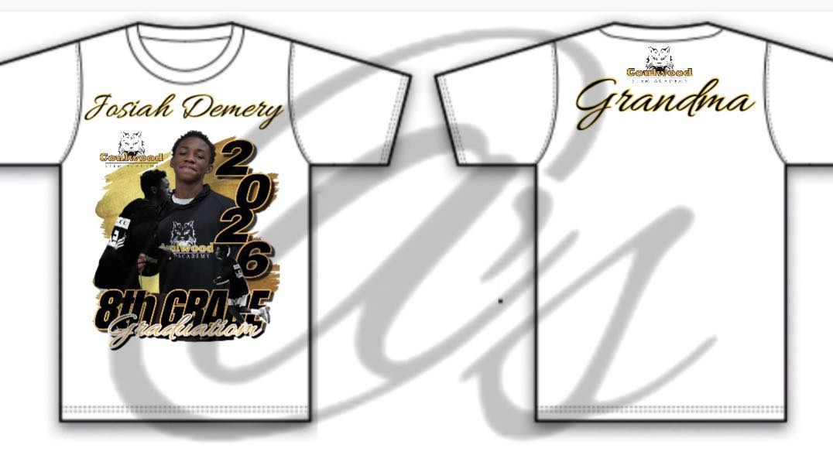
Agent: (2026-06-01 14:15)
Do you want transfer or t shirt?
Agent: (2026-06-01 14:16)
And what is the size are you looking for?
Customer: (2026-06-01 14:16)
Price for both
Customer: (2026-06-01 14:16)
2 sm
5 md
1 lg
Agent: (2026-06-01 14:22)
Can I get your shipping address so that I can give you full quote
Customer: (2026-06-01 14:23)
110 Habitat Dr. Savannah GA 31419
Agent: (2026-06-01 14:26)
Since you told me that you need transfers may we know what is the size of your heat transfer?
Agent: (2026-06-01 14:27)
So that we can suggest the best size possible so that your quote can be cost efficient
Customer: (2026-06-01 14:27)
15x15
Agent: (2026-06-01 14:28)
And what size do you prefer for transfers?
Customer: (2026-06-01 14:28)
12x12
Agent: (2026-06-01 14:29)
and what about the back one?
Customer: (2026-06-01 14:29)
12x3
Agent: (2026-06-01 14:30)
Thank you for clearing out let me send you quote for both
Agent: (2026-06-01 14:36)
For transfers the quote will be $58 and for t shirts the quote will be $109. In both quotes shipping is included
Customer: (2026-06-01 14:36)
ETA
Agent: (2026-06-01 14:37)
Our estimated shipment time is 1 to 2 days and we choose rush shipping to deliver the package
Customer: (2026-06-01 14:37)
Are transfers on a gang sheet
Agent: (2026-06-01 14:38) [LAST]
Yes Sir

7. Lynn Miller — ✅ ORDERED
Outcome | Placed a one-time order
Order value | $123.00
Products discussed | 40 DTF transfers 11.5 x 14
Stage reached | quoted
Messages | 27 · customer artworks shared: 2
What happened | Lynn Miller is interested in ordering 40 DTF transfers sized 11.5 x 14. The total cost is quoted at $123, including shipping. Lynn has provided a shipping address and is ready to proceed with the order.
Complete conversation:
Agent: (2026-06-02 23:52) [FIRST]
Lynn Miller replied to an ad.
Agent: (2026-06-02 23:52)
Hi Lynn! Please let us know how we can help you.
Customer: (2026-06-02 23:52)
How long does delivery take?
Agent: (2026-06-02 23:52)
Fast shipping 🚚
DTF transfers are usually shipped within 1–2 business days after confirmation
Agent: (2026-06-02 23:52)
Do you have your design ready?
Customer: (2026-06-02 23:58)
Yes
Customer: (2026-06-02 23:59)
I need them to be 11.5 x 14
Agent: (2026-06-02 23:59)
You can send us the design
Agent: (2026-06-02 23:59)
What is the quantity do you want?
Customer shared their artwork: (2026-06-03 00:03)

Customer: (2026-06-03 00:03)
40
Agent: (2026-06-03 00:04)
Do you need all 40 designs in this size 11.5 x 14?
Customer: (2026-06-03 00:05)
As of right now yes
Agent: (2026-06-03 00:06)
We would suggest that go for 10.75 x 14 instead of 11.5 x 14 because it will be cost efficient for you. There is not a big difference in sizing but it will be difference in quote
Customer: (2026-06-03 00:08)
Okay
Customer: (2026-06-03 00:09)
What would the price be
Agent: (2026-06-03 00:14)
The price will be $123 which includes 40 transfers
Agent: (2026-06-03 00:15)
Can you send us your shipping address so that we can give you shipping cost
Customer: (2026-06-03 00:15)
Lynn Miller, Sumner, MI 48889
Customer shared their artwork: (2026-06-03 00:17)

Agent: (2026-06-03 00:17)
So yeah the total cost will be $136 including shipping
Customer: (2026-06-03 00:18)
The second picture is better quality
Agent: (2026-06-03 00:18)
Thank you for providing the image of better quality
Agent: (2026-06-03 00:20)
We will use the second image for your order
Customer: (2026-06-03 00:20)
No problem
Agent: (2026-06-03 00:21)
Great! Would you like to proceed with the payment now to get your order started? 😊
Agent: (2026-06-04 16:14) [LAST]
Hi , apprecaite to know if you are interested in order or just a delay for any information compiling or approval

8. Tanisha Renee Spencer — ✅ ORDERED
Outcome | Placed a one-time order
Order value | $60.00
Products discussed | polyester t-shirts
Stage reached | inquiry
Messages | 29 · customer artworks shared: 1
What happened | Tanisha Renee Spencer is interested in ordering bulk polyester t-shirts in assorted colors for Father's Day. The agent confirmed the availability of assorted colors and provided pricing details. The conversation is ongoing as Tanisha awaits the color options and further details.
Complete conversation:
Agent: (2026-05-31 21:02) [FIRST]
Tanisha Renee Spencer replied to an ad.
Agent: (2026-05-31 21:02)
Hi Tanisha! Please let us know how we can help you.
Customer: (2026-05-31 21:02)
Can I order in bulk?
Agent: (2026-05-31 21:02)
Yes absolutely 😊
We offer special bulk pricing for businesses, brands & resellers 🔥
Send your quantity for the best quote.
Customer: (2026-05-31 21:03)
How soon would I get them
Customer: (2026-05-31 21:04)
Do you have a bulk of assorted colors
Agent: (2026-05-31 21:04)
Yes
Customer: (2026-05-31 21:04)
All sizes as well
Agent: (2026-05-31 21:04)
How many transfers do you need
Customer: (2026-05-31 21:04)
20
Customer: (2026-05-31 21:05)
I need t-shirts.Do you sell t shirts in bulk
Agent: (2026-05-31 21:05)
Yes
Customer: (2026-05-31 21:05)
Do\nYou sell a sordid colors and bulk
Customer: (2026-05-31 21:05)
Assorted colors
Customer: (2026-05-31 21:05)
Assorted colors in bulk , if so , how much
Agent: (2026-05-31 21:06)
Is your artwork / design ready ?
Agent: (2026-05-31 21:07)
Do you need blank t-shirts or custom printed t-shirts ?
Agent: (2026-05-31 21:08)
Blank t-shirt price is $3 per pcs
Agent: (2026-05-31 21:08)
Any color and sizes S-XL
Customer: (2026-05-31 21:12)
Right now I just need bulk in t-shirts.I will need you in the future to print.What is your turnaround on transfers
Agent: (2026-05-31 21:12)
1-2 days
Agent: (2026-05-31 21:13)
Blank t-shirt price is $3 per pcs
Agent: (2026-05-31 21:13)
Sizes : S -XL
Agent: (2026-05-31 21:15)
How many pcs do you need
Customer: (2026-05-31 21:36)
20 what colors do you have, please?I am doing some t-shirt for father's day please and thank you
Agent: (2026-05-31 21:47)
Let me send your the shades tomorrow morning
Customer: (2026-06-01 00:12)
Are you able to put a bulk together for I'd prefer polyester t-shirts do you have those an assorted colors I would like to see your shades tomorrow that's fine thank you
Agent: (2026-06-01 00:24)
I’ll send you all the available polyester t-shirt colors and shades tomorrow. We can also discuss your bulk order details then. Thank you!
Customer shared their artwork: (2026-06-01 00:24)
[customer artwork shared — could not embed]

9. Teresa Ward — ✅ ORDERED
Outcome | Placed a one-time order
Order value | $132.00
Products discussed | custom T-shirts
Stage reached | quoted
Messages | 31 · customer artworks shared: 2
What happened | Teresa Ward is interested in ordering custom T-shirts and has confirmed her desired sizes and quantities. After some discussion about DTF transfers, she decided to proceed with T-shirts instead. The total cost for her order is $132 plus shipping.
Complete conversation:
Agent: (2026-06-14 01:56) [FIRST]
Teresa Ward replied to an ad.
Agent: (2026-06-14 01:56)
Hi Teresa! Please let us know how we can help you.
Agent: (2026-06-14 01:56)
Hi Teresa! We wanted to follow up. Do you have any questions?
Customer: (2026-06-14 01:56)
What is the minimum order quantity?
Agent: (2026-06-14 01:56)
Our minimum order is $25, which is approximately 60 inches of DTF transfers. If you're unsure about sizing, send us your artwork and we'll help you calculate the required inches.
Customer shared their artwork: (2026-06-14 01:57)

Customer: (2026-06-15 20:50)
Hello
Customer: (2026-06-15 20:50)
Never
Agent: (2026-06-15 20:50)
Do you want DTF transfer?
Agent: (2026-06-15 20:50)
Sizes and quantity?
Customer shared their artwork: (2026-06-15 20:50)

Agent: (2026-06-15 20:50)
Could you please let us know what you’re looking for—DTF transfers or custom T-shirts?
Customer: (2026-06-15 20:50)
T shirts
Agent: (2026-06-15 20:50)
Ok sounds good
Agent: (2026-06-15 20:50)
Can you please tell me size and quantity?
Customer: (2026-06-15 20:50)
1-4x 1-2x&9 xl
Customer: (2026-06-15 20:50)
Make tht 8 large
Agent: (2026-06-15 20:50)
Just to confirm, are the sizes:
• 1 × 4XL
• 1 × 2XL
• 3 × Large (L)
Is that correct?
Customer: (2026-06-15 20:50)
And 9 xl
Agent: (2026-06-15 20:50)
1-4XL
1-2XL
3-L
7-XL
IS THIS CORRECT?
Customer: (2026-06-15 20:50)
Yes
Agent: (2026-06-15 20:50)
So total 12 pcs with one front location print
Customer: (2026-06-15 20:50)
Yes
Agent: (2026-06-15 20:50)
It will cost $11 per pcs
Customer: (2026-06-15 20:50)
Oh ok that’s ok
Agent: (2026-06-15 20:50)
Total cost will be = 12 x $11 =$132 plus shipping
Customer: (2026-06-15 20:50)
I will go another route with this
Agent: (2026-06-15 20:50)
Do you find it’s costly ?
Agent: (2026-06-15 20:50)
Alternatively you can DTF transfers and heat press yourself
Agent: (2026-06-15 20:50)
DTF Transfers will cost you $30 plus shipping for 12 transfers
Agent: (2026-06-15 20:50) [LAST]
You can use iron if you don’t have heat press

10. Denise Wright — ✅ ORDERED
Outcome | Placed a one-time order
Order value | $50.00
Products discussed | 12 small DTF transfers 3x3
Stage reached | inquiry
Messages | 32 · customer artworks shared: 1
What happened | The customer is interested in ordering 12 small DTF transfers with a chest design. They confirmed the design size and shipping options, and the total cost is $50 plus shipping. The order is set to be delivered based on the chosen shipping method.
Complete conversation:
Customer: (2026-06-15 02:37) [FIRST]
How long does shipping take?
Agent: (2026-06-15 02:37)
Production takes 1–2 business days, with standard shipping taking 2–5 business days within the USA. Rush production and expedited shipping are also available for urgent orders.
Customer shared their artwork: (2026-06-15 02:38)

Customer: (2026-06-15 02:38)
Could u make this a dtv with out the blue background
Agent: (2026-06-15 02:38)
Yes of course we can
Agent: (2026-06-15 02:39)
Can you please tell me the quantity and size?
Customer: (2026-06-15 02:39)
20
Customer: (2026-06-16 14:21)
9.5 wide
Agent: (2026-06-16 14:21)
Ok got it
Customer: (2026-06-16 14:21)
Price
Agent: (2026-06-16 14:21)
If we keep the width at 9.5”, the height will come out to approximately 10.17” while maintaining the original proportions.
Customer: (2026-06-16 14:21)
Ok
Agent: (2026-06-16 14:21)
It will be $50 plus shipping
Customer: (2026-06-16 14:21)
What is the turn around time and how much for 12 for the chest
Agent: (2026-06-16 14:21)
Our production time is 1–2 business days. Could you please confirm the size of the chest design so I can provide an accurate price for 12 pieces?
Agent: (2026-06-16 14:21)
Shipping options:
• Standard Shipping (4–5 business days): $13
• 2-Day Shipping: $18
Customer: (2026-06-16 14:21)
What is a normal size size 3x3
Agent: (2026-06-16 14:21)
Just to confirm, would you like the design placed on the right chest area and not centered on the shirt?
Customer: (2026-06-16 14:21)
For the small one
Agent: (2026-06-16 14:21)
And if we set the width to 3 inches, the height will be approximately 3.5 inches while maintaining the design’s proportions.
Customer: (2026-06-16 14:21)
Ok
Agent: (2026-06-16 14:21)
20 pcs? Or 12?
Customer: (2026-06-16 14:21)
12 for the smaller one
Agent: (2026-06-16 14:21)
you will receive 32 transfers in total:
• 20 large transfers (9.5” × 10.17”)
• 12 small transfers (3” × 3.5”)
The total price will be $50 plus shipping.
Customer: (2026-06-16 14:21)
How much is shipping
Customer: (2026-06-16 14:21)
13471
Agent: (2026-06-16 14:21)
You have two options: Standard Shipping for $13 or 2-Day Shipping for $18
Customer: (2026-06-16 14:21)
So when would I get them if I didn2 day
Agent: (2026-06-16 14:21)
You will receive your order by Thursday.
Agent: (2026-06-16 14:21)
My bad. Do you mean if you don’t choose 2-day shipping, when would you receive your order?
Customer: (2026-06-16 14:21)
U can tell me that way too
Agent: (2026-06-16 14:21) [LAST]
If you place your order today and choose Standard Shipping, you should receive it by Saturday, depending on whether the courier delivers on weekends in your area.
If you place your order today and choose 2-Day Shipping, you should receive it by Thursday.

11. Norma Ferrer Acosta — ✅ ORDERED
Outcome | Placed a one-time order
Order value | $37.00
Products discussed | DTF transfers
Stage reached | payment_pending
Messages | 35 · customer artworks shared: 1
What happened | Norma Ferrer Acosta is interested in ordering DTF transfers for an X-Large t-shirt. She has inquired about payment options and shipping details. The total cost discussed is $37, which includes shipping, and she is considering having her grandson assist with the payment.
Complete conversation:
Agent: (2026-06-01 22:53) [FIRST]
Norma Ferrer Acosta replied to an ad.
Agent: (2026-06-01 22:53)
Hi Norma! Please let us know how we can help you.
Customer: (2026-06-01 22:53)
I have an image I want made
Agent: (2026-06-01 22:53)
Pls share your image
Agent: (2026-06-01 22:53)
How many transfers do you need for that image
Customer shared their artwork: (2026-06-01 22:54)
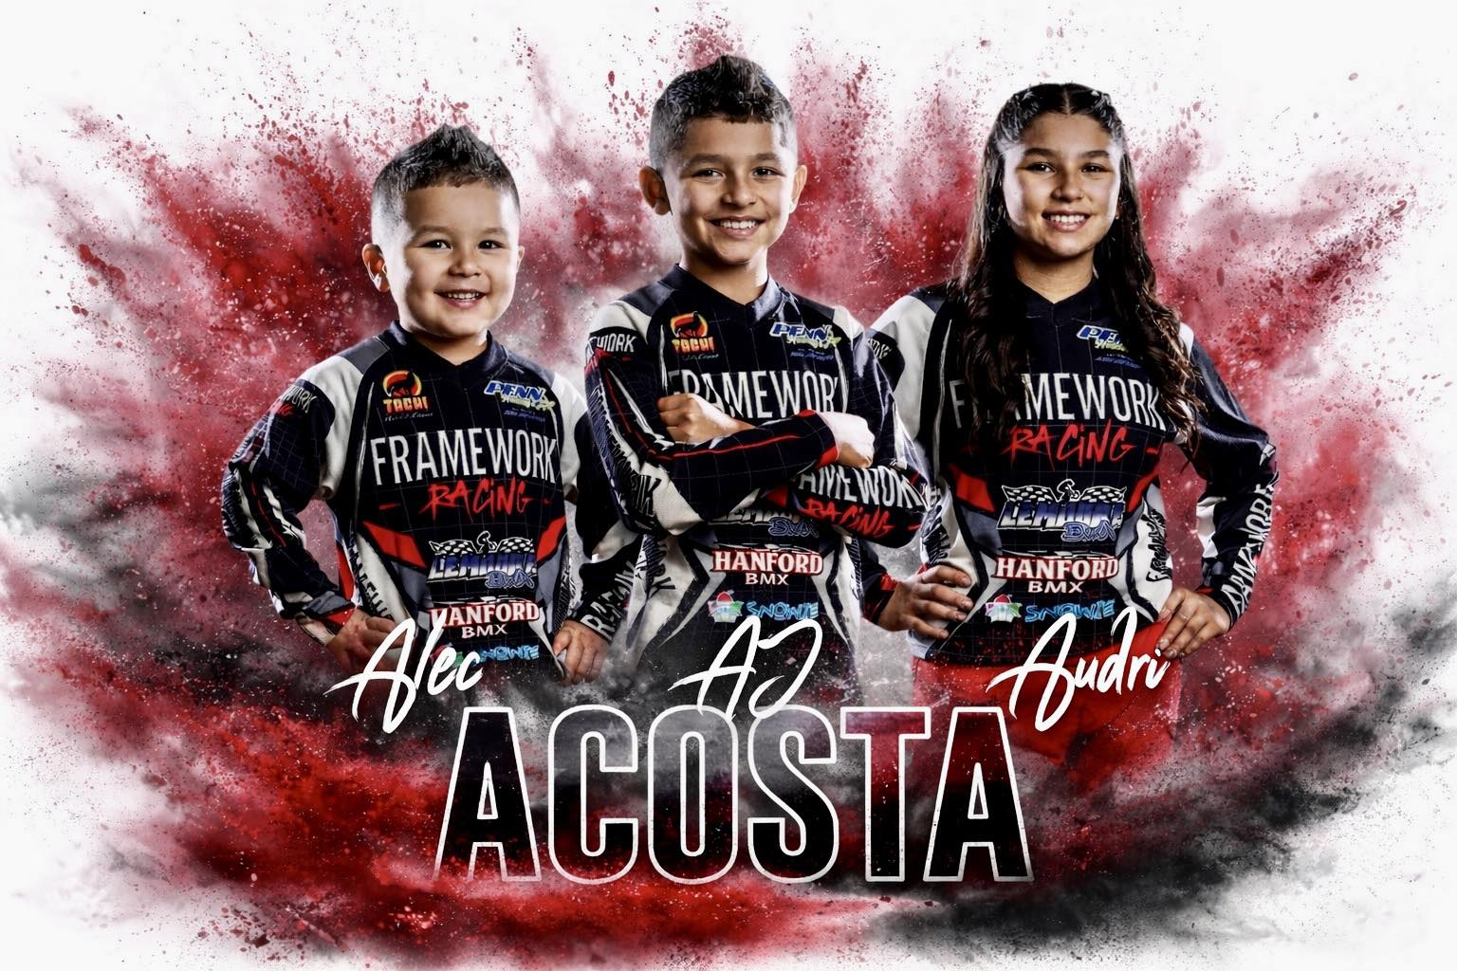
Customer: (2026-06-01 22:55)
For an X-Large tee shirt
Customer: (2026-06-01 22:55)
I need about 4 of them
Agent: (2026-06-01 22:56)
It will cost $20 plus shipping
Customer: (2026-06-01 22:57)
What the measurements
Agent: (2026-06-01 22:57)
What is your shipping address with zip code
Customer: (2026-06-01 22:57)
93245
Agent: (2026-06-01 22:57)
For XL it will be about 12 x 14
Customer: (2026-06-01 22:58)
Perfect
Customer: (2026-06-01 22:58)
$20 for each
Agent: (2026-06-01 22:58)
$20 for 4
Agent: (2026-06-01 22:59)
$5 each
Customer: (2026-06-01 22:59)
Ok can I have all the details
Customer: (2026-06-01 23:00)
Like an ordered form or how do I do that to send my payment
Agent: (2026-06-01 23:01)
Shipping cost is $17
Customer: (2026-06-01 23:01)
That’s fine
Agent: (2026-06-01 23:02)
You need transfers right ?
Customer: (2026-06-01 23:03)
Dtf yes
Agent: (2026-06-01 23:03)
Not t-shirts
Customer: (2026-06-01 23:03)
No tee shirts
Agent: (2026-06-01 23:03)
Ok
Agent: (2026-06-01 23:04)
Total cost is $37 including shipping .
Process time is 1-2 days . Standard shipping is 4 days
Customer: (2026-06-01 23:04)
Ok
Agent: (2026-06-01 23:05)
You can pay by Zelle or PayPal thru our company’s office id
Agent: [sent a mockup / design back]
Agent: (2026-06-01 23:06)
Email id is : info@decoinks.com
Customer: (2026-06-01 23:06)
Ok I will see if my grandson can do this for me because I don’t have Zelle or PayPal
Customer: (2026-06-01 23:07)
Thank you
Agent: (2026-06-01 23:07)
Ok
Agent: (2026-06-01 23:07) [LAST]
Our website is :
www.decoinks.com

12. Kayy Mulaa — ✅ ORDERED
Outcome | Placed a one-time order
Order value | $50.00
Products discussed | DTF transfers
Stage reached | quoted
Messages | 36 · customer artworks shared: 2
What happened | Kayy Mulaa is interested in ordering DTF transfers for custom apparel. They inquired about the minimum order quantity and shipping times, and they have decided on ordering 15 transfers for a total cost of $50 plus shipping. The next steps involve sending their artwork for sizing assistance.
Complete conversation:
Agent: (2026-06-13 17:41) [FIRST]
Kayy Mulaa replied to an ad.
Agent: (2026-06-13 17:41)
Hi Kayy! Please let us know how we can help you.
Agent: (2026-06-13 17:41)
Hi Kayy! We wanted to follow up. Do you have any questions?
Customer: (2026-06-13 17:41)
What is the minimum order quantity?
Agent: (2026-06-13 17:41)
Kayy Mulaa replied to an ad.
Agent: (2026-06-13 17:41)
Our minimum order is $25, which is approximately 60 inches of DTF transfers. If you're unsure about sizing, send us your artwork and we'll help you calculate the required inches.
Agent: (2026-06-13 17:41)
Hi Kayy! Please let us know how we can help you.
Customer: (2026-06-13 17:41)
How long does shipping take?
Agent: (2026-06-13 17:41)
Hi Kayy! We wanted to follow up. Do you have any questions?
Customer: (2026-06-13 17:41)
What do I get with the 1000-inch bulk offer?
Agent: (2026-06-13 17:41)
Production takes 1–2 business days, with standard shipping taking 2–5 business days within the USA. Rush production and expedited shipping are also available for urgent orders.
Agent: (2026-06-13 17:41)
Buy 1000 inches, get 100 inches FREE, plus enjoy an extra 10% OFF your order!
Agent: (2026-06-13 17:41)
Pls share your designs and I will guide you further
Customer: (2026-06-13 17:42)
Where do ii send my transfers to so I can get the size
Agent: (2026-06-13 17:42)
You can send here
Customer: (2026-06-13 17:42)
What is the minimum order quantity?
Agent: (2026-06-13 17:42)
Our minimum order is $25, which is approximately 60 inches of DTF transfers. If you're unsure about sizing, send us your artwork and we'll help you calculate the required inches.
Agent: (2026-06-13 17:43)
We our our designs who can modify and get them print ready
Customer: (2026-06-13 17:43)
Where do ii send my work to
Agent: (2026-06-13 17:43)
Pls send here or email at info@decoinks.com
Agent: (2026-06-13 17:44)
But you can send here
Agent: (2026-06-13 17:44)
Use the attachment icon and send here
Customer shared their artwork: (2026-06-13 17:44)
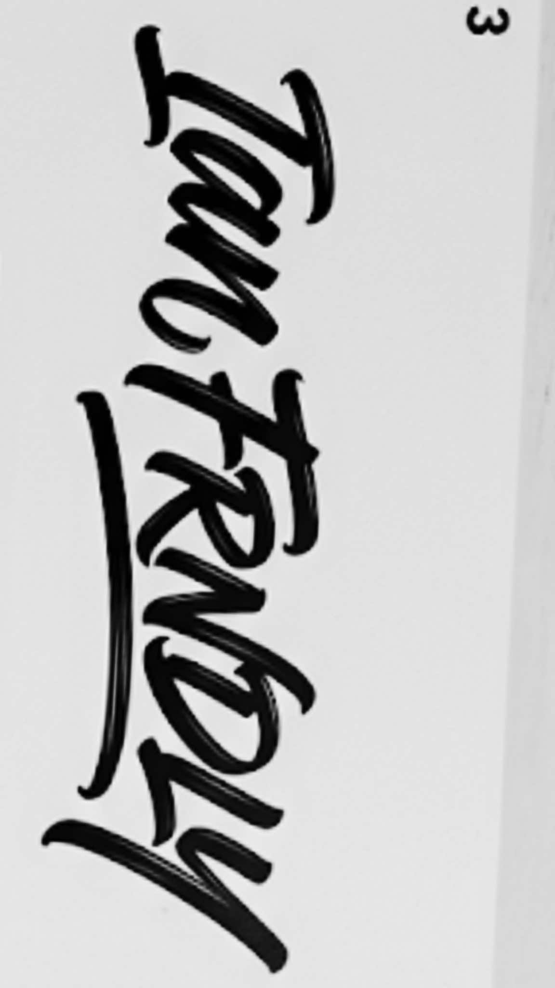
Agent: (2026-06-13 17:45)
How many of that do you need ? Only one design or more ?
Customer shared their artwork: (2026-06-13 17:45)
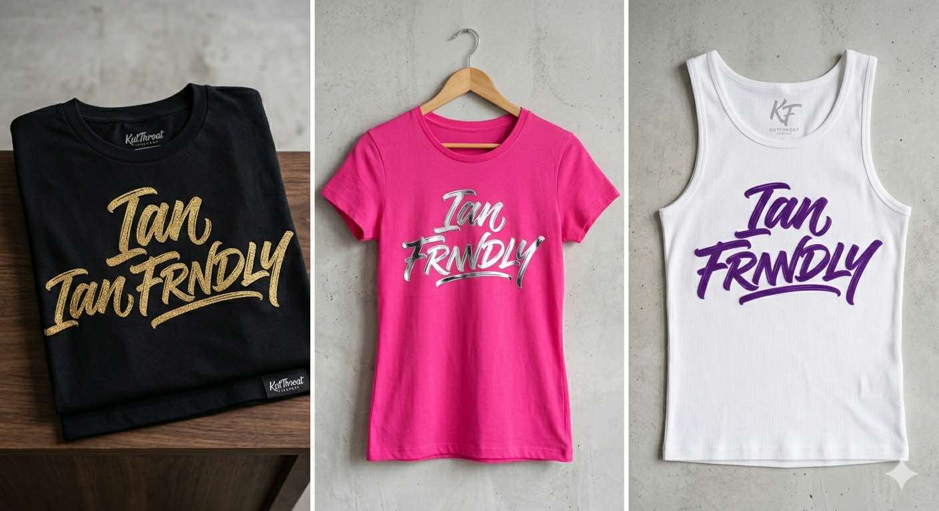
Customer: (2026-06-13 17:45)
All those ways
Agent: (2026-06-13 17:46)
That’s fine
Agent: (2026-06-13 17:46)
Do you need all type of layout as per your designs
Customer: (2026-06-13 17:46)
Yes those colors && exact layouts
Agent: (2026-06-13 17:49)
How many total of them do you need
Agent: (2026-06-13 17:49)
And each of it
Customer: (2026-06-13 17:50)
At least 5 of each
Agent: (2026-06-13 17:50)
So total 15
Agent: (2026-06-13 17:51)
Do you know the artwork size ?
Agent: (2026-06-13 17:54)
It will cost $50 plus shipping for 15 transfers
Agent: (2026-06-13 17:55) [LAST]
Pls share your address with zip code for shipping cost

13. Stephaniy GoGra — ✗ LEFT WITHOUT ORDERING
Outcome | Inquired, then left without ordering
Order value | —
Products discussed | mandiles
Stage reached | inquiry
Messages | 6 · customer artworks shared: 1
What happened | El cliente está interesado en imprimir 12 mandiles con el logotipo de Ford para un evento, pero se le informó que no se pueden imprimir diseños protegidos por derechos de autor. El cliente también preguntó sobre la posibilidad de imprimir camisetas para su negocio. Actualmente, no hay un pedido confirmado.
Complete conversation:
Customer: (2026-06-17 12:40) [FIRST]
Hola, necesito imprimir 12 mandiles con el logotipo de Ford para un evento. Yo ya tengo los mandiles. ¿Cuánto me cobrarían por el trabajo y en cuánto tiempo podrían tenerlos listos? Los necesito antes del martes. ¡Gracias!
Agent: (2026-06-17 12:40)
Hola,
Gracias por contactarnos. Lamentablemente, no podemos imprimir diseños, logotipos o marcas registradas protegidas por derechos de autor sin la autorización correspondiente. El logotipo de Ford es una marca registrada y, por esa razón, no podemos producir este pedido.
Agradecemos su comprensión. Si desea un diseño personalizado u otro arte que no esté protegido por derechos de autor, estaremos encantados de ayudarle.
¡Gracias por su comprensión!
Customer: (2026-06-17 12:40)
Hola y para camisas de mi negocio si pueden?
Agent: (2026-06-17 12:40)
Sí, podemos hacer camisetas para su empresa. Por favor, envíenos su diseño.
Customer shared their artwork: (2026-06-17 12:40)
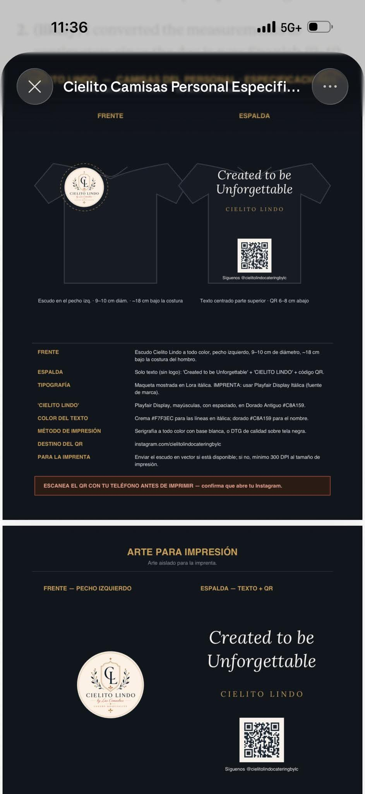
Customer: (2026-06-17 12:40) [LAST]
algo por el estilo

14. Cathy Riley — ✗ LEFT WITHOUT ORDERING
Outcome | Inquired, then left without ordering
Order value | —
Products discussed | shirt with a picture
Stage reached | inquiry
Messages | 9 · customer artworks shared: 1
What happened | Cathy Riley reached out regarding printing a picture on a shirt. She inquired about shipping times and confirmed that her design is ready. The conversation is ongoing as she has not yet placed an order.
Complete conversation:
Agent: (2026-06-27 00:07) [FIRST]
Cathy Riley replied to an ad.
Agent: (2026-06-27 00:07)
Hi Cathy! Please let us know how we can help you.
Agent: (2026-06-27 00:07)
Hi Cathy! We wanted to follow up. Do you have any questions?
Customer: (2026-06-27 00:07)
How long does shipping take?
Customer: (2026-06-27 00:07)
can you put this on a shirt
Agent: (2026-06-27 00:07)
Production takes 1–2 business days, with standard shipping taking 2–5 business days within the USA. Rush production and expedited shipping are also available for urgent orders.
Agent: (2026-06-27 00:08)
Is your design ready?
Customer: (2026-06-27 00:08)
It's a picture
Customer shared their artwork: (2026-06-27 00:08)
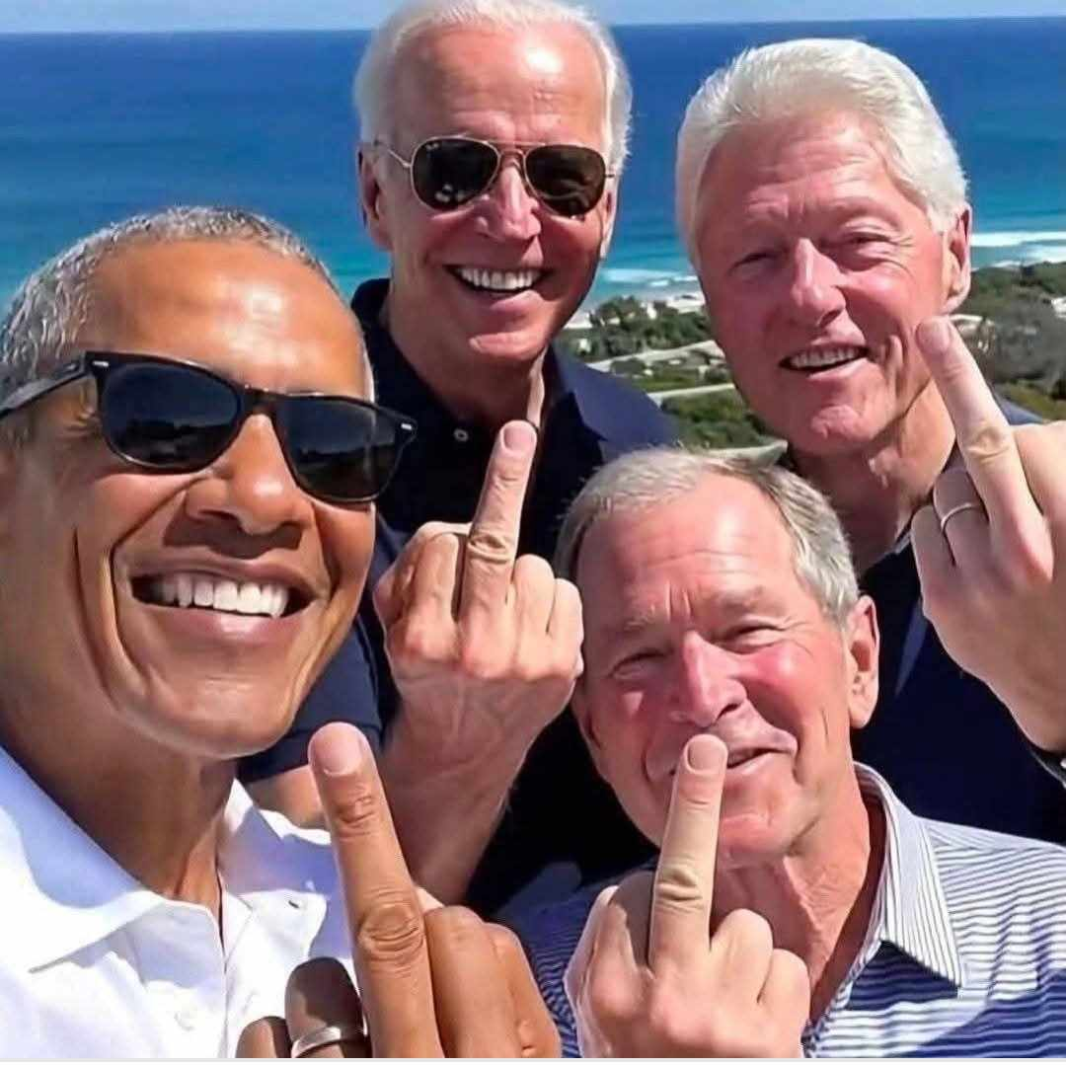

15. Jamicha Wheeler — ✗ LEFT WITHOUT ORDERING
Outcome | Inquired, then left without ordering
Order value | —
Products discussed | custom design services for t-shirts
Stage reached | inquiry
Messages | 10 · customer artworks shared: 1
What happened | The customer is interested in custom design services for apparel, specifically for t-shirts. They inquired about sending a design picture for printing. The conversation indicates a willingness to proceed with the design process.
Complete conversation:
Customer: (2026-06-10 19:21) [FIRST]
Do you offer custom design services?
Agent: (2026-06-10 19:27)
Yes we do
Customer: (2026-06-10 19:29)
Can I send you a picture of a design
Agent: (2026-06-10 19:30)
Yes please
Customer shared their artwork: (2026-06-10 23:28)
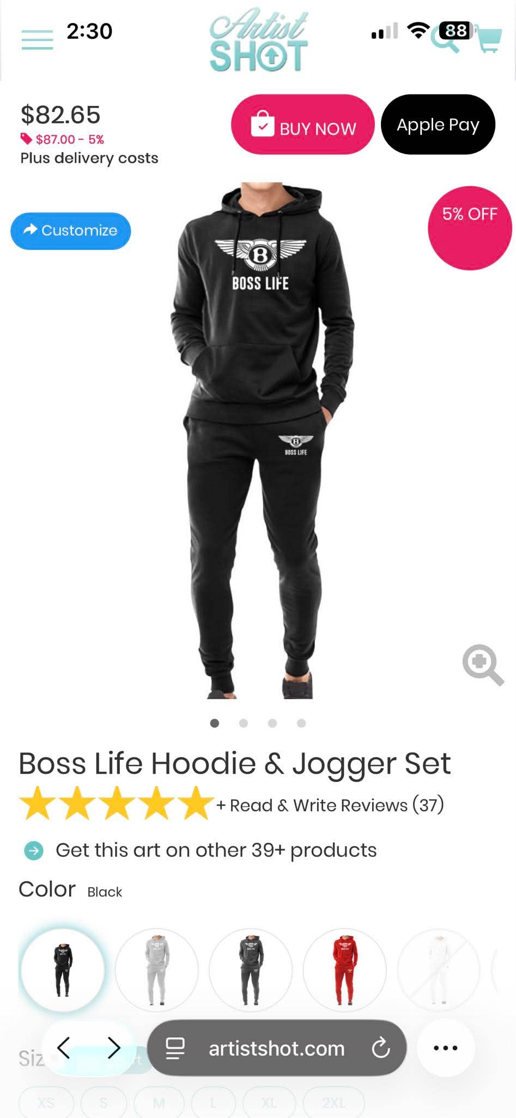
Customer: (2026-06-10 23:28)
Can yall make this design
Agent: (2026-06-11 00:36)
Yes sure
Agent: (2026-06-11 00:44)
How many pcs do you need
Agent: (2026-06-11 00:44)
And two differnet size of transfers t-shirt and bottom
Agent: (2026-06-11 00:44) [LAST]
Or just one for t-shirts front

16. Manuel Gomez — ✗ LEFT WITHOUT ORDERING
Outcome | Inquired, then left without ordering
Order value | —
Products discussed | custom Koi fish transfers
Stage reached | inquiry
Messages | 11 · customer artworks shared: 0
What happened | Manuel Gomez is looking for custom Koi fish transfer designs for his pond business, specifically without flowers. The agent has offered to create designs based on his preferences and is awaiting further details from him.
Complete conversation:
Agent: (2026-06-10 00:25) [FIRST]
Manuel Gomez replied to an ad.
Agent: (2026-06-10 00:25)
Hi Manuel! Please let us know how we can help you.
Customer: (2026-06-10 00:26)
What is the minimum order quantity?
Agent: (2026-06-10 00:33)
60” x 22” gangsheet
Customer: (2026-06-10 00:53)
I have been looking for Koi fish transfer. But the only one so far has flowers, and that's too feminine for our little pond business .
Agent: (2026-06-10 01:21)
We can definitely help with that. We can create custom Koi fish transfer designs without flowers and make them more suitable for your pond business. Do you prefer a realistic Koi fish, Japanese-style artwork, or a logo-style design? If you have your business name or logo, please send it over and we'll create some concepts for you.
Agent: [sent a mockup / design back]
Agent: [sent a mockup / design back]
Agent: [sent a mockup / design back]
Agent: [sent a mockup / design back]
Agent: (2026-06-10 20:53) [LAST]
We have sent you two designs as a sample let us know if you need any changes

17. Facebook user — ✗ LEFT WITHOUT ORDERING
Outcome | Inquired, then left without ordering
Order value | —
Products discussed | custom apparel
Stage reached | inquiry
Messages | 11 · customer artworks shared: 1
What happened | Derrick reached out after seeing an ad for custom apparel. He inquired about shipping times and the possibility of printing specific logos but was informed about copyright issues. Derrick is interested in ordering 12 items of a specific size and is awaiting a price quote.
Complete conversation:
Agent: (2026-07-03 09:47) [FIRST]
Customer replied to an ad.
Agent: (2026-07-03 09:47)
Hi Derrick! Please let us know how we can help you.
Customer: (2026-07-03 09:47)
How long does shipping take?
Agent: (2026-07-03 09:47)
Production takes 1–2 business days, with standard shipping taking 2–5 business days within the USA. Rush production and expedited shipping are also available for urgent orders.
Agent: (2026-07-03 09:47)
Customer replied to an ad.
Agent: (2026-07-03 09:48)
Is your design ready?
Customer: (2026-07-03 10:31)
12 each 2 1/2 ×2 1/2
Customer shared their artwork: (2026-07-03 10:31)

Customer: (2026-07-03 10:31)
Price
Agent: (2026-07-03 10:51)
Thanks for your enquiry but these logos can have copy right infringement issues and we are not autorize to print them. Thanks for your understanding.
You are always welcome to approach us when you want to print any other ideas or designs . Our design team can support without any additional charges.
Agent: (2026-07-04 02:20) [LAST]
Customer replied to an ad.

18. Harold Williams — ✗ LEFT WITHOUT ORDERING
Outcome | Inquired, then left without ordering
Order value | —
Products discussed | custom printed t-shirts
Stage reached | inquiry
Messages | 13 · customer artworks shared: 6
What happened | Harold Williams is interested in custom apparel and inquired about using his own design for printing. The agent confirmed that he can send his artwork for printing. The conversation is ongoing as Harold has not yet provided his design.
Complete conversation:
Agent: (2026-07-06 01:29) [FIRST]
Harold Williams replied to an ad.
Customer: (2026-07-06 01:29)
Can I use my own design?
Agent: (2026-07-06 01:29)
Yes! Just send us your artwork or logo, and we'll print it for you.
Agent: (2026-07-06 01:29)
Hi Harold! Please let us know how we can help you.
Customer shared their artwork: (2026-07-06 01:30)

Customer shared their artwork: (2026-07-06 01:31)

Customer shared their artwork: (2026-07-06 01:34)

Customer shared their artwork: (2026-07-06 01:35)

Customer shared their artwork: (2026-07-06 01:35)

Customer shared their artwork: (2026-07-06 01:36)

Agent: (2026-07-06 03:46)
Do you need transfers or custom printed t-shirts
Agent: (2026-07-06 18:03)
Yes! Just send us your artwork or logo, and we'll print it for you.
Customer: (2026-07-06 20:17) [LAST]
Not yet

19. Ron Amoako — ✗ LEFT WITHOUT ORDERING
Outcome | Inquired, then left without ordering
Order value | —
Products discussed | DTF transfers
Stage reached | inquiry
Messages | 14 · customer artworks shared: 1
What happened | Ron Amoako is interested in placing an order for DTF transfers and inquired about the minimum order quantity. The agent provided information about the minimum order being $25, which corresponds to approximately 60 inches of DTF transfers. Ron has not yet placed an order but is considering sending artwork for further assistance.
Complete conversation:
Agent: (2026-06-26 23:36) [FIRST]
Hi Ron! Please let us know how we can help you.
Customer: (2026-06-26 23:36)
What is the minimum order quantity?
Agent: (2026-06-26 23:36)
Ron Amoako replied to an ad.
Agent: (2026-06-26 23:36)
Our minimum order is $25, which is approximately 60 inches of DTF transfers. If you're unsure about sizing, send us your artwork and we'll help you calculate the required inches.
Customer: (2026-06-26 23:41)
60 X ??
Agent: (2026-06-27 00:25)
Our minimum order is based on 60 linear inches of DTF transfers, not a fixed size.
Agent: (2026-06-27 00:25)
For example, if your design is 12” wide, you would get about 5 prints (12” × 5 = 60”). If your design is smaller, you’ll be able to fit more prints.
Agent: (2026-06-27 00:25)
Just send us your artwork and the size you’d like, and we’ll calculate exactly how many transfers you can get within the minimum order.
Customer shared their artwork: (2026-06-27 00:26)
[customer artwork shared — could not embed]
Agent: (2026-06-27 03:03)
Our Custom design services which is free of cost for our customers . The scope of services including creating designs as per your directives , modification in your existing , T-shirt mock-ups with your artworks and getting ready the final artwork for DTF printing.
Agent: (2026-06-28 02:24)
Hi Ron! Please let us know how we can help you.
Agent: (2026-06-28 02:24)
For example, if your design is 12” wide, you would get about 5 prints (12” × 5 = 60”). If your design is smaller, you’ll be able to fit more prints.
Agent: (2026-06-29 01:51)
Hi Ron! Please let us know how we can help you.
Agent: (2026-06-29 01:51) [LAST]
For example, if your design is 12” wide, you would get about 5 prints (12” × 5 = 60”). If your design is smaller, you’ll be able to fit more prints.

20. Allah Freedom — ✗ LEFT WITHOUT ORDERING
Outcome | Inquired, then left without ordering
Order value | —
Products discussed | t-shirt with logo
Stage reached | inquiry
Messages | 14 · customer artworks shared: 1
What happened | The customer, Allah Freedom, is interested in printing a logo on a 5X t-shirt and inquired about the possibility of using their own design. They have not yet specified the number of transfers needed. The conversation is ongoing, and they are awaiting further instructions.
Complete conversation:
Agent: (2026-07-01 21:41) [FIRST]
Hi Allah! Please let us know how we can help you.
Agent: (2026-07-01 21:41)
Yes! Just send us your artwork or logo, and we'll print it for you.
Customer: (2026-07-01 21:41)
Can I use my own design?
Agent: (2026-07-01 21:41)
Allah Freedom replied to an ad.
Customer shared their artwork: (2026-07-01 21:41)

Customer: (2026-07-01 21:43)
Can you put the logo on the upper left side and on back or just on front size 5X shirt.
Agent: (2026-07-01 21:56)
How many transfers do you need altogehetr
Agent: (2026-07-01 21:56)
Do you need it for just one t-shirt
Agent: (2026-07-01 21:58)
Do you need it for just one t-shirt
Agent: (2026-07-01 22:52)
How many transfers do you need altogehetr
Agent: (2026-07-01 22:53)
How many transfers do you need altogehetr
Agent: (2026-07-02 16:59)
How many transfers do you need altogehetr
Agent: (2026-07-02 17:00)
How many transfers do you need altogehetr
Agent: (2026-07-02 21:12) [LAST]
Yes! Just send us your artwork or logo, and we'll print it for you.

21. Kimberly Evans Porter — ✗ LEFT WITHOUT ORDERING
Outcome | Inquired, then left without ordering
Order value | —
Products discussed | DTF transfers
Stage reached | inquiry
Messages | 15 · customer artworks shared: 2
What happened | Kimberly Evans Porter is inquiring about DTF transfers for a DIY project. She has asked multiple questions regarding pricing, minimum order quantity, and shipping times. The conversation is ongoing, and no order has been placed yet.
Complete conversation:
Customer: (2026-07-02 03:33) [FIRST]
How long does shipping take?
Agent: (2026-07-02 03:33)
Hi Kimberly! Please let us know how we can help you.
Agent: (2026-07-02 03:33)
Kimberly Evans Porter replied to an ad.
Customer: (2026-07-02 03:33)
What is the minimum order quantity?
Agent: (2026-07-02 03:33)
Production takes 1–2 business days, with standard shipping taking 2–5 business days within the USA. Rush production and expedited shipping are also available for urgent orders.
Agent: (2026-07-02 03:34)
Our minimum order is $25, which is approximately 60 inches of DTF transfers. If you're unsure about sizing, send us your artwork and we'll help you calculate the required inches.
Agent: (2026-07-02 03:34)
Kimberly Evans Porter replied to an ad.
Customer shared their artwork: (2026-07-02 03:35)
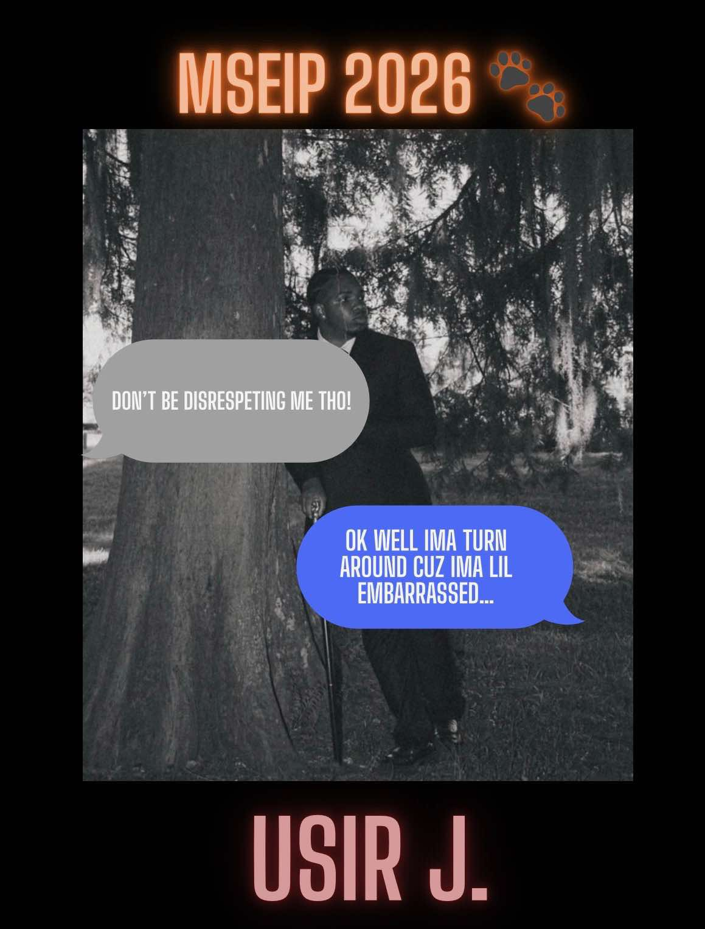
Customer: (2026-07-02 03:36)
How much for this to be on a diy transfer? 9/11
Customer shared their artwork: (2026-07-02 07:37)

Customer: (2026-07-02 10:00)
How long does shipping take?
Agent: (2026-07-02 10:01)
Our minimum order is $25, which is approximately 60 inches of DTF transfers. If you're unsure about sizing, send us your artwork and we'll help you calculate the required inches.
Customer: (2026-07-02 13:39)
How long does shipping take?
Agent: (2026-07-02 21:12)
Kimberly Evans Porter replied to an ad.
Agent: (2026-07-02 21:12) [LAST]
Production takes 1–2 business days, with standard shipping taking 2–5 business days within the USA. Rush production and expedited shipping are also available for urgent orders.

22. Zbo Zia Shelly — ✗ LEFT WITHOUT ORDERING
Outcome | Inquired, then left without ordering
Order value | —
Products discussed | DTF transfers
Stage reached | inquiry
Messages | 16 · customer artworks shared: 1
What happened | Zbo Zia Shelly is in urgent need of shirt prints for an upcoming event this weekend due to a last-minute cancellation from another provider. They reached out for assistance and are looking for guidance on how many transfers and sizes they need. The team has provided information on production and shipping timelines.
Complete conversation:
Agent: (2026-06-16 05:46) [FIRST]
Zbo Zia Shelly replied to an ad.
Agent: (2026-06-16 05:46)
Hi Zbo! Please let us know how we can help you.
Agent: (2026-06-16 05:46)
Hi Zbo! We wanted to follow up. Do you have any questions?
Customer: (2026-06-16 05:46)
How long does shipping take?
Agent: (2026-06-16 05:46)
Production takes 1–2 business days, with standard shipping taking 2–5 business days within the USA. Rush production and expedited shipping are also available for urgent orders.
Agent: (2026-06-16 05:46)
Pls share your designs and I will guide you further
Customer: (2026-06-16 05:46)
Hi, desperate need for prints for shirts, for this weekend. My person kinda bailed on me & now im looking for someone who can print my design. Lemme knw if u can help in a way or two.
Agent: (2026-06-16 05:46)
pls share your designs and how many of them do you need
Agent: (2026-06-16 05:46)
We'll surely help you but need your information quickly
Customer shared their artwork: (2026-06-16 05:46)

Agent: (2026-06-16 05:46)
You need one with multiple versions for each member , right ?
Agent: (2026-06-16 05:46)
You need one designwith multiple versions for each member , right ?
Customer: (2026-06-16 05:46)
im sorry i dont understand
Agent: (2026-06-16 05:46)
how many transfers do you need of this design and what size ?
Agent: (2026-06-16 05:46)
sometimes on birthday even , people print the names of the participant for each
Agent: (2026-06-16 05:46) [LAST]
Pls let me know the no of transfers you need in this design , and do you want the specific size for that

23. Richard Palmer — ✗ LEFT WITHOUT ORDERING
Outcome | Inquired, then left without ordering
Order value | —
Products discussed | custom T-shirt
Stage reached | inquiry
Messages | 16 · customer artworks shared: 1
What happened | Richard Palmer is interested in ordering custom T-shirts for himself and his mother. He inquired multiple times about the cost of a custom T-shirt and was informed that the price starts at $16 plus shipping. However, he has not yet provided specific details regarding the quantity or design.
Complete conversation:
Agent: (2026-07-03 22:57) [FIRST]
Richard Palmer replied to an ad.
Agent: (2026-07-03 22:57)
Hi Richard! Please let us know how we can help you.
Agent: (2026-07-03 22:57)
Hi Richard! We wanted to follow up. Do you have any questions?
Customer: (2026-07-03 22:57)
How much does a custom T-shirt cost?
Agent: (2026-07-03 22:57)
Prices vary based on quantity, design, and shirt style. Send us your details for a FREE quote!
Agent: (2026-07-03 22:58)
if you could pls inform us the quantity ,we can quote you our best offer
Agent: (2026-07-03 22:58)
Our custom design servies is absolutely free with the orders. The scope of our custom designing including creative design, your design modifications, T-Shirt Mock-ups and getting artworks ready for final dtf printing. All these for no charges !
Agent: (2026-07-03 22:59)
So pls share your design and qty of shirts you need
Customer shared their artwork: (2026-07-03 23:00)
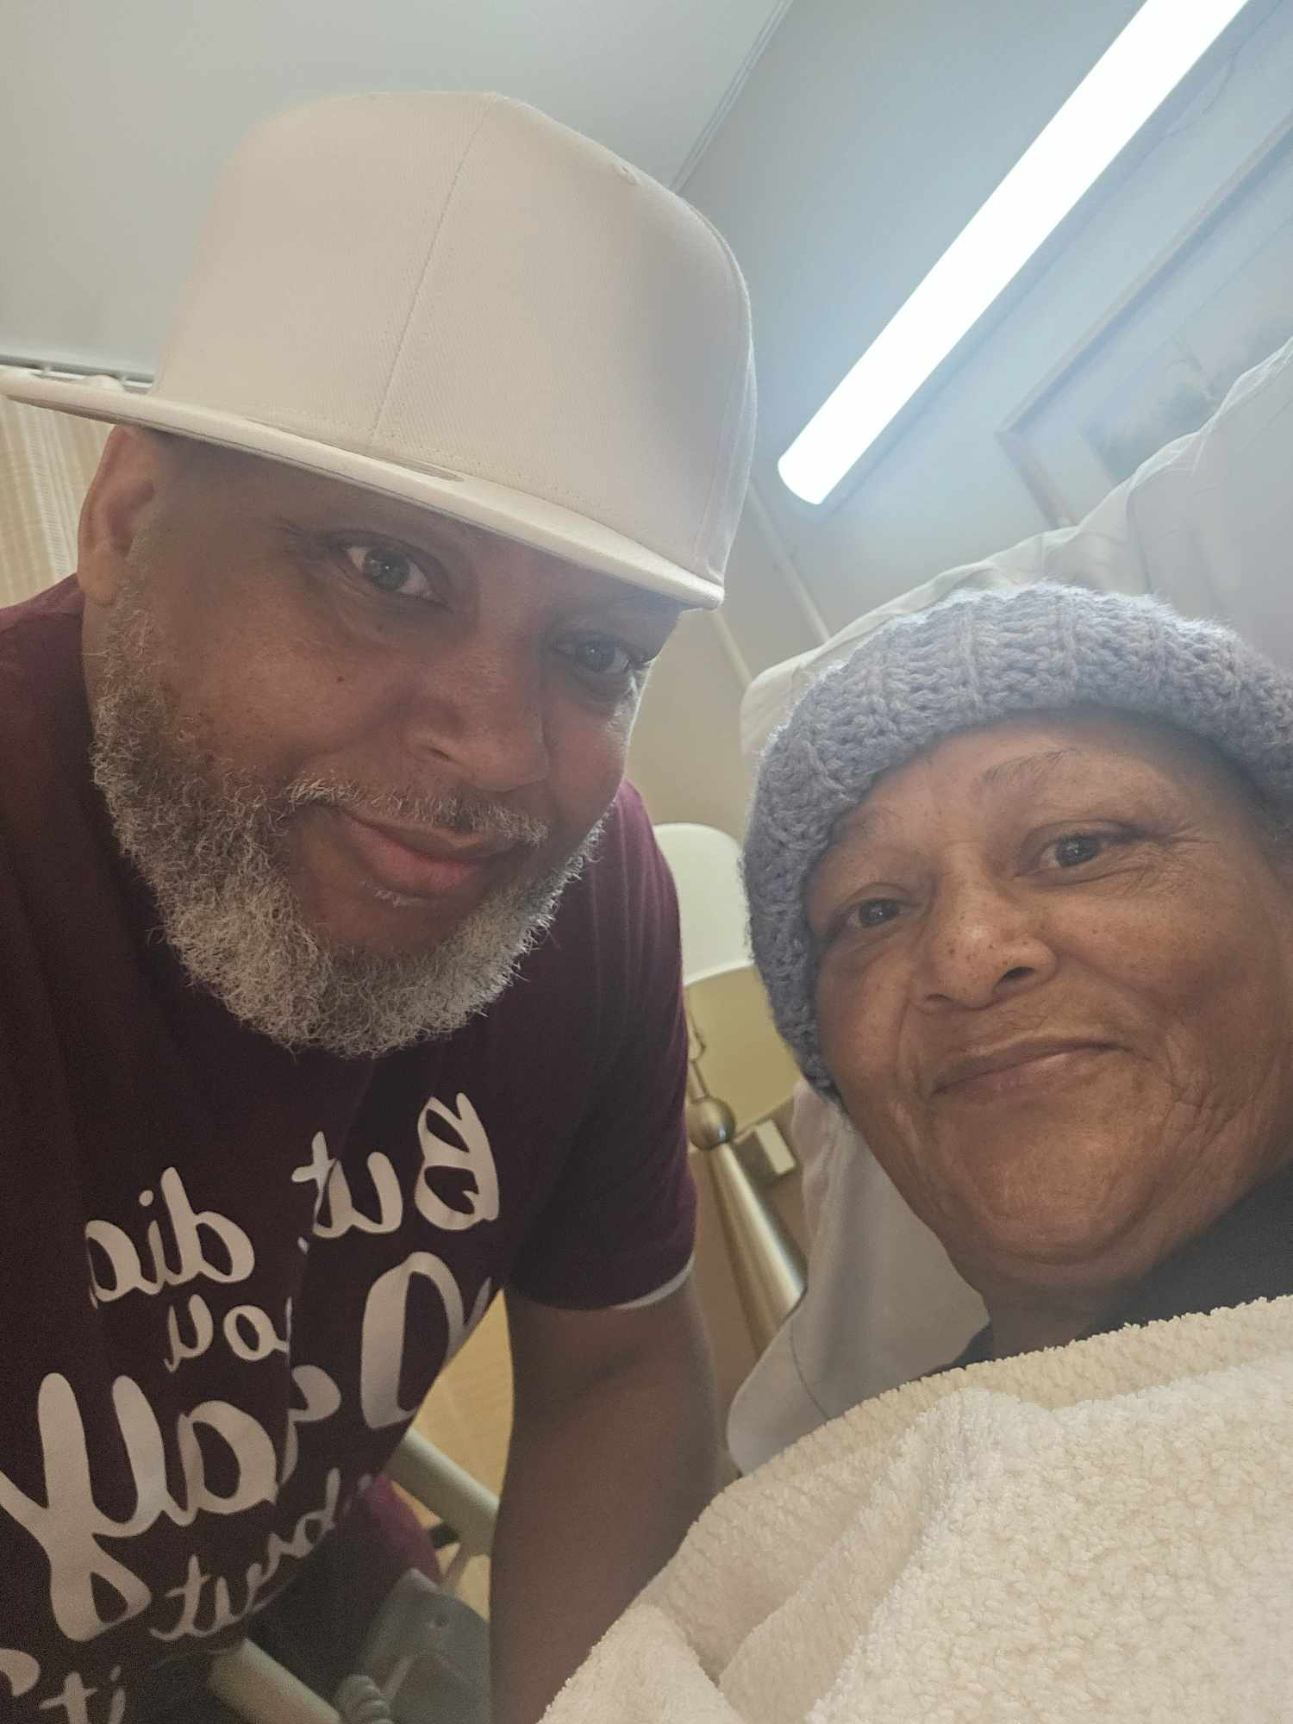
Customer: (2026-07-03 23:01)
Mom and me 1 custom made shirt
Agent: (2026-07-03 23:01)
it will cost yu $16 plus shipping cost
Agent: (2026-07-04 05:15)
Richard Palmer replied to an ad.
Agent: (2026-07-04 21:33)
Richard Palmer replied to an ad.
Agent: (2026-07-04 21:34)
Richard Palmer replied to an ad.
Customer: (2026-07-05 03:05)
How much does a custom T-shirt cost?
Customer: (2026-07-05 03:32) [LAST]
How much does a custom T-shirt cost?

24. Manuel Gali — ✗ LEFT WITHOUT ORDERING
Outcome | Inquired, then left without ordering
Order value | —
Products discussed | custom logos for t-shirts
Stage reached | inquiry
Messages | 18 · customer artworks shared: 1
What happened | Manuel Gali is looking to order custom logos for t-shirts, specifically 50 designs featuring brands and letters. He inquired about pricing and requested a catalog to choose from. The agent provided links to design options and is awaiting further details from Manuel.
Complete conversation:
Agent: (2026-06-29 02:27) [FIRST]
Hi Manuel! Please let us know how we can help you.
Agent: (2026-06-29 02:27)
Manuel Gali replied to an ad.
Customer: (2026-06-29 02:27)
hola cual es el precio
Agent: (2026-06-29 02:27)
Hi Manuel! We wanted to follow up. Do you have any questions?
Agent: (2026-06-29 02:51)
Hola. Ofrecemos transferencias DTF y camisetas personalizadas. El precio depende del tamaño de su diseño o impresión. Por favor, compártanos el diseño que desea imprimir o indíquenos el tema que está buscando, como religión, escuelas, deportes o cualquier otra categoría. Con gusto le mostraremos opciones de nuestra biblioteca de diseños para que pueda elegir y le proporcionaremos la mejor cotización.
Customer: (2026-06-29 02:53)
Quiero logos para pecho para personalizar playeras unos 50 diseños
Agent: (2026-06-29 03:01)
Manuel Gali replied to an ad.
Agent: (2026-06-29 03:43)
Manuel Gali replied to an ad.
Agent: (2026-06-29 04:17)
Indíquenos qué tipo de diseños está buscando. ¿De qué categoría los necesita? Por ejemplo: profesiones, deportes, religión, Halloween, animales, vehículos, naturaleza o cualquier otro tema. Con gusto le mostraremos opciones para que pueda elegir.
Customer shared their artwork: (2026-06-29 04:28)
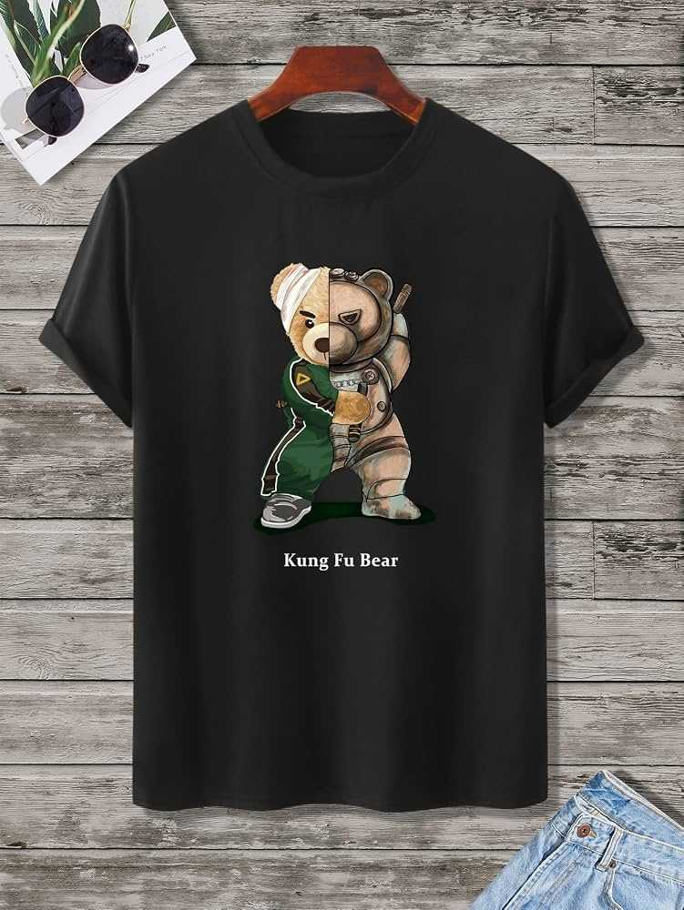
Customer: (2026-06-29 04:29)
Marcas ,y algunas letras
Agent: (2026-06-29 04:33)
Perfecto. Lo enviaré a nuestro equipo de diseño para que comience a trabajar en ello. ¿Cuántas transferencias necesita de cada diseño?
Customer: (2026-06-29 04:34)
Si tiene catalogo para elegir
Agent: (2026-06-29 04:40)
Puede ver algunos de nuestros diseños en nuestra página de Pinterest:
https://www.pinterest.com/decoinks/
También puede buscar ideas en otros sitios web, como:
https://www.teepublic.com
Si encuentra algún diseño o estilo que le guste, envíenoslo y con gusto le ayudaremos a preparar su pedido.
Customer: (2026-06-29 19:26)
Marcas ,y algunas letras
Customer: (2026-06-30 04:23)
Si tiene catalogo para elegir
Customer: (2026-06-30 04:23)
Si tiene catalogo para elegir
Agent: (2026-06-30 22:23) [LAST]
Hola. Ofrecemos transferencias DTF y camisetas personalizadas. El precio depende del tamaño de su diseño o impresión. Por favor, compártanos el diseño que desea imprimir o indíquenos el tema que está buscando, como religión, escuelas, deportes o cualquier otra categoría. Con gusto le mostraremos opciones de nuestra biblioteca de diseños para que pueda elegir y le proporcionaremos la mejor cotización.

25. Angel Miranda — ✗ LEFT WITHOUT ORDERING
Outcome | Inquired, then left without ordering
Order value | —
Products discussed | DTF transfers
Stage reached | inquiry
Messages | 19 · customer artworks shared: 2
What happened | Angel Miranda reached out after seeing an ad, inquiring about DTF transfers. They asked about delivery times and pricing for 20 XL transfers. The conversation is ongoing as they have yet to provide their designs for further assistance.
Complete conversation:
Agent: (2026-06-08 04:23) [FIRST]
Angel Miranda replied to an ad.
Agent: (2026-06-08 04:23)
Hi Angel! Please let us know how we can help you.
Customer: (2026-06-08 04:23)
How long does delivery take?
Agent: (2026-06-08 04:23)
Fast shipping 🚚
DTF transfers are usually shipped within 1–2 business days after confirmation
Agent: (2026-06-08 04:34)
Pls share your design and we can guide you futher
Agent: (2026-06-08 04:34)
Our design services provide cusomization and getting print ready the designs you send with no additional charges
Agent: (2026-06-10 13:10)
Angel Miranda replied to an ad.
Agent: (2026-06-10 13:10)
Hi Angel! Please let us know how we can help you.
Customer: (2026-06-10 13:10)
Do you have like this?
Agent: (2026-06-10 13:55)
pls send your design
Customer shared their artwork: (2026-06-10 14:28)
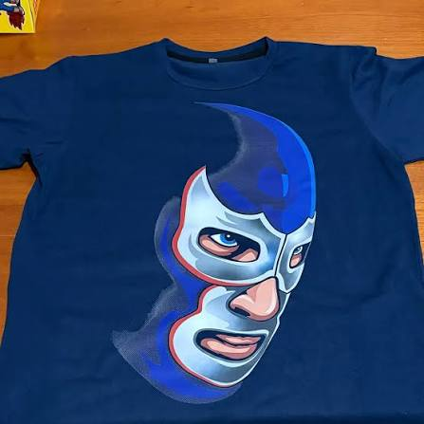
Customer: (2026-06-10 14:28)
Like this
Agent: (2026-06-10 14:44)
Do you want these two designs which you shared?
Customer shared their artwork: (2026-06-10 15:47)

Agent: (2026-06-10 15:55)
How many pcs do you need for each design?
Customer: (2026-06-10 16:01)
How mouch for 20
Agent: (2026-06-10 16:02)
Can you please tell us the size so that we can give you rate accordingly
Customer: (2026-06-10 16:03)
Xl
Agent: (2026-06-10 16:06) [LAST]
You want the transfers right?

