Securing ERC-4337 Paymasters
A Defense Framework Against Abuse and Deposit Drain Attacks

Rahulkumar Rajeshkumar Ankola
Capstone Project | Spring 2026

Abstract
ERC-4337 paymasters are smart contracts that sponsor gas fees on behalf of users, enabling gasless transactions in Account Abstraction architectures. Their open sponsorship model exposes them to deposit drain attacks, spam exploitation, and gas penalty abuse. This paper presents a comparative security analysis of two paymaster implementations deployed on the Ethereum Sepolia testnet: a permissive Baseline Paymaster serving as a control, and a Secured Paymaster enforcing gas caps, contract whitelisting, per-user and per-dapp daily quotas, and cryptographic sponsorship authorization. Attack simulations across two traffic mixes (80/10/10 valid/overcap/non-whitelist and 100% valid) demonstrate that the Secured Paymaster eliminates all simulated exploit costs with a break-even malicious traffic threshold of approximately 17.87%, yielding $1,600/month in projected savings at 100k transactions with 20% attack traffic. A hybrid routing strategy is proposed for production deployments.

Keywords: ERC-4337, Account Abstraction, Paymaster, Gas Sponsorship, Smart Contract Security, Deposit Drain, Rate Limit



Index

Sr.No | Heading | Page
1 | Introduction  1.1 Problem Statement  1.2 Objective | 4
2 | Background  2.1 ERC-4337 and Account Abstraction  2.2 The ERC-4337 Transaction Flow  2.3 Paymaster Lifecycle and Economics  2.4 Production Deployment Context  2.5 Related Work | 5
3 | Threat Model  3.1 Attacker Capabilities  3.2 Attack Surfaces  3.3 Out of Scope | 7
4 | Baseline Paymaster  4.1 Design  4.2 Limitations | 8
5 | Attach vectors  5.1 Spam and Griefing  5.2 Gas Penalty Exploitation  5.3 Non-Whitelisted Target Exploitation  5.4 PostOp Failure | 9
6 | Secured Paymaster Design  6.1 Gas Cap Enforcement  6.2 Contract Whitelisting  6.3 Quotas and Rate Limiting  6.4 Signature Validation and Replay Protection | 10
7 | System Architecture  7.1 On-Chain Components  7.2 Off-Chain Components | 13
8 | Implementation  8.1 Repository Structure  8.2 Contract Overview  8.3 Key Functions: validatePaymasterUserOp  8.4 Key Functions: postOp  8.5 Implementation Challenges and Resolutions | 14
9 | Methodology  9.1 Test Setup  9.2 Traffic Scenarios  9.3 Metrics Collection | 17
10 | Results  10.1 Cost Analysis: Total Sponsor Drain  10.2 Cost Analysis: Breakdown by Scenario Type  10.3 Performance Analysis: Execution Time  10.4 Tradeoffs Summary | 20
11 | Break-even analysis  11.1 Derivation  11.2 Decision Matrix  11.3 Economic Projection | 23
12 | Deployment strategy  12.1 When to Use Secured vs Baseline  12.2 Hybrid Deployment  12.3 Operational Considerations | 24
14 | Limitation | 25
15 | Future Work | 26
16 | Conclusion | 26

1. Introduction

1.1 Problem Statement
ERC-4337 introduces Account Abstraction (AA) to Ethereum without requiring protocol-level changes, enabling smart contract wallets that can perform actions previously restricted to Externally Owned Accounts (EOAs). A critical enabler of this architecture is the Paymaster, a smart contract that pays gas fees on behalf of users. While this unlocks powerful user experience improvements such as gasless transactions and ERC-20 token payments for gas, it introduces a high-value attack target: the paymaster's ETH deposit.

Poorly secured paymasters are vulnerable to deposit drain attacks, where adversaries craft malicious UserOperations designed to maximally consume the paymaster's deposit. Attack vectors include submitting operations with inflated gas limits to trigger penalty charges, targeting non-whitelisted contracts to probe validation logic, and flooding the paymaster with spam operations to exhaust daily quotas. In production environments, even a small percentage of malicious traffic can result in significant financial losses for protocol operators.

As of 2026, ERC-4337 is live on Ethereum mainnet and major L2s including Arbitrum, Optimism, Polygon, and Base, with production deployments by Coinbase, Alchemy, Biconomy, and others serving millions of transactions. The financial stakes of paymaster security failures are therefore substantial.

1.2 Objective
This project designs, implements, and empirically evaluates a Secured Paymaster that enforces a multi-layered defense framework against known abuse vectors. The core contributions are:
- A production-grade SecuredPaymaster contract with gas cap enforcement, contract whitelisting, per-user and per-dapp daily quotas, and cryptographic sponsorship authorization.
- A permissive BaselinePaymaster deployed as a controlled benchmark for side-by-side comparison.
- End-to-end attack simulation scripts that inject realistic mixed-traffic scenarios (valid, overcap, non-whitelist operations) against both paymasters on the Sepolia testnet.
- Quantitative cost and performance analysis, including a break-even malicious traffic threshold model and production deployment decision matrix.

The goal is to provide protocol operators with evidence-based guidance on when and how to deploy secured paymaster infrastructure.

2. Background

2.1 ERC-4337 and Account Abstraction
ERC-4337, finalized on Ethereum mainnet in March 2023, achieves Account Abstraction at the application layer by introducing a higher-layer pseudo-transaction called a UserOperation. Rather than submitting transactions directly to the Ethereum mempool, users submit UserOperations to a separate mempool managed by a network of Bundlers. Bundlers aggregate multiple UserOperations into a single on-chain transaction and submit it to a singleton EntryPoint smart contract that orchestrates execution.

This architecture separates transaction validation from execution and introduces pluggable components for each wallet's signature scheme, gas payment, and execution logic. Smart contract wallets conforming to the IAccount interface gain programmable authorization, enabling multi-sig, social recovery, session keys, and other advanced features that would require EOA key management in a traditional setup.

2.2 The ERC-4337 Transaction Flow
A complete UserOperation lifecycle proceeds through the following stages:
- User constructs a UserOperation struct containing sender, nonce, callData, gas parameters, and paymaster data.
- UserOperation is submitted to the alt mempool and picked up by a Bundler.
- Bundler calls EntryPoint.handleOps(), which invokes the Paymaster's validatePaymasterUserOp() during the validation phase.
- If validation passes, the Paymaster approves sponsorship and pre-funds the EntryPoint for the estimated gas cost.
- EntryPoint executes the UserOperation's callData on the sender smart account.
- EntryPoint calls the Paymaster's postOp() to settle actual gas costs, with only 90% of unused pre-fund refunded.

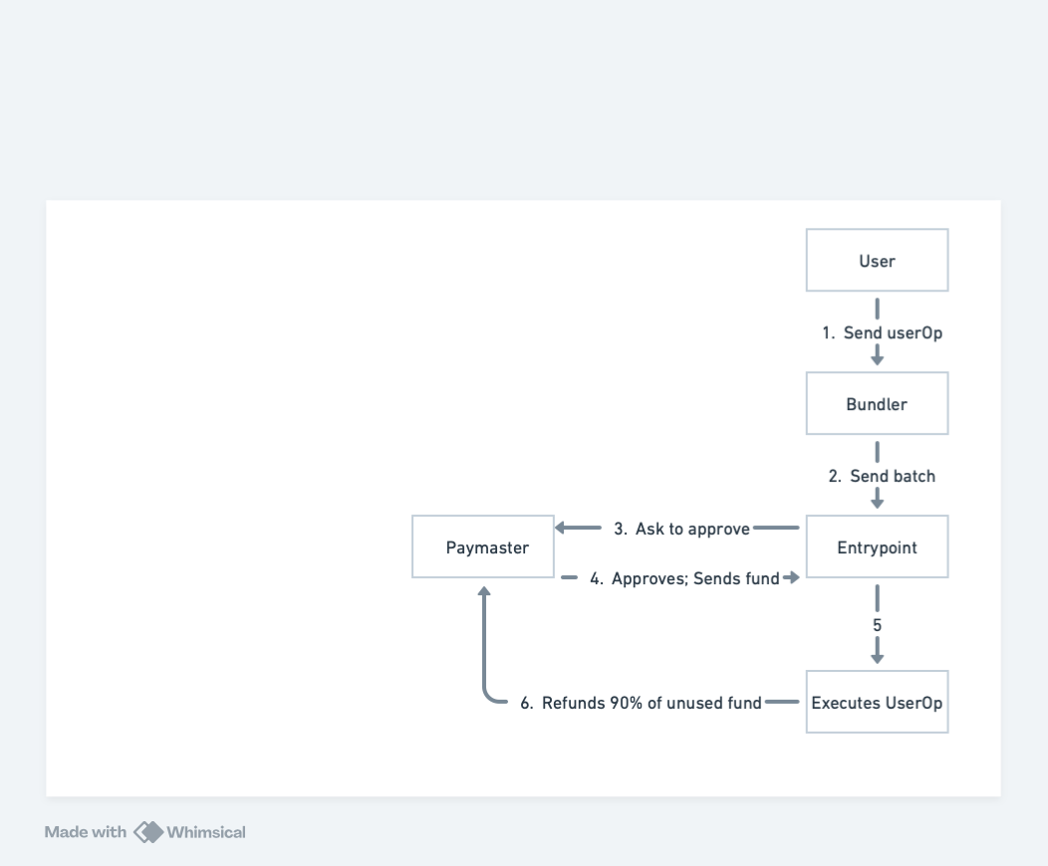
Figure 1. ERC-4337 transaction lifecycle with Baseline Paymaster.

2.3 Paymaster Lifecycle and Economics
Paymasters maintain an ETH deposit at the contract. During validation, the EntryPoint reserves a requiredPreFund amount (computed from the UserOperation's gas limits) from this deposit. If the operation is rejected post-validation by a bundler (e.g., due to simulation failure), the paymaster may incur a penalty charge of up to 10% of the pre-fund as a grieving deterrent defined in EIP-4337. Actual execution costs are settled in postOp, with unused gas returned.

This economic model creates two attack surfaces: (1) the validation phase, where inflated gas limits can trigger large pre-fund reservations and potential penalty charges, and (2) the execution phase, where unlimited sponsorship allows adversaries to drain the deposit through high volumes of operations.

2.4 Production Deployment Context
ERC-4337 paymasters are no longer experimental. Coinbase Smart Wallet, Alchemy's Gas Manager, Biconomy, ZeroDev, and Safe all operate sponsored-transaction infrastructure on Ethereum mainnet and major L2s including Arbitrum, Optimism, Polygon, and Base. Web3 gaming platforms (Immutable, Sequence, Gods Unchained) sponsor millions of in-game micro-transactions to remove wallet friction; DeFi protocols use paymasters to enable ERC-20 gas payment and complex multi-step flows; enterprise providers use them for treasury-controlled corporate wallets. Across these deployments, paymaster deposits collectively hold tens of millions of dollars in ETH, making any systemic vulnerability in paymaster validation logic a high-value target for adversaries.

2.5 Related Work
This project synthesizes and extends prior work on ERC-4337 security from three complementary streams: academic vulnerability analysis, vendor-published security disclosures, and industry best-practice guidance. The literature broadly agrees on the attack surfaces but lacks an empirically-quantified comparison of mitigation strategies — the gap this work addresses.

2.5.1 Academic Analysis of Account Abstraction Security
Boi et al., "Account Abstraction, Analysed" (arXiv:2309.00448), provides an early systematic analysis of ERC-4337 from a security standpoint. The paper argues that moving authorization, gas payment, and execution policy from the protocol layer into smart contracts shifts the security burden onto application developers. The authors highlight that programmability at the paymaster layer is a double-edged sword: it unlocks novel UX patterns but introduces a class of validation-logic bugs that did not exist with protocol-enforced gas payment. Their analysis identifies griefing through gas penalties and unbounded sponsorship as the two primary economic attack surfaces, but does not quantify the cost of these attacks in deployed systems. This work builds on their categorization by implementing both vulnerable and hardened reference paymasters and measuring the actual ETH cost of each attack vector under controlled conditions on Sepolia.

2.5.2 Vendor Security Research on UserOperation Encoding
Alchemy's research team has published technical analyses identifying signature-related vulnerabilities in early ERC-4337 implementations, particularly around how UserOperation hashes are constructed. Their findings show that signing fewer fields than required (for example, omitting callData or initCode from the digest) allows an attacker to substitute the omitted fields after signature, leading to unauthorized sponsorship. This motivated the present work's design of the sponsorship signature digest, which explicitly binds paymaster contract address, chainId, virtualUserId, validUntil, sponsorshipNonce, and sponsoredMaxCostWei into the signed payload, and enforces strict nonce-replay protection through an on-chain consumed-nonce mapping.

2.5.3 Industry Defensive Patterns
Industry practitioners — including Calibraint, Stackup, and Pimlico — have published architectural guidance advocating quotas, target whitelisting, and gas caps as the minimum defense set for production paymasters. These recommendations are typically presented as design patterns rather than measured controls, and individual operators are left to estimate the cost-benefit tradeoff. The Secured Paymaster implemented in this project translates these recommendations into a concrete, auditable Solidity contract and provides the first empirical break-even analysis (Section 11) tying their cost to observed attack rates.

2.5.4 Position of This Work
Prior literature establishes the threat surface and recommends mitigations qualitatively. This project's contribution is to (a) implement a complete, side-by-side baseline-vs-secured deployment, (b) replay an identical, randomized traffic mix against both implementations, and (c) derive a closed-form break-even threshold (~17.87%) above which the secured design is strictly preferable on both cost and latency. The result is a deployment decision matrix grounded in measured cost, not assumed cost.

3. Threat Model

3.1 Attacker Capabilities
We model an adversary with the following capabilities:
- Ability to create arbitrary smart contract wallet addresses and submit UserOperations to the public alt mempool.
- Knowledge of the paymaster contract address and its ABI, which are publicly visible on-chain.
- Ability to craft UserOperations with arbitrary gas parameters, callData, and paymasterAndData fields.
- No privileged access to the paymaster's signing keys, admin functions, or off-chain infrastructure.
- Ability to execute attacks at high frequency, limited only by Sepolia/mainnet mempool rate limits.

3.2 Attack Surfaces

3.2.1 Gas Penalty Exploitation
A paymaster with no gas cap enforcement will approve UserOperations with arbitrarily high gas limits. If the bundler's simulation then rejects the operation on-chain (e.g., due to out-of-gas in execution), EIP-4337 allows the bundler to charge the paymaster a penalty proportional to the pre-fund. An attacker can systematically submit operations with inflated gas limits (e.g., 5x normal) to maximally trigger these penalty deductions.

3.2.2 Non-Whitelisted Target Exploitation
Without target whitelisting, a paymaster will sponsor gas for calls to any contract address. An attacker can route operations through arbitrary contracts that may cause execution failures, trigger edge-case gas behaviors, or simply consume sponsorship budget on operations unrelated to the paymaster operator's intended use case.

3.2.3 Quota Exhaustion / Spam
With no rate limiting, a single attacker identity (or a sybil set of identities) can flood the paymaster with valid-looking operations that exhaust the daily sponsorship budget, denying service to legitimate users. This is a resource-exhaustion attack analogous to application-layer DDoS.

3.2.4 Signature Replay
If a paymaster uses off-chain authorization signatures but does not enforce nonce uniqueness or expiry, an attacker who intercepts or guesses a valid signature can replay it across multiple operations, bypassing quota and authorization checks.

3.3 Out of Scope
This analysis does not consider protocol-level attacks against the EntryPoint contract itself, bundler censorship attacks, or attacks requiring compromise of the paymaster operator's signing key.

4. Baseline Paymaster

4.1 Design
The BaselinePaymaster is an intentionally permissive implementation that extends the OpenZeppelin-compatible BasePaymaster from @account-abstraction/contracts. It is designed to represent a naive "sponsor everything" approach that an inexperienced developer might deploy, serving as a controlled benchmark for comparison.

The core validation logic is a no-op:
function _validatePaymasterUserOp(
PackedUserOperation calldata,
bytes32,
uint256
) internal pure override
returns (bytes memory context, uint256 validationData)
{
return ("", 0);
}

The function accepts the PackedUserOperation, userOpHash, and requiredPreFund arguments but ignores all of them, returning an empty context and a zero validationData (indicating unconditional approval). The postOp function is similarly a no-op, performing no cost accounting after execution.

4.2 Limitations
The baseline design exhibits the complete vulnerability profile described in the Threat Model:
- No target validation: the paymaster will sponsor operations directed at any contract or EOA address.
- No identity or authorization checks: any sender can submit operations for sponsorship without any form of credential.
- No replay protection: there are no nonces or expiry mechanisms on the sponsorship.
- No quota or rate limiting: a single attacker can exhaust the paymaster deposit in a single burst.
- No gas cap enforcement: UserOperations with arbitrarily inflated gas limits are approved unconditionally.

These limitations make the BaselinePaymaster unsuitable for any production deployment, but it provides a clean empirical baseline for quantifying the cost impact of each security control added by the SecuredPaymaster.

5. Attack Vectors

5.1 Spam and Griefing
In a spam attack, the adversary submits a high volume of UserOperations that are technically valid (they pass validation) but economically wasteful. The paymaster sponsors each operation at the normal gas cost, draining the deposit without providing any legitimate service. In a griefing variant, the operations are designed to fail after validation (e.g., by calling a contract that always reverts), maximizing the bundler's penalty charges against the paymaster. Against the BaselinePaymaster, both attack types succeed unconditionally since there are no identity checks, quotas, or target restrictions.

5.2 Gas Penalty Exploitation
The gas penalty attack is a more targeted form of deposit drain. The attacker crafts UserOperations with gas limits set at multiples of the legitimate cost — in our simulation, 5x the normal profile. The large pre-fund reservation triggers a correspondingly large penalty if the operation fails post-validation. Against the BaselinePaymaster, overcap operations proceed to on-chain execution and incur significantly higher costs:

Scenario | Baseline Cost Per Transaction
Valid (avg) | 0.000077 ETH
Overcap 5x (avg) | 0.000312 ETH
Overcap multiplier | ~4.05x cost

The SecuredPaymaster rejects overcap operations in _validatePaymasterUserOp before any on-chain commitment, reducing the cost for these operations to exactly 0 ETH.

5.3 Non-Whitelisted Target Exploitation
In this attack, the adversary sends operations targeting contract addresses not in the paymaster's approved list. Without whitelisting, the paymaster sponsors calls to arbitrary contracts. In the simulation, non-whitelist operations target a signer EOA address, which is a common pattern when an attacker probes the paymaster's scope. Against the BaselinePaymaster, these operations succeed at approximately 0.000075 ETH each. The SecuredPaymaster rejects them at validation with zero cost.

5.4 PostOp Failure
The ERC-4337 spec allows a paymaster's postOp to be called in a separate execution context after the main call. If postOp reverts, EIP-4337 can charge the paymaster the full pre-fund as a penalty. A sophisticated attacker can attempt to engineer conditions that cause postOp to revert, compounding the deposit drain. The BaselinePaymaster's no-op postOp is immune to this specific attack vector by virtue of having no logic, but it provides no protection against the other vectors. The SecuredPaymaster's postOp implementation handles quota reconciliation defensively to avoid revert conditions.

6. Secured Paymaster Design
The SecuredPaymaster implements a defense-in-depth validation pipeline. Each check is independent; a UserOperation must pass all checks to receive sponsorship. The checks are ordered from cheapest to most expensive to minimize gas cost for rejection paths.
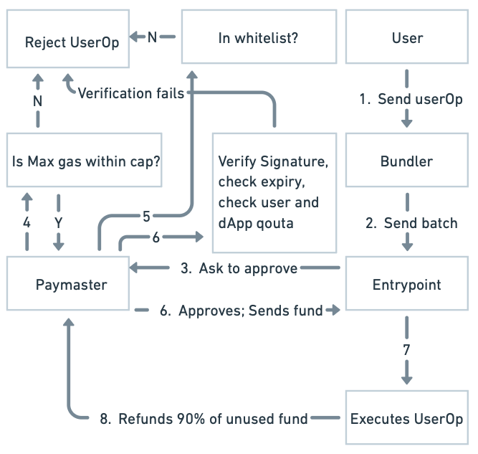
Figure 2. SecuredPaymaster validation pipeline: gas cap → whitelist → signature & quota check → approve / reject.

6.1 Gas Cap Enforcement
The paymaster maintains configurable maximum values for each gas component of the UserOperation: maxVerificationGasLimit, maxCallGasLimit, maxPaymasterVerificationGasLimit, maxPaymasterPostOpGasLimit, and maxPreVerificationGas. During validation, each component is compared against its cap:
if (maxVerificationGasLimit != 0) {
require(
userOp.unpackVerificationGasLimit() <= maxVerificationGasLimit,
"SecuredPaymaster: verificationGasLimit exceeds cap"
);
}
// ... similar checks for callGasLimit, preVerificationGas, etc.

A value of zero for any cap disables that particular check, allowing operators to selectively enforce only the gas fields relevant to their deployment. UserOperations exceeding any active cap are rejected with no on-chain cost to the paymaster.

6.2 Contract Whitelisting
The paymaster maintains a mapping(address => bool) allowedTargets storage variable. During validation, the callData of the UserOperation is parsed to extract the target address using the _extractExecuteTarget helper, which validates the 4-byte function selector against the BaselineAccount.execute(address, uint256, bytes) ABI:
address target = _extractExecuteTarget(userOp.callData);
require(allowedTargets[target], "SecuredPaymaster: target not allowed");

Operations targeting non-whitelisted addresses are rejected at this step. The whitelist is administered by the paymaster owner through the setAllowedTarget(address, bool) function, allowing operators to add and remove approved contracts without redeployment.

6.3 Quotas and Rate Limiting
The paymaster enforces two independent daily spending limits: per-virtual-user and per-dapp (global). User identity is represented as a bytes32 virtualUserId, decoupled from on-chain address identity to support privacy-preserving user management at the off-chain layer.

Daily reset logic uses block.timestamp divided by the seconds-per-day epoch:
uint48 currentDay = uint48(block.timestamp / 1 days);
UserDailyQuota storage userQuota = userDailyQuota[virtualUserId];
if (userQuota.dayIndex != currentDay) {
userQuota.dayIndex = currentDay;
userQuota.spentWei = 0;
}
require(
userQuota.spentWei + requiredPreFund <= userDailyLimitWei,
"SecuredPaymaster: user daily quota exceeded"
);
require(
dappSpentWei + requiredPreFund <= dappDailyLimitWei,
"SecuredPaymaster: dapp daily quota exceeded"
);
In our experiment, the per-user daily limit was set to 0.01 ETH and the dapp-global limit to 0.1 ETH. User1 was assigned 40 of the 80 valid operations to create concentrated quota pressure and test the reset mechanism.

6.4 Signature Validation and Replay Protection
Every sponsored operation must carry a signed authorization payload embedded in the paymasterAndData field. The payload is encoded as (bytes32 virtualUserId, uint48 validUntil, uint256 sponsorshipNonce, uint256 sponsoredMaxCostWei, uint8 v, bytes32 r, bytes32 s). The sponsorship signature is produced off-chain by a designated signer key and binds the following fields into a digest:
- Paymaster contract address (prevents cross-contract replay)
- Chain ID (prevents cross-chain replay)
- virtualUserId (binds the sponsorship to a specific user identity)
- validUntil (expiry timestamp, set to 3 minutes from issuance in experiments)
- sponsorshipNonce (unique per-authorization nonce)
- sponsoredMaxCostWei (maximum ETH the sponsor commits to covering)

bytes32 digest = _sponsorshipDigest(
virtualUserId, validUntil, sponsorshipNonce, sponsoredMaxCostWei
);
address recoveredSigner = _recoverSigner(digest, v, r, s);
require(recoveredSigner == sponsorSigner,
"SecuredPaymaster: bad sponsor signature");

require(!usedSponsorshipNonce[sponsorshipNonce],
"SecuredPaymaster: nonce already used");

The usedSponsorshipNonce mapping persists consumed nonces indefinitely, providing unconditional replay protection. Signatures are validated using EIP-191 personal_sign format (\x19Ethereum Signed Message:\n32).

7. System Architecture

7.1 On-Chain Components
The on-chain stack consists of five deployed contracts on the Ethereum Sepolia testnet:

Contract | Address (Sepolia) | Role
EntryPoint | 0xc388b22Cc99Db398e6F04a5a39e879dcC6333c5d | ERC-4337 singleton orchestrator
BaselinePaymaster | 0xF011e6134eC20eA4Da73e8272C14dfF00Ef61188 | Permissive control benchmark
SecuredPaymaster | 0x867e56382b806DEB838e4C65a0d64C9597301185 | Policy-enforced sponsor
BaselineAccount | 0xD4923772777916bf3867BDC6095c13bE64Be8E48 | Minimal smart contract wallet
MockTarget | 0x97a9b16839d578e33F392654Ba4cF94b944d4E04 | Whitelisted target contract

All contracts were compiled with Solidity 0.8.28 with optimization enabled and evmVersion set to 'cancun'. The BaselineAccount uses a deliberately permissive signature validation (always valid) to isolate paymaster-level security behavior from account-level security.
The deployment workflow uses the following Hardhat scripts (see package.json for full set):
npm run deploy:entrypoint:sepolia
npm run deploy:baseline:sepolia
npm run deploy:account:sepolia
npm run deploy:secured:sepolia
npm run deploy:mocktarget:sepolia
npm run whitelist:mocktarget:sepolia

7.2 Off-Chain Components
The off-chain layer comprises five main components:
- Signing Scripts (TypeScript): runScenarioMatrix_80_10_10.ts and runScenarioMatrix_100.ts generate sponsorship signatures using the deployer's private key, build UserOperation structs, and submit them to the Sepolia bundler via ethers.js. The same randomized operation plan is replayed against both paymasters for controlled comparison.
- Backend Analytics Server (Node.js/Express): backend/server.js parses matrix script terminal output, pulls transaction receipts via ethers.js, extracts UserOperationEvent.actualGasCost from EntryPoint logs, and persists results to CSV and JSON in backend/data/.
- Dashboard Frontend (React + Vite + TypeScript): frontend/src/App.tsx renders live cost, drain, latency, and quota metrics consumed from the backend REST API. Used during experiment runs to monitor scenarios and post-hoc to compare runs.
- Sponsorship Service Scaffold (backend/sponsorship.js): A planned production signing service currently implemented as a placeholder (signature: '0x'). In production, this would be an authenticated API that issues time-limited, nonce-bound signatures per user request.
- Analysis Pipeline (Python): results/paymaster_analysis.py loads userop-results.csv with pandas, computes summary statistics, generates the break-even cost curve, and produces the figures used in this report.

8. Implementation

8.1 Repository Structure
The codebase is organized into five top-level directories to separate concerns between contracts, deployment scripts, off-chain services, analytics, and the experiment dashboard:
ERC4337-Paymasters/
├── contracts/ Solidity sources
│ ├── BaselinePaymaster.sol Permissive control benchmark
│ ├── SecuredPaymaster.sol Policy-enforced sponsor
│ ├── BaselineAccount.sol Minimal IAccount wallet
│ ├── EntryPoint.sol Re-export from @account-abstraction
│ └── MockTarget.sol Whitelisted target contract
├── scripts/ Hardhat + ethers.js scripts
│ ├── deploy*.ts Per-contract deployment
│ ├── runScenarioMatrix_80_10_10.ts Mixed-traffic experiment
│ ├── runScenarioMatrix_100.ts Clean-traffic experiment
│ ├── sendUserOpWith*.ts Single-op verification scripts
│ └── whitelistSecuredPaymasterMockTarget.ts
├── backend/ Node.js / Express analytics server
│ ├── server.js Parses results, exposes REST API
│ ├── sponsorship.js Sponsorship signing scaffold
│ └── data/ CSV + JSON outputs
├── frontend/ React + Vite dashboard
│ └── src/App.tsx Live metrics viewer
├── results/ Analysis artifacts
│ ├── paymaster_analysis.py Python plotting + stats
│ ├── comparison_summary.csv Aggregated metrics
│ ├── breakeven_analysis.csv Cost curves vs. malicious %
│ └── paymaster_analysis.png Final figure set
├── deployments.json Deployed Sepolia addresses
├── hardhat.config.ts Solc + network config
└── Documents/ Final report + presentation

The split between scripts/ and backend/ reflects a deliberate separation: scripts/ holds short-lived experiment runners that talk directly to Sepolia, while backend/ holds the long-running analytics server that reads experiment outputs and serves them to the frontend dashboard. This makes it possible to re-run experiments without touching the dashboard and vice versa.

8.2 Contract Overview
The project contains four primary contracts:

Contract | Purpose
BaselinePaymaster.sol | Permissive paymaster; _validatePaymasterUserOp returns ("", 0) unconditionally.
SecuredPaymaster.sol | Policy-enforced paymaster with gas caps, whitelist, quotas, and signature validation.
BaselineAccount.sol | Minimal IAccount implementation; always-valid signature, EntryPoint-only execution.
MockTarget.sol | Minimal contract deployed as the whitelisted target for valid scenario traffic.

8.3 Key Functions: validatePaymasterUserOp

8.3.1 Baseline Implementation
The baseline implementation trivially satisfies the BasePaymaster interface:
function _validatePaymasterUserOp(
PackedUserOperation calldata,
bytes32,
uint256
) internal pure override
returns (bytes memory context, uint256 validationData)
{
return ("", 0);
}

The return value of (context, validationData) = ("", 0) signals unconditional approval to the EntryPoint with an empty context passed to postOp.

8.3.2 Secured Implementation
The secured implementation performs the full validation pipeline described in Section 6. The complete function signature and quota update logic is as follows:
function _validatePaymasterUserOp(
PackedUserOperation calldata userOp,
bytes32,
uint256 requiredPreFund
) internal override returns (bytes memory context, uint256 validationData) {
// 1. Gas cap checks (Section 6.1)
// 2. Whitelist check (Section 6.2)
// 3. Decode paymasterAndData sponsorship payload
// 4. Expiry + nonce replay check (Section 6.4)
// 5. Signature verification (Section 6.4)
// 6. Quota enforcement + update (Section 6.3)
userQuota.spentWei += requiredPreFund;
dappSpentWei += requiredPreFund;
usedSponsorshipNonce[sponsorshipNonce] = true;
return (abi.encode(virtualUserId, requiredPreFund), 0);
}

The context returned encodes (virtualUserId, requiredPreFund) for use by postOp. The validationData of 0 indicates unconditional approval (no time-bound validation through the EntryPoint's native mechanism — expiry is handled explicitly in the logic).

8.4 Key Functions: postOp
The BaselinePaymaster's postOp is a no-op. The SecuredPaymaster's postOp performs quota reconciliation:
function _postOp(
PostOpMode mode,
bytes calldata context,
uint256 actualGasCost,
uint256
) internal override {
(bytes32 virtualUserId, uint256 reservedCostWei) =
abi.decode(context, (bytes32, uint256));
if (actualGasCost < reservedCostWei) {
uint256 refund = reservedCostWei - actualGasCost;
userDailyQuota[virtualUserId].spentWei -= refund;
dappSpentWei -= refund;
}
}

If the actual gas cost is lower than the pre-fund reservation, the difference is refunded back to both the user's and dapp's daily quota counters. This ensures that quota consumption accurately reflects actual spending rather than worst-case pre-fund estimates.

8.5 Implementation Challenges and Resolutions
Several non-trivial issues surfaced during implementation. Each is documented below with its resolution to make the engineering effort reproducible.

Challenge | Resolution
paymasterAndData layout | The packed UserOperation format places the paymaster address in the first 20 bytes of paymasterAndData, followed by paymaster verification and post-op gas limits (32 bytes), with sponsorship payload starting at byte offset 52. Initial implementations decoded from offset 20, producing malformed signature recovery. Resolution: standardized on userOp.paymasterAndData[52:] for ABI-decoding the sponsorship payload.
EIP-191 digest construction | Off-chain signing initially used the raw keccak256 hash, but on-chain ECDSA recovery expects the EIP-191 prefix. Resolution: implemented _toEthSignedMessageHash inside _sponsorshipDigest and matched it in the TypeScript signer with ethers.signMessage.
Gas estimation under Sepolia volatility | Sepolia's gas price oscillates more than mainnet, occasionally producing requiredPreFund values that exceeded the per-user daily quota for legitimate users. Resolution: added a 20% gas-price safety margin in the matrix scripts and tuned the per-user limit to 0.01 ETH to comfortably absorb fluctuations.
Bundler simulation rejections | Early scenario runs hit AA33 reverted: SecuredPaymaster errors during bundler simulation, which silently dropped operations from the mempool. Resolution: added explicit revert reason parsing in the matrix scripts to log rejected operations into the CSV with result=reverted, allowing them to be counted against attack-blocking statistics.
Quota refund accuracy | The first version of postOp did not reconcile actual cost vs. pre-fund, causing the user quota to deplete based on worst-case estimates. Resolution: rewrote _postOp to refund the difference (reservedCostWei - actualGasCost) back to both userQuota.spentWei and dappSpentWei.
Whitelist target extraction | callData decoding initially accepted any 4-byte selector, allowing operations whose selector did not match BaselineAccount.execute to bypass whitelisting silently. Resolution: _extractExecuteTarget now reverts on selector mismatch, forcing all sponsored ops through the validated execute(address,uint256,bytes) path.

9. Methodology

9.1 Test Setup
All experiments were conducted on the Ethereum Sepolia testnet using a dedicated deployer account. Both paymasters were funded with 0.05 ETH at the EntryPoint deposit prior to each scenario run. The Hardhat development environment was configured with the Alchemy Sepolia RPC endpoint and a dedicated deployer private key.

The technology stack is summarized as follows:
Component | Technology
Smart Contract Language | Solidity 0.8.28
Development Framework | Hardhat + TypeScript
AA Library | @account-abstraction/contracts v0.8
EVM Library | ethers.js v6
Network | Ethereum Sepolia Testnet
RPC Provider | Alchemy
EVM Version | Cancun
Dashboard Backend | Node.js / Express
Dashboard Frontend | React + Vite + TypeScript
Analytics | Python (pandas, matplotlib)
Data Storage | CSV + JSON (local filesystem)

Hardhat is configured for Solidity 0.8.28 with the Cancun EVM and the Sepolia network:
// hardhat.config.ts
solidity: {
version: "0.8.28",
settings: {
optimizer: { enabled: true, runs: 200 },
evmVersion: "cancun"
}
},
networks: {
sepolia: {
url: process.env.SEPOLIA_RPC_URL,
accounts: [process.env.DEPLOYER_PRIVATE_KEY]
}
}

9.1.1 Tool and Technology Justification
Tool choices and their main rationale:

Choice | Rationale
Hardhat (vs. Foundry) | TS-native scripting and ethers.js integration; needed for orchestrating off-chain signing + on-chain calls.
Solidity 0.8.28 / Cancun EVM | Required by @account-abstraction/contracts v0.8 (transient storage).
@account-abstraction/contracts | Canonical, audited EntryPoint matching production deployments.
ethers.js v6 | Native PackedUserOperation support and mature AA tooling ecosystem.
Sepolia testnet | Realistic bundler/mempool conditions at zero cost; mainnet rejected on cost grounds.
Alchemy RPC | Reliable rate limits for high-volume scenario runs.
Node.js + Express backend | Reuses ethers.js types from scripts; Python used only for post-hoc analytics.
React + Vite frontend | Minimal config for a local single-page metric dashboard.
CSV + JSON storage | Append-only experiment data, human-inspectable, version-controllable.

9.2 Traffic Scenarios
Two distinct traffic mixes were tested, each replayed against both the Baseline and Secured paymasters with identical operation sequences:

Label | Mix | Total Ops | Description
Scenario A | 80-10-10 | 200 total ops | 80% valid, 10% overcap (5x gas), 10% non-whitelist. User1 assigned 40 valid ops for quota pressure.
Scenario B | 100% Valid | 200 total ops | 100% valid operations with randomized user assignment. No attack traffic.

For the overcap simulation, normal gas profile values were multiplied by 5x. Non-whitelist operations were directed at the deployer EOA address (not in the whitelist). The same randomized assignment was used for both paymasters in Scenario A to ensure a controlled comparison. Scenario B provides a clean-traffic baseline to measure the overhead cost of the secured validation pipeline with no benefit.

9.3 Metrics Collection
The following metrics were collected for each UserOperation:
- sponsor_drain_eth: ETH deducted from paymaster deposit, sourced from UserOperationEvent.actualGasCost emitted by the EntryPoint.
- txn_cost_eth: Total on-chain transaction cost, computed as gasUsed * effectiveGasPrice from the transaction receipt.
- result: Success or failure of the UserOperation execution.
- user_quota / dapp_quota: Remaining daily quota after each operation (SecuredPaymaster only).
- Execution time: Wall-clock time per operation, measured in the TypeScript scripts.

Data was stored in both JSON (userop-history.json) and CSV (userop-results.csv) formats for analysis. The CSV schema is: type, case, txn_hash, sponsor_drain_eth, txn_cost_eth, result, user_quota, dapp_quota.

The CSV (userop-results.csv) follows this schema:
Field | Type | Example | Description
type | string | baseline / secured | Paymaster variant used
case | string | valid / overcap / non-whitelist | Operation scenario type
txn_hash | string (0x...) | Sepolia txn hash | On-chain transaction hash
sponsor_drain_eth | float | e.g. 0.000095 | ETH deducted from paymaster deposit
txn_cost_eth | float | e.g. 0.000110 | Total txn cost (gasUsed * effectiveGasPrice)
result | string | success / reverted | UserOperation execution result
user_quota | float | Remaining ETH in quota | User daily quota remaining (Secured only)
dapp_quota | float | Remaining ETH in quota | Dapp daily quota remaining (Secured only)

10. Results

10.1 Cost Analysis: Total Sponsor Drain
Table 3 and Figure 4 summarize the total sponsor drain (ETH deducted from paymaster deposit) for each scenario and paymaster variant.

Metric | Scenario A (80-10-10) | Scenario B (100% Valid)
Baseline — Total | 0.010056 ETH | 0.006905 ETH
Baseline — Per-Txn Avg | 0.000101 ETH | 0.000069 ETH
Secured — Total | 0.009541 ETH | 0.011144 ETH
Secured — Per-Txn Avg | 0.000095 ETH | 0.000111 ETH
Delta (Secured saves) | +0.000515 ETH (+5.1%) | -0.004239 ETH (-61.4%)
Winner | Secured ✓ | Baseline ✓

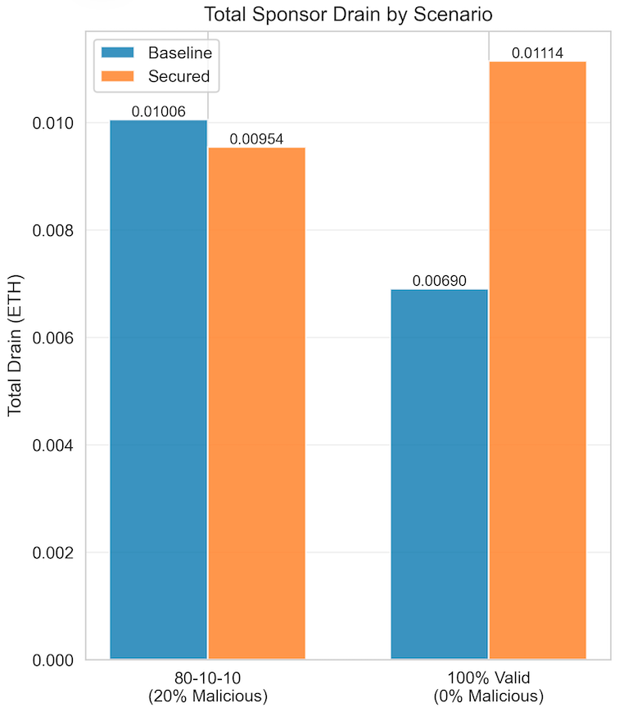
Figure 4. Total sponsor drain by scenario — Baseline vs. Secured Paymaster, 80-10-10 mix and 100% valid mix (200 ops each).

In Scenario A (20% malicious traffic), the Secured Paymaster achieves a 5.1% reduction in total drain by completely eliminating costs from overcap and non-whitelist operations. In Scenario B (0% malicious traffic), the Secured Paymaster incurs 61.4% higher drain per-transaction due to the validation overhead cost with no offsetting attack prevention benefit.

10.2 Cost Analysis: Breakdown by Scenario Type
Figure 5 and Table 4 decompose the per-transaction cost for the 80-10-10 scenario by operation type.

Operation Type | Baseline Avg Cost | Secured Avg Cost | Delta
VALID (80 ops) | 0.000077 ETH | 0.000119 ETH | +54.5% overhead
OVERCAP (10 ops) | 0.000312 ETH | 0.000000 ETH | 100% blocked
NON-WHITELIST (10 ops) | 0.000075 ETH | 0.000000 ETH | 100% blocked

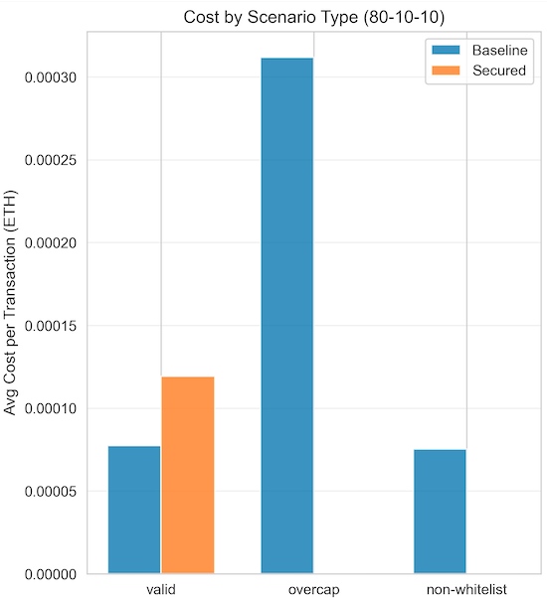  Figure 5. Per-transaction cost by operation type (80-10-10): Secured drops overcap and non-whitelist costs to zero while adding overhead on valid ops. | 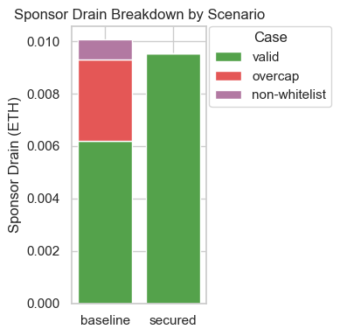  Figure 5b. Sponsor drain breakdown — Baseline drain stacks valid + overcap + non-whitelist contributions; Secured drain is composed only of valid traffic.
The Secured Paymaster achieves zero cost on both attack categories (overcap and non-whitelist), confirming that the validation pipeline completely blocks the simulated exploits at the pre-execution stage. Valid operations carry a per-transaction overhead of approximately 0.000042 ETH due to the additional validation computation.

10.3 Performance Analysis: Execution Time

Paymaster | Total Time | Per-Txn Time | Comparison
Baseline | 1572.8 s (total) | 15.73 ms/txn | —
Secured | 1353.1 s (total) | 13.53 ms/txn | 14.0% faster
Baseline | 1320.2 s (total) | 13.20 ms/txn | —
Secured | 1465.9 s (total) | 14.64 ms/txn | 10.9% slower

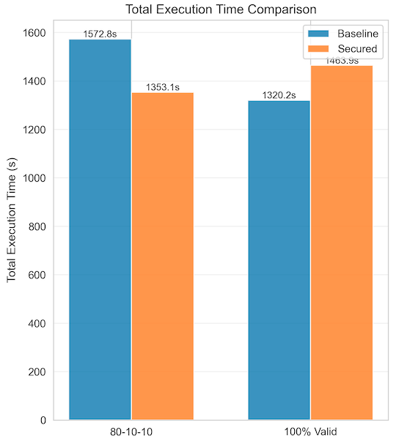
Figure 6. Total execution time comparison — Secured is 14% faster on 80-10-10 (fail-fast on attacks) and 10.9% slower on 100% valid (validation overhead with no rejections).

In Scenario A, the Secured Paymaster is 14% faster overall despite adding validation overhead on valid operations. This is because early rejection of 20 malicious operations (each of which would have proceeded to on-chain execution under the baseline) saves more time than validation adds to the 80 valid operations. The fail-fast property of early rejection is a key performance advantage in attack conditions.

In Scenario B (no attack traffic), the Secured Paymaster is 10.9% slower, as all 100 operations incur full validation overhead with no compensating rejections.

10.4 Tradeoffs Summary
The empirical results confirm the fundamental tradeoff: the Secured Paymaster imposes a fixed overhead on every valid transaction in exchange for complete elimination of attack costs. This overhead is justified only when attack traffic exceeds the break-even threshold derived in Section 11.
Important caveat — these results depend on the assumed traffic mix and volume. The 5.1% savings, the per-transaction overhead, and the 17.87% break-even point are all derived from a 200-operation experiment with overcap multipliers of 5x and a specific gas profile. In production, the cost picture varies sharply with both the intensity of the attack (gas-limit multiplier, how aggressively quotas are abused) and the absolute number of malicious operations submitted.
A single high-intensity attack — even at low total volume — can drain a large share of a paymaster's deposit before any rate-limit signal is observed; conversely, a sustained low-intensity attack can drain it slowly without ever crossing a per-operation alarm threshold. Operators should re-derive these thresholds against their own observed traffic distribution rather than treating the 17.87% figure as universal.

11. Break-Even Analysis

11.1 Derivation
The break-even point is the percentage of malicious traffic at which the Secured Paymaster's savings from attack prevention equal its additional cost from validation overhead. Define:
- validation_overhead = 0.000042 ETH (per valid transaction overhead)
- avg_malicious_baseline_cost = 0.000193 ETH (weighted avg cost of overcap + non-whitelist ops under Baseline)
- secured_malicious_cost = 0.000000 ETH (Secured blocks all malicious ops)

The break-even formula is:
breakeven_pct = (validation_overhead /
(avg_malicious_baseline_cost + validation_overhead)) * 100

breakeven_pct = (0.000042 / (0.000193 + 0.000042)) * 100
= 17.87%

At 17.87% malicious traffic, the cost of Secured validation overhead on valid operations exactly equals the cost savings from blocking malicious ones. Above this threshold, the Secured Paymaster is economically advantageous.

11.2 Decision Matrix
Malicious Traffic % | Cost Winner | Speed Winner | Recommendation
0–10% | Baseline | Baseline | Overhead not justified; clean traffic best served by low-latency baseline.
11–17% | Monitor | Mixed | Approaching break-even; begin monitoring attack rate trends.
18–30% | Secured | Secured | Both cost and speed favor Secured at this attack rate.
>30% | Secured (strongly) | Secured (strongly) | Secured provides strong ROI; hybrid routing may still help for verified users.

11.3 Economic Projection
Assuming 100,000 transactions per month with 20% malicious traffic and the empirically observed savings rate of 0.0008 ETH per 100 transactions:
Monthly savings = (100,000 / 100) * 0.0008 ETH
= 0.8 ETH/month
≈ $1,600/month (at $2,000/ETH)

This projection assumes ETH price of approximately $2,000 USD. The actual savings scale linearly with transaction volume and ETH price.

12. Deployment Strategy

12.1 When to Use Secured vs Baseline
Based on the break-even analysis, the Secured Paymaster is recommended when:
- Network malicious traffic is at or above the 18% threshold (using the experimental dataset as reference).
- Gas-cap, whitelist, and quota enforcement are contractual or compliance requirements for the sponsoring protocol.
- The paymaster deposit is at risk from known adversarial actors who have demonstrated exploit capability.
- The operator cannot monitor and manually revoke individual addresses quickly enough to prevent drain.

The Baseline Paymaster may be appropriate when:
- The operator is in a fully closed environment where all senders are verified (e.g., enterprise internal transactions).
- Traffic is entirely clean and the operator has strong off-chain verification before UserOps reach the paymaster.
- The per-transaction overhead of ~0.000042 ETH is unacceptable for the use case (e.g., very high-frequency micro-transactions).

12.2 Hybrid Deployment
A recommended production architecture routes traffic dynamically based on risk signals:
Incoming UserOperation
|
|--> [Off-chain Risk Scoring]
|
|--> Score < threshold --> BaselinePaymaster (known-good user)
|
|--> Score >= threshold --> SecuredPaymaster (unknown/risky user)

Risk scoring inputs can include address age, historical transaction success rate, virtual user ID reputation score, and membership in a verified user registry. This hybrid approach captures the low overhead of the Baseline for trusted users while protecting against unknown or adversarial actors with the Secured path. The key implementation requirement is an off-chain router that can make the paymaster selection decision before UserOp submission.

12.3 Operational Considerations
- Attack rate monitoring: Deploy dashboards that track the ratio of rejected to accepted operations over time. Alert when the rejection rate approaches the break-even threshold from either direction.
- Quota calibration: Set daily per-user limits based on the 95th percentile (or higher) of legitimate user gas consumption, not on attack scenarios. Over-conservative limits will create false positives for power users.
- Signer key management: The sponsorship signing key must be protected with HSM or MPC-based custody. A compromised signing key invalidates all signature-based security guarantees.
- Whitelist governance: Maintain an on-chain governance process (multi-sig or timelock) for whitelist modifications to prevent admin key compromise from instantly opening the paymaster to arbitrary targets.

13. Limitations
The Secured Paymaster's design comes with explicit tradeoffs. Validation adds approximately 10.9% latency overhead on clean traffic and increases per-op verification gas, which feeds into requiredPreFund. Signature validation creates a hard dependency on the off-chain signing service, which in this project is a placeholder; production deployment requires HA infrastructure with HSM-backed key management. Fixed daily quotas can produce false positives for high-volume legitimate users and need calibration against observed traffic. The signature scheme uses EIP-191 personal_sign rather than typed EIP-712 data, which is weaker for cross-application replay protection. Whitelist target extraction assumes the BaselineAccount.execute(address,uint256,bytes) ABI, creating a hidden coupling between paymaster and account implementations. Finally, all measurements were taken on Sepolia; absolute ETH values do not reflect mainnet EIP-1559 dynamics, but the percentage-based results (e.g., 17.87% break-even, 5.1% savings at 80-10-10) are expected to generalize.

14. Future Work
Several extensions would materially strengthen the framework. Adaptive controls — dynamic gas caps tracked from rolling means, automated quota scaling tied to user reputation, and ML-based anomaly detection at the bundler layer — would let static thresholds evolve with attack patterns. Decentralized authorization (k-of-n multi-party signing, ZK-proof-based eligibility, or on-chain reputation oracles such as EAS / Gitcoin Passport) would remove the single-key trust assumption. Migrating from EIP-191 to EIP-712 typed structured data would bind signatures to a specific paymaster's domain and prevent cross-contract replay even under shared keys. The placeholder sponsorship signing service should be replaced with an authenticated, rate-limited, HSM-backed production service with audit logging. Finally, a comparative study against production paymasters (Biconomy, Alchemy, ZeroDev) and post-mortems of real-world incidents would validate whether the 17.87% break-even threshold holds at production scale.

15. Conclusion
This paper presented a practical defense framework for securing ERC-4337 paymasters against deposit drain attacks. We deployed and evaluated two paymaster implementations on the Ethereum Sepolia testnet — a permissive BaselinePaymaster and a policy-enforced SecuredPaymaster — across controlled attack simulation scenarios.

The SecuredPaymaster's four-layer defense stack (gas cap enforcement, contract whitelisting, per-user and per-dapp daily quotas, and cryptographic sponsorship authorization with replay protection) achieved complete elimination of all simulated exploit costs, reducing overcap and non-whitelist operation costs from an average of 0.000193 ETH per attack to exactly zero. Under 20% malicious traffic, the Secured Paymaster achieved 5.1% total cost savings over the baseline despite per-transaction validation overhead.

The empirical break-even analysis establishes a critical decision threshold of approximately 17.87% malicious traffic, above which the Secured Paymaster is both cheaper and faster than the Baseline. Below this threshold, the validation overhead is not economically justified, and a hybrid routing strategy — directing known-good users to the Baseline and unknown or risky users to the Secured path — offers the best tradeoff between security and efficiency.

For production deployments at 100,000 transactions per month with 20% attack traffic, the Secured Paymaster projects savings of approximately 0.8 ETH per month (~$1,600/month at current prices). As ERC-4337 adoption scales across Ethereum mainnet and L2 ecosystems with billions of dollars in paymaster deposits, the financial stakes of these security decisions grow proportionally.

The key insight is that paymaster security is not a binary choice between "open" and "secure" but an engineering tradeoff parameterized by the operator's observed attack rate, traffic volume, and performance requirements. The frameworks and tooling presented in this paper provide the empirical foundation for making that tradeoff with data.

