|  |  |  |  |
| --- | --- | --- | --- |
| SlNo | Contact Name | Phone No | Email |
| 1 | Monica | 77019 28401 | hello@classplus.co |
|  |  |  |  |

**Organisation Code: YOWWA**

**Link for Training**

<https://www.youtube.com/playlist?list=PL6JQv4FC-UVnf5hH116AXJT3kFBfOkKWZ>

**Login For ClassPlus:**

Web.classplusapp.com/login

**WORK FLOW OF CLASSPLUS**

* **BATCH CREATION IN CLASSPLUS**

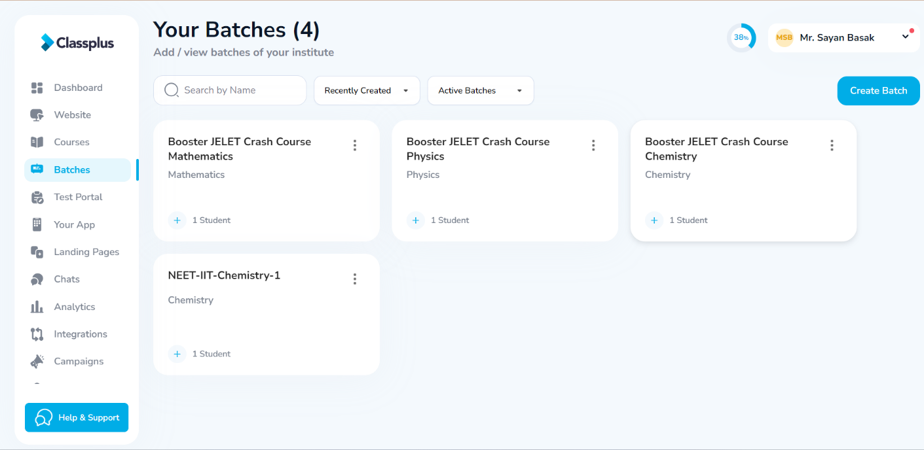

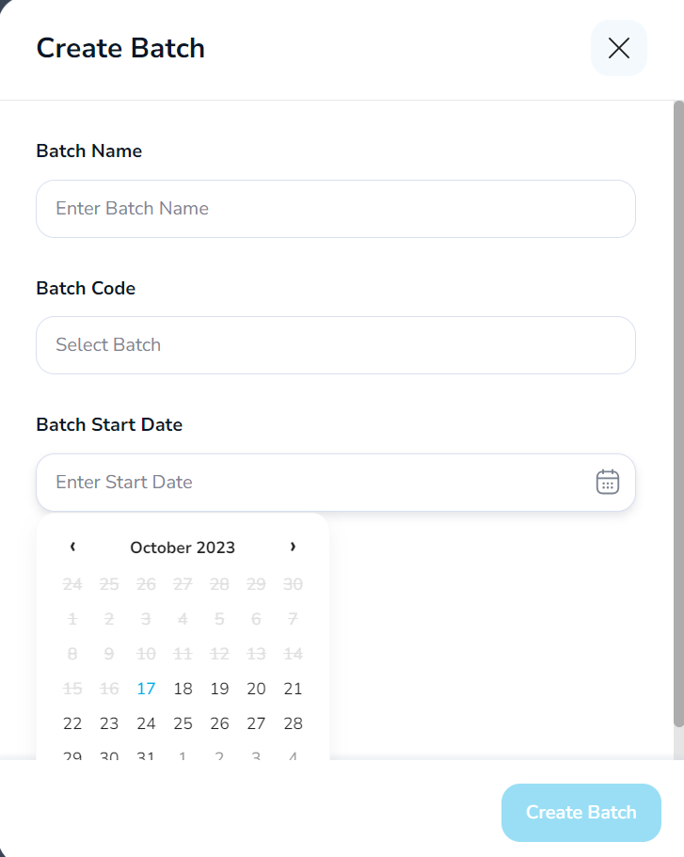

* **DELETING BATCHES**

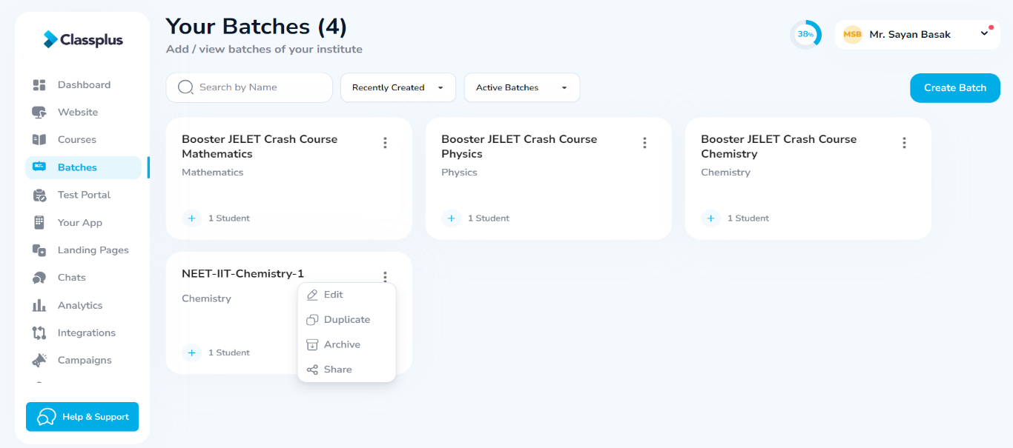

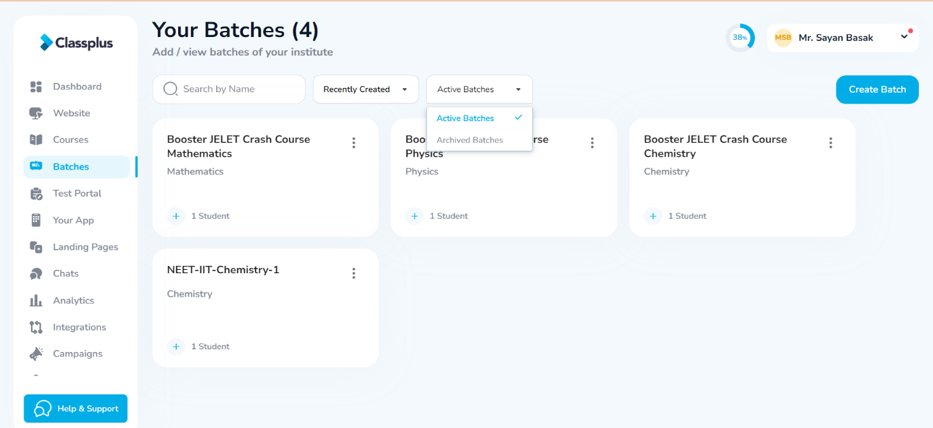

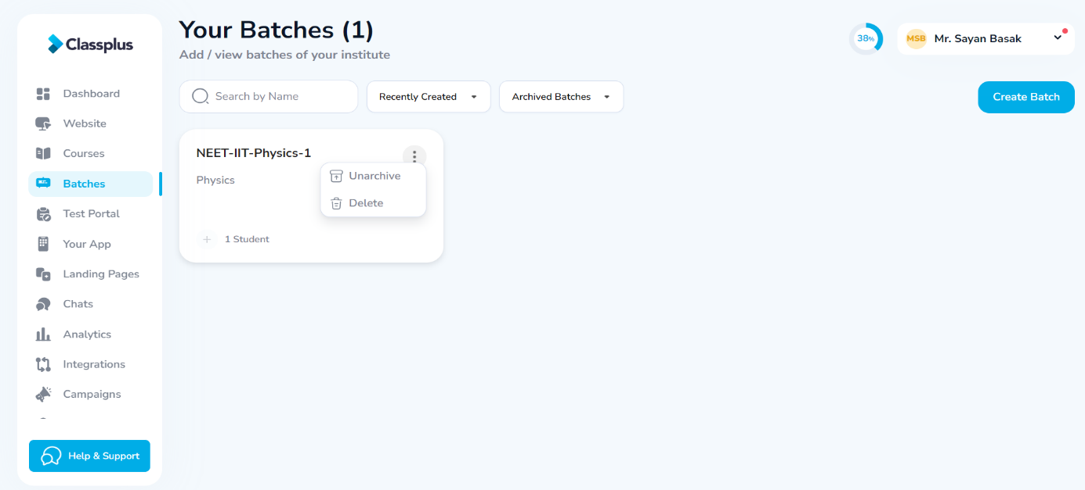

**N.B. – TO RESTORE AN ARCHIVED BATCH, CLICK ON UNARCHIVE**

* **CREATING BATCH CLASSES**

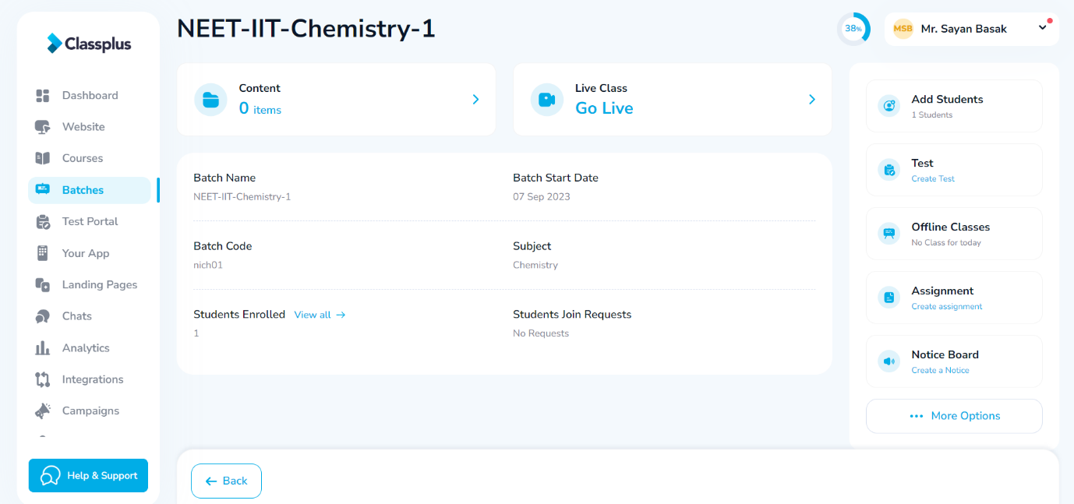

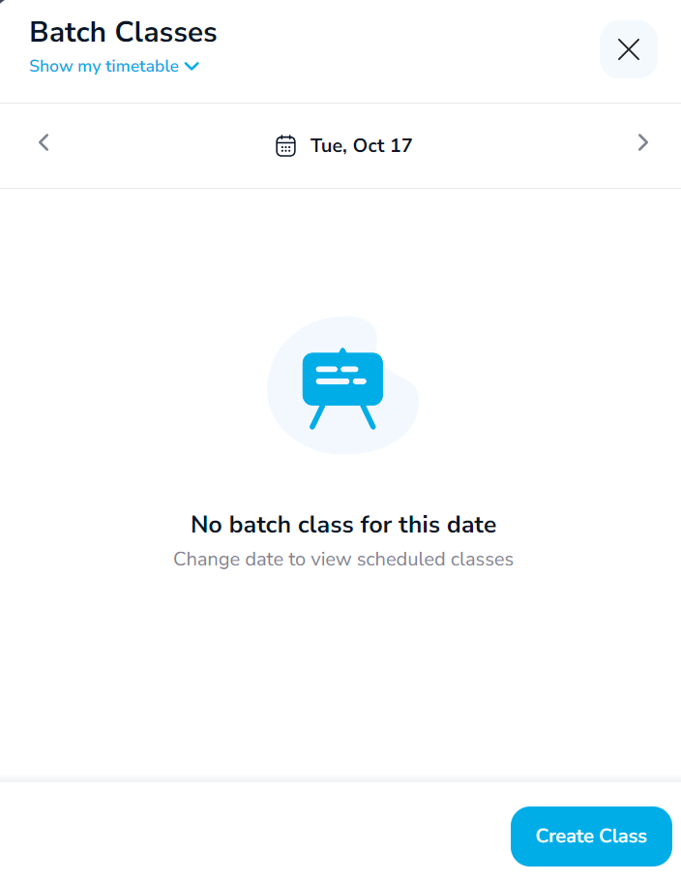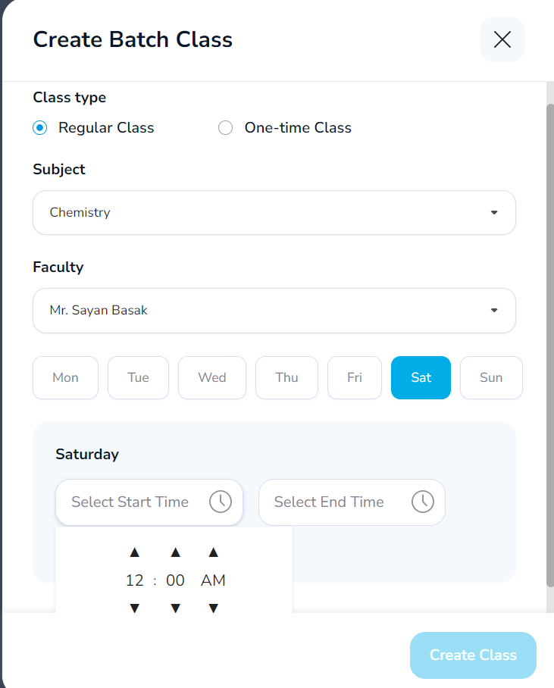

**TOGGLE TO SHOW ORG TIMETABLE TO VIEW SCHEDULED CLASSES.**

* **HOW TO FETCH ATTENDANCE DATA FROM THE CLASSPLUS APP**

