A REPORT ON

**DIRECT MANIPULATION INTERFACES**

PERTAINING TO THE AREA

**IMPLEMENTATION OF DIRECT MANIPULATION PARADIGM**

SUBMITTED BY

Rahul Barigidad – 2018A7PS0220P

in partial fulfilment of the course

**Human Computer Interaction**

**BITS F364**

As

**Project September-November 2020**

Under the guidance of

**Dr. Mukesh Kumar Rohil**



**Date: 4th November 2020**

# Abstract

Direct manipulation interfaces are coming to become one of the commonly found interfaces in today’s technology-dependent world. They save the user the efforts of both the time and having the expertise to interact with advanced technology found abundantly in today’s era. It has been noticed that this interaction paradigm has 2 phenomena that stand out compared to most other interfaces which makes it a popular choice for designers to implement. One deals with the “distance” of processing information between the user’s intentions and facilities that are provided by the machines. Reduction of this “distance” induces the directness of the paradigm by reducing the effort of the user to accomplish their goals. The second phenomenon deals with the visualization of objects that behave as though they were the objects themselves. This provides a direct and unambiguous relation between input and output vocabularies of the interface design. This report brings forth one example of such an implementation, through the design of a webpage. The basic design of the study is that of an e-commerce platform, enriched with a graceful user interface alongside interchangeable themes. Direct manipulation interfaces include the provision for reversible, repeatable actions that provide immediate visual feedback that the user can comprehend without any prior expertise.

Keywords: Direct Manipulation, Gulf of execution, Gulf of evaluation, Interfaces, user experience

Table of Contents

Abstract 1

Introduction to the problem 2

How to approach a solution 3

Carousel 4

Text editing using toggle buttons (Bold, Italic, etc.) 5

Changing theme of website by choosing from a list of themes 5

Add to cart/ remove from cart on e-commerce websites 6

Design for the solution 7

Basic design 7

Carousel 7

Palette module 8

E-commerce section 9

Item description module 9

Item Cart Module 10

Summary and Conclusions 12

References 13

# Introduction to the problem

Some common examples related to direct manipulation that are found in today’s world include the touchscreen devices that we use (phones, tablets, etc.). Owing to the ever-rising popularity of choice of implementation of all human computer interaction, this study helps determine what makes this paradigm a popular choice to implement over most other uncommon ones.

There are 2 major aspects of Direct Manipulation interfaces that stand out. One being the ability to reduce the distance of the gulf of execution, which in layman terms refers to reducing the semantic difference between the user’s intentions and facilities that can be provided by the implemented interface. The other is the ability to reduce the distance of the gulf of evaluation, which simply refers to reduction of difficulty in the comprehension, followed by the interpretation of the output after having interacted with the machine.

Looking at the above arguments, it can be said that Direct Manipulation Paradigms are represented by complex commands, reduced to a more user-friendly, intuitive interface. Any objects of interest should have a continuous representation, so that the output could be represented by immediate visual feedback after any action made by a user with the interface. In order to encourage exploration on the user’s end, it should also be taken into account that the actions performed by the user are made to be reversible, from the programmer’s end. An additional argument to aid the user’s exploration is the avoidance of error messages as much possible. This helps reduce the user’s anxiety, as the system is comprehensible, and any action is easily reversible.

Taking into account the multiple conditions of a Direct Interaction Paradigm as mentioned above, a programming language should be chosen which is capable of representing visual elements, which further help to represent progress and provide feedback of his/her actions to the user. For its simplicity, designing an interactive webpage using a scripting language like JavaScript (provides functionality to interface), combined with HTML (for providing structure) and CSS (for look and feel of interface) can be done to highlight the key points that represent a Direct Interaction Paradigm.

Other languages, such as Java, Python may also be used as a replacement. As mentioned in the above paragraph, however, using HTML/CSS/JS achieves modularity as well as high readability and writability due to the nature of commands present in each language mentioned. Designing such an interface using solely Java, Python, or any other such standalone language could reduce readability for any developers that may be referring to the code in the future, hence increasing overall debugging time.

The next sections introduce to the reader, the further implementation of the study, the basic workflow of approaching a solution (as defined above) with images to help support the text, with a summary and conclusions determined while implementing this project.

# How to approach a solution

Most of us have had the luxury of browsing websites during our spare time. It should also be taken into account that there were no tutorials we had to refer to in order to browse the internet as per our convenience, as the process came to us naturally. There may have been a few websites where we struggled to navigate to a page which contains our desired information, due to ambiguity of functionality of certain interactable elements on these web pages. Similarly, there have been a few websites, where we had no trouble at all in navigating to our desired data. The functionality of each element present was unambiguous in nature, allowing the user to speedily complete his/her intended task on a smooth, well-designed interface.

This project aims to highlight those paradigms which reduce the gap between complex commands and simple, intuitive functionality which can be achieved by minimalistic actions, while also improving the look and feel of the interface, to make it user-friendly as well.

Examples of such interfaces are:

## Carousel

**Image 1: Carousel Interface**

This interface provides pictorial representation of images, usually allowing the user to scroll through the images using the arrows on the sides of the image, or the dots at the bottom. Each image also contains some helper/header text to assist the image. These interfaces are usually used as header/title representations for any website, where the images used are relevant to the website in which it is used.

## Text editing using toggle buttons (Bold, Italic, etc.)

**Image 2: Text Editor using HTML**

This interface provides a basic functionality to type your text and format it at the click of a button. As shown in Image 2, there are multiple icons which can be clicked to format the text as the user wishes. In case the format chosen isn’t what the user wished for, he/she can simply reverse the action performed by clicking the same icon pressed to initially format the text. The example shown is relatively simpler compared to many modules present on the World Wide Web. More complex editors allow complex formatting such as curving the text along an arc, providing 3D effects to the text and so on.

## Changing theme of website by choosing from a list of themes

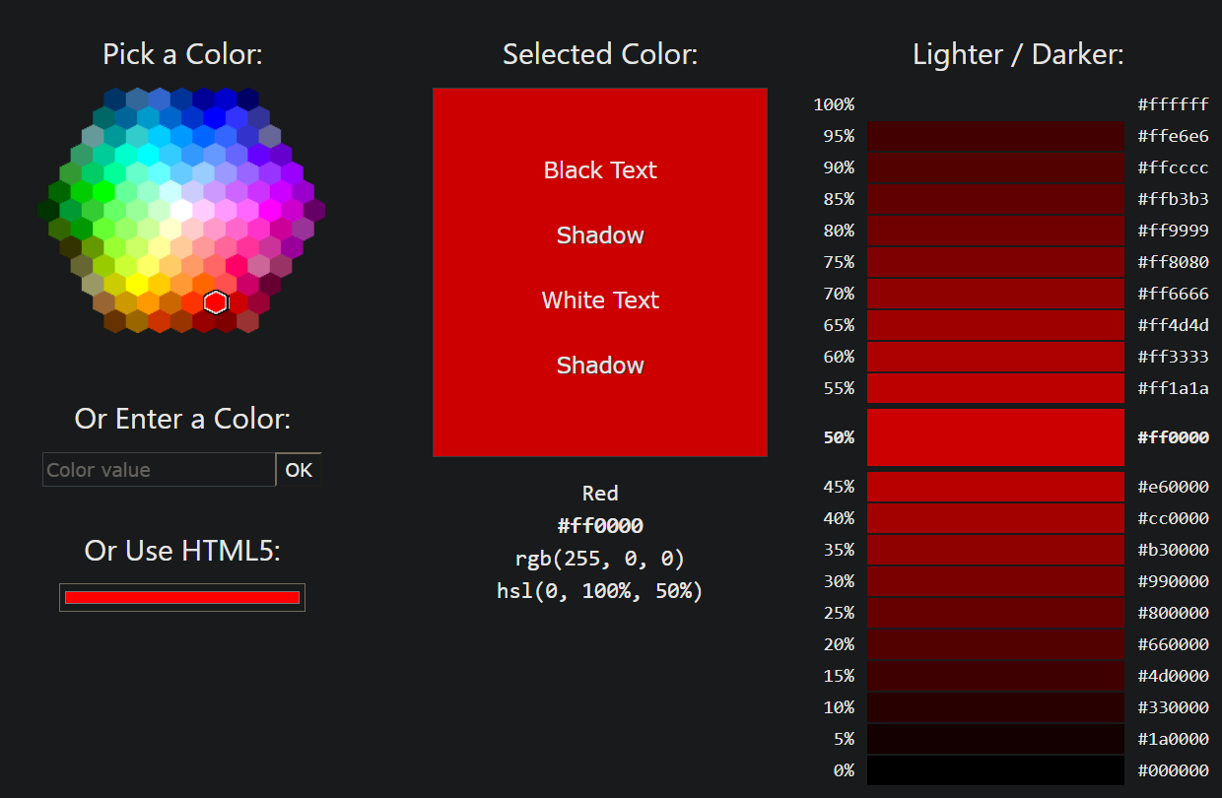

**Image 3: Theme picker**

The above module is a complex version of a theme picker. It creates the provisions to pick colors as per the required hue, saturation and lightness values. If the user wishes to choose a more precise set of HSL values, he/she is free to use the HTML5 color picker module, as shown in Image 3. The theme, once picked, changes the look and feel of the entire website, without affecting the structure of the webpage.

## Add to cart/ remove from cart on e-commerce websites

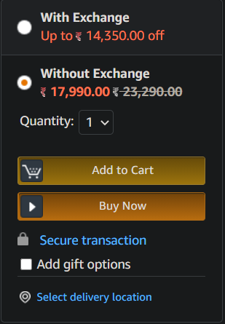

**Image 4: Add to cart functionality (e-commerce websites)**

The above image showcases one of many modules implemented in e-commerce websites that people have increasingly been using lately. The user is able to easily navigate to the item that they wish to purchase, read more details, such as the price, quantity they wish to order, expected delivery time and so on. E-commerce platforms also give you an option to change your “cart” before you check out, by clearing it out or changing the quantities of items already present.

A simple solution can be built, taking reference from these paradigms to assimilate a compact interface that showcases the main features of a direct manipulation interface. As mentioned earlier, for the simplicity that the languages bring forth, we will be moving further with a solution coded in HTML+JS+CSS.

# Design for the solution

The primary focus of this assignment will be the carousel, e-commerce website design and a palette to choose any amongst multiple themes from. The workflow plan is described in the subsections that follow:

Requirements:

Web browser: Google Chrome (any version is fine)

(No other special requirements)

## Basic design

|  |  |
| --- | --- |
| Carousel for generic display information about items on sale in e-commerce section as below | |
| Palette containing multiple themes for text, background colours etc. | Item descriptions with functionality to add items to a cart that compiles all the items added to cart. Items added can be removed at anytime by the user once added, before checking out.  The cart will be visible, and can be interacted with in a similar manner as compared to item modules above. |

**Image 5: Basic workflow plan**

The implementation of each of the sections created in Image 5 are simpler versions of those provided in the section “How to approach a solution”, as the aim of the study is to showcase the ‘directness’ of each of the paradigms mentioned rather than to exact the entire functionality of the module.

## Carousel

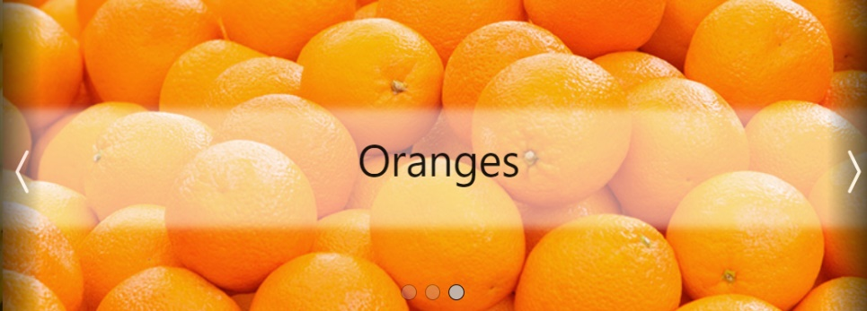

**Image 6: Carousel interface**

The carousel automatically transitions between items on display using a side-scrolling animation. If the user wishes, he/she can interact with the carousel by clicking on the left or right black bars to shift the carousel left or right respectively. An alternate way to interact with this paradigm is by clicking the translucent dots right below the text, which lights up based on which image is shown on the carousel at the moment.

## Palette module

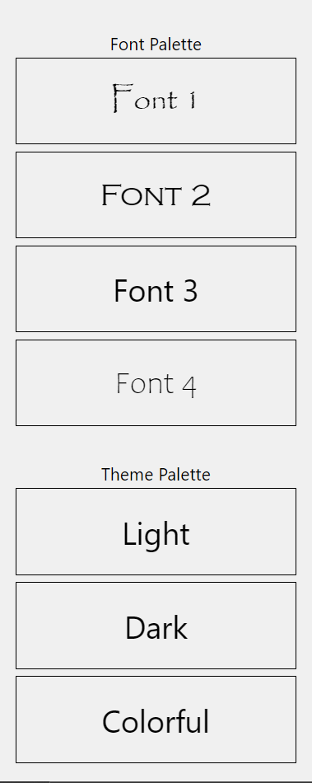

**Image 7: Palette picker**

The theme palette allows the user to change the entire look and feel of the user interface. The palette is implemented as a column of simple one-click buttons that toggle the chosen theme. The labels corresponding to each button provide a slight insight as to what can be expected of a certain theme. Even so, changing between themes is a one-click, easily reversible process with instant visual feedback. This is the simplest module to implement, while most appropriately falling under the category of a direct manipulation interface.

## E-commerce section

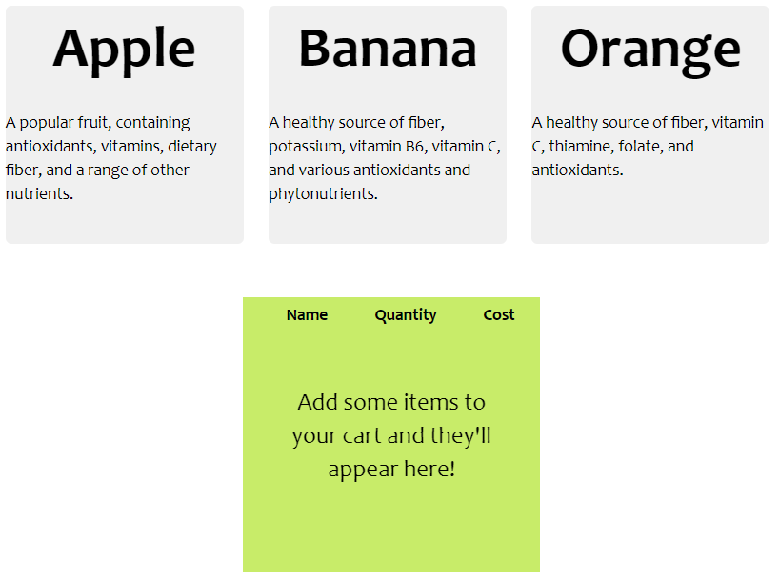

**Image 8: E-commerce layout**

This module contains the highest complexity amongst the defined interfaces, and so will be explained with more images to support the text descriptions that follow:

### Item description module

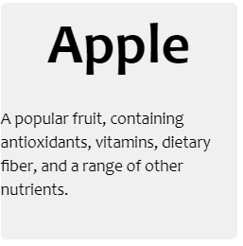

**Image 9: Item description module (before hovering)**

The item description module is a clean, simple container that contains information about the item to be sold and its price. The add-to-cart functionality is also implemented in this module as shown in Image 11 below:

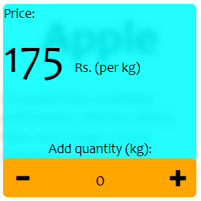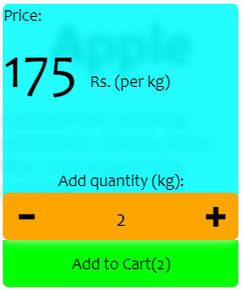

**Image 10 & 11: Item description (after hovering) shown with add-to-cart functionality**

The item module updates to show its add-to-cart functionality as well as price details, when you hover over it as shown in Images 10 and 11. The + and – icons increment and decrement the item count to be added to the cart, which is finalized only after the user presses the ‘Add to Cart’ button below the module (Image 11). The reversibility, as well as visual feedback regarding this action will be seen in the next subsection:

### Item Cart Module

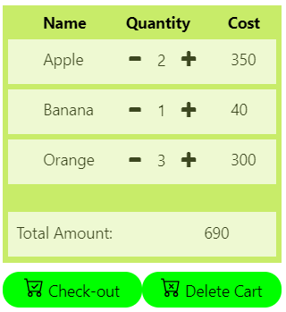

**Image 12: Populated item cart module**

The columns are justified to provide enough space for each column required in the cart module. This module informs the user regarding the items in their cart to be checked out, as shown in Image 12.

Items can be added/deleted directly from the cart interface using the ‘+’ and ‘-’ icons within each item tuple. They are automatically removed as a visual object when the item quantity is reduced to 0 or deleted from the item cart directly (triggered upon hovering over the item of interest):

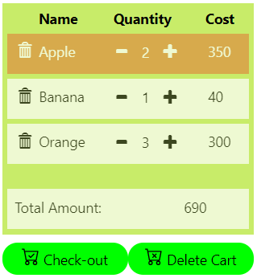

**Image 13: Item about to be deleted**

The buttons “Check-out” and “Delete Cart” do as their respective labels say; the first confirms the transaction and thanks the user for the purchase they made, while the latter cancels the entire order and resets the cart module to as shown in Image 8.

In this entire interface, all actions performed by the user are reversible in nature. This encourages user exploration and there are no complex commands to be entered by the user at any stage of the interaction process. All interactions are also supported by immediate visual feedback. (All of these are characteristics of Direct Manipulation Interfaces).

# Summary and Conclusions

This study evaluates what makes Direct Manipulation Paradigms such a popular choice for implementation of user interfaces and aims to bring out those features which stand out as compared to other user interface paradigms in today’s ever-evolving world. A few points that were brought up multiple times during this report included:

* Direct Manipulation Interfaces bridge the gap between the user’s intentions and the machine’s capabilities (Gulf of execution).
* They simultaneously bridge the gap between the output of the machine and the ability of a human to comprehend this output, for further evaluation of the next action(s) to be performed (Gulf of evaluation).
* They require no previous expertise, as they remove all complex commands, leaving the user with an interface that provides rapid visual feedback on abstractions of multiple visual objects that are intuitive for the user to interact with.
* A lack of error messages, as well as reversibility of any actions helps encourage the user to search through the exhaustive list of functionalities provided by any direct manipulation interface.

These 4 points were brought up as an implementation of a website design, made using HTML+JS+CSS.

The ability to make interaction with machines so effortless allows this category of user interface paradigms to be one of the most implemented categories as of today. We can find such interfaces implemented in almost every machine we use nowadays: mobile phones, tablets, websites, drag-and-drop interfaces and so on.

Going forward, it is possible that the most commonly available devices on a large-scale will develop further on direct manipulation interfaces, as they are incredibly convenient to use and require little to no expertise in order to seamlessly extract the desired output from complex machines. It may even be possible that such a process has begun with the introduction of AI assistants (Apple’s Siri, Window’s Cortana, Amazon’s Alexa etc.), where the user communicates to the machine as though it was another human, in order to directly receive the desired output with no additional efforts.

# References

1. David F. Huynh, Dennis Quan, David R. Karger; “User Interaction Experience for Semantic Web Information”; MIT AI Laboratory/LCS, Cambridge, MA 02139 USA; 2003 pages 1-2.
2. Edwin L. Hutchins; James D. Hollan; Donald A. Norman; “Direct Manipulation Interfaces”; University of California, San Diego; Volume 1, 1985 pages 311-338.
3. www.healthline.com (Accessed on 30th October 2020)
4. [www.w3schools.com](http://www.w3schools.com) (Accessed on 2nd November 2020)