



**CU6008NI Visual Effects for Computer Graphics and Games**

Choose Coursework Percentage **Individual Coursework**

**2023-24 Autumn**

**Student Name: Rahul Balami**

**London Met ID: 22067315**

**College ID: np01mm4a220025**

**Assignment Due Date: Thursday, November 28, 2024**

**Assignment Submission Date: Thursday, November 28, 2024**

**Word Count:**

**Project File Links:**

|  |  |
| --- | --- |
| **YouTube Link:** | Keep Unlisted YouTube URL of your Project Here |
| **Google Drive Link:** | Keep Google Drive URL of your Project Here with Anyone in Organization can View Option Enabled |

*I confirm that I understand my coursework needs to be submitted online via Google Classroom under the relevant module page before the deadline in order for my assignment to be accepted and marked. I am fully aware that late submissions will be treated as non-submission and a mark of zero will be awarded.*

# Product review.

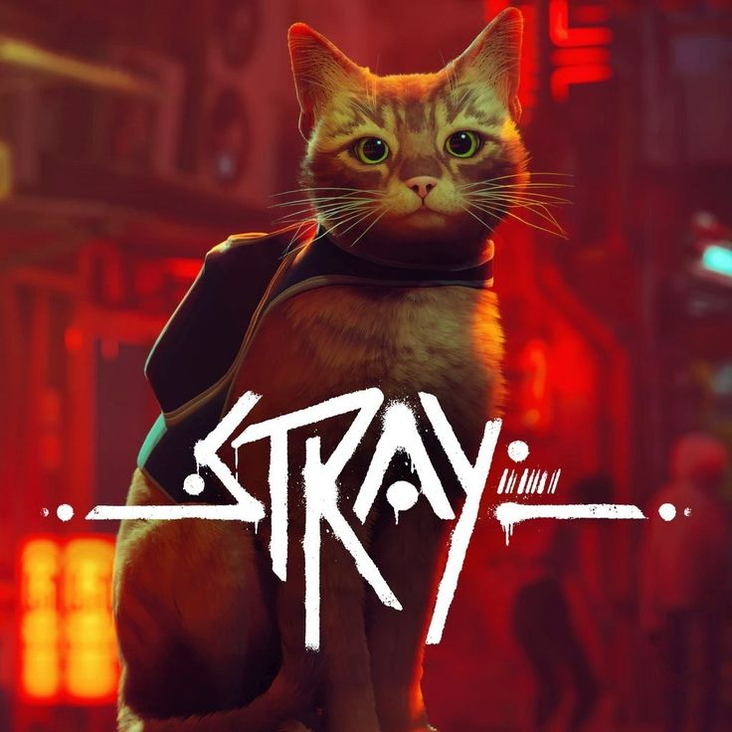

For the Submission of my DMP, I will be Developing a 2d platformer Video Game. There are various inspirations for the mechanics, art style, and the concept of this game. The product reviews of the inspirations for the game are listed below.

## Stray:

### Overview:

Stray is a game developed by Blue twelve Studio. It is a game that follows the story of a stray cat, hence the name. Its Setting is in a cyber punk city where the cat has to solve puzzles, interact with the robots in the city and find his way back home. It is a 3d game and its premise, Movement and gameplay are truly outstanding.

### Strengths:

#### Immersion:

The game is very good in capturing the interest of the player from its premise, to the unique story and gameplay. It Is truly a unique experience with a great story.

#### **Visual Design**:

The visuals of this game is truly well liked. The neon light city, how alive it feels, the dark gritty environment of the future without humanity, controlled by robots is presented really well with its own distinct cyberpunk, post-apocalyptic style.

#### **Emotional Narrative**:

The narrative of the cat and its drone companion is very distinct and unique. It also resonates well with the players.

### Inspiration for Game:

The cat movements, visuals and the unique story telling are the inspirations that have been taken.

### Criticism:

Some criticisms of the game are repetitive mechanics and limited interactions.

## Celeste:

### Overviw:

Celeste is an indie platformer game. It is developed by Maddy Makes Games. It is the story of a character named Madeline, who decides to climb the mountain Celeste, to challenge her anxiety. It reflects mental struggles in real life with the game. Its setting is in a beautifully crafted 2D pixel art platformer world.

### Strengths:

Gameplay: The game mechanics of celeste is truly masterful. It is well appreciated in the gaming industry as one of the most smooth, interactive and well-crafted game mechanics. Its story telling blends with the gameplay perfectly, creating a very compelling and enjoyable experience for the players.

Visual Design: The visual design of celeste is truly outstanding. Its pixel art style is very distinct and adds a different flare to the game. Its color palate is very appealing to the eyes.

Emotional Narrative: Celeste is a very personal story about mental health, self-acceptance, and perseverance. The journey of the main character is a metaphor for combating mental struggles. The story truly resonates with its players.

Soundtrack:

Inspiration for Game:

### Criticism:

Some criticisms include the steep difficulty curve that might not appeal to all players, and the story can be interpreted in a way that may not fully engage those unfamiliar with the themes of mental health.

# Name

Purrkour