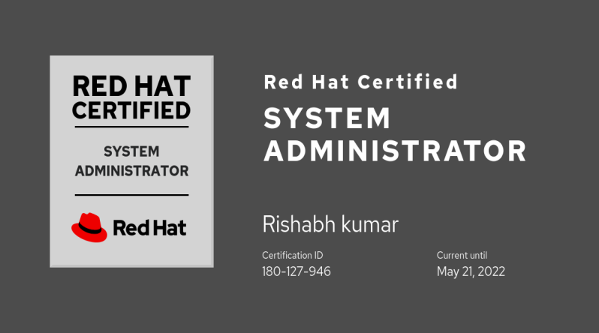
Rishabh Kumar
Contact No.- 8840836573
E-mail- rishabhksahu28@gmail.com
Address- C1 Jaichand apartment, Near noble cooperative bank sector 22, Noida
Career Objective
To work in a progressive & professionally managed organization, which can provide adequate opportunities and a culture of finding and sharing of new ideas with conductive environment for growth and continuous learning.

Project Work

- Six months Major Project during B. Tech in Online Data Storage Application through JavaEE from CMC Limited Pitampura, New Delhi in 2014.
- Six weeks Minor Project during B. Tech in information Security and Ethical Hacking from Appin Technology Lab Allahabad in 2013.

Educational Qualification

- B. Tech (IT) from Mahatma Gandhi Chitrakoot Gramodaya University in 2014 with 69% marks.
- Intermediate in Science from U.P. Board in 2009 with 54 % marks.
- High school in Science from U.P. Board in 2007 with 63.5 % marks.

Professional Abridgement

- IBM India Pvt. Ltd. (Offrole on Hi Tech Informatics Pvt. Ltd. Payrole):- IBM India Private Limited is the Indian subsidiary of IBM. Since 2006, IBM has been the multinational with the largest number of employee in India. IBM is very secretive about the geographic distribution of its employees. By most estimates, it has close to a third of its 430,000 employees (~ 140,000) in India, and it likely has more employees there than in the US.

November 26 2019 to Till Now.

- I2K2 NETWORKS :- Established in April 1999, with just a few clients and 4 employees, i2k2 Networks has now grown into a leading data center and web hosting company with more than 4000 clients across the globe. i2k2 Networks, one of the leading Data Center service providers in India with its data centers in India – Mumbai, Delhi NCR – Noida & Bengaluru has the capability to cater to the processing, networking, storage, management, and data distribution demands of both small and large enterprises.

December 2018 to June 2019.

- IT BRAINS TECHNOLOGY PVT. LTD :- The organization is a leader in IT staffing, consulting &hardware support as well. They have tie-ups with multiple tech giants for outsourcing, manpower solutions & support related to their servers, storage & data centres services. One of their major area of expertise is devops & cloud services.

January 2016 to October 2018.

Designation: Linux Server Administrator

Job Description :-

- Linux Server administration and troubleshooting of servers running on Data centers.

Responsibilities

- Day to day Linux server admin activities.
- Scheduling cron jobs.
- File system management which includes disk space, permissions and ownership related issues.
- User and Group Management.
- Performance monitoring and resource utilization.
- Management of over 3000 Linux Servers.
- Worked on Linux & vmware Esxi cluster..
- Following SLA and working on ticketing tool.

Functional

- Installation, Configuration, Maintenance and Administration of RHEL 6,7 & 8 Centos & Ubuntu.

- Type 1 Hypervisor: Vmware Esxi 6.0, vmware HA (High Availability) cluster administration & all operations.

- Installation & management of zimbra mail server.

- Database mysql.

- User administration on zimbra & Linux.

- GIT installation & basics.

- Basic AIX & Windows server 2016 administration.

- IBM Spectrum Scale (gpfs) cluster basic.

- Disk & partition management using LVM2& fdisk.

- Package Management (RPM & YUM).
- Configuration and management of standard Linux services like SSH, Samba, NFS and Autofs.

- Dell Poweredge r630 & r930 servers administration by Dell Idrac & Dell Essential.

- Automating jobs to run with Cronjob.

- Scripting Bash.

Strengths:-
Ability of quick learning and decision making, Enthusiasm, Team work, Hardworking with Go-Getter Attitude.

Personal Information
Father's Name:- Mr. Rajendra Prashad sahu
Mother’s Name:- Mrs. Sunita Sahu
Date of Birth:- 27-05-1991
Hobbies:- Cricket ,Chess,
Languages:- English, Hindi.
Nationality:- Indian
Marital Status:- Single

DECLARATION

I hereby declare that the information’s furnished above are true to the best of my knowledge and I will contribute my best efforts to the great extent in achieving the objectives of the organization.

Date Rishabh Kumar

