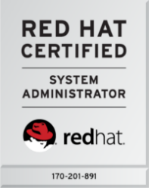**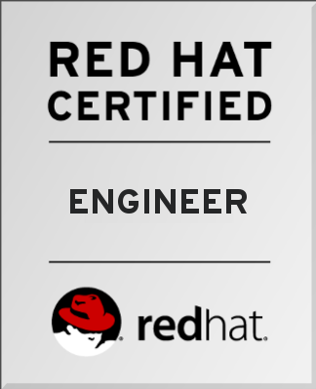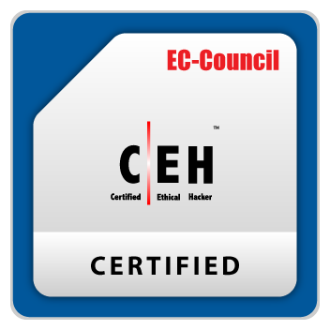Abdul Arshad**

E-Mail:- [abdularshad390@gmail.com](mailto:abdularshad390@gmail.com),

Mobile: +91-9109912023, 8269776421.

Address: - H. No. E 34, Mayur Vihar Colony,

Ashoka Garden, Bhopal (M.P.)



**Professional Summary**

* Result-driven professional with 4 years + of knowledge and exposure in Linux (Red Hat, Centos Server), Windows Server, Hardware, Networking, Technical IT-Support and Server Administrator.
* Experience in configuration of Server and Client, systems administration, disaster recovery management, customer support for systems & software up-gradation.
* Skilled in providing hardware & operating system support in Linux, Windows Server.
* Demonstrated abilities in installing, configuring and providing support to Linux Server and Windows Server Operating Systems, Local Area Network (LAN).
* An effective communicator with strong team management, analytical and problem-solving skills.
* Networking & implementation (LAN, WAN), maintenance of hardware and user accounts administration, VPN, VLAN.
* Basic Knowledge of Docker, AWS EC2 Instance, Python, Kali Linux, Cluster.

**Certifications**

* Red Hat Certified Engineer (RHCE - 170-201-891)
* Red Hat Certified System Administrator (RHCSA - 170-201-891)
* Certified Network Defender (CND) of EC Council
* Certified Ethical Hacker (CEH) of EC Council

**Work Experience**

1. Organization:  **Confidential**

Designation: **Executive Linux**

Duration: **From November 2019 to Till Date.**

* XMPP Server Configuration – Ejabberd, Mongooseim, Prosody.
* Kamailio SIP Server.
* Server Configuration, Testing, Deployment, Update & Security Patch, R&D.
* Co-ordination with software team.

1. Organization:  **Linux Solution.**

Designation: **Linux Administrator**

Duration: **From 17th April 2017 to 31st- October 2019**

* Linux Administrator
* DNS, DHCP, Apache, SFTP, LVM, Raid, Samba User and Group Administration.
* Backup and Restore, Troubleshooting.

1. Organization:  **NSB BPO Solutions Pvt. Ltd. Bhopal**

Designation: **Hardware & Network Engineer**

Duration: **From September 2015 to 15 April 2017**

**Hardware, Network, Windows Servers and Linux**:

* Desktop Support, Troubleshooting all technical - Hardware, Networking, OS, Software.
* Maintain DNS, DHCP, Web server, FTP Server, Network Services, Raid, RDP.
* Responsible for all computer & Server maintenance, upgrades, installation and repairs, including Windows-7, Winndows Server 2008, 2008 R2, CentOS 7.
* Server Backup.
* Computer Hardware & network administration.
* Installation and configuration of Linux servers in the network as per the requirement.
* Computer viruses and security.
* E-mail and internet programs.
* Remote Access and Solve Problems.

**Academic Qualifications**

* **BE** (**Computer Science)** with CGPA 7.4, from Girdhar Group of institution, Mandideep (M.P)
* **12th** (PCM) with (2nd Division) from Crescent Public School, Madhya Pradesh Board of Secondary Education in Bhopal, Madhya Pradesh.
* **10th**  with (1st Division) from Crescent Public School, Madhya Pradesh Board of Secondary Education in Bhopal, Madhya Pradesh.

**Technical Skills**

* Linux Administration RHEL-5, 7 and CentOS-5, 7, familiar with Linux Distribution- rpm, debian
* Windows Administration – Windows Server 2008 R2, 2003, 2012, Windows 7, 8, 8.1, 10.
* Hardware & Networking.
* **Server Configuration:**
* DNS, DHCP, Samba, Samba Swat, Samba Domain Controller, Yum/DNF, FTP, SSH, Telnet, Web Server, NFS, NIS, Squid Proxy, Zimbra Mail and Troubleshooting.

**Security:**

* Firewall and SeLinux Security.

**Storage Management:**

* LVM, Raid, Swap Management.

**User Administration:**

* User Account Database – Add, Delete, Modify.
* Password Aging Policies.
* Group Administration.
* File and Directory Permission.

**Network:**

* Network Teaming, VLAN, VPN
* Basic IP Assigning & Routing.
* IP Forwarding.

**Automation:**

* Cron

**Backup and Restore:**

* tar, dd, scp, scp, rsync
* automation backup with python script and cron tab.

**Personal Details**

Father's Name : Mr. Abdul Aziz

Date of Birth : 07-Mar-1993

Nationality : Indian

Language Known : English, Hindi, Urdu, Arabic

**DECLARATION**

I hereby declare that the above information is true & best of my knowledge and belief.

**Place : Bhopal**

**Signature**

**Date :**