**Resume [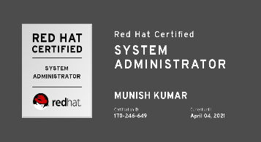](https://www.redhat.com/rhtapps/services/certifications/badge/verify/Y3CYX4DTZTL3DFNCH3WMITBUNAAEQU3CUPSQX2KSDXT6RW46LQ3T7ULZ55KZZ56SKO7EQ3ETTLYZQ4U5NQYTCNA62RUWOCM34WWBUYQ=) [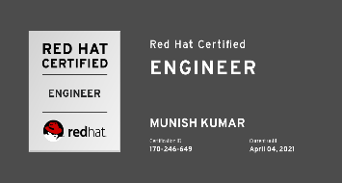](https://www.redhat.com/rhtapps/services/certifications/badge/verify/Y3CYX4DTZTL3DFNCH3WMITBUNAAEQU3CUPSQX2KSDXT6RW46LQ3XCZJWRJNV7ILTXVE4I6VB7OTCG4U5NQYTCNA62RUWOCM34WWBUYQ=)**

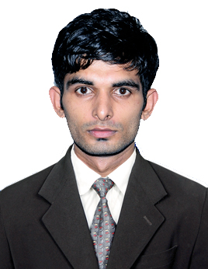

**MUNISH KUMAR**

Address: Village- Bera, Post Office- Pingla, Tehsil- Sarkaghat, Distt-Mandi, Himachal Pradesh, Pin code- 175049

Email: [munish2361993@gmail.com](mailto:munish2361993@gmail.com)

Contact: +918679630422, +918072541566

**CAREER OBJECTIVE:**

To secure challenging and responsible position in an Organization, where there is a scope of contributing and updating my knowledge and skills for development of self and Organization.

**PROFILE SUMMARY:**

* Having around 4.5 Years of experience in Windows Administration, Network Administration and Linux Administration as well as good command in area of IT support.

**PROFESSIONALEXPERIENCE:**

**April 2016 to July 2017:** Joined as system trainee in Jhaver Group With company name First India Pvt Technology under training with Prodapt solutions Pvt Ltd.

* Assembling, Upgrading, Troubleshooting and Maintenance of Computers
* Assembling and reassembling of computer peripherals.
* Installation of Operating Systems
* Installation and Troubleshooting of Win XP, Win 7, Win 10, Win 2008, Win 2012, Win 2012 R2, Ubuntu, centos, Red Hat Operating Systems.
* Troubleshooting issues for onsite engineers using Remote Tools.
* Office Package: Microsoft office, Microsoft Outlook, Microsoft Visio.
* Operating System: Windows 7, Vista, XP, 2003 & 2008 server, Red Hat , Ubuntu and Cent OS
* Configuring and creating the virtual machines.
* Troubleshooting website down and URL related issues.
* Handling L1 tasks in Windows/Linux/Mac/Networking Troubleshooting.
* Worked with Live tickets & rectify all issues with In SLA.
* Configuration & troubleshooting of VPN.

**August 2017 to Present:** [Prodapt Solutions](http://www.prodapt.com/) PVT LTD - IT Support Engineer (Global Support)

* Configured Zabbix Monitoring server to monitor whole Infrastructure of company like Network/servers/IPSEC tunnels/VPN.
* Monitoring internet traffic with NetFlow analyser tool.
* Troubleshooting network connectivity in a LAN/WAN environment.
* Configured switches and access points.
* Create VLANs, Changing VLANs, Troubleshooting Over Switch.
* Managing syslog server and checking logs.
* Troubleshooting with vendors related ISP issues.
* Managing asset management Tool to manage all infra assets.
* Call log with vendors if any issues with server and any infra devices.
* Installing and configuring the VMWARE ESXI
* Configuring and managing the virtual machines.
* Troubleshooting issues for onsite engineers using Remote Tools.
* ADS management (user account creation, deletion, and configuration).
* Interacting with US/UK/Germany/Netherland customer through phone to fix the windows server related issues
* Scheduling and maintaining cronjob in servers
* Creating, Maintaining, Monitoring Mysql/MariaDB/Postgres databases in both format Windows and Linux.
* Scheduling backup in linux using with Rsync scripts under Crontab.
* Raid Creation
* Creation of Apache server and hosting websites, ssl certificates and protecting websites in apache server.
* Configuring NFS server under a network to sync files from one system to another.
* Creating and maintaining Samba server
* Well known with how to do LVM creation, extension and reduce.
* Firewall Management in Linux
* Configuration of Postfix Mail server
* Configuring clusters
* Configuring RAID
* AWS EC2, S3, VPC
* Working on Security prospective to scan infra devices for finding vulnerabilities and work along with specific teams to mitigate vulnerabilities
* Working on Qualys and Nessus kind of tools.
* Prepared Wazuh server for monitoring vulnerabilities and integrity management.

**EDUCATION**

* B. TECH in Mechanical Engineering (2015) from International Institute of Telecom & Technology ENGINEERING COLLEGE (Himachal Pradesh University Shimla (H.P), India) with 67% aggregate.
* Higher secondary Education (2010) From Himachal Pradesh board of school education Dharamshala (H.P) with 67%
* senior secondary school from Himachal Pradesh board of school education Dharamshala (H.P) with 67%.

**CERTIFICATION, TRAININGS AND ACHIEVEMENTS**

* Certified Red Hat System Administrator.
* Certified Red Hat Certified Engineer.
* AWS solution architect - Associate

**ACHIEVEMENTS**

* Participated in National Service scheme camp.
* Participated in National Cadet Corp seven days camp.
* Having NCC certificate A Grade.

**PERSONAL SKILLS**

* Comprehensive problem-solving abilities
* Good verbal and written communication skills
* Quick learner
* Smart working
* Ability to be a good team player

**PERSONAL PROFILE**

**Father’s Name:** Vidya Dutt

**Mother’s Name:**Savitri Devi

**Nationality  :**Indian

**Date of Birth :**23/06/1993

**Languages Known:** English, Hindi

**DECLARATION**

I hereby declare that the information furnished above is true to the best of my knowledge

**Place :** Chennai

**Date : (Munish Kumar)**