 Utopia Model United Nations ’19 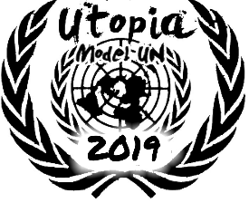

International Press Applications

|  |
| --- |
| Name:  Class & Section:  Email ID:  Phone Number: |

MUN Experience (As a Delegate):

|  |  |  |  |  |  |
| --- | --- | --- | --- | --- | --- |
| Name of Conference | Year | Host Organization | Committee | Portfolio | Award (if any) |
|  |  |  |  |  |  |

MUN Experience (As an IP Member):

|  |  |  |  |  |  |
| --- | --- | --- | --- | --- | --- |
| Name of Conference | Year | Host Organization | Committee | Portfolio | Award (if any) |
|  |  |  |  |  |  |

Mention your contribution(s) to Utopia.

Which position are you applying for?

* Reporter
* Caricaturist
* Photographer

Reporters

Write an essay on one of the topics in not more than 1000 words.

“With rapid technological advancement, industrial work is getting increasingly automated. Do you agree that this will negatively impact human employment in the next decade?”

OR

Present your views in about 300 words on the role played by the International Press and how it helps facilitate the functioning of the UN.

Photographers

Submit any five of your best photographs (preferably of an MUN Conference). Avoid Post Processing.

Caricaturists

Submit three cartoons on any global or political issue.

Kindly mail the required samples to:

[utopiamun2019@gmail.com](mailto:     utopiamun2019@gmail.com    )

**NOTE: The last date to submit this application is 5th May, 2019 by 5:00 PM.**