Analyzing Amazon Sales Data

***Wireframe Documentation***

Excel Charts

Below are the screenshots of Dataset and Charts: -

1. **Top 10 Items in Sales:**

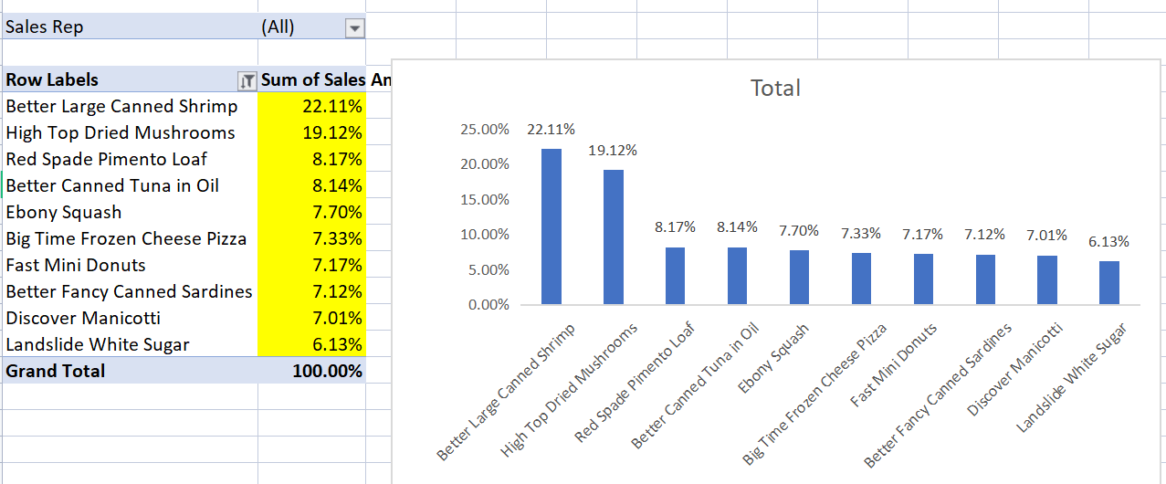

1. **Sales Amount Vs Discount Amount**

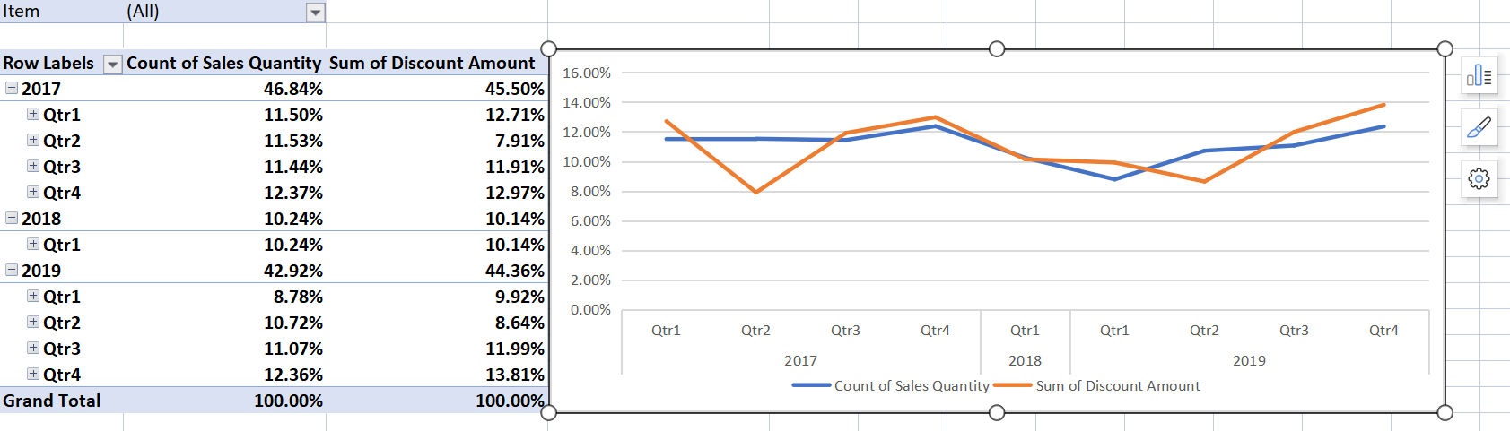

1. **Margin Amount Vs Cost Amount**

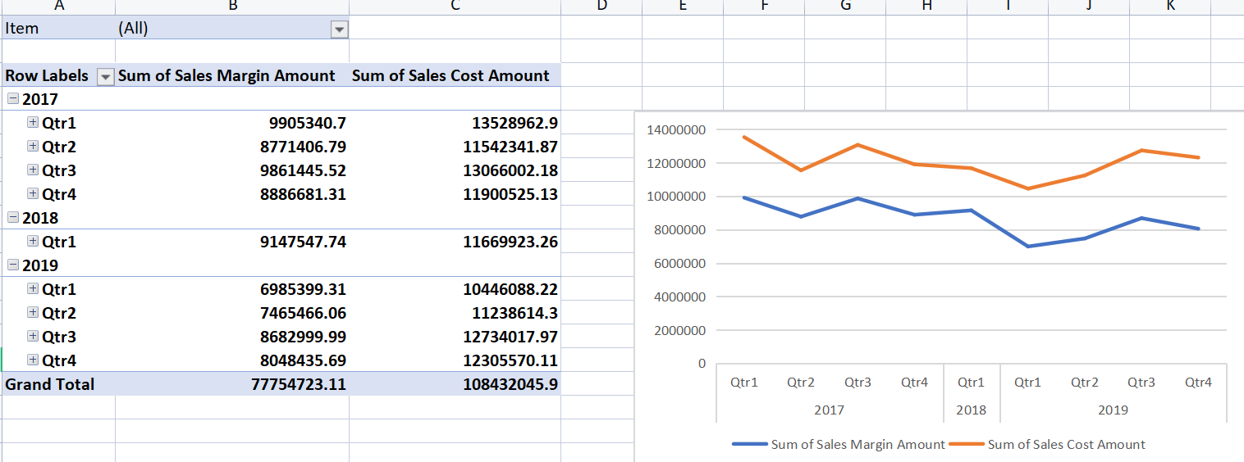

1. **Sales Margin Analysis**

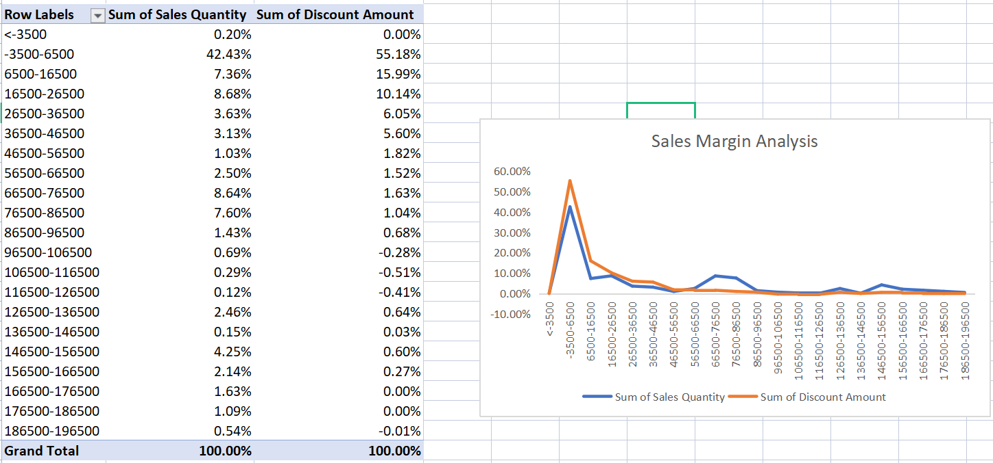

1. **Number of Sales by Sales Representative**

