**D.K.T.E. Society’s Textile and Engineering Institute, Ichalkaranji.**

**(An Autonomous Institute)**

**Department of Computer Science & Engineering**

2021-2022(year)



The project report on

Resume Building

**Under The Guidance Of**

**D.Bhosale**

**DEVELOPED BY:**

1. **Shrutika Kole Roll No.19UCS062**
2. **Priyanka Kshirsagar Roll No.19UCS064**
3. **Anjali Kuchekar Roll No.19UCS065**
4. **Pratiksha Kumbhar Roll No.19UCS074**

**D.K.T.E. Society’s Textile and Engineering Institute, Ichalkaranji.**

**(An Autonomous Institute)**

**Department of Computer Science & Engineering**

CERTIFICATE

This is to certify that,

**1. Shrutika Kole Roll No.19UCS062**

**2. Priyanka Kshirsagar Roll No.19UCS064**

**3. Anjali Kuchekar Roll No.19UCS065**

**4. Pratiksha Kumbhar Roll No.19UCS074**

Have successfully completed the project work, entitled,

**Resume Building**

In partial fulfillment for the award of degree of Bachelor of Engineering in Computer Science & Engineering at Shivaji University, Kolhapur. This is the record of their work carried out during academic year 201x-201y.

Date: Place: Ichalkaranji

Faculty name Prof.Dr.D.V.Kodavade Prof.Dr.P.V.Kadole

[Project Guide] [H.O.D] **[Director] [External Examiner]**

**DECLARATION**

We the undersigned students of T.E.C.S.E. declare that the project work report entitled **Resume Building** written and submitted under the guidance of Prof._D.Bhosale is our original work. The empirical findings in this report are based on the data collected by us. The matter assimilated in this report is not reproduction from any readymade report.

Date:

Place: Ichalkaranji.

Name Signature

1. Shrutika Kole

2. Priyanka kshirsagar

3. Anjali Kuchekar

4. Pratiksha Kumbhar

**INDEX**

**CONTENTS PAGE**

1. Abstract 5
2. Introduction 6
3. Problem statement 7
4. Problem description 8
5. Requirement specification 9

1. Problem solution 11
2. System Design 12-13-14

1. Results and Result Analysis 15
2. Conclusion 16
3. References 17
4. **ABSTRACT**

A resume is a document that contains a summary or listing of relevant job experience and education. The résumé or CV is typically the first item that a potential employer encounters regarding the job seeker and is typically used to screen applicants, often followed by an interview, when seekingemployment.In the job search process, a well-written and well-designed résumé is essential. Our program does the thinking and writing for you. Resume Builder simplifies the work of finding the job by providing intelligent and user-friendly software Resume Builder can display the resume structure in a user-friendly format, so that you can choose which sections of the resume to publish. You can also modify the order of the Published Sections – Biographical Data, Objective, Employment History, Education History, Personal, Skill Areas, Publications, Summary and Certifications.

1. **INTRODUCTION**

As placement season of most of the colleges is going to start, making Resume is a very hectic work for all the students. Also, many companies judge the candidature of a student just by his/her Resume. So it is necessary for the student to think beyond the third dimension while making the Resume.

Automated Resume Builder is the Web Application which helps students to get their resume in hand just by filling up a simple form where important credentials need to be filled.

The resume is downloadable in PDF format. Also, the user can log in again to access the previous resume that he had made.

The resume is of Standard Format as stated by most of the Engineering Colleges of India.

1. **PROBLEM STATEMENT**

To develop a automated resume builder

1. **PROBLEM DESCRIPTION**

1. **REQUIREMENT SPECIFICATION**

**Tools Used :-**

PHP server-XAMPP.

MySQL Database – For managing data entered by the user.

Editor –VS code

Other Requirements – HTML, CSS, Bootstrap, Javascript

1. **REQUIREMENT ANALYSIS**
2. **PROBLEM SOLUTION**

**Main algorithm/Technique:**

1. Design html form with multiple input boxes as per the requirement.

2. Add a submit button.

3. Create another file and design resume template for displaying data.

4. Add PHP Script for sending and recieving input on server side.

1. **SYSTEM DESIGN**

Diagrams:

Flow Chart

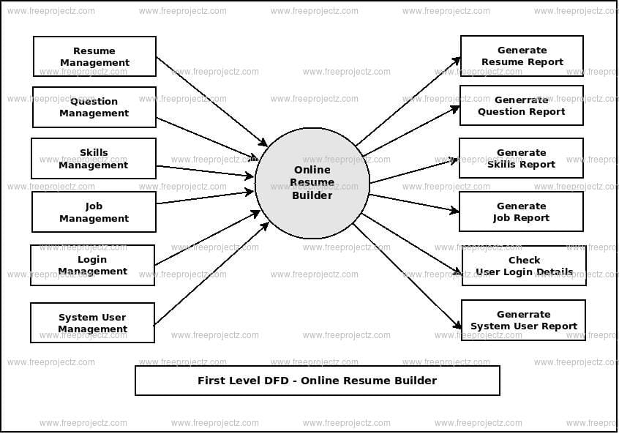

ER Diagram

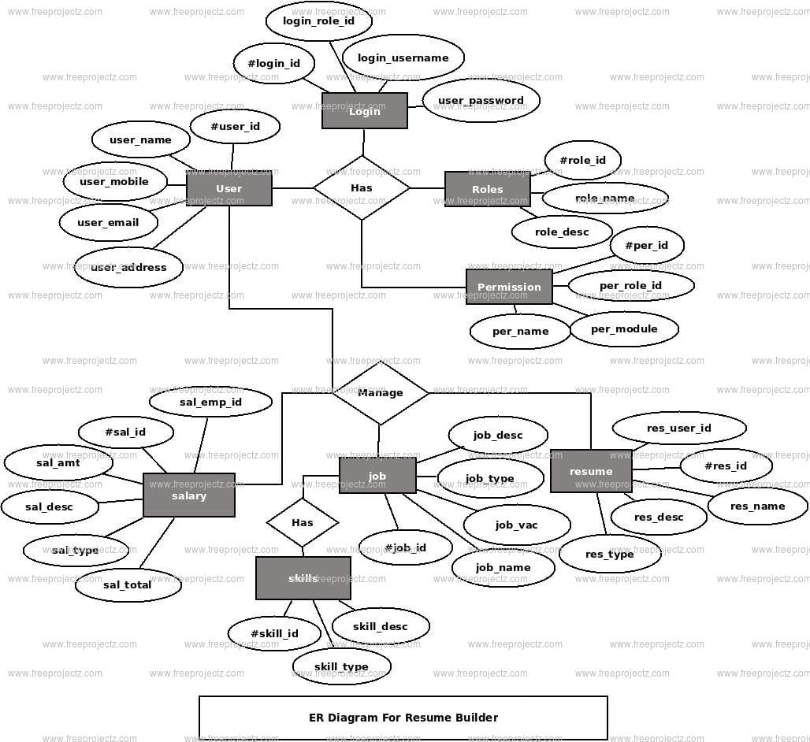

System Architecture

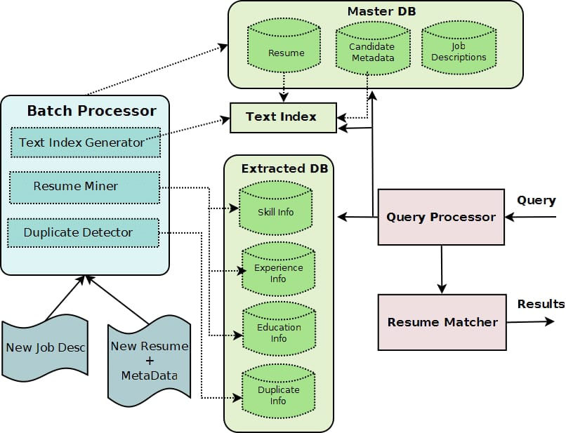

1. **Results and Result Analysis**

* Snapshots/Graphs/analysis of result

1. **CONCLUSION**

Conversion of current web page content into PDF format.

Encrypting password for user privacy.

Login and Logout system in PHP.

Making a website compatible to use on other devices.

1. **REFERENCES**

Websites:-

* <https://www.livecareer.com/resume/examples/data-systems->administration/documentation-specialist
* https://www.geeksforgeeks.org/project-idea-automated-resume-builder