**“Deep Convolutional Neural Network for Real Time Visual Inspection of Structural Audit”**

Submitted in partial fulfilment of the requirements of the degree of

Bachelor of Technology

(Information Technology)

By

**Aditya Shenoy** (161080036)

**Rahul Bhoir** (161080063)

**Kalyani Borkar** (171081990)

**Rani Deore** (171081993)

**B. Tech. (Information Technology)**

**2019-2020**

Under the guidance of

**Dr. V. B. Nikam**



Department of Computer Science and Information Technology

Veermata Jijabai Technological Institute

(An Autonomous institute affiliated to University of Mumbai)

Mumbai-400019

2019-20

**CERTIFICATE**

This is to certify that Mr. Aditya Shenoy (161080036), Mr. Rahul Bhoir (161080063), Ms. Kalyani Borkar (171081990) and Ms. Rani Deore (171081993), students of Bachelor of Technology in Information Technology has successfully completed the report, entitled “**Deep Convolutional Neural Network for Real Time Visual Inspection of Structural Audit**” to our satisfaction.

Dr. V.B.Nikam Dr. Dhiren R. Patel

**Project Guide / Head, Dept. Of CE & IT** **Director, VJTI**

**Date**: ______________

**Place: VJTI, MUMBAI**

**DECLARATION OF THE STUDENT**

I declare that this written submission represents my ideas in my own words and where other’s ideas or words have been included, I have adequately cited and referenced the original sources.

I also declare that I have adhered to all principles of academic honesty and integrity and have not mis-represented or fabricated or falsified any idea / data / fact / source in my submission.

I understand that any violation of the above will be cause for disciplinary action by the Institute and can also evoke penal action from the sources which have thus not been properly cited or from whom proper permission has not been taken when needed.

(Signature) (Signature) (Signature) (Signature)

Aditya Shenoy Rahul Bhoir Kalyani Borkar Rani Deore

Roll: 161080036 Roll: 161080063 Roll: 171081990 Roll: 171081993

**Date**: ______________

**Place: VJTI, MUMBAI**

**APPROVAL SHEET**

The report entitled, “**Deep Convolutional Neural Network for Real Time Visual Inspection of Structural Audit**” submitted by Mr. Aditya Shenoy (161080036), Mr. Rahul Bhoir (161080063), Ms. Kalyani Borkar (171081990) and Ms. Rani Deore (171081993), is found to be satisfactory and is approved for the Degree of Bachelor of Technology in Information Technology.

Dr. V.B.Nikam

**Project Guide Examiner 1**

**Examiner 2**

**Date**: ______________

**Place: VJTI, MUMBAI**

**ACKNOWLEDGEMENT**

I would like to thank all those people whose support and cooperation has been an invaluable asset during the Stage I of this Project. I would also like to thank our Guide

**Dr. V. B. Nikam** guiding me throughout this project and giving it the present shape. It wouldhave been impossible to begin the project without their support, valuable suggestions, criticism, encouragement and guidance.

I am also grateful for all other teaching and non-teaching staff members of the Computer Engineering and Information Technology Department for directly or indirectly helping us for the completion of this stage of the project and the resources provided.

**Abstract**

Structural audit requires manual expertise of surveyors that can be subjective and erroneous. To solve this problem, researchers are studying digital image processing and deep learning techniques for crack detection. The digital image processing techniques are specialized only to the domain it is designed for and the deep learning techniques have only been applied to a single class of structural faults, that is crack, but there are other structural faults that are part of the visual inspection of the structural audit. There is a need for a single generalized model, which can classify more than one structural defect during the visual inspection of structural audit. The proposed system classifies cracks, dampness and paint peel-off using a single generalized model as a part of visual inspection while doing structural audit of infrastructures. The contribution of this work is 95% overall accuracy, 95% average precision, 95.25% average recall, and 95% average F1-score. Usage of a non-complex model has reduced the time taken for training the model and getting predictions from the model. This paper performs multi label classification, which gives more information to the structural auditors than just crack information.

Table of Contents

Chapter 1 8

Introduction 8

Chapter 2 9

Literature Review 9

Chapter 3 12

Proposed Solution 12

3.1 Transfer Learning 12

3.2 Effective Defect Classifier (EDC) Architecture 12

Chapter 4 14

Results and Analysis 14

4.1 Dataset 14

4.2 Experimental Analysis 15

Chapter 5 21

Conclusion and Future Scope 21

Chapter 6 21

Appendix 21

Chapter 7 23

References 23

# Chapter 1

## Introduction

Construction of different infrastructures is a necessity for human life as it brings value to the society, fulfils human needs, and develops the geographic area around it. As the building gets old, the risk of living/working in the building increases. The structure and walls of old buildings show cracks, paint peel off, and dampness. The building needs to be examined after 30 years. The process is called structural audit. For structural audit, the expert has to go to the location and do visual inspection of the building, do different chemical tests, and so forth. While performing visual inspection for detection of cracks, dampness, paint peel off, the process totally depends on the surveyor’s experience and knowledge. Sometimes there may be human errors.

The literature states digital image processing techniques for crack detection. Image processing techniques cannot automatically learn complex features and thus need to be hardcoded and is specialized for only one domain. Papers, which are working in the same domain, are detecting only cracks in their work. However, there are other structural defects in the infrastructure that can be detected visually including dampness of wall and peeling off paint.

There is a need for a single generalized model, which can classify more than one structural defect during the visual inspection of structural audit. The proposed system classifies cracks, dampness and paint peel-off using a single generalized model as a part of visual inspection while doing structural audit of buildings.

The remainder of this paper is structured as follows: the Literature Review section provides a background of the work done in this area; the Proposed Model section describes the classification models of four classes of wall in the structural audit; and in the Results and Analysis section, this research paper presents the results of the model. The final sections conclude the proposed work and add scope of research for future works in the related fields.

# Chapter 2

## Literature Review

S. Kang et al. [1] state that there are several techniques used for crack detection. Laser method is time consuming, the acceleration sensor method has low accuracy. So a camera based method that uses image processing is used which gave an accuracy of 89.33%. J. Vora et al. [2] research on binarization. RGB image undergoes binarization and is converted to a grayscale image and then to binary image by setting a threshold value. User’s parameters (sensitivity and window size) in binarization sometimes causes the crack to remain undetected. Therefore, two new user’s parameter are set Pw and Pl. Using these parameters two binary images are obtained which undergo an edge detection algorithm. R. K. Meghana et al. [3] state that images are captured using UAV, then converted to grayscale. Void detection in concrete is done using MATLAB. Image stitching is carried out to merge the images to get a clear view of crack. Binary image is formed and then thresholding is carried out to remove skeleton pixels. X. Liu et al. [4] propose that for enhancing the noisy image multiscale enhancement method is used. MESG algorithm is used. SOBEL filter is used for obtaining binary image. Morphological processing is done to remove noise and join parts of cracks. W. Li et al. [5] present method to identify deformation, crack and surface damage normal edge detection is not enough, and therefore CANNY edge detection algorithm is used. Using this, the paper got the relative length and width, centre ratio. M. Lin et al. [6] present that an original image is pre-processed using a band pass filter method to reduce the noise in the image and then an adaptive line detector is used due to changing region size and direction. Then the HMRF-EM algorithm is used to increase the accuracy to label the data. Start and ends of labelled data are clustered on relative positions to get true ends. L. Peng et al. [7] propose a traditional method for defect detection on the wind turbine, which is very costly, has low efficiency and takes lots of time. New method applies Wiener filter on the image to remove the motion blur. An adaptive median filtering method is used for removing the noise from the image. To regain the image quality, enhancement algorithms are used. L. Calderón et al. [8] state that edge detection is applied on the image to reduce pixels. Not every dark pixel is a crack so the pixels, which are dark but not crack, are removed by passing them to a modified line kernel.

Y. Wang et al. [9] present a research to capture random size inputs by using Full Convolution Network (FCN). This paper also captures temporal features of subsequent frames by using Convolutional Long Short Term Memory (Conv-LSTM). As this paper is using FCN, the output generated is a pixel level segmentation of videos. H. Shi et al. [10] research on the object detection on traffic camera videos. The paper compares two deep learning methods namely Region-based Full Convolutional Network (R-FCN) and Faster Region-based Convolutional Neural Network (R-FCN). The results of this paper shows that RFCN performs better than Faster RCNN. P. Babayan et al. [11] compare three deep learning techniques for vehicle and pedestrian recognition namely, RCNN, YOLO, and SSD. Faster R-CNN performs well in terms of AUC and mAP. The processing time of Faster R-CNN is higher than YOLO. B. Hou et al. [12] state a method of object detection in high resolution remote sensing videos. This paper considered two architectures, YOLO and Faster R-CNN. Faster R-CNN was selected as it produces better result for smaller sized objects which are present in remote sensing video. K. Mouri et al. [13] focus on using R-FCN for selecting goods (objects) in stock in the logistics industry automatically. After object detection, the paper’s methodology uses Grow cut algorithm for segmentation. This segmentation refines the bounding box produced by R-FCN to real shape of the object using background and foreground seeding method. B. Tian et al. [14] state object detection methods in video dataset using deep learning methods for traceability. Once trained, the model is deployed online and objects are detected and traced using Gaussian background modelling and other non-parametric modelling. The results show that this deep learning method is suitable for downloaded videos as well as real time video analysis. M. Gasmallah et al. [15] state a methodology for Predictive Object Detection (POD) using deep learning techniques. The architecture used in the paper uses YOLOv2 (You Only Look Once version 2) and LSTM (Long Short Term Memory). The YOLO architecture has time benefits as it processes the image only once. The LSTM architecture is used to incorporate temporal features of previous frames in the video. A. Anjum et al. [16] propose a method for video stream analysis using cloud computing for object detection and classification. This paper states that saving the input video data on the cloud, decoding videos, and moving operator function code to the computing nodes on the cloud can give scalability and time benefits. The nodes on the cloud have GPU cores, thereby collectively improving the time required for analysis of videos.

N. Truong et al. [17] propose a Super Resolution (SR) reconstruction and marker detection model based on deep learning for drone landing. In SR reconstruction, the low-resolution image frame 320 × 240 pixel is captured which is given to the module for detecting the landing area. The inputted image is given to CNN with DCSCN produced high-resolution image. C. Wang et al. [18] state an approach for map construction of the unfamiliar surroundings and using it to localize. The model includes Deep Reinforcement Learning (DRL), Reinforcement Learning (RL), Markov Decision Processes (MDP), and Partially Observable Markov Decision Processes (POMDP), which helps in navigation in complex environments. Recurrent Deterministic Policy Gradient (RDPG) and fast RDPG algorithm helps in navigation. S. Hassan et al. [19] present deep learning based YOLO model for detecting UAV. YOLO model takes input image, which is resized and divided into grids. If the object falls on the grid centre, then the duty of the grid is to detect object, forecast B’s bounding boxes, calculate bounding box x, y, z, h confident, predict conditional probability, determine bounding box confidence score, otherwise undefined body. YOLOv2 is 92.10% precise and YOLOv3 is 95.20%, which is enhanced, but YOLOv3 took longer training time. A. Zeggada et al. [20] state a multi-label classification model for UAV images. In this model, CNN features extracted from tile using GoogLeNet. For multi-labelling issue, the paper proposed multi-label layer. A. Mahadik et al. [21] state structural audit method for building. It is necessary and important to carry out the structural audit specialists and act instantly through advices provided in the audit report to ensure safety of the building.

N. Yusof et al. [22] propose a method to classify and detect pavement crack using deep CNN. This study states a deep convolution neural network (DCNN) that is capable to sense the crack robustly while dealing with complicated background image. The network is trained using stochastic gradient (SGD) training algorithm. Exploring how the size of input image affects deep CNN with respect to detection and classification performance, different sizes, and grid scale are adopted in architecture. S. Liang et al. [23] identify the problem in organizing crack images in health checking of structures and hence propose a novel algorithm for concrete crack detection. In this algorithm, obtained attributes are used as input to train a SVM classifier. This algorithm had a better capability to identify cracks with noticeable contours. Hessain matrix based linear filtering approach is used to increase the crack area and regulate threshold gap to get the crack binarization segmentation result. L. Zhang et al. [24] state that using the Internet of Things (IoT) technology for collecting video data is easy. The methodology used in this paper is CNN. This method could successfully solve the problems of high risk factor in domestic and low fracture analysis. M. David Jenkins et al. [25] represent a DFCN network to achieve pixel-wise classification of road and pavement cracks. This paper presents an algorithm for semantic segmentation of road and pavement surface cracks using a U-Net. Dataset used is openly accessible CrackForest. F. Nagata et al. [26] state application of DCNN for vision-based fault examination. The DCNNs are trained using the man-made images and then tested through classification trials. The designed DCNNs are trained using the generated images and then evaluated through classification experiments. X. Wang al. [27] research on the segment of roadway crack images into variable scales of nets and then image is cut into nets. CNN is to check for cracks. The model only keeps the nets that contain crack so that the bones of crack is conserved. S. Gibb et al. [28] propose a method that utilizes Genetic Algorithm for CNN model improvement. This method evolved several parameters that dictate the structure of CNN, including: the number of conv layers, filters size, and number of filters. Developing CNN structures produces high-performance networks that have higher sorting accuracy than the existing network when tested on images containing cracks. Nilkamal More et al. [29] states use of Support Vector Machine (SVM) for classification of satellite images and for identifying green space areas.

# Chapter 3

## Proposed Solution

The proposed system classifies cracks, dampness and paint peel-off using a single generalized model as a part of visual inspection while doing structural audit of buildings. As the structural audit domain is not explored much before, two model architectures were experimented including Transfer Learning (ResNet-50) and a custom Convolutional Neural Network, Effective Defect Classifier (EDC).

### 3.1 Transfer Learning

Training a model from scratch with a small dataset does not always give good accuracy. So one could try to increase the size of the dataset by using available similar datasets on the Internet but as this domain is not explored previously, there was no similar dataset available. Alternatively, one can use someone else’s model which is already trained on a very large dataset. Transfer learning (TL) is a research problem in machine learning (ML) that focuses on storing knowledge gained while solving one problem and applying it to a different but related problem. This paper tried using the pre-trained ResNet-50 model (Figure 1) for the problem. This model is trained on the CIFAR-10 dataset. The dataset is made of animals, vehicles, fruits, insects, man-made objects, and so forth.

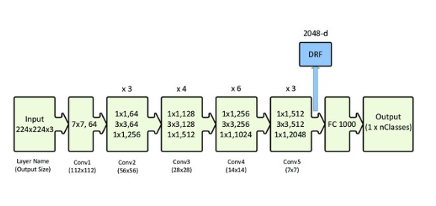

***Fig. 1.*** *ResNet-50 Architecture*

### 3.2 Effective Defect Classifier (EDC) Architecture

The classification problem involves detection of complex features in the image data. Hence, a custom Convolutional Neural Network (CNN) was tried. CNN is a type of Deep Learning technique in which the model tries to capture different features, shapes, edges, and so forth in the input image. A typical architecture of a CNN includes convolution layers at the beginning and fully connected dense layers at the end. The convolutional layers extract features from the input and the dense layers combine these features to learn to recognize the classes in the dataset.

For the architecture, hyper parameters like number of convolutional layers, number of filters in each convolutional layer and number of dense layers were tuned. The final architecture is illustrated in Figure 2, which consists of four convolutional layers with 16 filters each and a kernel size of 3*3. Max Pooling of 2*2 is used after each convolutional layer. One hidden dense layer is added before the output layer containing 32 nodes. The input layer matches the dimensions of the images in the dataset, that is (256, 256, 3) where 3 is the number of channels in JPG images. The output layer consists of four nodes as the dataset has four classes. The dataset consists of 36,000 images (32,000 training images and 4,000 validating images).

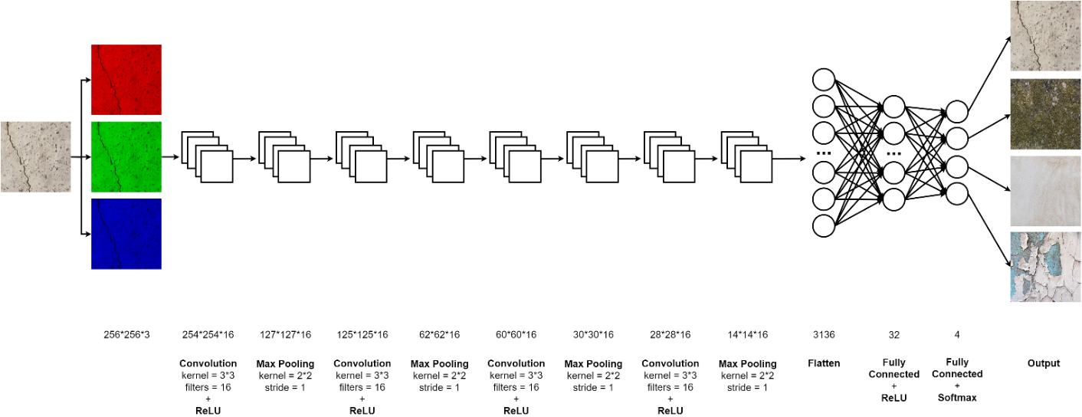

***Fig. 2.*** *Effective Defect Classifier (EDC) Architecture*

# Chapter 4

## Results and Analysis

This section discusses the characteristics of the custom dataset and the pre-processing algorithm applied to the dataset before passing it to the model. This section also analyses the results on ResNet-50 and Effective Defect Classifier (EDC) Architectures based on various metrics.

### 4.1 Dataset

This paper is using a custom dataset, as the dataset for all structural defects has not been created before. The dataset consists of four classes that is Crack, Dampness, Paint Peel Off, and Plain wall. The images were captured in the Veermata Jijabai Technological Institute (VJTI) campus, Mumbai. These images are cropped and then each cropped sample is resized to 256*256 pixels. Using RGB images easily captures many important features of the classes can be instead of using grayscale images. The dataset consists of 36,000 images in total out of which 32,000 images were used for training and 4,000 were used for validating. Table 1 shows the count of the raw cropped samples for each class. Then pre-processing techniques were applied to the raw images to make it ready for model training and validation.

**Table 1** Information about Raw Dataset

|  |  |
| --- | --- |
| Class | Raw cropped Samples |
| Crack | 705 |
| Dampness | 630 |
| Paint Peel Off | 650 |
| Plain Wall | 1095 |
| Total | 3080 |

Each of the four classes contains an unequal amount of cropped images. So random 625 samples are picked for each class from the cropped samples. Each class now has an equal number of samples of 625 images per class (total 2,500 images) which makes the dataset not skewed to any class. The four classes are not orientation dependent that is even after flipping, rotating orthogonally, or transposing on any diagonal, the class would not change. For example, a crack if rotated by 90 degrees would still remain a crack. Thus seven non-distorting transformations (it does not add any synthetic pixels) are applied to the images. These seven non-distorting transformations are: rotate image by 90 degrees, rotate image by 180 degrees, rotate image by 270 degrees, flip image horizontally, flip image vertically, transpose image, transverse image.

These original images and their seven non distorted transformation images are saved. By this step, the dataset size is scaled up by a factor of eight resulting to a total of 8*625 = 5000 images per class (total 20,000 images). These images are then split into training and validating images in an 80:20 ratio. So 4000 images per class (total 16,000 images) are used for training purposes while 1000 images per class (total 4,000 images) are used for validation. In the process of training, distorting transformations are applied so that the model does not overfit and generalizes on unseen output. Two random distorting transformations are generated per training image. The total training images per class then results to 4000*2 = 8000 images per class (total 32,000 images). Both training images and validate images are then saved in the train folder and validate folders respectively.

### 4.2 Experimental Analysis

This section, experiments and analyses different parameters for the model, which will improve the accuracy of the model. This section then discuss the metrics of the experiment results.

4.2.1 Optimal Training and Validation Split of Dataset

As a custom dataset is generated for this paper, various split points were experimented to split the dataset into training and validating images. Six split points were tried in this experiment: 65:35, 70:30, 75:25, 80:20, 85:15, and 90:10. Figures 3 to 14 have plotted the accuracy versus epochs and loss versus epochs for each of these model experiments.

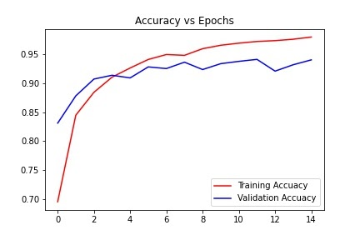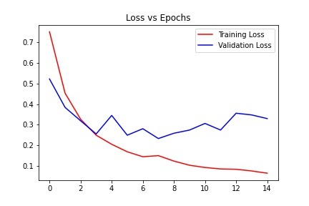

***Fig. 3.*** *Accuracy vs Epochs 65:35 split* ***Fig. 4.*** *Loss vs Epochs 65:35 split*

Figures 3 and 4 show that the intersection between training accuracy (or loss) and validation accuracy (or loss) is at epoch 3. This early intersection indicates that due to lower training data, the model has started to overfit since epoch 3. This overfitting indication is clearer in Figure 4 where the validation loss is gradually increasing as the number of epoch’s increases.

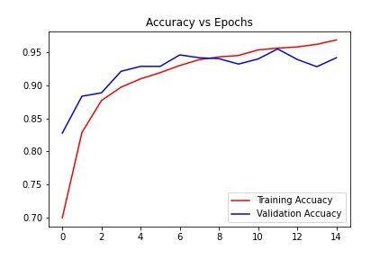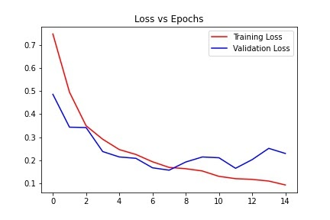

***Fig. 5.*** *Accuracy vs Epochs 70:30 split* ***Fig. 6.*** *Loss vs Epochs 70:30 split*

In the 70:30 split case, the intersecting point is shifted towards right at epoch 8. This shift is because the model is getting more training images this time and is thus learning better than the 65:35 case. But similar to the 65:35 case, the model is showing overfitting indications at epoch 8 and onwards, which can again be seen by the gradual increase in slope of validation loss in Figure 6.

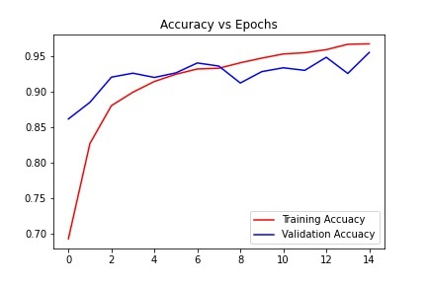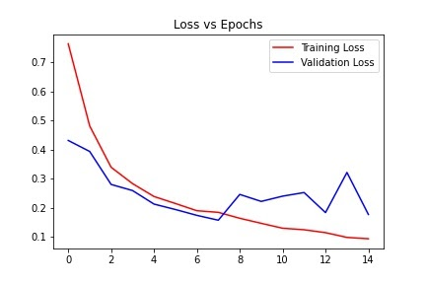

***Fig. 7.*** *Accuracy vs Epochs 75:25 split* ***Fig. 8.*** *Loss vs Epochs 75:25 split*

Next, the 75:25 split was tried. This experiment showed very less overfitting, as compared to the above two cases, which is shown in Figures 7 and 8. In Figure 8, the validation loss almost has a zero slope even after the intersection point, which is at epoch 7, which indicates that this model is showing signs of a well-fitted model. Thus, 75:25 split was one of the candidates for the final model.

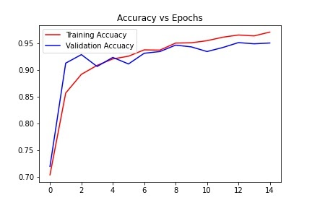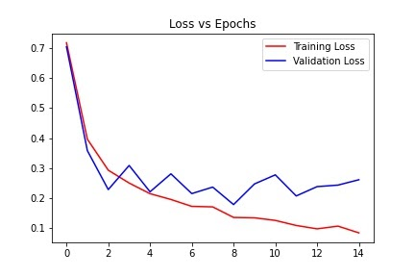

***Fig. 9.*** *Accuracy vs Epochs 80:20 split* ***Fig. 10.*** *Loss vs Epochs 80:20 split*

When the 80:20 split case was tried, the Figures 9 and 10 indicated similar signs as of the 75:25 split. The validation loss in Figure 10 has an almost zero slope after the intersection point (at epoch 3). Thus, this model has also shown signs of a well-fitted model. Thus, the 80:20 split was also one of the final candidates for the final model.

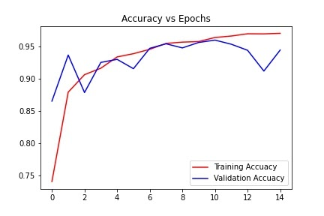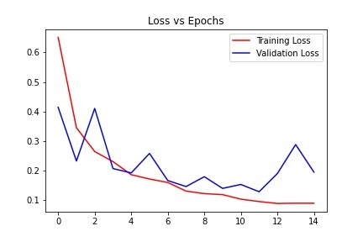

***Fig. 11.*** *Accuracy vs Epochs 85:15 split* ***Fig. 12.*** *Loss vs Epochs 85:15 split*

Figures 11 and 12 show the result of the 85:15 split case. The model is showing signs of overfitting at epoch 13 and further where even the validation accuracy in Figure 11 is decreasing along with an increase in the validation loss in Figure 12. Thus, this model is over fitted. The probable reason for this overfitting is due to the higher proportion of training dataset as compared to the validation dataset. This reason is also applicable to the next case of 90:10 split, as the training proportion is much higher than the validation in the 90:10 case, the graphs have a huge gap between the training and validation accuracy in Figure 13 and training and validation loss in Figure 14.

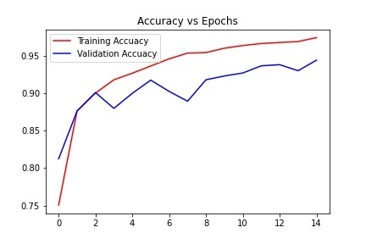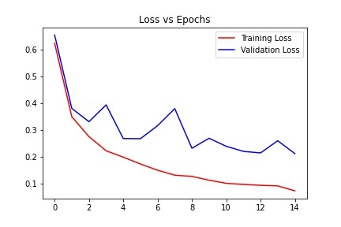

***Fig. 13.*** *Accuracy vs Epochs 90:10 split* ***Fig. 14.*** *Loss vs Epochs 90:10 split*

The results would have come similar with any one of two final candidates that is 75:25 and 80:20. This paper went with 80:20 because the part of the zero slope in the 80:20 case is smoother than the 75:25 case.

4.2.2 Transfer Learning

The ResNet-50 model was trained for 30 epochs by using the ‘conv5_block3_2_relu’ layer output as the convolution layer and with one dense layer. Training the model gave a training accuracy of 70% but validation accuracy of 80% (Figures 15 and 16). However, on testing this model on unseen images, the model predicted every image as paint peel-off resulting in a testing accuracy of 25%. The requirement for transfer learning to give good results is that the problem should be similar to the problem on which the model is trained. Hence, the problem is not similar to the ResNet-50.

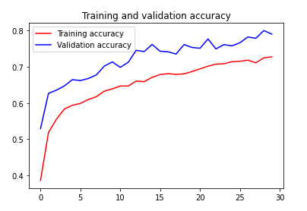 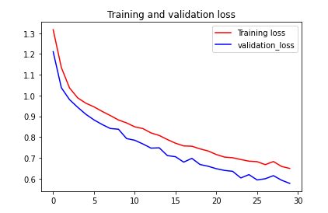

***Fig. 15.*** *Accuracy vs Epochs -Transfer Learning* ***Fig. 16.*** *Loss vs Epochs -Transfer Learning*

#### 4.2.3 Effective Defect Classifier (EDC)

Training time: The training time history is shown in Appendix 1. This table shows that as the model consists of a reasonably lower number of layers, the average time required for model training (77.6 seconds) is low too.

*Accuracy and Loss:* Training the model for 15 epochs gave the following results for accuracy and loss. Figure 10 shows that the loss of the model is almost steadybetween epochs 2 and 14 and it will overfit if the number of epochs increases. Hence, the model is well fitted. The validation accuracy in this case is 95%, which is a great increase from earlier attempts. See Appendix 2 for table of results.

*Confusion matrix:* The confusion matrix, shown in Table 2, shows that the values of true positive are very good. The classes of Crack, Dampness, Plain Wall, and Paint Peel Off are abbreviated as letters C, D, N, and P respectively. Out of 1000 test images per class, approximately 950 images (95%) per class are identified correctly. Tables 3 to 6 mention class wise confusion matrices for each of the four classes. Here TP, FP, FN, and TN refer to True Positives, False Positives, False Negatives, and True Negatives respectively*.*

**Table 2** Confusion Matrix

|  |  |  |  |  |  |
| --- | --- | --- | --- | --- | --- |
| Predicted→  Actual ↓ | C | D | N | P | Total |
| C | 932 | 27 | 13 | 28 | 1000 |
| D | 16 | 966 | 8 | 10 | 1000 |
| N | 8 | 10 | 957 | 25 | 1000 |
| P | 24 | 11 | 19 | 946 | 1000 |

**Table 3** Confusion Matrix of Crack Class

|  |  |  |
| --- | --- | --- |
| Predicted→  Actual ↓ | C | Not C |
| C | TP = 932 | FN = 68 |
| Not C | FP = 48 | TN = 2952 |

**Table 4** Confusion Matrix of Dampness Class

|  |  |  |
| --- | --- | --- |
| Predicted→  Actual ↓ | D | Not D |
| D | TP = 966 | FN = 34 |
| Not D | FP = 48 | TN = 2952 |

**Table 5** Confusion Matrix of Plain Wall Class

|  |  |  |
| --- | --- | --- |
| Predicted→  Actual ↓ | N | Not N |
| N | TP = 957 | FN = 43 |
| Not N | FP = 40 | TN = 2960 |

**Table 6** Confusion Matrix of Paint Peel Off Class

|  |  |  |
| --- | --- | --- |
| Predicted→  Actual ↓ | P | Not P |
| P | TP = 946 | FN = 54 |
| Not P | FP = 43 | TN = 2957 |

*Precision, Recall, and F1-Score:* Precision measures the relative number of FP as compared to the number of TP. Higher precision indicates that the amount of negatives predicted as positive is low. Similarly, Recall measures the relative number of FN as compared to the number of TP. Higher recall indicates that the amount of positives falsely classified as negative is low. Ideally, both precision and recall should be high. F1-score unifies both of these scores. The calculation of these values for Crack class is shown below. Similarly, other classes’ metrics have been calculated and all the values are filled in the Table 7.

Precision, Recall and F1-score for crack class:

Precision = TP / TP+FP = 932 / 932+48 = 0.95

Recall = TP / TP+FN = 932 / 932+68 = 0.93

F1 Score = 2 * (Recall * Precision) / (Recall + Precision)

= 2 * (0.93*0.95) / (0.93+0.95) = 0.94

**Table 7** Class wise Metrics

|  |  |  |  |  |
| --- | --- | --- | --- | --- |
|  | Precision | Recall | F1-score | Total |
| Crack | 0.95 | 0.93 | 0.94 | 1000 |
| Dampness | 0.95 | 0.97 | 0.96 | 1000 |
| Plain Wall | 0.96 | 0.96 | 0.96 | 1000 |
| Paint Peel Off | 0.94 | 0.95 | 0.94 | 1000 |

*Comparison between available models and Effective Defect Classifier model*: Available models are binary classifiers and they only classify between crack and non-crack. EDC model is a multi-label classifier and it classifies crack, dampness, plain wall and paint peel-off with an accuracy of 95%.

# Chapter 5

## Conclusion and Future Scope

This paper has generated a dataset with four classes (Crack, Dampness, Paint peel-off, Plain wall) and each class has 9,000 images. Testing this dataset using the ResNet-50 model gave a low validation accuracy. Then a custom CNN model, Effective Defect Classifier (EDC), gave a validation accuracy of 95%, which can classify more classes as compared to the existing models. Precision for crack, dampness, plain wall and paint peel-off, is 95%, 95%, 96% and 94%. Recall is 93%, 97%, 96%, 95%. F1-score is 94%, 96%, 96%, 94%.

Current dataset consists of four classes, which can be increased by identifying more varieties of defects. Current dataset has 9,000 images per class. By doing more surveys, one can increase the count of images and by using a good camera; one can improve the image quality. Pre-processing techniques can be applied on the dataset to get more features from images.

# Chapter 6

## Appendix

**Appendix 1** Training Time History

|  |  |  |  |
| --- | --- | --- | --- |
| **Epochs** | **Training Time (sec)** | **Epochs** | **Training Time (sec)** |
| 1 | 80 | 9 | 77 |
| 2 | 80 | 10 | 77 |
| 3 | 78 | 11 | 77 |
| 4 | 78 | 12 | 77 |
| 5 | 78 | 13 | 77 |
| 6 | 77 | 14 | 77 |
| 7 | 77 | 15 | 77 |
| 8 | 77 | - | - |
| Avg. Training Time per Epoch | | 77.6 seconds | |
| Total Training Time For 15 Epochs | | 19 minutes 24 seconds | |

**Appendix 2** Accuracy and Loss

|  |  |  |  |  |
| --- | --- | --- | --- | --- |
| **Epochs** | **Training Accuracy**  **(%)** | **Validation Accuracy (%)** | **Training Loss** | **Validation Loss** |
| 1 | 70.36 | 71.95 | 0.71 | 0.70 |
| 2 | 85.69 | 91.30 | 0.39 | 0.35 |
| 3 | 89.21 | 92.90 | 0.29 | 0.22 |
| 4 | 90.88 | 90.68 | 0.25 | 0.30 |
| 5 | 92.09 | 92.37 | 0.21 | 0.22 |
| 6 | 92.60 | 91.15 | 0.19 | 0.28 |
| 7 | 93.79 | 93.15 | 0.17 | 0.21 |
| 8 | 93.74 | 93.48 | 0.17 | 0.23 |
| 9 | 95.06 | 94.67 | 0.13 | 0.17 |
| 10 | 95.12 | 94.35 | 0.13 | 0.24 |
| 11 | 95.51 | 93.48 | 0.12 | 0.27 |
| 12 | 96.16 | 94.23 | 0.10 | 0.20 |
| 13 | 96.57 | 95.15 | 0.09 | 0.23 |
| 14 | 96.41 | 94.92 | 0.10 | 0.24 |
| 15 | 97.12 | 95.07 | 0.08 | 0.26 |

# Chapter 7

## References

[1] S. Kang, C. Chun, S. Shim, S. Ryu and J. Baek, "Real Time Image Processing System for Detecting Infrastructure Damage: Crack," 2019 IEEE International Conference on Consumer Electronics (ICCE), Las Vegas, NV, USA, 2019, pp. 1-3.

[2] J. Vora, M. Patel, S. Tanwar and S. Tyagi, "Image Processing Based Analysis of Cracks on Vertical Walls," 2018 3rd International Conference On Internet of Things: Smart Innovation and Usages (IoT-SIU), Bhimtal, 2018, pp. 1-5.

[3] R. K. Meghana, S. Apoorva, Mohana and Y. Chitkara, "Inspection, Identification and Repair Monitoring of Cracked Concrete structure –An application of Image processing," 2018 3rd International Conference on Communication and Electronics Systems (ICCES), Coimbatore, India, 2018, pp. 1151-1154.

[4] X. Liu, Y. Ai and S. Scherer, "Robust image-based crack detection in concrete structure using multi-scale enhancement and visual features," 2017 IEEE International Conference on Image Processing (ICIP), Beijing, 2017, pp. 2304-2308.

[5]W. Li, M. Zhang, Z. Shen, W. Hu and P. Li, "Track Crack Detection Method in Complex Environment," 2018 11th International Symposium on Computational Intelligence and Design (ISCID), Hangzhou, China, 2018, pp. 356-359.

[6] M. Lin, R. Zhou, Q. Yan and X. Xu, "Automatic Pavement Crack Detection Using HMRF-EM Algorithm," 2019 International Conference on Computer, Information and Telecommunication Systems (CITS), Beijing, China, 2019, pp. 1-5.

[7] L. Peng and J. Liu, "Detection and analysis of large-scale WT blade surface cracks based on UAV-taken images," in IET Image Processing, vol. 12, no. 11, pp. 2059-2064, 11 2018.

[8] L. S. Calderón and J. Bairán, "Crack detection in concrete elements from RGB pictures using modified line detection Kernels," 2017 Intelligent Systems Conference (IntelliSys), London, 2017, pp. 799-805.

[9] Y. Wang, Y. Lyu, Y. Cao and M. Y. Yang, "Deep Learning for Semantic Segmentation of UAV Videos," *IGARSS 2019 - 2019 IEEE International Geoscience and Remote Sensing Symposium*, Yokohama, Japan, 2019, pp. 2459-2462.

[10] H. Shi, Z. Liu, Y. Fan, X. Wang and T. Huang, "Effective object detection from traffic camera videos," 2017 IEEE SmartWorld, Ubiquitous Intelligence & Computing, Advanced & Trusted Computed, Scalable Computing & Communications, Cloud & Big Data Computing, Internet of People and Smart City Innovation (SmartWorld/SCALCOM/UIC/ATC/CBDCom/IOP/SCI), San Francisco, CA, 2017, pp. 1-5.

[11] P. V. Babayan, M. D. Ershov and D. Y. Erokhin, "Neural Network-Based Vehicle and Pedestrian Detection for Video Analysis System," 2019 8th Mediterranean Conference on Embedded Computing (MECO), Budva, Montenegro, 2019, pp. 1-5.

[12] B. Hou, J. Li, X. Zhang, S. Wang and L. Jiao, "Object Detection and Trcacking Based on Convolutional Neural Networks for High-Resolution Optical Remote Sensing Video," IGARSS 2019 - 2019 IEEE International Geoscience and Remote Sensing Symposium, Yokohama, Japan, 2019, pp. 5433-5436.

[13] K. Mouri, H. Lu, J. K. Tan and H. Kim, "Object Detection on Video Images Based on R-FCN and GrowCut Algorithm," 2018 International Conference on Information and Communication Technology Robotics (ICT-ROBOT), Busan, 2018, pp. 1-4.

[14] B. Tian, L. Li, Y. Qu and L. Yan, "Video Object Detection for Tractability with Deep Learning Method," 2017 Fifth International Conference on Advanced Cloud and Big Data (CBD), Shanghai, 2017, pp. 397-401.

[15] M. H. Gasmallah and F. Zulkernine, "Video Predictive Object Detector," 2018 IEEE 9th Annual Information Technology, Electronics and Mobile Communication Conference (IEMCON), Vancouver, BC, 2018, pp. 365-371.

[16] A. Anjum, T. Abdullah, M. F. Tariq, Y. Baltaci and N. Antonopoulos, "Video Stream Analysis in Clouds: An Object Detection and Classification Framework for High Performance Video Analytics," in IEEE Transactions on Cloud Computing, vol. 7, no. 4, pp. 1152-1167, 1 Oct.-Dec. 2019.

[17] N. Q. Truong, P. H. Nguyen, S. H. Nam and K. R. Park, "Deep Learning-Based Super-Resolution Reconstruction and Marker Detection for Drone Landing," in IEEE Access, vol. 7, pp. 61639-61655, 2019.

[18] C. Wang, J. Wang, X. Zhang and X. Zhang, "Autonomous navigation of UAV in large-scale unknown complex environment with deep reinforcement learning," 2017 IEEE Global Conference on Signal and Information Processing (GlobalSIP), Montreal, QC, 2017, pp. 858-862.

1. S. A. Hassan, T. Rahim and S. Y. Shin, "Real-time UAV Detection based on Deep Learning Network," 2019 International Conference on Information and Communication Technology Convergence (ICTC), Jeju Island, Korea (South), 2019, pp. 630-632.
2. A. Zeggada, F. Melgani and Y. Bazi, "A Deep Learning Approach to UAV Image Multilabeling," in IEEE Geoscience and Remote Sensing Letters, vol. 14, no. 5, pp. 694-698, May 2017.

[21] A.B. Mahadik and M.H. Jaiswal, “Structural Audit of Buildings,” 2014 International Journal of Civil Engineering Research, 2014, ISSN 2278-3652 Volume 5, Number 4 (2014), pp. 411-416

[22] N. A. M. Yusof, M. K. Osman, M. H. M. Noor, A. Ibrahim, N. M. Tahir and N. M. Yusof, "Crack Detection and Classification in Asphalt Pavement Images using Deep Convolution Neural Network," 2018 8th IEEE International Conference on Control System, Computing and Engineering (ICCSCE), Penang, Malaysia, 2018, pp. 227-232.

[23]S. Liang, X. Jianchun and Z. Xun, "An Extraction and Classification Algorithm for Concrete Cracks Based on Machine Vision," in IEEE Access, vol. 6, pp. 45051-45061, 2018.

[24] L. Zhang, G. Zhou, Y. Han, H. Lin and Y. Wu, "Application of Internet of Things Technology and Convolutional Neural Network Model in Bridge Crack Detection," in IEEE Access, vol. 6, pp. 39442-39451, 2018.

[25] M. David Jenkins, T. A. Carr, M. I. Iglesias, T. Buggy and G. Morison, "A Deep Convolutional Neural Network for Semantic Pixel-Wise Segmentation of Road and Pavement Surface Cracks," 2018 26th European Signal Processing Conference (EUSIPCO), Rome, 2018, pp. 2120-2124.

[26] F. Nagata, K. Tokuno, K. Watanabe and M. K. Habib, "Design Application of Deep Convolutional Neural Network for Vision-Based Defect Inspection," 2018 IEEE International Conference on Systems, Man, and Cybernetics (SMC), Miyazaki, Japan, 2018, pp. 1705-1710.

[27] X. Wang and Z. Hu, "Grid-based pavement crack analysis using deep learning," 2017 4th International Conference on Transportation Information and Safety (ICTIS), Banff, AB, 2017, pp. 917-924

[28] S. Gibb, H. M. La and S. Louis, "A Genetic Algorithm for Convolutional Network Structure Optimization for Concrete Crack Detection," 2018 IEEE Congress on Evolutionary Computation (CEC), Rio de Janeiro, 2018, pp. 1-8

[29] Nilkamal More, V. B. Nikam & Biplab Banerjee (2020): Machine learning on high performance computing for urban greenspace change detection: satellite image data fusion approach, International Journal of Image and Data Fusion, DOI: 10.1080/19479832.2020.1749142

[30] Nikam, V. B., and B. B. Meshram. "Modeling rainfall prediction using data mining method: A Bayesian approach." 2013 Fifth International Conference on Computational Intelligence, Modelling and Simulation. IEEE, 2013.