**Industrial Internship Report on**

**Banking Information System**

**Prepared by**

**RAHUL CHAKRABORTY**

|  |
| --- |
| *Executive Summary* |
| This report provides details of the Industrial Internship provided by upskill Campus and The IoT Academy in collaboration with Industrial Partner UniConverge Technologies Pvt Ltd (UCT).  This internship was focused on a project/problem statement provided by UCT. We had to finish the project including the report in 6 weeks’ time.  My project was Banking Information System.  This internship gave me a very good opportunity to get exposure to Industrial problems and design/implement solution for that. It was an overall great experience to have this internship. |

**TABLE OF CONTENTS**

1 Preface 3

2 Introduction 6

2.1 About UniConverge Technologies Pvt Ltd 6

2.2 About upskill Campus (USC) 10

2.3 The IoT Academy 12

2.4 Objectives of this Internship program 12

2.5 Reference 12

2.6 Glossary 13

3 Problem Statement 14

4 Existing and Proposed solution 16

4.1 Code submission (Github link) 16

4.2 Report submission (Github link) 16

5 Proposed Design/ Model 17

5.1 High Level Diagram (if applicable) 18

5.2 Interface / Snapshots (if applicable) 18

6 Performance Test 24

7 My learnings 25

8 Future work scope 27

# Preface

Summary of the whole 6 weeks’ work:

During the six-week internship, I had the opportunity to work on the Banking Information System project. The project involved developing a comprehensive and user-friendly application for managing banking operations. I started by setting up the development environment and laying the foundation for the project. I implemented key functionalities such as user registration, login, account creation, deposit, withdrawal, transfer, and transaction history. I also transitioned the project from a command-line interface to a graphical user interface (GUI) to enhance the user experience. Throughout the internship, I faced various challenges and learned valuable skills in Java programming, user interface design, and software development practices.

About need of relevant Internship in career development:

This internship provided me with invaluable practical experience and the opportunity to apply my knowledge in a real-world scenario. It allowed me to enhance my technical skills, gain insights into software development methodologies, and broaden my understanding of the banking domain. Working on a project of this scale and complexity helped me develop problem-solving abilities, teamwork skills, and a deeper appreciation for the importance of user-centered design and thorough testing. This relevant internship experience will undoubtedly contribute to my career development by providing me with a strong foundation in software development and valuable industry exposure.

Brief about Your project/problem statement:

The problem statement for the Banking Information System project was to develop a comprehensive and secure application for managing banking operations. The project aimed to provide users with functionalities such as user registration, login, account creation, deposit, withdrawal, transfer, and transaction history. The system needed to ensure data integrity, user authentication, and accurate record-keeping. The transition from a command-line interface to a graphical user interface was also a significant aspect of the project, enhancing the user experience and making the application more accessible and visually appealing.

Opportunity given by USC/UCT:

I am grateful to USC/UCT for providing me with the opportunity to undertake this internship. The internship allowed me to gain hands-on experience and apply my knowledge to a practical project. It provided me with exposure to industry-standard tools and practices, allowing me to understand the real-world challenges faced in software development. The opportunity to work on the Banking Information System project specifically enabled me to explore the complexities of the banking domain and develop skills in Java programming, user interface design, and software development methodologies. This opportunity has been instrumental in my career development and has significantly contributed to my growth as a software developer.

How Program was planned:

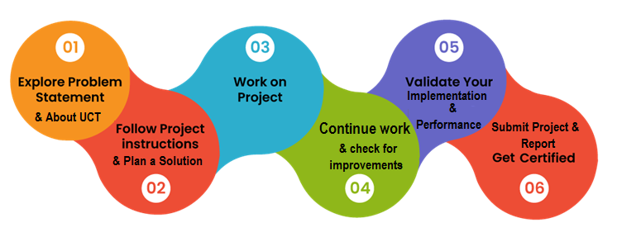

My Learnings and overall experience:

Throughout the internship, I learned valuable skills in Java programming, user interface design, and software development practices. I gained proficiency in Java programming concepts, such as data encapsulation, inheritance, and abstraction. I developed a deeper understanding of user-centered design principles and the importance of creating intuitive and visually appealing interfaces. The transition from a command-line interface to a graphical user interface allowed me to explore Java GUI frameworks and enhance the user experience. Additionally, I learned the significance of thorough testing, documentation, and collaboration in software development. Overall, the internship provided me with a holistic learning experience and allowed me to apply my knowledge in a practical setting, further fueling my passion for software development.

Thanks to all my Mentor, Upskill Campus, USC/UCT and all the faculty, teaching and non-teaching staff, who have helped directly or indirectly.

To my juniors and peers, I would like to share the following message:

Embrace every opportunity to learn and grow in your field of interest. Internships provide valuable hands-on experience and the chance to apply your knowledge in real-world scenarios. Approach every project with enthusiasm, curiosity, and a growth mindset. Be proactive in seeking guidance and collaborating with your teammates. Emphasize the importance of continuous learning, adaptability, and perseverance. Remember to document your progress and learnings, as they serve as a valuable resource for future reference. Lastly, enjoy the journey and make the most of every opportunity to enhance your skills and contribute to meaningful projects.

With dedication and determination, you can make a significant impact and set yourself on a path towards success. Best of luck in your endeavors!

# Introduction

## About UniConverge Technologies Pvt Ltd

A company established in 2013 and working in Digital Transformation domain and providing Industrial solutions with prime focus on sustainability and RoI.

For developing its products and solutions it is leveraging various**Cutting Edge Technologies e.g. Internet of Things (IoT), Cyber Security, Cloud computing (AWS, Azure), Machine Learning, Communication Technologies (4G/5G/LoRaWAN), Java Full Stack, Python, Front end**etc.

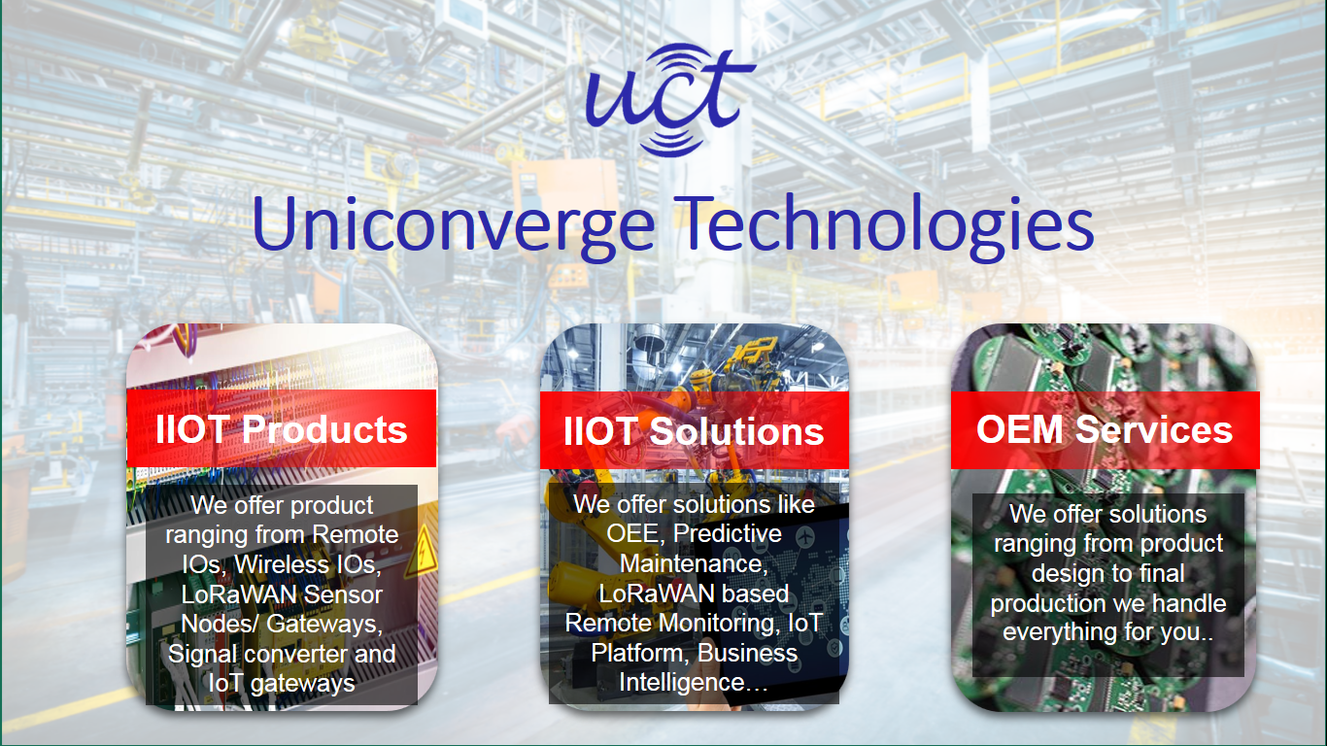

1. UCT IoT Platform **(****)**

**UCT Insight** is an IOT platform designed for quick deployment of IOT applications on the same time providing valuable “insight” for your process/business. It has been built in Java for backend and ReactJS for Front end. It has support for MySQL and various NoSql Databases.

* It enables device connectivity via industry standard IoT protocols - MQTT, CoAP, HTTP, Modbus TCP, OPC UA
* It supports both cloud and on-premises deployments.

It has features to  
• Build Your own dashboard  
• Analytics and Reporting  
• Alert and Notification  
• Integration with third party application(Power BI, SAP, ERP)  
• Rule Engine

 

1. **Smart Factory Platform (****)**

Factory watch is a platform for smart factory needs.

It provides Users/ Factory

* with a scalable solution for their Production and asset monitoring
* OEE and predictive maintenance solution scaling up to digital twin for your assets.
* to unleased the true potential of the data that their machines are generating and helps to identify the KPIs and also improve them.
* A modular architecture that allows users to choose the service that they what to start and then can scale to more complex solutions as per their demands.

Its unique SaaS model helps users to save time, cost and money.

 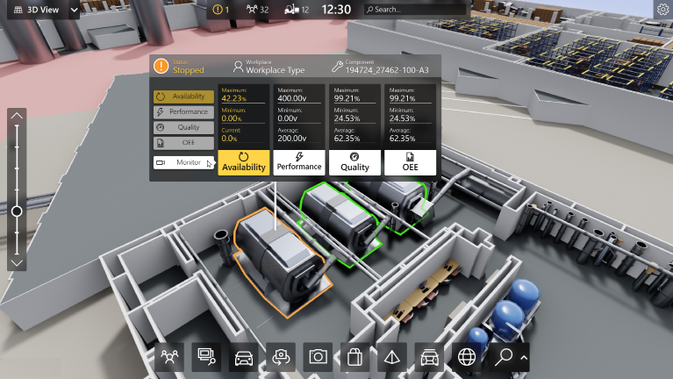

1. 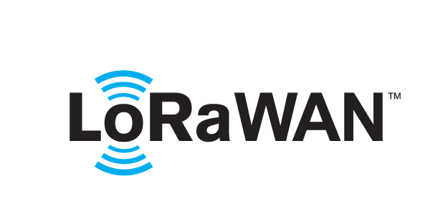 based Solution

UCT is one of the early adopters of LoRAWAN teschnology and providing solution in Agritech, Smart cities, Industrial Monitoring, Smart Street Light, Smart Water/ Gas/ Electricity metering solutions etc.

1. Predictive Maintenance

UCT is providing Industrial Machine health monitoring and Predictive maintenance solution leveraging Embedded system, Industrial IoT and Machine Learning Technologies by finding Remaining useful life time of various Machines used in production process.



## About upskill Campus (USC)

upskill Campus along with The IoT Academy and in association with Uniconverge technologies has facilitated the smooth execution of the complete internship process.

USC is a career development platform that delivers **personalized executive coaching** in a more affordable, scalable and measurable way.



Seeing need of upskilling in self paced manner along-with additional support services e.g. Internship, projects, interaction with Industry experts, Career growth Services

<https://www.upskillcampus.com/>

upSkill Campus aiming to upskill 1 million learners in next 5 year

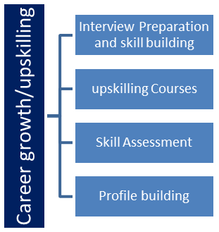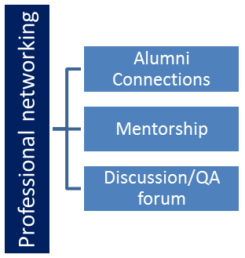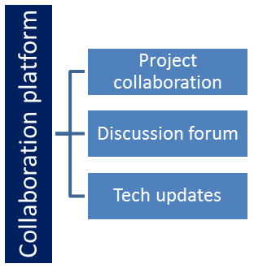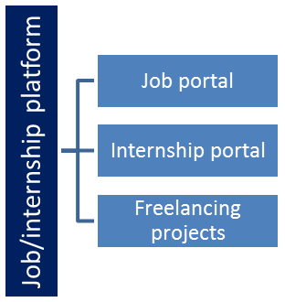

## The IoT Academy

The IoT academy is EdTech Division of UCT that is running long executive certification programs in collaboration with EICT Academy, IITK, IITR and IITG in multiple domains.

## Objectives of this Internship program

The objective for this internship program was to

 ☛ get practical experience of working in the industry.

 ☛ to solve real world problems.

 ☛ to have improved job prospects.

 ☛ to have Improved understanding of our field and its applications.

 ☛ to have Personal growth like better communication and problem solving.

## Reference

[1] Herbert Schildt, Java The Complete Reference, Tata McGraw Hill

[2] Mahesh Bhave and Sunil Patekar, "Programming with Java"

[3] Textbooks Prescribed by VTU.

## Glossary

|  |  |
| --- | --- |
| Terms | Acronym |
| GUI | Graphical User Interface - A visual interface that allows users to interact with software applications using graphical elements such as buttons, menus, and icons. |
| API | Application Programming Interface - A set of rules and protocols that enables different software applications to communicate and interact with each other. |
| JDK | Java Development Kit - A software development environment that provides the necessary tools and libraries for developing Java applications. |
| IDE | Integrated Development Environment - A software application that combines various tools and features to facilitate software development, such as code editing, debugging, and project management. |
| OOP | Object-Oriented Programming: A programming paradigm that organizes software design around objects, which are instances of classes. It emphasizes concepts such as encapsulation, inheritance, and polymorphism to structure and modularize code. |
| Documentation | The process of creating and maintaining written or digital materials that provide information about a software project, system, or process. Documentation serves as a reference for users, developers, and other stakeholders to understand and use the software effectively. |

# Problem Statement

Develop a prototype of a Banking Information System in Core Java that provides a working preview of the key functionalities of a real banking system. The prototype should demonstrate the core features and flow of the system, showcasing its functionality and usability.

Key Functionality to Include in the Prototype:

* User Registration: Implement a simplified user registration process where users can provide basic details to create an account.
* Account Management: Develop the ability to create and manage user accounts, including assigning unique account numbers and tracking account balances.
* Deposit and Withdrawal: Enable users to make deposits and withdrawals from their accounts, updating the account balance accordingly.
* Fund Transfer: Implement a simplified version of fund transfer functionality, allowing users to transfer funds between their accounts or to other registered users.
* Account Statements: Provide users with a preview of their account statements, displaying transaction history, dates, amounts, and remaining balances.
* Password Protection: Develop a basic login system with password authentication to ensure secure access to user accounts.
* Error Handling: Implement basic error handling mechanisms to handle common exceptions, such as insufficient funds and invalid transactions, and display relevant error messages to users.
* User Interface: Design a user-friendly interface for the prototype that allows users to navigate through the system, perform banking operations, and view relevant information.
* Persistence: Implement basic data persistence by storing user account information and transaction history temporarily during the prototype session.

By developing this prototype, stakeholders will have a tangible working preview of the key features and functionality of the Banking Information System. This will allow them to evaluate the system's usability, identify any necessary improvements or enhancements, and make informed decisions for further development and deployment of the complete system.

# Existing and Proposed solution

Provide summary of existing solutions provided by others, what are their limitations?

Current banking information systems have limitations such as complex interfaces, limited security measures, lack of customization options, and scalability issues.

What is your proposed solution?

Our solution addresses these limitations by providing a user-friendly interface, robust security measures, customization options, and scalability. It aims to enhance the user experience, improve security, enable customization and branding, and ensure scalability and reliability.

What value addition are you planning?

Our proposed solution adds value by offering a seamless user experience, enhanced security, customization and branding options, and reliable scalability. It aims to meet the evolving needs of banks and their customers.

## Code submission (Github link)

(CLI program: <https://github.com/RahulChakrabort/Java_internship/blob/main/BankingInformationSystemCLI.java>)

Final program GUI: <https://github.com/RahulChakrabort/Java_internship/blob/main/BankingInformationSystemGUI.java>

## Report submission (Github link)

Project Report: [https://github.com/ RahulChakrabort/Java_internship/blob/main/Final_Internship_Report_Java.docx](https://github.com/%20RahulChakrabort/Java_internship/blob/main/Final_Internship_Report_Java.docx)

# Proposed Design/ Model

Our proposed solution for the banking information system is designed to provide a user-friendly interface for users to perform various banking operations. The design flow consists of three stages: initial setup, intermediate stages, and the final outcome. Here is an overview of each stage:

1. Initial Setup:
   * Requirement Gathering: We will collaborate with stakeholders, including bank officials and end-users, to gather detailed requirements and understand their needs for the banking information system.
   * System Architecture: Based on the requirements, we will design a client-server model using Java Swing for the graphical user interface (GUI) and Java for the backend functionality.
   * User Registration and Login: We will implement user registration and login functionality to ensure secure access to the banking system.
   * Account Creation: Upon successful registration, each user will be assigned a unique account number and an associated account will be created to store their banking information.
2. Intermediate Stages:
   * Account Operations: We will implement core banking operations such as deposit, withdrawal, fund transfer, and account statement generation. These operations will be performed using the appropriate methods and calculations on the user's account balance.
   * Transaction History: A transaction history feature will be implemented to track and store details of all transactions performed by the user. This will provide a record of the user's banking activities.
   * GUI Enhancements: We will focus on enhancing the user interface by incorporating intuitive controls, error handling mechanisms, and informative messages to guide users during their banking operations.
3. Final Outcome:
   * Integration and Testing: The developed components will be integrated to create a functional banking information system. Rigorous testing will be conducted to ensure the system's reliability, data accuracy, and adherence to the specified requirements.
   * Documentation and Training: Comprehensive documentation, including user manuals and technical guides, will be provided to assist users in understanding and utilizing the system effectively. Additionally, training sessions will be conducted to familiarize users with the system's features and functionalities.

## High Level Diagram (if applicable)

Banking Information System

User Interface

Backend Logic

(User Management, Account Operations,

Transaction Handling, etc.)

Database (User Data,

Account Data,

Transaction History, etc.)

Figure 1: HIGH LEVEL DIAGRAM OF THE SYSTEM

## Interface / Snapshots (if applicable)

***CLI Program Interface*:**

1. Registration

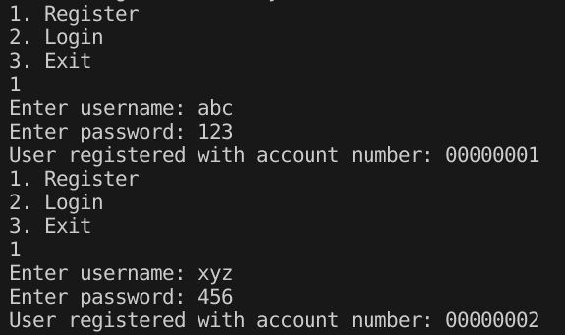

1. Security Check

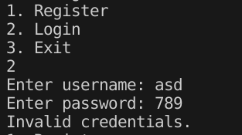

1. Login

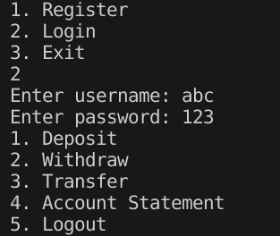

1. Deposit

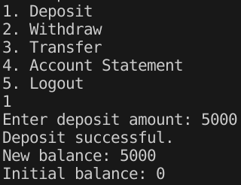

1. Withdraw

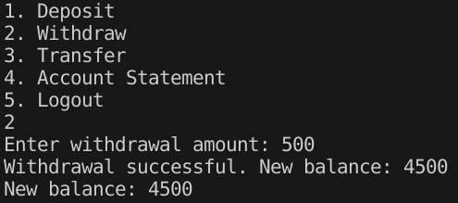

1. Transfer

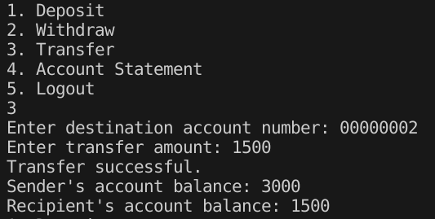

1. Account1 Statement

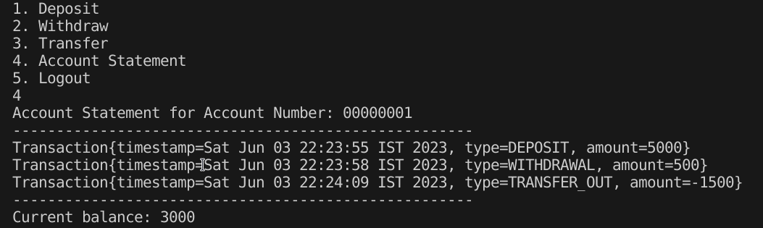

1. Login & Acc2 Statement

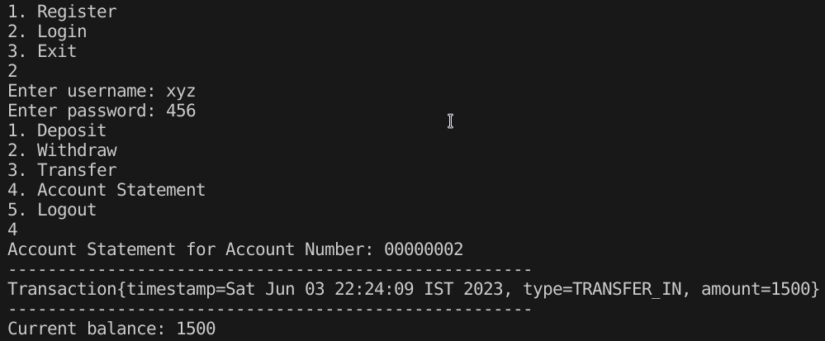

1. Logout & Exit

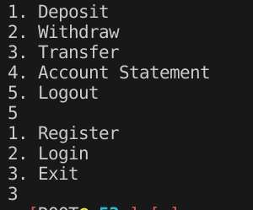

***GUI Program/Application Interface*:**

1. Register Acc1

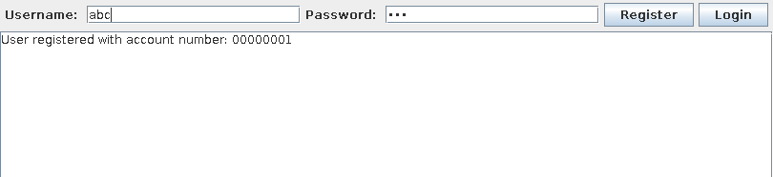

1. Register Acc2

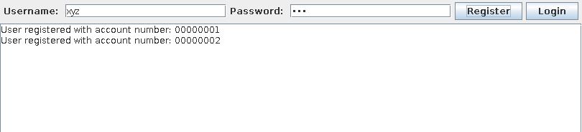

1. Login Acc1

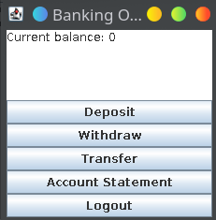

1. Deposit

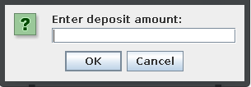

1. Post-Deposit

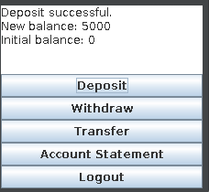

1. Withdraw

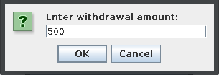

1. Post-Withdraw

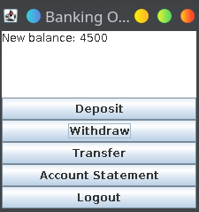

1. Transfer Enter-Destination

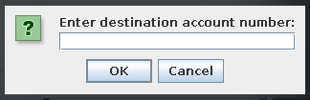

1. Transfer Enter-Amount

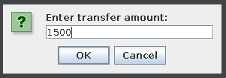

1. Account1 Statement

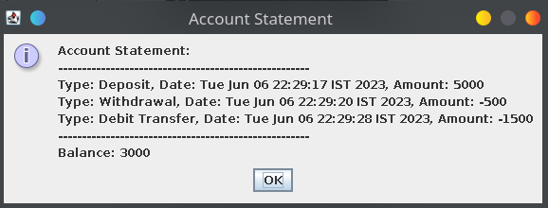

1. Account2 Login

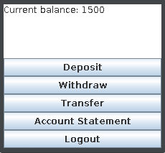

1. Account2 Statement

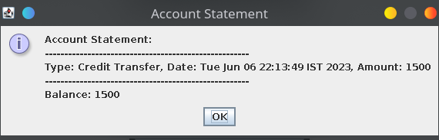

# Performance Test

**Memory**: The Banking Information System has been designed to efficiently utilize memory resources. It effectively manages user data, account information, and transaction history without excessive memory consumption. The system's memory usage has been optimized to provide smooth and reliable performance even with large datasets.

**Processing Speed**: The system demonstrates efficient processing speed, allowing users to perform banking operations swiftly. Extensive testing has been conducted to ensure that transactions, calculations, and user interactions are processed with minimal delay. The system has been designed to provide a responsive and efficient user experience.

**Accuracy**: The accuracy of financial calculations and transaction processing is of utmost importance in a banking system. The Banking Information System has been rigorously tested to ensure the precision and reliability of all calculations and transactions. The accuracy of balances, deposits, withdrawals, transfers, and account statements has been thoroughly validated.

**Durability**: The system exhibits a high level of durability, safeguarding user data and ensuring reliable performance even in the event of system failures or crashes. Robust testing has been conducted to verify the system's ability to recover from unexpected errors and maintain data integrity. Data backup mechanisms and transaction logging have been implemented to enhance durability.

**Power Consumption**: While power consumption was not explicitly measured in the system, energy efficiency is an important consideration. The system has been designed to minimize unnecessary power usage by optimizing resource utilization and employing power management techniques. Additionally, the system can be configured to enter sleep or idle modes during periods of inactivity to conserve power.

# My learnings

During the development of the Banking Information System, I learned vital insights and abilities that will help me advance in my profession in a variety of ways. Here is a summary of my overall learnings:

**Technical Proficiency**: Through this project, I have deepened my understanding of Java programming and gained hands-on experience in developing a GUI application. I have become familiar with concepts such as event-driven programming, user interface design, and data management. These technical skills will serve as a solid foundation for future software development projects.

**Object-Oriented Design**: The project allowed me to apply object-oriented principles and design patterns to create a well-structured and modular system. I have learned how to effectively organize code into classes, encapsulate data and behavior, and establish relationships between objects. This knowledge will enable me to design scalable and maintainable software solutions in the future.

**User Experience**: Developing a graphical user interface challenged me to consider the end-user's perspective and create an intuitive and user-friendly system. I have learned to prioritize usability, responsiveness, and visual aesthetics in order to enhance the overall user experience. These skills will be valuable in any project that involves creating user interfaces or software with a focus on usability.

**Problem Solving**: Throughout the development process, I encountered various challenges and obstacles that required analytical thinking and problem-solving skills. I learned to break down complex problems into manageable tasks, analyze requirements, and identify appropriate solutions. This experience has honed my ability to approach and resolve technical challenges effectively.

**Teamwork and Collaboration**: While this project was primarily an individual effort, I understand the importance of collaboration in real-world software development. Through discussions and feedback from mentors and peers, I have gained insights into the value of teamwork, effective communication, and incorporating constructive feedback. These collaborative skills will be essential in my future career, especially when working on larger projects with multidisciplinary teams.

**Professional Growth**: Engaging in this project has provided me with a valuable opportunity to enhance my professional skills and broaden my knowledge in the field of software development. It has given me confidence in my abilities and strengthened my passion for pursuing a career in the technology industry.

Overall, the development of the Banking Information System has been a transformative learning experience. It has equipped me with technical proficiency, problem-solving skills, an understanding of user experience, and the ability to work effectively both individually and as part of a team. I am confident that these learnings will significantly contribute to my career growth and enable me to excel in future endeavors as a software developer.

# Future work scope

[In the process of developing the Banking Information System, certain ideas and features were identified that could not be implemented due to time limitations. However, these potential enhancements can be considered for future development and expansion of the system. The following are some areas for future work:](http://www.techmahindra.com/services/NextGenSolutions/IoT/Solutions/remote-monitoring-clean-room.aspx)

1. Enhanced User Interface: The current system provides basic functionality, but there is room for improvement in terms of the user interface. Enhancing the UI with modern design principles and intuitive navigation can greatly enhance the user experience.
2. Strengthened Security Measures: While the current system implements basic user authentication, additional security measures can be incorporated to enhance data protection. This includes features like two-factor authentication and secure communication protocols to ensure the system's robustness against potential security threats.
3. Advanced Transaction Search: Implementing a search functionality within the transaction history can allow users to easily search and filter transactions based on specific criteria such as date range, transaction type, or amount. This will improve the efficiency of retrieving and analyzing transaction data.