**STEP 1: Import EEG/MEG data in Brainstorm**

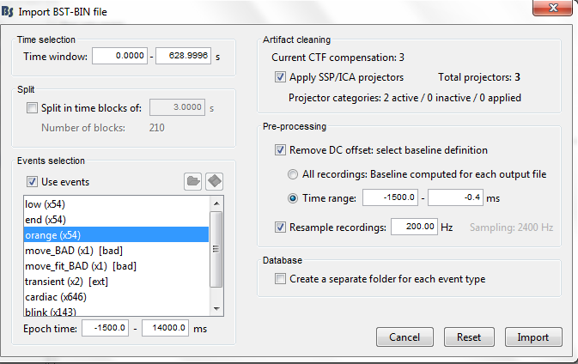

**STEP 2: Import all subjects MEG data into ‘files to process’ window**

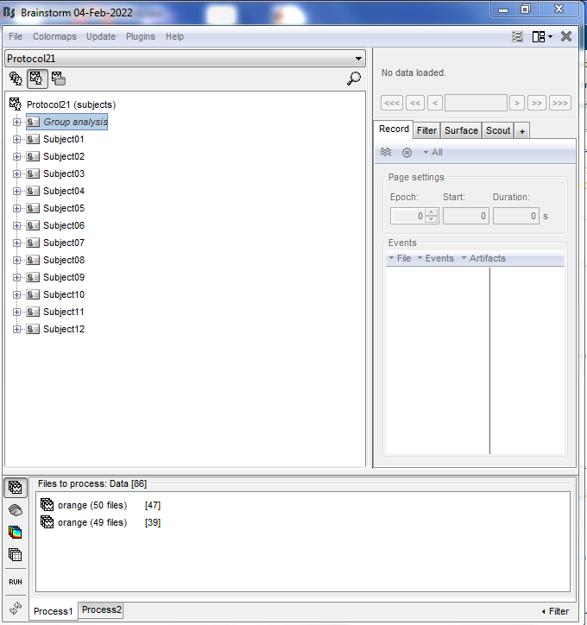

**STEP 3: Run the following process to concatenate all subjects MEG time course (raw signal).**

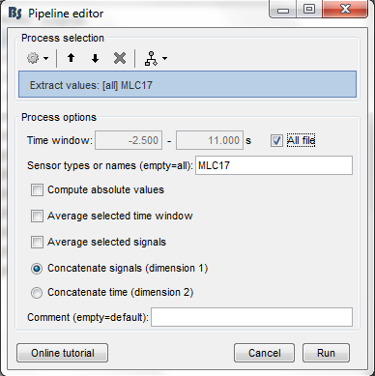

**STEP 4: Export the output file to matlab and convert to .csv format.**

e.g. ‘Bimanual_old.csv’ (attached)

**STEP 5: Import the csv file and run the following scripts:**

* **HMM_bursts.ipynb:** This script is for detecting bursts and computing burst characteristics using HMM method. You can set interval details in the script based on the desired portion of the signal. Further this script runs on time_series data. So no need to compute time frequency using Brainstorm. It will extract beta waves from the raw signal and extract bursts and its characteristics for individual trials. The output is saved as a csv file.
* **Threshold_bursts.ipynb:** This is exactly the same as before but it uses threshold method to extract bursts. There is an option in the script to set a threshold value.

Run the above scripts using the sample file ‘Bimanual_old.csv’ to get an idea. The output should be similar to this file ‘file_name.csv’.

‘Bimanual_old.csv’ contains raw MEG signals of individual trials of 12 older subjects.