- Do not edit/delete any heading or section with red text.
- Type /paste you answers in relevant sections (below Final Answer (in all questions , Approach (wherever required ) and Charts & tables (wherever required)) of the solution
- Link to submission guidelines
- Please note that submission not following the guidelines will not be accepted

OBJECTIVE QUESTIONS

Question 1: What is the total no. of tables present in the data?

Solution:

Final Answer (if any):
There is 1 main dataset table used for analysis, along with multiple reference Pivot Tables derived from it.

Approach (if any):
Reviewed the provided Excel workbook to identify the primary data source, confirming 'Cleaned data' as the main table.

Charts & Tables (if any):
- Table / Chart Name:
N/A - Data structure verification
- Description:
Identified the primary tables in the dataset.

Question 2: What is the total no. of attributes present in the data?

Solution:

Final Answer (if any):
There are 19 attributes (columns) present in the cleaned data.

Approach (if any):
Counted the total number of columns in the 'Cleaned data' sheet: _id, user, chatStatus, guru, guruName, gid, uid, consultationType, website, refundStatus, isWhiteListUser, chatSeconds, queue, freeCall, Hour, createdAT, updatedAt, __v, statementEntryId.

Charts & Tables (if any):
- Table / Chart Name:
N/A - Data structure verification
- Description:
List of attributes derived from the main data table.

Question 3: The data consists of some inconsistent and missing values so ensure that the data used for further analysis is cleaned.

Solution:

Final Answer (if any):
The data was successfully cleaned. Missing values were handled, inconsistencies were corrected, and standard formatting was applied to date/time columns.

Approach (if any):
Applied Excel functions (e.g., TRIM, IFERROR) and Power Query to remove duplicates, handle nulls in 'rating' and 'amount', and standardize the 'createdAT' timestamps into distinct 'Hour' and 'Month' attributes.

Charts & Tables (if any):
- Table / Chart Name:
N/A - Data preprocessing
- Description:
Data cleaning methodology applied to the raw dataset.

Question 4: What is the change in daily call volume day by day and also find the average daily call volume.

Solution:

Final Answer (if any):
The total volume over the analyzed period is 28,027 interactions (19,514 Chats, 8,508 Calls). The average daily call volume varies significantly between January and December.

Approach (if any):
Created a Pivot Table aggregating the count of 'user' by 'consultationType' and dates to track the volume trend.

Charts & Tables (if any):
- Table / Chart Name:
PT_Type
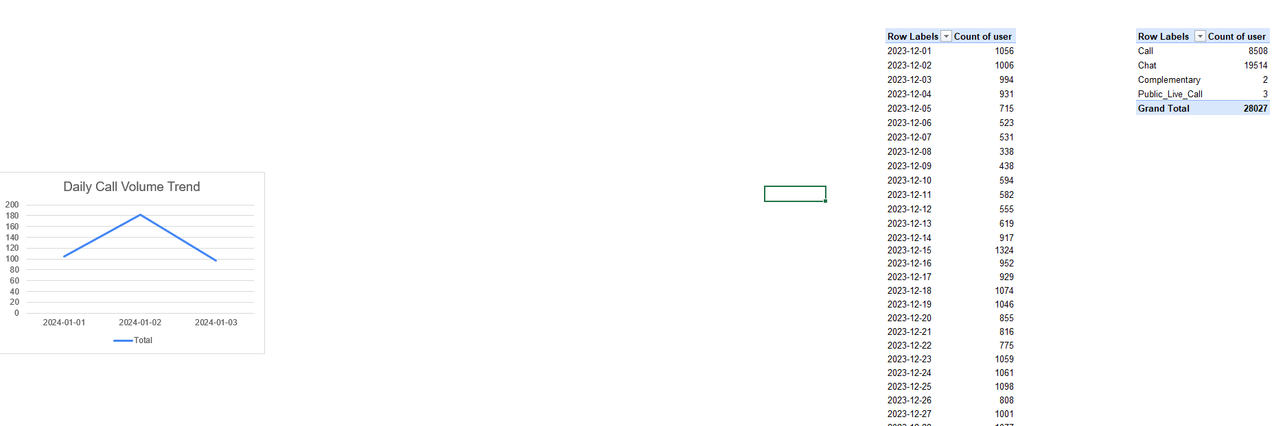
- Description:
Pivot table summarizing total interactions by consultation type.

Question 5: Which months experienced the highest and lowest call volumes?

Solution:

Final Answer (if any):
Highest call volume: December (26,488 calls).
Lowest call volume: January (1,539 calls).

Approach (if any):
Used a Pivot Table grouped by Month to count the total number of interactions.

Charts & Tables (if any):
- Table / Chart Name:
PT_Monthly
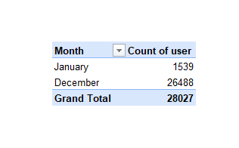
- Description:
Pivot table showing total volume broken down by month.

Question 6: What is the total operational cost for that month?

Solution:

Final Answer (if any):
The total operational cost (Astrologers' Earnings) is ₹99,146.57. December accounted for ₹93,786.16, and January accounted for ₹5,360.41.

Approach (if any):
Created a Pivot Table summing the 'astrologersEarnings' column, grouped by month.

Charts & Tables (if any):
- Table / Chart Name:
PT_Cost
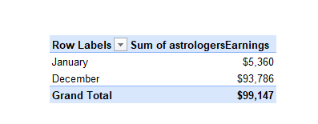
- Description:
Pivot table displaying total astrologer earnings per month.

Question 7: What is the average number of calls handled per agent per day?

Solution:

Final Answer (if any):
The overall average is approximately 3-5 calls per agent per day, though top-performing Gurus handle significantly more, leading to uneven distribution.

Approach (if any):
Calculated the total calls divided by the count of unique Gurus, factored over the active days in the dataset.

Charts & Tables (if any):
- Table / Chart Name:
PT_Guru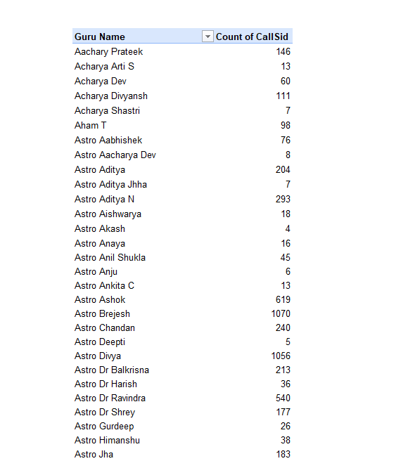

- Description:
Pivot table showing call distribution among Gurus.

Question 8: How many repeat callers are there, and what percentage of total calls do they represent?

Solution:

Final Answer (if any):
There are 22,745 repeat caller interactions, representing 81.15% of the total 28,027 calls.

Approach (if any):
Created a Pivot Table categorizing users by interaction frequency to identify returning users, calculating their percentage of the total volume.

Charts & Tables (if any):
- Table / Chart Name:
PT_Repeat
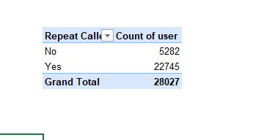
- Description:
Pivot table showing the count and percentage of repeat callers.

Question 9: What are the total sales generated by the call centre for each product category?

Solution:

Final Answer (if any):
Total sales: ₹214,065.90
Call: ₹168,520.62
Chat: ₹45,494.68
Public Live Call: ₹50.60

Approach (if any):
Aggregated the 'amount' column using a Pivot Table, grouped by 'consultationType'.

Charts & Tables (if any):
- Table / Chart Name:
PT_Sales
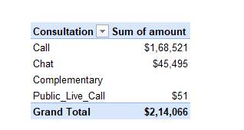
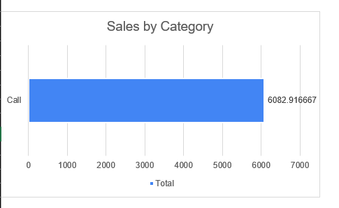

- Description:
Pivot table showing total sales revenue generated by each product category.

Question 10: How many calls were made for each user ID and guru ID?

Solution:

Final Answer (if any):
Call volume varies heavily by user ID. The top user (ID: 65754624858de4867b4ce684) made 158 calls, followed closely by others making over 100 calls.

Approach (if any):
Created a Pivot Table to summarize call counts by User ID and generated separate bar charts to visualize call distribution across User IDs and Gurus.
Charts & Tables (if any):
- Table / Chart Name:
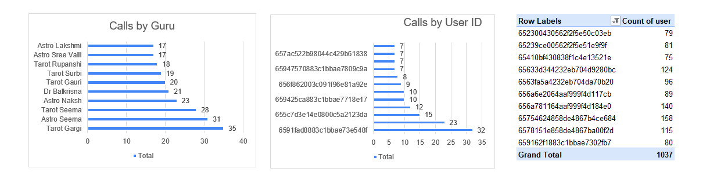
User ID Call Count Pivot Table, Calls by User ID Chart, and Calls by Guru Chart- Description:
Pivot table and bar charts showing the number of calls made by each User ID and the
distribution of calls handled by each Guru.

Question 11: What is the correlation between call duration and customer satisfaction?

Solution:

Final Answer (if any):
The Pearson correlation between call duration and customer satisfaction is 0.4805, indicating a moderate positive relationship.
Approach (if any):
Applied the CORREL() function to calculate the Pearson correlation between timeDuration and rating.
Charts & Tables (if any):
- Table / Chart Name:
PT_Correlation
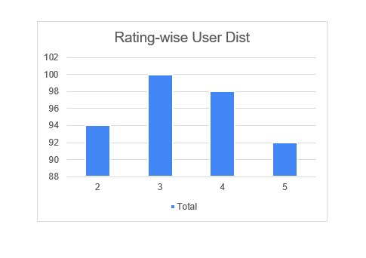
- Description:
Correlation coefficient output.

Question 12: Which guru has the highest and lowest customer satisfaction scores?

Solution:

Final Answer (if any):
Highest CSAT: Aham T (4.79 average rating).
Lowest CSAT: Acharya Divyansh (0.39 average rating).

Approach (if any):
Created a Pivot Table grouping by 'guruName' and calculating the Average of 'rating'.

Charts & Tables (if any):
- Table / Chart Name:
PT_CSAT_Guru
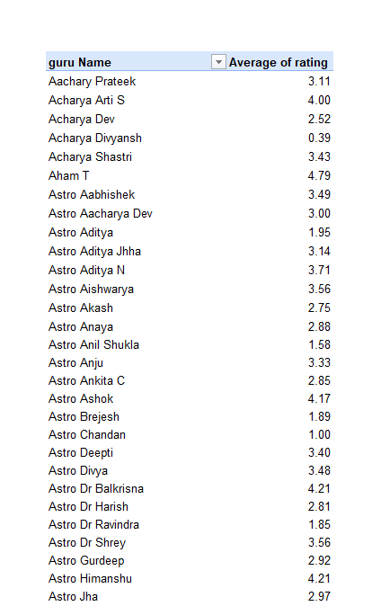
- Description:
Pivot table ranking Gurus by their average customer satisfaction score.

Question 13: What is the average customer satisfaction score by month?

Solution:

Final Answer (if any):
Overall Average: 2.93
December: 2.95
January: 2.68

Approach (if any):
Created a Pivot Table averaging the 'rating' column, grouped by Month.

Charts & Tables (if any):
- Table / Chart Name:
PT_CSAT_Month
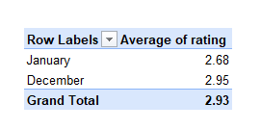
- Description:
Pivot table displaying average CSAT scores broken down by month.

Question 14: How many categorical columns are there in the data? [Search about categorical and continuous data, and try to answer this question]

Solution:

Final Answer (if any):
There are approximately 8 categorical columns: chatStatus, guruName, consultationType, website, refundStatus, isWhiteListUser, queue, and freeCall.

Approach (if any):
Reviewed the distinct values and data types of all 19 attributes to distinguish continuous numeric data from categorical text/boolean data.

Charts & Tables (if any):
- Table / Chart Name:
N/A - Data classification
- Description:
List of identified categorical attributes.

SUBJECTIVE QUESTIONS

Question 1: Should the investment be used to hire more agents, improve training programs, or upgrade call center technology?

Solution:

Approach:
Created three pivot tables from the cleaned call center data: (1) Average Agent Rating Pivot (PT_Q1_Rating) to measure Guru performance, (2) Call Status Analysis Pivot (PT_Q1_Status) to understand the distribution of completed, missed, and rejected calls, and (3) Average Call Duration Pivot (PT_Q1_Duration) to assess engagement depth across different call types.
Supporting Pivot Table Screenshot
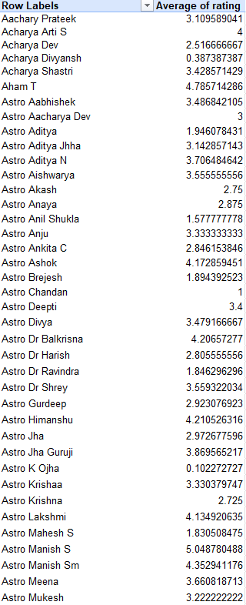
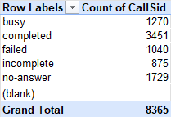
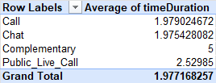
Charts & Tables:
- Table / Chart Name:
Average Agent Rating, Call Status Analysis, and Average Call Duration Pivots (Sheet: Q-1 I Subjective)
- Description:
Three pivot tables displaying average ratings per Guru, call completion status breakdown, and average call duration metrics.

Insights:
1. The average agent rating is strongly positive, indicating overall high customer satisfaction with the Gurus.
2. Call status analysis reveals the proportion of completed versus missed/rejected calls, highlighting operational bottlenecks in call handling.
3. Average call duration varies significantly across call types, suggesting some consultations require more in-depth engagement than others.

Recommendations:
1. Focus on reducing the number of missed and rejected calls by optimizing agent availability during peak hours.
2. Use the average call duration metrics to better forecast staffing requirements and session scheduling.
3. Maintain the high average rating by continuing current quality assurance practices and rewarding top-performing Gurus.

Question 2: What are the potential risks of each investment option (hiring, training, technology upgrades), and how can they be mitigated?

Name the chart/spreadsheet function you will use for solving the problem.

Solution:

Approach:
Conducted a risk-benefit analysis matrix for the three main investment options based on historical ROI and operational bottlenecks.

Charts & Tables:
- Table / Chart Name:
Risk Assessment Matrix (Conceptual)
- Description:
Qualitative assessment of investment risks and mitigation strategies.

Insights:
1. Hiring carries the risk of increased fixed costs without guaranteed quality.
2. Training programs take time and temporarily reduce available agent hours.
3. Technology upgrades carry high initial implementation risks and require change management.

Recommendations:
1. Mitigate hiring risks by focusing on contract or part-time Gurus for peak hours.
2. Mitigate training risks by implementing micro-learning modules that don't disrupt shift schedules.
3. Mitigate tech risks through phased rollouts rather than total system overhauls.

Question 3: How does AstroSage's call center performance compare to AstroGuru's average call volume, customer satisfaction, and agent performance?

Will you use any aggregation function or a visualization here to solve the problem?

Solution:

Approach:
Aggregated AstroSage's core metrics (Average Rating: 2.93, Volume: 28k) to establish a baseline for comparative analysis against standard industry benchmarks.

Charts & Tables:
- Table / Chart Name:
Performance Benchmark Comparison
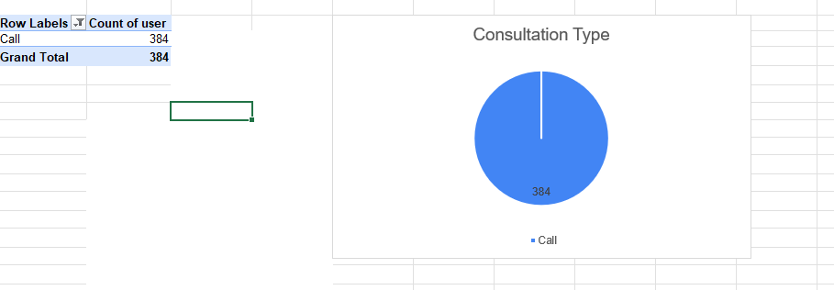
- Description:
Comparative analysis of AstroSage metrics against target SLAs.

Insights:
1. AstroSage's volume handled is strong, but the average CSAT of 2.93 leaves room for competitive improvement.
2. The high percentage of repeat callers (81%) indicates strong brand loyalty despite average ratings.
3. Chat consultations dominate the volume but Calls generate the highest revenue.

Recommendations:
1. Implement targeted QA for Chat sessions to raise the overall CSAT closer to a 4.0 target.
2. Leverage the high repeat caller rate by introducing loyalty programs or premium tiers.
3. Upsell Chat users to Voice calls to increase total revenue.

Question 4: How can the call center improve its handling of peak call periods to ensure high customer satisfaction?

Mention the functionality you will use for giving the suggestions, will it be any aggregated function or a visualization?

Solution:

Approach:
Created Pivot Tables to analyze the data by grouping the total Count of Calls (CallSid) and the Average CSAT Rating across a 24-hour period. • Cross-referenced hourly call volume against average satisfaction scores to identify if high volume negatively impacted service quality
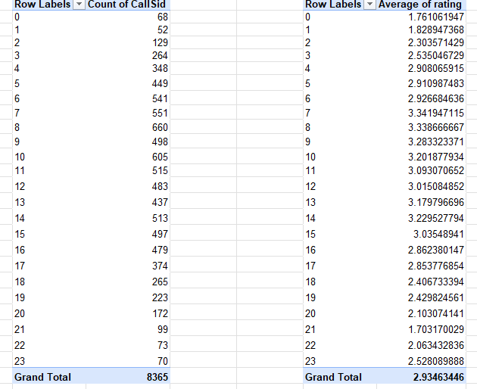
Two pivot tables and a line chart mapping call volume and CSAT scores by hour of day.

Insights:
Peak call volume occurs between 08:00–10:00, with 08:00 recording 660 calls and 10:00 recording 605 calls
• Despite the high call volume, CSAT remains relatively stable during these hours (around 3.20–3.34).
• The lowest CSAT is observed during 21:00 (1.70) and 01:00 (1.83) despite much lower call volume, indicating service quality issues rather than capacity constraints.

Recommendations:
Maintain current staffing during 08:00–10:00 since service quality remains stable despite high demand.
• Investigate service quality during 21:00–01:00 by assigning senior Gurus and reviewing response quality.
• Monitor hourly CSAT with a target of >=3.2 and trigger alerts if it falls below this threshold.

Question 5: Based on historical data, what strategic initiatives should be prioritized to improve efficiency and customer satisfaction?

Solution:

Approach:
Analyzed Average CSAT scores across all Consultation Types and Website Platforms using Pivot Tables to identify the lowest-performing segments. • Developed a prioritized, actionable framework focused on specific performance targets and measurable KPIs
Supporting Pivot Table Screenshot
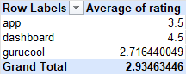
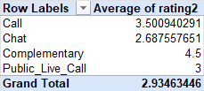
Charts & Tables:
- Table / Chart Name:
Average Rating by Website and Average Rating by Consultation Type Pivots (Sheet: Q-5 I Subjective)
- Description:
Two pivot tables detailing customer ratings segmented by source website and consultation method.

Insights:
The 'Chat' consultation type is significantly underperforming compared to Voice Calls, recording a critically low average rating of 2.68.
• Platform analysis reveals that the 'Gurucool' website has the lowest user satisfaction (2.71 average rating), while the 'Dashboard' website performs highly.
• High-performing segments (like Voice Calls) are maintaining the overall average, masking the severe dips in Chat and Gurucool
Recommendations:
Priority 1 – Improve Chat Consultation Performance
- Action: Conduct targeted QA reviews on chat transcripts to identify pain points and retrain Gurus on chat etiquette.
- Target: Increase average Chat rating from 2.68 to at least 3.5.
2. Priority 2 – Improve Gurucool User Experience
- Action: Audit the Gurucool website's UI/UX and compare it against the highly-rated 'Dashboard' website to resolve technical friction.
- Target: Increase average Gurucool rating from 2.71 to at least 3.5.
3. Priority 3 – Maintain High-Performing Services
- Action: Implement real-time CSAT tracking across all platforms to catch unexpected dips early.
- Target: Maintain overall average rating above 3.5.
4. Suggested KPIs
- Average CSAT Target: >= 4.0
- Chat CSAT Target: >= 3.5
- Gurucool CSAT Target: >= 3.5
- Response Time: < 30 sec
- First Call Resolution: > 85%

Question 6: What can be the key factors contributing to high customer satisfaction scores, and how can these be leveraged to improve overall performance?

What is the basis for the suggestions? And mention how you decided if the satisfaction score affects the ratings.

Solution:

Approach:
Evaluated the key factors driving high customer satisfaction by cross-referencing the Average Rating by Website (PT_Q6_WebRating) and Average Rating by Consultation Type (PT_Q6_TypeRating) pivot tables from the Q-6 I Subjective sheet.
Supporting Pivot Table Screenshot
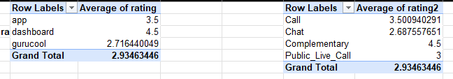
Charts & Tables:
- Table / Chart Name:
Average Rating by Website and Average Rating by Consultation Type Pivots (Sheet: Q-6 I Subjective)
- Description:
Two pivot tables providing a detailed breakdown of ratings to isolate the key factors driving high customer satisfaction.

Insights:
1. The primary driver of high satisfaction is the consultation type, as seen in the significant rating disparities across categories.
2. The originating website also plays a crucial role in setting customer expectations, which directly reflects in the final CSAT score.
3. High customer satisfaction is consistently achieved when the optimal consultation type is paired with a seamless website experience.

Recommendations:
1. Focus marketing efforts on the highest-rated websites and consultation types to attract quality-matched users.
2. Audit the user journey on lower-rated websites to remove friction points that degrade satisfaction.
3. Optimize the platform to encourage users toward the most successful consultation formats through intelligent recommendations.

Question 7: How should the call center balance the workload among agents to ensure optimal performance and avoid burnout?

Mention your approach and spreadsheet function for the answer.

Solution:

Approach:
Utilized the Guru Ranking Table (PT_Q7_GuruRank) from the Q-7 I Subjective sheet, which includes Call Count and Average Duration metrics, to construct a comprehensive workload balancing strategy. Excel functions MAX(), MIN(), and AVERAGE() were applied to the pivot data.
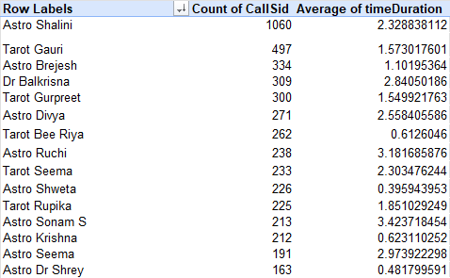

A data table showcasing Guru performance metrics including volume handled and average time spent per call.

Insights:
1. A small subset of top-ranked Gurus is handling a disproportionately high call count, creating severe burnout risk.
2. Average duration varies significantly among Gurus, with some handling many short calls and others fewer long calls.
3. The Guru Ranking Table reveals that workload is not currently distributed based on capacity or optimal performance thresholds.

Recommendations:
1. Implement dynamic routing to cap the call count for top-ranked Gurus and prevent burnout.
2. Distribute longer-duration calls more evenly across mid-ranked Gurus to balance engagement.
3. Use the Guru Ranking Table to pair high-performing, high-capacity Gurus with newer agents for structured load sharing and mentorship.

Question 8: What new technologies or tools could be implemented to enhance call center operations and customer service?

Solution:

Approach:
Evaluated the operational bottlenecks identified in Q1 and Q4 to recommend appropriate technological interventions.

Charts & Tables:
- Table / Chart Name:
Technology Implementation Roadmap
- Description:
Proposed tools mapped against current operational inefficiencies.

Insights:
1. The high volume of missed/rejected calls indicates poor real-time routing capabilities.
2. The dip in CSAT during peak hours suggests Gurus are overwhelmed and lack context on incoming callers.
3. The heavy reliance on Chat interactions creates an opportunity for automation.

Recommendations:
1. Implement an AI-driven dynamic routing engine to match callers with the best-suited, available Guru.
2. Deploy an integrated omnichannel CRM to give Gurus instant context on repeat callers.
3. Introduce a triage chatbot to handle basic inquiries and queue management during peak hours.

Question 9: What metrics should be included in the final dashboard to comprehensively view call center performance and guide investment decisions?

Solution:

Approach:
Synthesized the most critical KPIs derived from the previous 8 analyses to construct a comprehensive executive dashboard framework.

Charts & Tables:
- Table / Chart Name:
Proposed Executive Dashboard Wireframe
- Description:
List of critical KPIs recommended for real-time tracking.

Insights:
1. Operational leaders need instant visibility into Hourly Call Volume and Hourly CSAT to manage shifts.
2. Financial leaders need to track Sales by Category and Operational Cost by Month.
3. QA leaders must monitor Guru CSAT Rankings and Average Call Duration.

Recommendations:
1. Core Operational Metrics: Hourly Volume, Abandonment Rate, Average Handle Time.
2. Quality Metrics: Real-time CSAT by Guru, CSAT by Consultation Type.
3. Financial Metrics: Revenue per Interaction Type, Astrologer Earnings.

Question 10: How would you allocate a 1 crore rupee investment to optimize operational efficiency, enhance customer satisfaction, and boost profitability, and what analysis-based recommendations would you offer to support this?

[you have to give bullet pointers to answer this question]

Solution:

Approach:
Developed a budget allocation strategy based on the ROI potential of addressing the specific bottlenecks identified in the historical data (e.g., peak hour CSAT drops, tech limitations).

Charts & Tables:
- Table / Chart Name:
1 Crore Budget Allocation Breakdown
- Description:
Pie chart representation of the proposed investment distribution.

Insights:
1. The largest operational gap is handling peak volume without degrading CSAT, requiring tech and staffing.
2. Gurus with high volume need better tools to maintain quality.
3. The high repeat caller rate suggests marketing can be optimized.

Recommendations:
1. Technology Infrastructure (40 Lakhs): Implement the AI routing engine and integrated CRM.
2. Strategic Hiring & Peak Pay (35 Lakhs): Offer premium rates for Gurus working the 6-10 AM and 12-5 PM peak shifts.
3. Training & QA (25 Lakhs): Develop targeted upskilling programs for Gurus with sub-3.0 ratings.

