1.**TOTAL REVENUE**

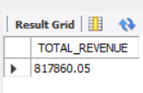Select SUM(quantity * Unit_price) AS TOTAL_REVENUE From pizza_sales;

2. **AVERAGE ORDER VALUE**

SELECT SUM(Total_price)/COUNT(DISTINCT(Order_id))

AS Avg_order_value

FROM pizza_sales;

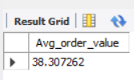

3. **TOTAL PIZZA SOLD**

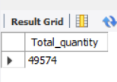SELECT SUM(quantity) AS Total_quantity FROM pizza_sales;

4. **TOTAL NO’S OF ORDER**

SELECT COUNT(DISTINCT(Order_id)) AS Total_orders FROM pizza_sales;

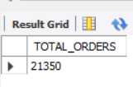

5. **AVERAGE PIZZAS PER ORDER**

SELECT SUM(quantity)/COUNT(DISTINCT(Order_id)) AS Avg_pizzas_per_order FROM pizza_sales;

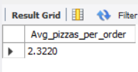

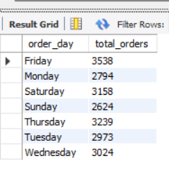6. **DAILY TRENDS FOR TOTAL ORDERS**

SELECT

DAYNAME(order_date) AS order_day,

COUNT(DISTINCT order_id) AS total_orders

FROM pizza_sales

GROUP BY DAYNAME(order_date);

7. **PERCENTAGE OF SALES BY PIZZA CATEGORY**

SELECT

pizza_category, SUM(total_price) AS total_sales,

ROUND (SUM(total_price) * 100 /(SELECT sum(total_price)

FROM pizza_sales),2) as total_rev_in_percentage

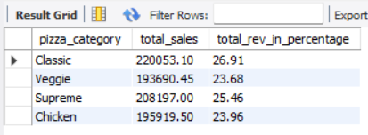FROM pizza_sales

GROUP_BY pizza_category ;

8. **PERCENTAGE OF SALES BY PIZZA SIZE**

SELECT pizza_size, SUM(total_price) AS total_sales,

SUM(total_price) * 100 / (SELECT sum(total_price)

FROM pizza_sales) as total_rev_in_percentage

FROM pizza_sales

GROUP BY pizza_size

ORDER BY total_rev_in_percentage DESC;

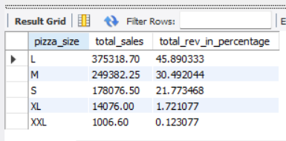

9. **TOTAL PIZZA SOLD BY PIZZA CATEGORY**

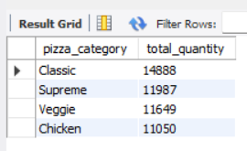SELECT pizza_category, SUM(quantity) AS total_quantity

FROM pizza_sales

GROUP BY pizza_category

ORDER BY total_quantity DESC ;

10. **TOP 5 BEST SELLERS BY TOTAL PIZZA SOLD**

SELECT pizza_name, SUM(quantity) AS total_pizza_sold

FROM pizza_sales

GROUP BY pizza_name

ORDER BY total_pizza_sold DESC

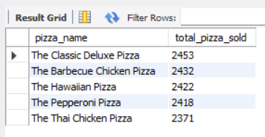LIMIT 5 ;

11. **TOP 5 WORST SELLERS BY TOTAL PIZZA SOLD**

SELECT pizza_name, SUM(quantity) AS total_pizza_sold

FROM pizza_sales

GROUP BY pizza_name

ORDER BY total_pizza_sold ASC

LIMIT 5 ;

