**Create Drw Res File(giving round back+color to text view)**

Drawable>new>DrawableResFile

Change root element from selector to shape(xml)

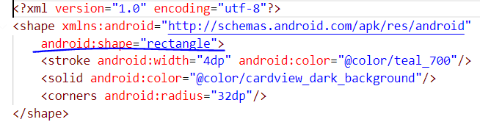

Then apply background. android:background="@drawable/back"

**Adding img to both sides via Code**

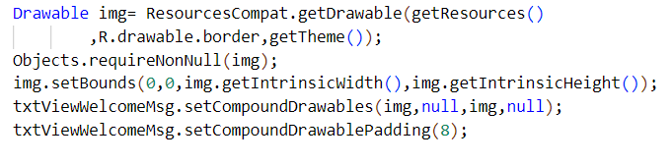**Changing VISIBILITY And BtnTEXT**

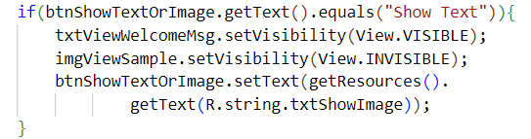**Touch Listener**

**1.**

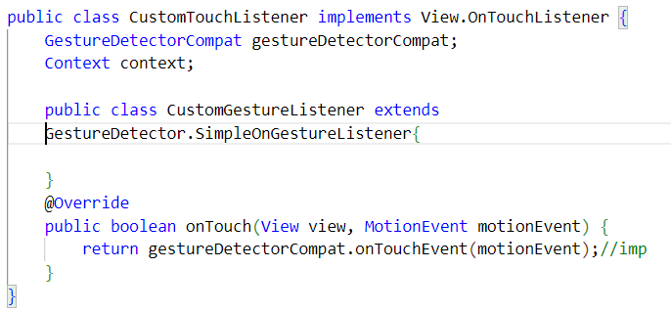

**2.over ride methods inside CustomGestureListener class(always select onDown method)**

**3.Constructor outerclass**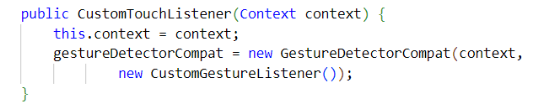

**4.On down return true**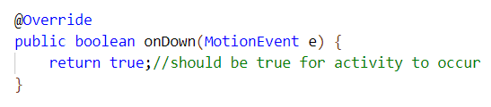

**5.Add methods to call(use 2nd option to create function def and change onDoubleClick ->public)**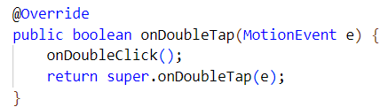

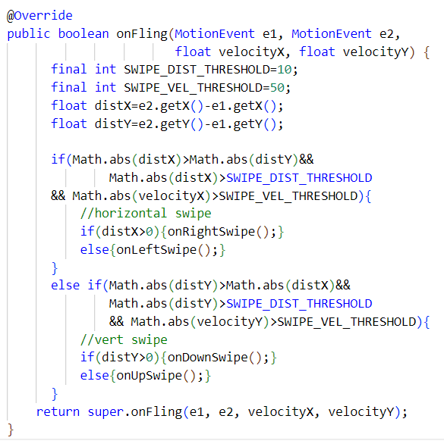

**6.Inside Main Activity(Override methods after this step)**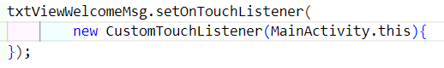

**7.Swipe Right and Left, Top/Bottom use horz_grav_mark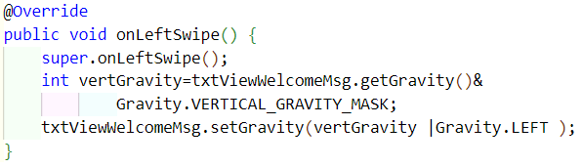8.For Strike Through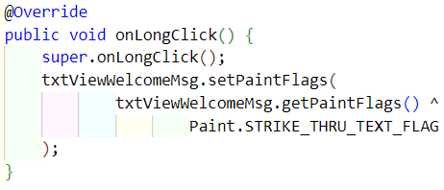9.Making Text Bigger**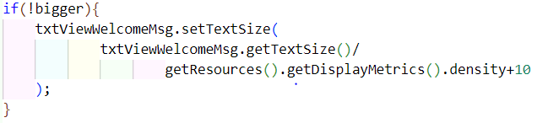

**10.Change Txt Color**

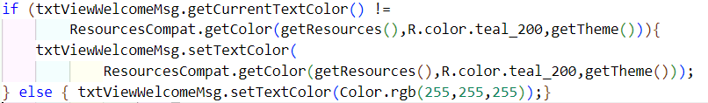

**11.Changing Image Scale**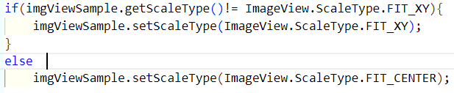

**12.Changing image**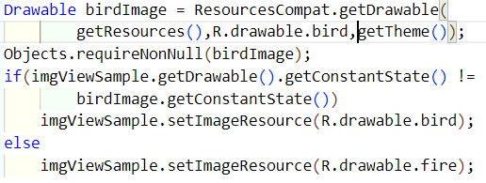

**Recycler View Demo**

**Tablayout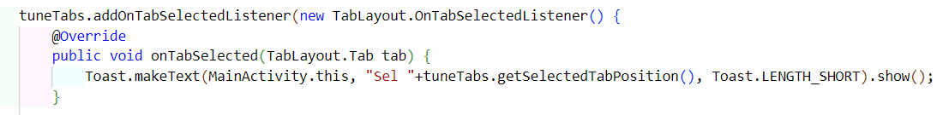Adding values to arrays****Sublisitng Array**

**RecyclerView Creation**

1. **Create adapter class**
2. **Create inner class extends viewHolder**

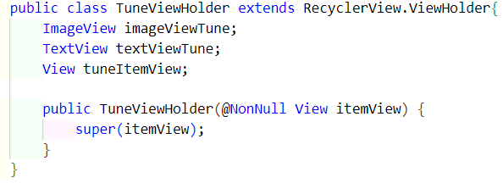

1. **Extend outer class with inner class and implement methods**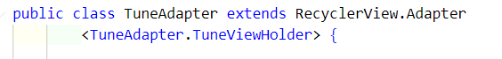
2. **Specify the data list and create constr , getters and setters**

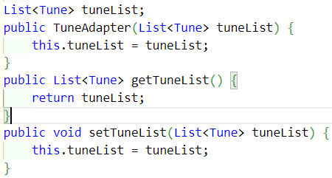

**5.OnCreate**

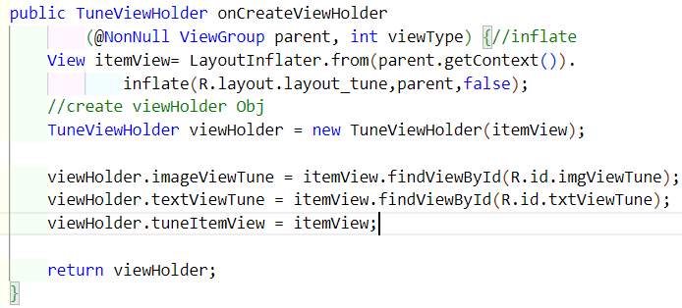

**6.OnBind**

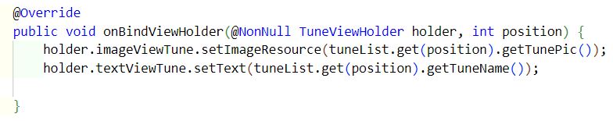

**7. setting grid layout and adapter in ManACtivity**

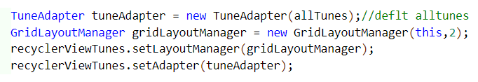

**8.changing data on each Tabs(addNotifyDataset methd in setter)**

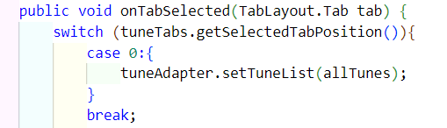

**9.Changing color of itemView when clicked(insude createvwHldr)**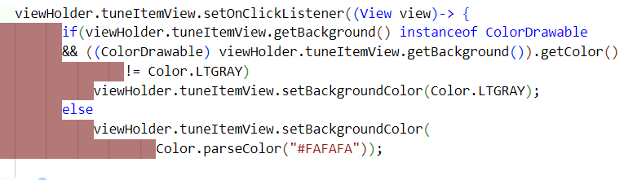

**10.To reset dirty views add this to onBind**

**Music Player**

**1.In adaper**



**2.In bind**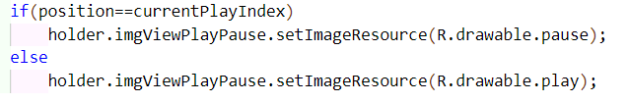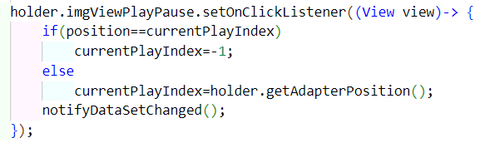

**3. Linear Layout**

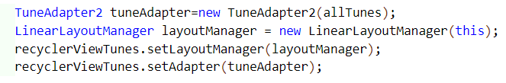**4.Prevent dirty views**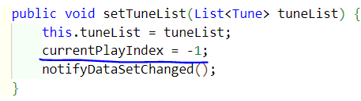

**Binding****Menu Functions(xml->res->menu)**

**Give include an id(mainContent)+ layout an id(mainLayout)**

Setting init background and button Color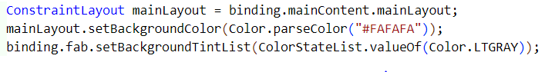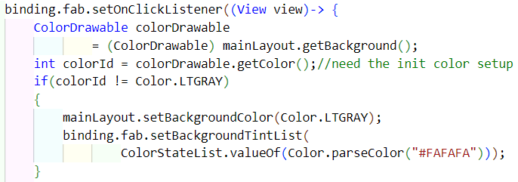

SnackBarDefining View Model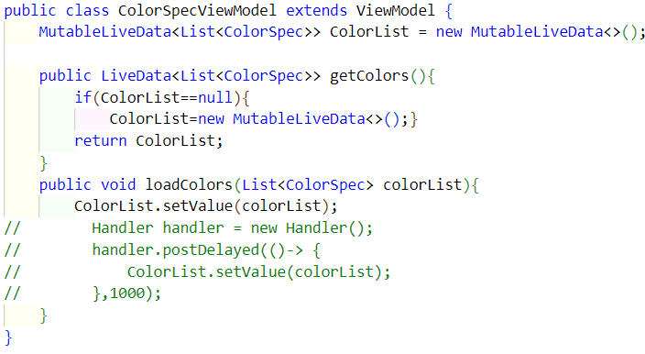**Inside Main Activity(loading data to List)**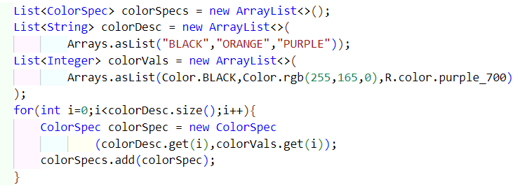

**Inside Main (Laoding data to view Model)**

**CustomAdapter-COlorList**

**1.new->xml->Layoutxml,then(layoutcoloritem),create constr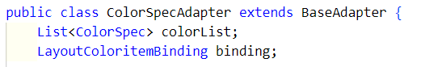implement the methods,then**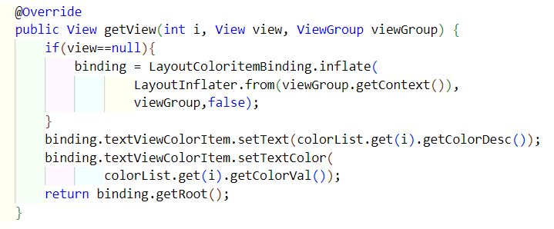

**Setting up Adapter from Fragment1**

**then,inside onViewCreated**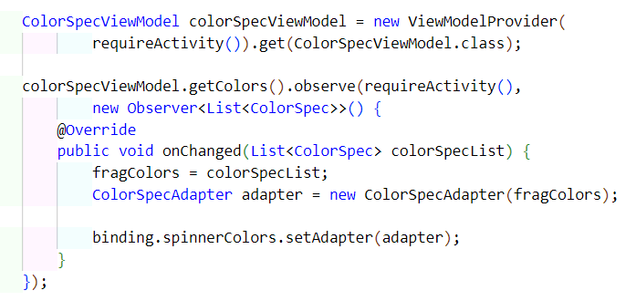

Passing colorData using Bundle(button Onclick)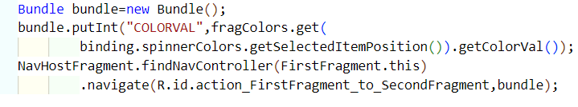Getting and setting the color(2nd frag->inside onViewCreated)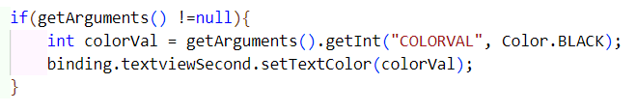Adding a csv file

Res->right click->new->androidres direc->res type=raw

Read from file,make list,parse Data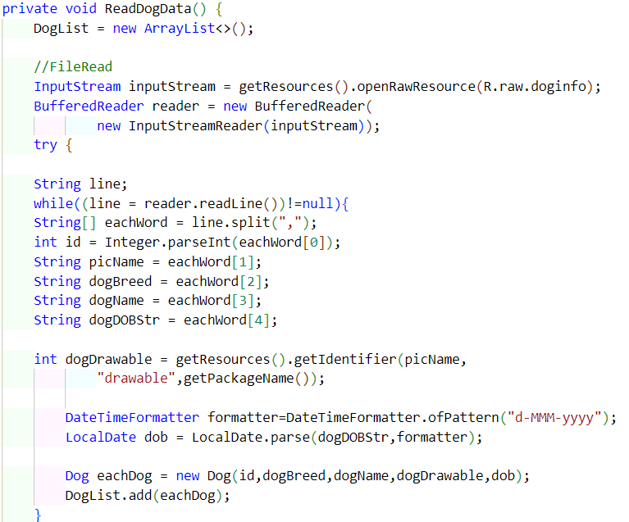

Recylcer View2.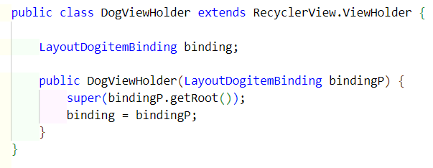

2.

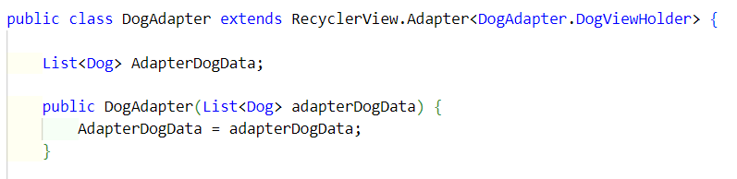

3.Implement Methods

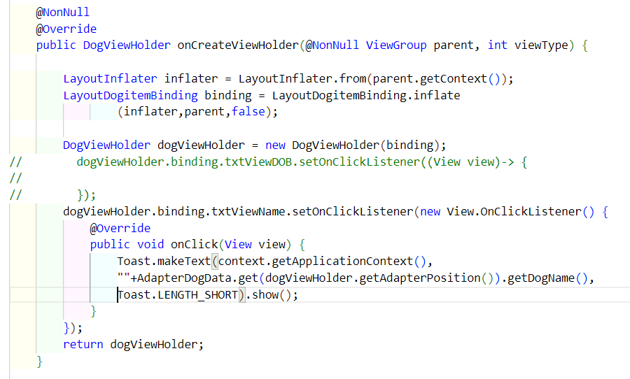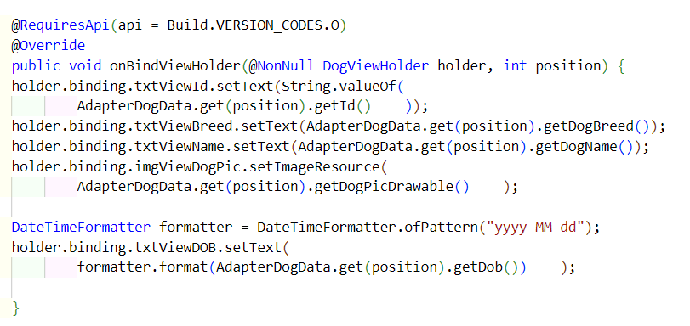

Main Activity

