19ECE101 INTRODUCTION TO IOT LABORATORY PROJECT

BRANCH : B.TECH – ELECTRONICS AND COMMUNICATION ENGINEERING

Submitted:-
- Rahul Varma Dommaraju – BL.EN.U4ECE22046
- Rohit Korada – BL.EN.U4ECE20047
- Abhinav P. Ajith – BL.EN.U4ECE22071

Amrita School Of Engineering , Bangalore
AMRITA VISHWA VIDYAPEETHAM
BENGALURU-560035


Aim: IOT based Surveillance Camera Car using ESP32 Camera Module
Components required:
- 4 D.C. motors + Car Chassis (for car body)
- Arduino UNO board (for uploading code)
- L298N Motor Driver
- ESP32 Wi-Fi Camera Module
- 7-12 V D.C. supply
Circuit Diagram:
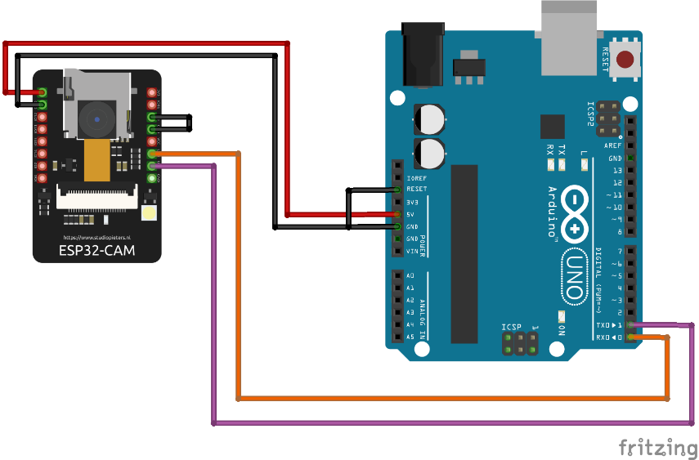
Uploading the code-
Before uploading the code https://dl.espressif.com/dl/package_esp32_index.json was installed. Then 2 libraries were installed, AsyncTCP library, and ESPAsyncWebServer library.
Then Board is setup to ESP32 Wrover Module, and 115200 upload speed. The flash frequency was set to 80Mhz, and Flash Mode was set to QIO. The partition scheme was selected as “Huge App”, and then the code was uploaded.

Explanation:
It is a small size , low power consumption camera module based on ESP32 , it comes with a OV2640 camera and provides onboard TF card slot. It is useful in wireless video monitoring Wi-Fi image upload. The camera has no USB port, so to upload the code UART method is used. Breadboard is used to upload the code.
The following connections are to be done:
ESP32 CAMERA | ARDUINO
VOR | RX
VOT | TX
5V | 5V
GND | GND
IO0-GND | Reset-GND

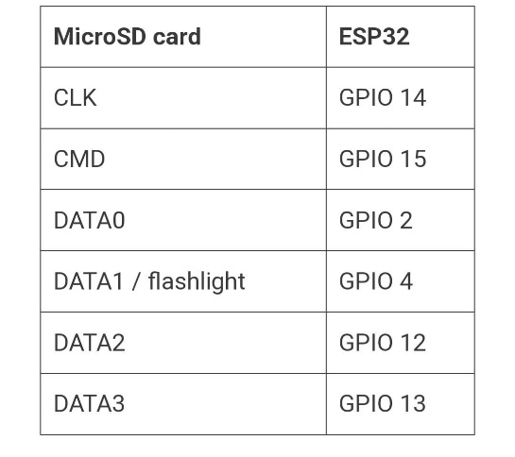
The functions of pins are as
- CLK- Camera License Key
- CMD- Command
- GPIO- General purpose Input/Output

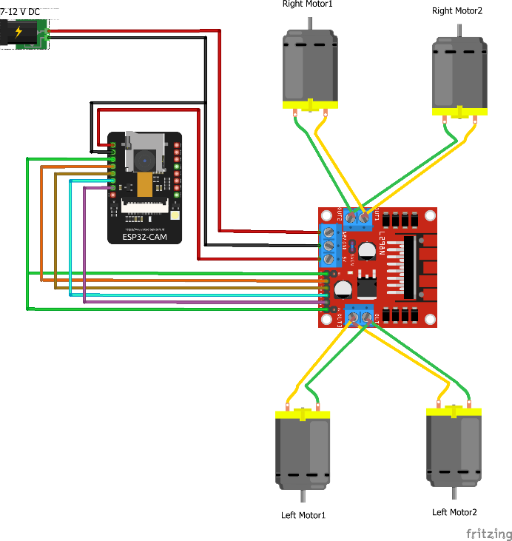
Circuit Diagram:
DC motors are connected to the L298N driver. The right motors’ positive side is connected to OUT2 of driver. Similarly, the left side of motor is connected to OUT1 of driver. The left motors, positive side is connected to OUT4 of driver. Similarly, the negative side is connected to OUT3 of driver. Any rechargeable battery of capacity 7-12V supply is used and its positive side is connect to 12V pin. The ground is connected to ground of motor driver . The 5V pin of camera is connected to 5V pin of driver pin. The connection of drivers and camera is a follow:

ESP32 CAMERA PINS | L298N DRIVER PINS
IO12 | enA
IO13 | IN1
IO15 | IN2
IO14 | IN3
IO2 | IN4
IO12 | enB
5V | 5V
GND | GND

Final assembly of Car and Web Interface Page:
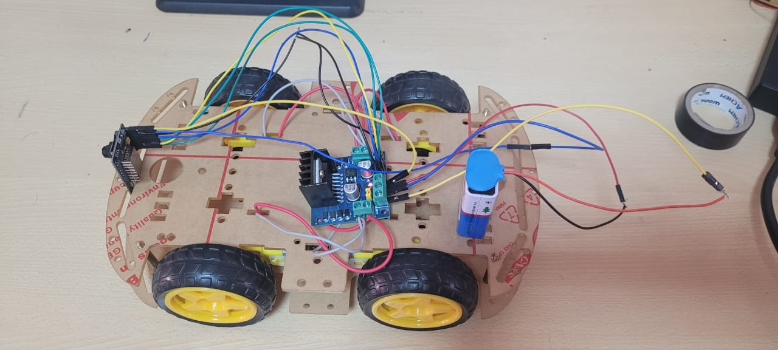

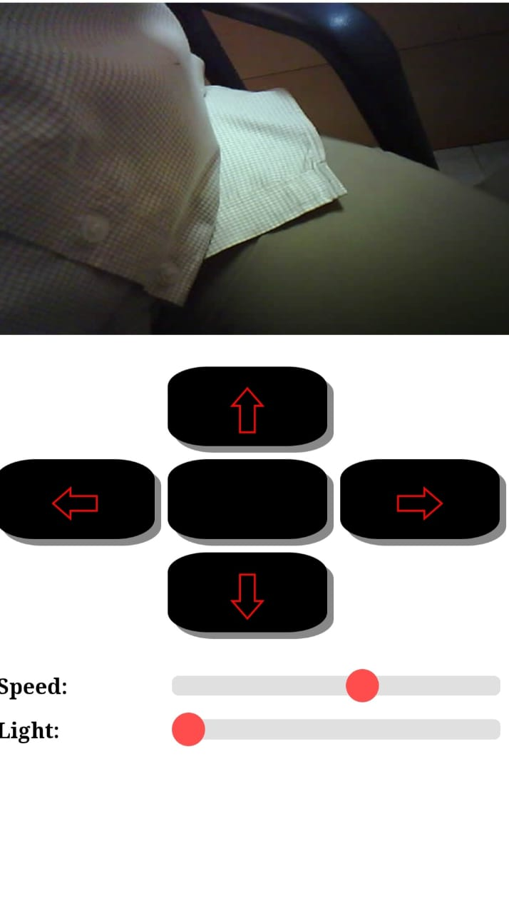
The L298N driver can control the direction and speed of DC motor, where speed is controlled by regulating voltage, and direction can be changed by reversing voltage. Car is controlled through a Web Interface designed by us , which is connected using HTTP Communication Protocol. The app can control the speed of the wheels, can control intensity of flashlight , and the direction can be controlled too. A 12V rechargeable battery with 1000mAH capacity was connected was used instead of the 9V regular battery shown in the diagram.


Code:
#include "esp_camera.h"
#include <Arduino.h>
#include <WiFi.h>
#include <AsyncTCP.h>
#include <ESPAsyncWebServer.h>
#include <iostream>
#include <sstream>

struct MOTOR_PINS
{
int pinEn;
int pinIN1;
int pinIN2;
};

std::vector<MOTOR_PINS> motorPins =
{
{12, 13, 15}, //RIGHT_MOTOR Pins (EnA, IN1, IN2)
{12, 14, 2}, //LEFT_MOTOR Pins (EnB, IN3, IN4)
};
#define LIGHT_PIN 4

#define UP 1
#define DOWN 2
#define LEFT 3
#define RIGHT 4
#define STOP 0

#define RIGHT_MOTOR 0
#define LEFT_MOTOR 1

#define FORWARD 1
#define BACKWARD -1

const int PWMFreq = 1000; /* 1 KHz */
const int PWMResolution = 8;
const int PWMSpeedChannel = 2;
const int PWMLightChannel = 3;

//Camera related constants
#define PWDN_GPIO_NUM 32
#define RESET_GPIO_NUM -1
#define XCLK_GPIO_NUM 0
#define SIOD_GPIO_NUM 26
#define SIOC_GPIO_NUM 27
#define Y9_GPIO_NUM 35
#define Y8_GPIO_NUM 34

#define Y7_GPIO_NUM 39
#define Y6_GPIO_NUM 36
#define Y5_GPIO_NUM 21
#define Y4_GPIO_NUM 19
#define Y3_GPIO_NUM 18
#define Y2_GPIO_NUM 5
#define VSYNC_GPIO_NUM 25
#define HREF_GPIO_NUM 23
#define PCLK_GPIO_NUM 22

const char* ssid = "MyWiFiCar";
const char* password = "12345678";

AsyncWebServer server(80);
AsyncWebSocket wsCamera("/Camera");
AsyncWebSocket wsCarInput("/CarInput");
uint32_t cameraClientId = 0;

const char* htmlHomePage PROGMEM = R"HTMLHOMEPAGE(
<!DOCTYPE html>
<html>
<head>
<meta name="viewport" content="width=device-width, initial-scale=1, maximum-scale=1, user-scalable=no">
<style>
.arrows {
font-size:40px;
color:red;
}
td.button {
background-color:black;
border-radius:25%;
box-shadow: 5px 5px #888888;
}
td.button:active {
transform: translate(5px,5px);
box-shadow: none;
}

.noselect {
-webkit-touch-callout: none; /* iOS Safari */
-webkit-user-select: none; /* Safari */
-khtml-user-select: none; /* Konqueror HTML */
-moz-user-select: none; /* Firefox */
-ms-user-select: none; /* Internet Explorer/Edge */
user-select: none; /* Non-prefixed version, currently
supported by Chrome and Opera */
}

.slidecontainer {
width: 100%;
}

.slider {
-webkit-appearance: none;
width: 100%;
height: 15px;
border-radius: 5px;
background: #d3d3d3;
outline: none;
opacity: 0.7;
-webkit-transition: .2s;
transition: opacity .2s;
}

.slider:hover {
opacity: 1;
}

.slider::-webkit-slider-thumb {
-webkit-appearance: none;
appearance: none;
width: 25px;
height: 25px;
border-radius: 50%;
background: red;
cursor: pointer;
}

.slider::-moz-range-thumb {
width: 25px;
height: 25px;
border-radius: 50%;
background: red;
cursor: pointer;
}

</style>

</head>
<body class="noselect" align="center" style="background-color:white">

<!--h2 style="color: teal;text-align:center;">Wi-Fi Camera &#128663; Control</h2-->

<table id="mainTable" style="width:400px;margin:auto;table-layout:fixed" CELLSPACING=10>

<tr>
<img id="cameraImage" src="" style="width:400px;height:250px"></td>
</tr>
<tr>
<td></td>
<td class="button" ontouchstart='sendButtonInput("MoveCar","1")' ontouchend='sendButtonInput("MoveCar","0")'><span class="arrows" >&#8679;</span></td>
<td></td>
</tr>
<tr>
<td class="button" ontouchstart='sendButtonInput("MoveCar","3")' ontouchend='sendButtonInput("MoveCar","0")'><span class="arrows" >&#8678;</span></td>
<td class="button"></td>
<td class="button" ontouchstart='sendButtonInput("MoveCar","4")' ontouchend='sendButtonInput("MoveCar","0")'><span class="arrows" >&#8680;</span></td>
</tr>
<tr>
<td></td>
<td class="button" ontouchstart='sendButtonInput("MoveCar","2")' ontouchend='sendButtonInput("MoveCar","0")'><span class="arrows" >&#8681;</span></td>
<td></td>
</tr>
<tr/><tr/>
<tr>
<td style="text-align:left"><b>Speed:</b></td>
<td colspan=2>
<div class="slidecontainer">
<input type="range" min="0" max="255" value="150" class="slider" id="Speed" oninput='sendButtonInput("Speed",value)'>
</div>
</td>
</tr>
<tr>
<td style="text-align:left"><b>Light:</b></td>
<td colspan=2>
<div class="slidecontainer">
<input type="range" min="0" max="255" value="0" class="slider" id="Light" oninput='sendButtonInput("Light",value)'>
</div>
</td>
</tr>
</table>

<script>
var webSocketCameraUrl = "ws:\/\/" + window.location.hostname + "/Camera";
var webSocketCarInputUrl = "ws:\/\/" + window.location.hostname + "/CarInput";
var websocketCamera;
var websocketCarInput;

function initCameraWebSocket()
{
websocketCamera = new WebSocket(webSocketCameraUrl);
websocketCamera.binaryType = 'blob';
websocketCamera.onopen = function(event){};
websocketCamera.onclose = function(event){setTimeout(initCameraWebSocket, 2000);};
websocketCamera.onmessage = function(event)
{
var imageId = document.getElementById("cameraImage");
imageId.src = URL.createObjectURL(event.data);
};
}

function initCarInputWebSocket()
{
websocketCarInput = new WebSocket(webSocketCarInputUrl);
websocketCarInput.onopen = function(event)
{
var speedButton = document.getElementById("Speed");
sendButtonInput("Speed", speedButton.value);
var lightButton = document.getElementById("Light");
sendButtonInput("Light", lightButton.value);
};
websocketCarInput.onclose = function(event){setTimeout(initCarInputWebSocket, 2000);};
websocketCarInput.onmessage = function(event){};
}

function initWebSocket()
{
initCameraWebSocket ();
initCarInputWebSocket();
}

function sendButtonInput(key, value)
{
var data = key + "," + value;
websocketCarInput.send(data);
}

window.onload = initWebSocket;
document.getElementById("mainTable").addEventListener("touchend", function(event){
event.preventDefault()
});
</script>
</body>

</html>
)HTMLHOMEPAGE";

void rotateMotor(int motorNumber, int motorDirection)
{
if (motorDirection == FORWARD)
{
digitalWrite(motorPins[motorNumber].pinIN1, HIGH);
digitalWrite(motorPins[motorNumber].pinIN2, LOW);
}
else if (motorDirection == BACKWARD)
{
digitalWrite(motorPins[motorNumber].pinIN1, LOW);
digitalWrite(motorPins[motorNumber].pinIN2, HIGH);
}
else
{
digitalWrite(motorPins[motorNumber].pinIN1, LOW);
digitalWrite(motorPins[motorNumber].pinIN2, LOW);
}
}

void moveCar(int inputValue)
{
Serial.printf("Got value as %d\n", inputValue);
switch(inputValue)
{

case UP:
rotateMotor(RIGHT_MOTOR, FORWARD);
rotateMotor(LEFT_MOTOR, FORWARD);
break;

case DOWN:
rotateMotor(RIGHT_MOTOR, BACKWARD);
rotateMotor(LEFT_MOTOR, BACKWARD);
break;

case LEFT:
rotateMotor(RIGHT_MOTOR, FORWARD);
rotateMotor(LEFT_MOTOR, BACKWARD);
break;

case RIGHT:
rotateMotor(RIGHT_MOTOR, BACKWARD);
rotateMotor(LEFT_MOTOR, FORWARD);
break;


case STOP:
rotateMotor(RIGHT_MOTOR, STOP);
rotateMotor(LEFT_MOTOR, STOP);
break;

default:
rotateMotor(RIGHT_MOTOR, STOP);
rotateMotor(LEFT_MOTOR, STOP);
break;
}
}

void handleRoot(AsyncWebServerRequest *request)
{
request->send_P(200, "text/html", htmlHomePage);
}

void handleNotFound(AsyncWebServerRequest *request)
{
request->send(404, "text/plain", "File Not Found");
}

void onCarInputWebSocketEvent(AsyncWebSocket *server,
AsyncWebSocketClient *client,
AwsEventType type,
void *arg,
uint8_t *data,
size_t len)
{
switch (type)
{
case WS_EVT_CONNECT:
Serial.printf("WebSocket client #%u connected from %s\n", client->id(), client->remoteIP().toString().c_str());
break;
case WS_EVT_DISCONNECT:
Serial.printf("WebSocket client #%u disconnected\n", client->id());
moveCar(0);
ledcWrite(PWMLightChannel, 0);
break;
case WS_EVT_DATA:
AwsFrameInfo *info;
info = (AwsFrameInfo*)arg;
if (info->final && info->index == 0 && info->len == len && info->opcode == WS_TEXT)
{
std::string myData = "";
myData.assign((char *)data, len);
std::istringstream ss(myData);

std::string key, value;
std::getline(ss, key, ',');
std::getline(ss, value, ',');
Serial.printf("Key [%s] Value[%s]\n", key.c_str(), value.c_str());
int valueInt = atoi(value.c_str());
if (key == "MoveCar")
{
moveCar(valueInt);
}
else if (key == "Speed")
{
ledcWrite(PWMSpeedChannel, valueInt);
}
else if (key == "Light")
{
ledcWrite(PWMLightChannel, valueInt);
}
}
break;
case WS_EVT_PONG:
case WS_EVT_ERROR:
break;
default:
break;
}
}

void onCameraWebSocketEvent(AsyncWebSocket *server,
AsyncWebSocketClient *client,
AwsEventType type,
void *arg,
uint8_t *data,
size_t len)
{
switch (type)
{
case WS_EVT_CONNECT:
Serial.printf("WebSocket client #%u connected from %s\n", client->id(), client->remoteIP().toString().c_str());
cameraClientId = client->id();
break;
case WS_EVT_DISCONNECT:
Serial.printf("WebSocket client #%u disconnected\n", client->id());
cameraClientId = 0;
break;
case WS_EVT_DATA:
break;
case WS_EVT_PONG:

case WS_EVT_ERROR:
break;
default:
break;
}
}

void setupCamera()
{
camera_config_t config;
config.ledc_channel = LEDC_CHANNEL_0;
config.ledc_timer = LEDC_TIMER_0;
config.pin_d0 = Y2_GPIO_NUM;
config.pin_d1 = Y3_GPIO_NUM;
config.pin_d2 = Y4_GPIO_NUM;
config.pin_d3 = Y5_GPIO_NUM;
config.pin_d4 = Y6_GPIO_NUM;
config.pin_d5 = Y7_GPIO_NUM;
config.pin_d6 = Y8_GPIO_NUM;
config.pin_d7 = Y9_GPIO_NUM;
config.pin_xclk = XCLK_GPIO_NUM;
config.pin_pclk = PCLK_GPIO_NUM;
config.pin_vsync = VSYNC_GPIO_NUM;
config.pin_href = HREF_GPIO_NUM;
config.pin_sscb_sda = SIOD_GPIO_NUM;
config.pin_sscb_scl = SIOC_GPIO_NUM;
config.pin_pwdn = PWDN_GPIO_NUM;
config.pin_reset = RESET_GPIO_NUM;
config.xclk_freq_hz = 20000000;
config.pixel_format = PIXFORMAT_JPEG;

config.frame_size = FRAMESIZE_VGA;
config.jpeg_quality = 10;
config.fb_count = 1;

// camera init
esp_err_t err = esp_camera_init(&config);
if (err != ESP_OK)
{
Serial.printf("Camera init failed with error 0x%x", err);
return;
}

if (psramFound())
{
heap_caps_malloc_extmem_enable(20000);
Serial.printf("PSRAM initialized. malloc to take memory from psram above this size");

}
}

void sendCameraPicture()
{
if (cameraClientId == 0)
{
return;
}
unsigned long startTime1 = millis();
//capture a frame
camera_fb_t * fb = esp_camera_fb_get();
if (!fb)
{
Serial.println("Frame buffer could not be acquired");
return;
}

unsigned long startTime2 = millis();
wsCamera.binary(cameraClientId, fb->buf, fb->len);
esp_camera_fb_return(fb);

//Wait for message to be delivered
while (true)
{
AsyncWebSocketClient * clientPointer = wsCamera.client(cameraClientId);
if (!clientPointer || !(clientPointer->queueIsFull()))
{
break;
}
delay(1);
}

unsigned long startTime3 = millis();
Serial.printf("Time taken Total: %d|%d|%d\n",startTime3 - startTime1, startTime2 - startTime1, startTime3-startTime2 );
}

void setUpPinModes()
{
//Set up PWM
ledcSetup(PWMSpeedChannel, PWMFreq, PWMResolution);
ledcSetup(PWMLightChannel, PWMFreq, PWMResolution);

for (int i = 0; i < motorPins.size(); i++)
{
pinMode(motorPins[i].pinEn, OUTPUT);
pinMode(motorPins[i].pinIN1, OUTPUT);

pinMode(motorPins[i].pinIN2, OUTPUT);

/* Attach the PWM Channel to the motor enb Pin */
ledcAttachPin(motorPins[i].pinEn, PWMSpeedChannel);
}
moveCar(STOP);

pinMode(LIGHT_PIN, OUTPUT);
ledcAttachPin(LIGHT_PIN, PWMLightChannel);
}

void setup(void)
{
setUpPinModes();
Serial.begin(115200);

WiFi.softAP(ssid, password);
IPAddress IP = WiFi.softAPIP();
Serial.print("AP IP address: ");
Serial.println(IP);

server.on("/", HTTP_GET, handleRoot);
server.onNotFound(handleNotFound);

wsCamera.onEvent(onCameraWebSocketEvent);
server.addHandler(&wsCamera);

wsCarInput.onEvent(onCarInputWebSocketEvent);
server.addHandler(&wsCarInput);

server.begin();
Serial.println("HTTP server started");

setupCamera();
}

void loop()
{
wsCamera.cleanupClients();
wsCarInput.cleanupClients();
sendCameraPicture();
Serial.printf("SPIRam Total heap %d, SPIRam Free Heap %d\n", ESP.getPsramSize(), ESP.getFreePsram());
}


Uses and Conclusion:
This project was designed to perform actions such as remote control and monitoring. This ESP32 camera enabled device can capture images, can stream live videos back to the web browser page.
The RC camera car can be used to access inaccessible areas or hostile areas , which is not possible for regular sized humans or situations which are dangerous for humans. This car can capture image for documentation purposes.
If upgraded , the car can be even used to collect and transport objects.
Practical uses of camera enabled car:
- Used as a probe.
- Can be used for inspection of Water supply lines, drainage lines.
- Useful in combat situations, where the user will have edge of the opponents.

