1. Import the dataset and do the usual exploratory analysis steps like checking the structure and characteristics of the dataset:
a)Data type of all columns in the "customers" table.
b)Get the time range between which the orders were placed.
c)Count the Cities and states of customers who ordered during the given period.

1a) Query:

SELECT
column_name,
data_type
FROM `sql-scaler-390716.Target_sql.INFORMATION_SCHEMA.COLUMNS`
WHERE table_name = 'customers'
ORDER BY ordinal_position;

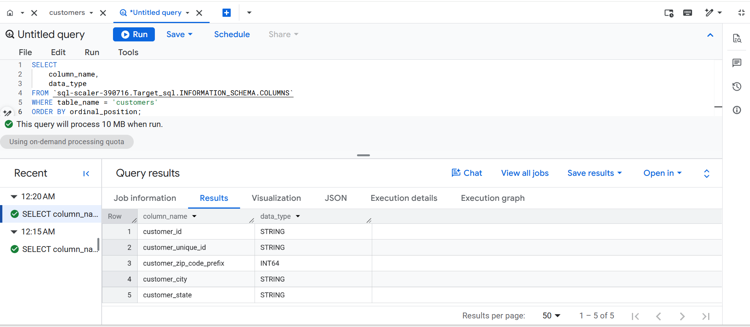

1b) Query:

SELECT
MIN(order_purchase_timestamp) AS first_order_timestamp,
MAX(order_purchase_timestamp) AS last_order_timestamp,
DATE_DIFF(
DATE(MAX(order_purchase_timestamp)),
DATE(MIN(order_purchase_timestamp)),
DAY
) AS span_days
FROM `sql-scaler-390716.Target_sql.orders`
WHERE order_purchase_timestamp IS NOT NULL;

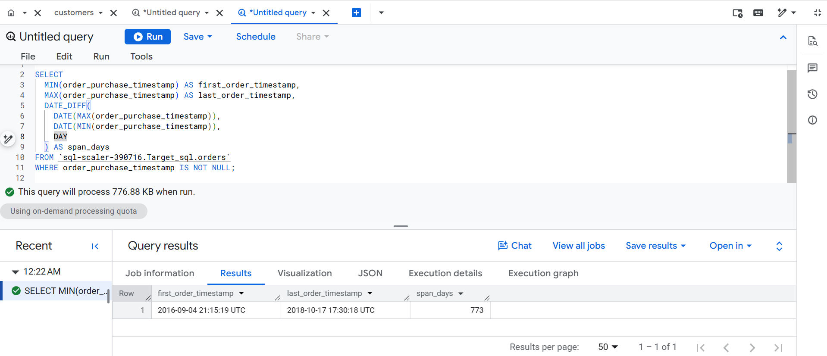

1c) Query:
SELECT
COUNT(DISTINCT customer_city) AS unique_cities,
COUNT(DISTINCT customer_state) AS unique_states
FROM `sql-scaler-390716.Target_sql.customers`
WHERE customer_id IN (
SELECT customer_id
FROM `sql-scaler-390716.Target_sql.orders`
);
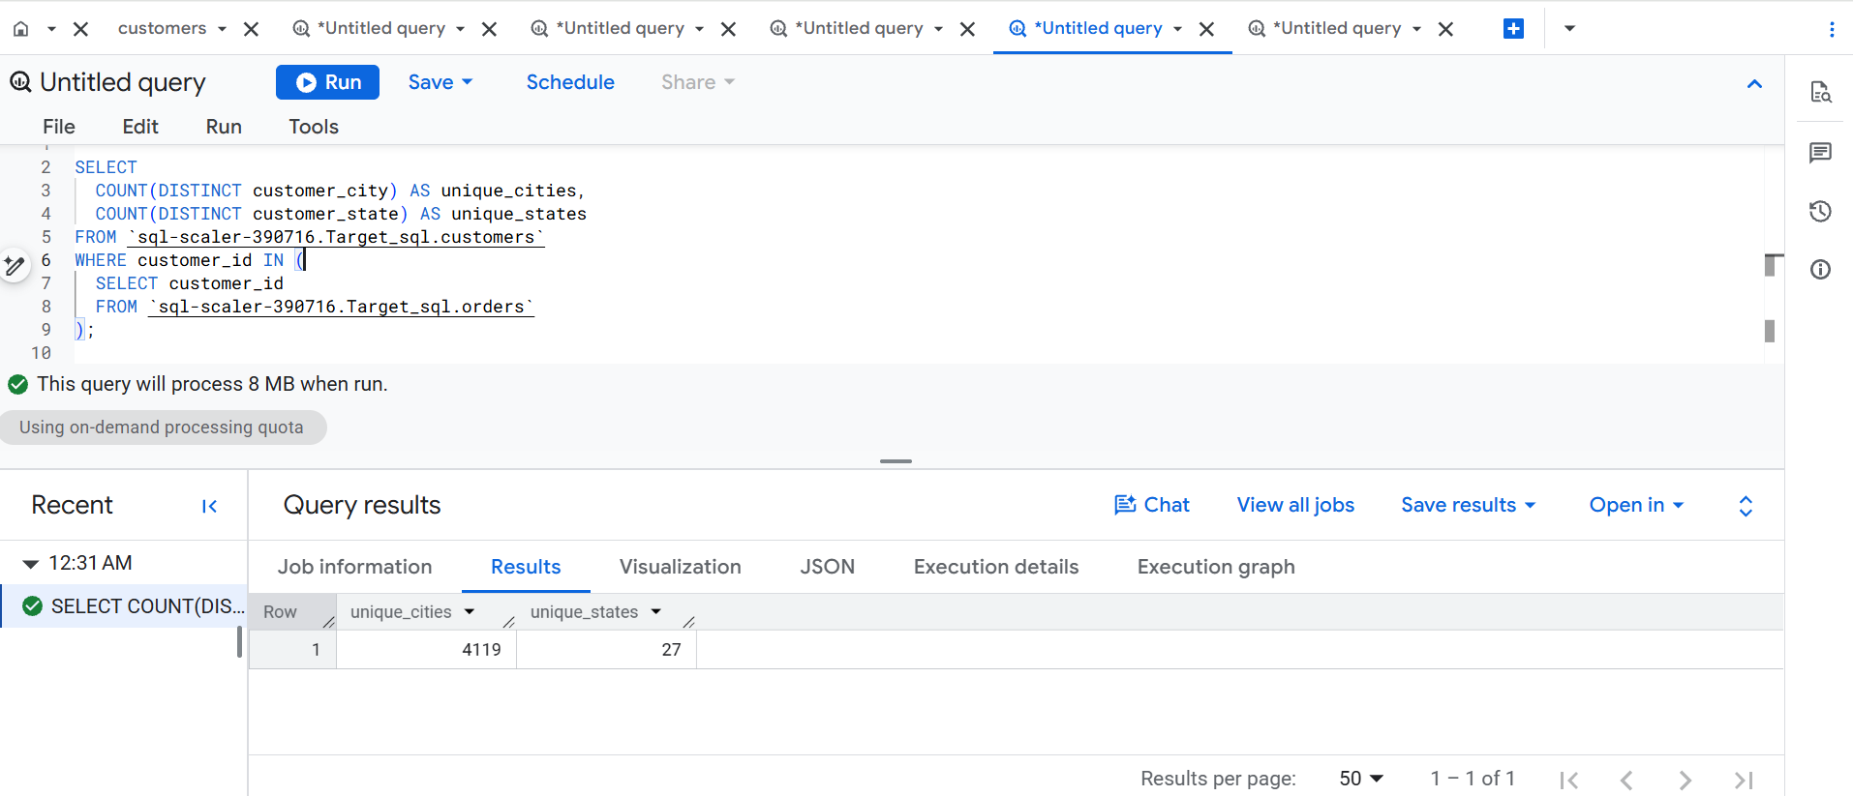

2. In-depth Exploration:

- Is there a growing trend in the no. of orders placed over the past years?
- Can we see some kind of monthly seasonality in terms of the no. of orders being placed?
- During what time of day do the Brazilian customers mostly place their orders?
(Dawn, Morning, Afternoon or Night)
  - 0-6 hrs: Dawn
  - 7-12 hrs: Mornings
  - 13-18 hrs: Afternoon
  - 19-23 hrs: Night

2a) Query:
SELECT
EXTRACT(YEAR FROM order_purchase_timestamp) AS order_year,
COUNT(*) AS total_orders
FROM `sql-scaler-390716.Target_sql.orders`
WHERE order_purchase_timestamp IS NOT NULL
GROUP BY order_year
ORDER BY order_year;

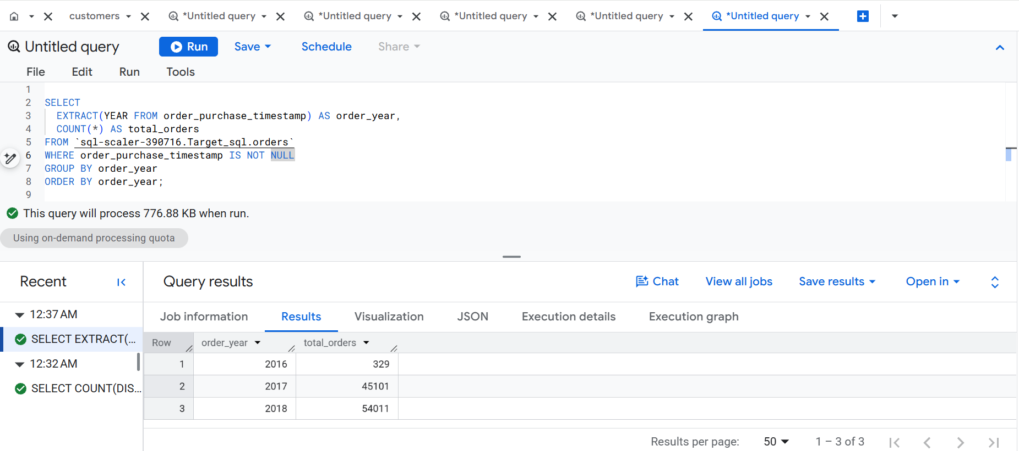

2b)Query:
SELECT
EXTRACT(MONTH FROM order_purchase_timestamp) AS order_month,
COUNT(*) AS order_count
FROM `sql-scaler-390716.Target_sql.orders`
WHERE order_purchase_timestamp IS NOT NULL
GROUP BY order_month
ORDER BY order_month;

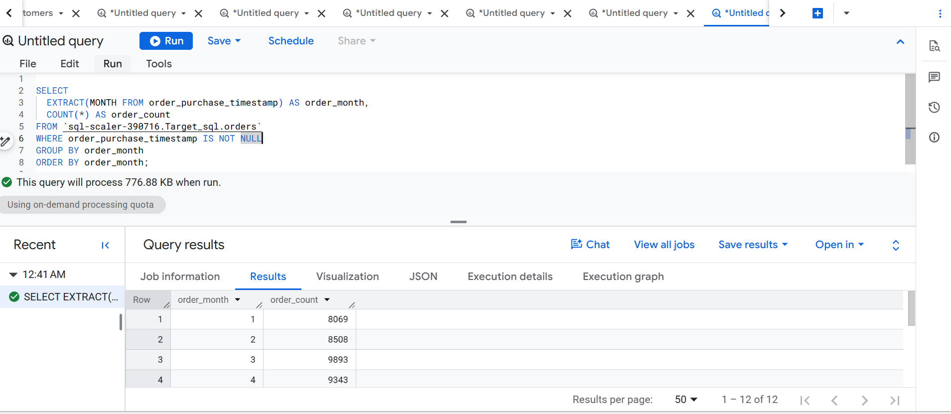

2c) Query:

SELECT
CASE
WHEN EXTRACT(HOUR FROM order_purchase_timestamp) BETWEEN 0 AND 6
THEN 'Dawn'
WHEN EXTRACT(HOUR FROM order_purchase_timestamp) BETWEEN 7 AND 12
THEN 'Morning'
WHEN EXTRACT(HOUR FROM order_purchase_timestamp) BETWEEN 13 AND 18
THEN 'Afternoon'
WHEN EXTRACT(HOUR FROM order_purchase_timestamp) BETWEEN 19 AND 23
THEN 'Night'
END AS time_of_day,
COUNT(*) AS total_orders
FROM `sql-scaler-390716.Target_sql.orders`
WHERE order_purchase_timestamp IS NOT NULL
GROUP BY time_of_day
ORDER BY
CASE time_of_day
WHEN 'Dawn' THEN 1
WHEN 'Morning' THEN 2
WHEN 'Afternoon' THEN 3
WHEN 'Night' THEN 4
END;

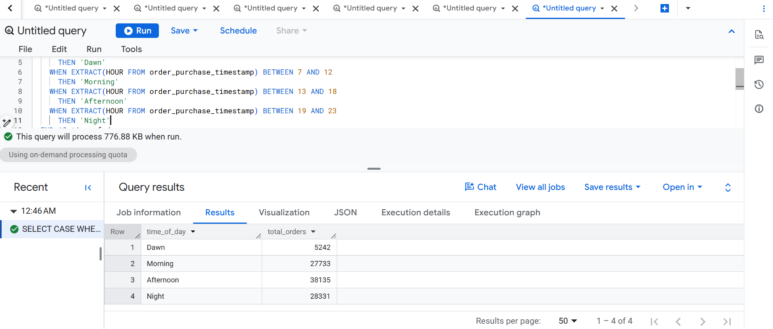
3. Evolution of E-commerce orders in the Brazil region:
a) Get the month-on-month no. of orders placed in each state.
b)How are the customers distributed across all the states?

3a) Query:

SELECT
c.customer_state,
DATE_TRUNC(DATE(o.order_purchase_timestamp), MONTH) AS order_month,
COUNT(o.order_id) AS total_orders
FROM `sql-scaler-390716.Target_sql.orders` AS o
JOIN `sql-scaler-390716.Target_sql.customers` AS c
ON o.customer_id = c.customer_id
WHERE o.order_purchase_timestamp IS NOT NULL
GROUP BY
c.customer_state,
order_month
ORDER BY
c.customer_state,
order_month;
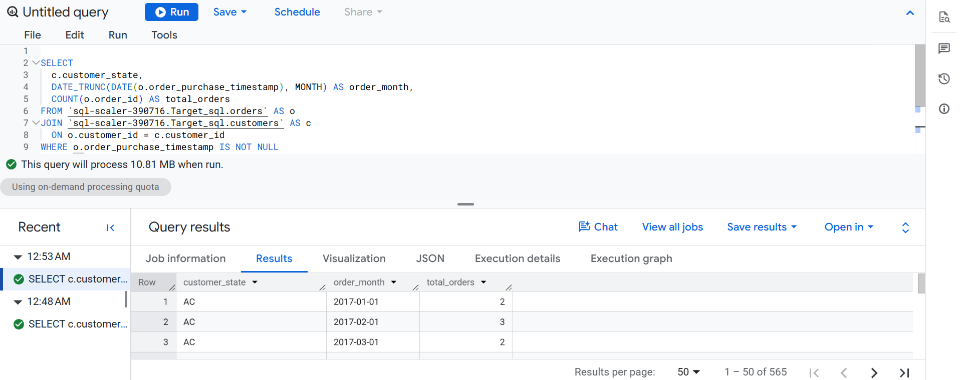
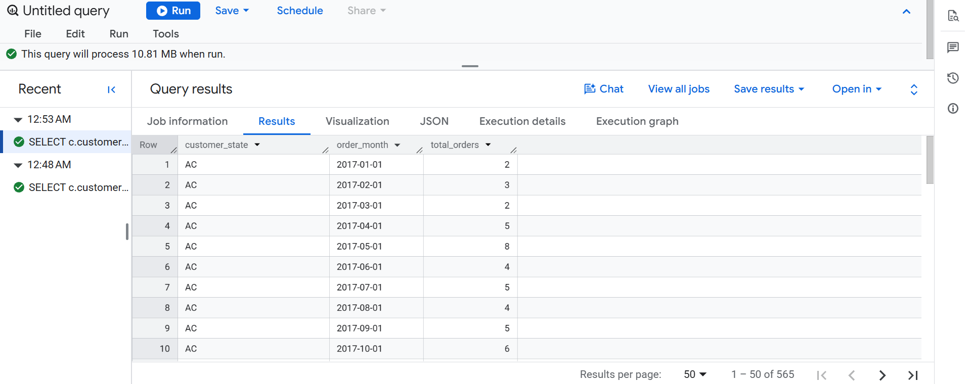
Row customer_state order_month total_orders
1 AC 2017-01-01 2
2 AC 2017-02-01 3
3 AC 2017-03-01 2
4 AC 2017-04-01 5
5 AC 2017-05-01 8
6 AC 2017-06-01 4
7 AC 2017-07-01 5
8 AC 2017-08-01 4
9 AC 2017-09-01 5
10 AC 2017-10-01 6
11 AC 2017-11-01 5
12 AC 2017-12-01 5
13 AC 2018-01-01 6
14 AC 2018-02-01 3
15 AC 2018-03-01 2
16 AC 2018-04-01 4
17 AC 2018-05-01 2
18 AC 2018-06-01 3
19 AC 2018-07-01 4
20 AC 2018-08-01 3
21 AL 2016-10-01 2
22 AL 2017-01-01 2
23 AL 2017-02-01 12
24 AL 2017-03-01 10
25 AL 2017-04-01 23
26 AL 2017-05-01 27
27 AL 2017-06-01 10
28 AL 2017-07-01 17
29 AL 2017-08-01 18
30 AL 2017-09-01 20
31 AL 2017-10-01 28
32 AL 2017-11-01 26

3b) Query:

SELECT
customer_state,
COUNT(DISTINCT customer_id) AS total_customers
FROM `sql-scaler-390716.Target_sql.customers`
GROUP BY customer_state
ORDER BY total_customers DESC;

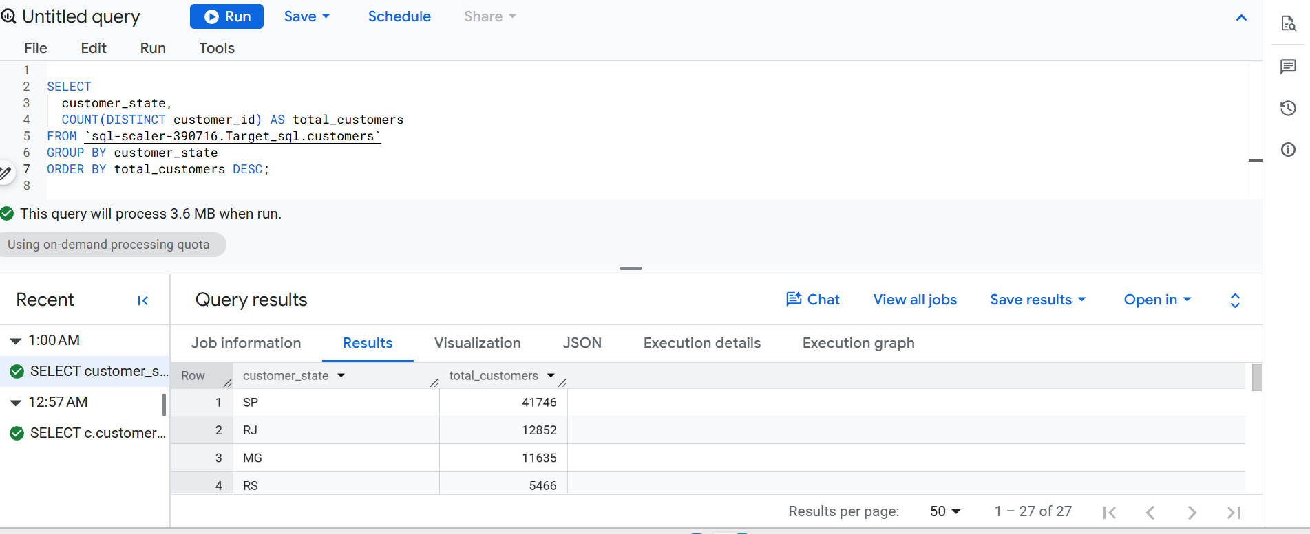
Output :
Row customer_state total_customers
1 SP 41746
2 RJ 12852
3 MG 11635
4 RS 5466
5 PR 5045
6 SC 3637
7 BA 3380
8 DF 2140
9 ES 2033
10 GO 2020
11 PE 1652
12 CE 1336
13 PA 975
14 MT 907
15 MA 747
16 MS 715
17 PB 536
18 PI 495
19 RN 485
20 AL 413
21 SE 350
22 TO 280
23 RO 253
24 AM 148
25 AC 81
26 AP 68
27 RR 46

4 . Impact on Economy: Analyze the money movement by e-commerce by looking at order prices, freight and others.
- Get the % increase in the cost of orders from year 2017 to 2018 (include months between Jan to Aug only).
You can use the "payment_value" column in the payments table to get the cost of orders.
- Calculate the Total & Average value of order price for each state.
- Calculate the Total & Average value of order freight for each state.

4a) Query :
WITH yearly_payments AS (
SELECT
EXTRACT(YEAR FROM o.order_purchase_timestamp) AS order_year,
SUM(p.payment_value) AS total_payment_value
FROM `sql-scaler-390716.Target_sql.orders` AS o
JOIN `sql-scaler-390716.Target_sql.payments` AS p
ON o.order_id = p.order_id
WHERE EXTRACT(MONTH FROM o.order_purchase_timestamp)
BETWEEN 1 AND 8
AND EXTRACT(YEAR FROM o.order_purchase_timestamp)
IN (2017, 2018)
GROUP BY order_year
)
SELECT
order_year,
ROUND(total_payment_value, 2) AS total_payment_value
FROM yearly_payments
ORDER BY order_year;
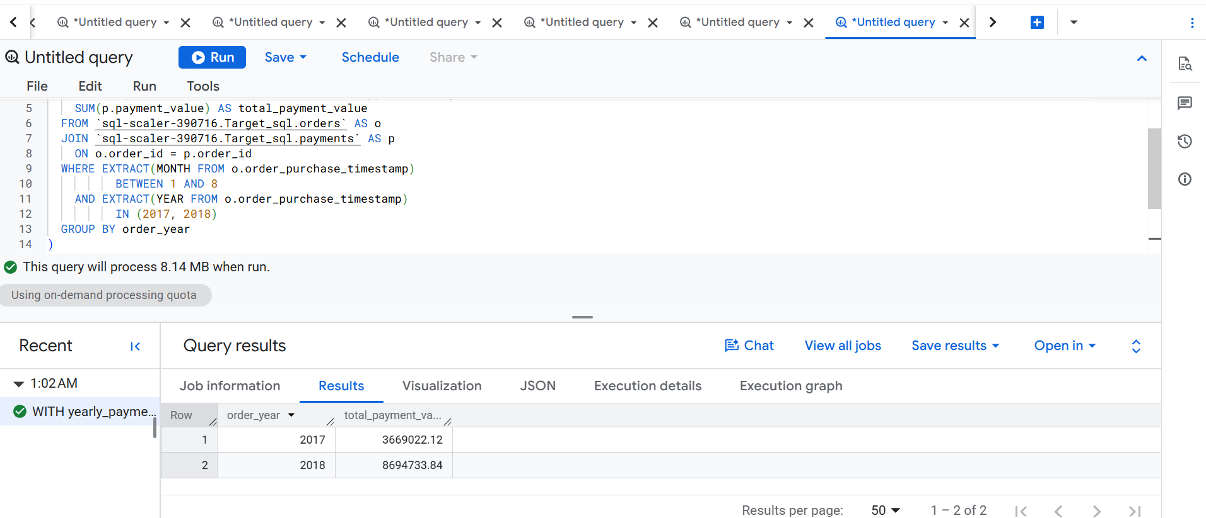

4a) Percentage increase calculation (Jan–Aug comparison)
The query above returns payment totals for the two comparable periods. The following query explicitly calculates the absolute and percentage increase.
WITH yearly_payments AS (
SELECT
EXTRACT(YEAR FROM o.order_purchase_timestamp) AS order_year,
SUM(p.payment_value) AS total_payment_value
FROM `sql-scaler-390716.Target_sql.orders` AS o
JOIN `sql-scaler-390716.Target_sql.payments` AS p
ON o.order_id = p.order_id
WHERE EXTRACT(MONTH FROM o.order_purchase_timestamp) BETWEEN 1 AND 8
AND EXTRACT(YEAR FROM o.order_purchase_timestamp) IN (2017, 2018)
GROUP BY order_year
),
pivoted AS (
SELECT
MAX(IF(order_year = 2017, total_payment_value, NULL)) AS payment_2017_jan_aug,
MAX(IF(order_year = 2018, total_payment_value, NULL)) AS payment_2018_jan_aug
FROM yearly_payments
)
SELECT
ROUND(payment_2017_jan_aug, 2) AS payment_2017_jan_aug,
ROUND(payment_2018_jan_aug, 2) AS payment_2018_jan_aug,
ROUND(payment_2018_jan_aug - payment_2017_jan_aug, 2) AS absolute_increase,
ROUND(SAFE_DIVIDE(payment_2018_jan_aug - payment_2017_jan_aug,
payment_2017_jan_aug) * 100, 2) AS percentage_increase
FROM pivoted;
Documented result: Jan–Aug 2017 = R$ 3,669,022.12; Jan–Aug 2018 = R$ 8,694,733.84; absolute increase = R$ 5,025,711.72; percentage increase = 136.96%. This is payment value, not necessarily net recognised revenue.
4b) Query:

WITH order_payments AS (
SELECT
order_id,
SUM(payment_value) AS order_payment_value
FROM `sql-scaler-390716.Target_sql.payments`
GROUP BY order_id
),
order_state_values AS (
SELECT
c.customer_state,
o.order_id,
op.order_payment_value
FROM `sql-scaler-390716.Target_sql.orders` AS o
JOIN `sql-scaler-390716.Target_sql.customers` AS c
ON o.customer_id = c.customer_id
JOIN order_payments AS op
ON o.order_id = op.order_id
)
SELECT
customer_state,
ROUND(SUM(order_payment_value), 2) AS total_payment_value,
ROUND(AVG(order_payment_value), 2) AS average_order_value
FROM order_state_values
GROUP BY customer_state
ORDER BY total_payment_value DESC;

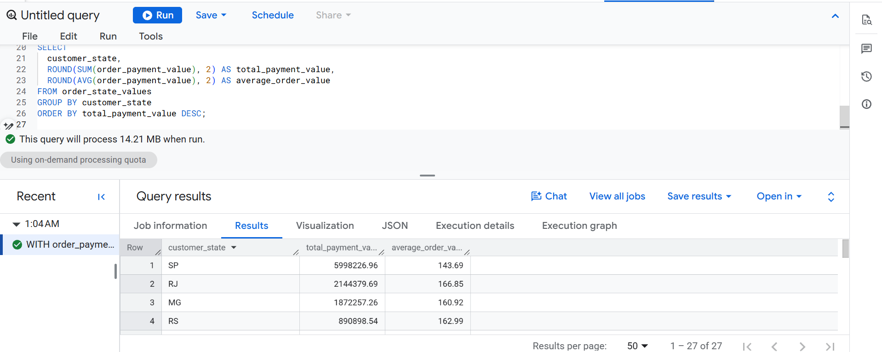

Output :
Row customer_state total_payment_value average_order_value
1 SP 5998226.96 143.69
2 RJ 2144379.69 166.85
3 MG 1872257.26 160.92
4 RS 890898.54 162.99
5 PR 811156.38 160.78
6 SC 623086.43 171.32
7 BA 616645.82 182.44
8 DF 355141.08 165.95
9 GO 350092.31 173.31
10 ES 325967.55 160.34
11 PE 324850.44 196.64
12 CE 279464.03 209.18
13 PA 218295.85 223.89
14 MT 187029.29 206.21
15 MA 152523.02 204.18
16 PB 141545.72 264.08
17 MS 137534.84 192.36
18 PI 108523.97 219.24
19 RN 102718.13 211.79
20 AL 96962.06 234.77
21 SE 75246.25 214.99
22 TO 61485.33 219.59
23 RO 60866.2 240.58
24 AM 27966.93 188.97
25 AC 19680.62 242.97
26 AP 16262.8 239.16
27 RR 10064.62 218.8

4c) Query:
WITH order_freight AS (
SELECT
order_id,
SUM(freight_value) AS order_freight_value
FROM `sql-scaler-390716.Target_sql.order_items`
GROUP BY order_id
)
SELECT
c.customer_state,
ROUND(SUM(ofr.order_freight_value), 2) AS total_freight_value,
ROUND(AVG(ofr.order_freight_value), 2) AS average_freight_per_order
FROM `sql-scaler-390716.Target_sql.orders` AS o
JOIN `sql-scaler-390716.Target_sql.customers` AS c
ON o.customer_id = c.customer_id
JOIN order_freight AS ofr
ON o.order_id = ofr.order_id
GROUP BY c.customer_state
ORDER BY total_freight_value DESC;
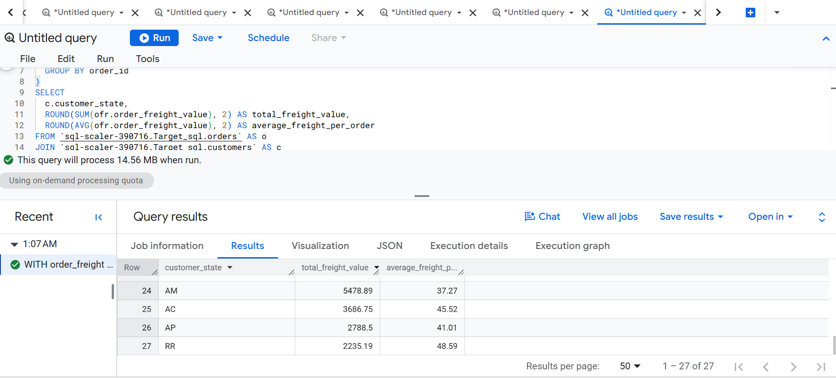

Output :
Row customer_state total_freight_value average_freight_per_order
1 SP 718723.07 17.37
2 RJ 305589.31 23.95
3 MG 270853.46 23.46
4 RS 135522.74 24.95
5 PR 117851.68 23.58
6 BA 100156.68 29.83
7 SC 89660.26 24.82
8 PE 59449.66 36.07
9 GO 53114.98 26.46
10 DF 50625.5 23.82
11 ES 49764.6 24.58
12 CE 48351.59 36.44
13 PA 38699.3 39.9
14 MA 31523.77 42.6
15 MT 29715.43 32.91
16 PB 25719.73 48.35
17 PI 21218.2 43.04
18 MS 19144.03 27.0
19 RN 18860.1 39.13
20 AL 15914.59 38.72
21 SE 14111.47 40.9
22 TO 11732.68 42.05
23 RO 11417.38 46.22
24 AM 5478.89 37.27
25 AC 3686.75 45.52
26 AP 2788.5 41.01
27 RR 2235.19 48.59

5 Analysis based on sales, freight, and delivery time.
1.)Find the no. of days taken to deliver each order from the order’s purchase date as delivery time.
Also, calculate the difference (in days) between the estimated & actual delivery date of an order.
Do this in a single query.

You can calculate the delivery time and the difference between the estimated & actual delivery date using the given formula:
time_to_deliver = order_delivered_customer_date - order_purchase_timestamp diff_estimated_delivery = order_estimated_delivery_date - order_delivered_customer_date
2.Find out the top 5 states with the highest & lowest average freight value.
3.Find out the top 5 states with the highest & lowest average delivery time.
4.Find out the top 5 states where the order delivery is really fast as compared to the estimated date of delivery.
You can use the difference between the averages of actual & estimated delivery date to figure out how fast the delivery was for each state.

5a) Query:

SELECT
order_id,
DATE_DIFF(
DATE(order_delivered_customer_date),
DATE(order_purchase_timestamp),
DAY
) AS delivery_days,
DATE_DIFF(
DATE(order_delivered_customer_date),
DATE(order_estimated_delivery_date),
DAY
) AS days_after_estimated_delivery
FROM `sql-scaler-390716.Target_sql.orders`
WHERE order_purchase_timestamp IS NOT NULL
AND order_delivered_customer_date IS NOT NULL
AND order_estimated_delivery_date IS NOT NULL
ORDER BY delivery_days DESC;

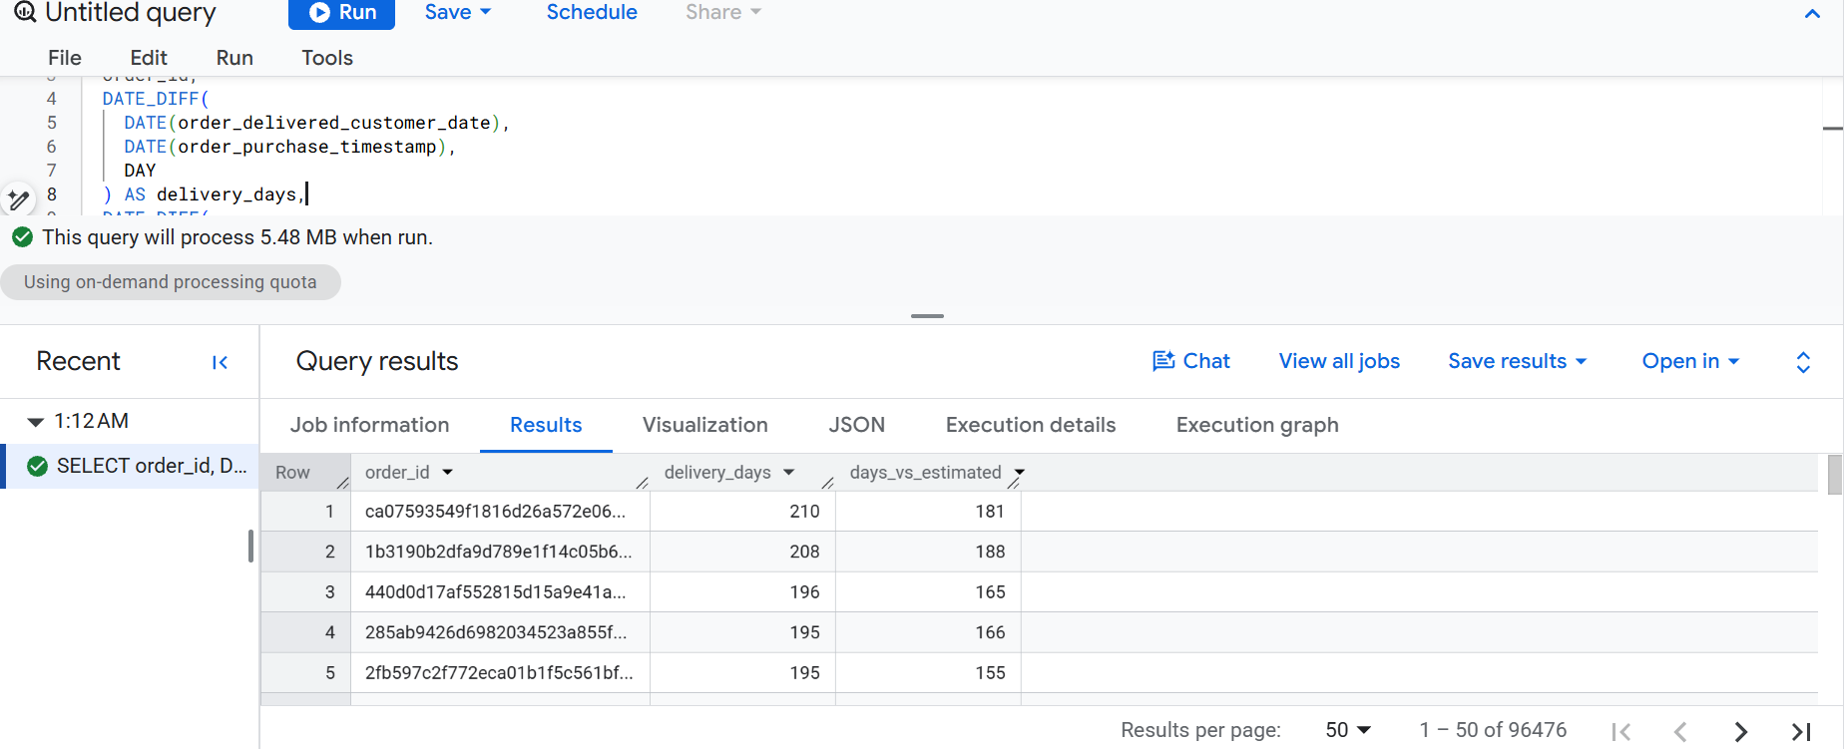
Output :
Row order_id delivery_days days_vs_estimated
1 ca07593549f1816d26a572e06dc1eab6 210 181
2 1b3190b2dfa9d789e1f14c05b647a14a 208 188
3 440d0d17af552815d15a9e41abe49359 196 165
4 285ab9426d6982034523a855f55a885e 195 166
5 2fb597c2f772eca01b1f5c561bf6cc7b 195 155
6 0f4519c5f1c541ddec9f21b3bddd533a 194 161
7 47b40429ed8cce3aee9199792275433f 191 175
8 2fe324febf907e3ea3f2aa9650869fa5 190 167
9 c27815f7e3dd0b926b58552628481575 188 162
10 2d7561026d542c8dbd8f0daeadf67a43 188 159
11 437222e3fd1b07396f1d9ba8c15fba59 187 144
12 dfe5f68118c2576143240b8d78e5940a 186 153
13 6e82dcfb5eada6283dba34f164e636f5 183 155
14 2ba1366baecad3c3536f27546d129017 181 152
15 d24e8541128cea179a11a65176e0a96f 175 161
16 3566eabb132f8d64741ae7b921bbd10e 174 137
17 ed8e9faf1b75f43ee027103957135663 173 153
18 2fa29503f2ebd9f53deba187160f3202 172 132
19 a452fba32eab28a4a62af18eed010c0b 168 138
20 525e11b26fdb7f41471d289897d0f6da 168 134
21 4fbc8d6f2f4db3e789d5a876fa349b56 168 134
22 df6d8b7768a047c2981bae0a24afbb01 168 132
23 6e6527028de694ccade37f5a15a6d84a 166 143
24 031e7d4e559a1bf08e71a419aa998d0a 166 123
25 cce224811ba8fea016c049693c3e0402 148 126
26 3c98e4bedff26f850c4f9989b16c8ee7 146 119
27 0b32bf55276b5feb681f6ed6fd670692 145 121
28 4f39a94d6e474819d898d6df7d394996 144 112
29 450cb96c63e1e5b49d34f223f67976d2 143 106
30 17cc6728043d53cc948551dfbf0a338b 142 110
31 815b68de0bc7fa6c117e4bcf855734ef 142 111
32 28f12a3e5117f5e70bbdb45be9188639 139 104
33 0b7b12a402b064d880d3cb31051f6d29 138 104
34 7e708aed151d6a8601ce8f2eaa712bf4 137 96
35 c5f43352377291361dad9a7366ae1c89 135 109
36 29c3b79aace1b72a82b1232bf494e16f 133 94
37 b31c7dea63bb08f8cdd1ec32514ccf0b 132 109
38 c2a550cc5f966506b717532441c221e5 131 104
39 b7624f6b70f7b79ea2b092b6f1be678c 131 96
40 a6a6c002fd9f0e9eb0c0148448cf8863 130 104
41 da81fbc27b55e0f3d2813cf2078dc780 127 100
42 773f048245dc975a5f7c67c2415c88a0 126 96
43 607a624a0fb32899edc4e3f9c9b24189 125 63
44 103188b1afa4614c023b86344f79727b 119 105
45 e7fc47a9bd5fd8c1d1b566d1553be0f4 117 104
46 5fc65d39393a0107a062195fdc96ad34 115 97
47 e7b87b156cde9f1d3a765da80d093d6a 110 88
48 a4efaffc506a395c9cea7402b078c1e5 110 73
49 e52c9dfec957c503bed5d050a39c740f 108 78
50 3b919fbc512d96f81330d2aae3ed0cf6 108 79

5b) Query:
WITH order_freight AS (
SELECT
order_id,
SUM(freight_value) AS order_freight_value
FROM `sql-scaler-390716.Target_sql.order_items`
GROUP BY order_id
),
state_freight AS (
SELECT
c.customer_state,
AVG(ofr.order_freight_value) AS avg_freight_per_order
FROM `sql-scaler-390716.Target_sql.orders` AS o
JOIN `sql-scaler-390716.Target_sql.customers` AS c
ON o.customer_id = c.customer_id
JOIN order_freight AS ofr
ON o.order_id = ofr.order_id
GROUP BY c.customer_state
),
ranked AS (
SELECT
customer_state,
ROUND(avg_freight_per_order, 2) AS avg_freight_per_order,
ROW_NUMBER() OVER (
ORDER BY avg_freight_per_order DESC
) AS highest_rank,
ROW_NUMBER() OVER (
ORDER BY avg_freight_per_order ASC
) AS lowest_rank
FROM state_freight
)
SELECT
customer_state,
avg_freight_per_order,
CASE
WHEN highest_rank <= 5 THEN 'Highest average freight'
WHEN lowest_rank <= 5 THEN 'Lowest average freight'
END AS freight_group
FROM ranked
WHERE highest_rank <= 5 OR lowest_rank <= 5
ORDER BY
CASE
WHEN highest_rank <= 5 THEN 1
ELSE 2
END,
avg_freight_per_order DESC;

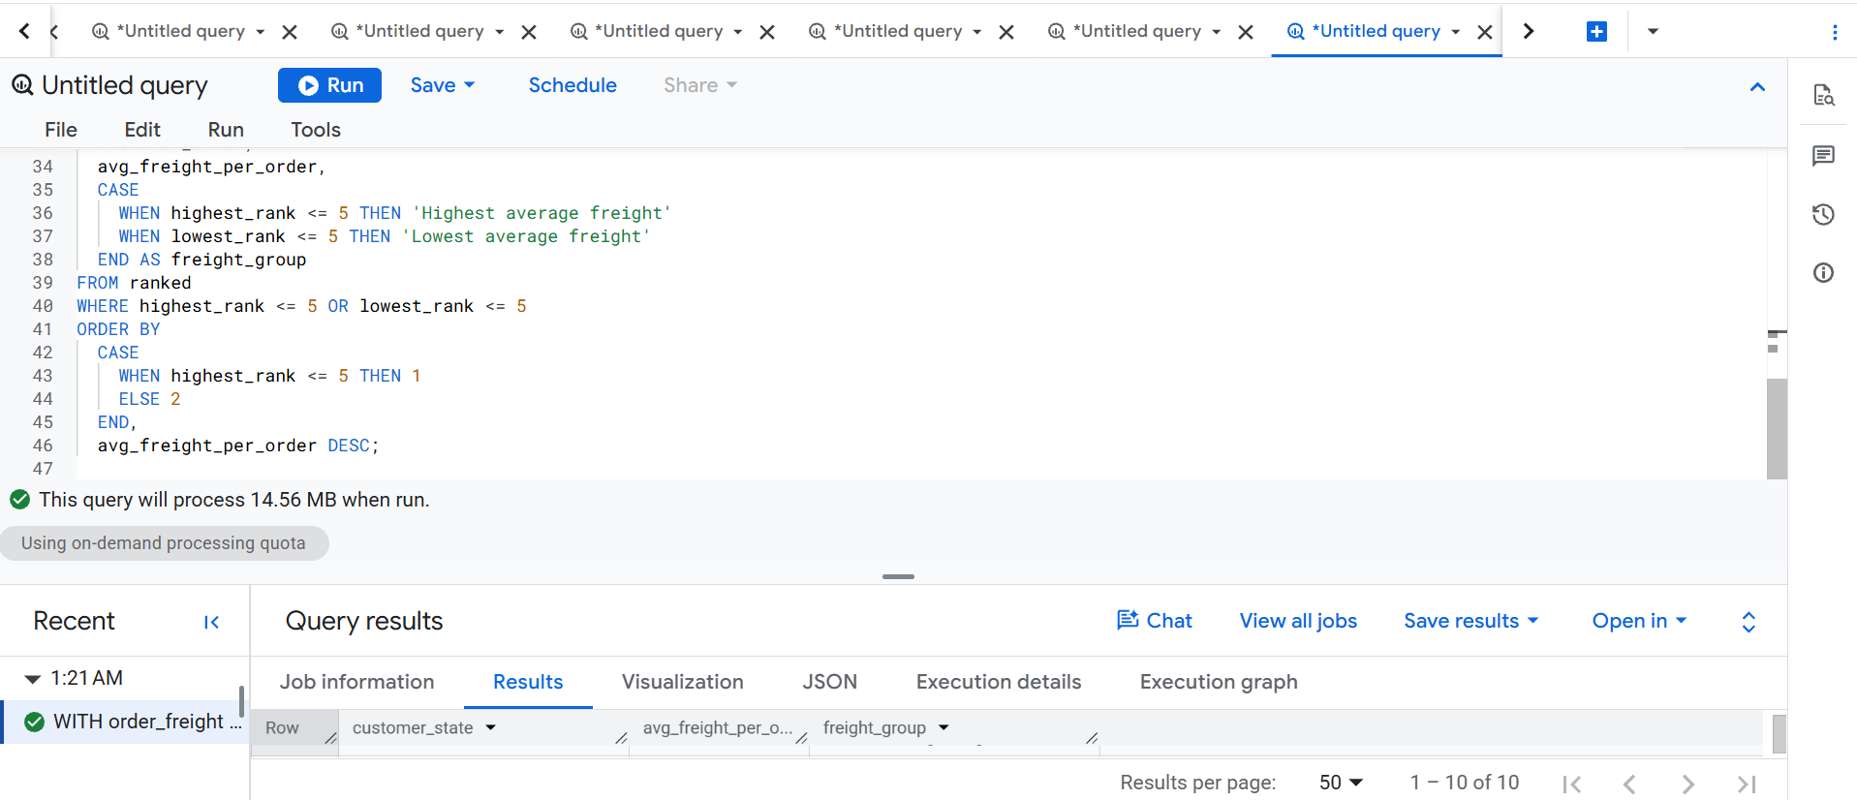

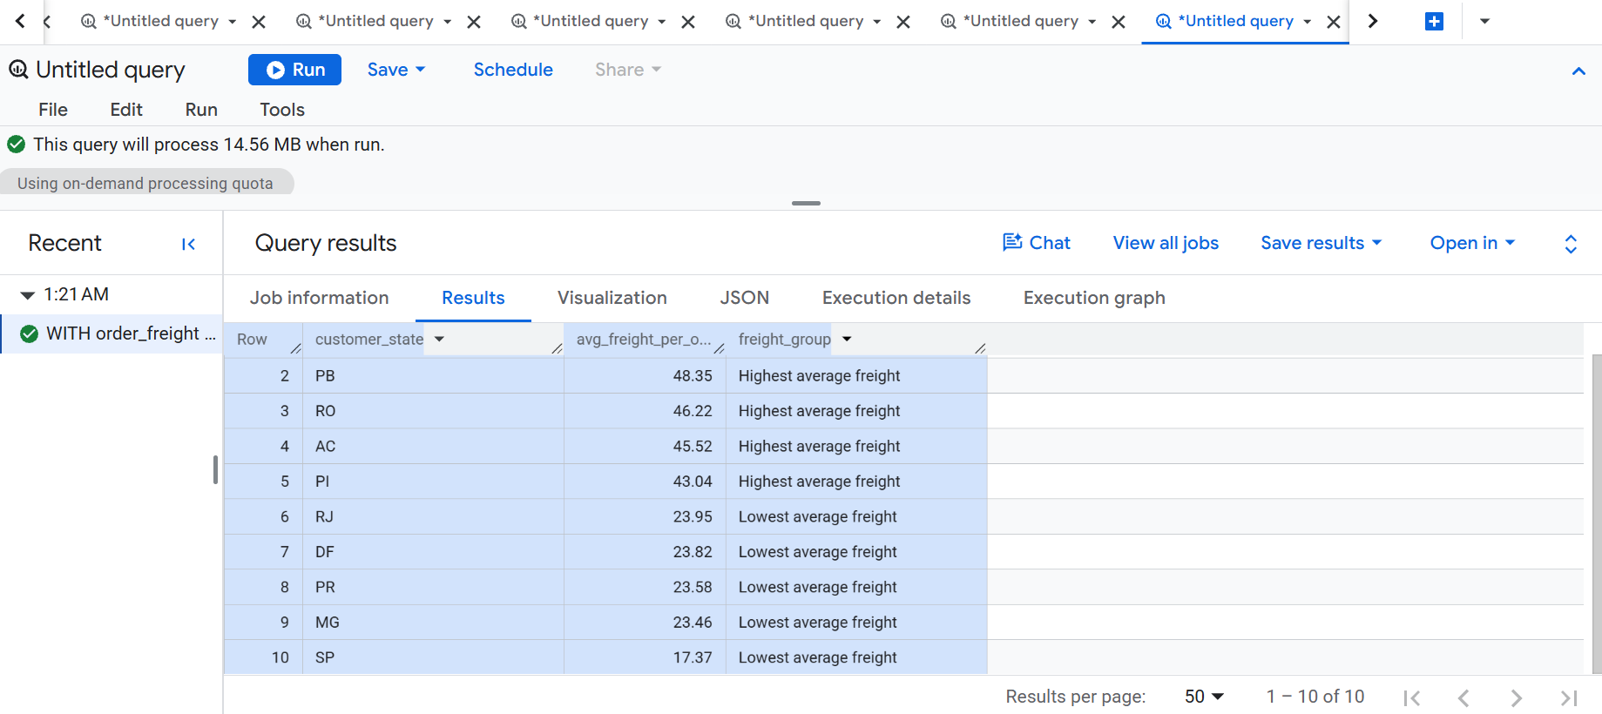
5c) Query:
Highest average delivery time :
SELECT
c.customer_state,
ROUND(
AVG(DATE_DIFF(
DATE(o.order_delivered_customer_date),
DATE(o.order_purchase_timestamp),
DAY
)),
2
) AS avg_delivery_days
FROM `sql-scaler-390716.Target_sql.orders` AS o
JOIN `sql-scaler-390716.Target_sql.customers` AS c
ON o.customer_id = c.customer_id
WHERE o.order_delivered_customer_date IS NOT NULL
AND o.order_purchase_timestamp IS NOT NULL
GROUP BY c.customer_state
ORDER BY avg_delivery_days DESC
LIMIT 5;

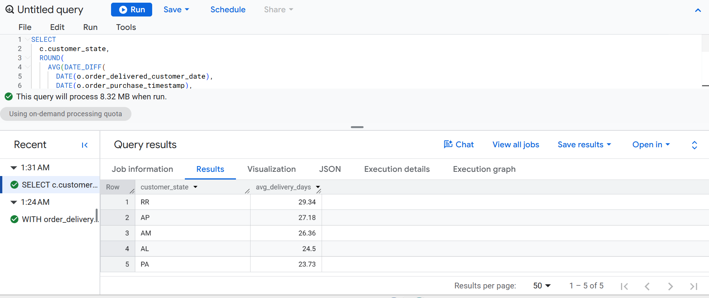
Lowest average delivery time :
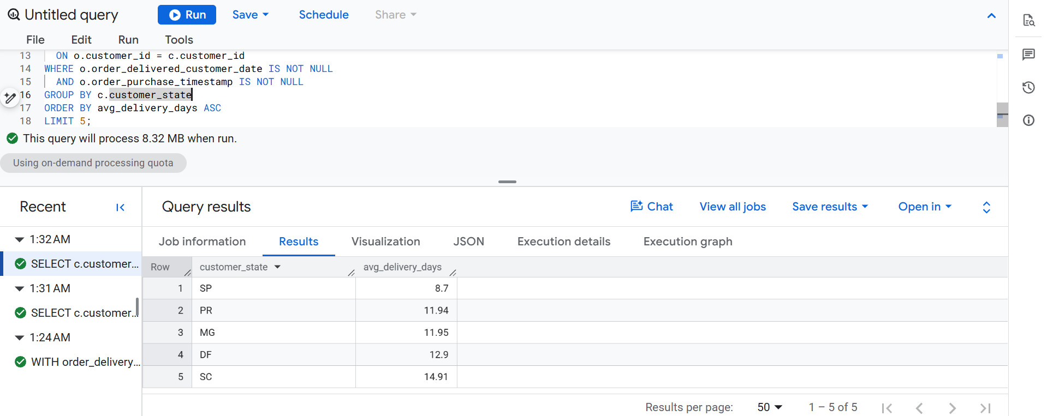

Lowest average delivery time — query and result
SELECT
c.customer_state,
ROUND(
AVG(DATE_DIFF(
DATE(o.order_delivered_customer_date),
DATE(o.order_purchase_timestamp),
DAY
)),
2
) AS avg_delivery_days
FROM `sql-scaler-390716.Target_sql.orders` AS o
JOIN `sql-scaler-390716.Target_sql.customers` AS c
ON o.customer_id = c.customer_id
WHERE o.order_delivered_customer_date IS NOT NULL
AND o.order_purchase_timestamp IS NOT NULL
GROUP BY c.customer_state
ORDER BY avg_delivery_days ASC
LIMIT 5;
Documented lowest average delivery times: RR — 29.34 days; AP — 27.18 days; AM — 26.36 days; AL — 24.50 days; PA — 23.73 days. These averages include delivered orders only.
Delivery-difference interpretation
The SQL uses actual delivery date minus estimated delivery date. Positive values mean delivery occurred after the estimated date (late); negative values mean delivery occurred before the estimated date (early); zero means delivery occurred on the estimated date.
5d) Query:

SELECT
c.customer_state,
ROUND(
AVG(
DATE_DIFF(
DATE(o.order_delivered_customer_date),
DATE(o.order_estimated_delivery_date),
DAY
)
),
2
) AS avg_days_vs_estimated
FROM `sql-scaler-390716.Target_sql.orders` AS o
JOIN `sql-scaler-390716.Target_sql.customers` AS c
ON o.customer_id = c.customer_id
WHERE o.order_delivered_customer_date IS NOT NULL
AND o.order_estimated_delivery_date IS NOT NULL
GROUP BY c.customer_state
ORDER BY avg_days_vs_estimated ASC
LIMIT 5;

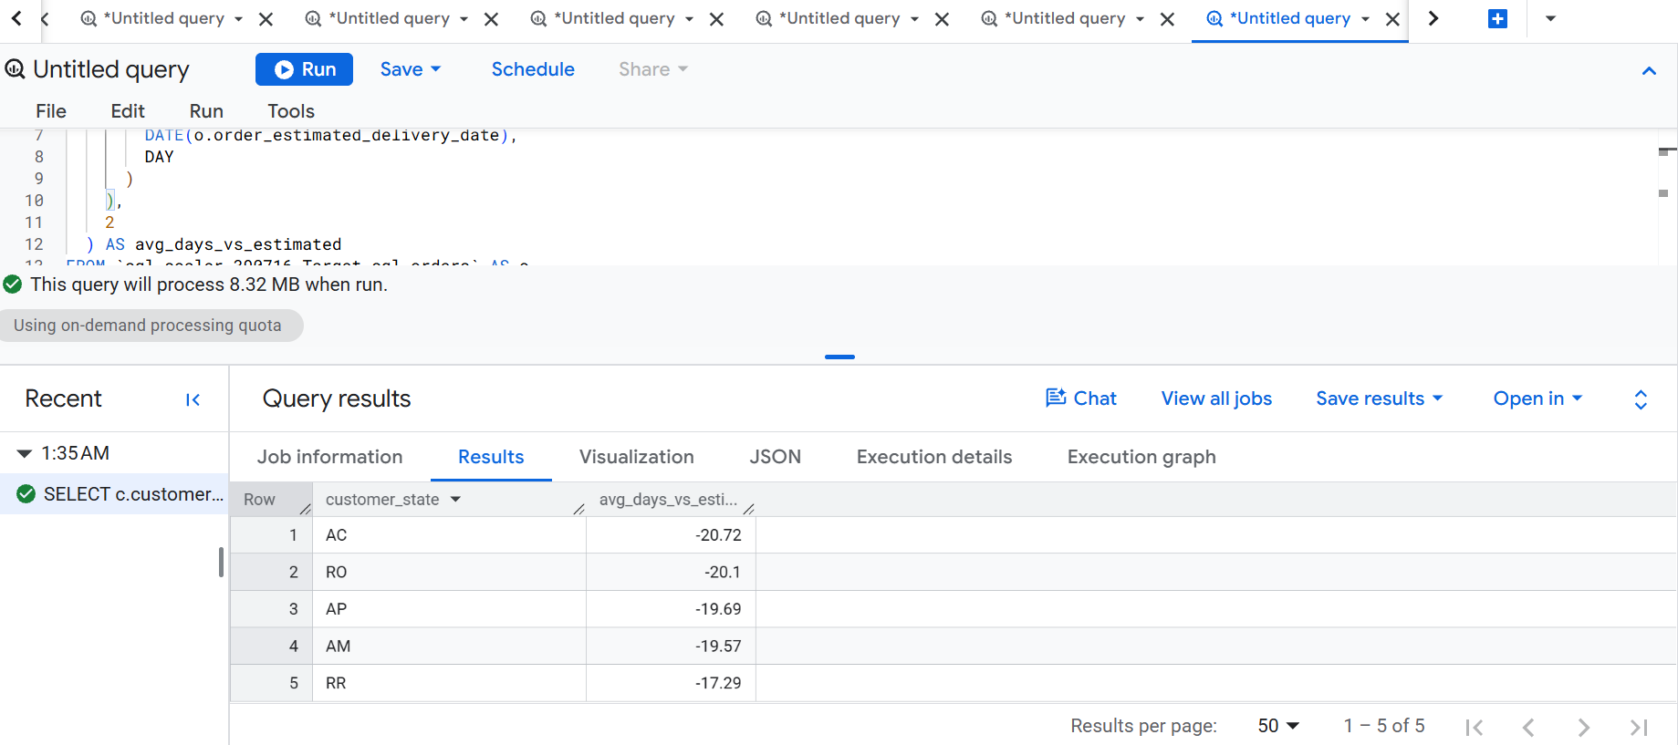

6. Analysis based on the payments:
- Find the month-on-month no. of orders placed using different payment types.
- Find the no. of orders placed on the basis of the payment installments that have been paid.

6a) Query:

SELECT
DATE_TRUNC(DATE(o.order_purchase_timestamp), MONTH) AS order_month,
p.payment_type,
COUNT(DISTINCT o.order_id) AS total_orders
FROM `sql-scaler-390716.Target_sql.orders` AS o
JOIN `sql-scaler-390716.Target_sql.payments` AS p
ON o.order_id = p.order_id
WHERE o.order_purchase_timestamp IS NOT NULL
GROUP BY order_month, p.payment_type
ORDER BY order_month, p.payment_type;

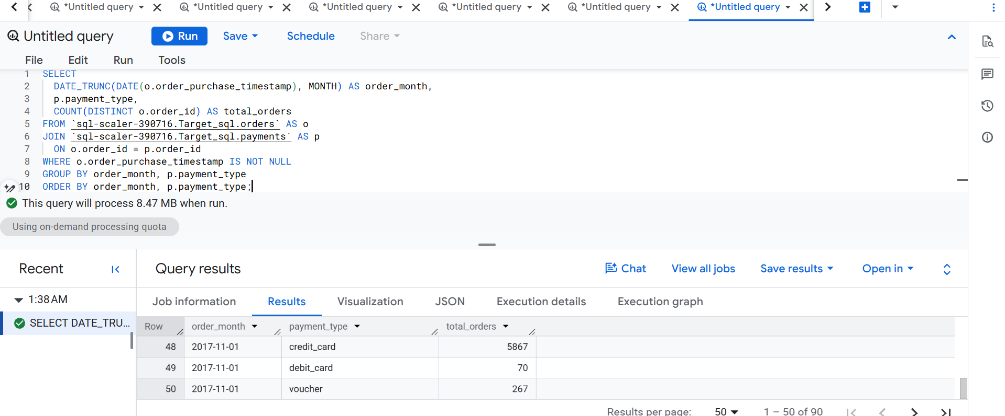

Output :

Q6(a) result interpretation
The query groups distinct orders by purchase month and payment type. The results reviewed showed credit card as the most frequently represented payment type. An order can appear under more than one payment type if it has multiple payment records. The full result table was not present in the uploaded report, so exact monthly counts are not reproduced here.
6b)Query:
SELECT
payment_installments,
COUNT(DISTINCT order_id) AS total_orders
FROM `sql-scaler-390716.Target_sql.payments`
GROUP BY payment_installments
ORDER BY payment_installments;

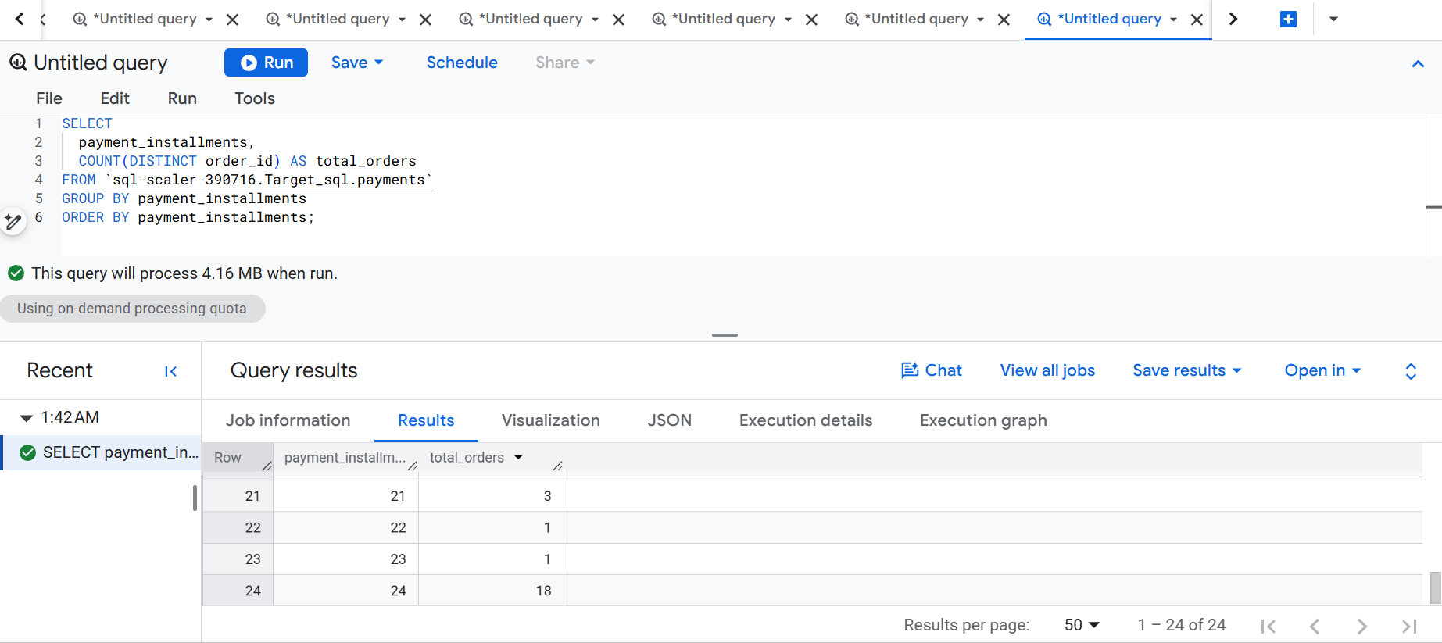
Output :
Installments | Total orders
0 | 2
1 | 49,060
2 | 12,389
3 | 10,443
4 | 7,088
5 | 5,234
6 | 3,916
7 | 1,623
8 | 4,253
9 | 644
10 | 5,315
11 | 23
12 | 133
13 | 16
14 | 15
15 | 74
16 | 5
17 | 8
18 | 27
20 | 17
21 | 3
22 | 1
23 | 1
24 | 18

