Student Management
Database

Enter the database in the Db.cs File .(connectionString)
And run the provided script file Script.sql.

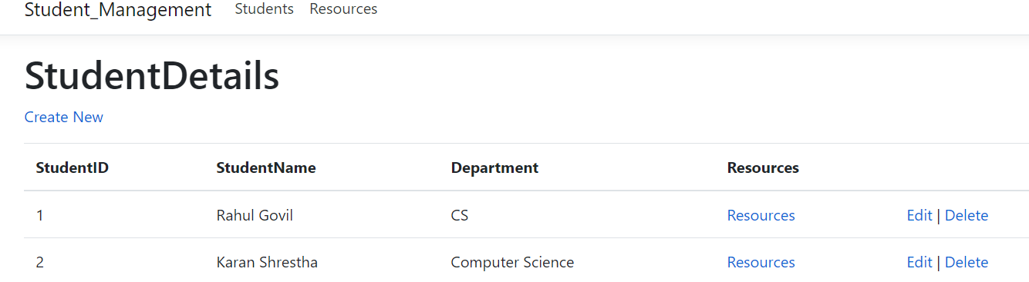

We have 2 tabs :
Student
Resources

STUDENT Page :

Provide you the options to create a new student record edit the existing and delete the existing record.

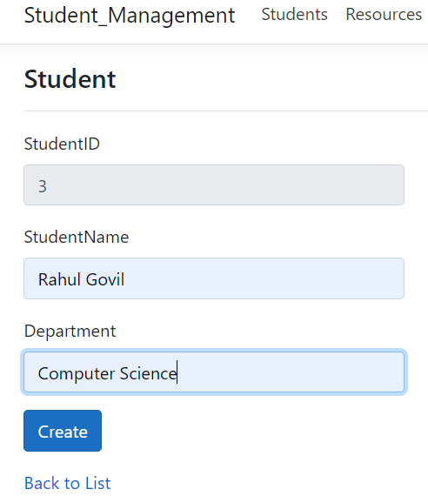
RESOURCE Page:
You can save edit and delete the resource :

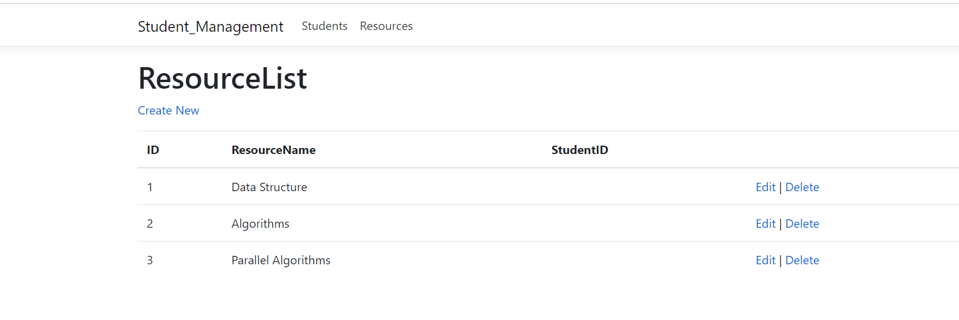

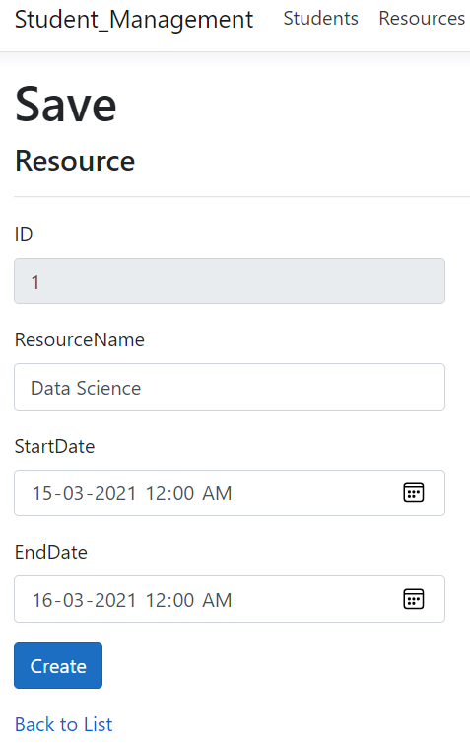
LINKING:
For linking of the resources to the student :
Student page show the linked resouces

Click and get to the linked resources and add or remove the resources:

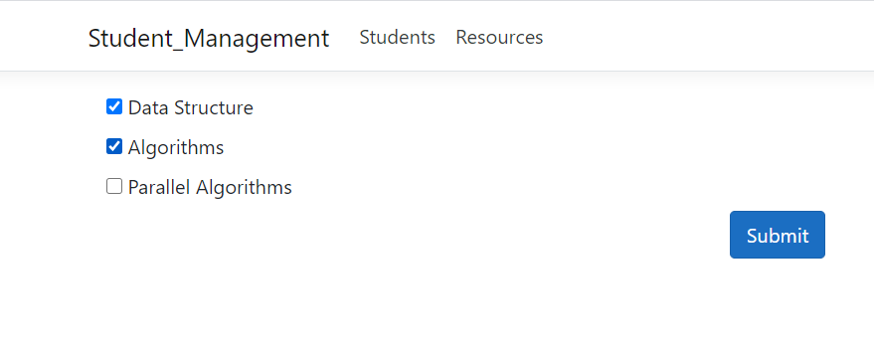
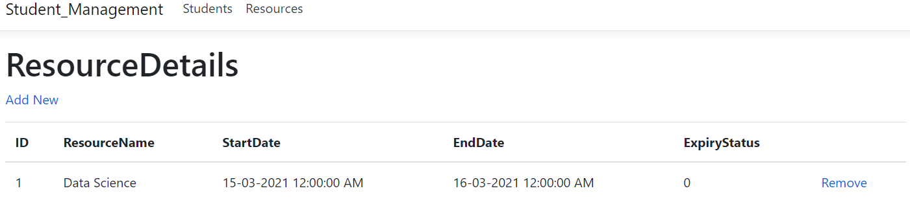

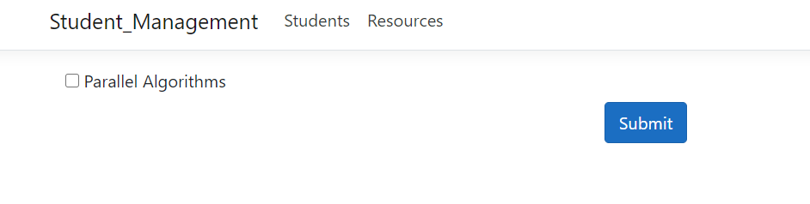
For the next linking only the remaining resources will be available :

