ID – 26561 Name - M.A.M.A.Chularathna

1. What is inheritance?

* Inheritance is a concept that use to inherit a class derived a feature of a base class. It means the child class can access the non-private data of the parent class.

1. How do you implement inheritance in java?

* Syntax

Public class parent {

}

Public class child extends parent {

}

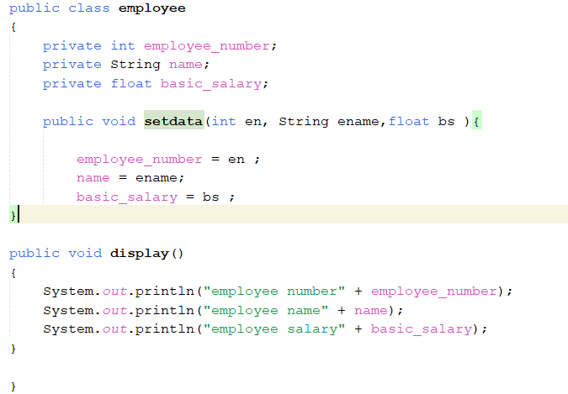

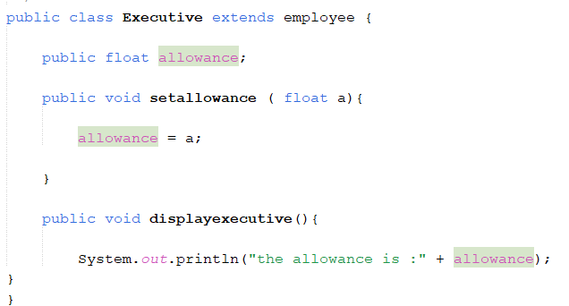

1. What is the use of constructors in java?

* The purpose of a constructor is to assign values to the member variable.

1. What is the difference between default and parameterize constructors in java?

* Default constructors does not have any parameter to pass to the method or to the objects, they simply denoted by empty parenthesis at the end of a class or an object.

Ex:



* Parameterize constructors pass user define arguments to the methods or to object to be used as variables.

Ex:

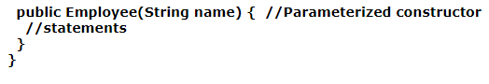

1. How do constructors work in inheritance?

* In inheritance when a child class extends from a parent class, the constructors of the parent class execute first followed by the constructors in child class.

1. Can a constructor be inherited?

* Constructors cannot be inherited because they are not members, but the constructors in the base class can be invoked from sub class.

1. What is constructor overloading?

* Constructor overloading means having two or more constructors in a class. A class can have different types of constructors differs by name or data type.

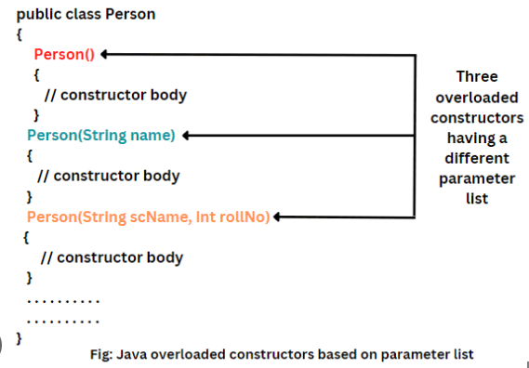

1. What is the use of super () keyword in java?

* It allows the child class to access methods and objects in the base class.

1. Can a subclass have its own constructors?

* Yes, A subclass can have the method and properties of the base class and their own methods and properties.

1. What happen if the super class doesn’t have default constructors?

* If a base class does not have any default or parameterize constructor it gives a compile time error.