**OIRA Guidebook System**

| Zhaoheng Li  Syracuse University  121 Lafayette Road, Syracuse  zli50@syr.edu | Akshay Bagde  Syracuse University  459 Westcott,  Syracuse  asbagde@syr.edu | **Lazarus Chavez**  Syracuse University  505 Walnut Avenue, Syracuse  lchavez@syr.edu | Rahul Jairaj  Syracuse University  351 Brighton Avenue, Syracuse  rjairaj@syr.edu |
| --- | --- | --- | --- |

# ABSTRACT

## OIRA office is Syracuse University’s Office of Institutional Research and Assessment. For agencies to construct university rankings, they need channels to gather credential data about each University. OIRA fulfills their data demand by supplying internal data from all departments across Syracuse University. The Guidebook system helps the OIRA staff to gather, manage, distribute and report this critical information. The goal of this project is to gain real-world system design experience with implementation followed.

## Author Keywords

OIRA; university rankings; departments; Guidebook; system; design.

# INTRODUCTION

Business Case of the Guidebook Development Project

OIRA is the office of institutional research and assessment at Syracuse University. For guidebook publishers to construct university rankings, they need access to University’s official channels to gather data. OIRA fulfills publishers’ data needs by supplying internal data collected from all departments across Syracuse University. The Guidebook system helps the OIRA staff to gather, manage, distribute and report the information.

The goal of upgrading the existing system is to further enhance OIRA’s efficiency and effectiveness. The upgraded system should reduce the redundant and complex nature of sending out questionnaires to University personnel and then try to re-map their responses back to the original requests from the guidebook publishers.

## IST 649 HCI Prototyping Team

Our prototype project is one of three teams that are working on the development of this project. Alongside us, we have two other teams working on system analysis and database analysis for the existing system, so that we could have all the information to engineer a new system for the future. We call ourselves HCI prototyping team, and our role is to build an MVP for the initiation and prepare others for the small details in the UI design. There’s possibility that we’ll keep working on building the UI for the new Guidebook system on the production platform instead of Wix we used now for prototyping.

## Team’s Design Intention

Our design goal is to deliver features, which people would understand and perform based on the common technology literacy without any formal guide. On one side, as students who study to prepare for a professional career, we long for real-world designing experiences. That’s why we want to prototype a system that other will eventually bring the system into life. On the other side, we experience HCI in our daily lives with features that have already become a part of the social norm, such as the search bar on the Google page, but people may experience HCI features without being aware. Through this project, we want to experience what the original designers went through to build these modern systems and platforms: Google, Amazon, and Facebook. Furthermore, we want to explore how much we need to do, so that we can build similar features into our prototype.

We define these features with the user-friendly terms borrowed from Don Norman’s book. Hopefully, potential users could perform most prototyped tasks without any guidance or user manual needed. Additionally, if time and opportunity allow, we would spend time exploring how our new system may impact our users in advance inspired from Orlikowski’s duality model.

# METHODOLOGY AND PROCESS

Overall, we’ll follow agile development life cycle through multiple iterations, with prototypes built in Wix, due to the uncertainty involved and everyone’s packed schedule. The graph alongside suggests a typical life cycle for one iteration. We plan to implement the methodology for all our deliverables involved throughout the project: essays, reports, interview designs, interview records, and prototypes.

Throughout the project, there are four major stages: requirement elicitation, design, draft prototype which is an MVP (minimal viable product), and then multiple iterations to improve the system through user tests.

**Figure 1. Development Lifecycle of Guidebook System**

User Testing: Participants & Evaluation Methodologies

The goal of our user testing is to evaluate whether we can achieve our design goal: to deliver features that people would perform based on the common technology literacy without any formal guide. Due to the schedule conflicts, it was impractical to involve our client on over 15 user tests, that’s why we have multiple groups to accommodate our testing needs.

For the user tests, there are three main groups of people. The first group are designers. We believe that it’s crucial for us to experience the prototype, and we performed system evaluation using cognitive walk-through methodology. In this group, we have 4 testers. Unfortunately, we didn’t document the walk-through as we built our prototypes early.

The second group of users are people around the age-group of 20-28 with similar backgrounds. The majority of these testers are people with education background in technology. We chose these candidates because of their similar background to a potential new operator in the OIRA office. Furthermore, because of our design goal, we also had few users with different academic background to test whether we have terms that are too technical for regular internet users. For this group, we plan to have over 10 testers. We implement a user testing session with a combination of think-out-loud, observation, and survey techniques. We’ll elaborate in the following sections.

The third group of users are people in OIRA. We’ll meet once with the key user to gather his feedback on the prototype. Our prototype built in IST 649 class will serve as the MVP (minimal viable product) for the development project. For the system development project, we’ll be able to involve clients on a weekly basis to gather user-testing data and feedback. For the class project, accessibility to our real client was a constraint. For this group, we plan to have 1 tester who is the main operator for the existing system. We’ll implement similar techniques as the second group, and we’ll have a detailed interview to gather his feedback about the key features that we prototyped.

# REQUIREMENTS ELICITATION

## Requirements Gathering

There are multiple resources for us to understand the requirements. In the beginning, the project manager had two interviews with the OIRA staff to gather requirements. Later, we also gained access to writing documentations on DFD analysis, database analysis, UML object-oriented analysis, project charter, and minutes of meetings from earlier interviews.

As a brief summary, there are the few key functional requirements that we need to consider for our MVP:

John should be able to manage questions & answers. John should be able to add, edit, delete, and search any questions & answers.

Respondents are people who answer questions. John should be able to manage respondents’ information. John should be able to add, edit, delete, and search any of the respondent’s information.

## Existing Business Process

At the highest level, the system helps the admin manage questions asked by publishing companies and respond to them appropriately.

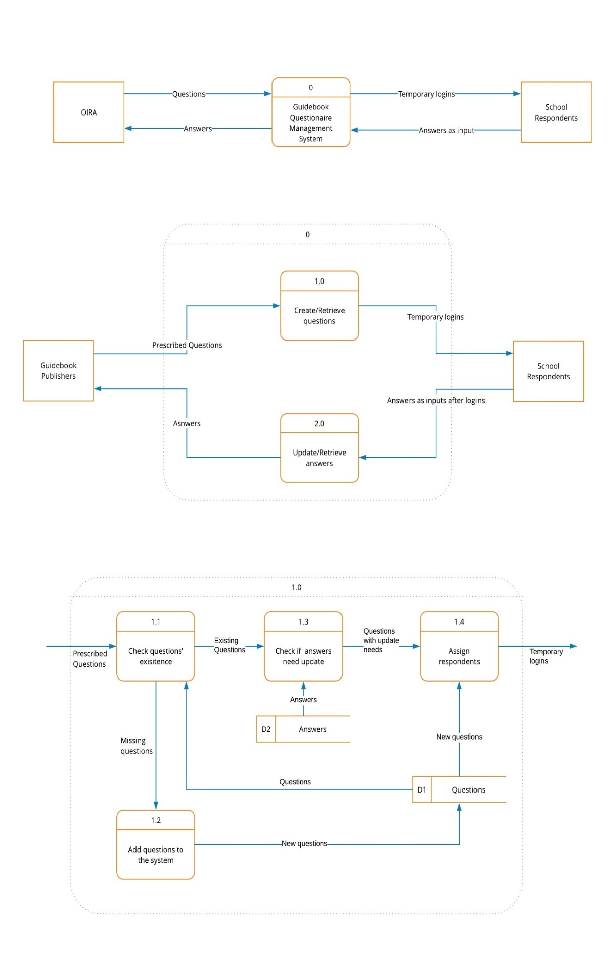

**Figure 2. High Level DFD**

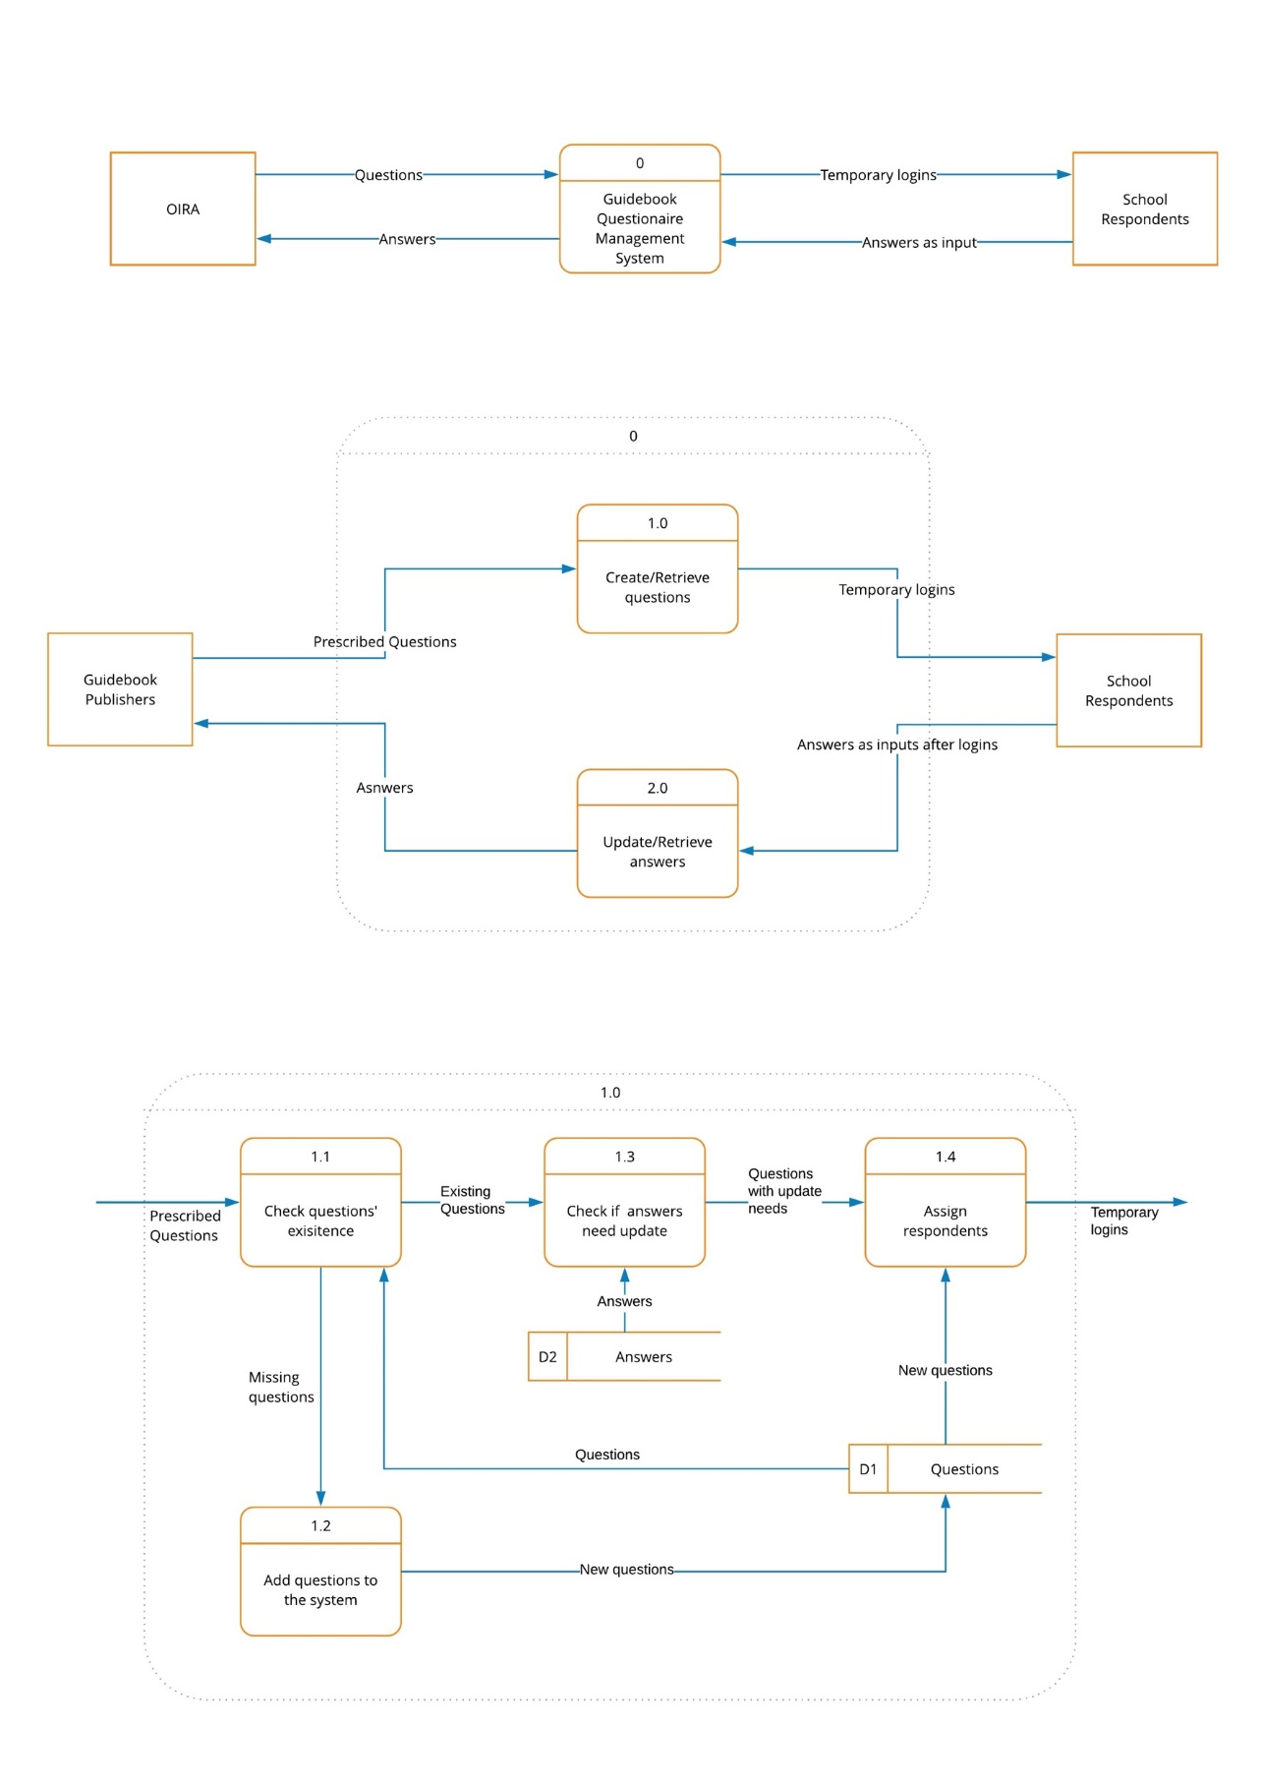

**Figure 3. Low Level DFD**

In addition, the admin has the ability to add/edit/remove respondents, guidebooks, publishers, departments and of course, questions.

## Entity Relationship Diagram

The following is the entity relationship diagram that we created for the existing system based on the current database structure.

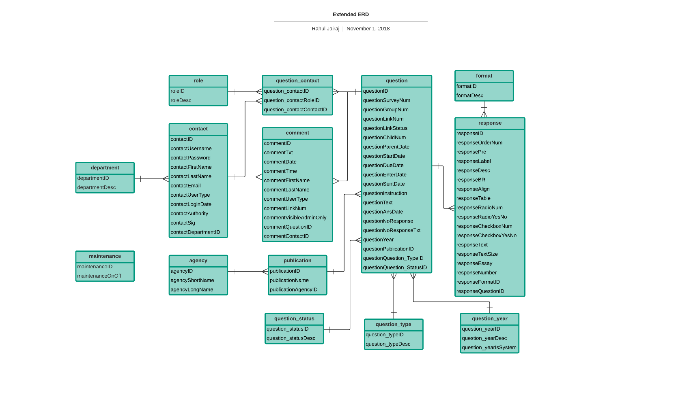

**Figure 4. E-R Diagram of the Guidebook System**

While examining the access database, we observed that there were 4 tables that were copies of existing tables – for e.g. the “response” table had a copy called “response-copy”. From our research, there were no provisions to perform any backups of any type anywhere in the existing website. So, we’ve excluded them from the ERD.

# DESIGN

## Prototyping Tool

Early on, we have a set of constriction on prototyping tools. We explored tools including: zipBoard, ConceptInbox, balsamiq, ConceptBoard, Adobe CC XD, etc. (the picture below was a page we made in Adobe CC XD) after experimenting with all the tools, we learned that their free versions all have restriction on collaborating features.

However, with XD, the main challenge we faced was collaboration. It was difficult to share files across users, and did not give us a common workspace. So, on further exploration, we ended up with Wix.com, where collaborative prototyping could be done using a common email ID, which we created for this project. This had another advantage in that, if we can create a working prototype accessible through the internet, we could assign test users use cases and ask them to perform think-out-loud. Lastly, Wix also gives us a higher fidelity, because the new system will also be web-based.

## Decisions Made on Initiating the Design

The team has access to the operating system that was built a decade ago by a single developer. We decided to abandon the UI of the existing system and start from scratch, because the UI was poorly designed and the system architecture was not reusable for the new system. We believed that we knew enough to start brainstorming and drafting, and we simply started to sit together, discuss, and draw things out on paper and whiteboards.

## The Initial Designs

We made some designs using the Adobe XD, and this is one of them. A mistake we made was that we did not document enough in the early stages. We did not keep our original scratches and designs. Below is one Adobe XD scratch that we still kept.

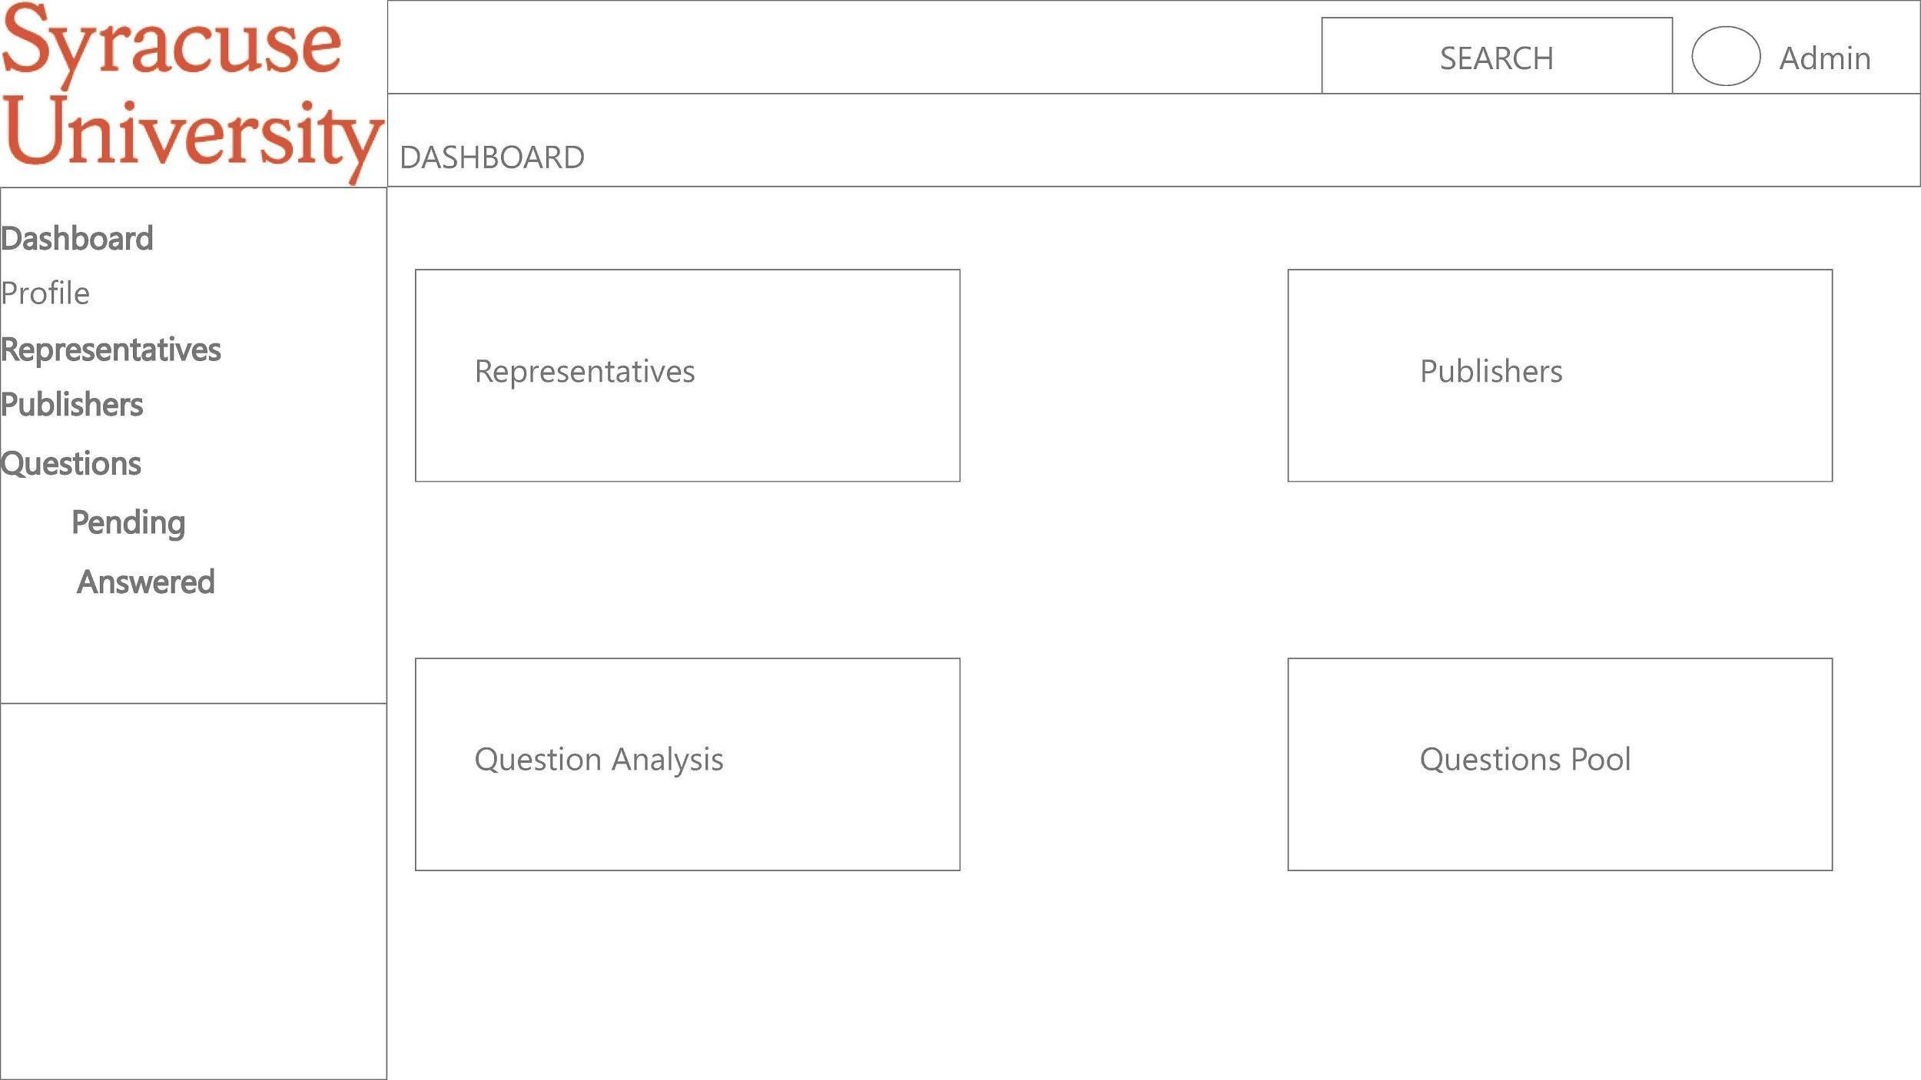

**Figure 5. Initial Administrator Home Page of the System**

# PROTOTYPING A MINIMAL VIABLE PROTOTYPE

## Login Section & Design Details

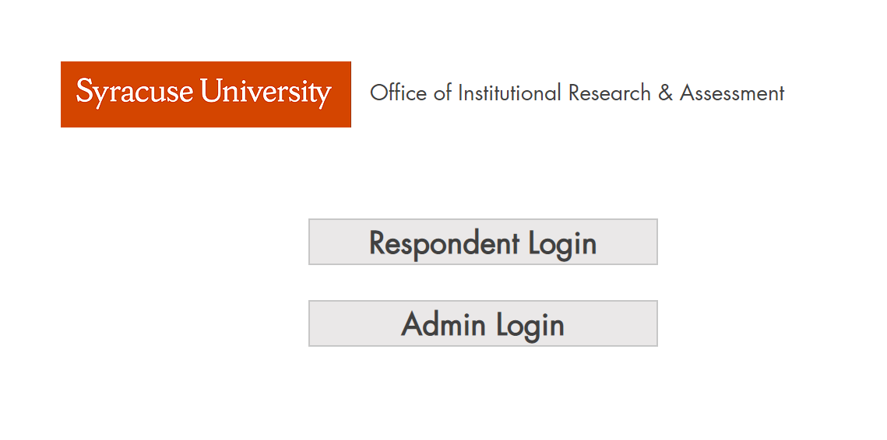

**Figure 6. Login Page of the Guidebook System**

For the login homepage, we paid extra attention on the button design and overall layout. We wanted it to look clean and appear easy to understand. We updated the button setting so that when user hovers the mouse over the button, it would change to a different color (dark gray) to indicate selection.

## Admin Section & Design Details



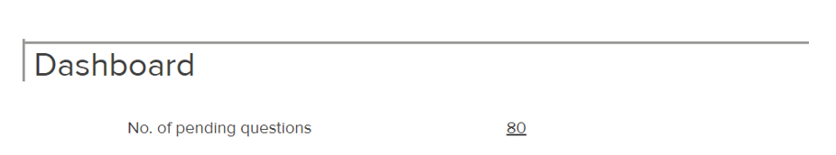

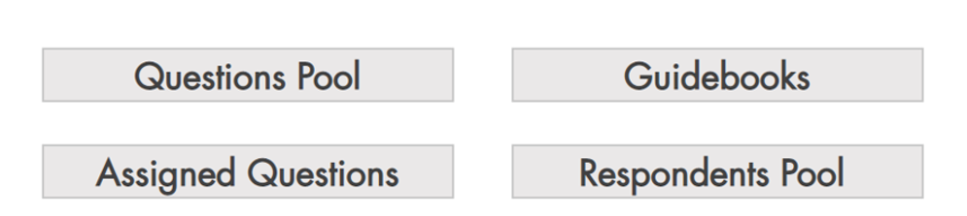

**Figure 7. Home page of the Administrator**

It would take some time for a new user to find the tabs hidden at the top, while adding questions and the two tables would be displayed openly. From our perspective, this system could be redesigned a little better. First of all, we thought to have a dashboard where all the upcoming deadlines could be displayed, including some other data from the Questions tab from the existing implementation.

In addition, we chose to have the admin home page have tiles, each of which can be basic maintenance tasks that can be performed. By maintenance, we mean the ability to add/edit questions, respondents, departments and guidebook and publishers. We chose tiles because it seemed very in-tune with applications we use nowadays, as opposed to simple having text links to navigate users to different screens.

Each of these tiles – like Guidebooks, Questions Pool, and Respondents will navigate the admin to another page, where the admin can add respective entities with relevant details as per the current implementation. The assigned questions section would allow the admin to link questions to respondents.

We have the Home button on the top left side of each screen. This button would navigate the user back to their respective home screen – if the user is an admin, it’ll navigate them back to the admin home screen and if the user is a respondent, it’ll navigate them back to the respondent home screen.

The “Log Out” button on the right would just navigate the user back to the log in screen. The Profile icon and the text next to it would redirect the user to a profile page where some information like the email ID of the user is shown. The top bar seems like a good place to nest these details as this needs to be present through every page in the website.

# Respondent Section & Design Details

The respondent home page has the same two tiles – the unanswered questions, recently answered questions. We thought it would be a good idea to add a third tile for all questions assigned to that respondent until that point in time, including historical data.

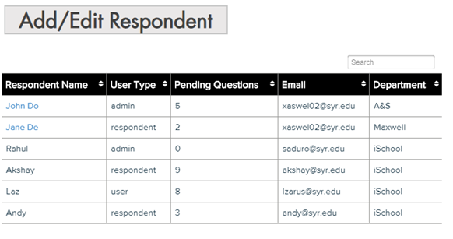

**Figure 8. Respondents page in the Guidebook System’s Admin Module**

**ITERATIONS INCLUDE TESTING, EVALUATION, AND IMPROVEMENTS**

## Techniques & Processes of Each User Testing

We plan to test out fundamental features about admin group and respondent group to see whether users need our assistance to perform these tasks. The techniques include think-out-loud, and survey. Throughout the user testing processes, we gathered feedback about the process itself & made changes accordingly. Our goal of the think-out-loud sessions was to measure whether users feel easy to use certain features of the prototype, and our goal of the brief survey is to measure the overall experience.

User Group One: Designers on the Team.

We spent some time reflecting on our design when we are working on the cognitive walk-through assignment. We cognitively walked through every single page, and then made many changes. We should have documented those changes.

User Group Two including 7 mock users and Two Admins at the Office

There are 5 steps:

Step 1: Background Information about the System & Think-out-loud for each use case question.

Step 2: Random website for think-out-loud (optional, only when the person is uncomfortable with the evaluation technique)

Step 3: Background Information about each use case

Step 4: Perform the task (No communication & time the process)

Step 5: Take a brief survey

The main attribute measured was the time taken to complete the task. We also measure ease of use/frustration in the survey. We feel that measures of time during the performance along with the survey data, can help us obtain a good idea on how favorable the system was to them.

Most of our users (5) did not have an extremely technical background, while the other 2 did. We felt this was appropriate as a person taking on admin responsibilities is not very likely to have a technical mindset and would just be used to going through regular websites to find information. Since most people around SU have experience navigating Blackboard, MySlice, or their school’s websites for locating data, they formed an appropriate, and easily accessible user base to test the prototype.

We also had an almost equal distribution of males and females in this test, to eliminate bias.

The use cases were executed in person, except for one, which was conducted over video call. However, we didn’t face any issues because of it, and the findings were consistent across the board.

We asked the users to speak out loud the actions they were performing in the prototype as they were doing it. This helped capture their frustration, or observations in the moment of performing the task.

Some users found it difficult to understand what we wanted them to do for this task, so in order to make them feel more comfortable, we asked them to navigate to a website they’re comfortable with, like “Amazon”, gave them a task to “Find the price for Red Dead Redemption 2” and asked them to perform the think-out-loud for this task. Once they were comfortable, we transitioned them along to our prototype.

After performing the task, we asked the users to take a survey, which asked them to rate the ease of performing tasks and also open-ended questions in the form of comments.

We kept the survey short, with only one overall ease of use question and one open ended comment question, as the average time needed to complete the use cases, with explanation and the survey started to exceed 10 minutes. We were of the opinion that if it did exceed 10 minutes, we wouldn’t be able to keep the users’ attention.

## Results from Survey

Use cases 1 through 3b covered tasks that an admin would usually perform, while 4a and 4b are tasks that respondents perform.

|  |  |  |  |  |
| --- | --- | --- | --- | --- |
| **Tester Name** | **Use Case 1** | **Use Case 2** | **Use Case 3a** | **Use Case 3b** |
| **User 1** | 1m10s | 49s | 1m39s | 38s |
| **User 4** | 1m40s | 41s | 34s | 37s |
| **Avg. Time** | **57.8s** | **40s** | **1m06s** | **37.5s** |

**Table 1. Use Case Results for Admin tasks**

|  |  |  |
| --- | --- | --- |
| **Tester Name** | **Use Case 4a** | **Use Case 4b** |
| **User 2** | 2m02s | 22s |
| **User 3** | 1m25s | 7s |
| **User 5** | 1m10s | - |
| **User 6** | 1m08s | - |
| **Avg. Time** | **1m26s** | **14.5s** |

**Table 2. Use Case Results for Respondents tasks**

# DISCUSSION

## Analysis of Use Case Results

One feedback that we received from a test user was that the dashboard is probably better placed above the tiles in the admin page. On re-evaluating, it does seem like a better option. It would make sense for the admin to be greeted by upcoming deadlines on logging in as opposed to tiles for maintenance, the use of which is infrequent as best. In pursuit of a good design we lost sight of functionality. Ultimately, we decided to follow the functional recommendation.

One user commented that it was difficult to understand that the tiles in the admin home page were for maintenance tasks, and for adding/editing data instead of reporting. However, since reporting was out of scope for this system, we feel that the admin would become familiar enough with the functionality. Additionally, she, along with another user also mentioned that the table’s scroll bar was hardly visible, and that it was difficult to identify columns after scrolling down. However, this is a limitation we faced from the prototyping side. The best table builder available on Wix.com doesn’t allow these functionalities in the free version, but we hope to accommodate this in implementation.

Most of the users (5 of 7) did not even notice the search bar functionality. Having a clearly visible search bar, above every column is something we can see in the final implementation, but not feasible in the prototype.

When navigating through the website, outside of the use case scenarios, one user commented that it would be nice if there was a quick answer feature for respondents trying to answer questions to just submit answers right from the respondent home page rather than navigating to another page, finding it in the cornucopia of questions and then typing it out. So, we implemented a sub form in our prototype with the first few unanswered questions assigned to them, directly being displayed on the respondent’s home page. On answering and submitting them, new questions are refreshed onto the form. We don’t know how feasible the refresh feature is, but at least the basic form should be implementable on the home screen; this would add a level of interaction on the respondent’s side.

## Discussion with Professor Semaan

After speaking with Prof. Semaan, we were given the information that using string parsers, we could technically have data in forms inputted directly into the database. From our interview with the client, we were made aware that some guidebooks are considerate enough to split the old questions from new ones using a separator in the form. For these cases, the admin can manually select the new questions and use the technology to input them into the database. In the case of guidebooks which don’t separate new and old questions, the admin will rely on the system to check if the question exists in the database and add it if it isn’t there already.

Consequently, we plan to have export functionality right in the questions pool. On clicking the button, a new column appears with checkbox. We think that there could be an option in the title, which on selection will allow the admin to select a question and all the questions above will be selected. This, compounded with the fact that the admin can drag questions and change their order in the table will make the admin’s life much easier.

## General tasks

In an attempt to not become too influenced by the existing website, we stayed away from it apart from when it was absolutely necessary. However, this blinded us to certain key attributes that were needed by the admin for day to day processing – such as the type attribute for questions. As it wasn’t openly discussed during the interview with the client, or during our weekly meetings, we missed out on including some attributes like this in our initial design. This was, however, resolved during this iteration of the design. We also thoroughly combed through the website until we were sure that no new information needed to be incorporated into our website.

The next point is in relation to respondent home page. Since we have both view recently answered questions and also view all questions, there is a scenario we didn’t consider. The view all questions would have to be a read only copy to see what values the respondent had previously sent to the admin. This is because the admin would have already sent the data for some of these questions to the respective guidebook companies. However, on reconsideration with the admin’s workflow, we’ve decided to remove this feature and following is why. If the respondent needs to check back on historical data it would be something that the admin already has. We’d discussed the concept of the string parser for entering the guidebook questions into the database previously. The admin should be able to use this technology to figure out whether the question already exists in the database and whether that value can be used to answer the question. In other words, it isn’t something the respondent needs to be worried about.

## Cumulative Requirements from User Testing

|  |  |
| --- | --- |
| ID | Requirement |
| F-1001 | The user should be able to log into the guidebook system. |
| F-1002 | The admin should be able to view the admin home page on logging in. |
| F-1003 | The respondent should be able to view the respondent home page on logging in. |
| F-1004 | The user should be able to Log Out by clicking the Log Out button in the menu. |
| F-1005 | The user should be able to navigate back to their respective home page using the home icon in the menu. |
| F-1006 | The admin should have the ability to add/edit/delete questions. |
| F-1007 | The admin should have the ability to add details to the questions – like instructions, year, due date. |
| F-1008 | The admin should have the ability to assign a question to a respondent. |
| F-1009 | The admin should have the ability to add/edit/delete publications and guidebooks details. |
| F-1010 | The admin should have the ability to add/edit/delete respondents and departments details. |
| F-2001 | The admin should have the ability to rearrange questions in the question pool. |
| F-2002 | The system should be able to accept string parsed input from a form to add new questions into the database. |
| F-2003 | The respondent should have the ability to interact and respond to unanswered questions directly from the home page. |
| F-2004 | The system should have a search functionality above each column header, where the text that the user enters will be filtered. |
| F-2005 | The respondent should not have the ability to view historic data. |

**Table 3. Cumulative requirements of the Client**

## Final Design

Covering the changes, we have the admin home page as follows:

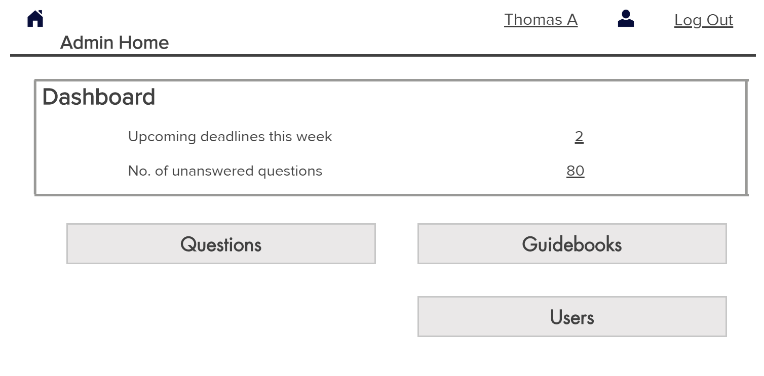

**Figure 9. Final Admin Home Page**

We moved the dashboard up, as it made more sense to have it be the first thing the admin sees. We also changed the name of “Respondents” tile to “Users” as most of our test users found the terminologies difficult to understand. We removed the questions assigned tab from the home page, due to the change decided. Now, admins can assign questions to respondents’ right in the questions tab.

Moving on to the admin questions page:

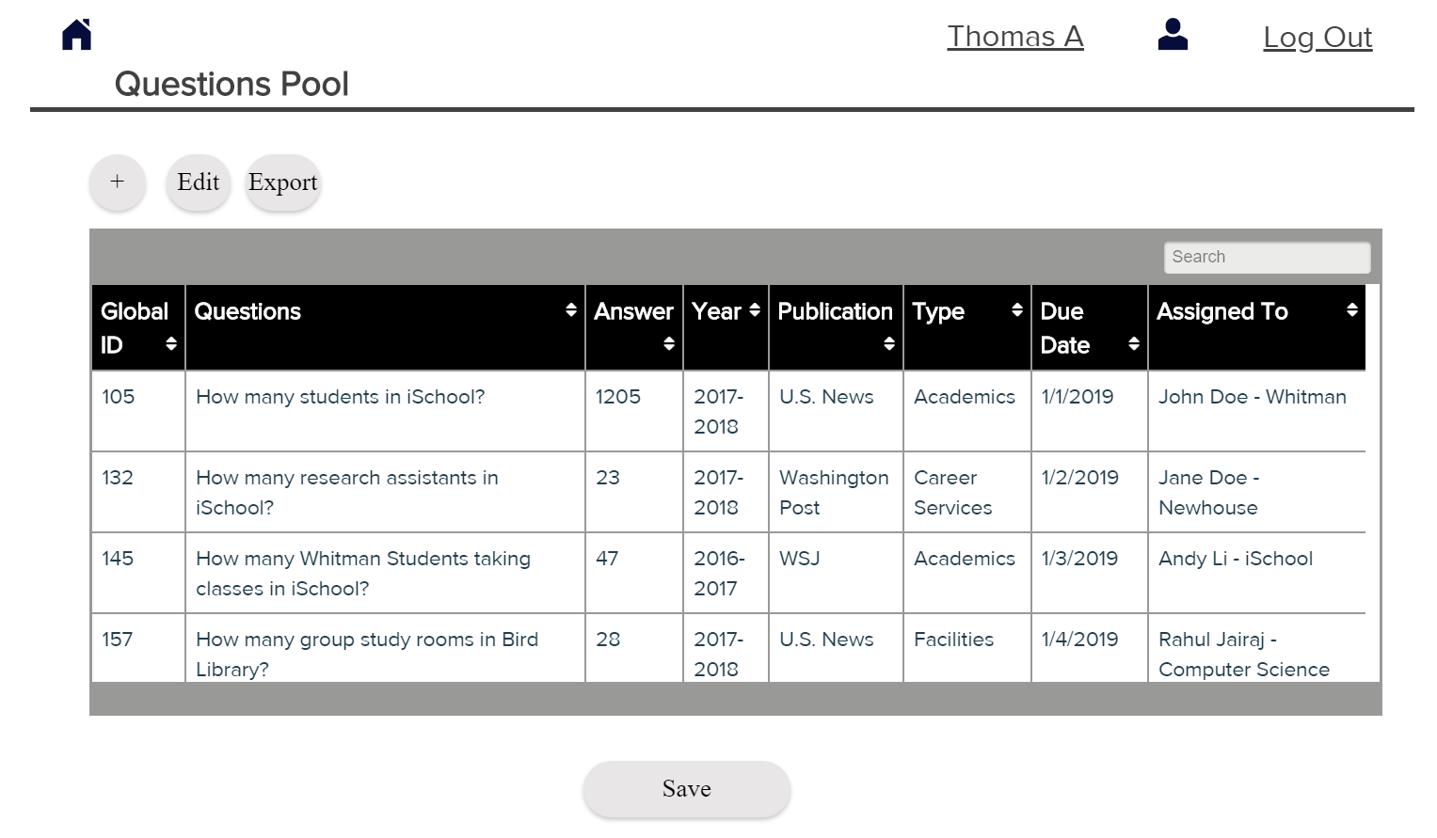

**Figure 10. Final Admin Module’s Questions Page**

We explicitly defined the Add, Edit and Save buttons so it seems easier to understand for the client, rather than just have one button above that says “Add/Edit”. We also added the export button, which when clicked, transforms the first column to checkboxes. Once the admin rearranges the questions, he/she can export any number of questions he/she wants to, to the guidebook company. Since the admin would like to select multiple questions at a time, we wanted the admin to rearrange the table, click the export button and select the last question he/she wants to export. This would export all the questions from the top till that point.

The respondent home page looks as follows:

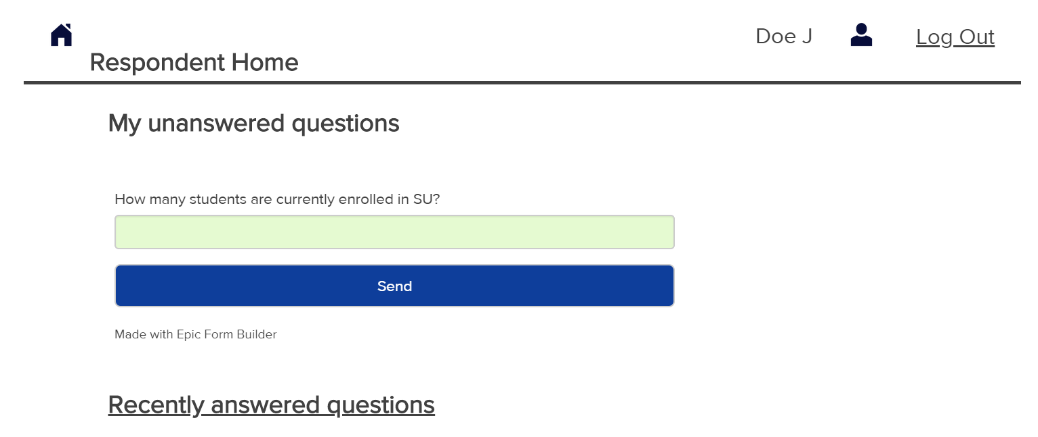

**Figure 11. Respondents’ Module Home Page**

We removed the “View all questions” option from the respondent home page. We also added “Unanswered questions” sub form, allowing the respondent to answer the question from the home page itself.

For uniformity, we changed the recently answered questions from a table to this form view. This would be more intuitive for re-editing for the respondent if they wanted to change their answers, as opposed to a table, which seems more optimized for viewing.

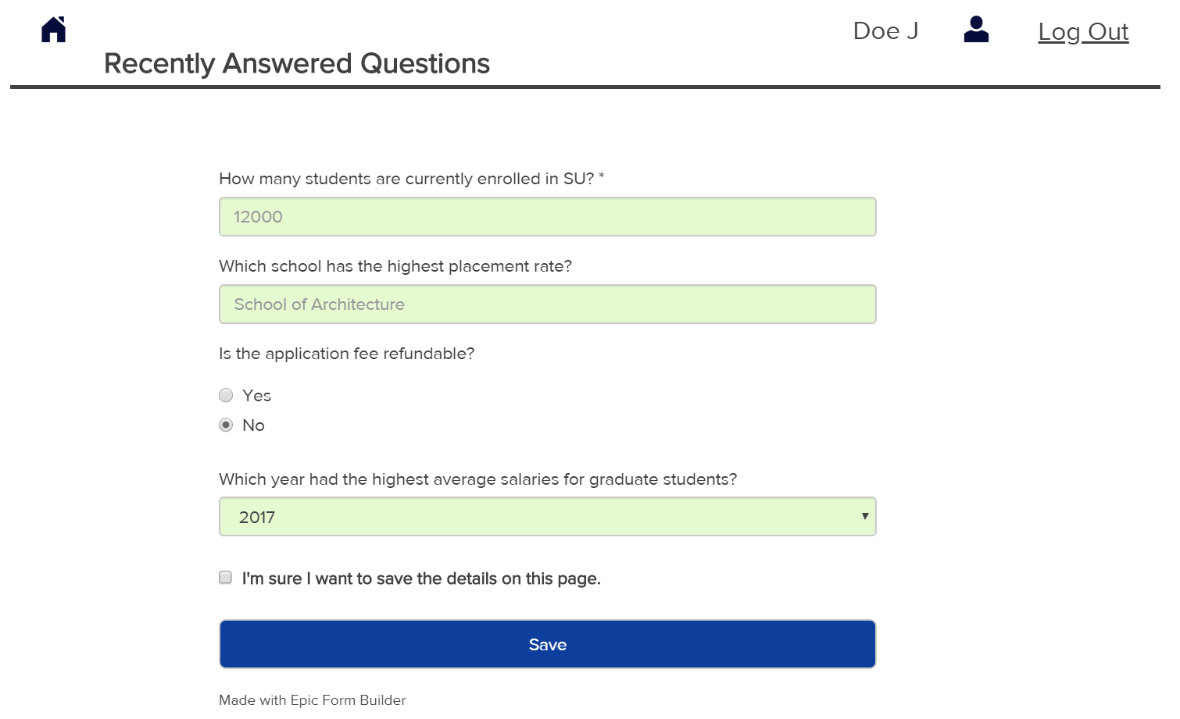

**Figure 12. Recently Answered Questions in the Respondents’ Module**

# CONCLUSION

One very important lesson we learnt was that to always keep asking questions. The client may not remember everything so, it’s important to keep asking questions to make sure that you have all your bases covered. Due to the constraints in our process, we were unable to continually meet with our clients, but given another chance, in a different setting and a much longer time frame, we’d plan to have multiple meetings with the client, all through the process.

Another important point we learnt was to not lose sight of your end goal. Design is meant to aid functionality, so keep the end use cases in mind while designing. We planned to make 4 tiles in the admin home page initially, for aesthetic reasons, but it ended up confusing 2 of our users during use case executions. In pursuit of design wholeness, we compromised on the ability of users to understand the design. This was rectified in the final iteration.

Another point of note is to consider all scenarios, especially when constructing new functionalities to existing systems. We need to actively observe for them as they would not be evident at first glance. While visualizing a solution for respondents, we felt that it would be beneficial if we added the ability to access historical information, without considering its effect downstream, whether the same has been submitted to a guidebook company by the admin, or whether or not the responsibility was of the respondent or not (string parser). Only upon careful reconsideration did we realize that this was indeed a redundant/unnecessary feature.

As for the future of the design, we feel that the prototype we built for use case testing was fine on Wix, but we’d like to migrate it to a professional prototyping tool, such as Balsamiq to create a high-fidelity prototype.

Functionally, we also foresee some features like reporting needing to be integrated into the design sometime in the future. Before all this, however, we feel that the database design needs to change – the documentation for which has been completed. The technical team will start work on the database during winter break 2018.

On a final note, one aspect of this project we were really proud of, was relating to some feedback we received during user testing. Several of our test users found the system itself very intuitive to use, as evidenced by their exclamations during the think out loud sessions. This was the ultimate goal of our design, to build a system which didn’t require any instructions – something that a user can simply pick up and use. So, we feel that we’ve at least found a solid starting point to further our work in the coming semester.