TECHNICAL WHITE PAPER
Public Health Signal Detection and Response Dashboard
Applied Public Health Informatics Engineering Prototype for Surveillance Analytics Modernization
Document Attribute | Description
Purpose | Technical white paper for surveillance analytics modernization and applied public health AI engineering.
System scope | Syndromic surveillance ETL, anomaly detection, forecasting, geospatial risk scoring, dashboard intelligence, RAG-assisted query, and synthetic HL7 simulation concepts.
Data boundary | Public aggregate and synthetic surveillance data; 50,000 raw rows transformed into 7,842 processed analytic records.
Prepared date | May 06, 2026

Executive Summary
Syndromic surveillance is a foundational public health intelligence capability because it allows agencies to monitor illness patterns before laboratory confirmation, case investigation, or final diagnosis coding is available. Emergency department and urgent care encounter patterns can provide early operational signals for respiratory illness, gastrointestinal outbreaks, overdose-related harms, heat illness, environmental exposures, and emergency events. At national scale, these signals support preparedness planning, cross-jurisdiction awareness, and faster allocation of analytic attention during uncertain public health conditions.
The Public Health Signal Detection and Response Dashboard is an applied public health informatics engineering prototype designed to demonstrate how modern analytics architecture can convert public or synthetic syndromic surveillance data into interpretable operational intelligence. The system integrates ETL, quality control, temporal feature engineering, rolling baselines, statistical anomaly detection, Isolation Forest scoring, risk stratification, geospatial ranking, forecasting, and analyst-facing visualizations. It also includes a retrieval-augmented natural language assistant pattern for grounded query and briefing workflows.
The platform is intentionally designed around explainable model outputs rather than opaque automation. Each signal is accompanied by baseline context, observed activity, anomaly scores, percent deviation, risk level, and review-oriented action logic. The architecture reflects healthcare data modernization priorities: modular pipelines, interoperable data concepts, governance-aware analytics, traceable model outputs, and a future path toward cloud-native streaming ingestion, standards-based HL7/FHIR integration, and controlled retrieval over surveillance knowledge assets.
Processed records | Raw source rows | States/regions | Syndromes | Anomaly flags | Completeness
7,842 | 50,000 | 51 | 3 | 236 | 98.2%
Table 1. Current prototype metrics computed from the repository processed surveillance dataset.

Public Health Context and Surveillance Modernization Need
Modern public health surveillance requires more than retrospective reporting. Agencies need timely, interoperable, and analytically usable data flows that can support situational awareness during routine monitoring and emergency response. Syndromic surveillance addresses this need by monitoring symptoms, chief complaints, discharge diagnoses, and visit patterns before confirmed diagnoses are available. This approach is especially relevant for early outbreak detection, respiratory illness monitoring, opioid and overdose surveillance, environmental health events, and emergency preparedness intelligence.
The prototype is informed by concepts used in CDC NSSP, ESSENCE, the BioSense Platform, HHS public health data modernization priorities, and WHO epidemic intelligence practices. These references establish the operational context: surveillance systems must ingest heterogeneous healthcare data, standardize it into usable analytic representations, detect unusual patterns, support cross-jurisdiction interpretation, and communicate findings to analysts without overstating automated conclusions.
Reference Domain | Operational Relevance to the Prototype
CDC NSSP / ESSENCE concepts | Near real-time syndromic surveillance, analytic queries, visualization, trend monitoring, and signal investigation workflows.
BioSense Platform concepts | Cloud-oriented public health data processing and monitoring infrastructure supporting early detection and situational awareness.
HHS modernization priorities | Timely, interoperable, governed data assets that improve preparedness, response, and public health decision support.
WHO epidemic intelligence | Detection, triage, verification, and assessment of signals from multiple sources to support public health risk awareness.
Emergency preparedness use cases | Respiratory surges, overdose-related events, heat illness, disaster response, environmental exposures, and cross-jurisdiction monitoring.

System Architecture
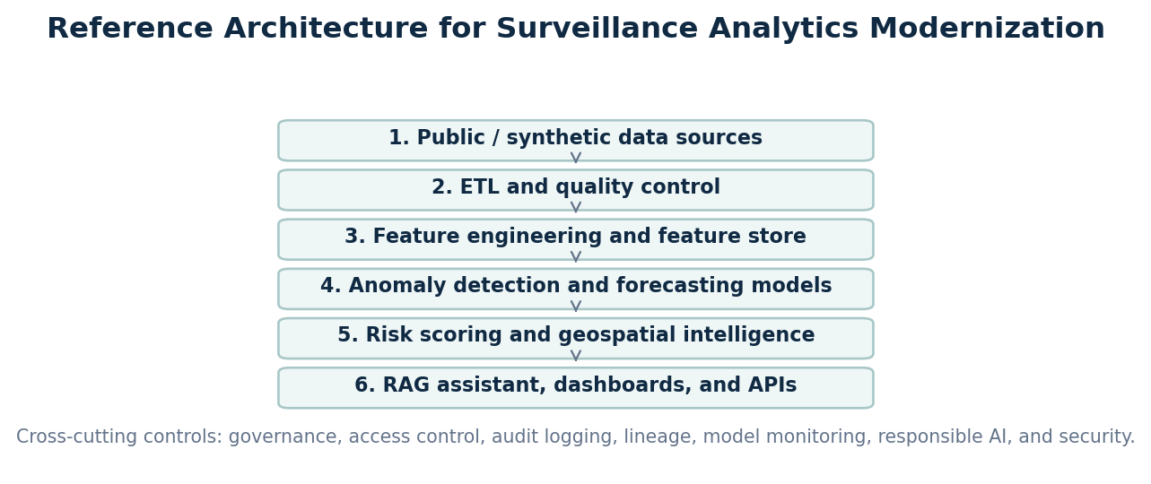
Figure 1. Reference architecture for modular syndromic surveillance analytics, including governance controls across the full data and model lifecycle.
The architecture is organized as a modular analytics pipeline rather than a monolithic dashboard script. The design separates ingestion, cleaning, feature engineering, model scoring, risk interpretation, geospatial visualization, retrieval, and presentation. This separation supports testability, governance, model replacement, cloud migration, and future API exposure.
Architecture Layer | Engineering Role
Data ingestion layer | Accepts local public/synthetic datasets today; can be extended to scheduled batch jobs, secure object storage, API feeds, HL7 messages, FHIR resources, and event streams.
ETL and quality layer | Normalizes dates, geography, syndrome labels, numeric values, missingness, duplicates, and analytic grain before model execution.
Feature engineering layer | Computes lag features, rolling baselines, rolling standard deviations, z-scores, percent change, and temporal acceleration by state-syndrome series.
Analytics engine | Executes statistical anomaly detection, Isolation Forest scoring, model agreement logic, forecasting, and risk stratification.
Geospatial engine | Aggregates risk by geography and supports state/region ranking, heat-map views, and spatial prioritization.
RAG/NLP layer | Retrieves grounded surveillance summaries, model outputs, quality reports, methodology notes, and reference guidance for analyst-facing responses.
Presentation/API layer | Provides Streamlit dashboard views today; future architecture can expose REST APIs, alert webhooks, BI connectors, and jurisdiction-specific dashboards.

Cloud-Native and Event-Driven Scaling Considerations
A production-grade evolution would use cloud-native service boundaries while preserving the current analytic contract. On AWS, a reference implementation could ingest files or messages into Amazon S3, route metadata events through EventBridge, process batch ETL with AWS Glue or containerized jobs on ECS/Fargate, persist curated features in a governed lakehouse, execute model scoring through scheduled workflows, and publish dashboard-ready aggregates through APIs or analytic warehouses. Streaming extensions could use Kinesis or managed Kafka for near-real-time event processing, with schema validation, dead-letter queues, and lineage capture.
Design Option | Technical Tradeoff
Batch-first deployment | Lower operational complexity; appropriate for daily or weekly public aggregate surveillance extracts.
Streaming ingestion | Better timeliness; requires stronger schema governance, idempotency controls, backpressure handling, and monitoring.
Feature store pattern | Improves model reproducibility and reuse; requires metadata management and feature versioning.
API-first dissemination | Supports integration with external dashboards and alerting systems; requires authentication, rate limiting, audit logging, and release management.
Multi-jurisdiction deployment | Supports local configuration and access boundaries; requires tenant isolation, data-use agreements, and jurisdiction-specific calibration.

AI/ML Methodology

Temporal Feature Engineering and Rolling Baseline Design
The feature engineering strategy is organized around state-syndrome time series. For each analytic series, the pipeline computes lagged values, a rolling mean baseline, rolling standard deviation, z-score, seven-period percent change, and trend acceleration. This design gives every observation temporal context and reduces the risk of interpreting normal regional variation as a signal. Rolling baselines are operationally useful because they can adapt to recent local behavior while remaining interpretable to analysts.

Statistical Anomaly Detection
The statistical detection layer uses z-score logic to measure how far an observed visit percentage deviates from its rolling baseline in standard deviation units. Z-scores are transparent, easy to audit, and useful for generating analyst trust because the output maps directly to a familiar baseline-deviation concept. In surveillance settings, this interpretability is important: analysts must understand why a signal was surfaced, whether it reflects volume change, baseline instability, missingness, or a true pattern requiring review.

Isolation Forest Detection
The machine learning layer uses Isolation Forest as an unsupervised anomaly detection method. Isolation Forest is suitable for prototype surveillance analytics because it can identify unusual multivariate patterns without requiring fully labeled outbreak data. The model evaluates a feature vector that includes observed visit percentage, rolling baseline, z-score, percent change, and trend acceleration. This enables detection of patterns that may not be captured by a single threshold, such as sudden increases combined with abnormal acceleration or unusual divergence from expected baseline.

Ensemble Risk Scoring and Analyst Trust
The risk engine combines statistical severity, growth, unsupervised anomaly flags, and persistence into a 0 to 100 score mapped to Low, Moderate, High, and Critical levels. The intent is not autonomous decision-making; the intent is analyst review prioritization. The dashboard exposes model components so reviewers can distinguish a high score caused by sustained growth from one caused primarily by a single unsupervised model flag. This supports explainability, reduces black-box behavior, and creates a pathway for model governance.
Method | Purpose | Operational Tradeoff
Rolling baseline | Recent local expected value for each state-syndrome series | Highly interpretable; sensitive to sparse early windows.
Z-score anomaly | Standardized deviation from rolling baseline | Transparent thresholding; requires stable variance estimates.
Isolation Forest | Unsupervised multivariate anomaly detection | Captures nonlinear unusual patterns; requires calibration and review.
Percent change | Growth relative to lagged observation | Useful for surge detection; unstable when prior values are near zero.
Risk score | Weighted composite of severity, growth, model flag, and persistence | Operationally scannable; weights require validation and governance.

Model Governance, Calibration, and Validation
Operational surveillance models require governance beyond code execution. Thresholds must be calibrated against jurisdiction-specific baseline behavior, seasonality, reporting artifacts, day-of-week effects, facility participation changes, and known public health events. False positives can create analyst burden, while false negatives can delay investigation. A production validation plan should include retrospective event review, analyst adjudication, drift monitoring, performance stratification by geography and syndrome, and documented threshold change control.
- Maintain model cards describing features, thresholds, intended use, limitations, and known failure modes.
- Track model version, feature version, input dataset hash, and scoring timestamp for every generated signal.
- Calibrate thresholds separately for high-volume and low-volume regions to reduce avoidable false positives.
- Use analyst feedback loops to distinguish data quality artifacts from epidemiologically meaningful signals.
- Monitor drift caused by coding changes, care-seeking behavior, reporting interruptions, and facility onboarding changes.

Forecasting Methodology and Operational Limits
Forecasting supports early warning and planning, but it must be presented carefully in public health operations. Short-term syndrome forecasting can help analysts understand expected near-future direction under recent trends, but forecasts should not be treated as authoritative predictions. The prototype documents ARIMA-style forecasting and fallback logic, while the broader architecture allows comparison with Prophet and future sequence models.
Forecasting Method | Use Case | Tradeoff
ARIMA | Interpretable univariate time-series forecasting for short horizons | Works well for simple temporal dynamics; needs stationarity checks and careful parameter selection.
Prophet | Trend and seasonality decomposition with holiday/event extensibility | Useful for operational seasonality; dependency and runtime stability must be managed.
Exponential smoothing | Lightweight fallback for recent trend projection | Low complexity; limited ability to capture complex nonlinear patterns.
LSTM / sequence models | Future deep learning option for multivariate temporal patterns | Higher capacity; requires more data, governance, explainability, and validation effort.
Lightweight forecasting was selected initially because the dataset is historical, aggregate, and intended for prototype demonstration. Simpler methods are easier to inspect, faster to run locally, and less likely to imply unsupported precision. Future deep learning approaches could be evaluated if the platform receives longer time histories, stable data feeds, adjudicated events, and governance controls for model drift and uncertainty communication.
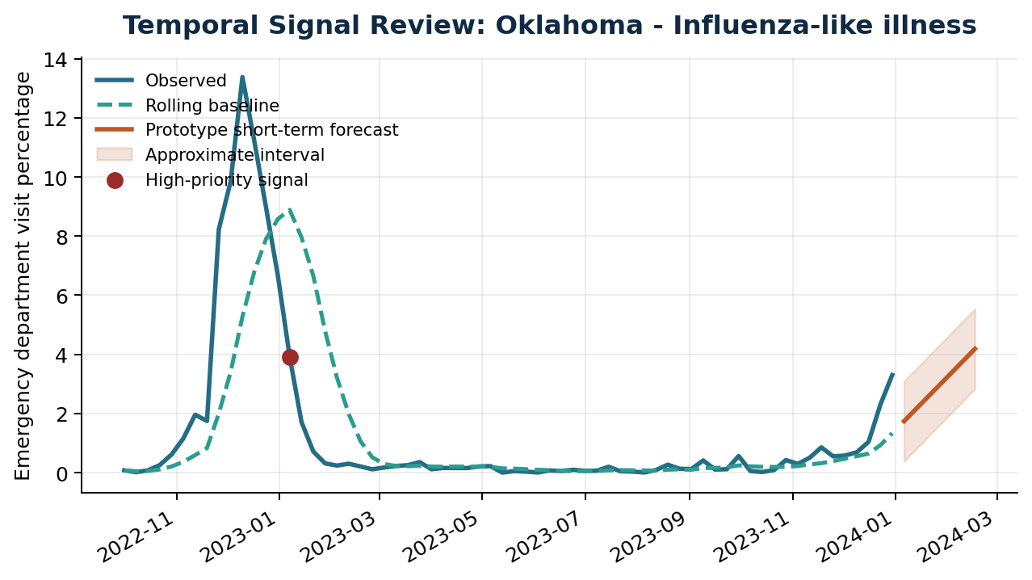
Figure 2. Example observed trend, rolling baseline, and prototype short-term forecast for a high-priority state-syndrome signal.

RAG and NLP Surveillance Assistant
The RAG-based assistant is designed as an analyst workflow augmentation layer rather than a general medical chatbot. Its purpose is to help users ask natural-language questions about current signals, risk rankings, anomaly explanations, data quality limitations, syndrome definitions, and methodology. Retrieval grounding constrains responses to app-generated outputs and curated reference notes, reducing the risk that the assistant fabricates unsupported conclusions.
A production-grade implementation would maintain a vector index over structured surveillance summaries, anomaly tables, data quality reports, model documentation, public health terminology notes, and approved reference material. Queries would be embedded, matched against the governed retrieval corpus, and answered with citations to the retrieved artifacts. The response layer would enforce policy boundaries: no diagnosis, no treatment advice, no claims of official public health direction, and no disclosure of restricted data.
RAG Component | Engineering Role
Retrieval corpus | Model outputs, alert summaries, data quality reports, methodology notes, syndrome definitions, and curated public health references.
Semantic retrieval | Vector search supports plain-language questions that do not exactly match column names or technical labels.
Grounded generation | Responses are generated only from retrieved app artifacts and public reference notes, reducing hallucination risk.
Ontology extension | Future integration with SNOMED CT, ICD-10-CM, LOINC, UMLS, or local syndrome definitions could improve terminology mapping.
Governance controls | Prompt boundaries, source citations, audit logs, restricted corpus access, and refusal behavior for medical advice questions.
Example analyst and policy-maker questions include: Which states show unusual respiratory activity this week? What regions have the highest anomaly scores? Summarize current signals for public health review. Which signals may reflect data quality issues? Explain why a state was flagged as high risk using baseline deviation and model outputs. This pattern supports faster orientation without replacing epidemiological judgment.

Synthetic Data and HL7 Simulation Framework
Synthetic data capability is important for surveillance engineering because many realistic development and validation scenarios involve sensitive healthcare data. The prototype includes synthetic HL7 generation concepts to simulate emergency department message patterns, chief complaints, syndrome categories, timestamps, and geography without exposing PHI. Synthetic streams can be used for pipeline testing, model stress testing, dashboard demonstrations, and training exercises.
GAN-based or other generative simulation methods are most appropriate here as synthetic data generation tools, not as the NLP assistant. A future synthetic module could learn statistical properties of aggregate emergency department trends and generate non-identifiable simulated patterns for outbreak surges, seasonal respiratory waves, reporting delays, facility onboarding changes, and anomalous spikes. Any such module would require privacy review, re-identification risk assessment, utility evaluation, and controls preventing synthetic records from being mistaken for real surveillance events.
Synthetic Capability | Operational Value
HL7 message simulation | Tests ingestion, parsing, schema validation, field normalization, and syndrome grouping logic.
Synthetic trend generation | Creates controlled outbreaks, seasonal baselines, data dropouts, and surge scenarios for model stress testing.
GAN-style simulation | Future option for realistic but non-identifiable aggregate ED trend patterns.
Privacy-preserving analytics | Supports development without exposing PHI, subject to re-identification risk controls.
Validation utility | Allows repeatable benchmark scenarios with known signal timing and severity.

Quantitative Evaluation and Prototype Metrics
The current repository provides measurable prototype outputs from the processed dataset. Some operational metrics, such as true anomaly precision and recall, require adjudicated ground truth labels and cannot be asserted from unlabeled public/synthetic data alone. The evaluation framework below separates observed prototype measurements from production validation metrics that would require labeled events, analyst adjudication, and controlled deployment telemetry.
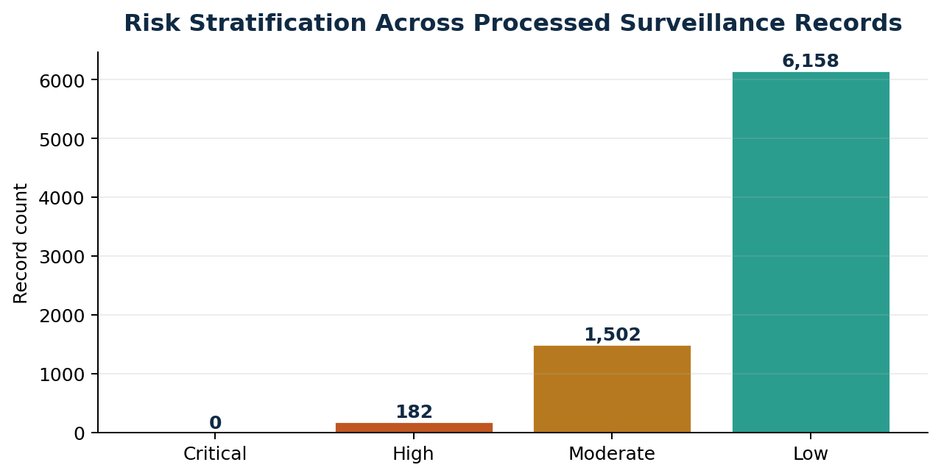
Figure 3. Current risk level distribution across processed analytic records.
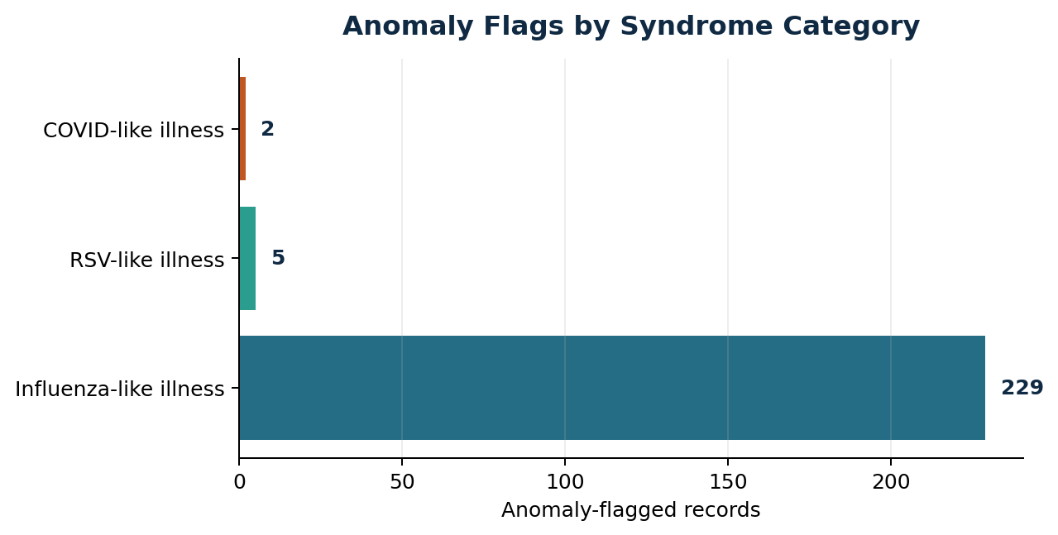
Figure 4. Current anomaly flags by monitored syndrome category.
Metric | Current Value or Validation Status | Interpretation
Data completeness | 98.2% | Observed in processed repository dataset.
Duplicate count | 0 | Observed exact duplicate count after processing.
Anomaly prevalence | 236 of 7,842 records | Observed any_anomaly flag count from statistical or Isolation Forest model output.
Model agreement count | 0 | Observed records where statistical and Isolation Forest anomaly logic both flagged.
High-priority records | 182 | Observed records mapped to High or Critical risk level.
Average risk score | 15.8 | Observed across processed records on 0 to 100 risk scale.
Maximum risk score | 76.3 | Observed highest model-assigned risk score.
Precision / recall | Requires adjudicated labels | Production validation should compare alerts to known events and analyst review outcomes.
Ingestion throughput | Benchmark target: batch-scale thousands to millions of records | Production test should measure rows per minute by deployment environment.
Dashboard response time | Benchmark target: sub-second to low-seconds for filtered aggregate views | Production test should measure p50/p95 latency under concurrent users.

Geospatial Risk Intelligence
Geospatial risk scoring translates record-level model outputs into state or regional prioritization. The current prototype uses aggregate state-level risk summaries and map-ready centroids to show where unusual activity is concentrated. In an operational environment, this layer could be extended to county, health district, hospital referral region, or jurisdiction-specific boundaries, subject to data availability, privacy rules, and aggregation thresholds.
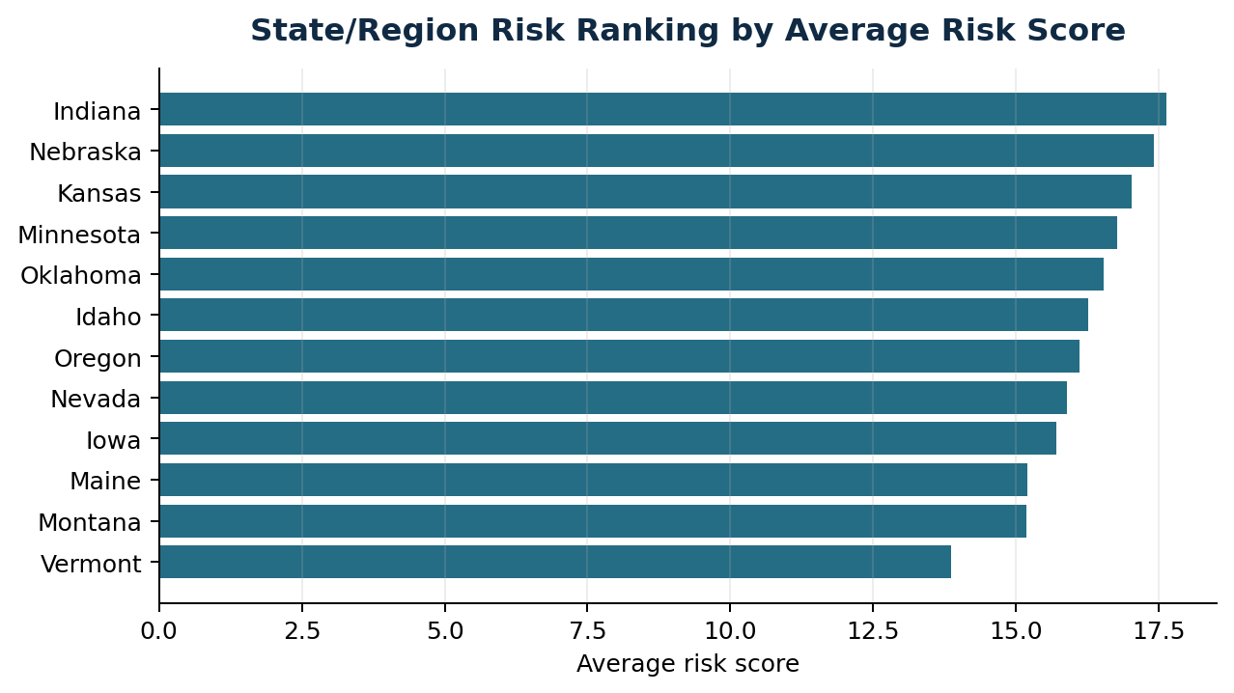
Figure 5. State/region average risk ranking generated from processed model outputs.
State/Region | Avg. Risk | Max Risk | Anomalies | High Signals
Oklahoma | 16.5 | 76.3 | 9 | 8
Nebraska | 17.4 | 74.7 | 9 | 9
Idaho | 16.3 | 73.2 | 7 | 7
Montana | 15.2 | 72.8 | 9 | 9
Vermont | 13.9 | 72.6 | 8 | 7
Minnesota | 16.8 | 69.5 | 7 | 4

Operational Readiness Considerations
A surveillance analytics platform must be evaluated not only for model performance but also for operational readiness. Healthcare and public health systems require strong controls for security, PHI handling, access management, audit logging, data retention, lineage, model governance, and responsible use. The prototype demonstrates the analytic architecture while identifying the additional controls required before any operational deployment.
Readiness Domain | Production Requirement
Cybersecurity | Authentication, authorization, encrypted storage, TLS, dependency scanning, secret management, and network boundary controls.
PHI and privacy | Minimum necessary data, de-identification or aggregation, role-based access, retention policies, and privacy impact review.
Auditability | Input dataset version, model version, feature version, scoring timestamp, user activity logs, and alert disposition history.
Interoperability | Future alignment with HL7 v2, FHIR resources, vocabulary standards, and jurisdiction-specific syndrome definitions.
Responsible AI | Human review, uncertainty communication, no medical advice, prompt boundaries, bias monitoring, and documented limitations.
Continuity | Automated monitoring, retries, dead-letter queues, runbooks, backup strategy, and incident response procedures.

National-Scale Public Health Relevance
Systems with this architecture are relevant to U.S. public health infrastructure because they address a recurring modernization challenge: converting heterogeneous healthcare data into timely, explainable, and operationally usable intelligence. National-scale surveillance requires local flexibility and shared analytic principles. A modular design can allow jurisdictions to adapt syndrome definitions, thresholds, and workflows while preserving common data quality checks, model documentation, and risk communication patterns.
Cross-jurisdiction situational awareness is especially important during respiratory illness surges, emerging infectious disease events, environmental emergencies, mass gatherings, and substance-related harms. A standardized analytic pipeline can help analysts compare trends across regions, identify unusual patterns earlier, and prioritize investigation while maintaining appropriate local control over data and interpretation.

Future Research and Development Directions
Research Direction | Technical Rationale
Federated analytics | Allow jurisdictions to compute comparable metrics locally while sharing aggregate signal summaries.
Privacy-preserving ML | Evaluate differential privacy, secure aggregation, synthetic data validation, and privacy risk scoring.
Adaptive anomaly detection | Tune thresholds dynamically by geography, seasonality, syndrome category, reporting quality, and volume.
Real-time streaming surveillance | Extend batch ETL into event-driven pipelines with schema validation, backpressure handling, and low-latency scoring.
Multimodal intelligence | Integrate structured visits, chief complaint text, lab signals, environmental feeds, and public health reference documents.
NLP summarization | Generate source-grounded analyst briefings with citations, uncertainty statements, and review recommendations.
Ontology-aware retrieval | Map user questions and syndrome language to standardized clinical/public health vocabularies.

Implementation Evidence in the Prototype Repository
Component | Repository Evidence
Data cleaning | src/data_cleaning.py transforms raw surveillance extracts into standardized analytic records.
Feature engineering | src/feature_engineering.py adds lag, rolling baseline, z-score, percent change, and acceleration features.
Anomaly detection | src/anomaly_detection.py implements z-score and Isolation Forest anomaly detection.
Risk scoring | src/risk_scoring.py converts model components into interpretable risk scores and levels.
Forecasting | src/forecasting.py contains ARIMA/Prophet/fallback forecasting patterns for short-term trend analysis.
Geospatial analytics | src/geospatial.py provides state/region mapping and risk visualization support.
NLP/RAG assistant | src/rag_assistant.py supports grounded public health search assistant behavior over app data and documentation.
Synthetic data | src/hl7_generator.py provides synthetic HL7-style generation concepts for testing and demonstration.
Application layer | app.py implements the Streamlit dashboard, filters, tabs, metrics, charts, map, RAG assistant, and methodology views.
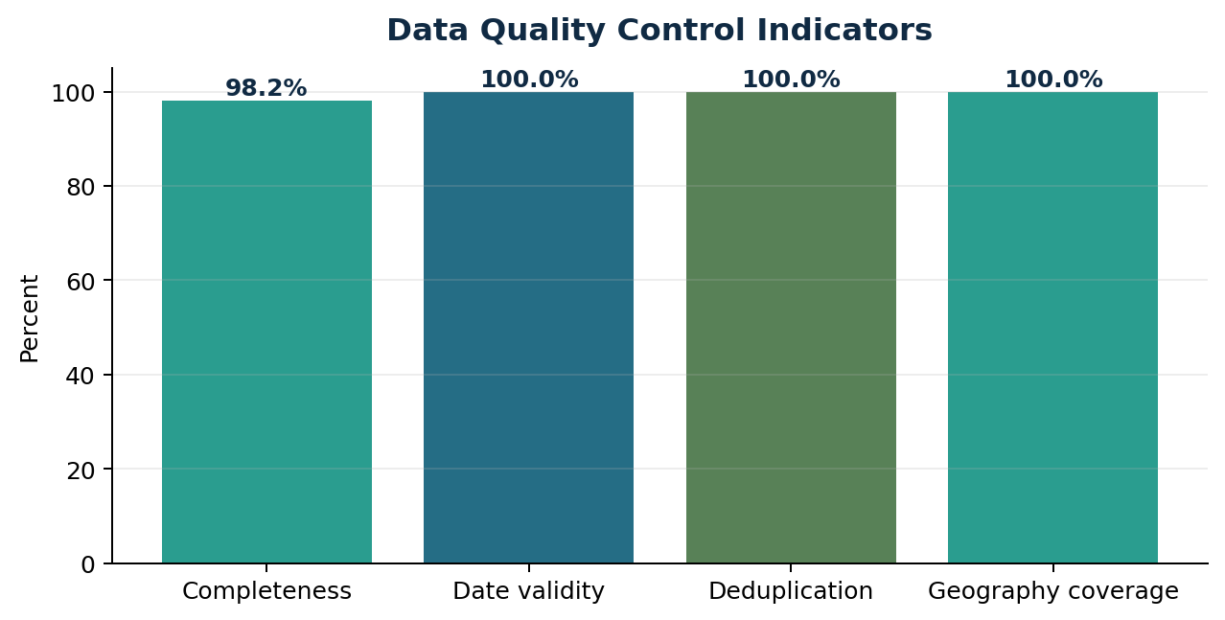
Figure 6. Data quality indicators available from the processed analytic dataset.

Limitations
- The current data boundary is public aggregate and synthetic data, not live operational surveillance feeds.
- The model outputs are prototype analytics intended for analyst review and require validation before operational use.
- Precision, recall, sensitivity, and specificity require adjudicated ground truth labels and cannot be inferred from unlabeled aggregate data alone.
- Forecasting is presented as a short-term analytic pattern, not as authoritative prediction or public health guidance.
- RAG responses must remain grounded in approved app data and documentation and must not provide medical advice or official public health instructions.
- Geographic outputs are state-level in the current prototype and do not represent facility-level or patient-level surveillance.

Official References
U.S. Department of Health and Human Services, Emergency Preparedness and Response: https://www.hhs.gov/programs/emergency-preparedness/index.html
CDC National Syndromic Surveillance Program: https://www.cdc.gov/nssp/
CDC BioSense Platform: https://www.cdc.gov/nssp/php/about/about-nssp-and-the-biosense-platform.html
CDC ESSENCE: https://www.cdc.gov/nssp/php/onboarding-toolkits/essence.html
CDC Data Modernization: https://www.cdc.gov/data-modernization/php/about/index.html
WHO Public Health Surveillance: https://www.who.int/westernpacific/menu/mega-menu/emergencies/surveillance
WHO Epidemic Intelligence from Open Sources: https://www.who.int/initiatives/eios
USA.gov Disasters and Emergencies: https://www.usa.gov/disasters-and-emergencies

Disclaimer
This document describes an independent public health analytics research prototype using public aggregate or synthetic data. It is not an official system of HHS, CDC, WHO, NSSP, BioSense, ESSENCE, or any government agency. It is not intended for clinical decision-making, diagnosis, treatment, or operational public health response.

