**LAB-EXAM-7**

**AWS-EKS**

Rahul C Kalekar

Using eksctl

Creating the image

Pushing it to ECR

Image on ECR

Configuring cluster

Creating cluster

Configuring deployment

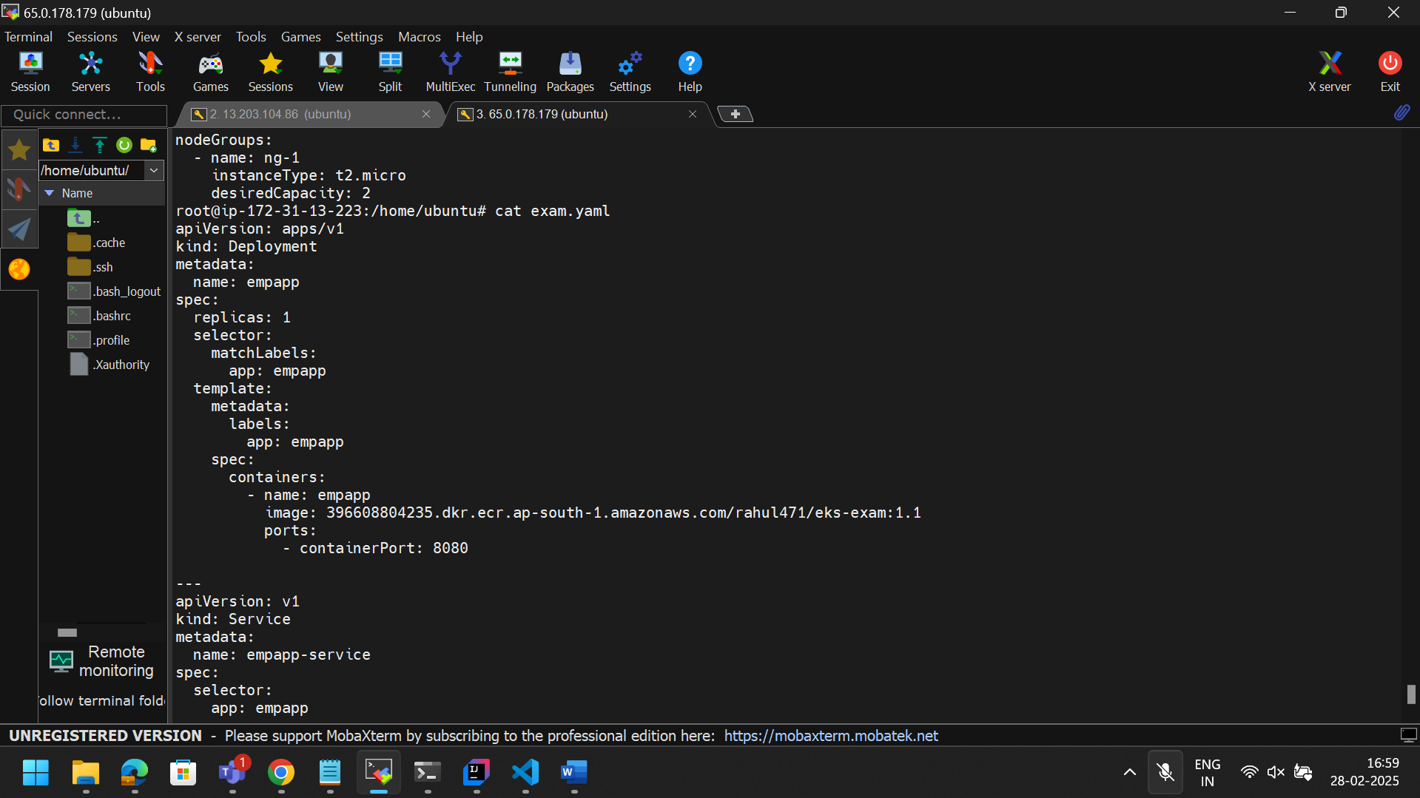

Scaling resources because it was not enough

Now we get the pod running status, use the external ip

Running on external ip

