EcoWell Modbus RTU Slave Simulator
Register Mapping & Simulator Design Document

Platform: ESP32-S3 (Freenove ESP32-S3-WROOM)
Framework: Arduino
Modbus Library: eModbus (ModbusServerRTU)
Serial Interface: USB CLI Simulator

1. Project Overview
This firmware implements a Modbus RTU Slave Simulator designed to model the physical sensor and actuator components of the EcoWell Water Softener system. It runs on an ESP32-S3, responding to requests from a Modbus Master (such as the EcoWell IoT Gateway) over RS-485 while allowing manual control over simulated process data using a serial command interface.

Key Features
- Modbus Server RTU: Fully compliant Modbus RTU Slave mapping standard FC02, FC03, and FC05 workers.
- Hardware Configuration: Communicates over Serial2 at 19200 baud, 8N2, on pins GPIO18 (RX) and GPIO17 (TX).
- Live Data Simulation: Simulates process telemetry parameters (water flow, pressure, salt level, TDS) and discrete statuses (power, active regeneration).
- Interactive Serial CLI: Provides commands via USB Serial to set values, trigger faults, and query internal register statuses.

2. System Architecture & Flow
The simulator is composed of the main Modbus Server RTU engine executing in a background task, the interactive Serial CLI, the register memory arrays, and the sync functions linking variables to Modbus registers.
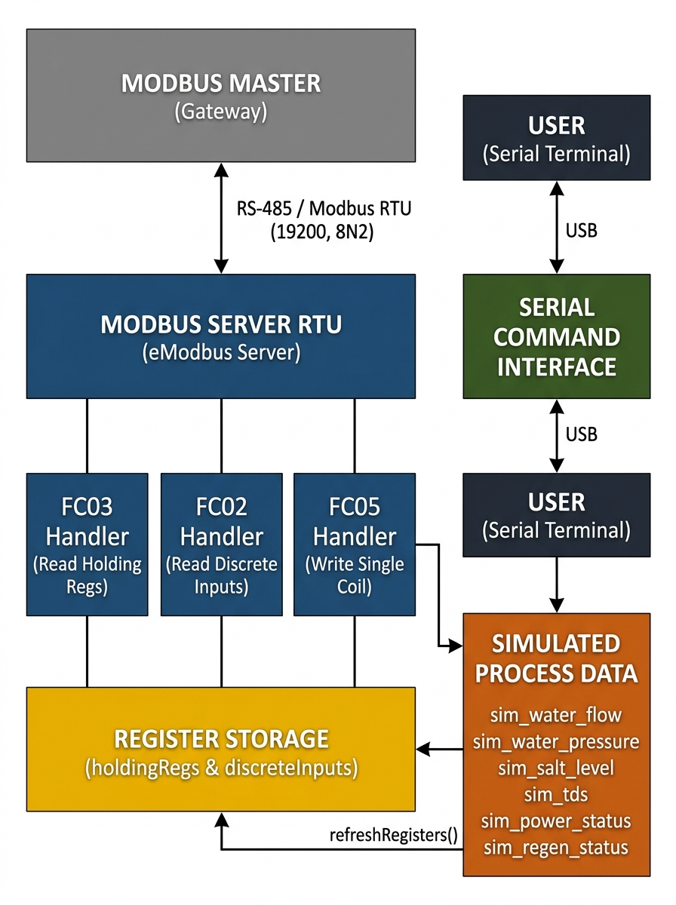
Figure: Slave Architecture

3. Register Mapping Specification
The simulator stores simulated process variables in native C++ structures, which are mapped to standard Modbus table categories. All register addresses are protocol-level (0-indexed) values.

3.1 Holding Registers (FC03 — Read Holding Registers)
Used by the Gateway to pull simulated analog telemetry. Floats are stored as two consecutive 16-bit registers using the CDAB (Word-swapped Big Endian) floating point format.
Protocol Address | Modbus Register | Data Type | Unit | Variable Name | Description
0–1 | 40001–40002 | FLOAT32 (CDAB) | L/min | sim_water_flow | Simulated water flow rate (Default: 12.5)
2–3 | 40003–40004 | FLOAT32 (CDAB) | psi | sim_water_pressure | Simulated line pressure (Default: 45.0)
4–5 | 40005–40006 | FLOAT32 (CDAB) | % | sim_salt_level | Brine tank salt level percentage (Default: 75.0)
6 | 40007 | UINT16 | ppm | sim_tds | Simulated total dissolved solids (Default: 250)
7 | 40008 | UINT16 | — | spare | Spare register (always returns 0)

3.2 Discrete Inputs (FC02 — Read Discrete Inputs)
Used by the Gateway to read binary/state flags representing system conditions.
Protocol Address | Modbus Bit | Data Type | Variable Name | Description
0 | 10001 | Boolean | sim_power_status | System power state (True = ON, False = OFF)
1 | 10002 | Boolean | sim_regen_status | Regeneration active status (True = active, False = idle)

3.3 Coils (FC05 — Write Single Coil)
Used by the Gateway to command a regeneration start or abort action on the softener.
Protocol Address | Modbus Coil Address | Data Type | Variable Name | Value & Description
0 | 00001 | Boolean | cmd_regen | Write 0xFF00 to trigger regeneration (sets sim_regen_status = true).  Write 0x0000 to stop/abort regeneration (sets sim_regen_status = false).

4. Data Encoding (CDAB Word Order)
The Gateway expects floating-point variables in the CDAB (Word-swapped Big Endian) format. The simulator accomplishes this encoding using direct type-punning through memcpy and shift/mask operations. When the master requests a read, refreshRegisters() compiles the floats as follows:
// Splitting 32-bit floats into two 16-bit registers (CDAB order)
static void encodeFloat_CDAB(uint16_t regIndex, float value){
uint32_t raw;
memcpy(&raw, &value, sizeof(float));
holdingRegs[regIndex] = raw & 0xFFFF; // Low word (CD)
holdingRegs[regIndex + 1] = (raw >> 16) & 0xFFFF; // High word (AB)
}

5. Control Handler Command Flow (FC05)
When the Master sends a write coil command (FC05) to protocol address 0, it calls the FC05 worker. The handler processes the command value, alters the simulation status variables, refreshes the registers, and echos the command back to the master.
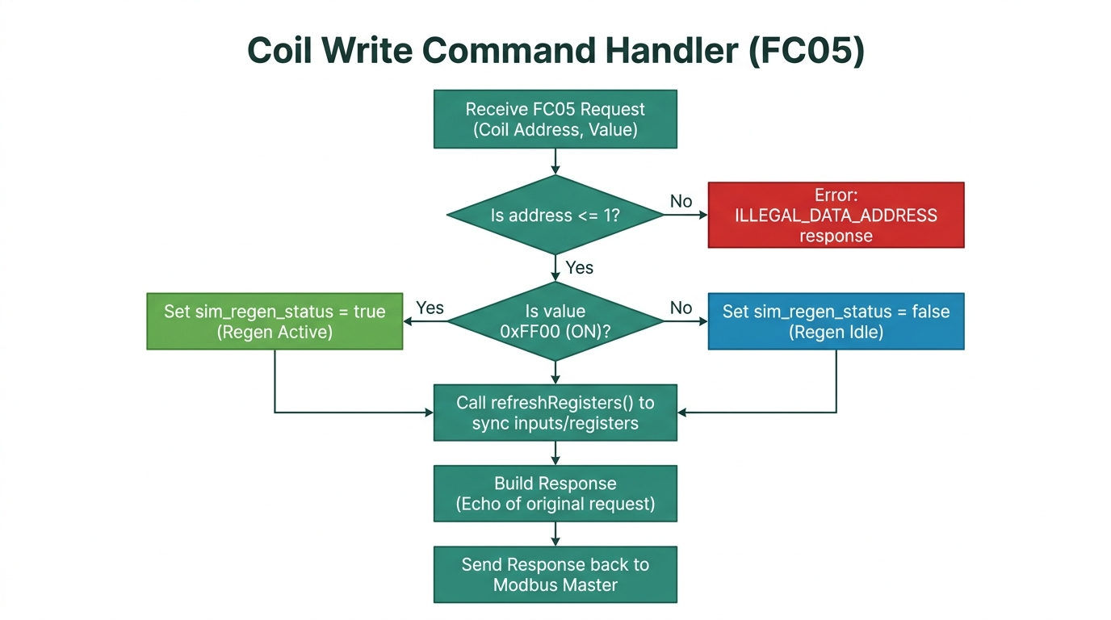
Figure: Slave Fc05 Flowchart

6. Serial Command Simulator Interface
The simulator is equipped with an interactive USB Serial interface (running at 115200 baud). Typing commands via a serial monitor changes the internal variables, updating the values returned to the Gateway in real-time. This enables active scenario testing (e.g. injecting pressure drops or salt depletion).

6.1 Available CLI Simulator Commands
Command | Syntax Example | Description
flow | flow 14.5 | Sets water flow simulation to 14.5 L/min
pressure | pressure 38.0 | Sets water pressure simulation to 38.0 psi
salt | salt 82.5 | Sets brine tank salt level simulation to 82.5 %
tds | tds 280 | Sets TDS measurement simulation to 280 ppm
power | power on / power off | Toggles simulated power discrete input state
regen | regen on / regen off | Toggles simulated regeneration discrete status
fault | fault | Shortcut command: Injects low pressure (10.0 psi) to trigger Gateway FAULT state
recover | recover | Shortcut command: Resets values to normal (45.0 psi, 75.0% salt)
status | status | Queries and prints the current status values of all simulated items
help | help | Prints the available commands command menu

6.2 Verifying Operation
Connecting to the USB serial interface will print confirmation statements on startup:
=====================================
EcoWell Modbus Slave Simulator v1.0
Slave ID: 1 | Baud: 19200 8N2
Type 'help' for commands
=====================================

