EcoWell MQTT-Modbus Gateway
Architecture & Design Document

Platform: ESP32-S3 (Freenove ESP32-S3-WROOM)
Framework: Arduino + FreeRTOS
Build System: PlatformIO

1. Project Overview
This firmware implements an Industrial IoT Gateway for an EcoWell water softener system. It bridges Modbus RTU field sensors/actuators to an MQTT cloud broker over Wi-Fi, enabling remote monitoring, telemetry, alerting, and command execution.

What It Does
Capability | Description
Sensor Polling | Periodically reads water flow, pressure, salt level, TDS, power status, and regeneration status from Modbus slave devices
Cloud Telemetry | Publishes sensor data as structured JSON to an MQTT broker at configurable intervals
Remote Commands | Receives cloud commands (e.g., trigger regeneration) via MQTT subscriptions and writes to Modbus actuators
Business Logic | Runs a water softener state machine — detects faults (low pressure, low salt), manages regeneration cycles
Alerting | Translates system events (faults, regen lifecycle) into severity-tagged JSON alerts published to a dedicated MQTT topic
Auto-Recovery | Wi-Fi auto-reconnect, MQTT reconnect, and Modbus communication health tracking

Technology Stack
Layer | Technology
Microcontroller | ESP32-S3 (Dual-core Xtensa LX7, 240 MHz)
Framework | Arduino (via PlatformIO)
RTOS | FreeRTOS (bundled with ESP-IDF/Arduino)
Modbus Library | eModbus — Modbus RTU Client
MQTT Library | PsychicMqttClient — Async MQTT
JSON Library | ArduinoJson v7 — Serialization/Deserialization
Build System | PlatformIO

2. High-Level Architecture
The system follows a layered, event-driven architecture with clear separation of concerns. Each module has its own FreeRTOS task and communicates via queues and events.
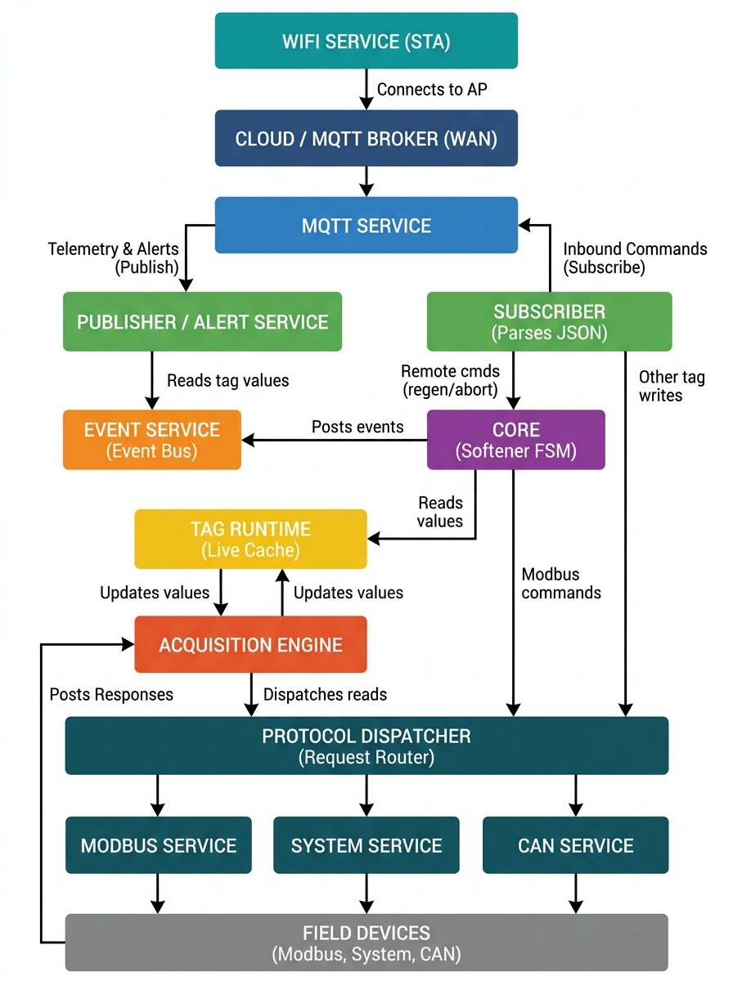
Figure: Architecture Diagram

3. Module Breakdown

3.1 Foundation Layer
These modules provide infrastructure that every other module depends on.
logger — logger.h / logger.cpp
Thread-safe serial logger using a FreeRTOS mutex. Provides four severity macros (LOG_INFO, LOG_WARN, LOG_ERROR, LOG_DEBUG) that format output as [LEVEL] [MODULE] message.
system_err — system_err.h
Defines the universal return type sys_status_t used by all modules: SYS_OK, SYS_ERR_FAIL, SYS_ERR_TIMEOUT, SYS_ERR_NO_MEMORY, etc.
event_service — event_service.h / event_service.cpp
Facade over the ESP-IDF default event loop. Provides event_register(), event_post(), event_unregister() — enabling fully decoupled publish/subscribe IPC between modules.
system_events — system_events.h / system_events.cpp
Defines two event bases and all event IDs:
Event Base | Events
APP_EVENTS | NETWORK_UP, NETWORK_DOWN, MQTT_CONNECTED, MQTT_DISCONNECTED, MODBUS_NETWORK_UP, MODBUS_NETWORK_DOWN, SYSTEM_FAULT
CORE_EVENTS | FAULT_LOW_PRESSURE, FAULT_LOW_SALT, FAULT_DATA_LOSS, REGEN_STARTED, REGEN_COMPLETED, REGEN_FAILED

3.2 Data Model Layer
A two-tier data model separates static configuration from live runtime state.
tag_registry — tag_registry.h / tag_registry.cpp
The static data dictionary — a compile-time table of 8 tag definitions. Each tag_config_t stores: identity (tagId, name, unit, topic, topicType), protocol info (source, access, dataType), and Modbus config (slaveId, address, quantity, functionCode, wordOrder).
Tags configured in this system:

ID | Name | Data Type | Source | MQTT Topic | Access
1 | water_flow | FLOAT32 | Modbus | ECO/WS-1/FT-101 | Read
2 | water_pressure | FLOAT32 | Modbus | ECO/WS-1/PT-101 (P: pressure T: transmit) | Read
3 | salt_level | FLOAT32 | Modbus | ECO/WS-1/SALT/AT-101 (A: Analytic T: Transmit) | Read
4 | tds | UINT16 | Modbus | ECO/WS-1/TDS/AT-101 (A: Analytic T: Transmit) | Read
5 | power_status | BOOL | Modbus | ECO/WS-1/YT-101 (Y: Power T: Transmit) | Read
6 | regen_status | BOOL | Modbus | ECO/WS-1/REGEN_STATE | Read
7 | cmd_regen | BOOL | Modbus | ECO/WS-1/CMD_REGEN | Write
8 | core_state | STRING | System | ECO/WS-1/CORE_STATE | Read

tag_runtime — tag_runtime.h / tag_runtime.cpp
The live value cache — a dynamically allocated array of tag_runtime_t structs (one per tag). Each entry holds: value (tag_value_t union supporting bool, uint16, int16, uint32, int32, float32, string), valid (whether the last read was successful), changed (flag for change-detection), and timestamp (last update time). Thread-safe access via FreeRTOS mutex.

3.3 Protocol Layer
modbus_codec — modbus_codec.h / modbus_codec.cpp
Pure utility functions for converting between Modbus uint16_t register arrays and typed tag_value_t values. Supports configurable word order (ABCD, CDAB, BADC, DCBA) for 32-bit types. Uses union-based type punning for IEEE 754 float encoding.
modbus_service — modbus_service.h / modbus_service.cpp
Manages the Modbus RTU master over Serial1 (UART). Configures serial port (19200 baud, 8N2, TX=GPIO17, RX=GPIO18). Dispatches read requests (FC 0x02 for discrete inputs, FC 0x03 for holding registers) and write requests (FC 0x05 for single coil, FC 0x06 for single register, FC 0x10 for multiple registers). Async callbacks decode responses via modbus_codec and post results back to acquisition. Tracks communication health — fires MODBUS_NETWORK_UP / MODBUS_NETWORK_DOWN events.
protocol_dispatcher — protocol_dispatcher.h / protocol_dispatcher.cpp
A routing layer that decouples the acquisition engine from specific protocols. Receives generic protocol_request_t messages from a FreeRTOS queue and routes them based on the tag's source field:
Tag Source | Routed To
TAG_SOURCE_MODBUS | modbus_read_request() / modbus_write_request()
TAG_SOURCE_SYSTEM | system_service_read_request()
TAG_SOURCE_CAN | Placeholder (logged, not yet implemented)

system_service — system_service.h / system_service.cpp
Handles read requests for internal "system" tags. Currently serves the core_state tag — reads the water softener state machine's current state and returns it as a UINT16 or STRING value.

3.4 Connectivity Layer
wifi_service — wifi_service.h / wifi_service.cpp
The largest module (297 lines). Implements a finite state machine for Wi-Fi connection lifecycle:
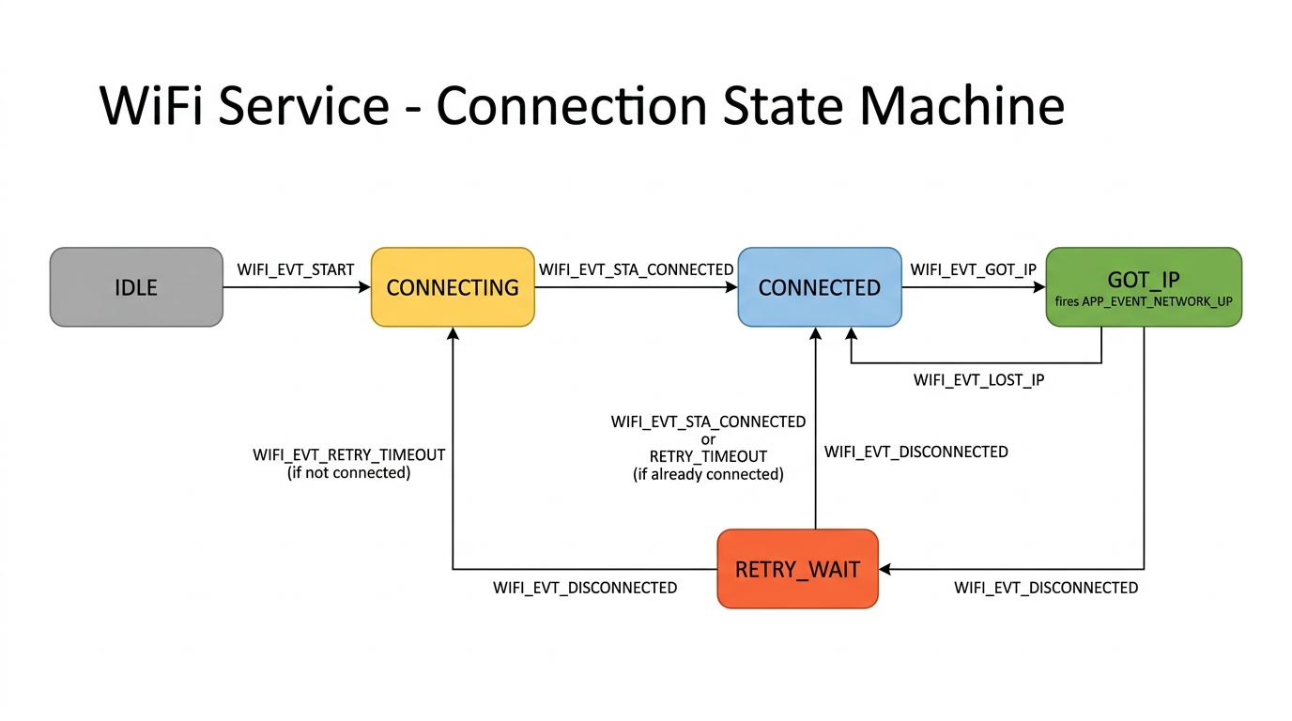
Figure: Wifi Fsm Diagram
Dedicated FreeRTOS task processes events from a queue. Auto-reconnect with configurable timeout (20s). Arduino WiFi event callbacks translated to internal events.
mqtt_service — mqtt_service.h / mqtt_service.cpp
MQTT client wrapper with: thread-safe publish via FreeRTOS TX queue (producer-consumer pattern), Last Will & Testament (ECO/WS-1/MQTT-STATUS → "offline", QoS 1, retain), auto-reconnect, and state machine (DEINITIALIZED → INITIALIZED → CONNECTING → RUNNING → STOPPED). Inbound messages forwarded to subscriber_post().

3.5 Application Layer
acquisition — acquisition.h / acquisition.cpp
The cyclic scan engine. A FreeRTOS task that every 10 seconds iterates all readable tags, builds a protocol_request_t (OP_READ) for each, posts to the protocol dispatcher queue, receives protocol_response_t results on a response queue (capacity: 30), and updates tag_runtime with new values, validity, and timestamps. Pinned to Core 1, priority 5.
publisher — publisher.h / publisher.cpp
A FreeRTOS task that every 20 seconds iterates all tags with TAG_TOPIC_TYPE_PUBLISH, skips invalid tags, serializes each as JSON ({id, ts, type: "telemetry", value}), and publishes to the tag's configured MQTT topic (QoS 1).
subscriber — subscriber.h / subscriber.cpp
Handles inbound MQTT commands. On start, subscribes to all tags with TAG_TOPIC_TYPE_SUBSCRIBE. Receives messages via subscriber_post() (called from MQTT service), looks up tag by topic, validates access mode, deserializes JSON, extracts value. Special case: cmd_regen tag routes to core_request_regen() / core_abort_regen(). General case: builds protocol_request_t (OP_WRITE) and posts to protocol dispatcher.
alert_service — alert_service.h / alert_service.cpp
Subscribes to APP_EVENTS and CORE_EVENTS via the event service, translates them into severity-tagged alerts, and publishes as JSON to ECO/WS-1/ALERTS:
Event | Severity
FAULT_LOW_PRESSURE | CRITICAL
FAULT_LOW_SALT | CRITICAL
REGEN_FAILED | CRITICAL
SYSTEM_FAULT | CRITICAL
FAULT_DATA_LOSS | WARNING
REGEN_STARTED | INFO
REGEN_COMPLETED | INFO

core — core.h / core.cpp
The domain logic brain — a FreeRTOS task evaluating the water softener state machine every 2 seconds:
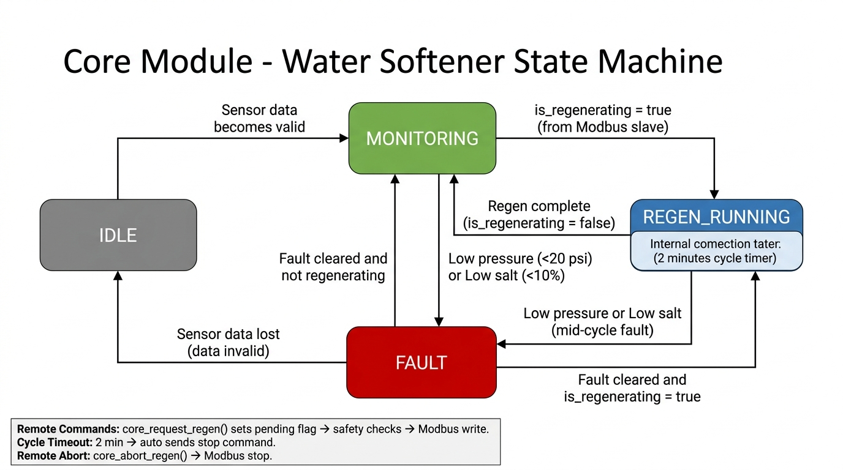
Figure: Core Fsm Diagram
Reads pressure (tag 2), salt (tag 3), and regen_status (tag 6) from tag_runtime. Fault thresholds: pressure < 20 psi, salt < 10%. Regeneration cycle timeout: 2 minutes.
Remote Command Processing & Safety Interlocks:
Remote command requests (start/abort regeneration) are received via the MQTT subscriber, which calls thread-safe functions (core_request_regen() and core_abort_regen()) to set pending flags protected by a mutex. The core task evaluates these flags at the end of its 2-second loop:
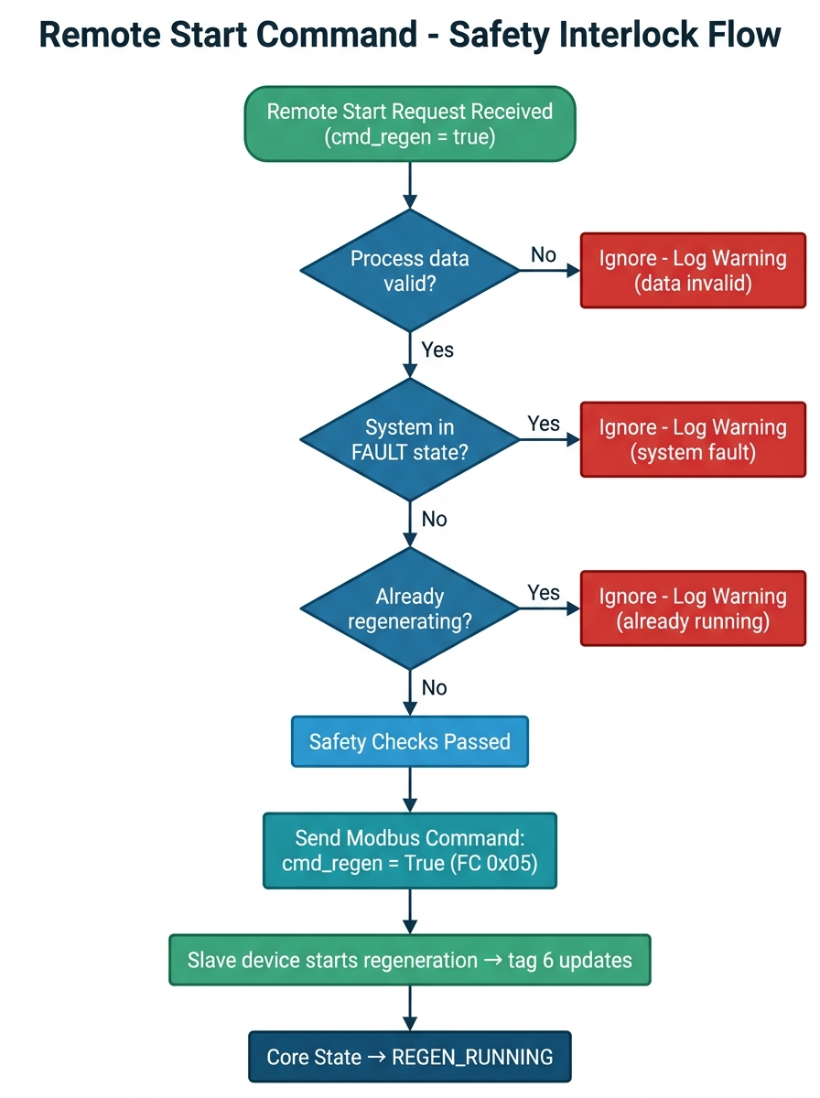
Figure: Safety Checks Flow
Regeneration Stop & Timeout Lifecycle:
A running regeneration cycle can be stopped in three ways: cycle timeout (automatic), remote abort command, or external hardware/manual intervention.
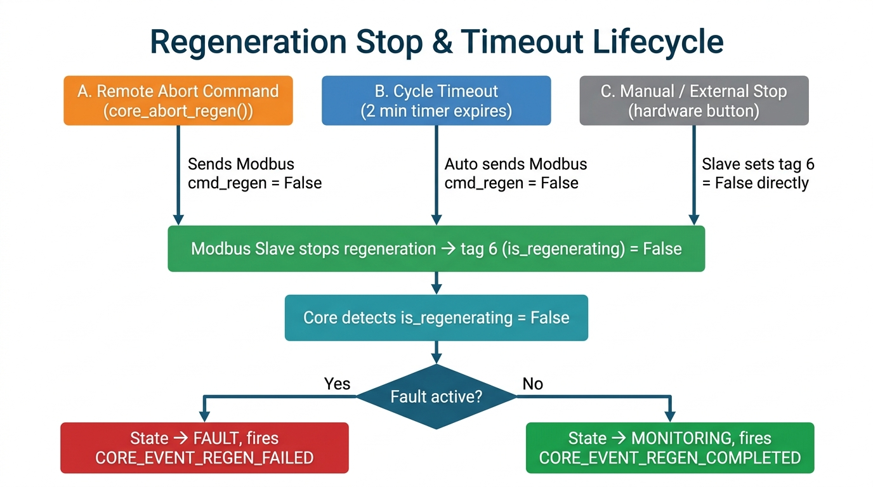
Figure: Regen Stop Flow

3.6 Entry Point — main.cpp
The Mediator/Orchestrator. Defines all hardware configuration structs (WiFi, MQTT, Modbus, acquisition, publisher). Calls app_init() — sequential initialization of all 12 modules in dependency order. Calls app_start() — starts alert, core, protocol_dispatcher, acquisition, wifi. Registers an app_event_handler() that coordinates service lifecycle via events:
- NETWORK_UP → start MQTT
- NETWORK_DOWN → stop MQTT
- MQTT_CONNECTED → start publisher & subscriber
- MQTT_DISCONNECTED → stop publisher & subscriber
fault_handler() handles critical errors (SYS_ERR_NO_MEMORY triggers reboot). loop() is intentionally empty — all work runs in FreeRTOS tasks.

4. Data Flow

4.1 Sensor Data (Field → Cloud)
Modbus Slave Devices
│ RS-485 / Modbus RTU (FC 0x02, 0x03)
▼
modbus_service ← async read request from protocol_dispatcher
│ raw uint16_t registers
▼
modbus_codec ← decodes to typed tag_value_t (handles word order)
│ protocol_response_t (tagId + value + status)
▼
acquisition ← posts response to acquisition queue
│ updates value, valid, changed, timestamp
▼
tag_runtime ← shared in-memory cache (mutex-protected)
│ reads valid + publishable tags
▼
publisher ← serializes to JSON with ArduinoJson
│ mqtt_msg_t → TX queue
▼
mqtt_service ← publishes to MQTT broker
│
▼
MQTT Broker (Cloud)

4.2 Commands (Cloud → Field)
MQTT Broker (Cloud)
│ incoming message on subscribed topic
▼
mqtt_service ← onMessage callback
│ mqtt_msg_t → subscriber queue
▼
subscriber ← finds tag by topic, parses JSON
│
├── cmd_regen? ──► core_request_regen() / core_abort_regen()
│
└── general write ──► protocol_request_t (OP_WRITE)
│
▼
protocol_dispatcher → modbus_write_request()
│
▼
modbus_service → Modbus RTU slave

4.3 Event-Driven Lifecycle
- WiFi connects → APP_EVENT_NETWORK_UP → main starts MQTT
- MQTT connects → APP_EVENT_MQTT_CONNECTED → main starts publisher + subscriber
- MQTT disconnects → APP_EVENT_MQTT_DISCONNECTED → main stops publisher + subscriber
- WiFi disconnects → APP_EVENT_NETWORK_DOWN → main stops MQTT
- Core detects fault → CORE_EVENT_FAULT_* → alert_service publishes alert JSON

5. Concurrency Model
All real work happens in FreeRTOS tasks communicating via queues and events. The Arduino loop() is intentionally empty.
Task | Core | Priority | Purpose
acquisitionTask | 1 | 5 | Cyclic scan of all tags (10s interval)
protocolDispatcherTask | 1 | 5 | Routes protocol requests to services
publisherTask | 1 | 5 | Publishes telemetry to MQTT (20s interval)
subscriberTask | 1 | 5 | Processes inbound MQTT commands
alertTask | 1 | 5 | Translates events to alert JSON, publishes
coreTask | 1 | 5 | Evaluates state machine (2s interval)
wifiFSTMTask | 1 | 5 | Wi-Fi connection FSM
mqttTask | 1 | 5 | Dequeues and sends MQTT messages

Synchronization Mechanisms:
- FreeRTOS Queues — acquisition responses (30-deep), protocol requests, MQTT TX, subscriber inbox, alert inbox, WiFi events
- FreeRTOS Mutex — tag_runtime access, Modbus bus lock, logger serial output
- portMUX Spinlock — core state access, MQTT state access, WiFi connection state

6. Design Patterns
Pattern | Where | Why
Event-Driven Architecture | Entire system | Modules are decoupled; lifecycle is coordinated via events rather than direct calls
Mediator | main.cpp | Centralizes all module coordination and lifecycle orchestration
Finite State Machine | core.cpp, wifi_service.cpp | Manages complex state transitions with well-defined states and transitions
Producer-Consumer | All FreeRTOS queues | Thread-safe asynchronous communication between tasks
Strategy / Router | protocol_dispatcher.cpp | Routes requests to different protocol handlers based on tag source
Registry | tag_registry.cpp | Central lookup table for tag configuration
Facade | event_service.cpp | Simplifies the ESP-IDF event loop API
Codec | modbus_codec.cpp | Isolates serialization / byte-order concerns from business logic
Observer | alert_service.cpp | Subscribes to events and reacts to state changes
Service Lifecycle | All modules | Consistent init() → start() → stop() pattern with state enums

7. Module Dependency Graph
main.cpp (orchestrator)
├── logger
├── event_service ◄── system_events
├── tag_registry
├── tag_runtime ◄── tag_registry
├── core ◄── tag_runtime, protocol_dispatcher, event_service
├── modbus_service ◄── modbus_codec, tag_registry, acquisition
├── protocol_dispatcher ◄── modbus_service, system_service
├── acquisition ◄── tag_registry, tag_runtime, protocol_dispatcher
├── wifi_service ◄── event_service
├── mqtt_service ◄── subscriber, event_service
├── publisher ◄── tag_runtime, mqtt_service
├── subscriber ◄── tag_registry, protocol_dispatcher, core, mqtt_service
└── alert_service ◄── event_service, mqtt_service

8. Initialization Sequence
The system boots in strict dependency order:
Step | Call | Purpose
1 | logger_init() | Serial @ 115200 baud
2 | event_init() | ESP-IDF default event loop
3 | Register app_event_handler | Lifecycle coordination
4 | alert_init() | Alert queue & event subscriptions
5 | tag_runtime_init() | Allocate runtime array for 8 tags
6 | core_init() | State machine initialization
7 | modbus_init() | Serial1 @ 19200 baud, 8N2
8 | protocol_dispatcher_init() | Request queue
9 | acquisition_init() | Response queue (30 slots)
10 | publisher_init() | Publish interval config
11 | subscriber_init() | Subscriber queue
12 | wifi_init() | WiFi STA mode config
13 | mqtt_init() | Broker URI, credentials, LWT
14 | alert_start() | Alert processing task
15 | core_start() | State machine task (2s eval)
16 | protocol_dispatcher_start() | Dispatcher task
17 | acquisition_start() | Scan task (10s interval,)
18 | wifi_start() | WiFi FSM task → connects
19 | NETWORK_UP → mqtt_start() | MQTT connection attempt (event-driven)
20 | MQTT_CONNECTED → publisher + subscriber start | Telemetry & command processing (event-driven)

9. Configuration Summary
Parameter | Value
WiFi | STA mode, auto-reconnect 20s
MQTT Broker | www.hostname.com:1883
MQTT Keep-Alive | 120 seconds
MQTT Clean Session | false
MQTT LWT Topic | ECO/WS-1/MQTT-STATUS
Modbus Baud Rate | Configurable (for my demo: 19200 (8N2))
Modbus TX/RX Pins | Configurable (for my demo: GPIO 17 / GPIO 18)
Modbus Timeout | 2000 ms
Acquisition Scan Interval | 10,000 ms
Publisher Interval | 20,000 ms
Core Evaluation Period | 2,000 ms
Pressure Fault Threshold | < 20 psi
Salt Fault Threshold | < 10%
Regen Timeout | 120,000 ms (2 min)

10. File Structure
EcoWell_MQTT-MODBUS_GATEWAY/
├── platformio.ini # Build config — ESP32-S3, libs, flags
├── include/ # Header files (public interfaces)
│ ├── system_err.h # Universal error codes
│ ├── logger.h # Logging macros & functions
│ ├── event_service.h # Event bus API
│ ├── system_events.h # Event ID definitions
│ ├── tag_registry.h # Tag config structs & enums
│ ├── tag_runtime.h # Runtime value cache
│ ├── modbus_codec.h # Register encode/decode
│ ├── modbus_service.h # Modbus RTU master
│ ├── protocol_dispatcher.h # Protocol routing
│ ├── system_service.h # System tag reader
│ ├── acquisition.h # Scan engine
│ ├── mqtt_service.h # MQTT client
│ ├── publisher.h # MQTT publisher
│ ├── subscriber.h # MQTT subscriber
│ ├── core.h # Business logic state machine
│ ├── alert_service.h # Alert generation
│ └── wifi_service.h # WiFi manager
├── src/ # Implementation files
│ ├── main.cpp # Entry point & orchestrator
│ ├── logger.cpp # Thread-safe serial logging
│ ├── event_service.cpp # ESP event loop wrapper
│ ├── system_events.cpp # Event base definitions
│ ├── tag_registry.cpp # 8 tag definitions
│ ├── tag_runtime.cpp # Runtime value store
│ ├── modbus_codec.cpp # Data type codec
│ ├── modbus_service.cpp # Modbus RTU driver
│ ├── protocol_dispatcher.cpp # Request router
│ ├── system_service.cpp # System tag handler
│ ├── acquisition.cpp # Cyclic scan task
│ ├── mqtt_service.cpp # MQTT client lifecycle
│ ├── publisher.cpp # Telemetry publisher
│ ├── subscriber.cpp # Command subscriber
│ ├── core.cpp # Water softener FSM
│ ├── alert_service.cpp # Event-to-alert translator
│ └── wifi_service.cpp # WiFi connection FSM
├── lib/ # Local libraries (empty)
└── test/ # Unit tests (empty)

11. Enum Ranges
Each module uses a unique hundred-block for its enum values to prevent collisions:
Range | Module
10–13 | Word order (tag_registry)
20–22 | Tag access mode
30–32 | Tag source
40–41 | Tag topic type
50–56 | Tag data type
100–104 | Log levels (logger)
150–154 | WiFi connection state
200–203 | WiFi service state / Protocol dispatcher state
300–303 | Acquisition state
400–406 | Core state / App events
500–503 | Publisher state
600–603 | Subscriber state
610–614 | MQTT state
700–705 | Core events

12. Summary
This project demonstrates a production-quality embedded IoT gateway architecture with:
- Clean layered design — Foundation → Data Model → Protocol → Connectivity → Application
- Event-driven architecture — Modules communicate via events, not direct coupling
- Real-time concurrency — 8 FreeRTOS tasks with queues, mutexes, and spinlocks
- Protocol abstraction — The dispatcher pattern allows adding CAN or other protocols without touching the acquisition engine
- Robust lifecycle management — Every service follows init → start → stop with state validation
- Fault tolerance — Auto-reconnect for WiFi and MQTT, Modbus health tracking, watchdog fault handler
- Domain intelligence — A state machine encodes water softener business rules (fault detection, regeneration management)

Total codebase: ~2,400 lines of C++ across 17 modules, with zero external framework dependencies beyond Arduino, FreeRTOS (built-in), and three well-chosen libraries (eModbus, PsychicMqttClient, ArduinoJson).

