Software Requirements Specification

for

Court Justice Portal
Version 1.1

Prepared by
Group Name: Code with Us
Rahul Kava | CE-97 | rahulkava024@gmail.com
Het Kalariya | CE-94 | hetkalariya273@gmail.com

Instructor: | Sheetal Pathar Ma’m
Course: | B.Tech
Lab Section: | SEPP(Subject Software Engineering Principle and Practices)
Teaching Assistant: | Sheetal Pathar Ma’m
Date: | <place the date of submission here>
Table of Contents ........................................................................................................ ii
Revision History .......................................................................................................... iii
- Introduction ............................................................................................................. 1
1.1 Purpose .................................................................................................................. 1
1.2 Document Conventions ......................................................................................... 1
1.3 Intended Audience and Reading Suggestions ....................................................... 1
1.4 Product Scope ........................................................................................................ 1
1.5 References ............................................................................................................. 2
- Overall Description .................................................................................................. 3
2.1 Product Perspective ............................................................................................... 3
2.2 Product Functions .................................................................................................. 3
2.3 User Classes and Characteristics .......................................................................... 7
2.4 Operating Environment ......................................................................................... 8
2.5 Design and Implementation Constraints ............................................................... 8
2.6 User Documentation .............................................................................................. 8
2.7 Assumptions and Dependencies ............................................................................ 9
- External Interface Requirements .......................................................................... 10
3.1 User Interfaces ..................................................................................................... 10
3.2 Hardware Interfaces ............................................................................................. 18
3.3 Software Interfaces .............................................................................................. 19
3.4 Communications Interfaces ................................................................................ 19
- System Features .................................................................................................... 19
4.1 Graph Visualization ............................................................................................. 19
4.2 Graph Layout ........................................................................................................ 22
4.3 Graph Metrics ....................................................................................................... 23
4.4 Filters ................................................................................................................... 24
4.5 Data Table ............................................................................................................ 25
4.6 Dynamic Graphs .................................................................................................. 28
4.7 Graph Export ........................................................................................................ 29
- Other Nonfunctional Requirements ...................................................................... 30
5.1 Performance Requirements ................................................................................. 30
5.2 Safety Requirements ............................................................................................ 30
5.3 Security Requirements ........................................................................................ 30
5.4 Software Quality Attributes ................................................................................ 30
Glossary ...................................................................................................................... 31

Introduction

Purpose
A Portal to file FIR or Case in court with the rules and regulation under judicial system ,as per the requirement of FIR registration case at court and assigning lawyer with tracking the status of case.

Document Convention
This Document was created based on the IEEE template for System Requirement Specification Documents.

Product Scope
Any Person/Victim who want to register FIR or wants to register Case in court.Victim,Police,lawyer,Judge can easily fetch the details regarding case study and trace the procedure of case

References and Acknowledgements

Overall Description

Product Overview
Victim will register For FIR to Portal and FIR will be fetched by Police and they will investigate on it and then there is required to move further in case then Police will help to request Lawyer and then Lawyer will guide police to find evidence and those evidence will be uploaded in portal so that lawyer can show them to judge and judge will check the all evidence and validate them and according to them Judge will Give Next hearing or give the Judgment of Case.

Product Functionality
- Login/Sign up for any user as Victim/Police/Lawyer/Judge
- Victim Requests for FIR
- Take Track of Status and Information of Case
- Victim can Hire lawyer as per Requirement
- Police Registers The FIR Approval
- Collecting Evidence for FIR
- Managing the Fine
- Lawyer validates the Case
- Review the Details of Evidence
- If Required then Negotiate and settle with Client/Victim
- Judge Schedules and Manages Cases
- Records Judgement and Order
- Last Decision of CaseResearch

Design and implementation Constraints
The Portal is developed with HTML,CSS,JAVASCRIPT. It uses a modular design where every feature is wrapped into a separate module and the modules depend on each other through well-written APIs.

User Classes and Characteristics

- Typical Victim,who wants to register FIR And Wants to fight for justice in court
- Any Police Officer who want to check the evidence and add,modify remove evidence
- Any Lawyer Who want Case to Proceed in Court and give justice to Victim
- Judge,to Manage the dates or verify the documents

Specific Requirements

External Interface Requirements

User Interfaces

1.Court Justice Portal Welcome Screen:
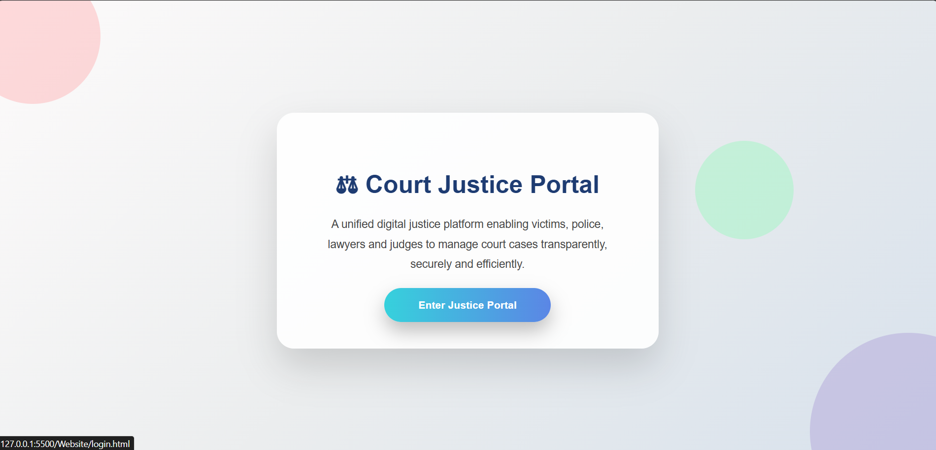

2.Login/Sign-up Screen
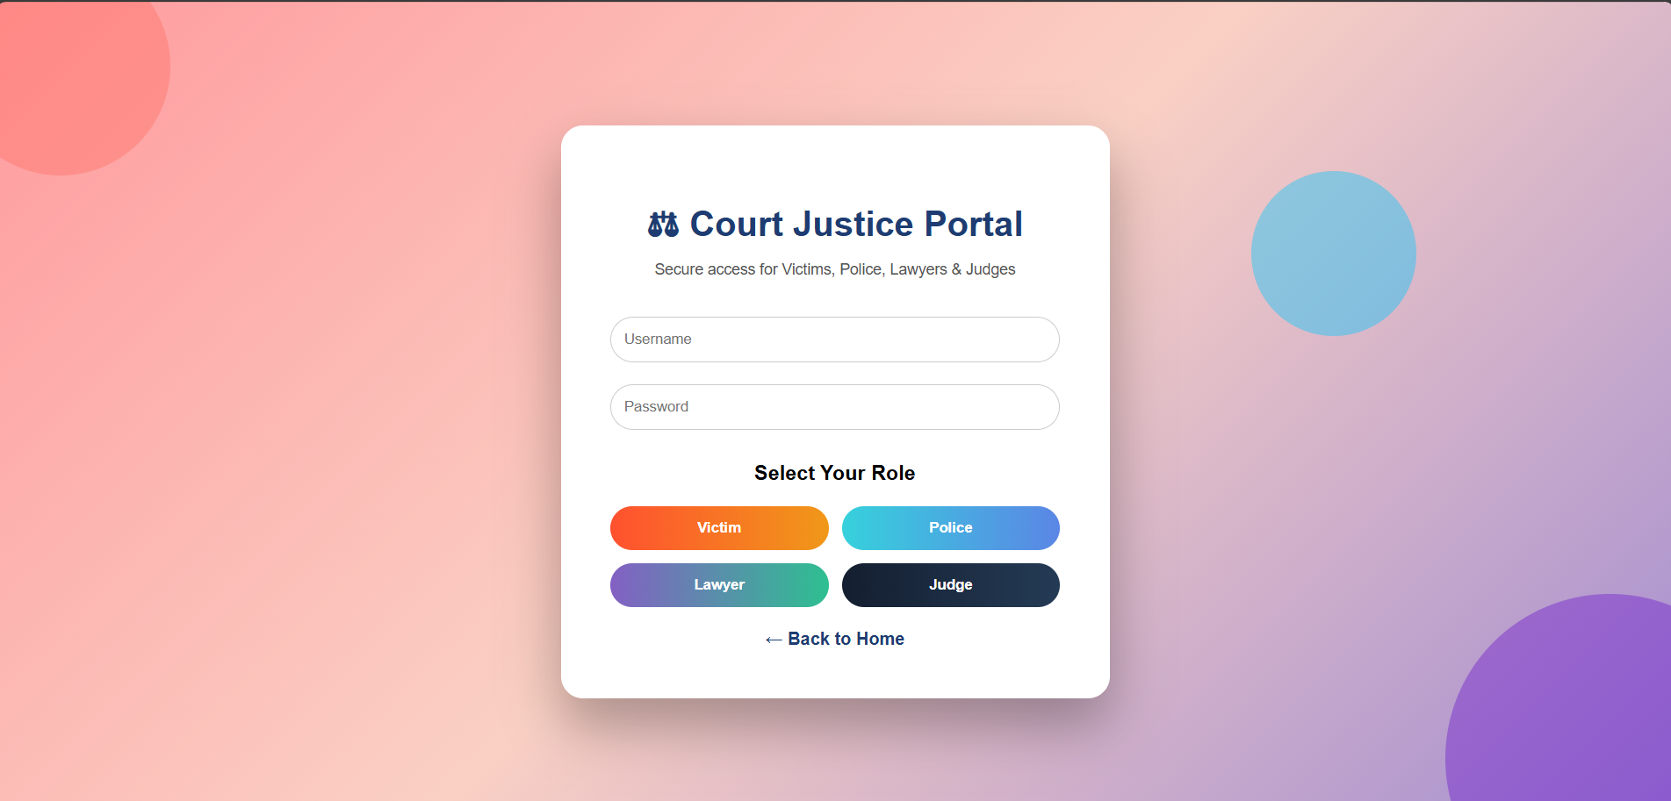

4.Victim/User DashBoard
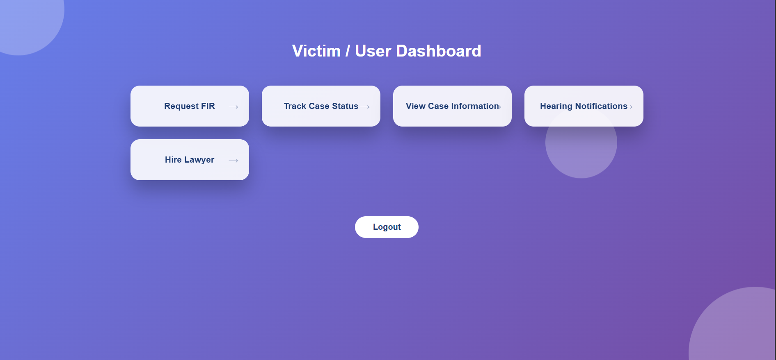

5.Police DashBoard
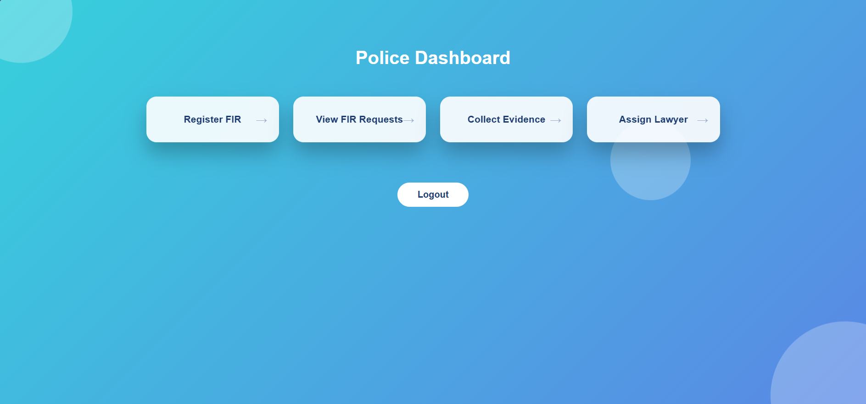

6.Lawyer DashBoard
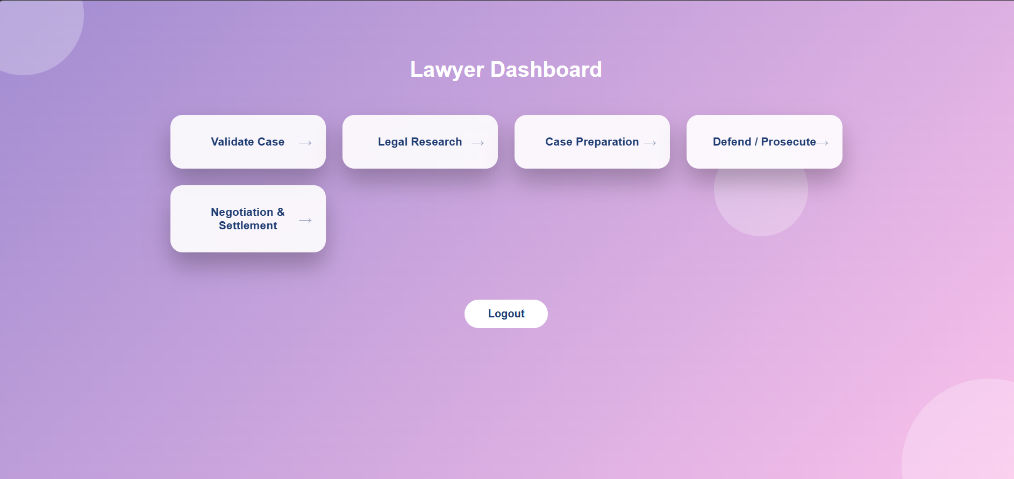

7.Judge DashBoard
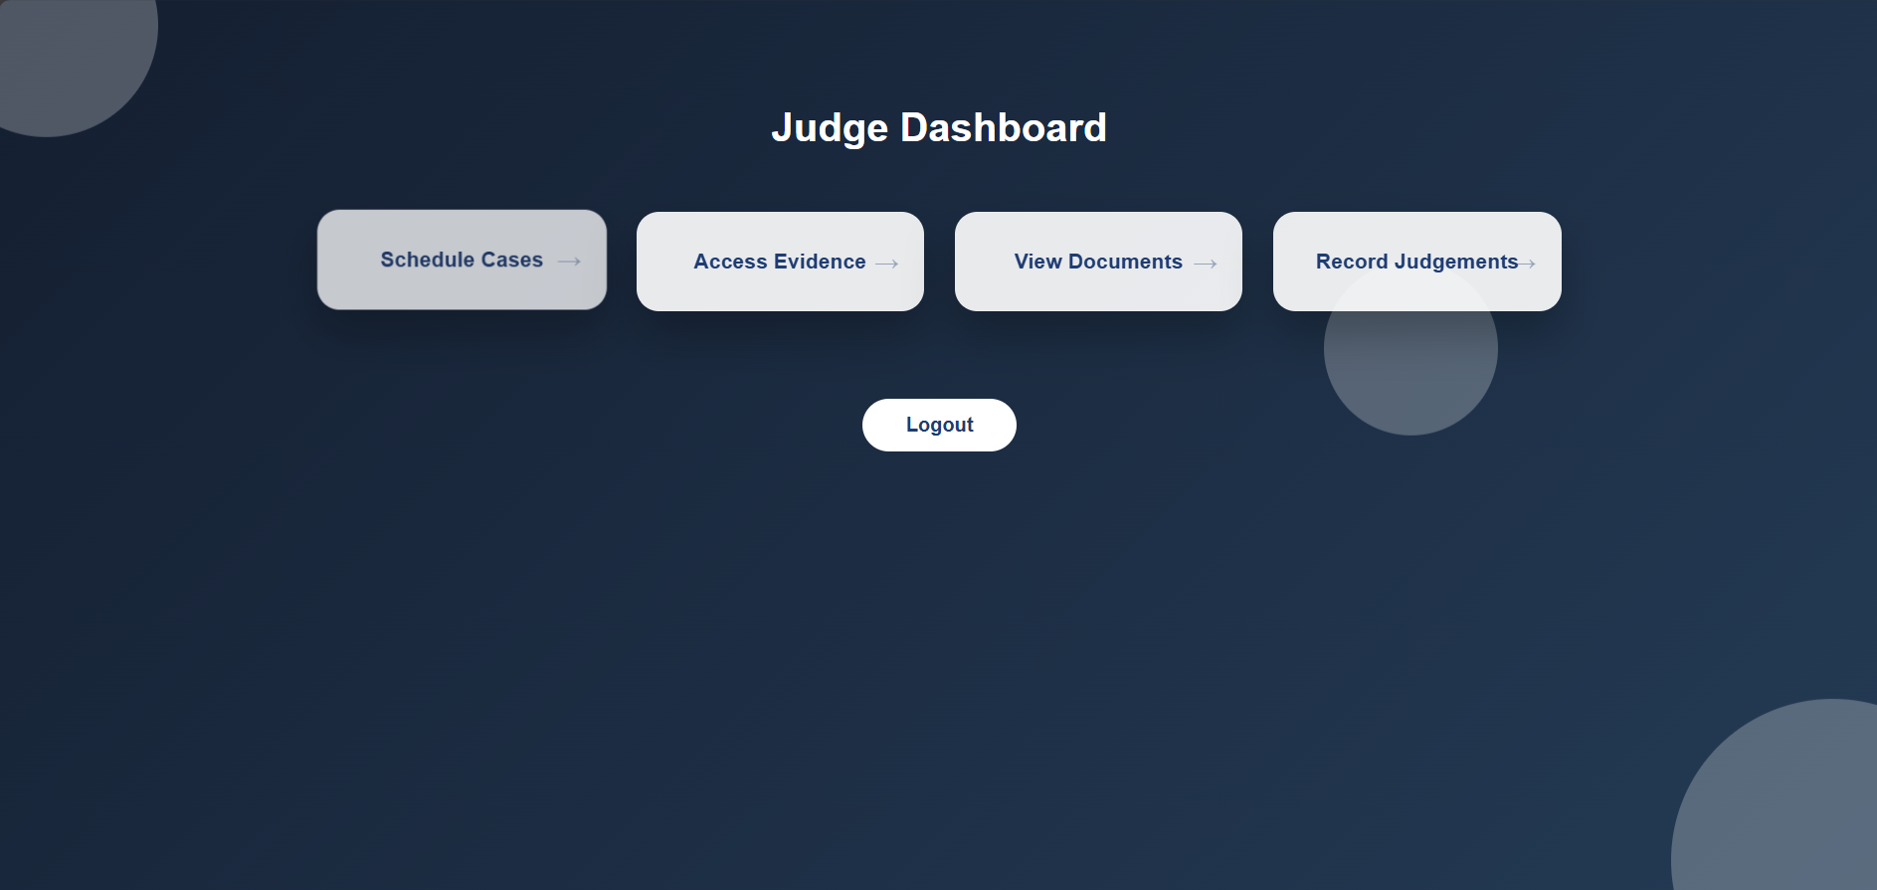

Hardware Interfaces

The minimum hardware requirements of Gephi are a 500 Megahertz CPU and 128 megabytes of RAM. Also, because Gephi uses an OpenGL 3D engine to speed up graph visualization, a compatible graphics card is required. A system with these specifications can handle a Network of approximately 1000 edges and nodes. For bigger networks, additional memory is required

Software Interfaces

Gephi requires Java to be installed on the system, more specifically Java version 7 or 8 for its latest release. Additional information can be found on section 2.7 of this document.
Gephi can be connected with a MySQL, SQLite or PostgreSQL database to import a graph edge list.

Functional requirements

R1 - Authentication :(victim,police,lawyer,judge)
→ Description : Login or Sign in as Victim or Lawyer or Judge or
Police
→ Input : Keywords(email , user type , password)
→ Output : Logged in successfully

R2 - Registration :

R 2.1 - User Information
→ Input : User details,valid documents

R 2.2 - Lawyer Information
→ Input : Lawyer details , valid i’d proofs

R 2.3 - Police Information
→ Input : Police details , police i’d , appointment later

R 2.4 - Judge Information
→ Input : Judge details , court i’d

R3 - Manage FIR :
→ Description : To add or validate FIR

R3.1 - Register FIR
→Input: Description of crime and evidence
→Output : FIR ID , Current FIR status

R3.2 - Validate FIR
→Output : Final status of FIR (Approved / Rejected)

R3.3 - FIR Status
→Input : FIR ID
→Output : current status of FIR (Pending / Approved)

R4 - Search Cases :
→ Description : Details of cases which are already registered

→ Input : case ID , case type
→ Processing : Search in database According to Case ID
→ Output : Case details , last hearing date and current status

R5 - Hire Lawyer :
→Description : To find the Lawyer for your case

R5.1 - Search for Lawyer
→ Input : Keywords(Name , experience and casetype)
→ Processing : Search based on criteria

R5.2 - View details of lawyer
→ Output : Lawyer name , number , fees , experience

R5.3 - Send request
→ Input : Case details , FIR number , Evidence

R5.4 - Approve Request
→ Output : Request accepted or rejected

R6 - Manage Case :
→Description : Validation of case by lawyer or modification by Judge

R6.1 - Request case
→ Input : Case type , Case description , supporting documents
→ Output : Case ID , Case type , Case details

R6.2 - Modify case
→ Processing : Updation or deletion of the existing case
→ Output : Modification of the case done successfully

R6.3 - Approve case

Use Case Model

Other Non-functional Requirements

N1 - Performance :
Description :
→Case search results will be displayed within 2–3 seconds.
→Modification of case will be done within 5 seconds.

N2 - Security :
Description:
→end to end encryption of Data of Victim.
→Multi-factor authentication will be required for users.

N3 - Reliability & Availability :
→ The system will be available 24/7 except during maintenance.

N4 - Portability:
→The Portal is Accessible from any Web Browser

N5 - Usability:
→user friendly interface and consist helping manual for users.

Other requirements

